Web Pages - Video call back from CMR (no Prototype and Visual):
https://gobeta.webex.com in 64-bit W7 EE SP1 with Firefox v39 web browser:
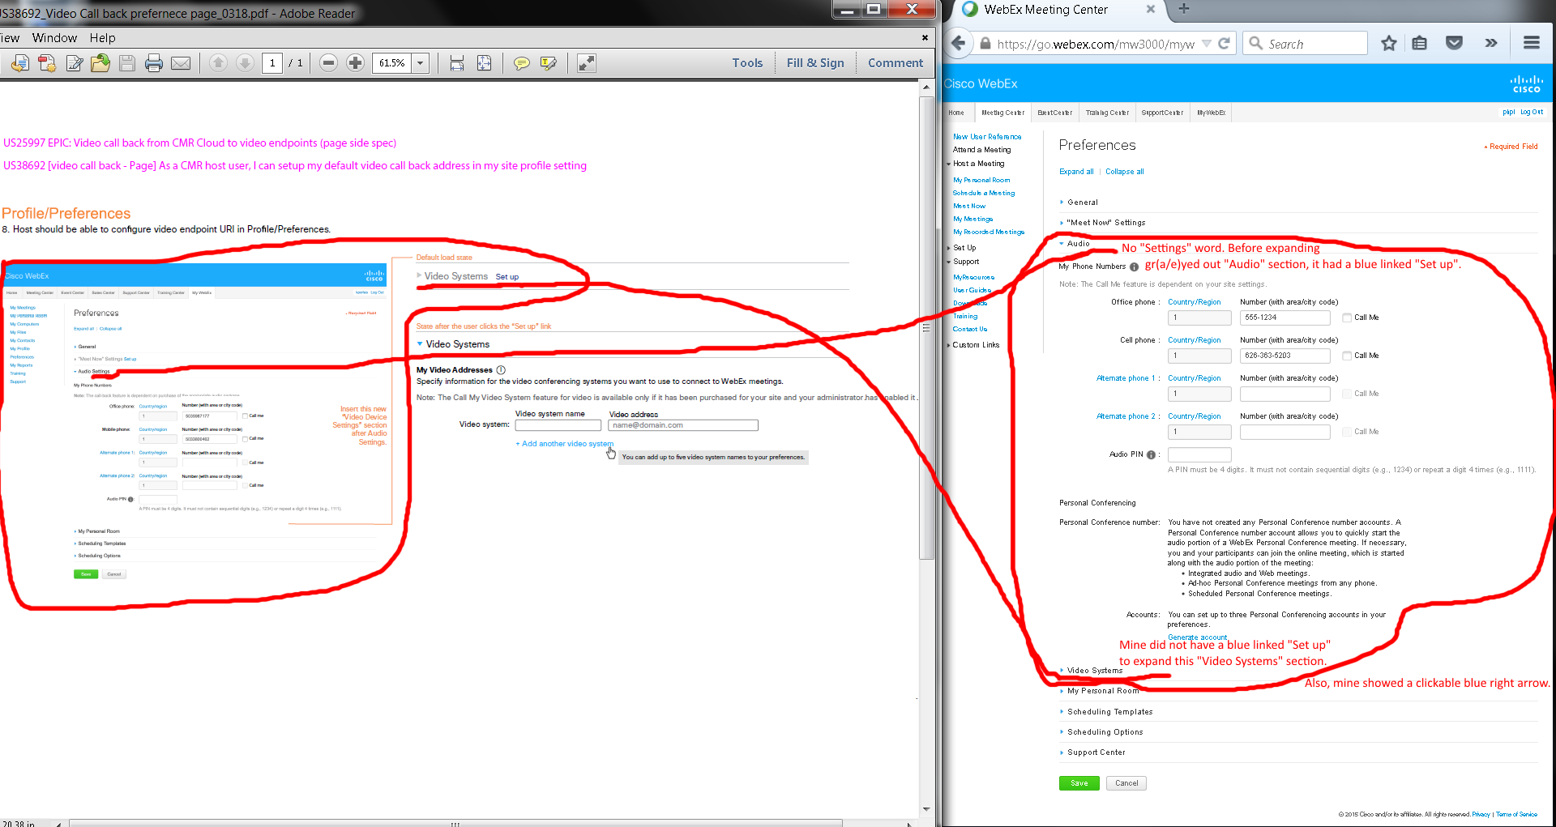
Issues:
- My go.webex.com’s profile preferences show no “Settings” after “Audio” text after expanding “Audio” section.
- My go.webex.com’s profile preferences show no blue “Set up” link after “Video Systems” text in collapsed “Video Systems” link. However, I did have a blue “Set up” link on the right of the gr(a/e)yed out “Audio” when it was collapsed before I clicked to expand it.

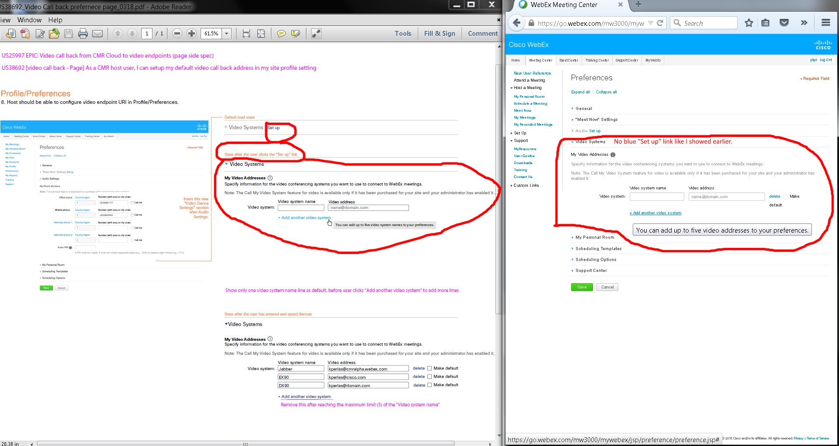
Issue: No blue “Set up” link in “Video Systems” section. Please ignore the "Make default" wordwrapping issue since I had to make everything smaller in sizes to screen capture. It was fine when not normal sizes.
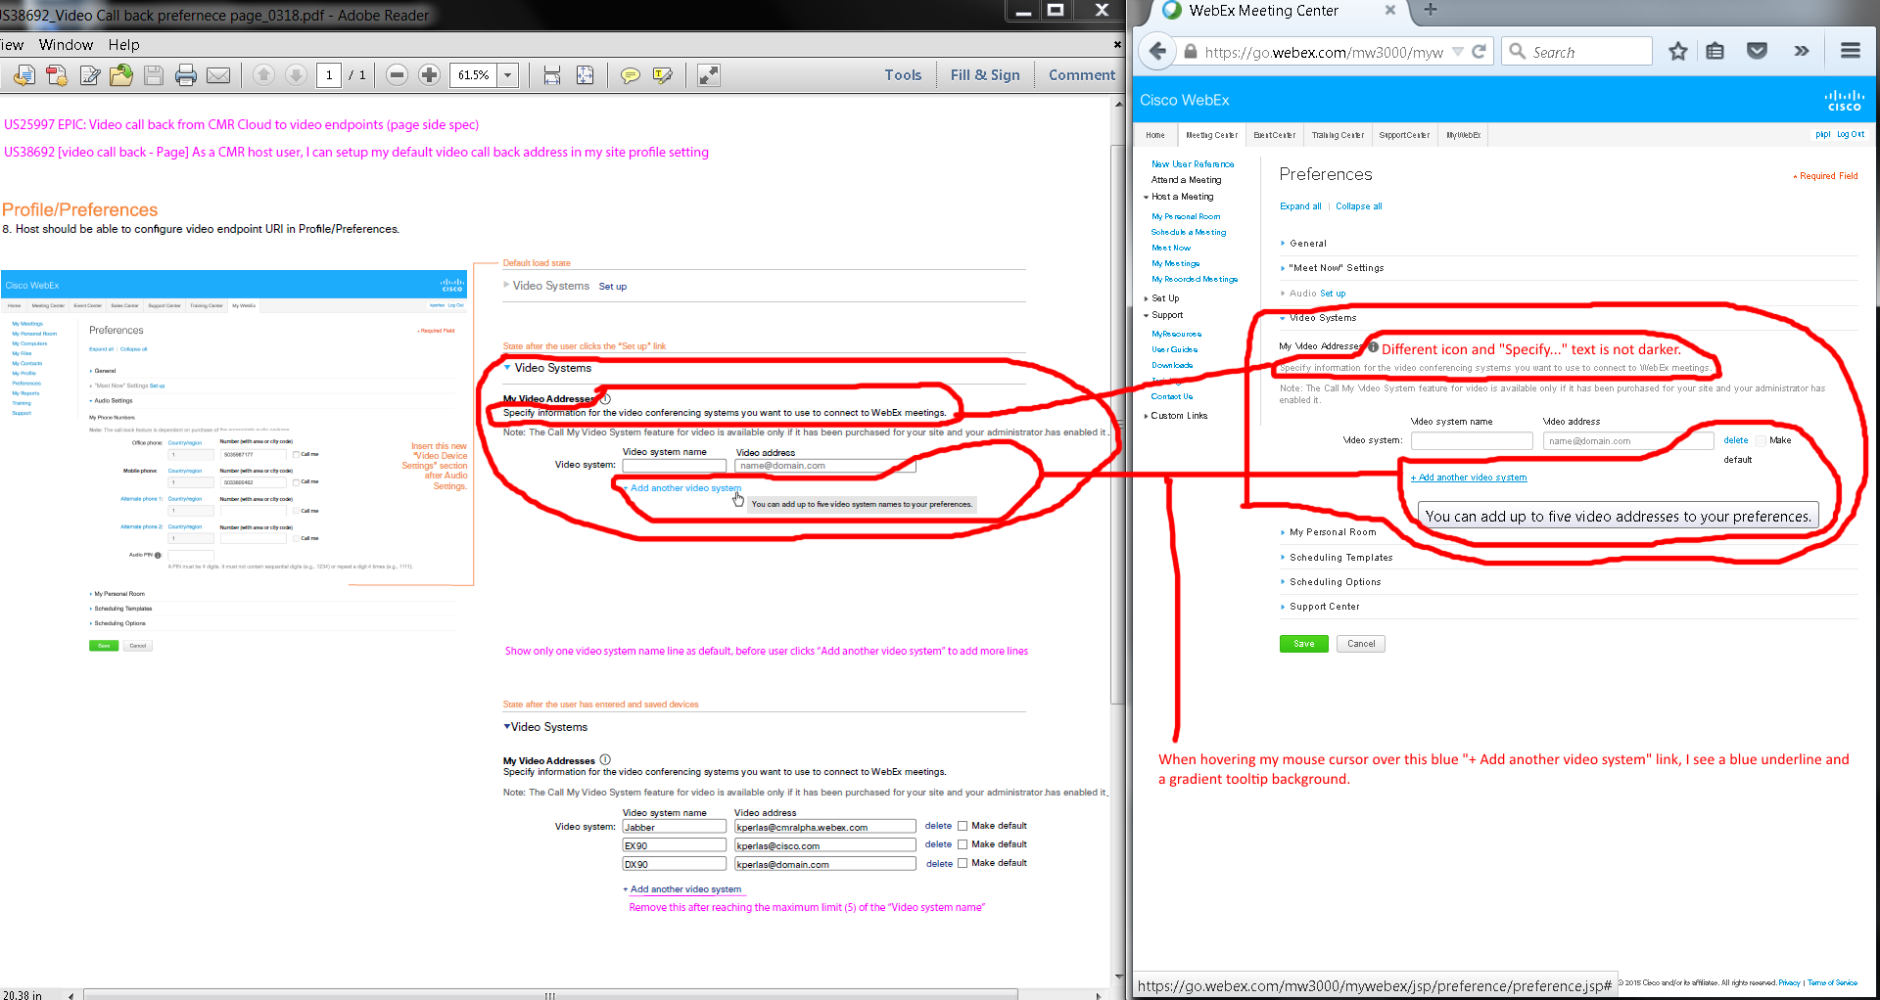
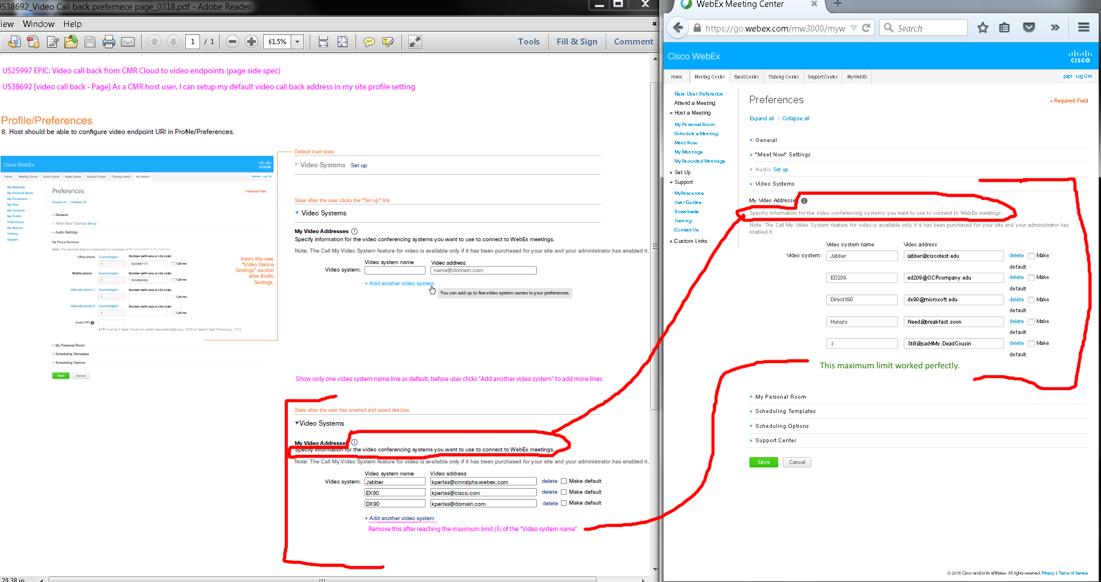
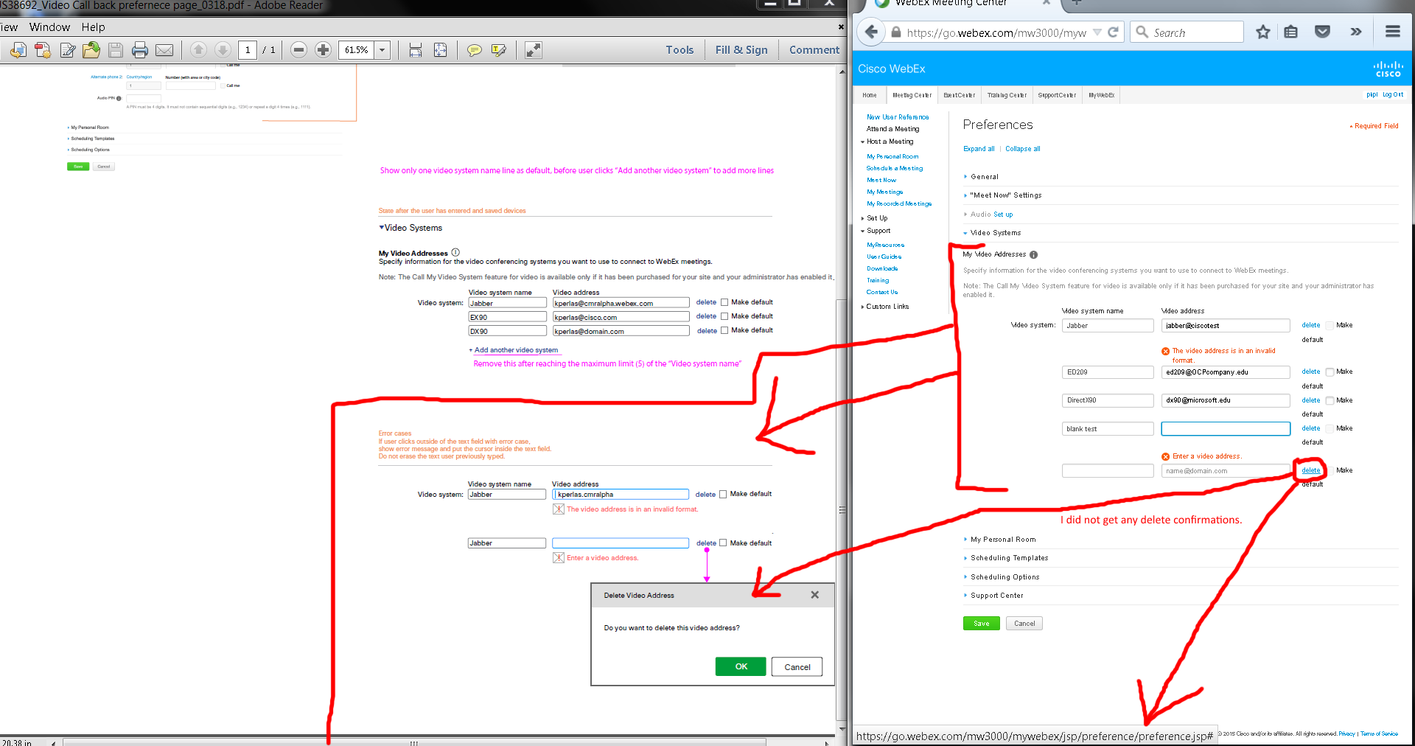
Issues:
- My “Video Addresses” section shows a different “i” icon and its “Specify information for the video conference systems you want to use to connect to WebEx meetings.” is a lighter color.
- I get a blue underline and a gradient tooltip background when I hover my mouse cursor over the blue “+ Add another video system” link.
- Deleting my inputted video address did not ask me to confirm.
Notes: Please ignore the "Make default" wordwrapping issue since I had to make everything smaller in sizes to screen capture. It was fine when not normal sizes.

OVERALL ISSUES:
- Please ignore the "Make default" wordwrapping issue since I had to make everything smaller in sizes to screen capture. It was fine when not normal sizes.
- My “Video Addresses” section shows a different “i” icon and its “Specify information for the video conference systems you want to use to connect to WebEx meetings.” is a lighter color.
- I get a blue underline and a gradient tooltip background when I hover my mouse cursor over the blue “+ Add another video system” link.
- Deleting my inputted video address did not ask me to confirm.
- My “Video Addresses” section shows a different “i” icon and its “Specify information for the video conference systems you want to use to connect to WebEx meetings.” is a lighter color.
- I get a blue underline and a gradient tooltip background when I hover my mouse cursor over the blue “+ Add another video system” link.
- Deleting my inputted video address did not ask me to confirm.

