Web Pages – User Guide (no prototype and visual):
https://gobeta.webex.com in 64-bit W7 EE SP1 (no antialias/ClearType) with its IE11 web browser:
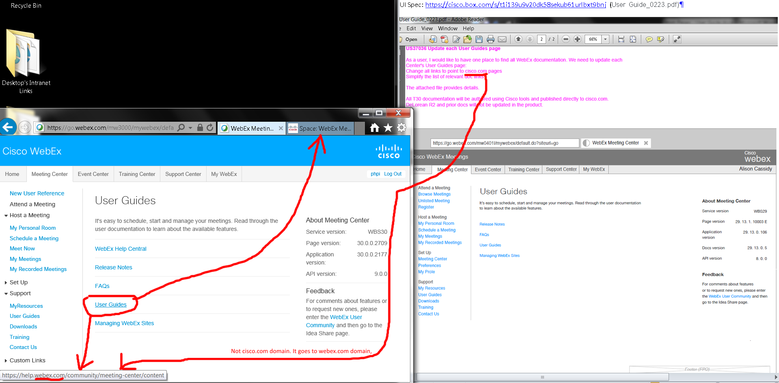
This URL shows:
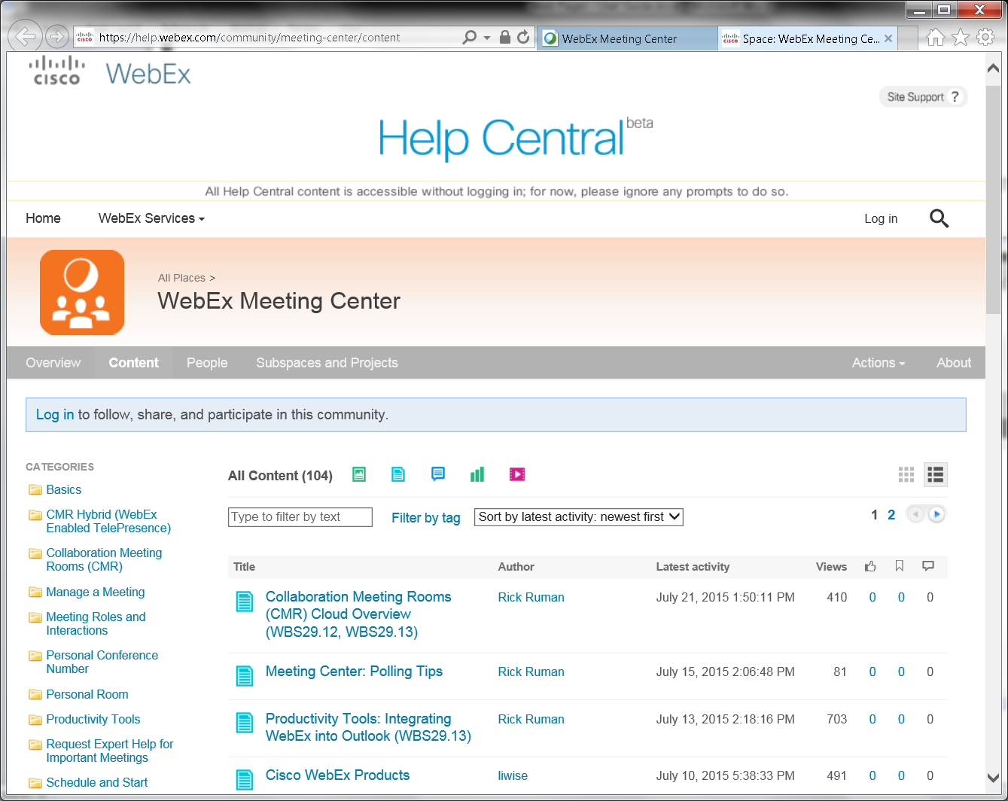
OVERALL ISSUES: User Guides” link did not go to cisco.com domain name, but webex.com domain name (Is this OK since Cisco owns both?).

