Web Pages’ Personal Room security (Force sign in) [no protoype and visual]:
In 64-bit W7 EE SP1 with Firefox v38.0.5 web browser on 7/3/2015:
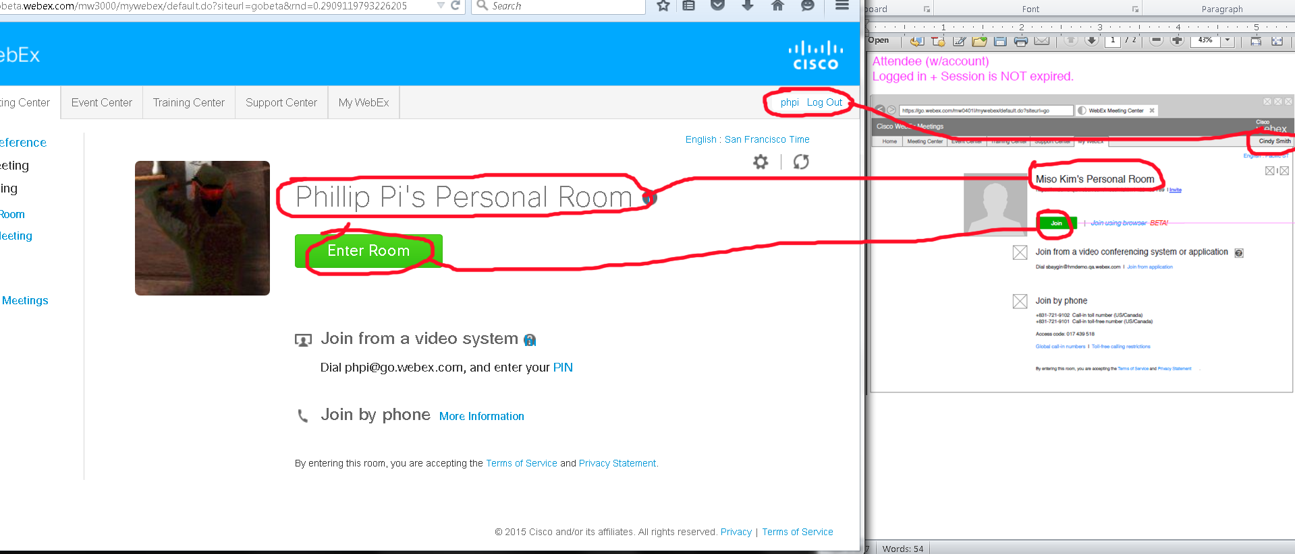
Issues: Since I only have one WebEx account, I was unable to test by logging into another WebEx account to a different WebEx account's host's personal room as shown in my above screen shot/capture (note the “Join”, names, etc.).

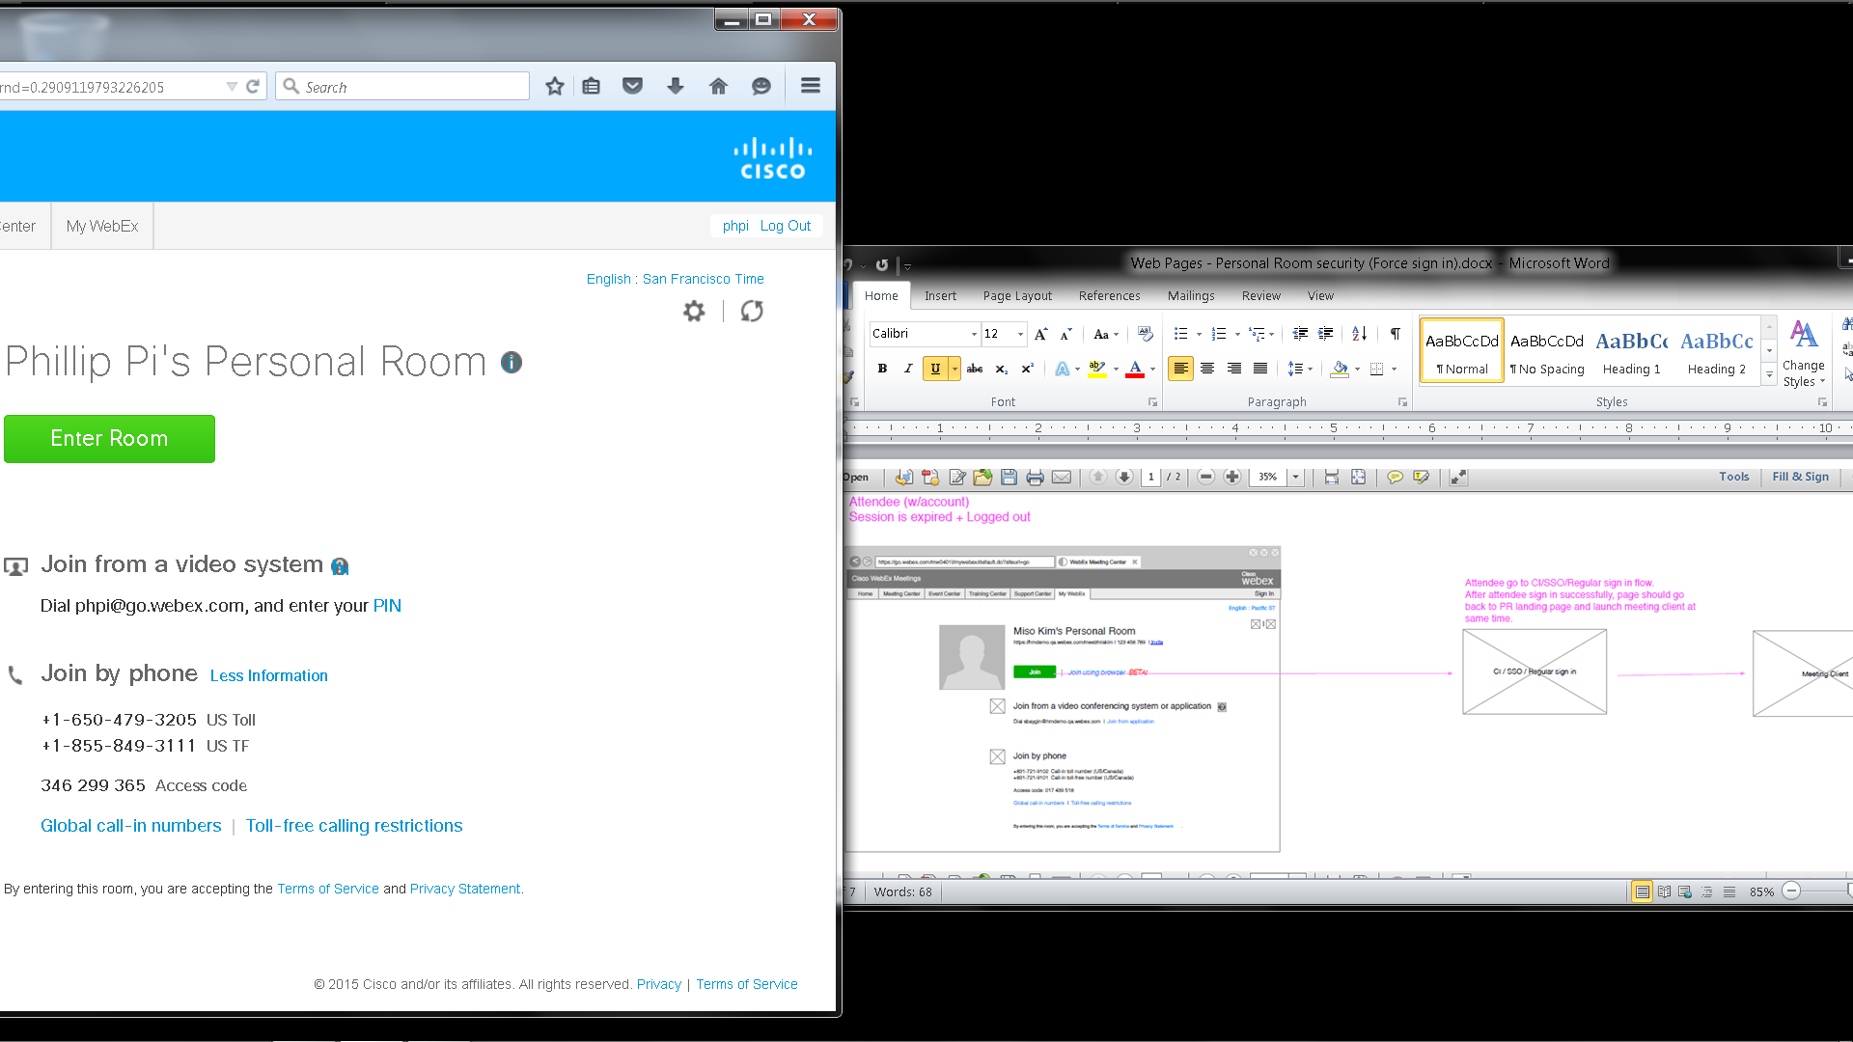
I used my Cisco account for my own personal room since I couldn’t reproduce this attendee scenario with my https://gobeta.webex.com/join/phpi. I idled for over a couple hours and got:
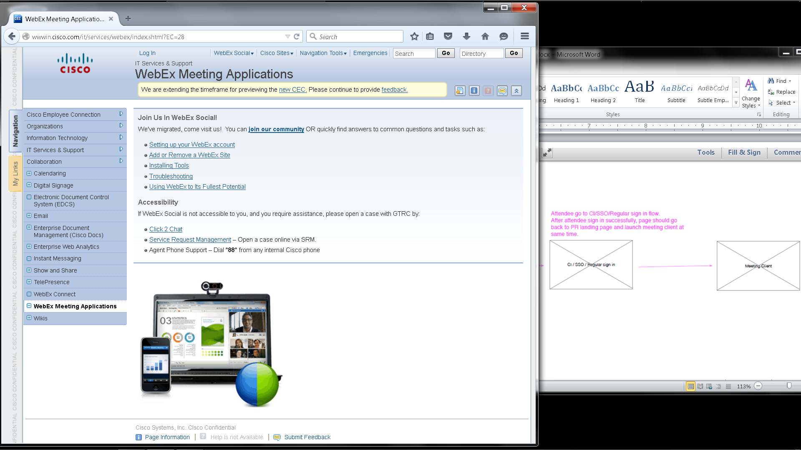
It took me to another Cisco web site without a sign in page.

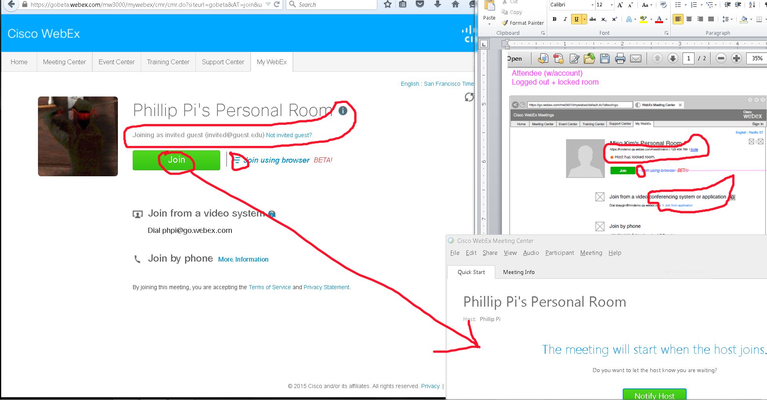
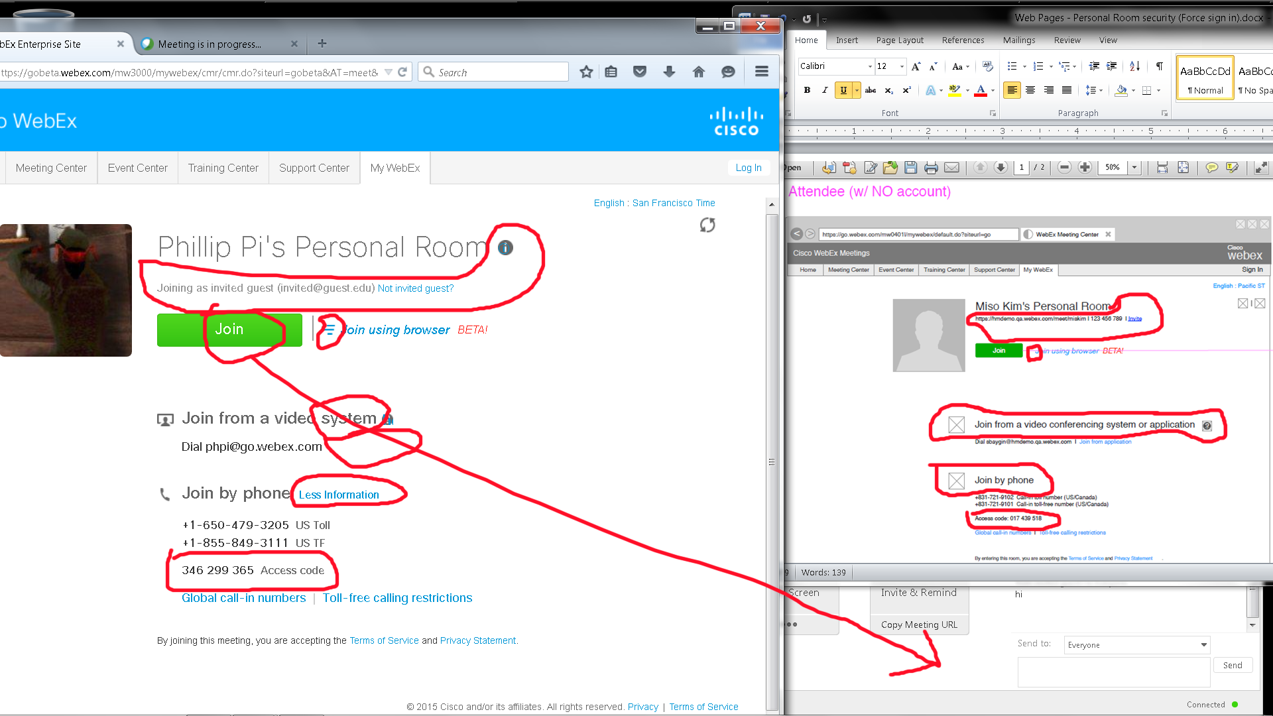
Issues:
- I saw different texts and image differences.
- I did not get a “Host has locked room.” message.
- Joining my own host’s personal room resulted no login as invited (guest/participant)s.

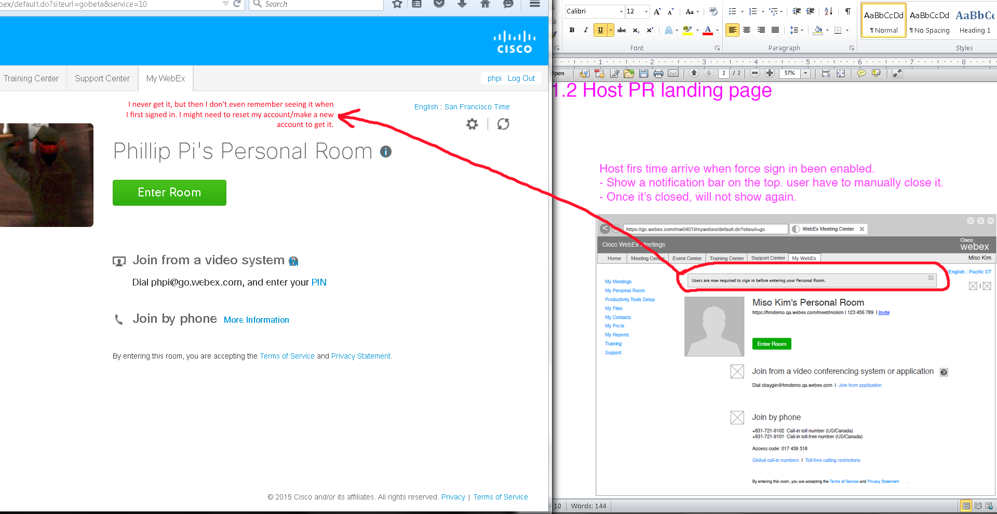
Issue: I do not get this “Users are now required to sign before entering your Personal Room.”

Overall Issues:
- Since I only have one WebEx account on gobeta web site, I was unable to test by logging into another WebEx account to join a different WebEx account's host's personal room as shown in my above screen shot/capture (note the “Join”, names, etc.).
- No sign in page after being idled for too long.
- Differences in texts, layouts, and graphics.
- Missing texts due to not being a first time visitor. Might need to reset my used account or get a new one?

