Web Pages’s Personal Room notification (no prototype):
https://gobeta.webex.com in 64-bit W7 EE SP1 with its IE11 web browser from 7/1-2/2015 & 7/7/2015:
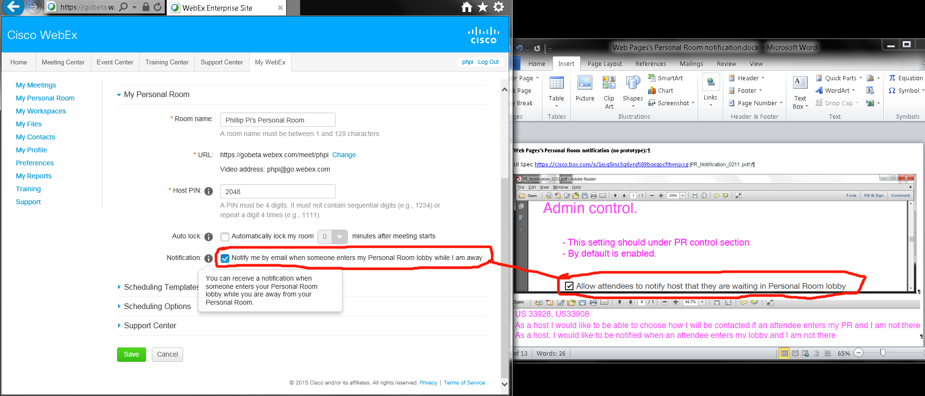
Issues:
- I don’t remember its original default settings and couldn’t find a revert back factory default settings.
- I could not find the exact “Allow attendees to notify host that they are waiting in Personal Rooms lobby”, but I think I found a similar option?

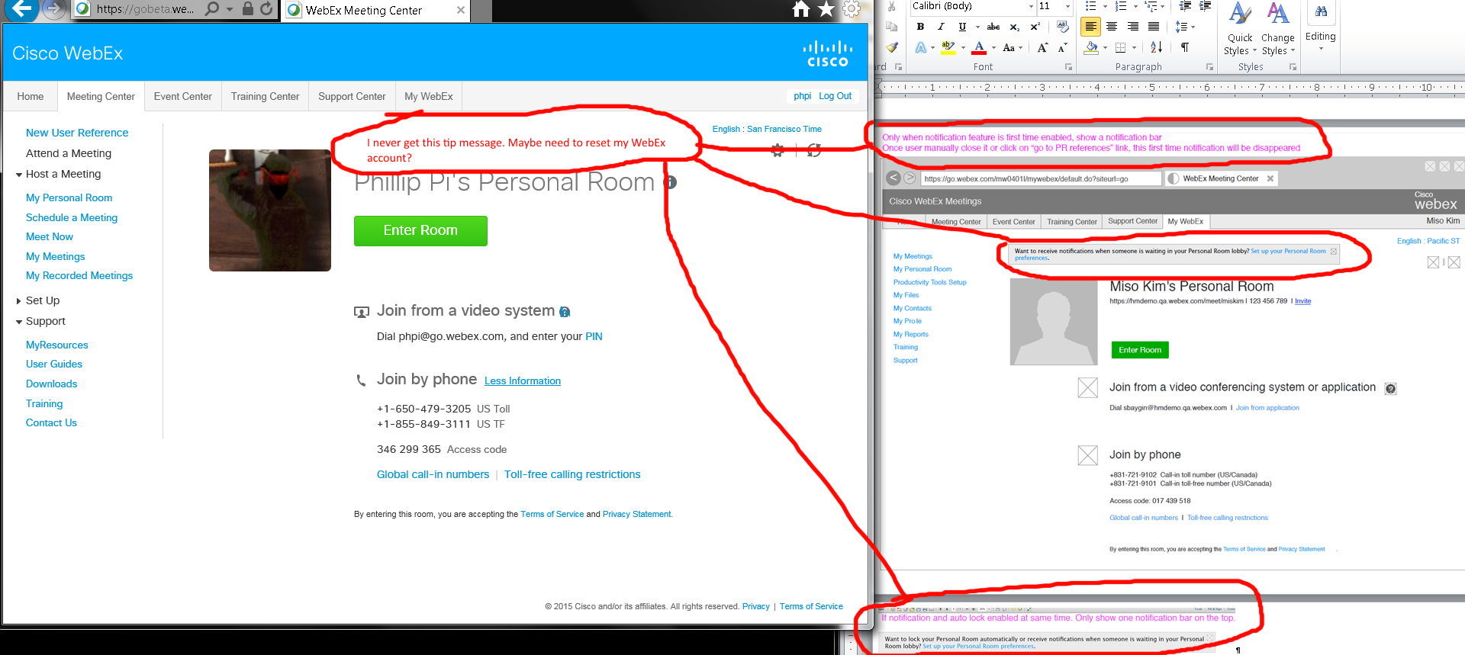
Issues: I have never seen this message before, but then I need to reset my room’s settings back to default factory settings since it only happens once per account usage which I am waiting for an answer so I can check.

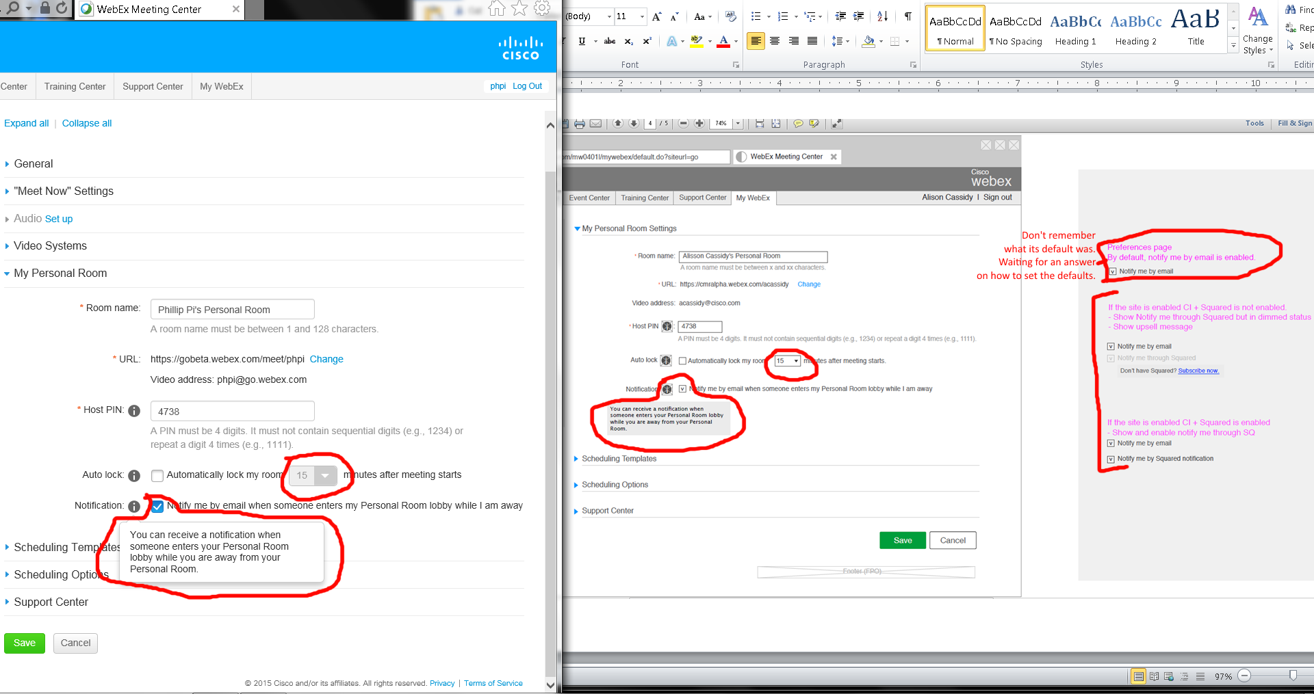
Issues:
- Auto-lock minutes menu pulldown menu look different between the document’s and my screen.
- I don’t know the default setting for “Notify me by email when someone enters my Personal Room lobby when I’m away”.
- Unable to get CI (Cisco account) and Squared (old Spark name) options to show up on my gobeta.webex.com settings. I’m waiting for answers from people. Miso Kim thinks this is outdated.

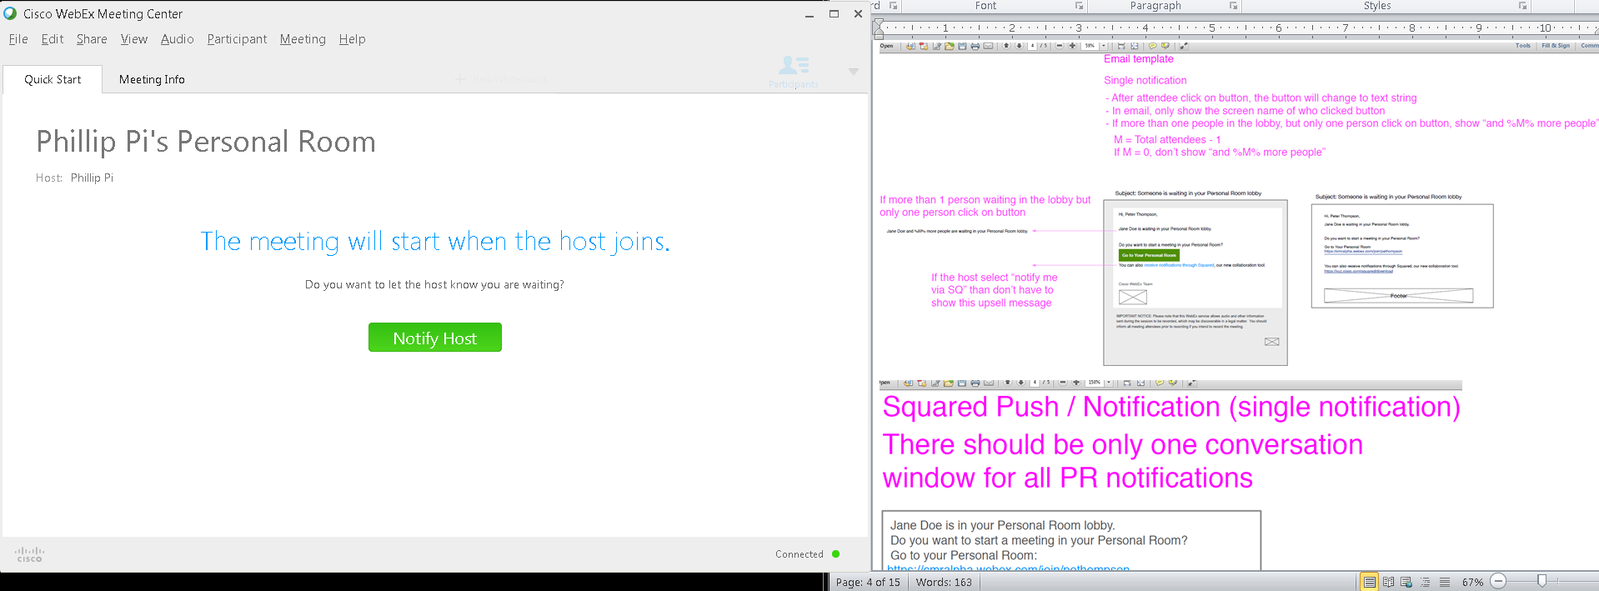
Joined as an invited guest (no login) with the host not currently in the personal room since WebEx client was exited. Manually clicked on the green “Notify Host” button and the host got the e-mail in less than a minute.
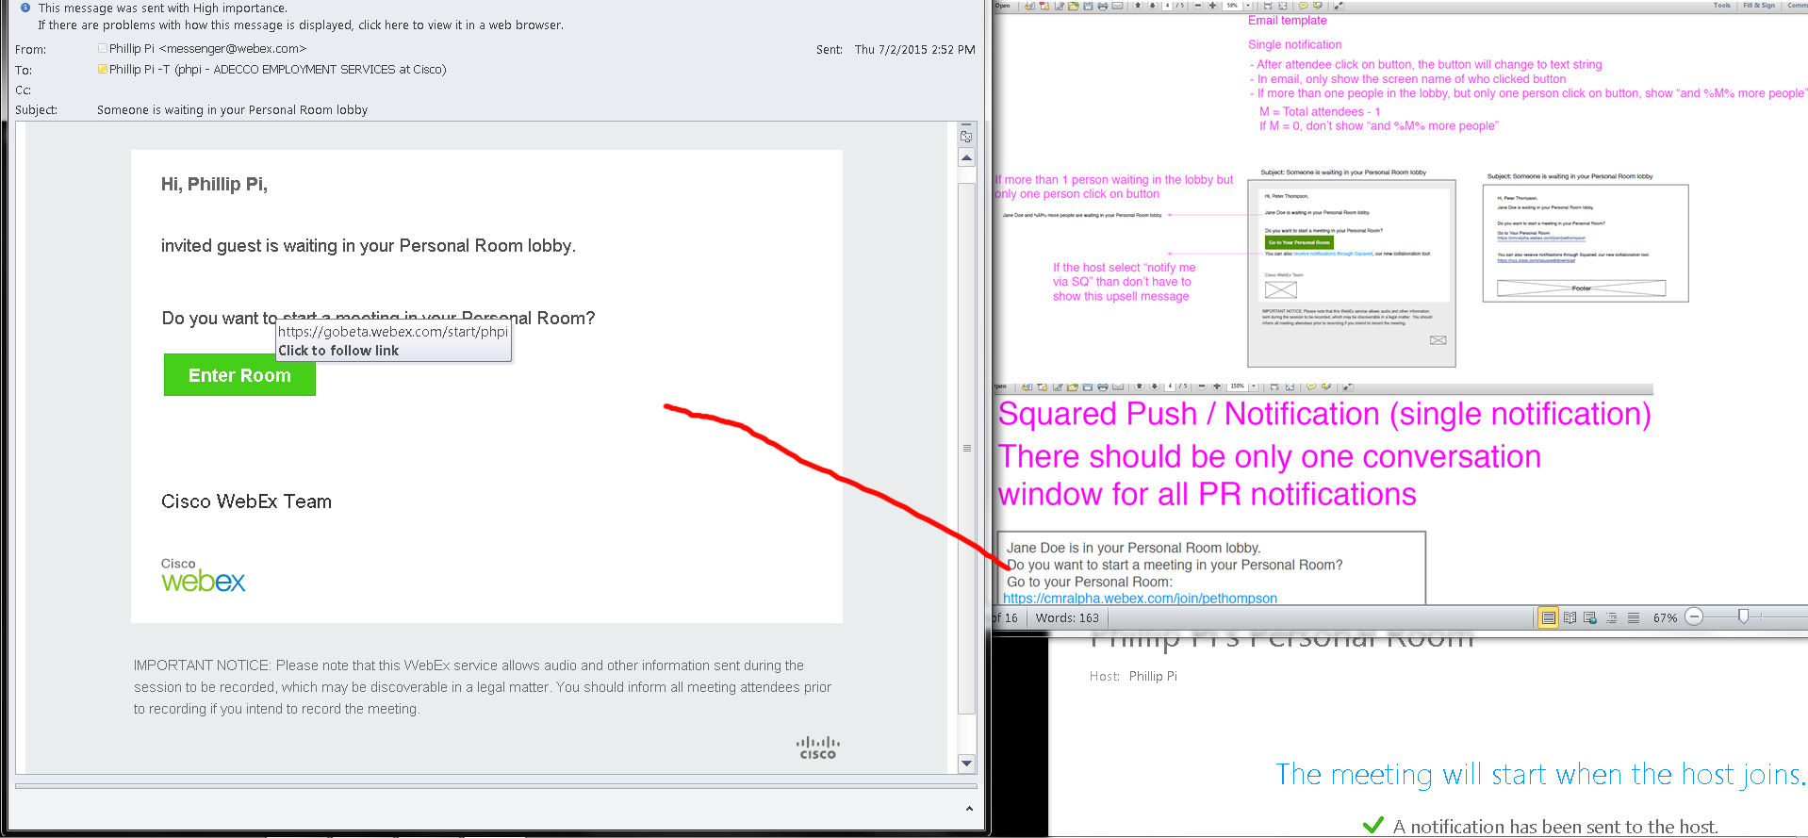
E-mail, with a link, went to the host’s Outlook 2010 inbox.
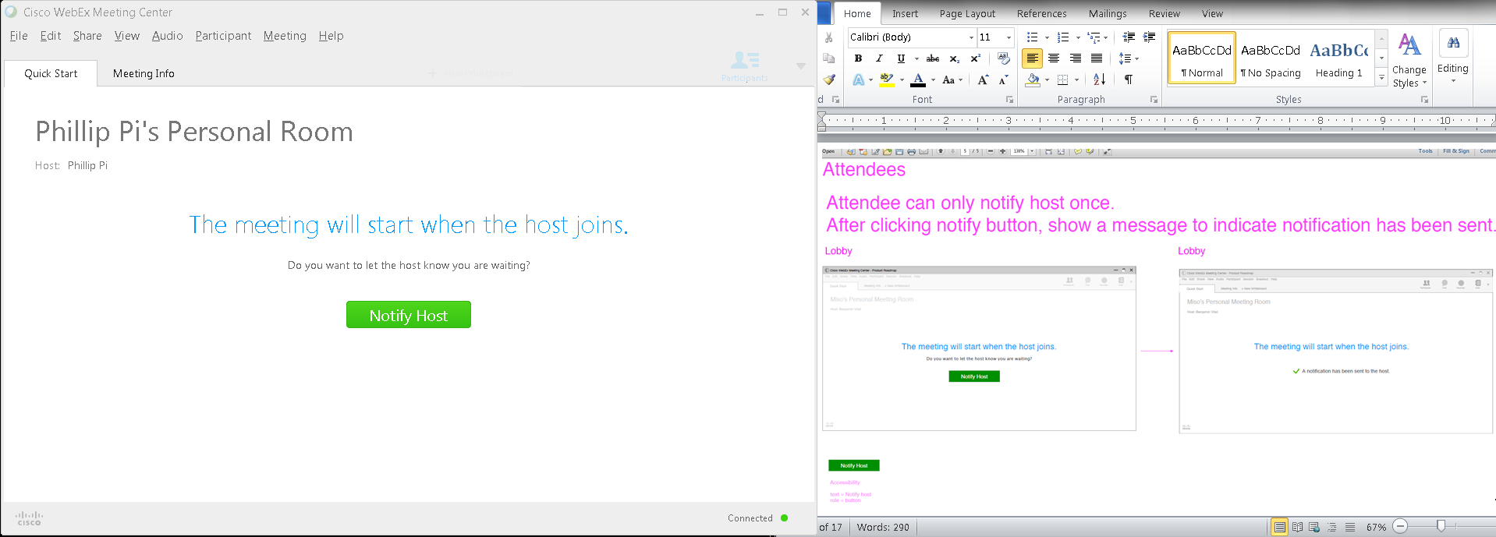
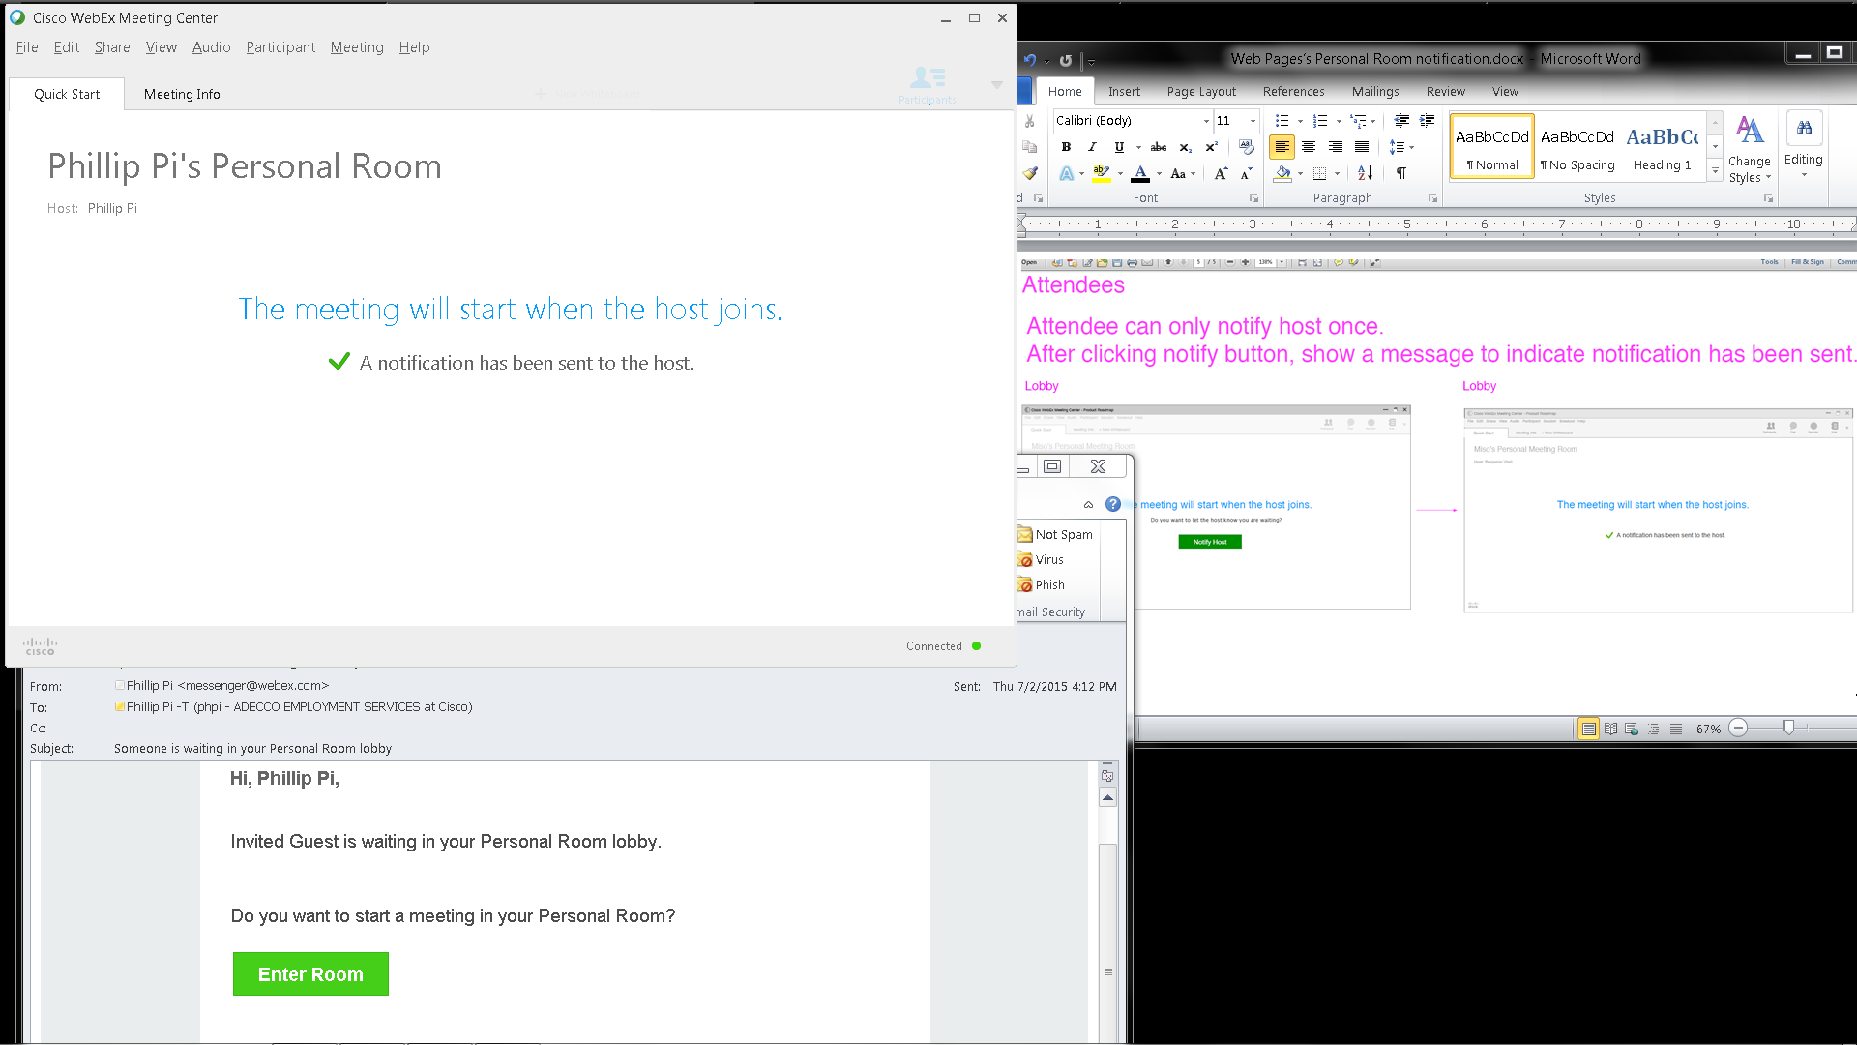

Issues:
- It doesn’t seem to do an automatic e-mail since I had my personal room’s settings to notify me when someone enters my personal room while I am not in it.
- Unable to do more than one participants in the host’s personal room due to thinking I am rejoining with Cisco WebEx Meetin Center software.

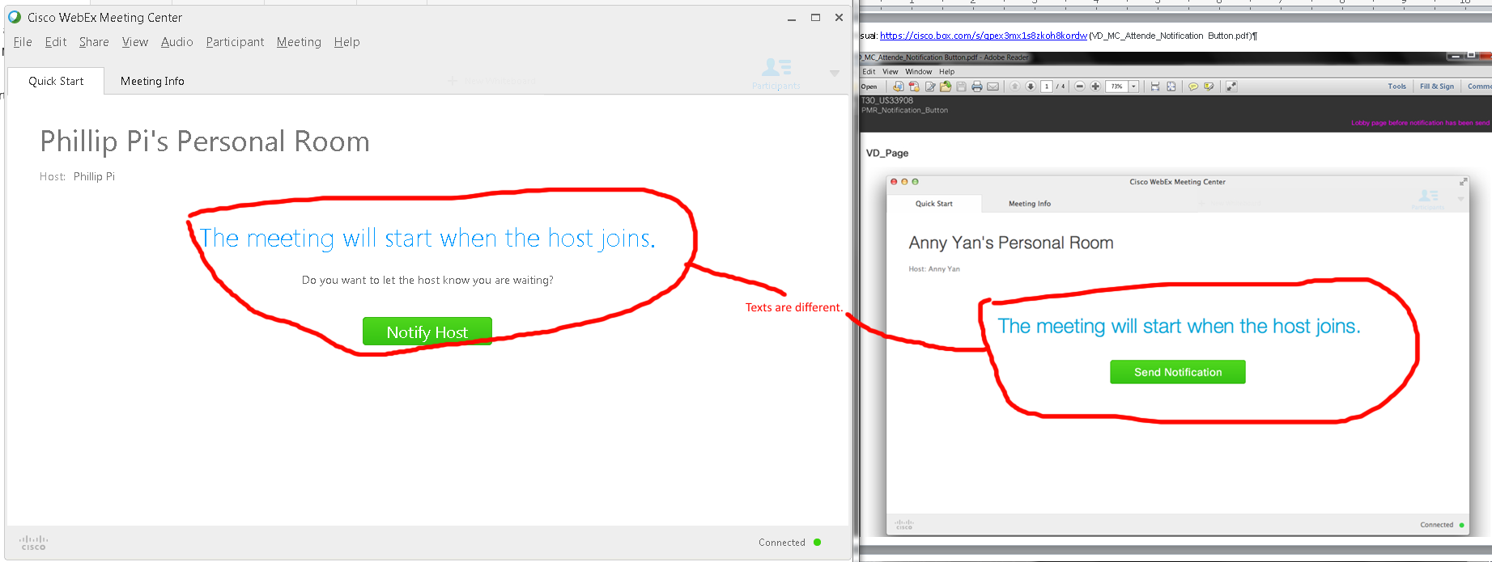
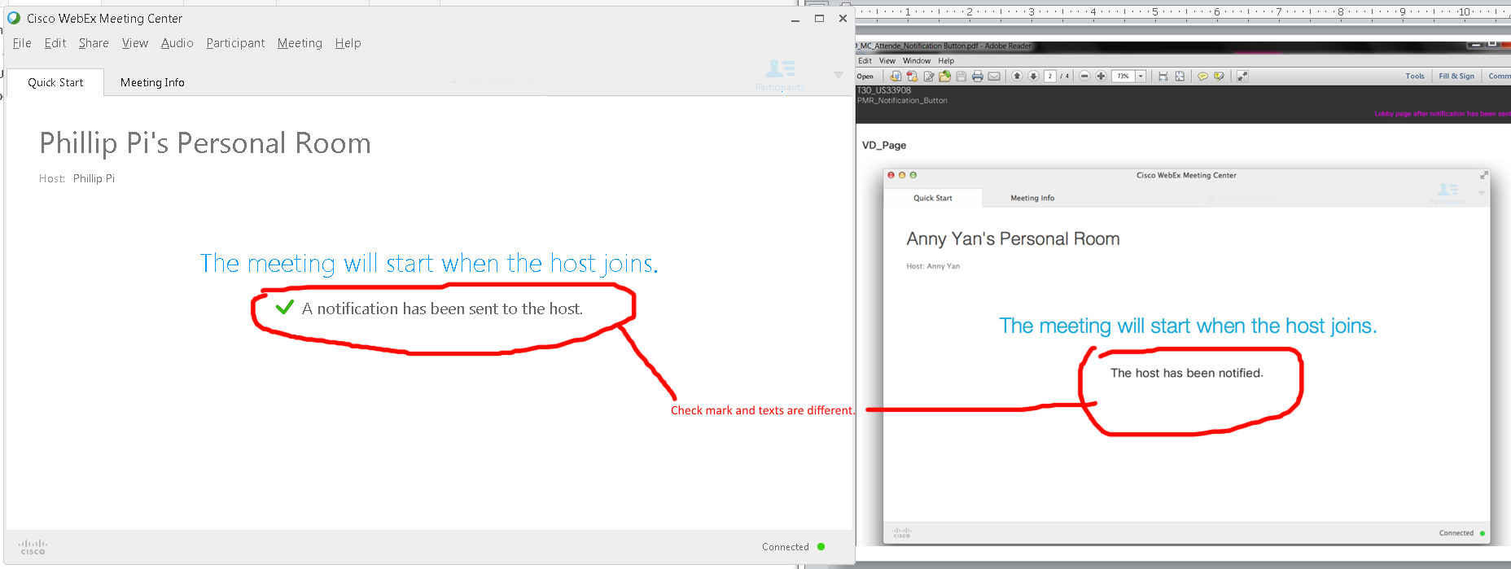
Issues: Texts and graphic differences.

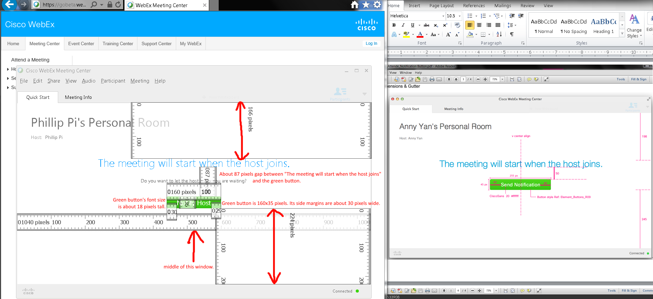
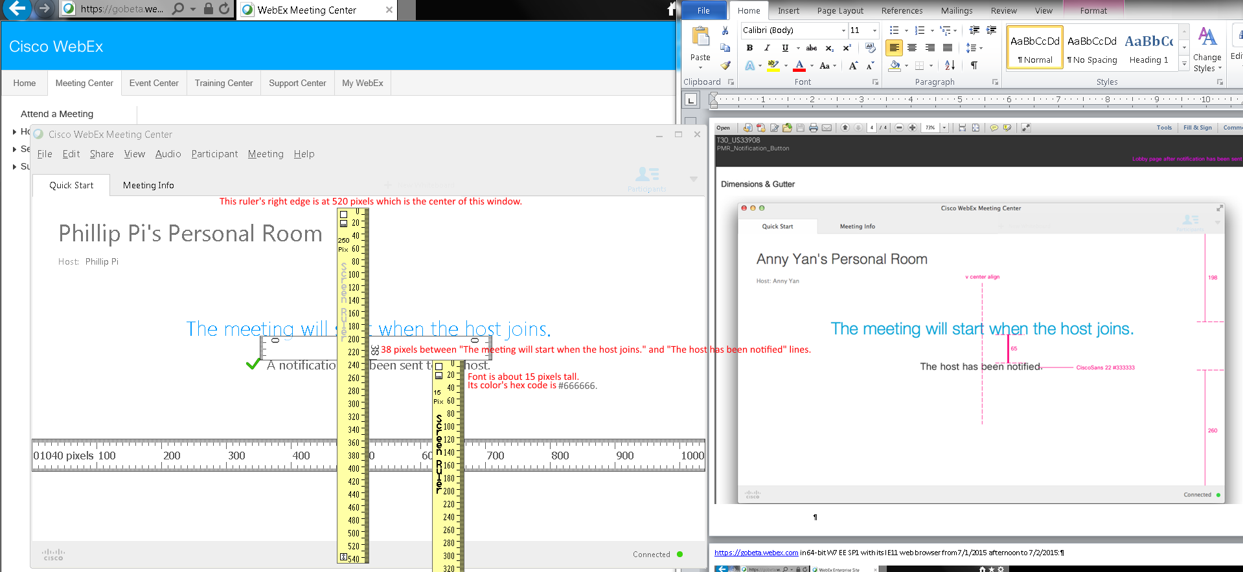
Issues: Dimension sizes are different.
Overall Issues:
- I don’t remember its original default settings (e.g., “Notify me by email when someone enters my Personal Room lobby when I’m away”) and one time messages and couldn’t find a revert back factory default settings. I need to reset my room’s settings back to default factory settings since it only happens once per account usage which I am waiting for an answer so I can check.
- I could not find the exact “Allow attendees to notify host that they are waiting in Personal Rooms lobby”, but I think I found a similar option?
- Auto-lock minutes' menu pulldown menu look different between the documents' and my screens.
- Unable to get CI (Cisco account) and Squared (old Spark name) options to show up on my gobeta.webex.com settings. I’m waiting for answers from people. Miso Kim thinks this is outdated.
- WebEx doesn’t seem to do an automatic e-mail since I had my personal room’s settings to notify me when someone enters my personal room while I am not in it.
- Unable to do more than one participants in the host’s personal room due to thinking I am rejoining with Cisco WebEx Meeting Center software.
- Differences in sizes, texts, and graphics.

