Web Pages - Personal Room landing page simplification (no Prototype):
https://gobeta.webex.com in 64-bit W7 EE SP1 with IE11 web browser on June 26th (evening hours PDT) and 29th, 2015:
From my phpi@cisco.com invitation e-mail with its https://gobeta.webex.com/join/phpi link:
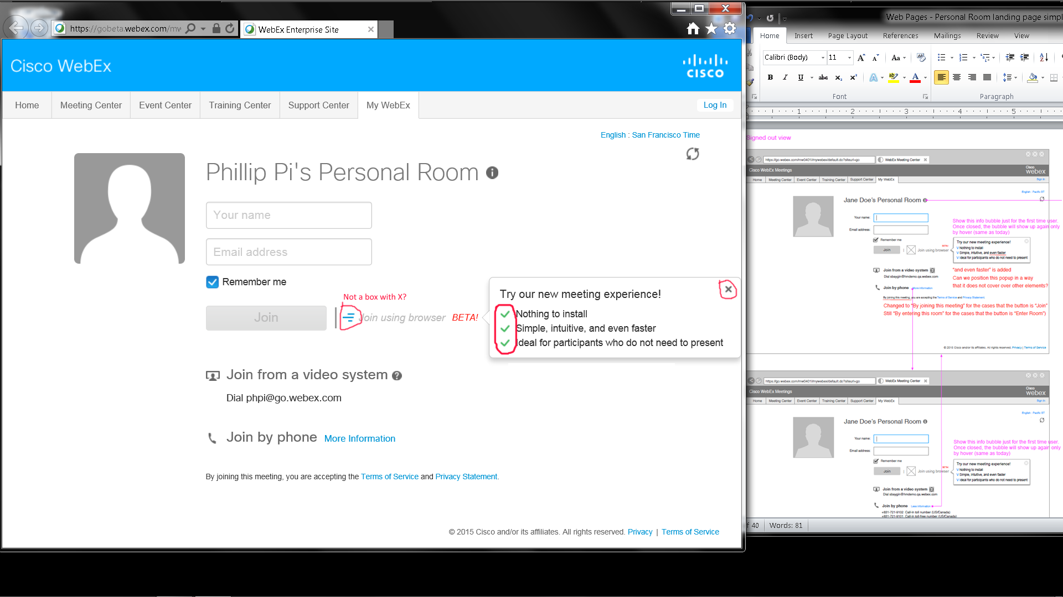

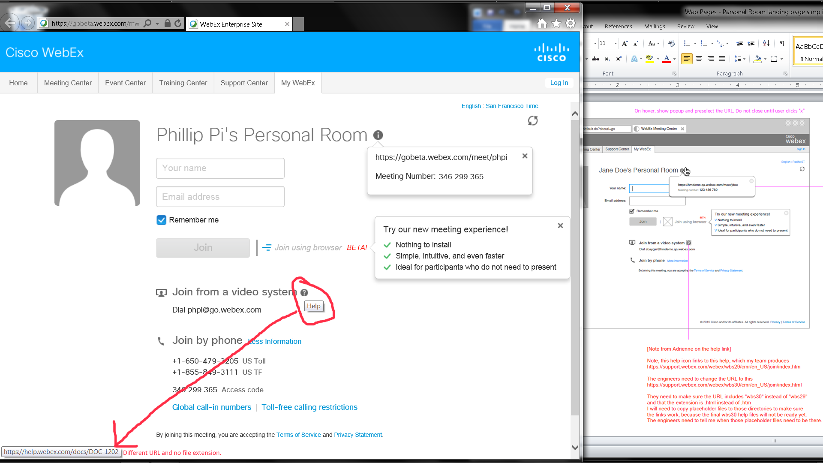

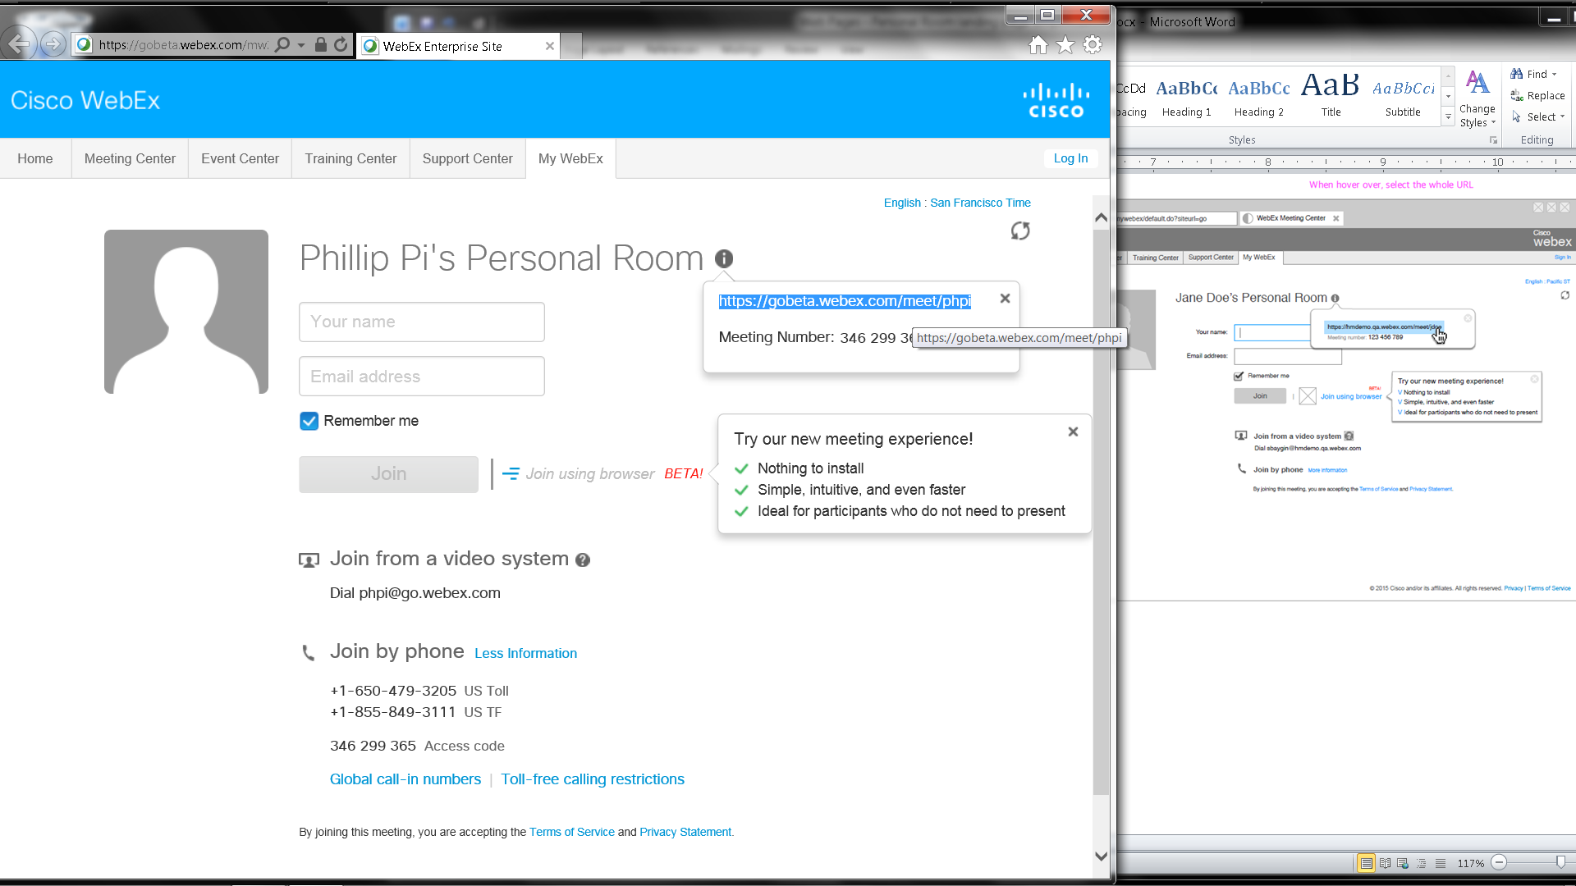
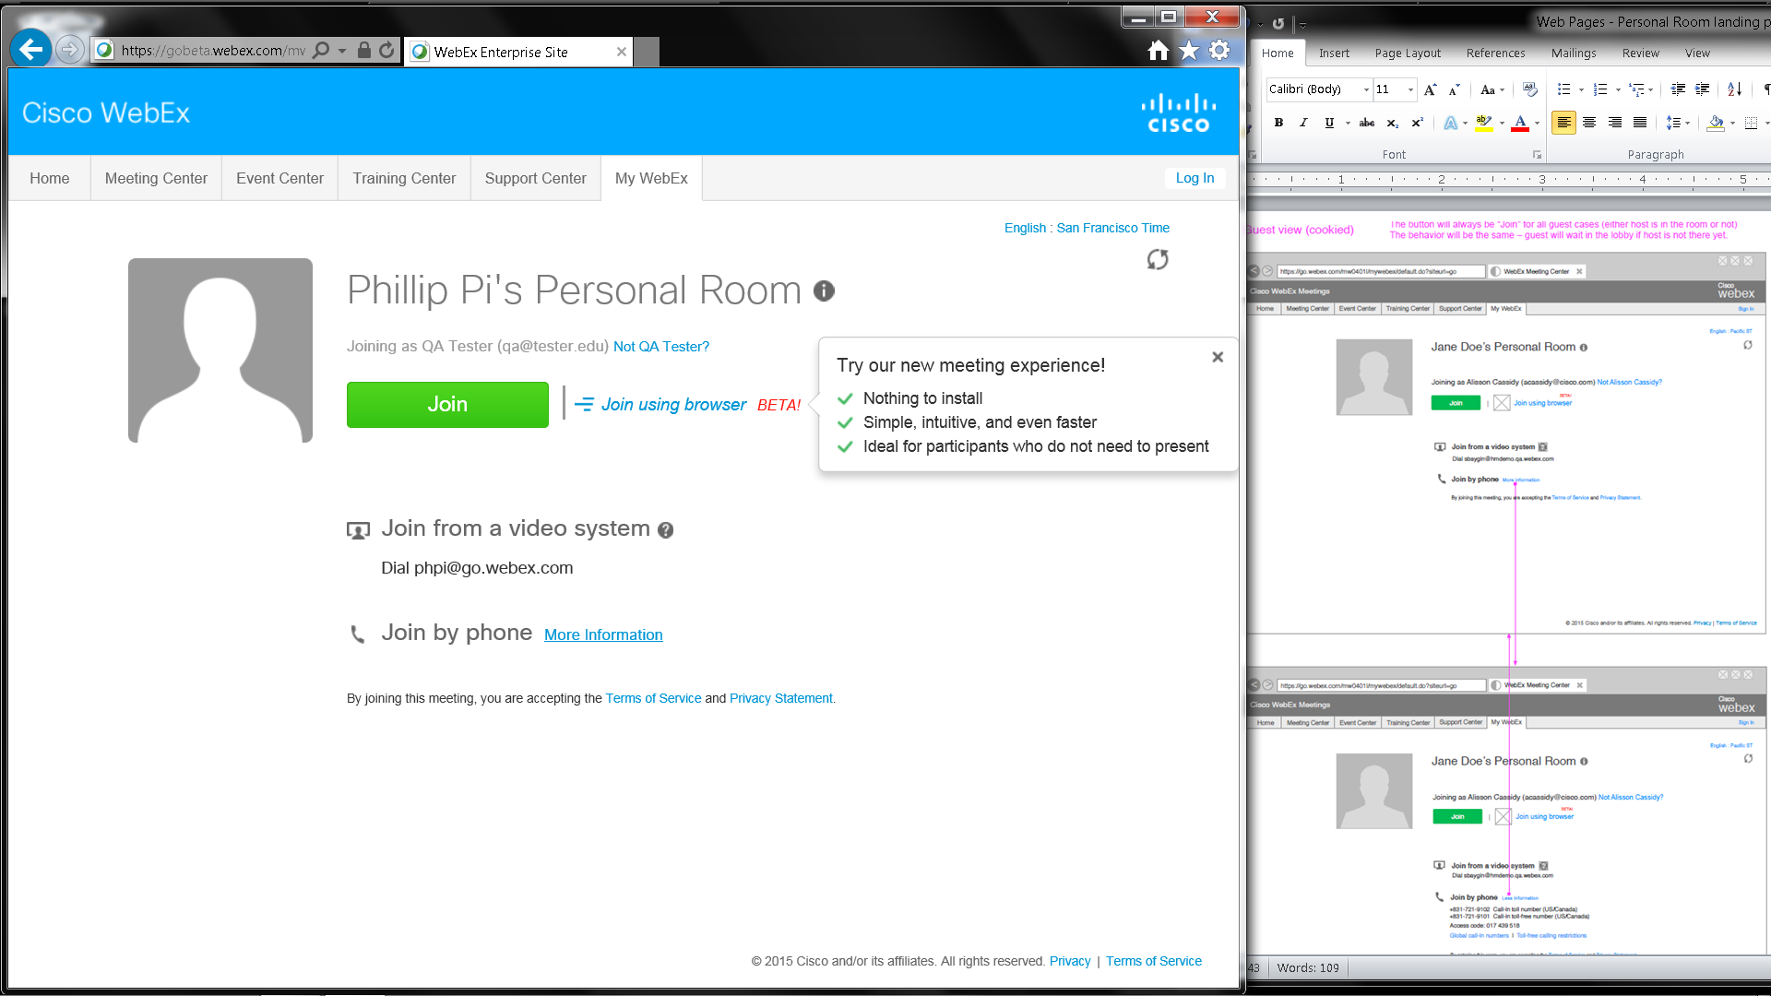

Unable to get a correct guest view, with its cookies saved and after logging with my phpi@cisco.com account, for my https://gobeta.webex.com/meet/phpi room. Need another user’s personal room that is not mine:
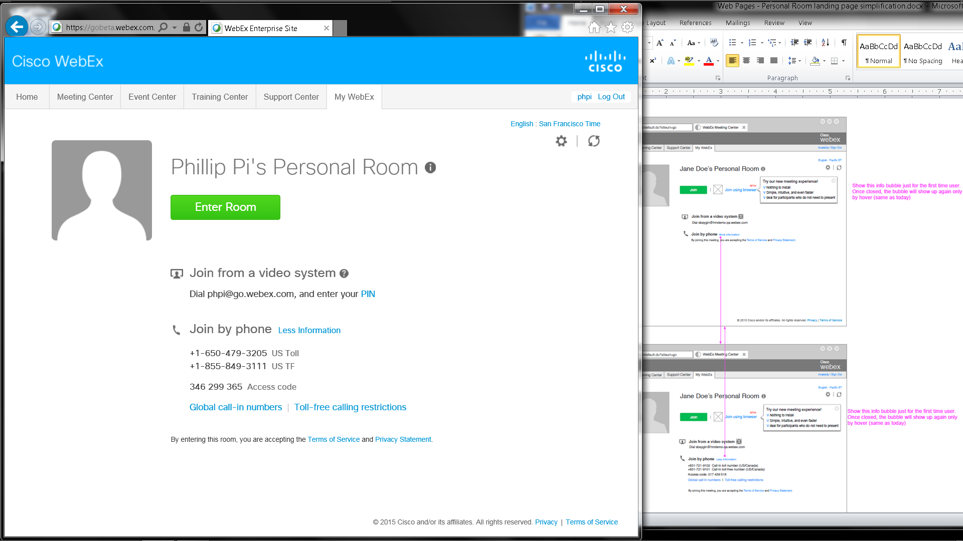
Issues:
- Different graphics on this invitation web page (collapsed and expanded “Join by phone …”).
- Different URL for “Join from a video system”’s ? icon link.
- Unable to get a correct guest view, with its cookies saved and after logging with my phpi@cisco.com account, for my https://gobeta.webex.com/meet/phpi room. Need another user’s personal room URL beside mine.

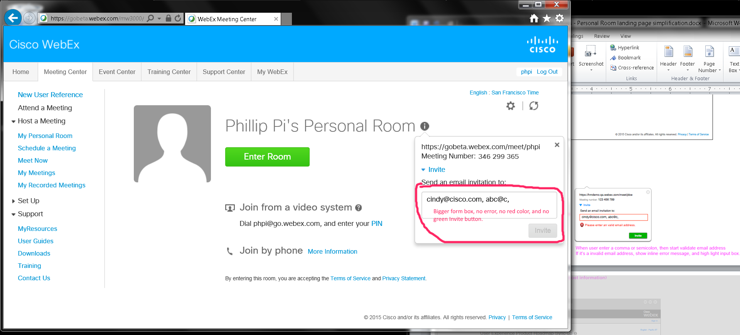
Issues: Different form box sizes, and no error and highlighted input box.
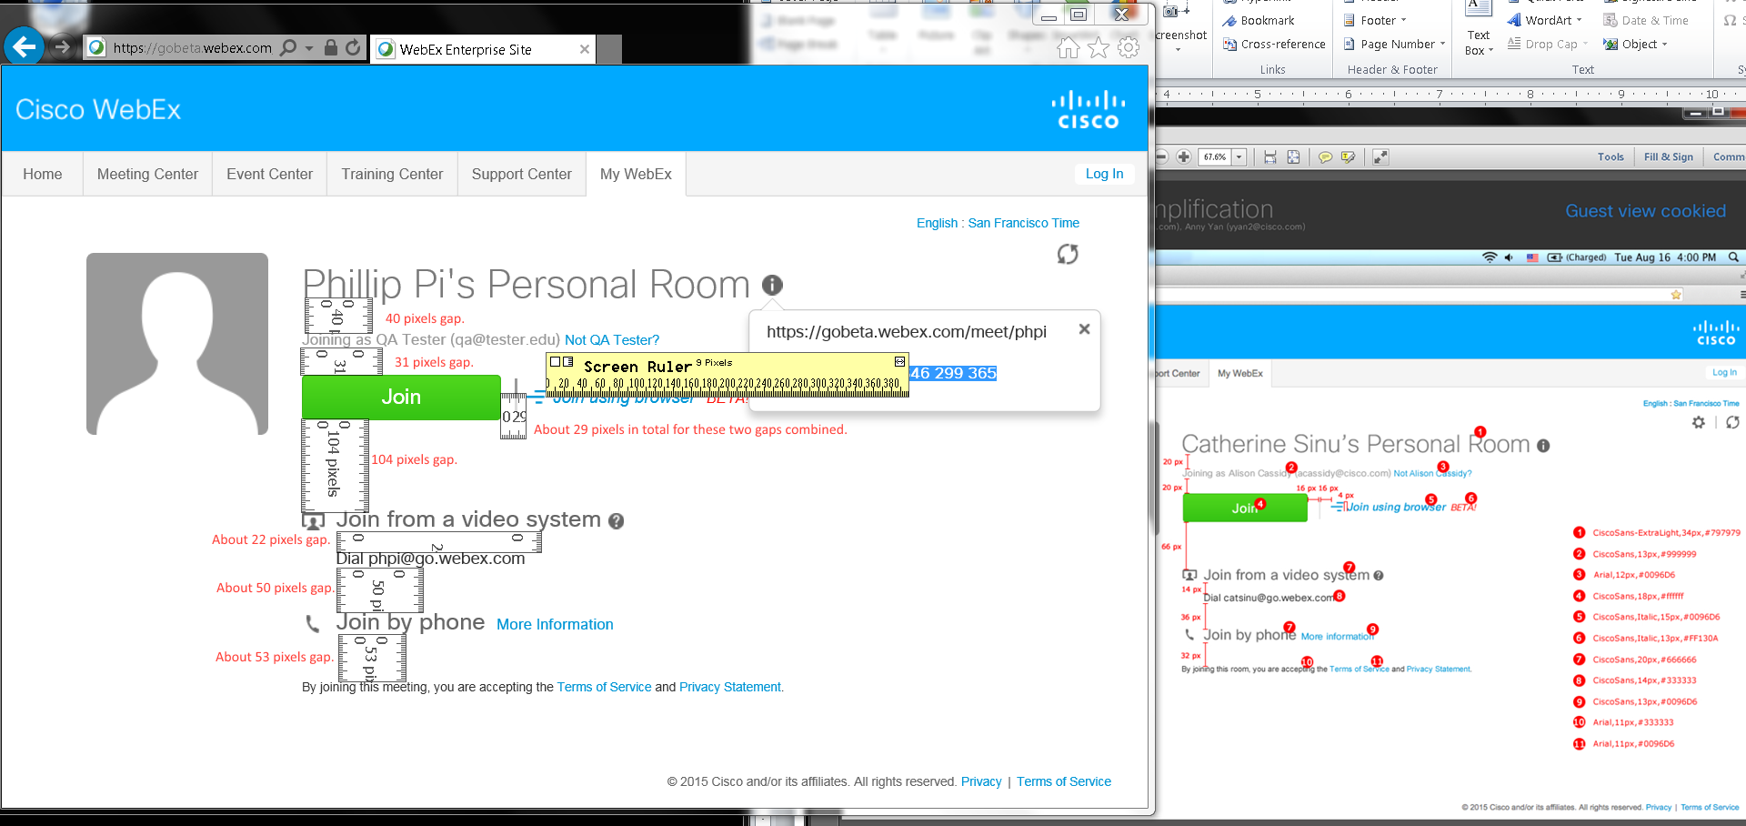
Text Properties Issues As Shown in Labeled Numbers (pixels were from screen rulers even though IE11's view inspector show correct codes; #3 had no problems):
1. 32 pixels tall for R letter.
2. 12 pixels tall for J letter.
4. 19 pixels tall for J letter.
5. 14 pixels tall for J letter. Did not see active (not crossed out) CiscoSans font. Saw font-family: "Helvetica Neue",Helvetica,Arial,sans-serif
6. 12 pixels tall for B letter. Did not see active (not crossed out) CiscoSan font. Saw font-family: Arial,Helvetica,sans-serif
7. 18 pixels tall for J, f, and h letters.
8. 13 pixels tall for D letter.
9. 13 pixels tall for M letter.
10. 10 pixels tall for t letter and 11 pixels tall for B letter.
11. 10 pixels tall for T and S letters.

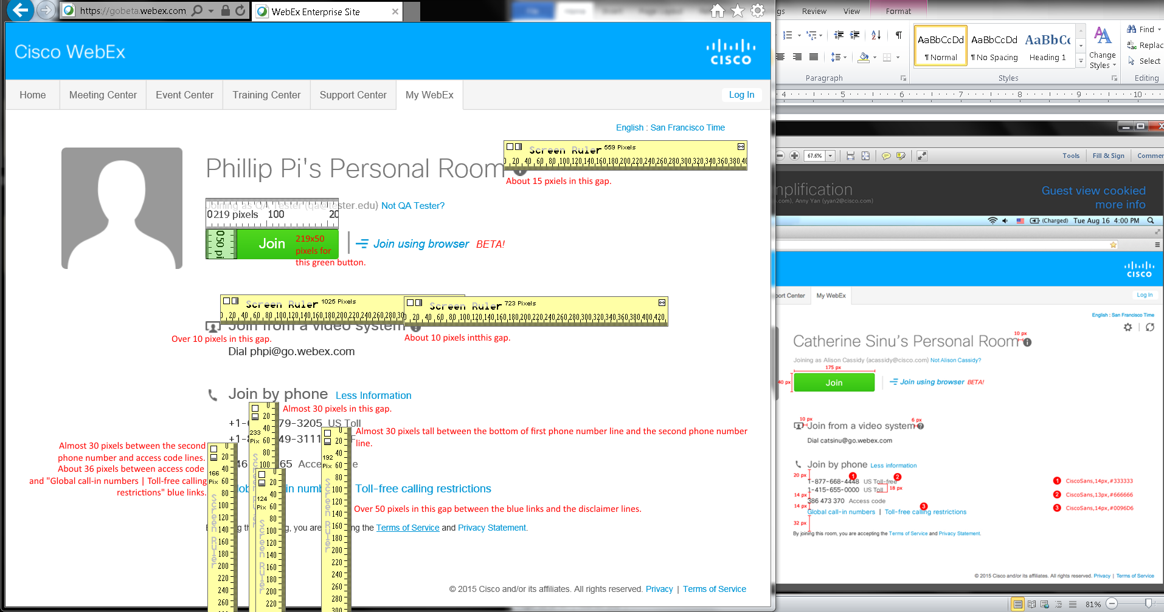
Text Properties Issues As Shown in Labeled Numbers (pixels were from screen rulers even though IE11's view inspector show correct codes):
1. 12 pixels tall.
2. 12 pixels tall.
3. 13-14 pixels for T and g letters.
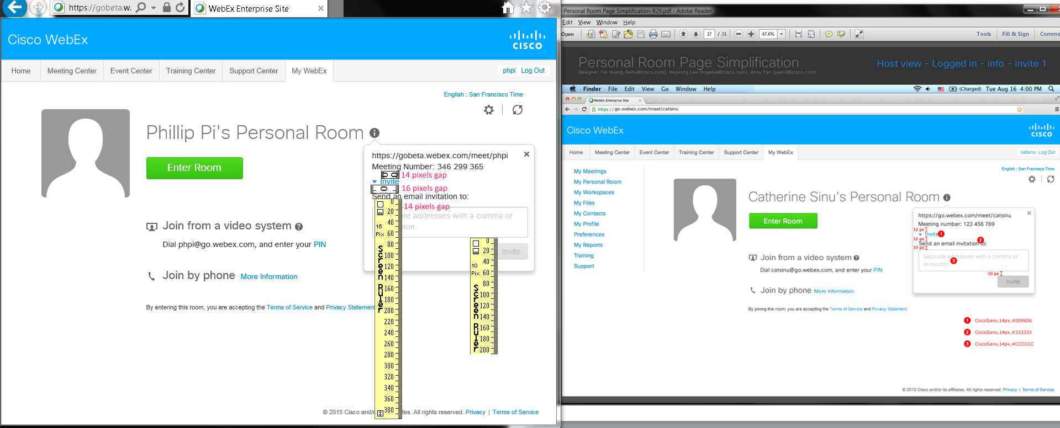
Issues: Each numbered measured font sizes show texts as 10 pixels tall even though their codes show them as 14 pixels tall according to IE11’s inspect element code.

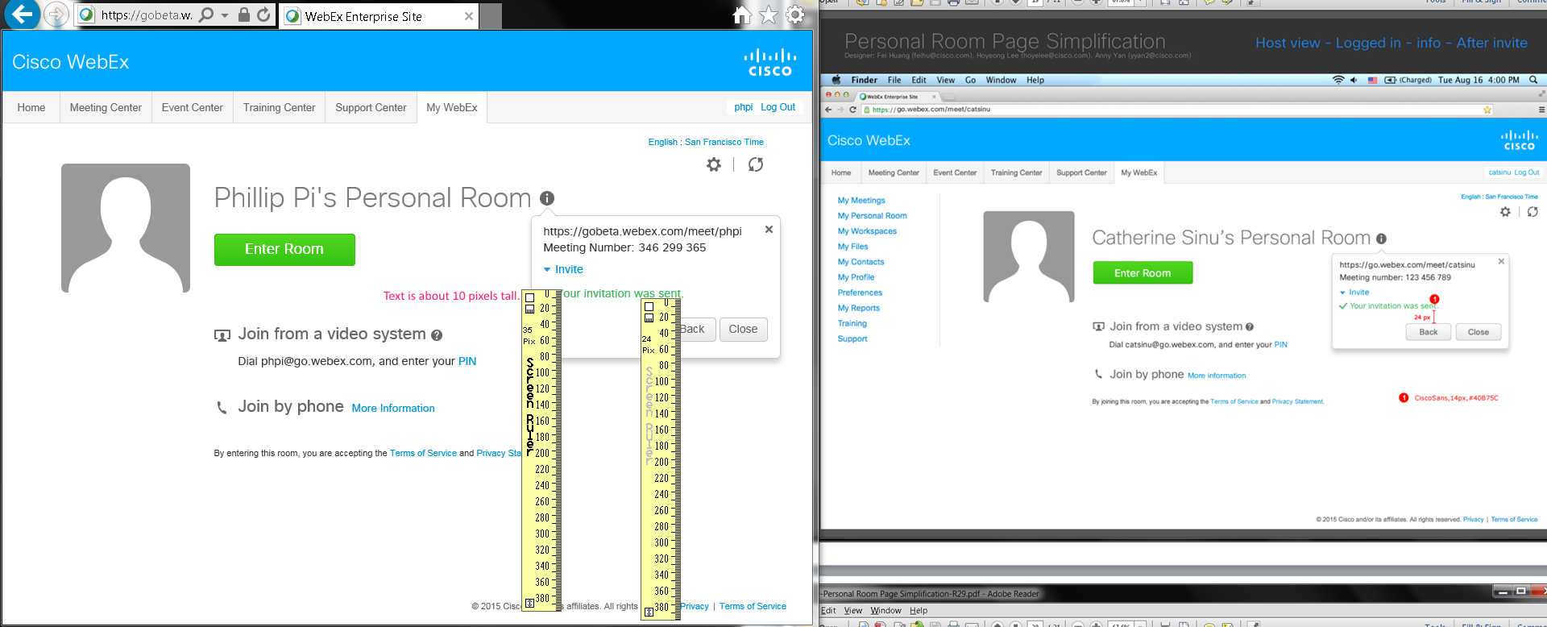
Issue: “Your invitation was sent.”’s font size was about 10 pixel tall even though IE11’s inspect element show the correct codes.

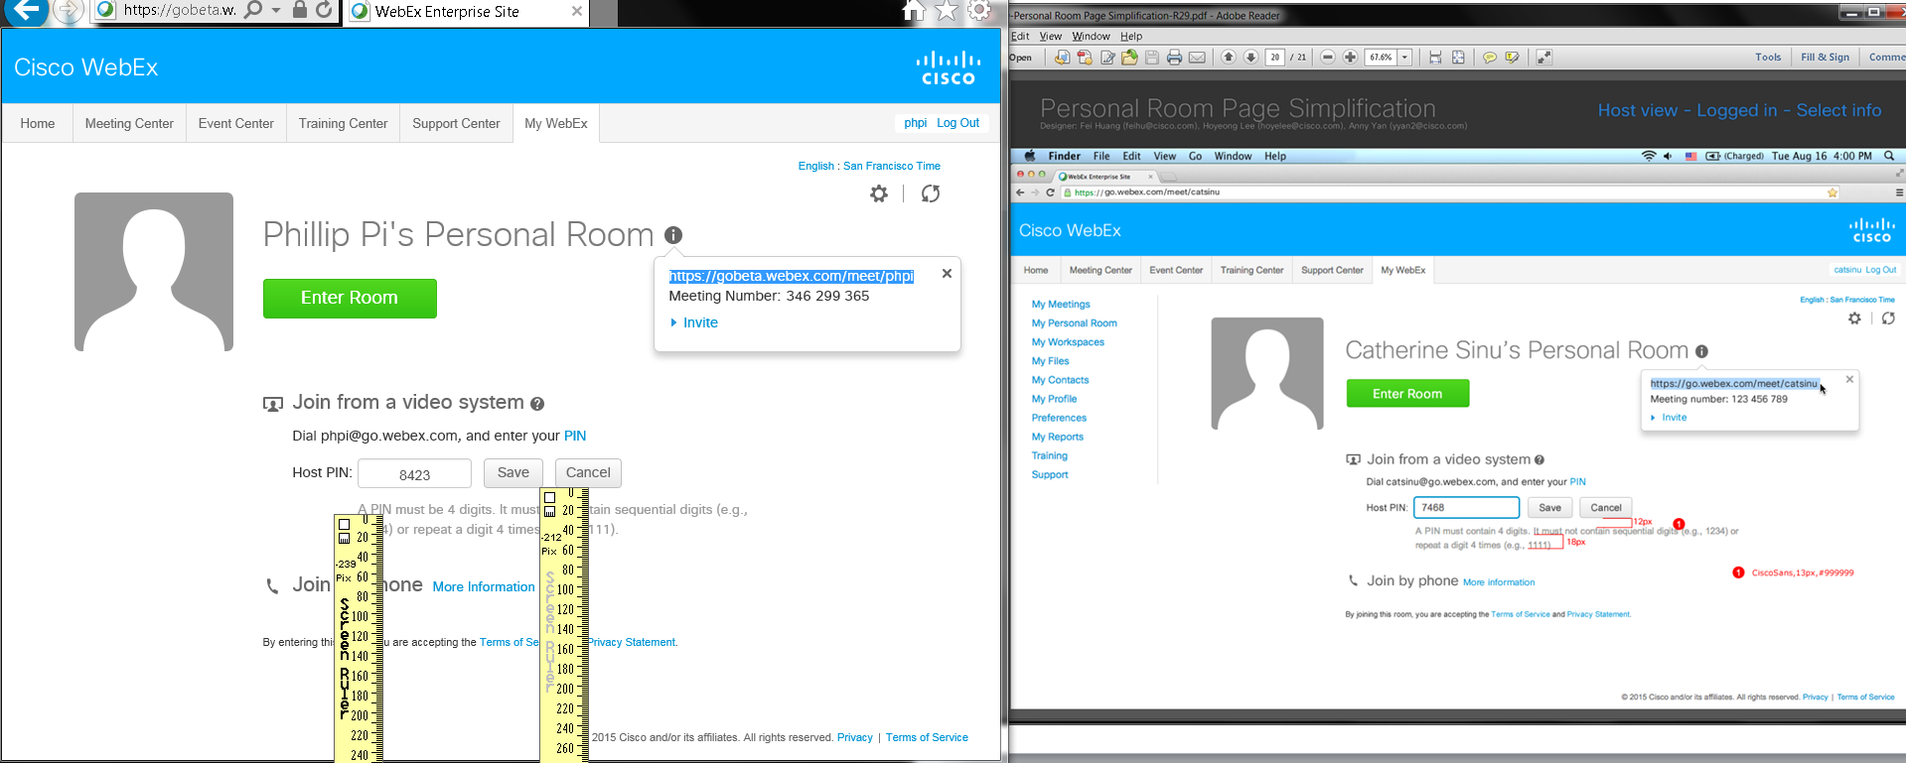
Issue: Between the two buttons (Save and Cancel) row and “A PIN must be 4 digits. It must not contain sequential digits (e.g., 1234) or repeat a digit 4 times (e.g., 1111).” have different pixel depths.

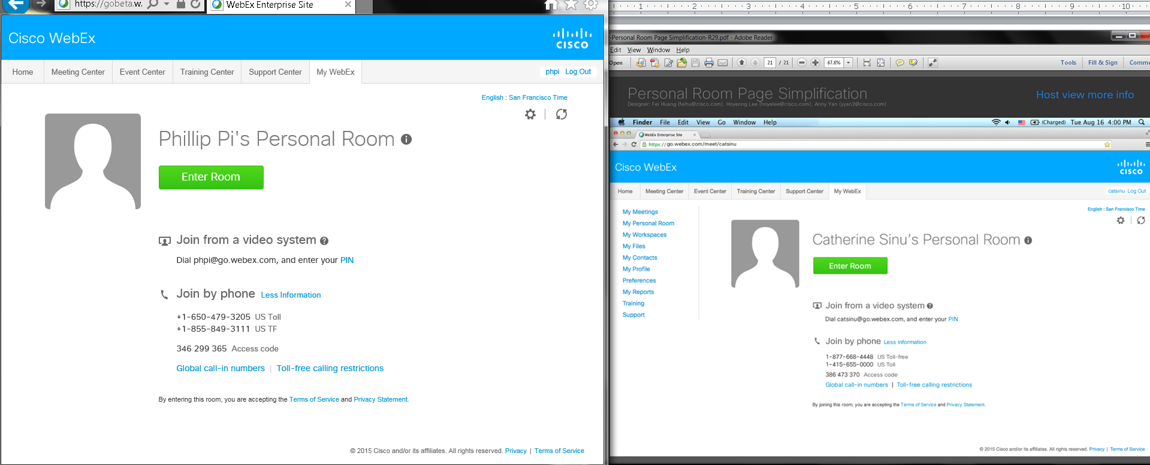

OVERALL ISSUES:
- Unable to view as a guest, with cookied data of another account, and with another account since it wants me to login with my Cisco account on http://gobeta.webex.com web site.
- Sizes, pixels, colors, font type, graphics, URLs, etc. seen.

