Web Page’ Personal Room auto lock (no prototype):
https://gobeta.webex.com in 64-bit W7 EE SP1 with Firefox v38.0.5 web browser from June 29th to July 1st, 2015:
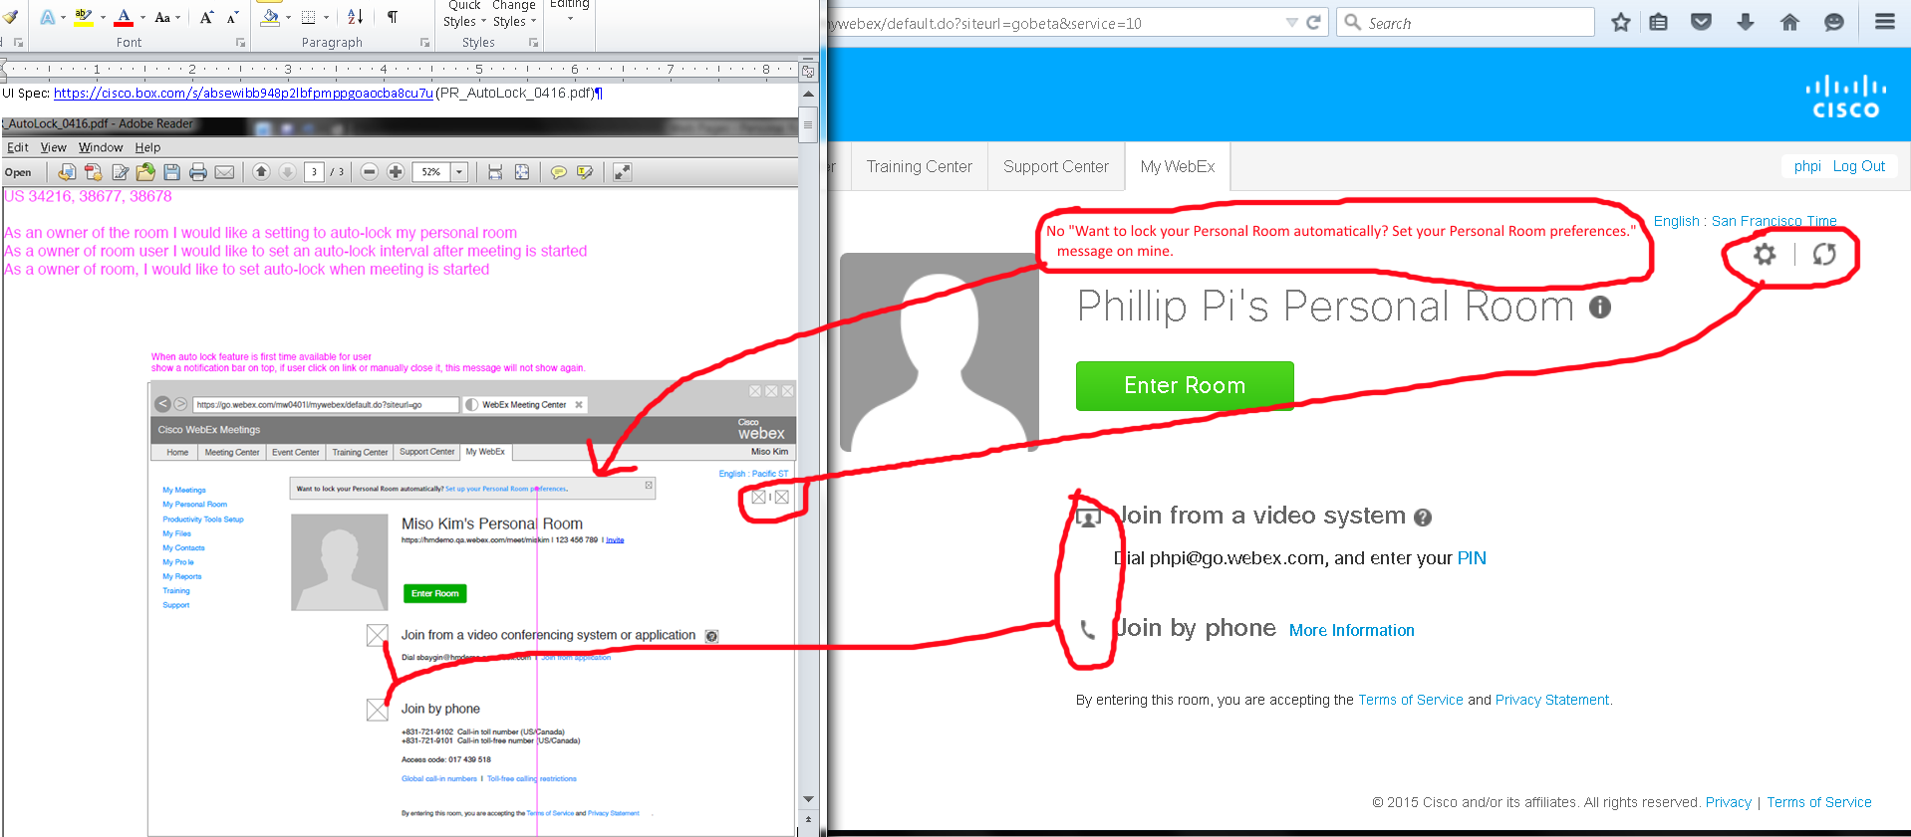
Issues: I never see this "Want to lock your Personal Room automatically? Set your Personal Room preferences." message on my gobeta.webex.com screens. I had to use its gear icon to get to my preferences web page. Also, document has missing icons (assuming the icons on gobeta server are correct).

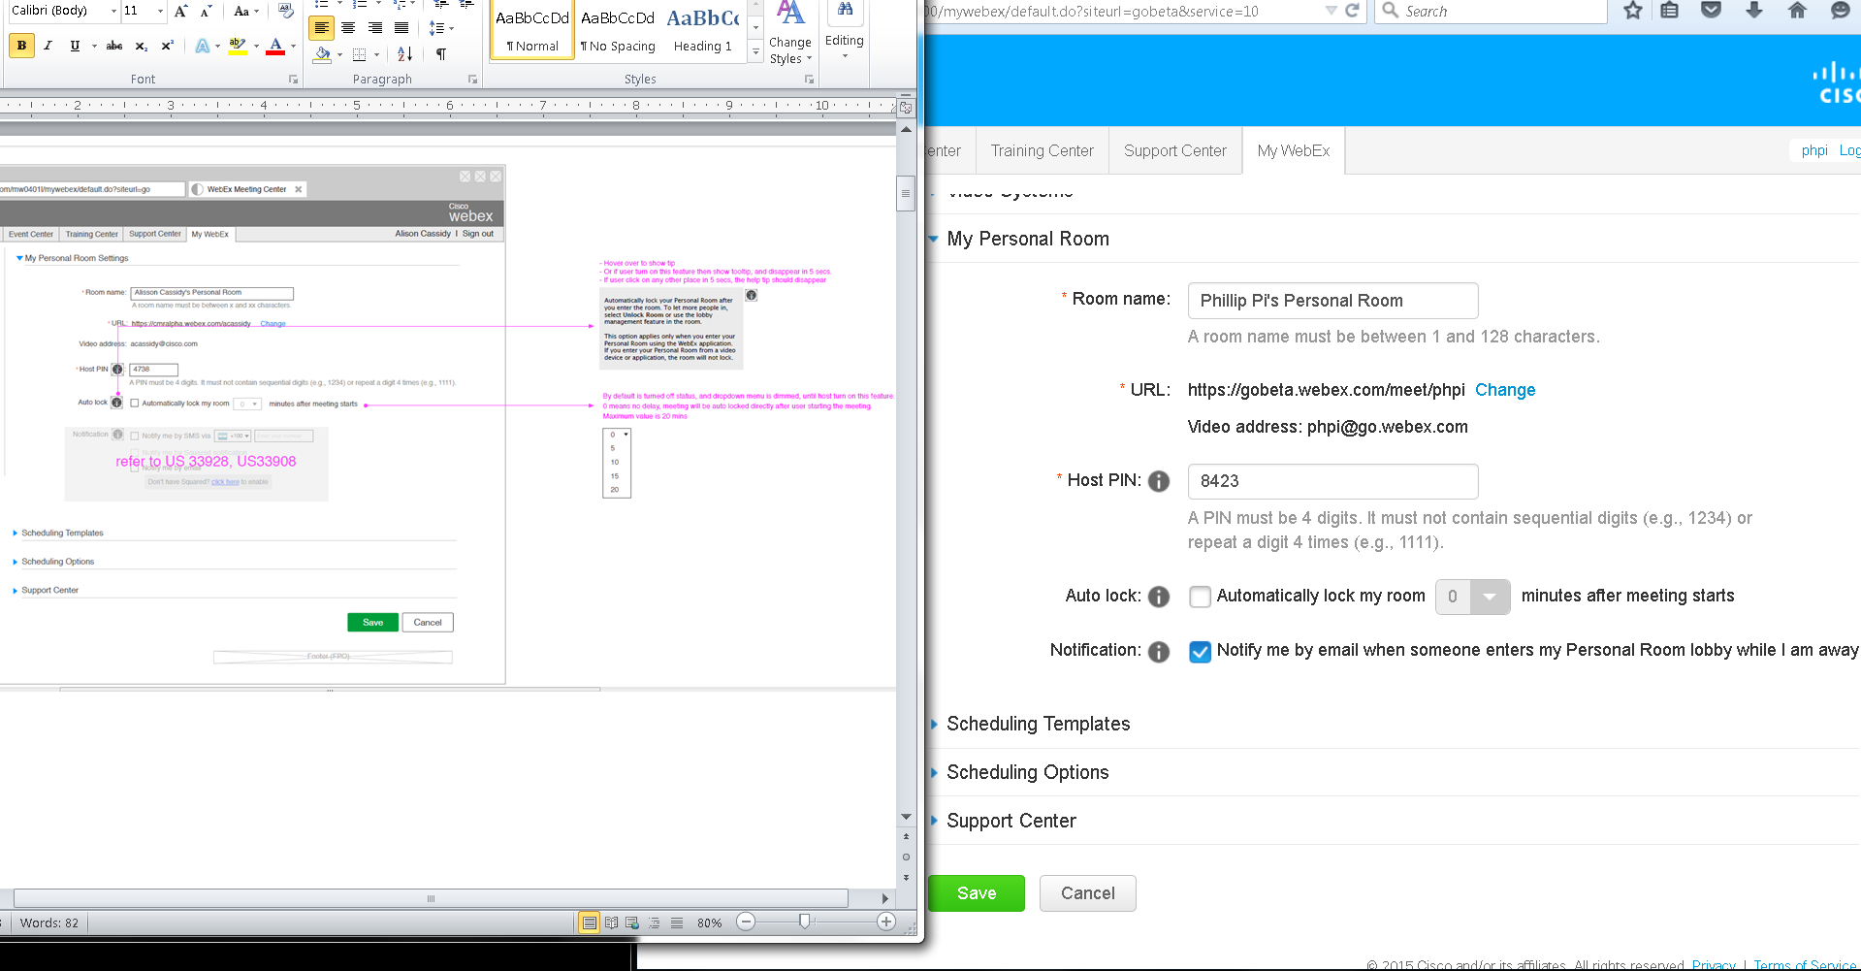
Issue: I need to reset my old or get a new gobeta.webex.com account to see the default settings.
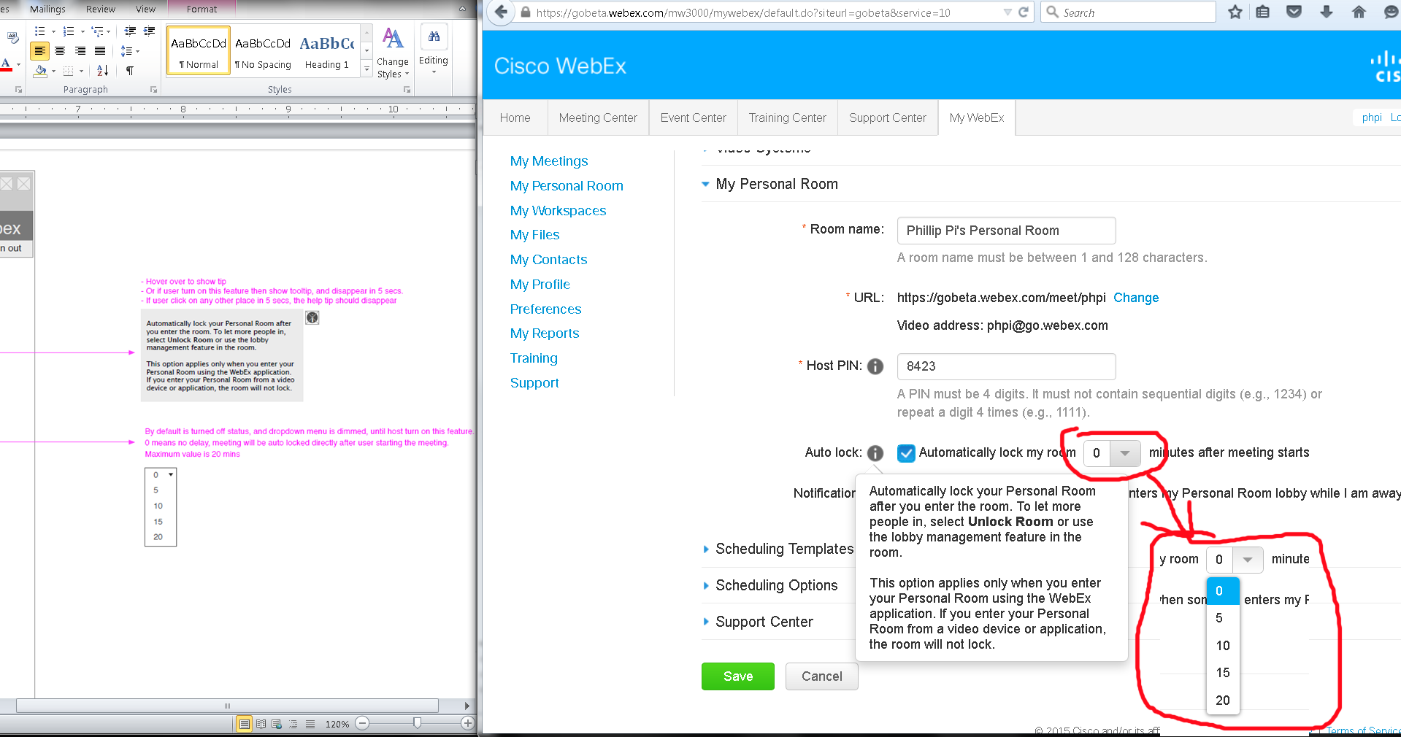
Everything looked fine and working to me.

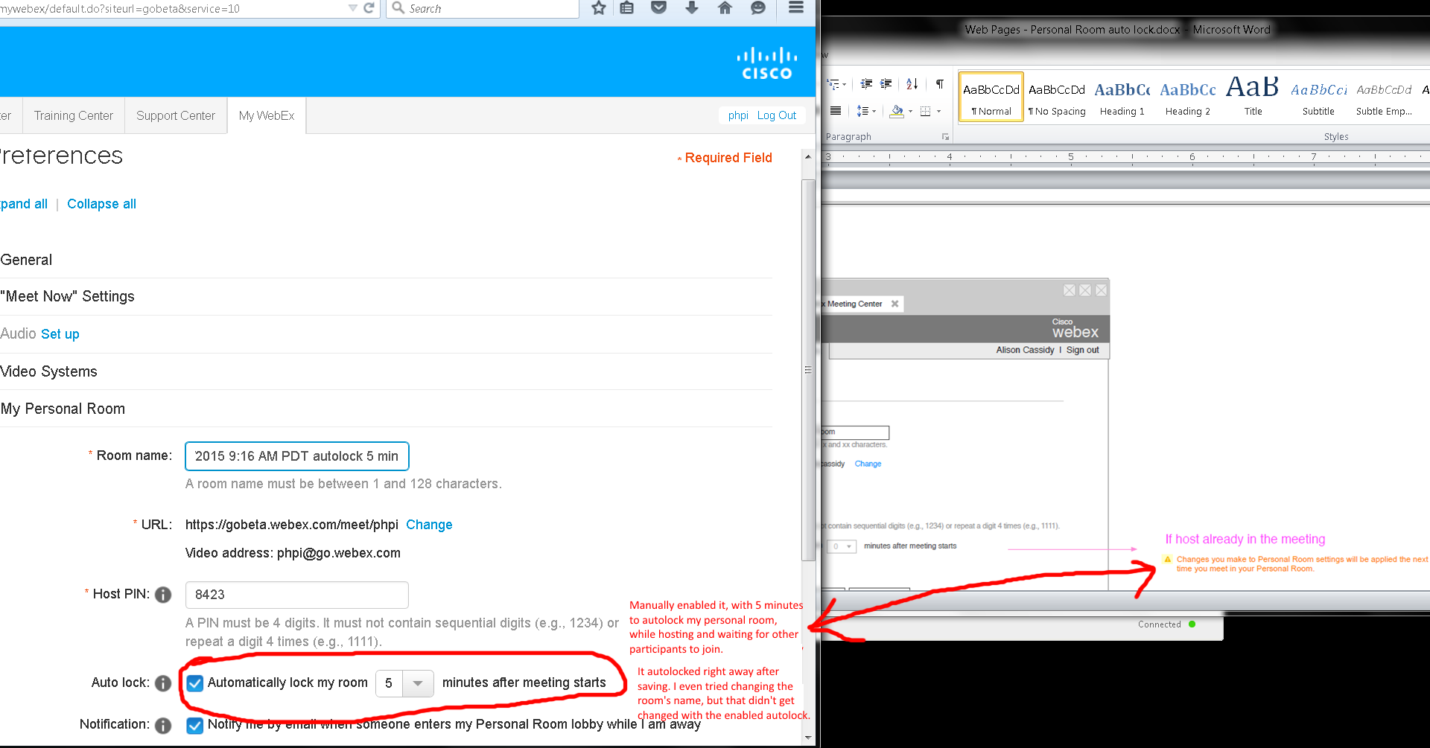
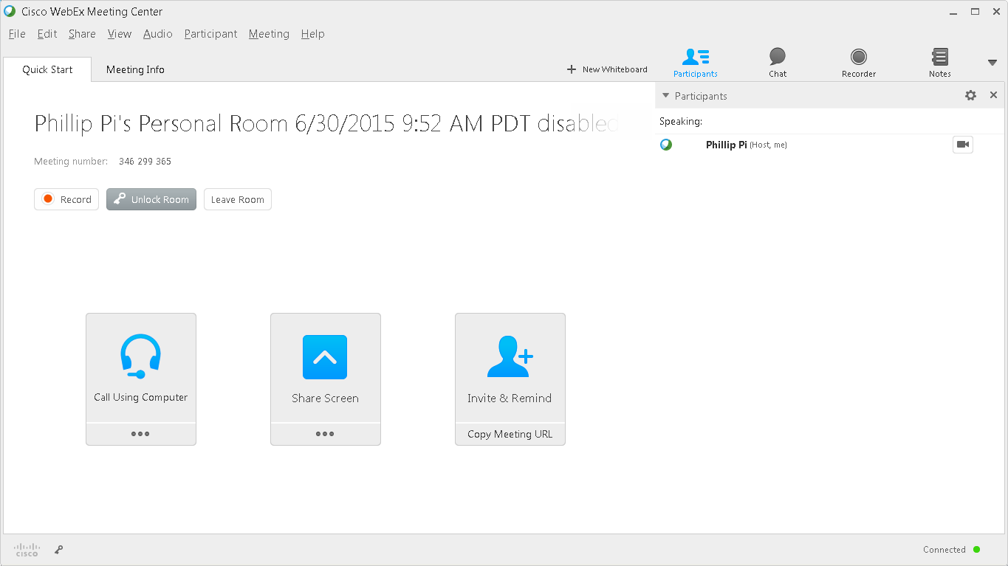
Issue: Autolock should not be changing in my current room that I started and in after I manually told it to autolock since I did not leave and rejoin. No one else came in too.

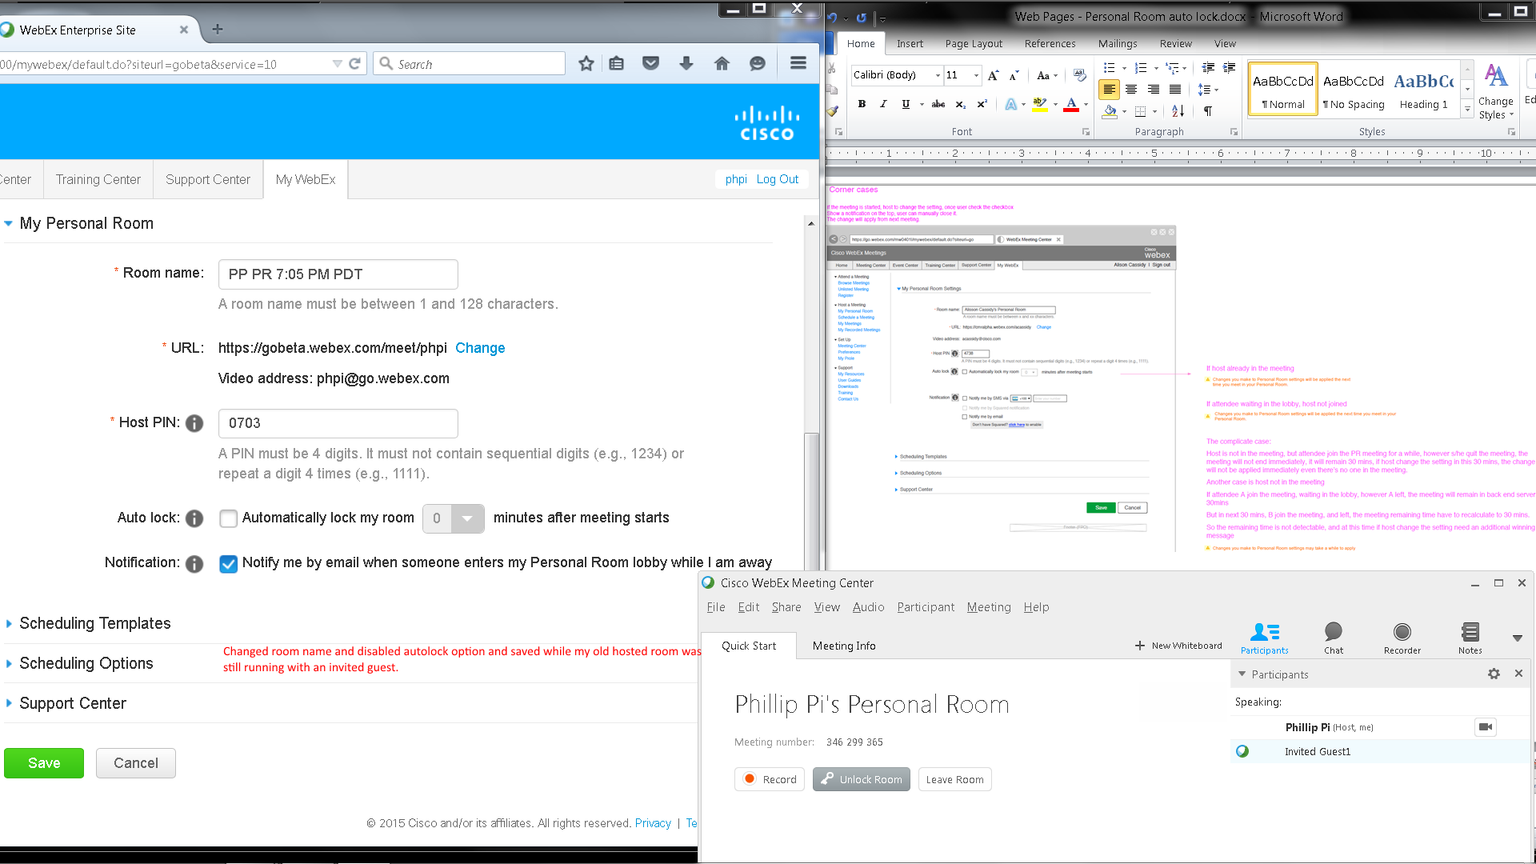
Issues: Unable to test the complicate case due to Cisco WebEx Meeting Center:
- Host required for the meeting.
- Wanting to dump all participants when host tries to leave the room.
- Thinking the host is rejoining on the same machine when trying to pass presenter status to the guest.

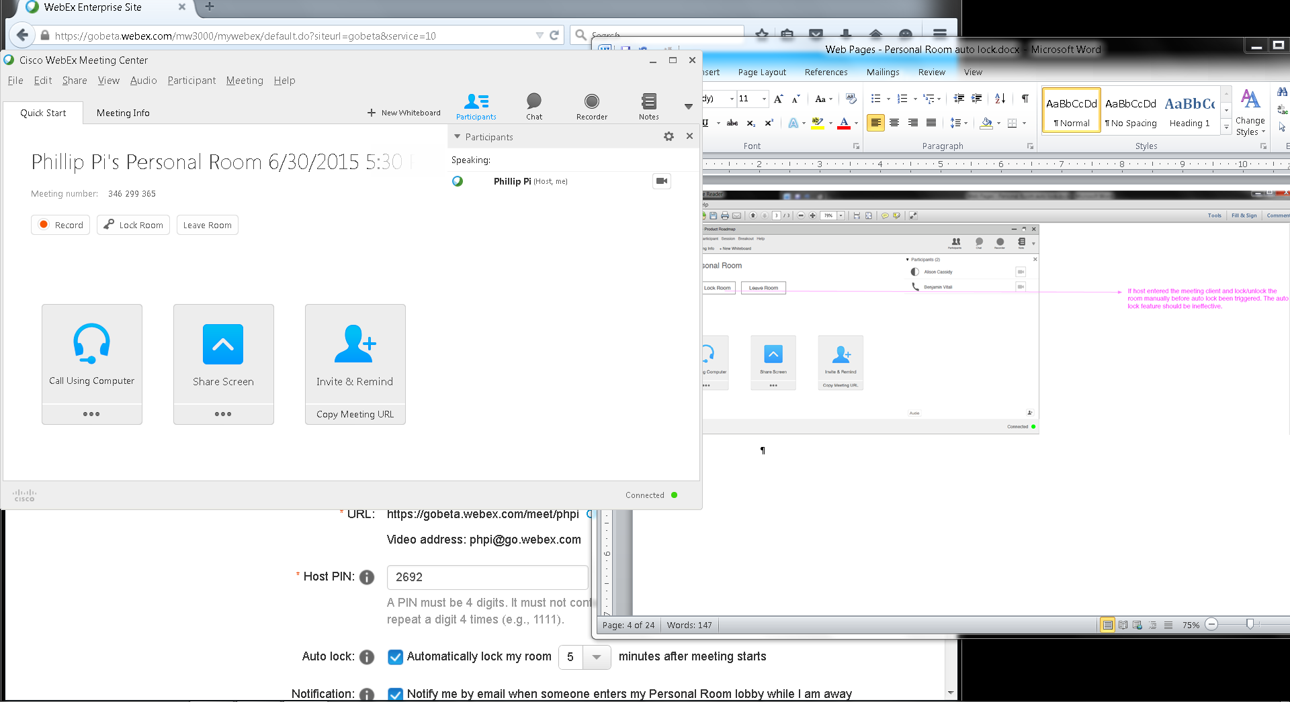
Waited over five minutes and no autolock occurred.

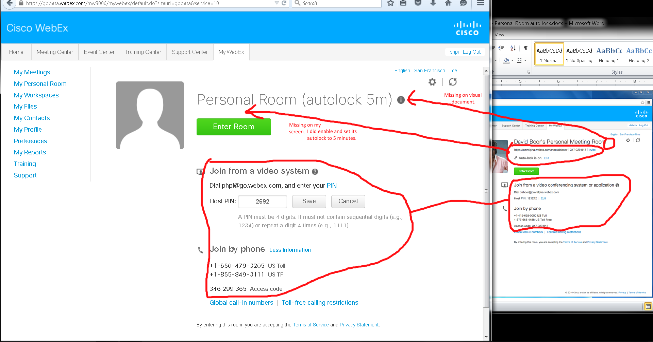

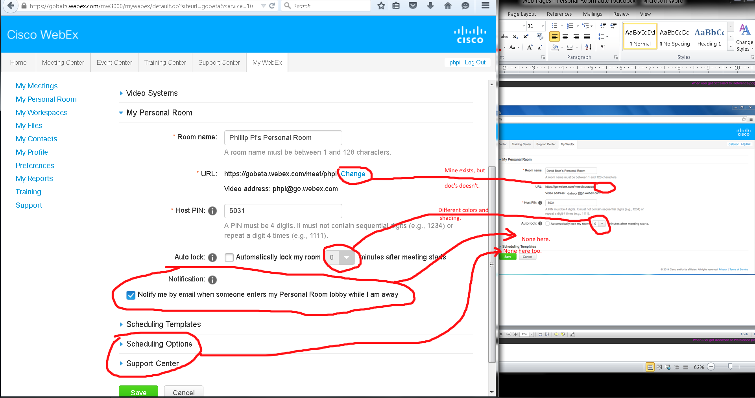
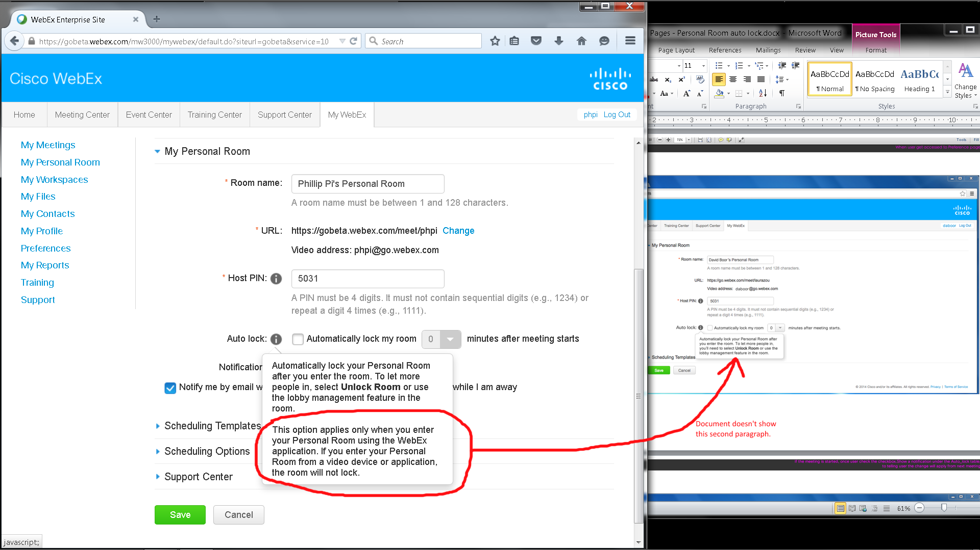
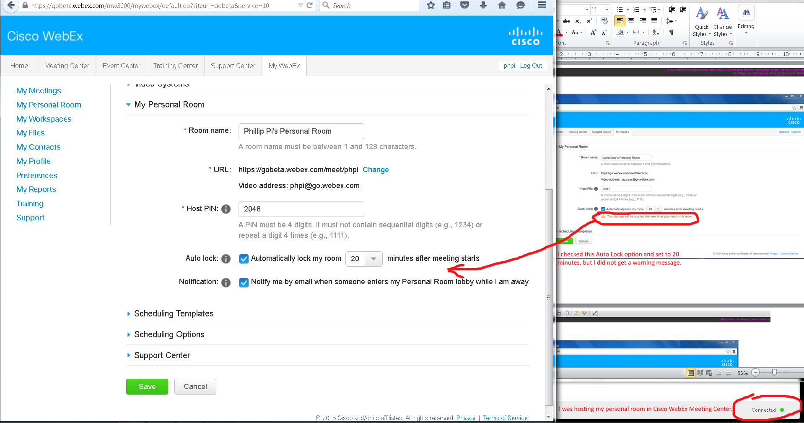
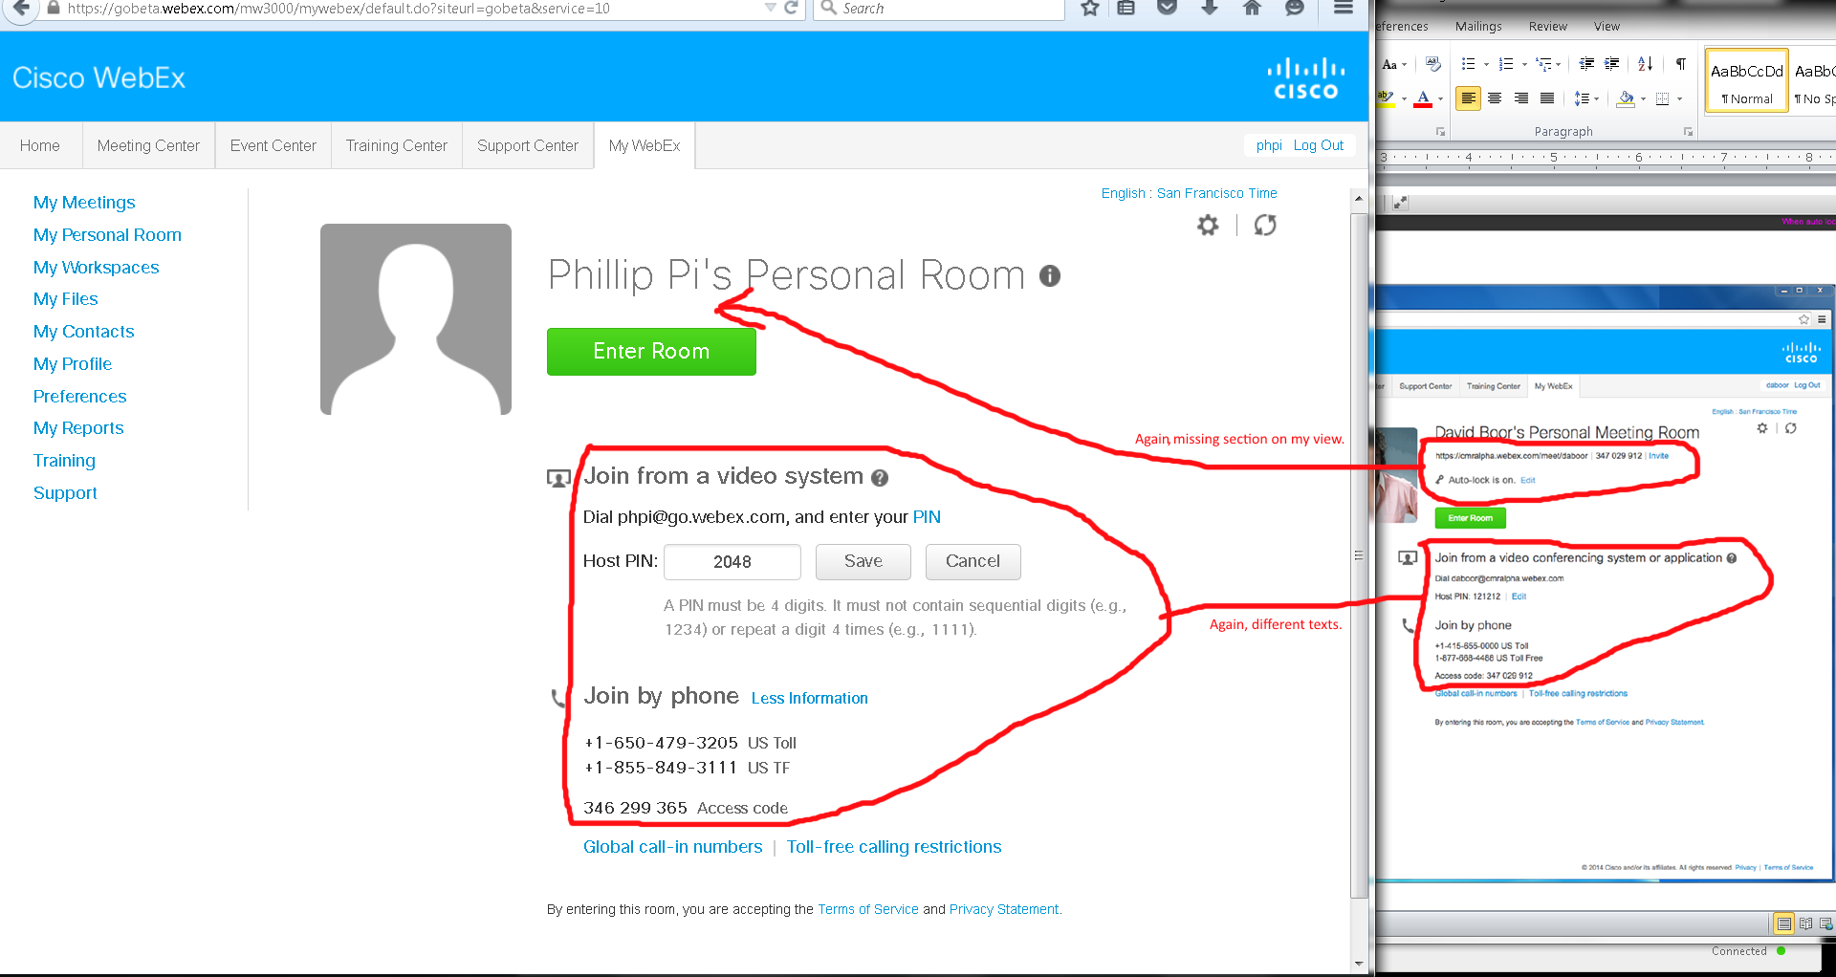
Issues from above images: Both my screen and the document’s show differences like missing texts, links, icon graphics, etc.

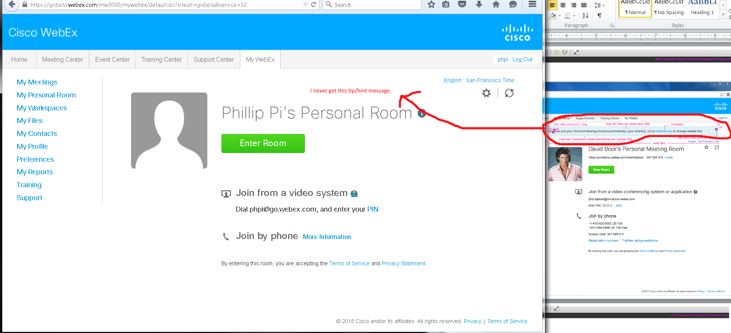
Issue: Missing hint/tip section. I have never seen it show up before too.
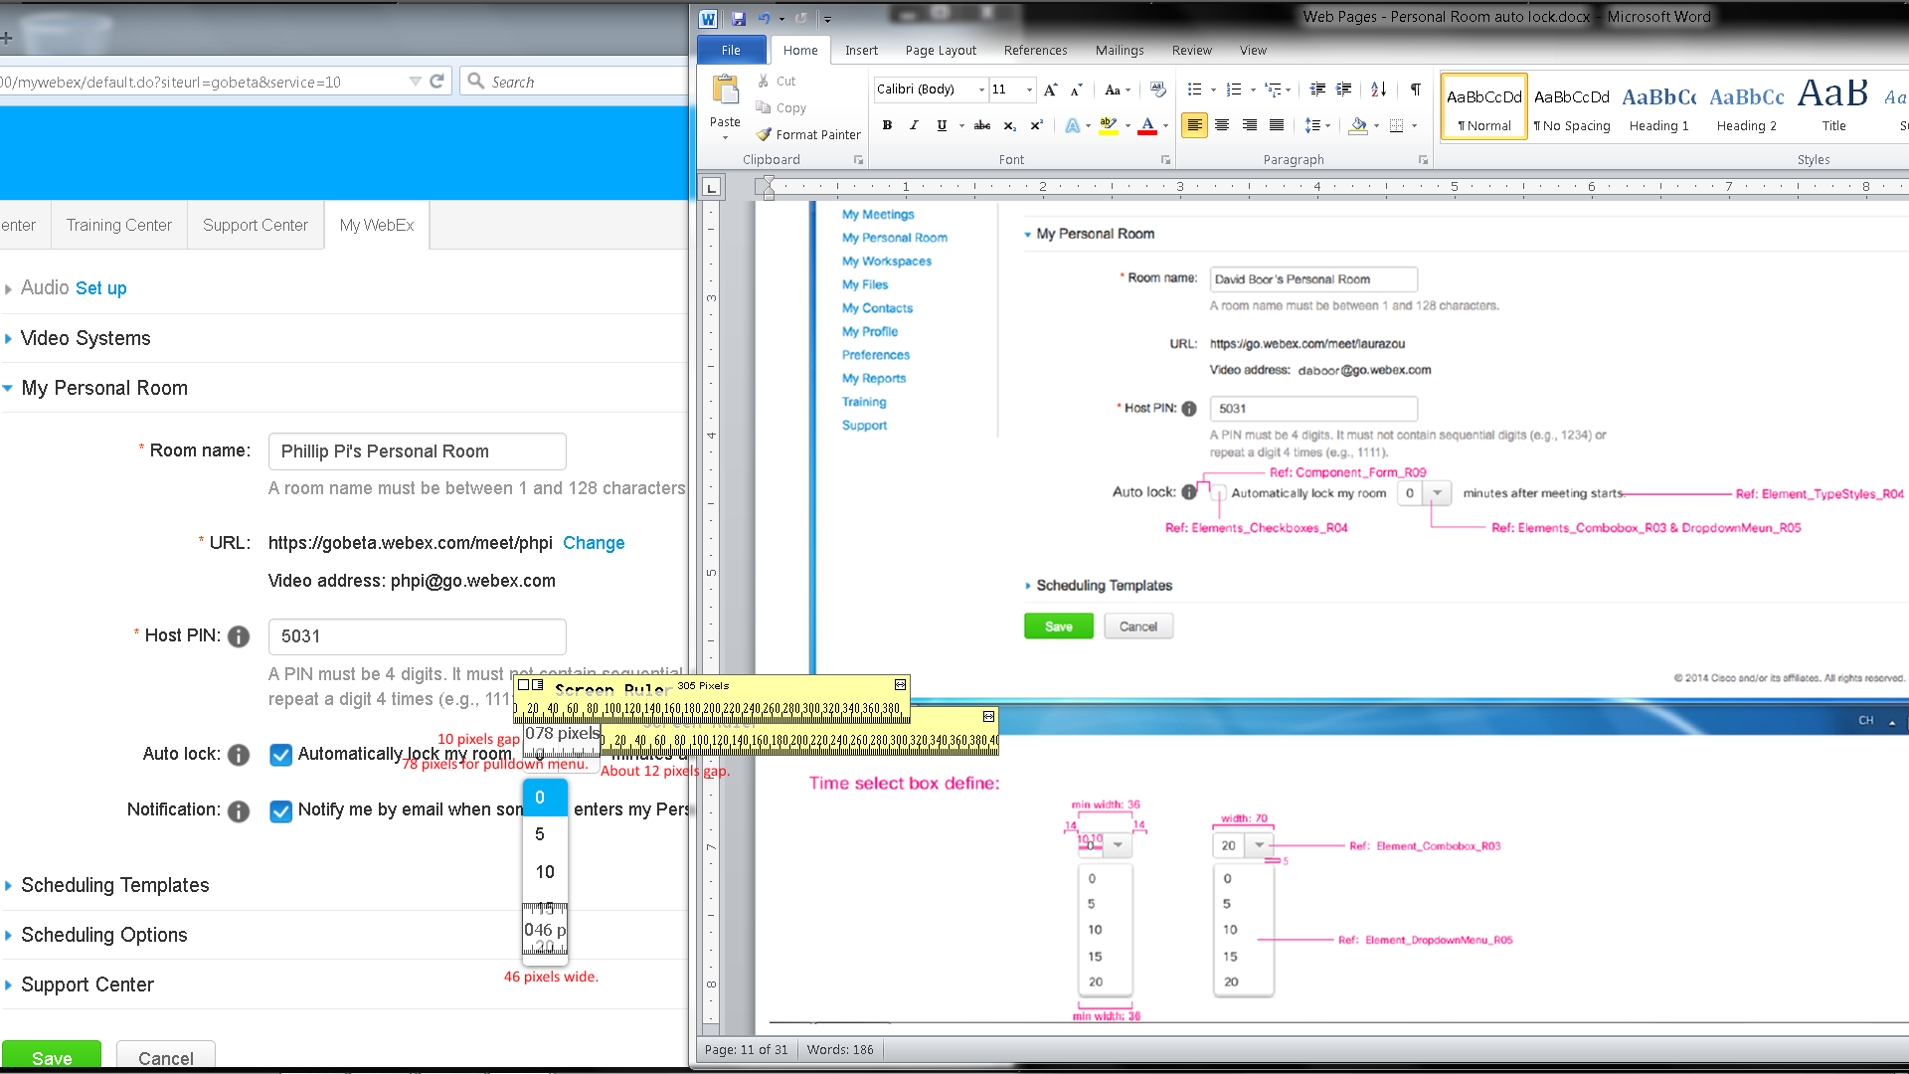
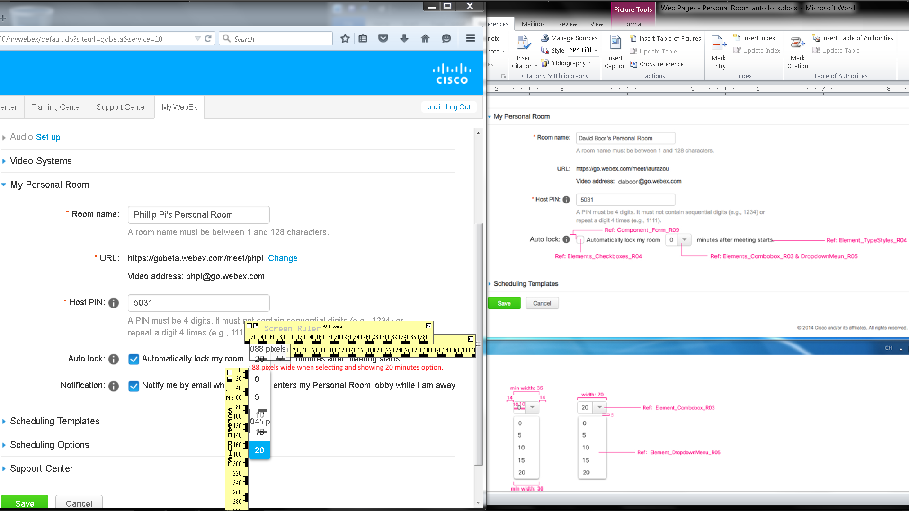
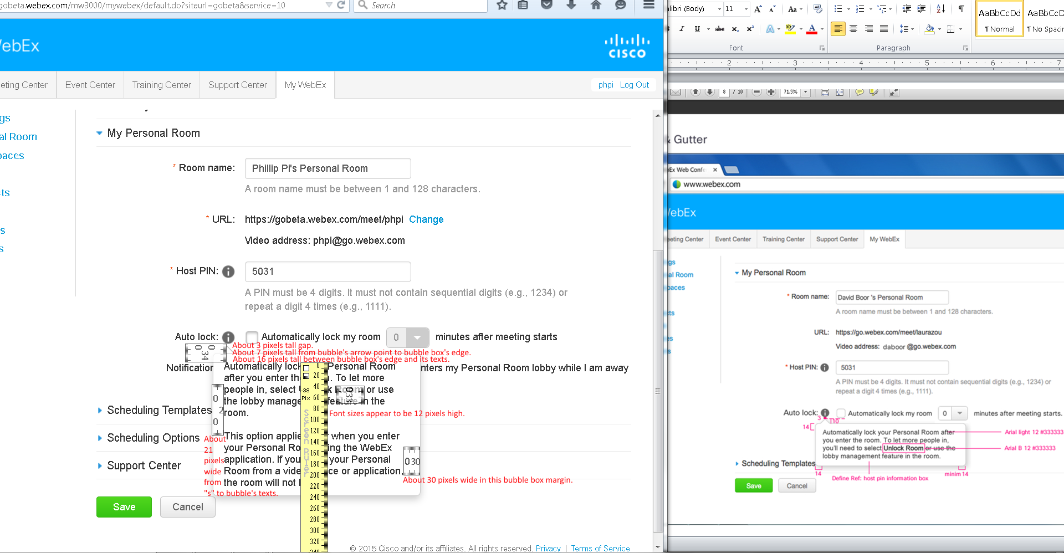
Issues:
- Dimension sizes.
- Need the sizes from “Ref …” texts. Asked for them.

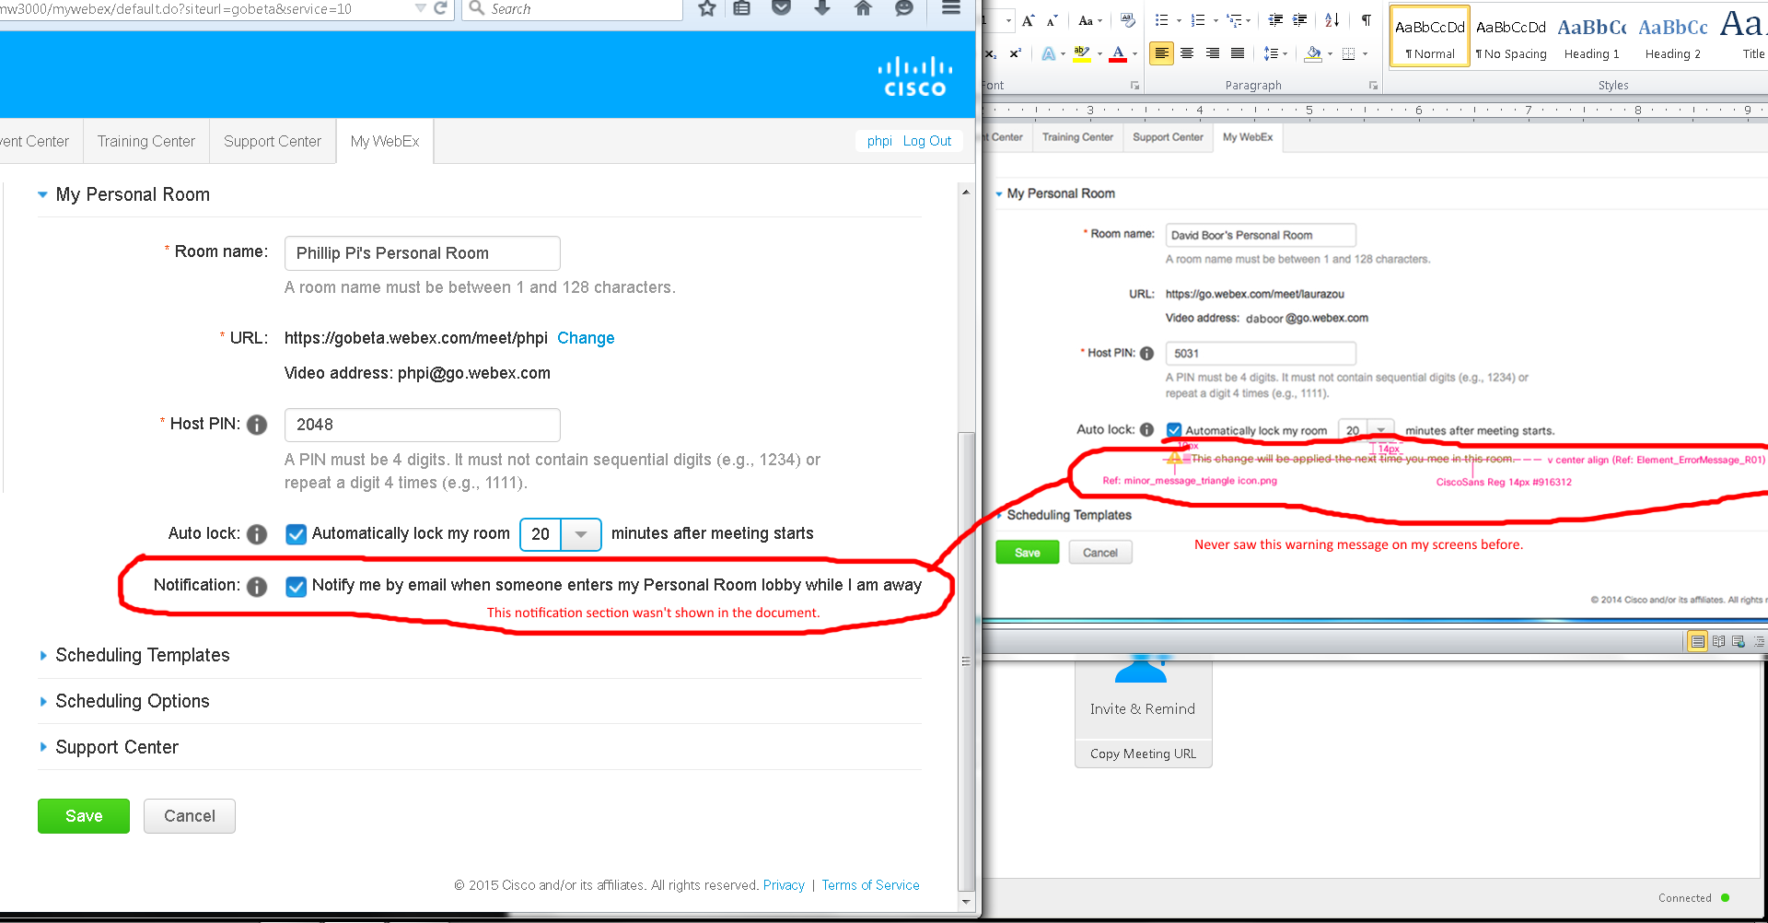
Issues:
- I never see these warning messages when I have Cisco WebEx Meeting Center running as a host and changing my room’s settings in the web browser
- I saw a Notification option on my screen, but not in the document’s.

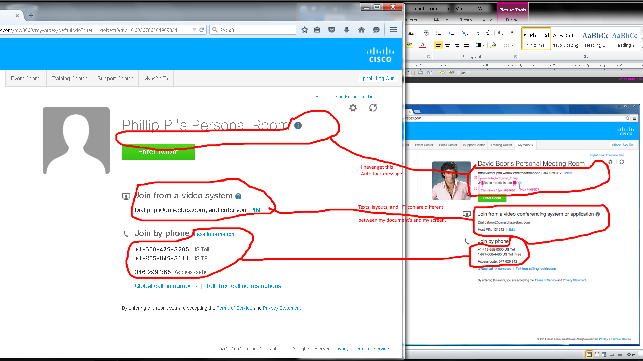
Issue: Many differences like texts, layouts, “i” icon between my screen and document’s.
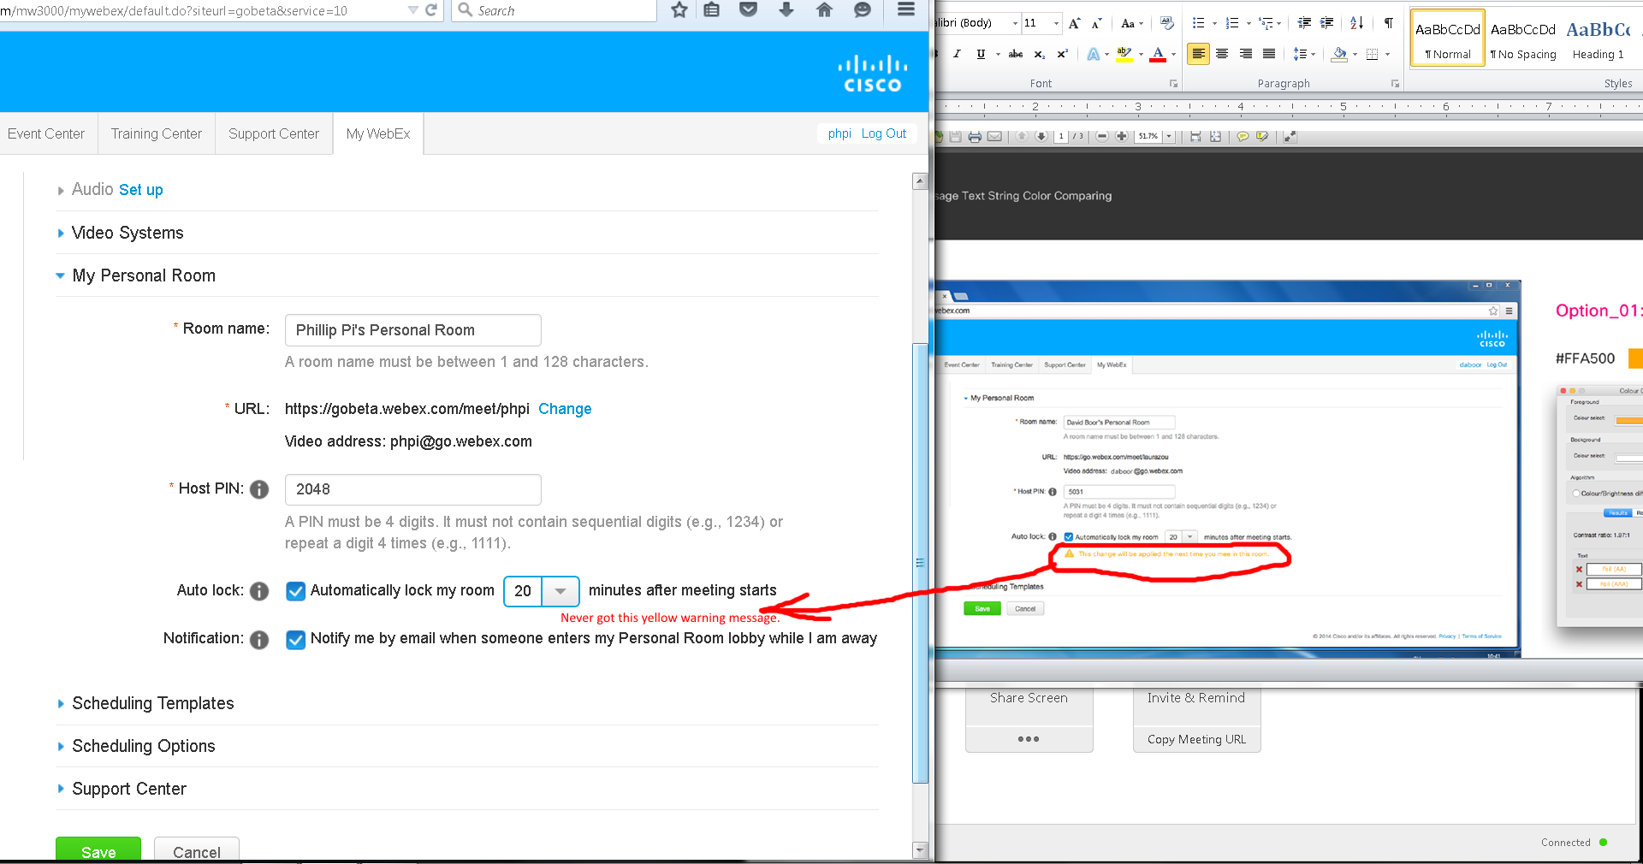
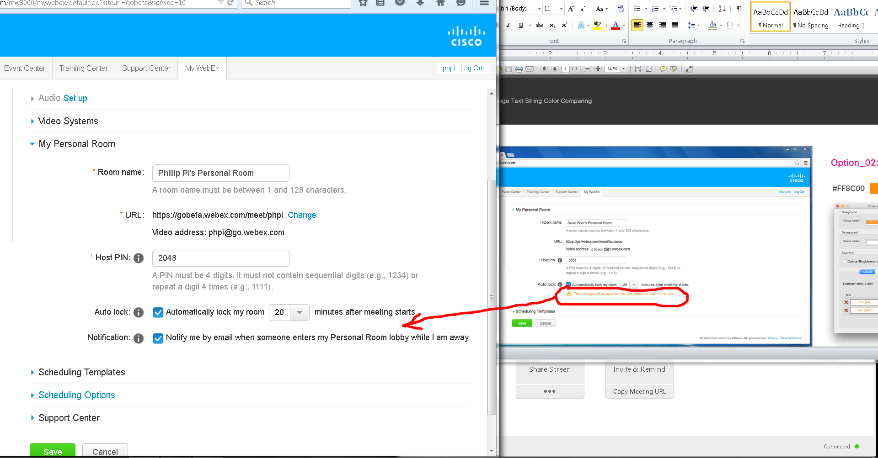
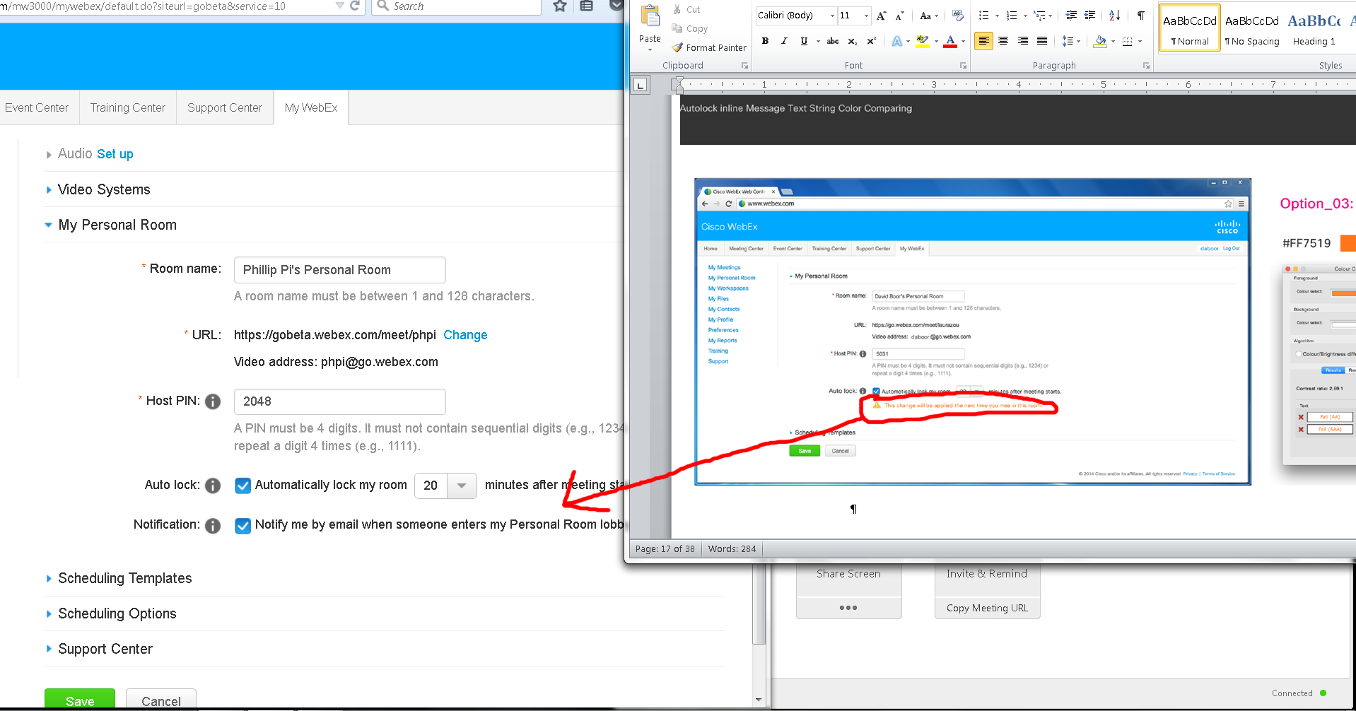
Issues: I never see these warning messages when I have Cisco WebEx Meeting Center running as a host and changing my room’s settings in the web browser.

Overall Issues:
- I never see some of the messages, like "Want to lock your Personal Room automatically? Set your Personal Room preferences." I had to use its gear icon to get to my preferences web page on my http://gobeta.webex.com screens.
- Autolock should not be changing in my current room that I started and in after I manually told it to autolock since I did not leave and rejoin. No one else came in too.
- Unable to test the complicate case due to Cisco WebEx Meeting Center: Host required for the meeting; Wanting to dump all participants; Thinking the host is rejoining on the same machine when trying to pass presenter status to the guest. Need another account and work computer?
- Both my screen and the documents' show differences like missing texts, links, icon graphics, etc.
- Dimension sizes.
- Need the sizes from “Ref …” texts. Asked for them.
- I never see these warning messages when I have Cisco WebEx Meeting Center running as a host and changing my room’s settings in the web browsers.
- I saw a Notification option on my screen, but not in the document’s.

