Web Pages – Disclaimer (no prototype):
In 64-bit W7 EE SP1 (no antialias/ClearType) with Firefox v39 web browser:
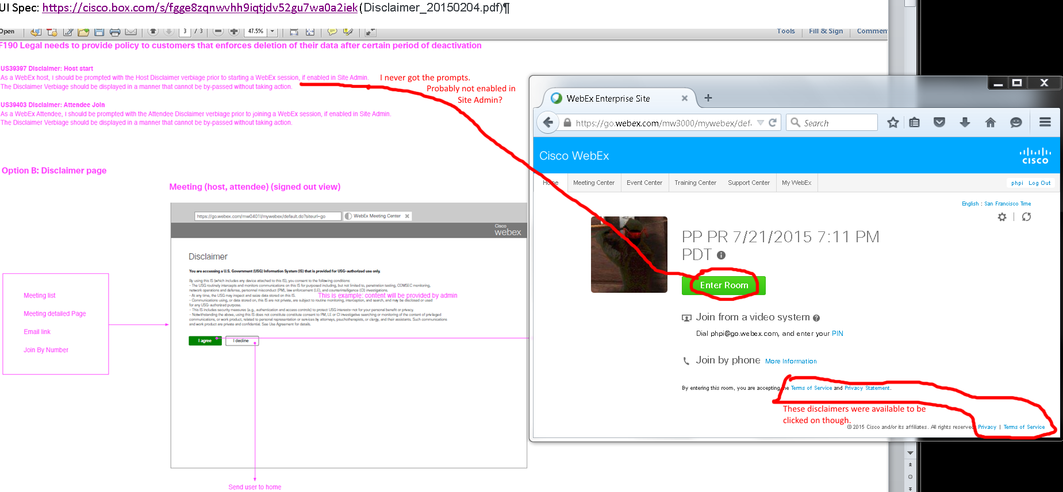
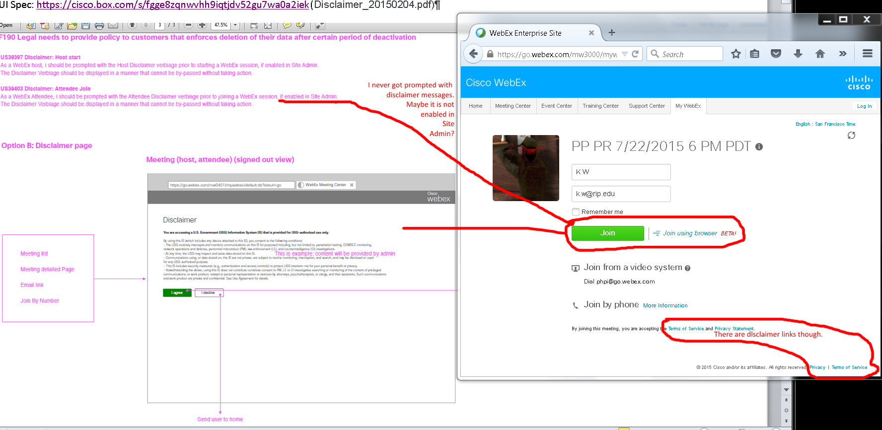
Issues: I never get the disclaimer prompts. It is probably disabled by site admin which I don’t have access to. It doesn't matter if I was signed in (phpi@cisco.com) or out.

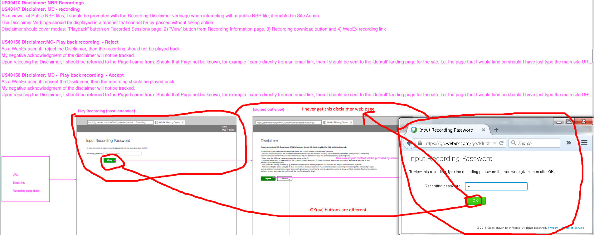
Issues:
- I never see the Disclaimer web pages with my streaming and download recorded meetings’ URLs. I assume site admin didn’t enable the disclaimer feature which I don’t have access to. It didn’t matter if I was signed in (phpi@cisco.com) or out.
- Green buttons have different green colors and texts.
- Unable to check disclaimers template to compare.

OVERALL ISSUES:
- I never get the disclaimer prompts. It is probably disabled by site admin which I don’t have access to. It doesn't matter if I was signed in (phpi@cisco.com) or out.
- Green buttons have different green colors and texts.
- Unable to check disclaimers template to compare.

