Web Pages - CI integration Flow (no prototype and visual):
In 64-bit W7 EE SP1 (125% DPI (medium) and mostly no antialias) with its IE11 web browser on 7/21-22/2015:
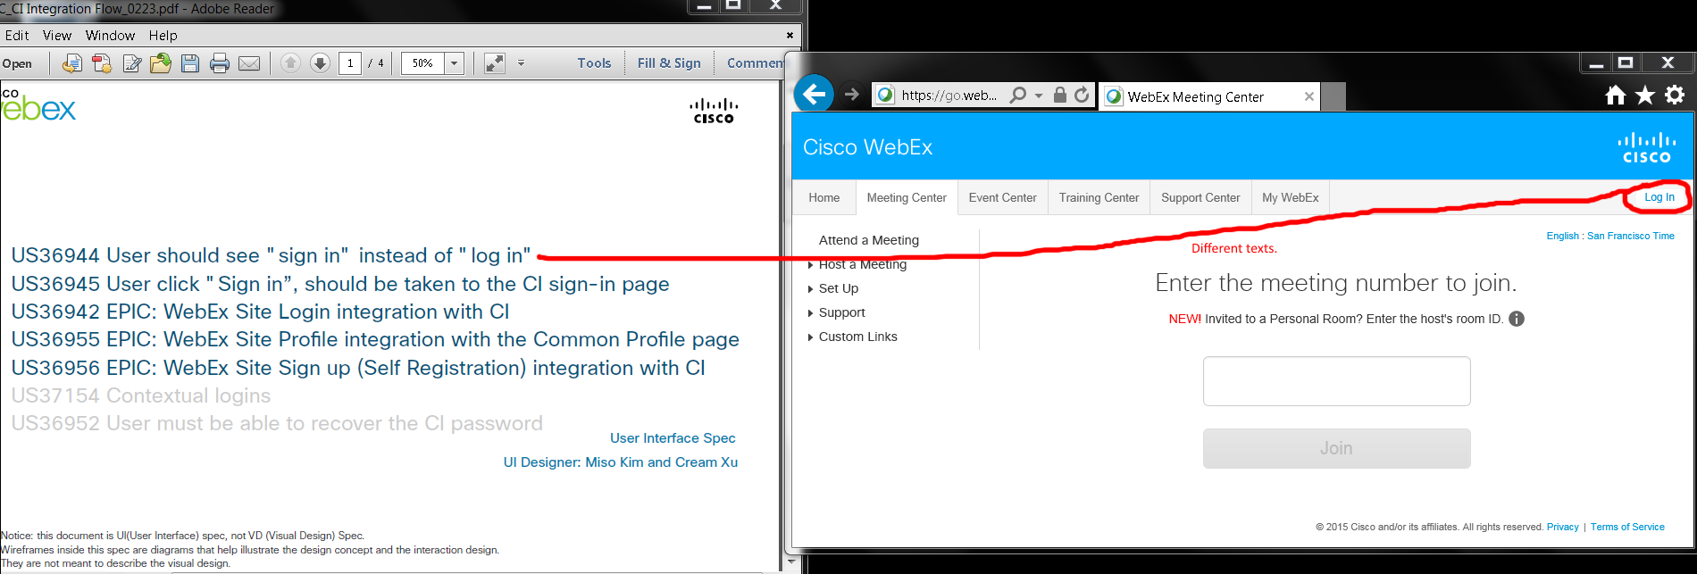
Issue: I saw “Log in” (lowercased “l”) link on https://go.webex.com/mw3000/mywebex/default.do?siteurl=go web page redirected from http://go.webex.com URL.

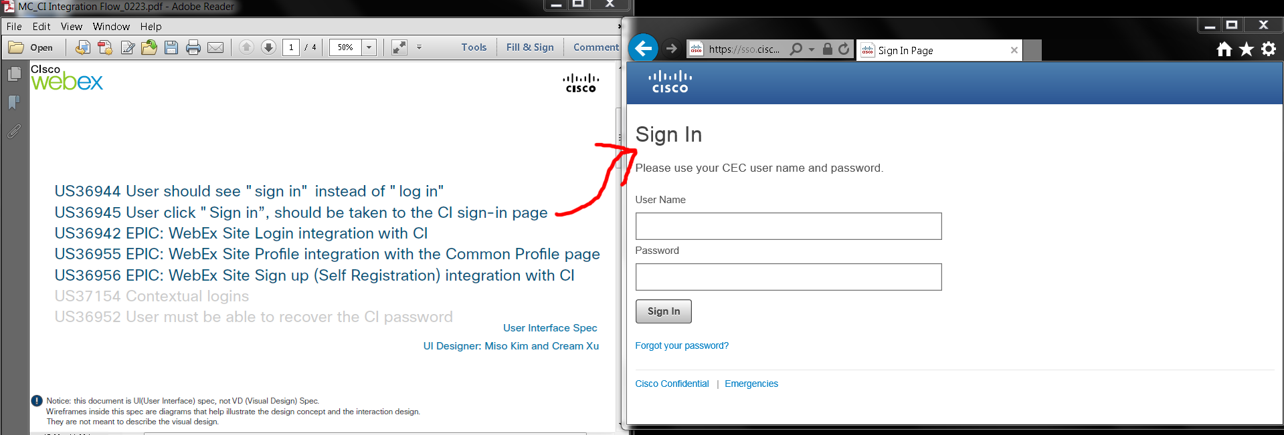
“Sign In” (capitalized “I”?) web page was at https://sso.cisco.com/autho/forms/rCECLogin.html.

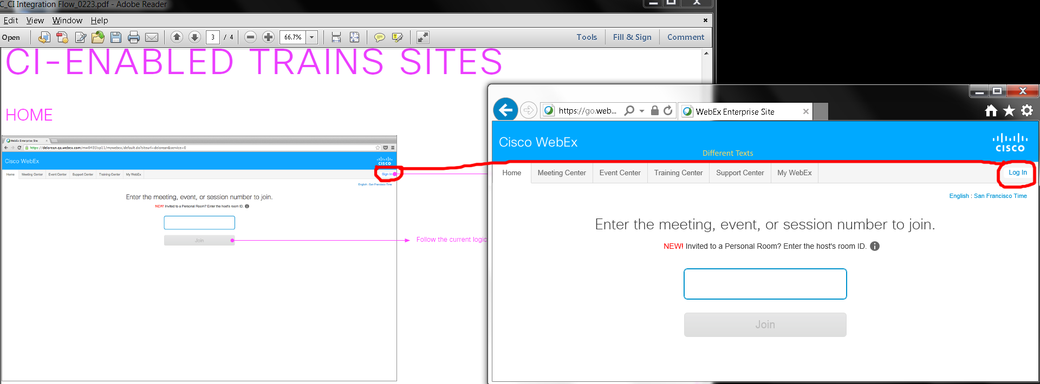
Issue: Home page’s “Sign in” and “Log In” buttons.

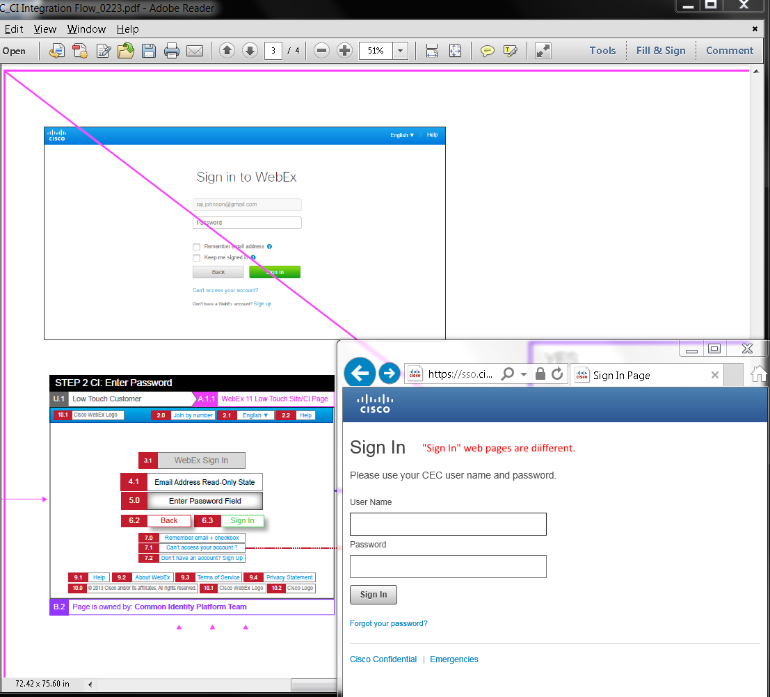
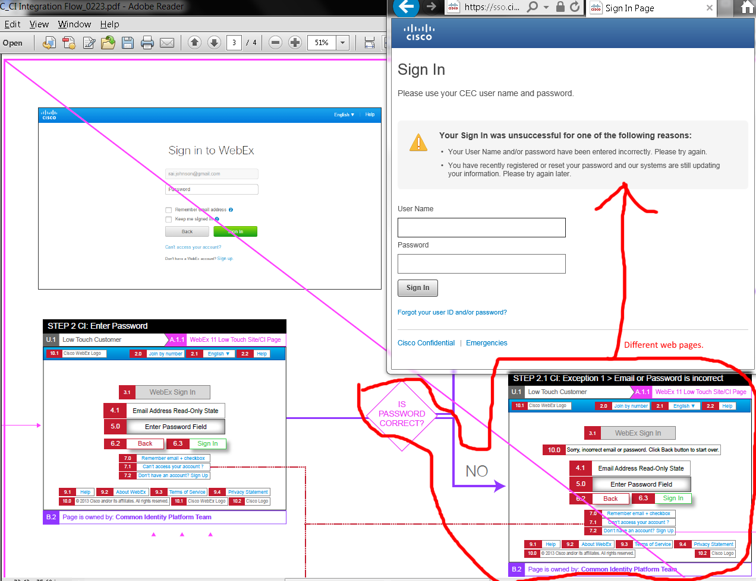
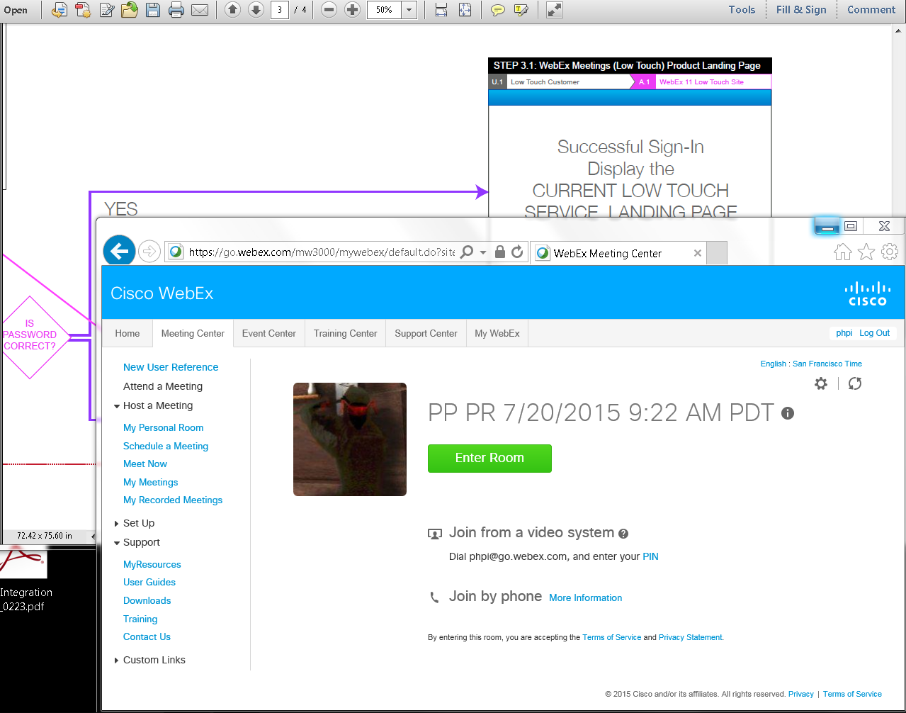
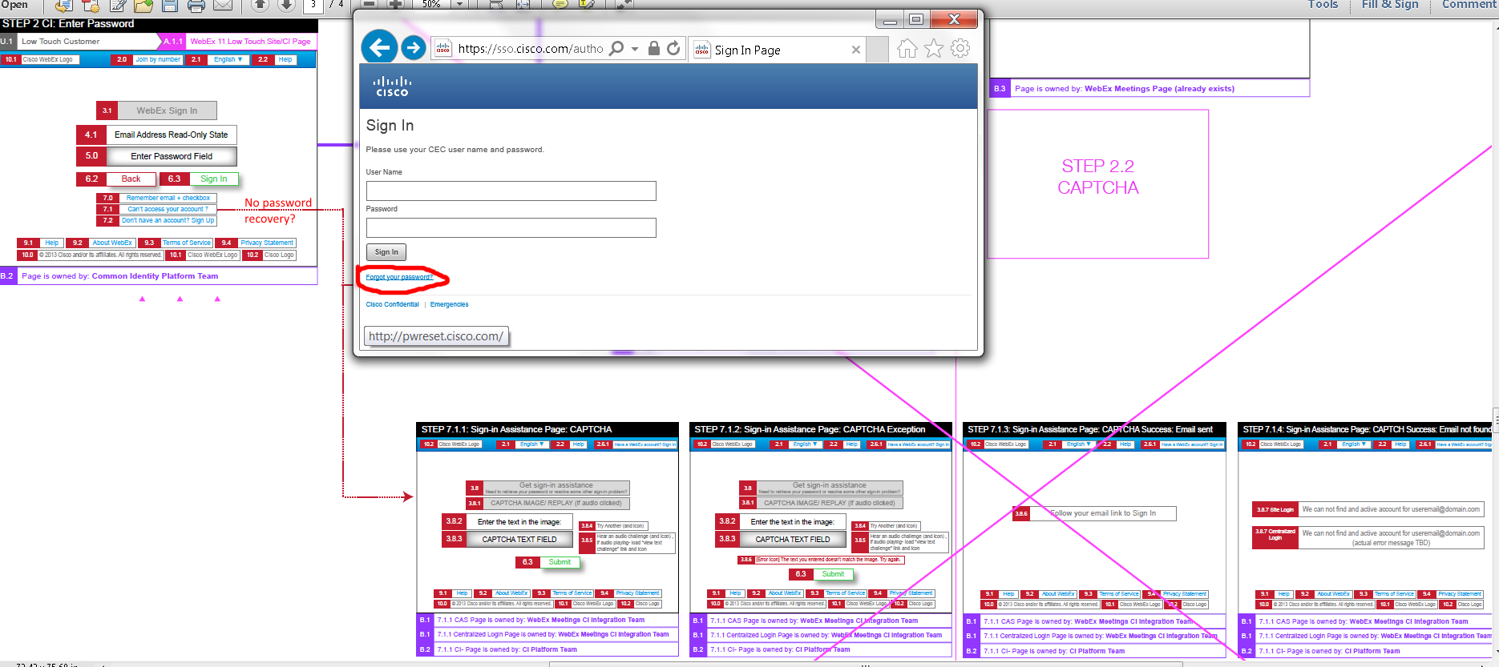

My “Forgot your password” link went to http://pwreset.cisco.com/ to https://pwreset.cisco.com/CISCO/psf.exe#2 web page:
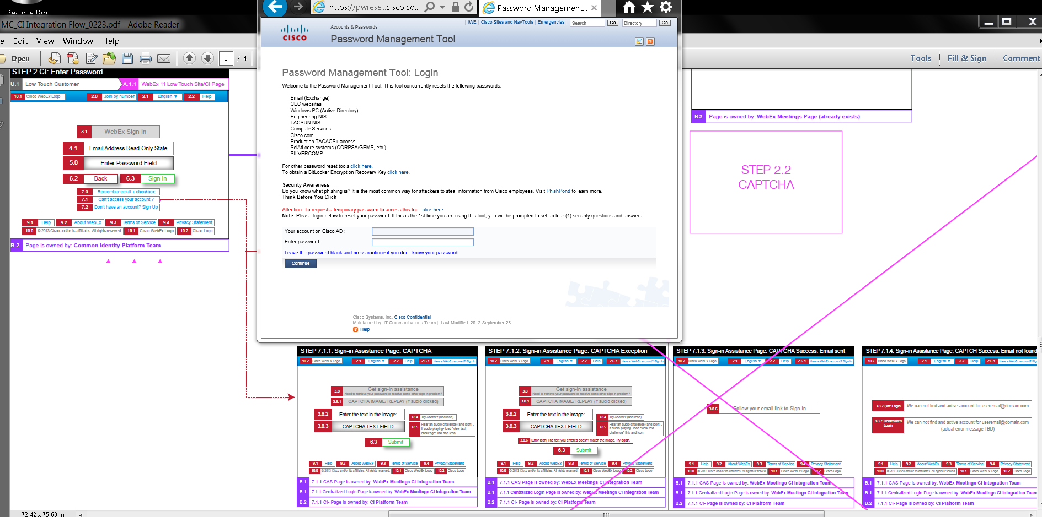
Issues: Results were different for password recovery.

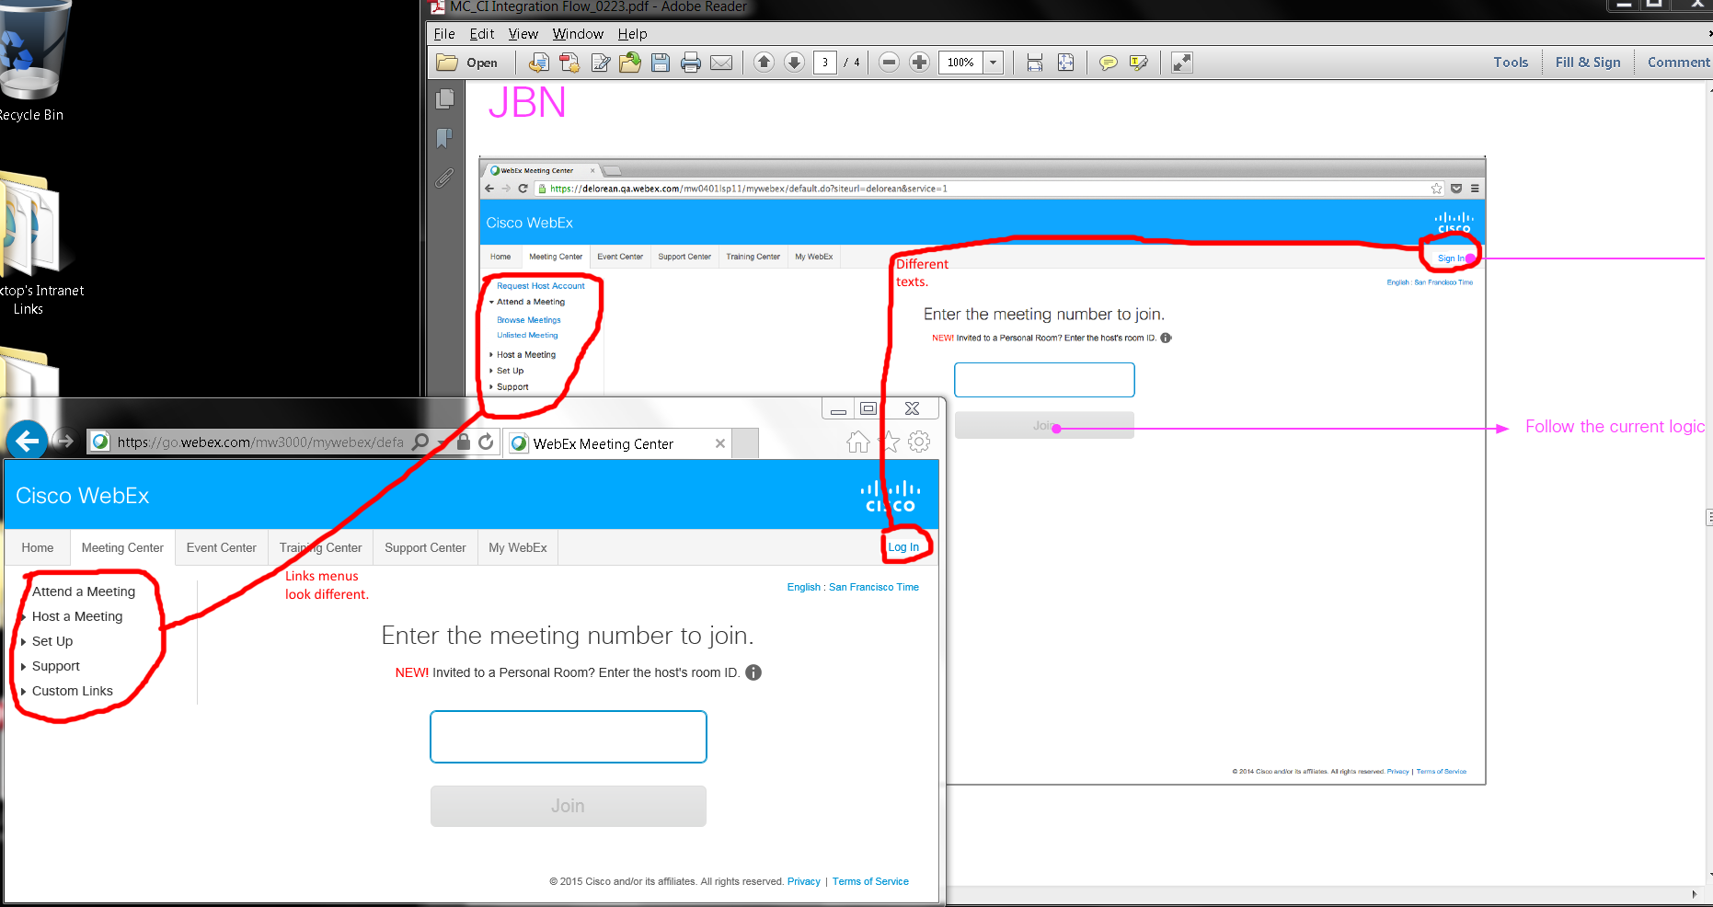
Issues:
- Top right corners’ Sign/Log In links.
- Log/Sign In links’ left menus are different.

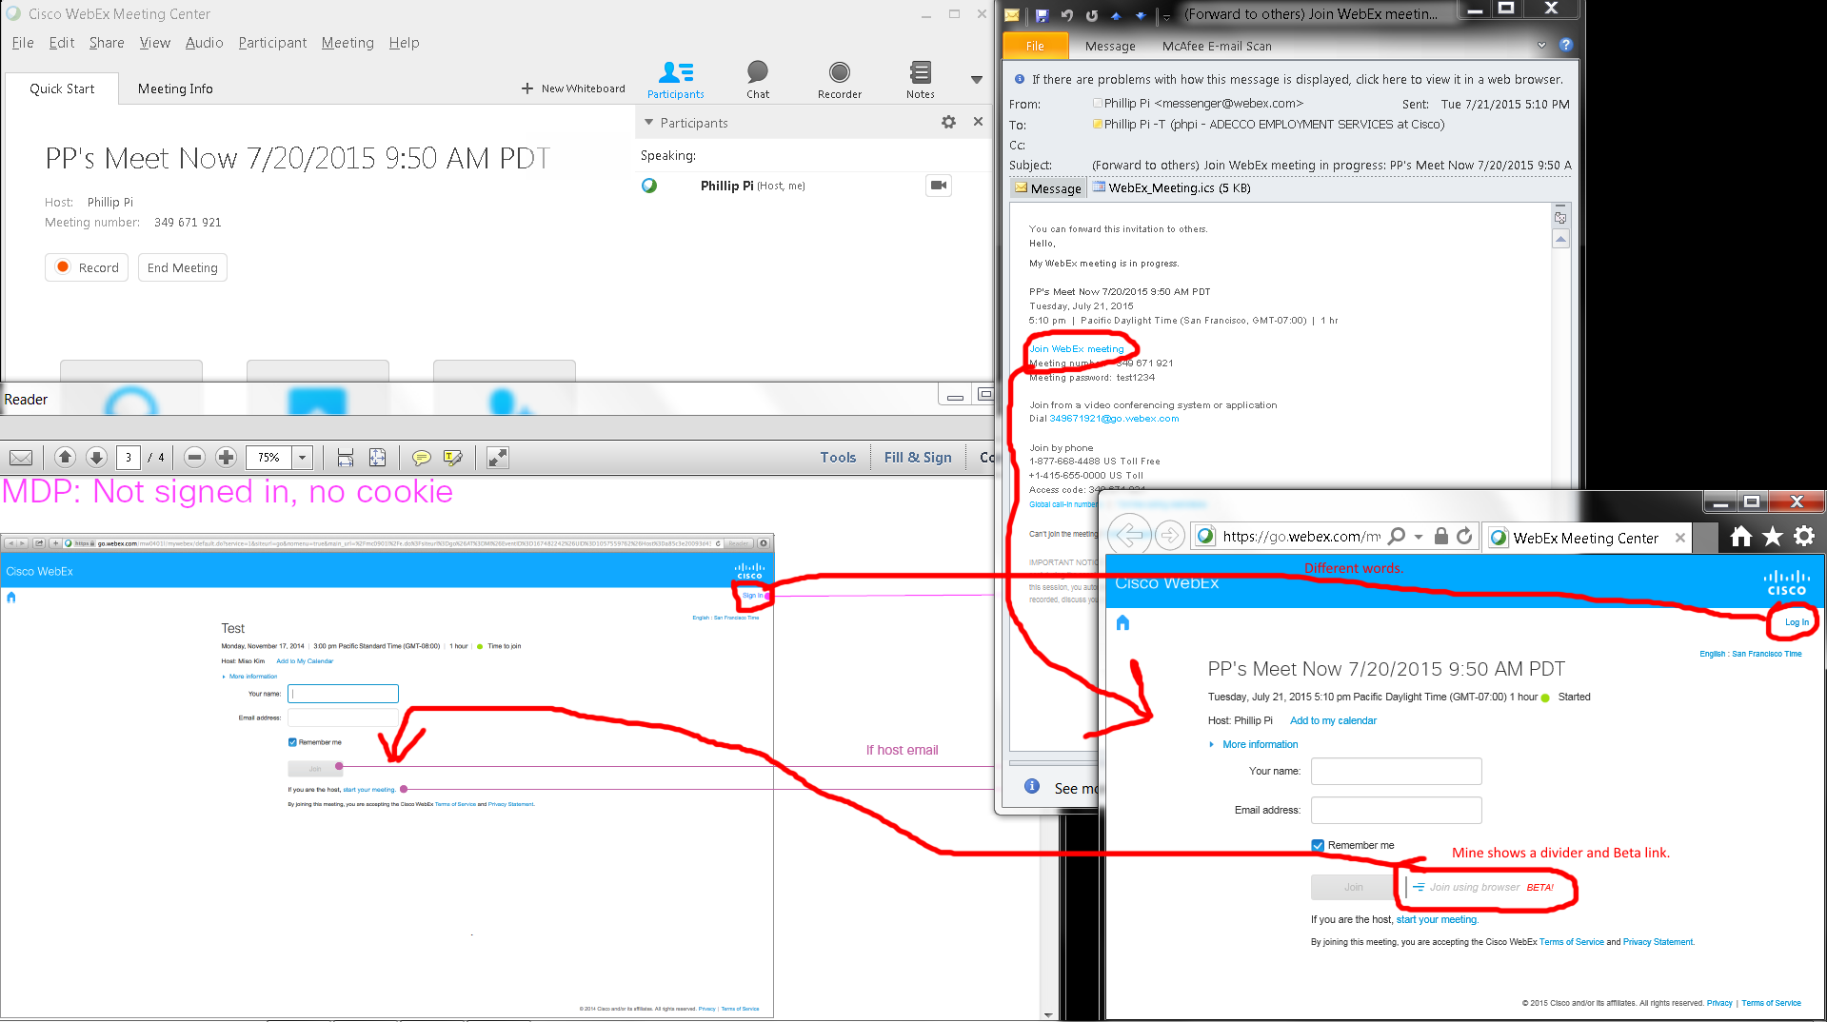
Issues:
- Sign/Log In texts.
- Mine shows “Join using browser BETA!” with its graphics and divider.

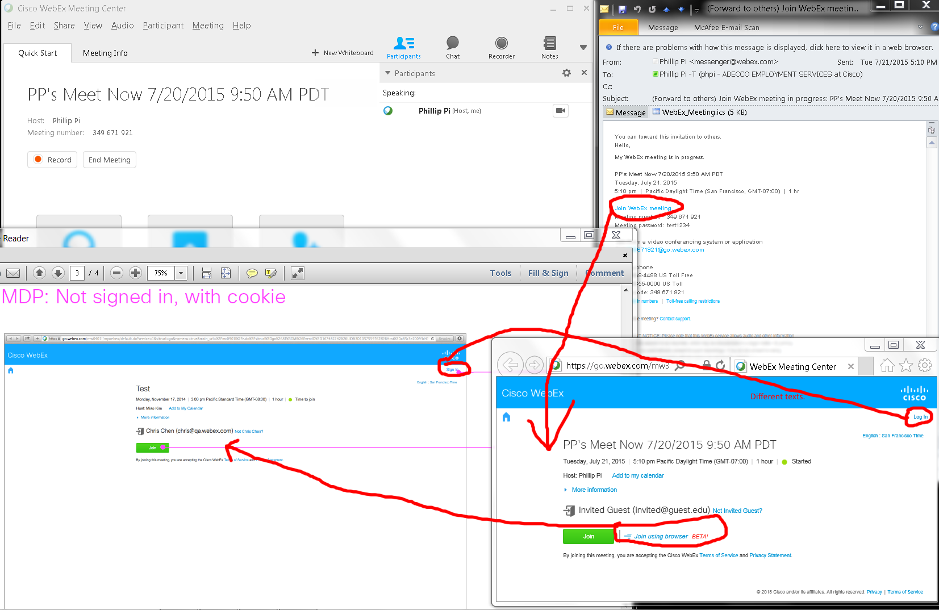
Issues:
- Top right corner’s Sign/Log In links have different words.
- Mine shows “Join using browser BETA!” with its graphics and divider.

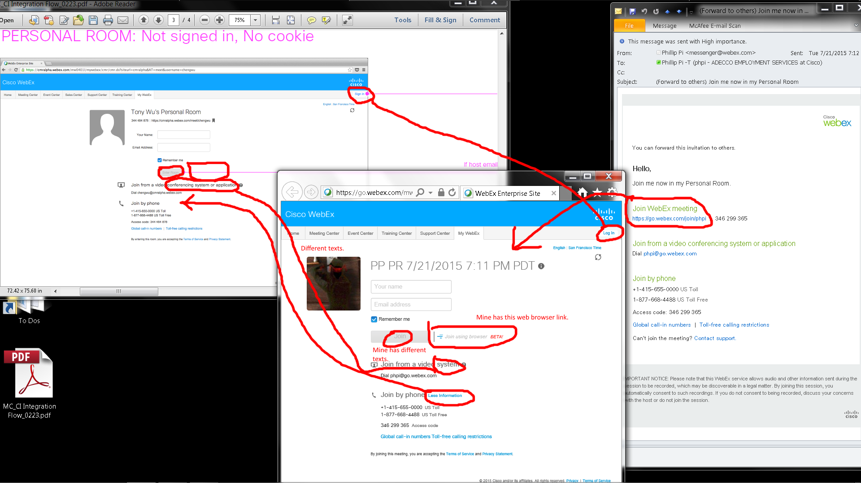
Issues:
- Mine shows a “Join” gr(e/a)y button.
- “Join by phone” information is expandable and collapsable on my screen.
- Mine shows “Join using browser BETA!” with its graphics and divider.
- “Join from a video…” texts are different.

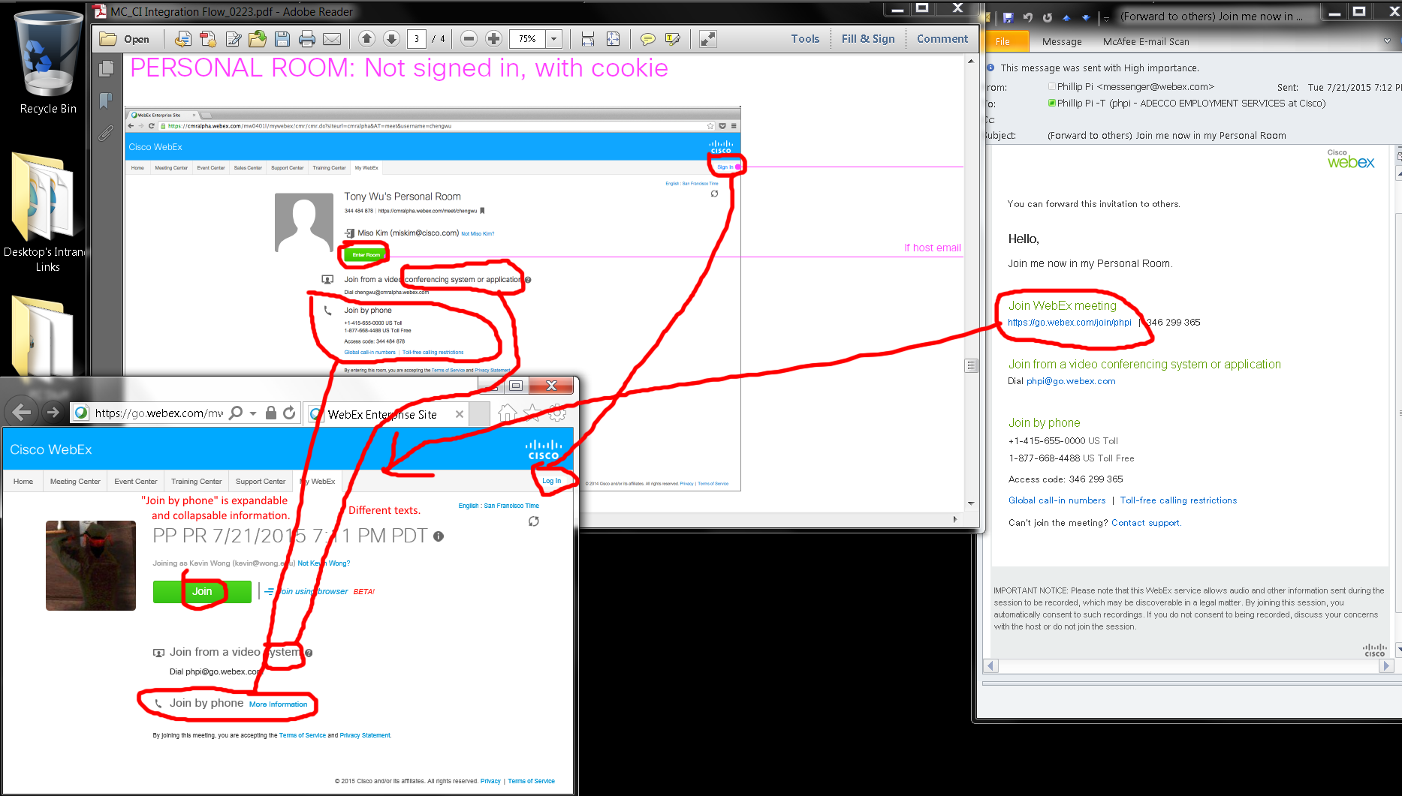
Issues:
- Different texts in the green buttons.
- “Join by phone” information is expandable and collapsable on my screen.
- Mine shows “Join using browser BETA!” with its graphics and divider.
- “Join from a video…” texts are different.

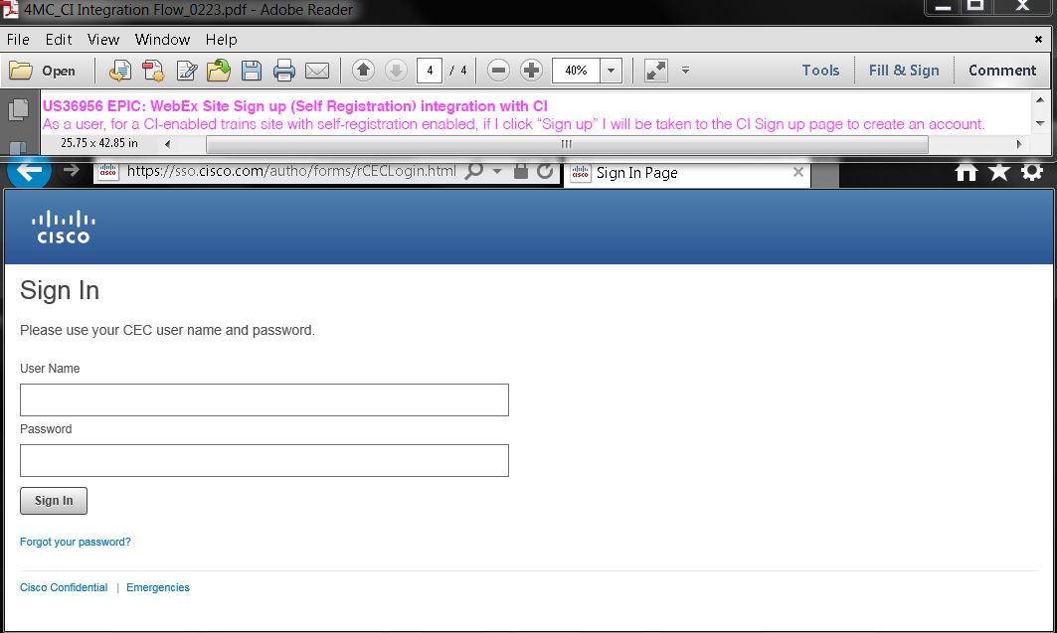
Issue: http://go.webex.com’s https://sso.cisco.com/autho/forms/rCECLogin.html does not have a sign up option. This web site uses my existing production Cisco Activedirectory account that is the same with other Cisco’s servers.
My Profiles:
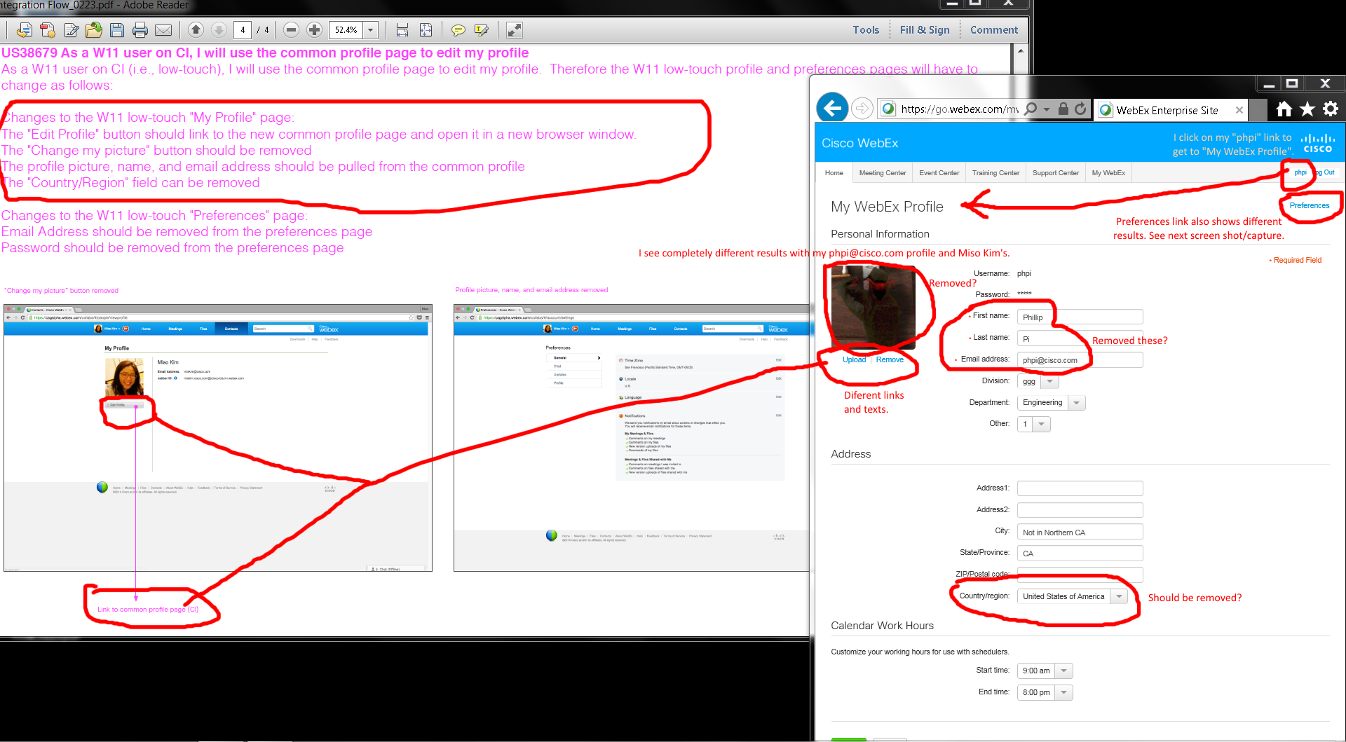

Preferences:
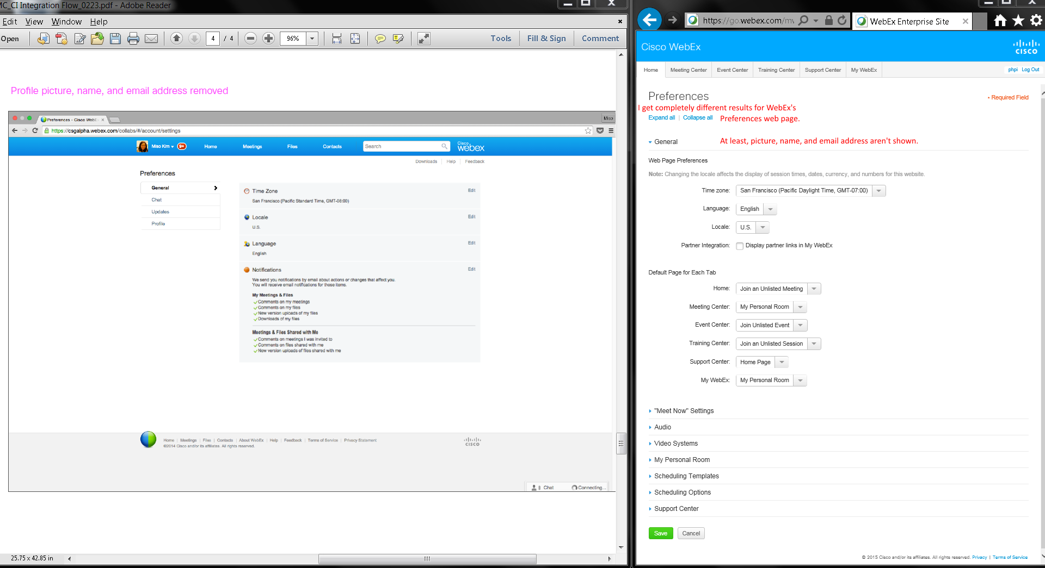
Issues:
- Completely different web page design, layouts, results, texts, links, etc.
- Many items remain and should be removed?
- My “phpi” link goes to “My WebEx” profile.

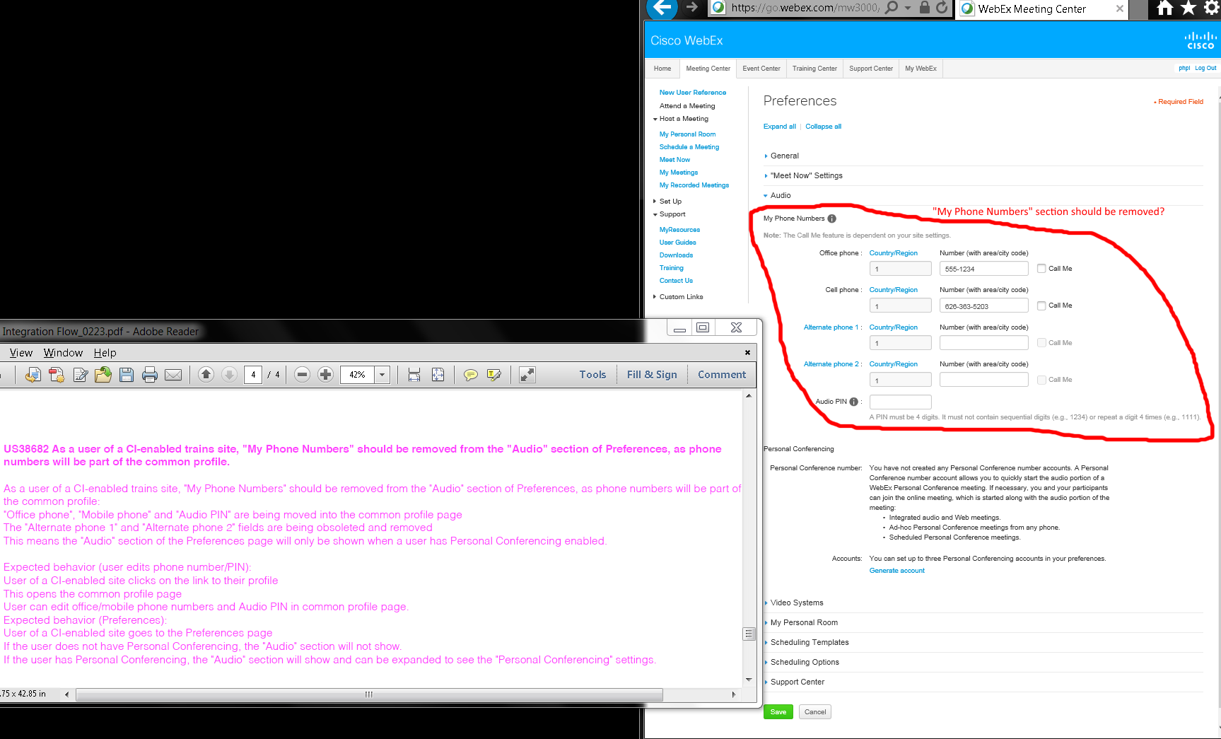

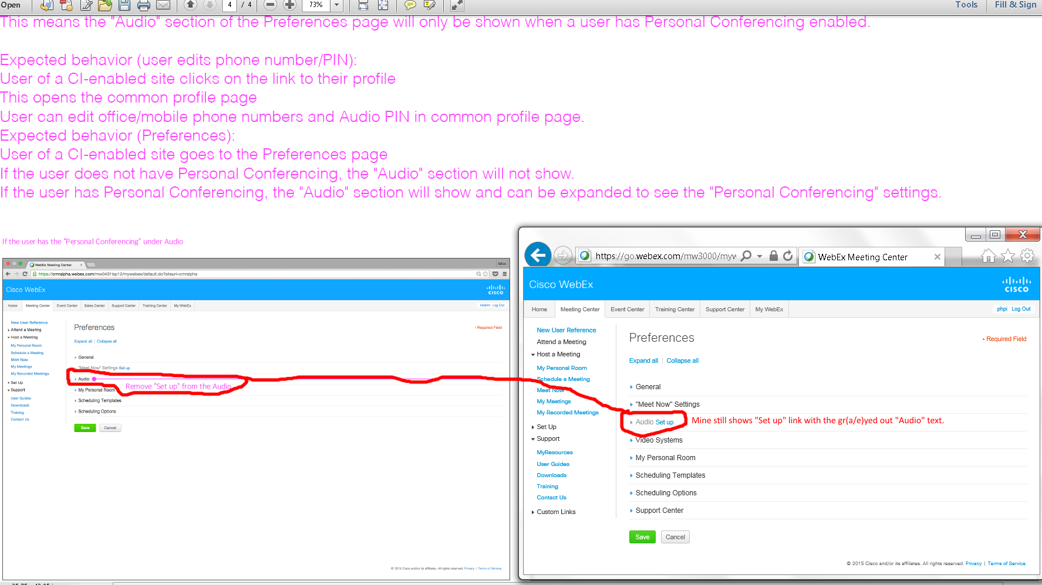
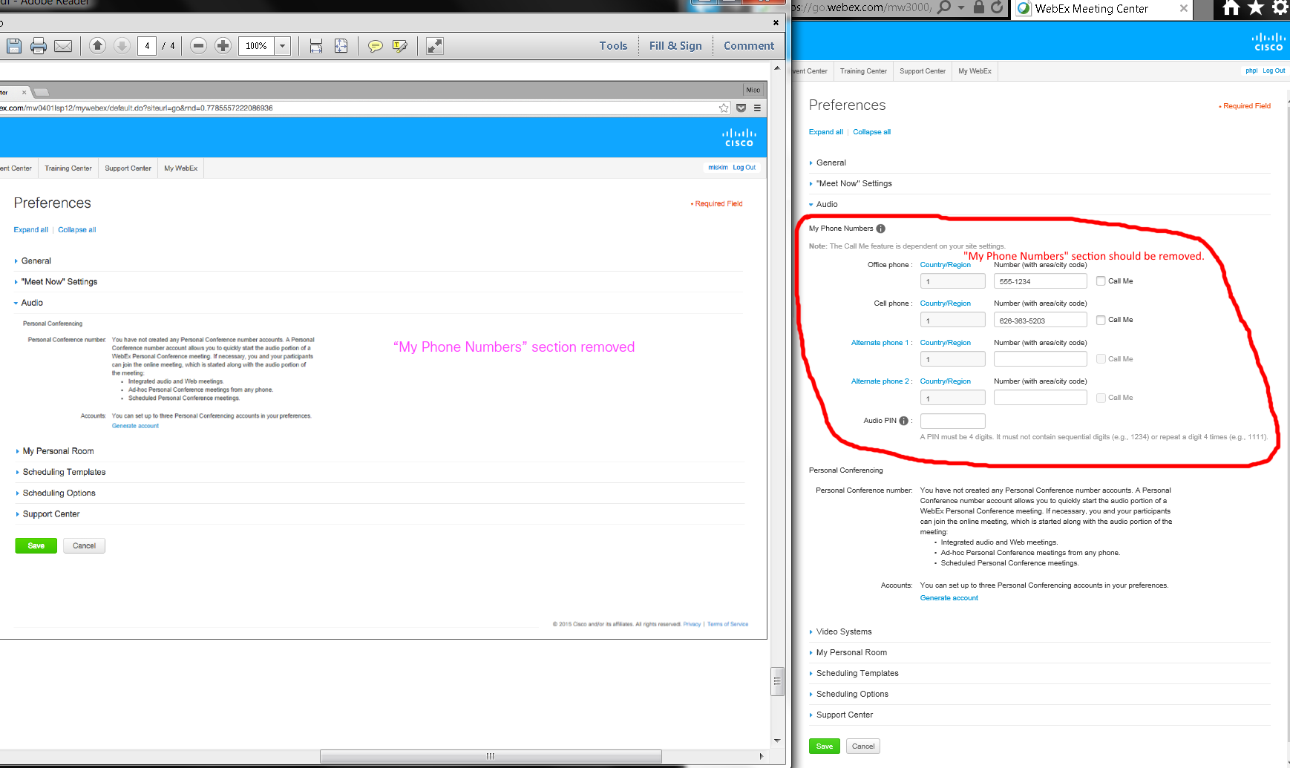
Issues:
- Mine shows a gr(e/a)yed out “Audio” with its linked blue “Set up” link.
- Audio’s phone number section should be removed?
- I was unable to test without "Personal Conferencing" for Preferences' Audio settings.

OVERALL ISSUES:
- I saw “Log in” (lowercased “l”) link on https://go.webex.com/mw3000/mywebex/default.do?siteurl=go web page redirected from http://go.webex.com URL.
- Home page’s “Sign in” and “Log In” buttons.
- Results were different for password recovery.
- Top right corners’ Sign/Log In links.
- Log/Sign In links’ left menus are different.
- Mine shows “Join using browser BETA!” with its graphics and divider.
- Mine shows a “Join” gr(e/a)y button.
- “Join by phone” information is expandable and collapsable on my screen.
- “Join from a video…” texts are different.
- Different texts in the green buttons.
- http://go.webex.com’s https://sso.cisco.com/autho/forms/rCECLogin.html does not have a sign up option. This web site uses my existing production Cisco Activedirectory account that is the same with other Cisco’s servers.
- Completely different web page design, layouts, results, texts, links, etc.
- Many items remain and should be removed?
- My “phpi” link goes to “My WebEx” profile.
- Mine shows a gr(e/a)yed out “Audio” with its linked blue “Set up” link.
- Audio’s phone number section should be removed?
- I was unable to test without "Personal Conferencing" for Preferences' Audio settings.

