Web Pages’ Audio Security (no prototype):
https://gobeta.webex.com on 7/16-17/2015 & http://go.webex.com on 7/20/2015 in updated 64-bit W7 EE SP1 with its IE11 web browser:
Personal Room:
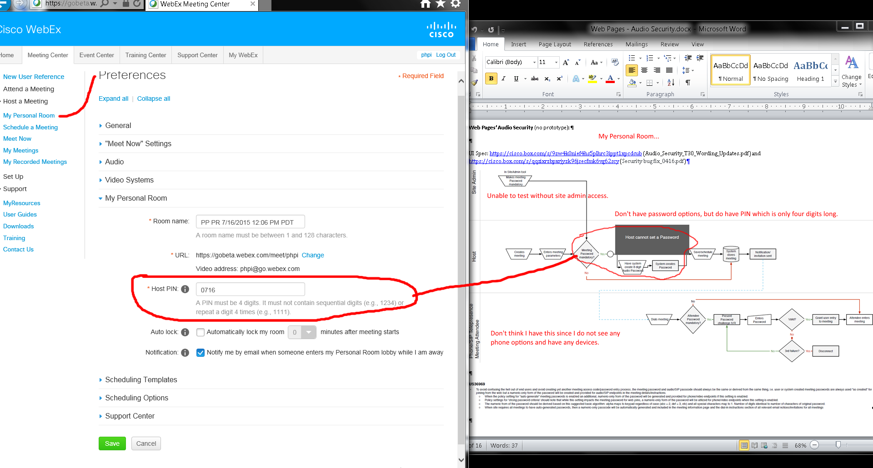
Issues:
- No site admin access.
- Did not see any phone/SIP options in my personal room’s preferences web page.

Schedule a Meeting (quick and not in its Advanced Scheduler):
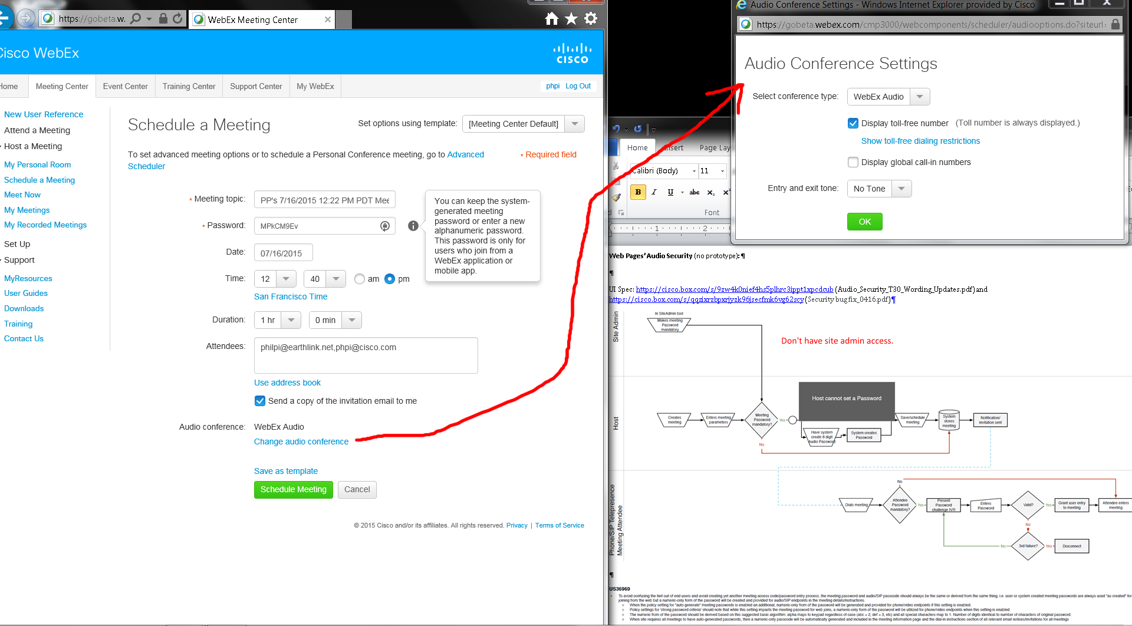
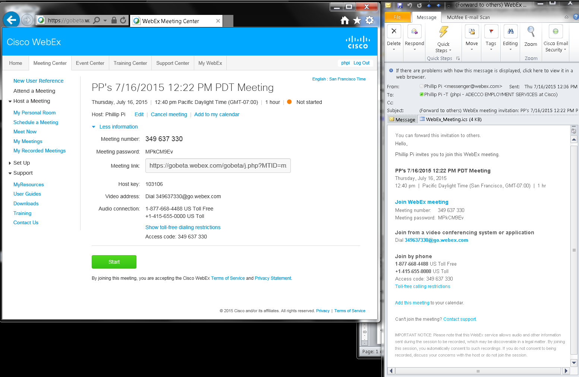
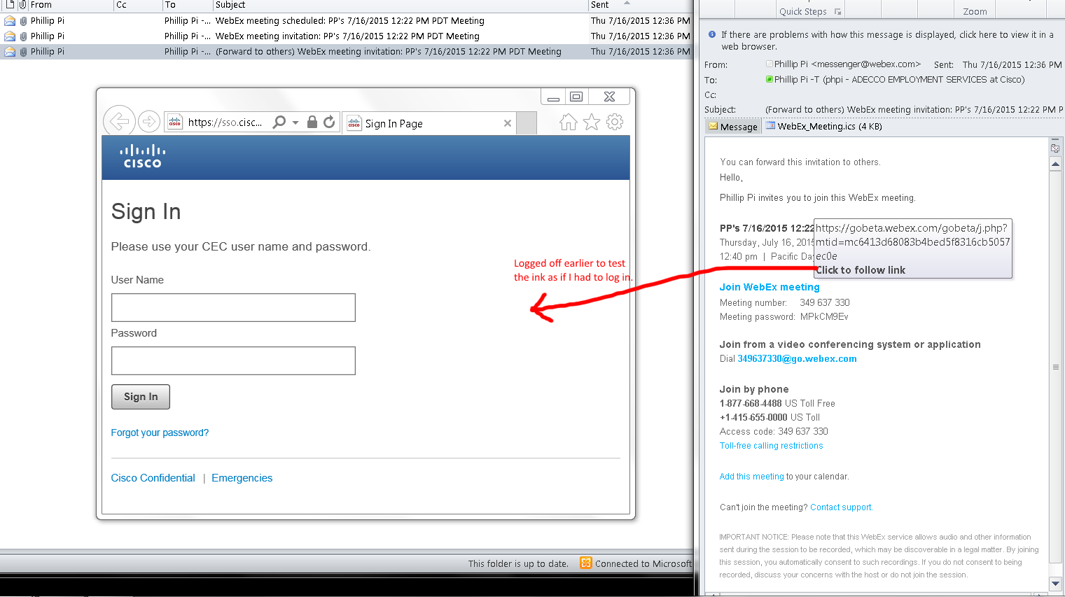

Both starting and joining resulted me as the logged in host in my scheduled meeting:
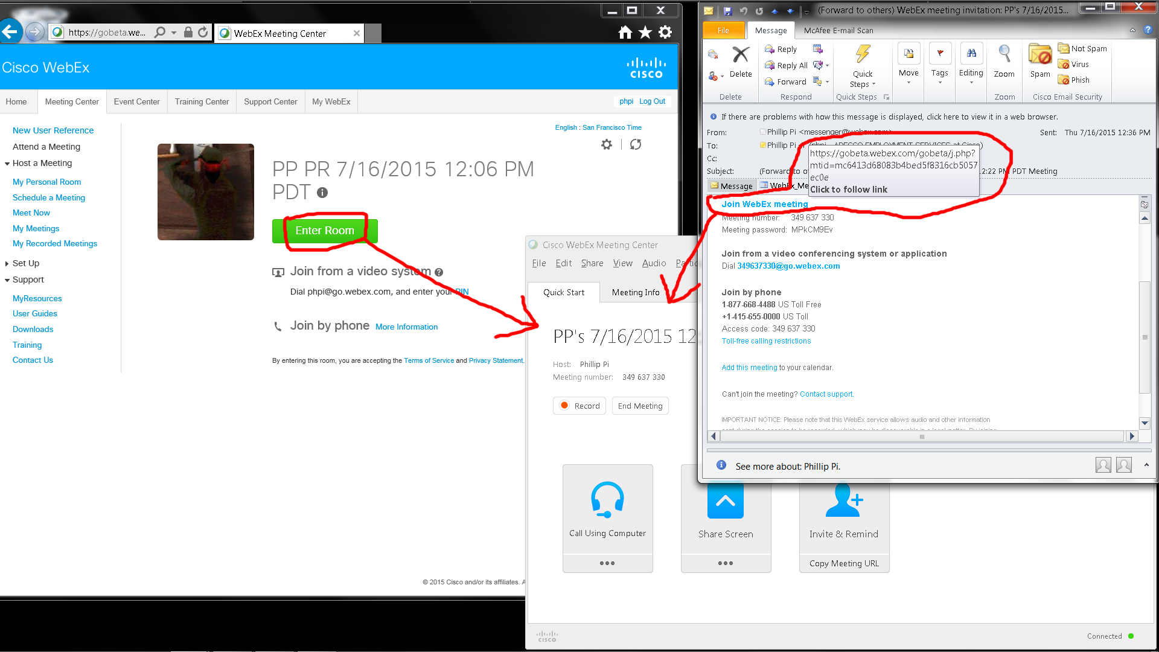

Schedule a Meeting (its Advanced Scheduler; skipped some numbered web pages like #2):
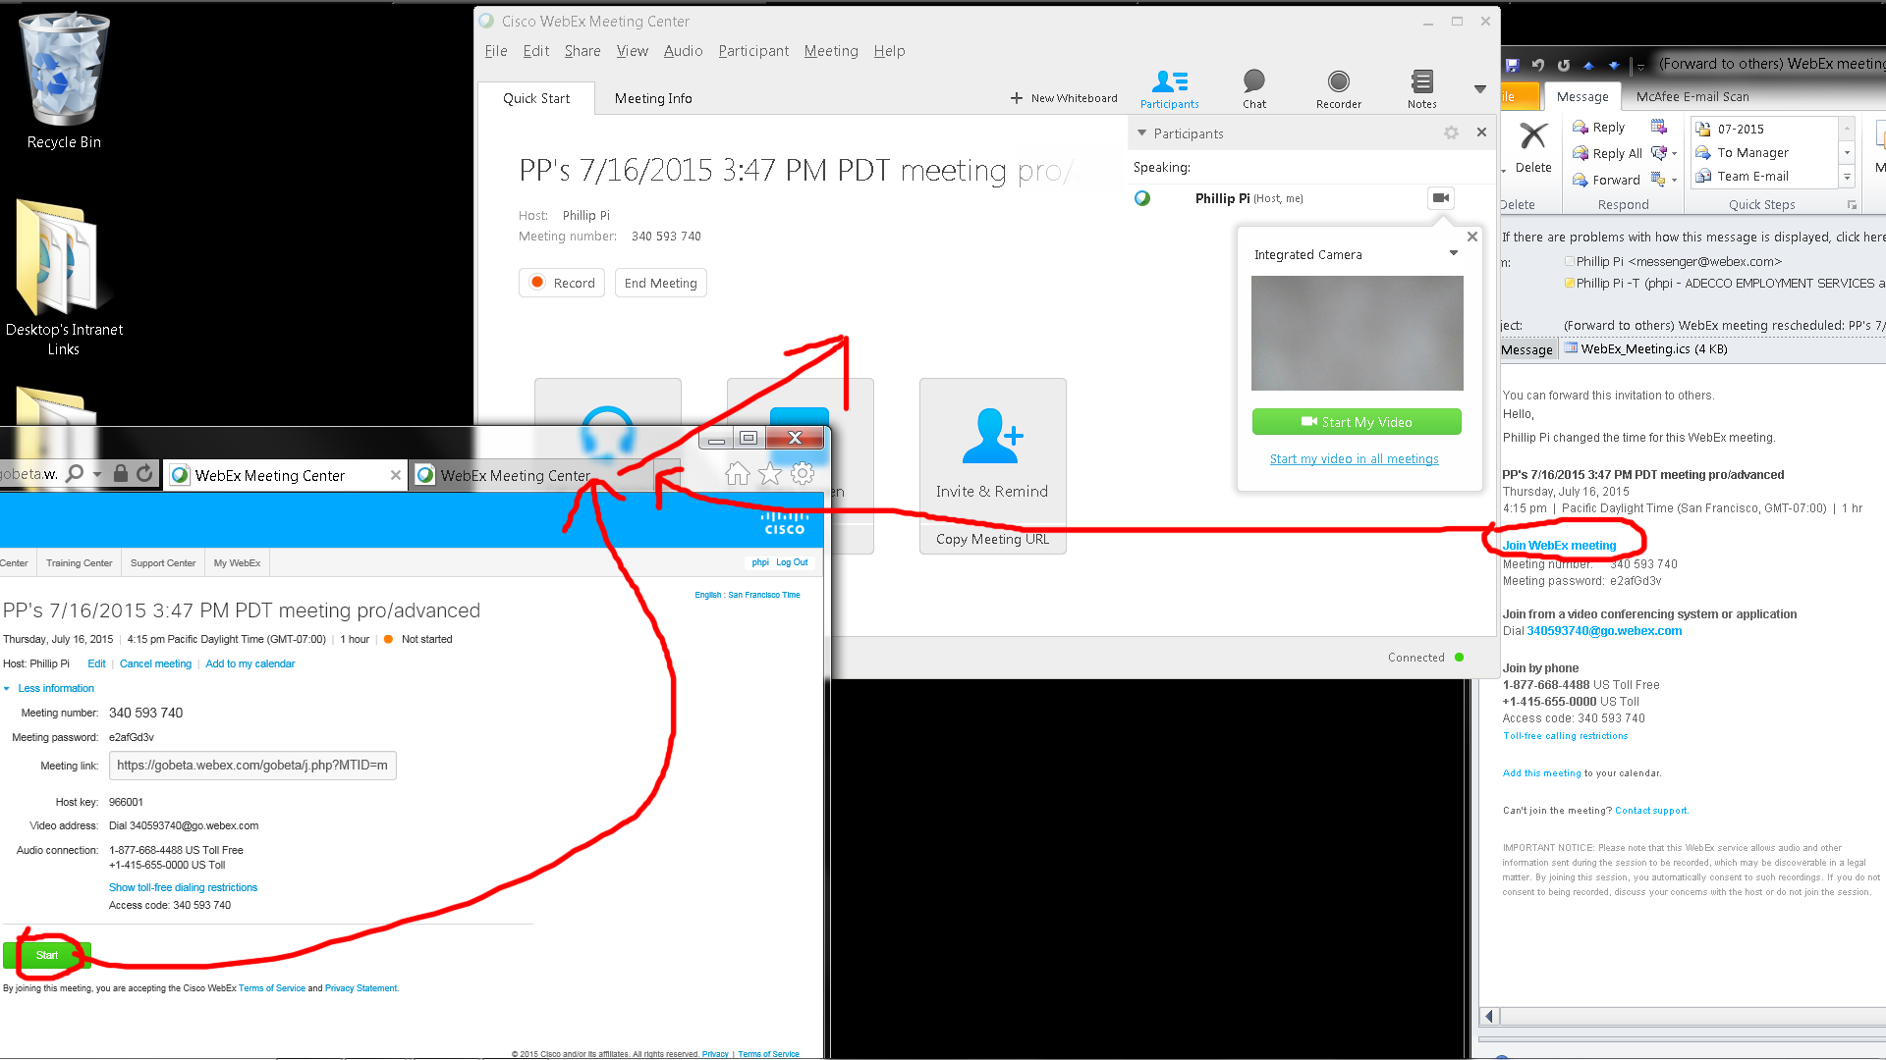
Note that this e-mail automatically included the generated password I asked for.

I told WebEx not to include the passwords in emails:
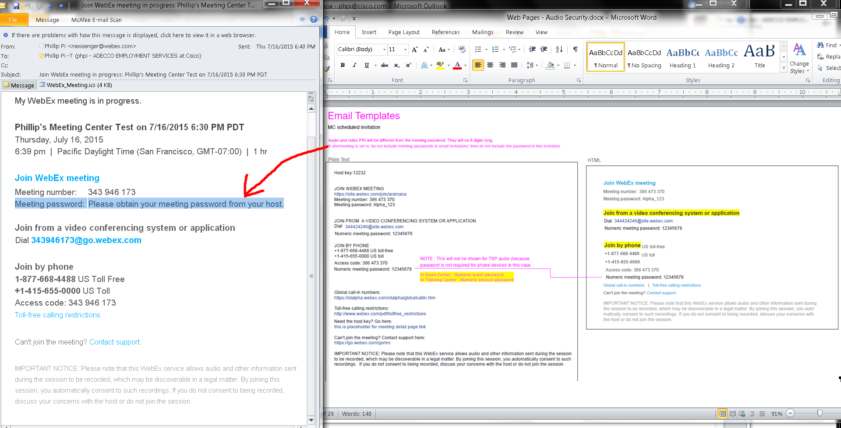
Issue: Don’t have admin access.
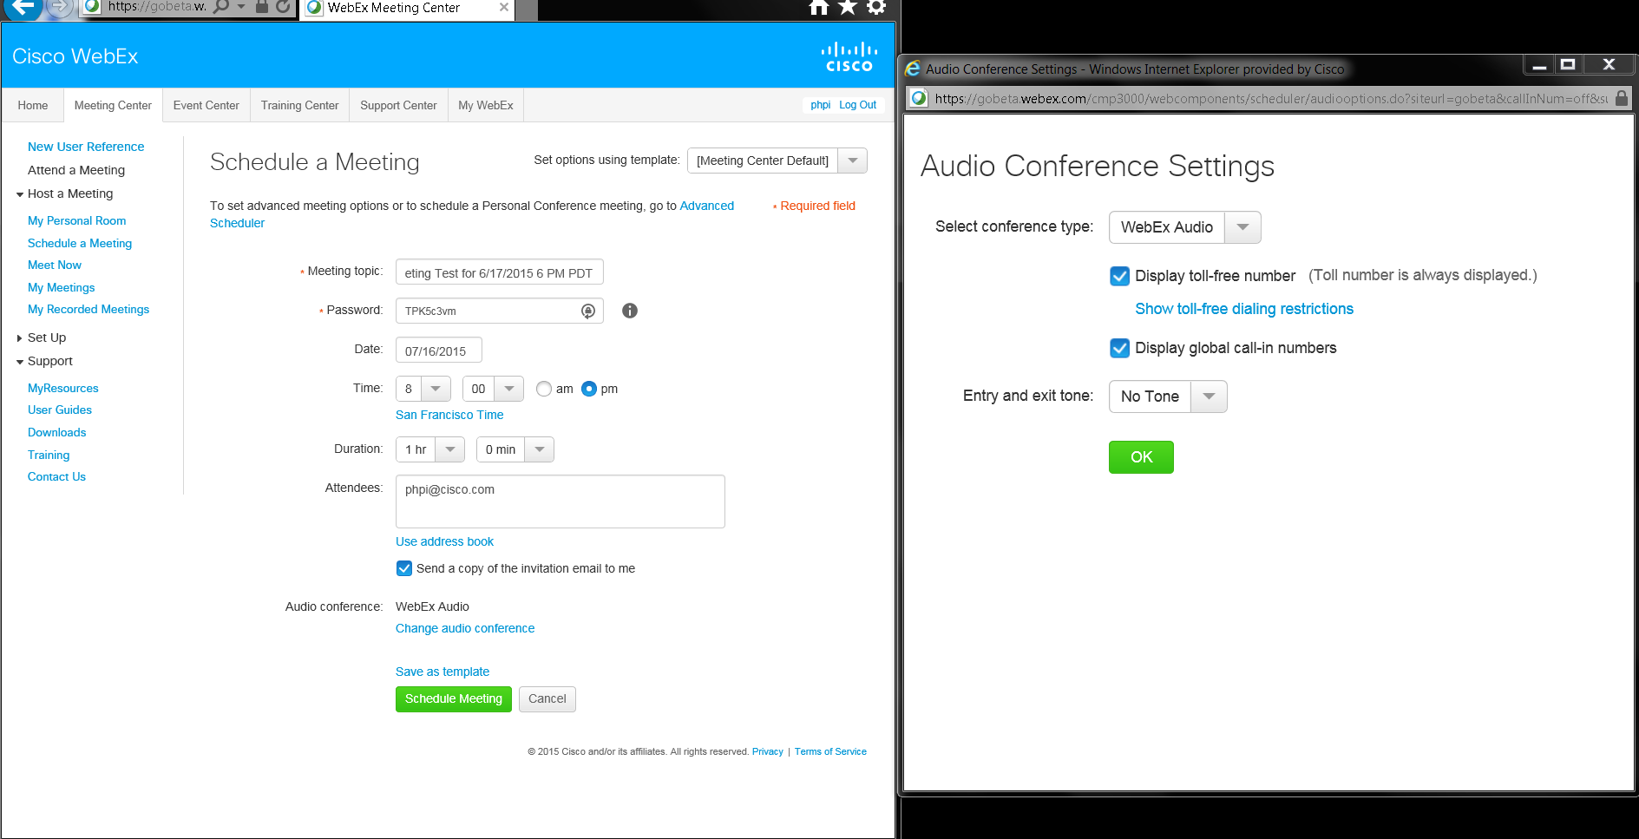
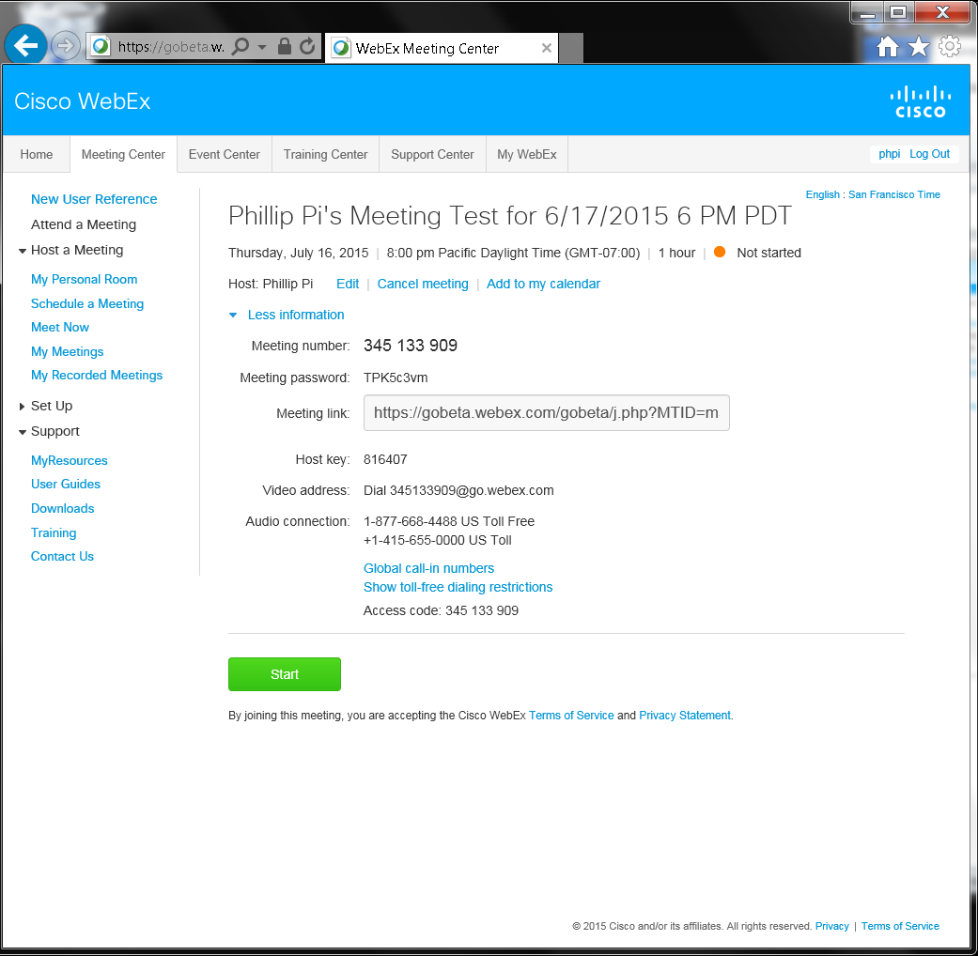
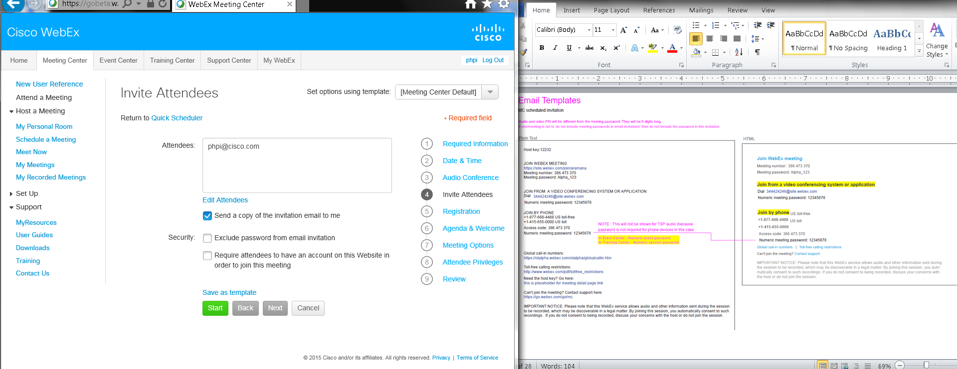
However, no plain text email format option for Meeting Center:
However, I did check in an online email webmail client to force plain text format out of this HTML WebEx email:
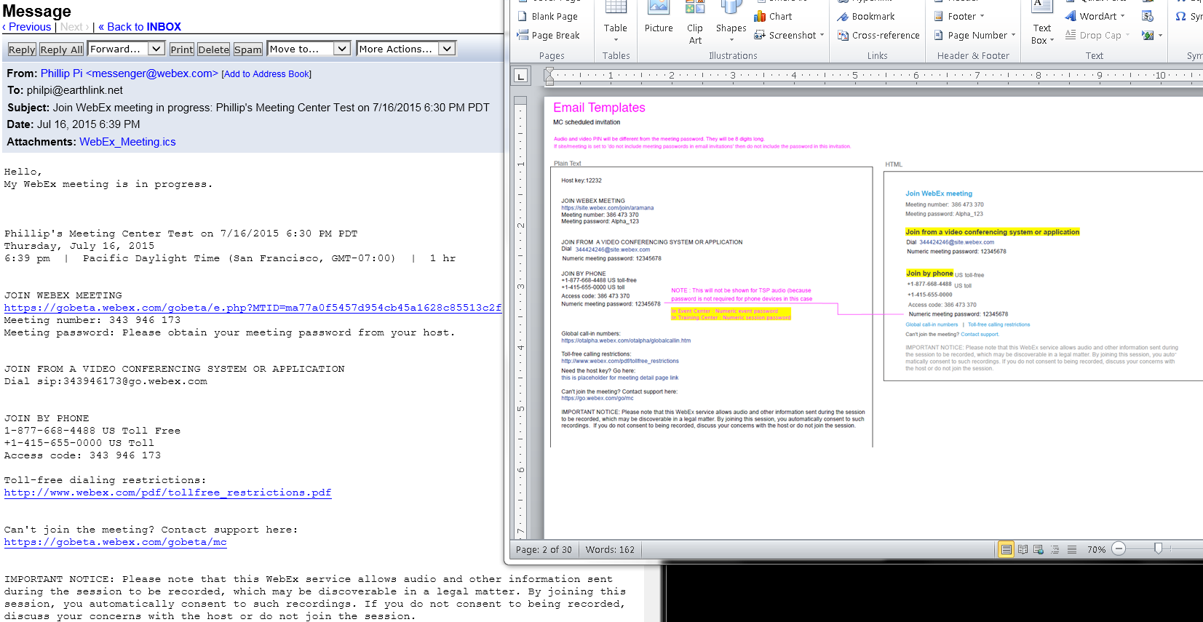
Issues:
- No option to send as HTML or plain text email format.
- Received e-mails show different layouts and texts compared to document’s email template.

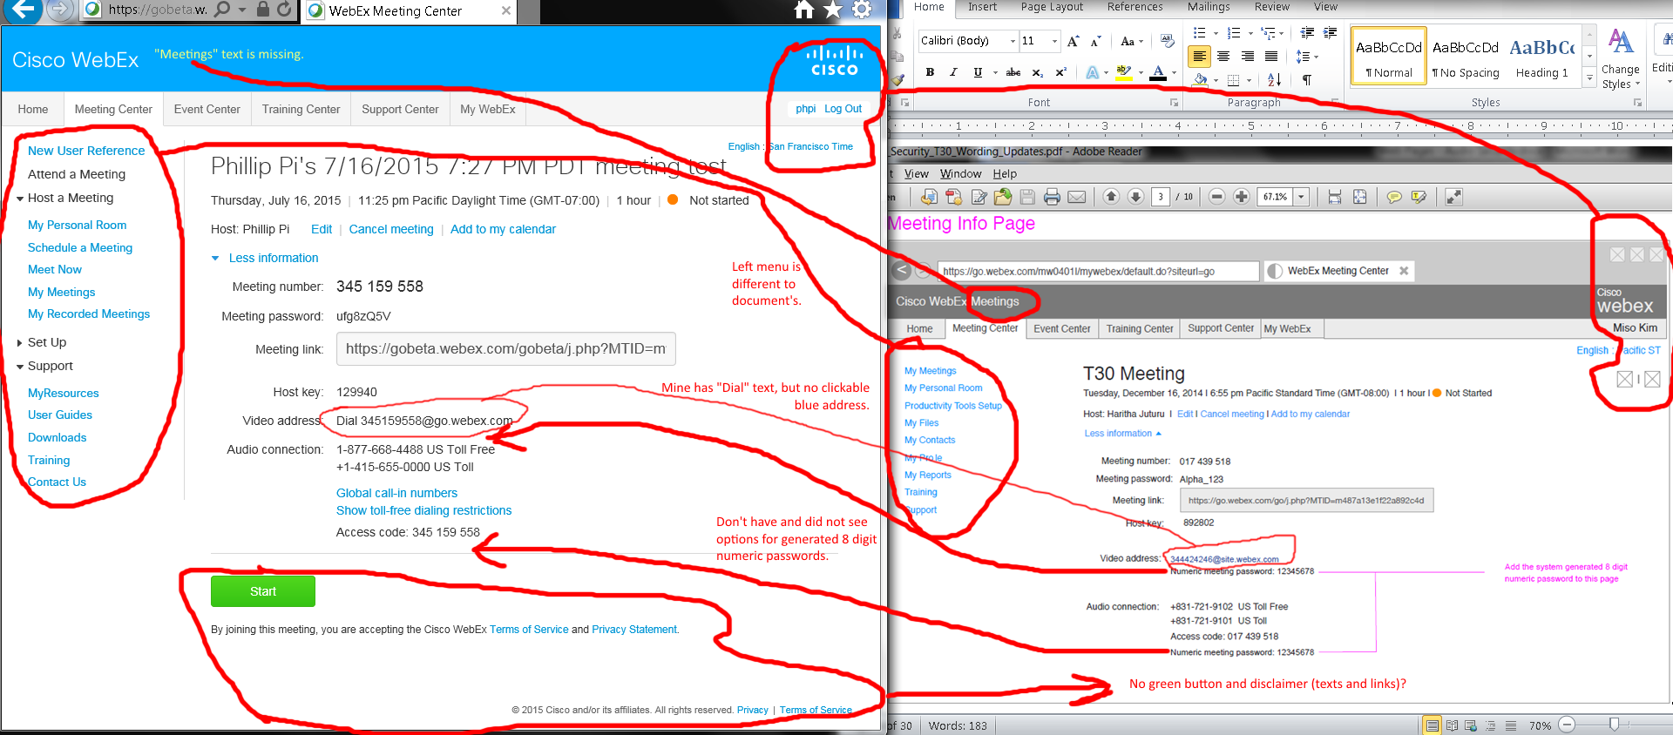
Issues:
- Video address: Mine shows “Dial” and no clickable blue address.
- My screen did not have system generated 8 digit numeric meeting passwords and options (if any).
- Left menu and top right corner are diffferent.
- No green button and disclaimer (links and texts).
- No “Meetings” in top left corner “Cisco WebEx” title.

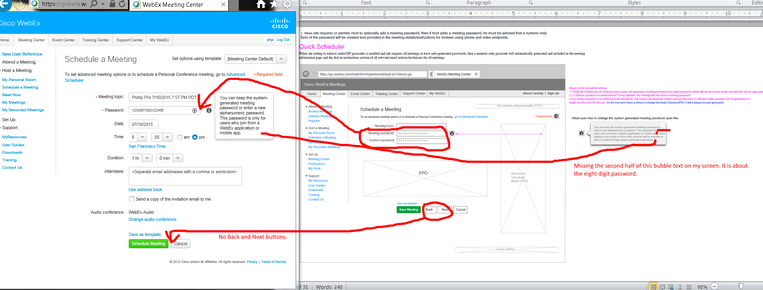
Issues:
- Diffferent Password forms.
- Missing Back and Next buttons on my screen.
- Missing second half of the Password’s bubble texts on my screen.
- Don’t have audio/SIP passcodes?

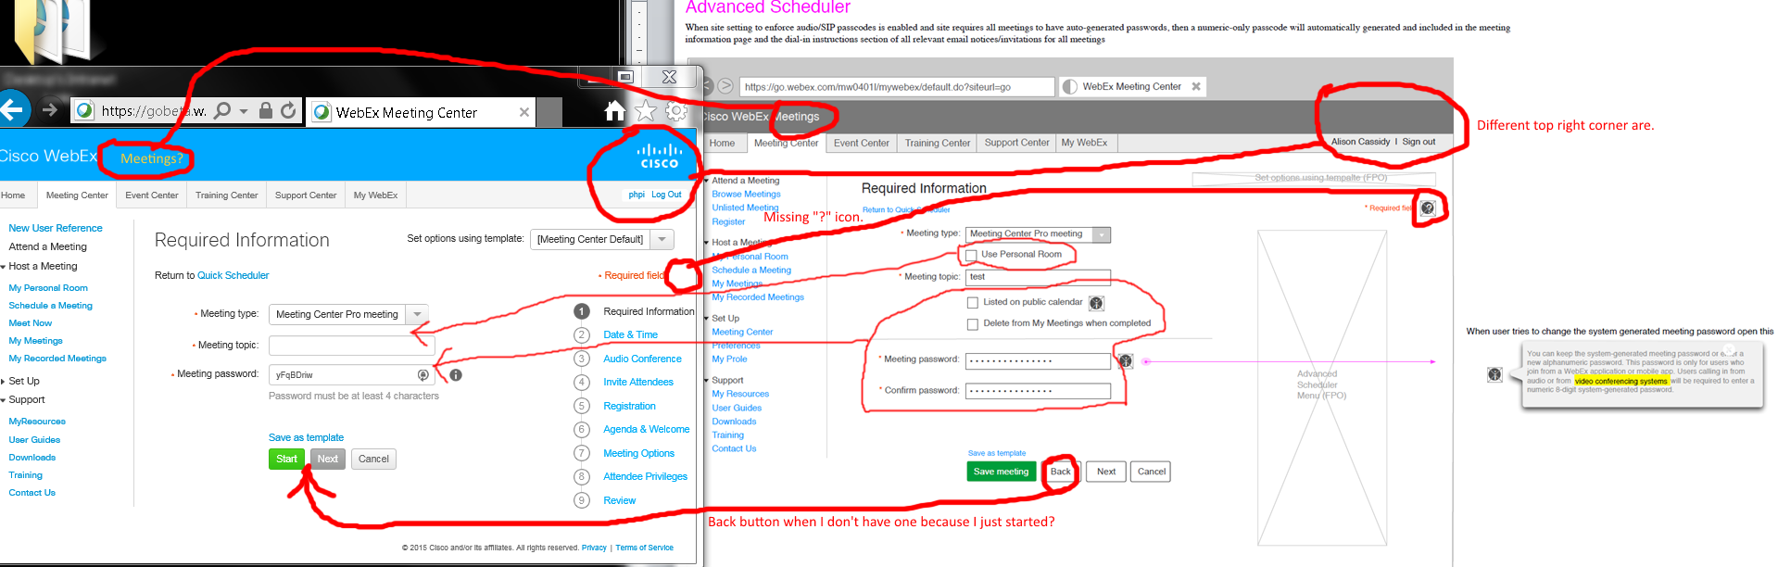
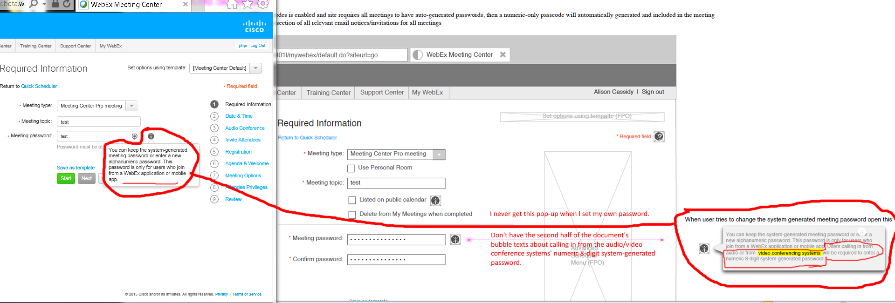

Issues:
- Missing "* Required field"'s "?" icon, "Next" button, "Use Personal Room" option, "Listed on public calendar" option, "Delete from My Meetings when completed" option.
- Different password form layouts.
- Missing the second half of pop-up balloon texts "... Users calling in from audio or from video conference systems will be required to enter a numeric 8-digit system-generated password." for "Meeting password"'s "i" icon.
- Missing "Meetings" title.
- Different top right corner.

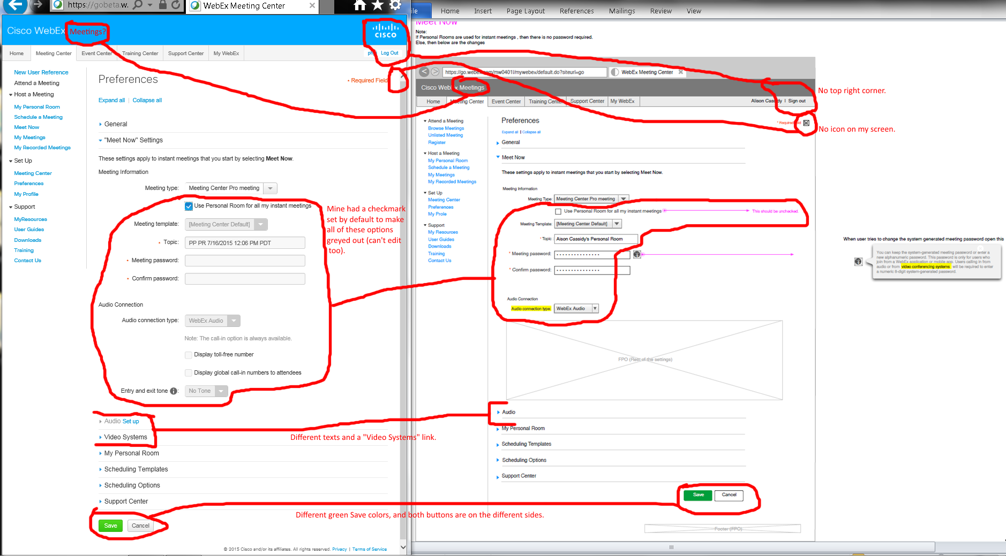
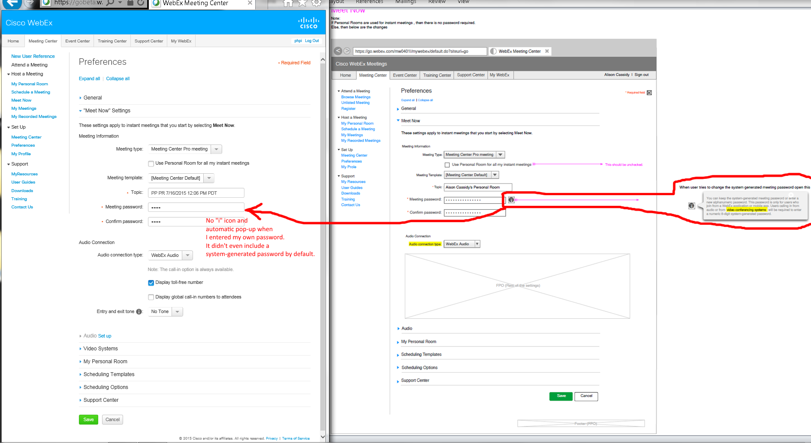
Issues:
- “Use Personal Room for all my instant meetings”’s option had a checkmark by default that made all of its below options greyed out. Unchecking it made them available and editable. However, password form still not have an ‘I’ icon for its pop-up texts balloon even when I entered a password manually. Also, there was no system-generated password before I typed a password.
- Audio and video options are different.
- My “*Required Field”’s right side text has a missing icon.
- Bottom web page’s buttons on different sides and their green colored “Save” buttons are different.
- My top left corner has missing “Meetings” text.
- Top right corners show differences.
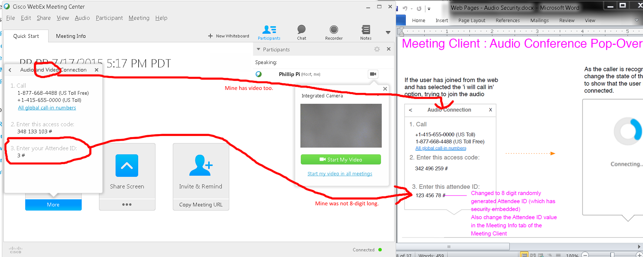
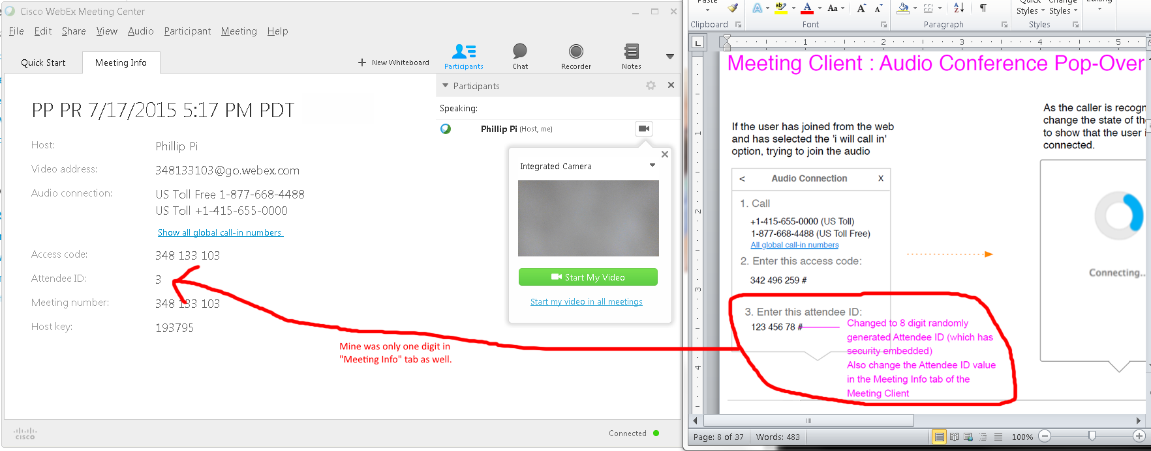
Issues:
- My Cisco WebEx Meeting Client software shows Video connection as well.
- My Attendee ID shows only random one digit in both “Quick Start” and “Meeting Info” tabs.
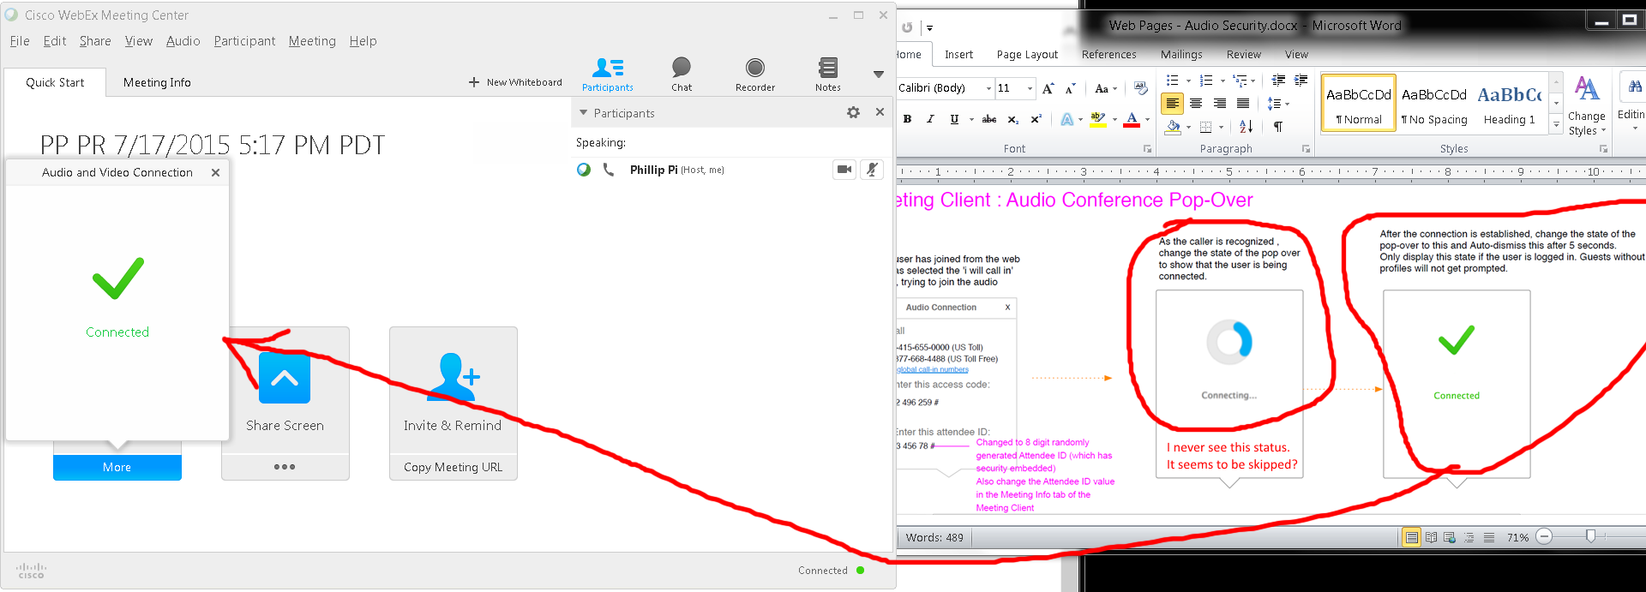
Issues (did it thrice):
- Dialing in and connecting from a phone seems to skip the blue “Connecting…” status pop-over.
- The green checkmark connected status went away in about a couple seconds.

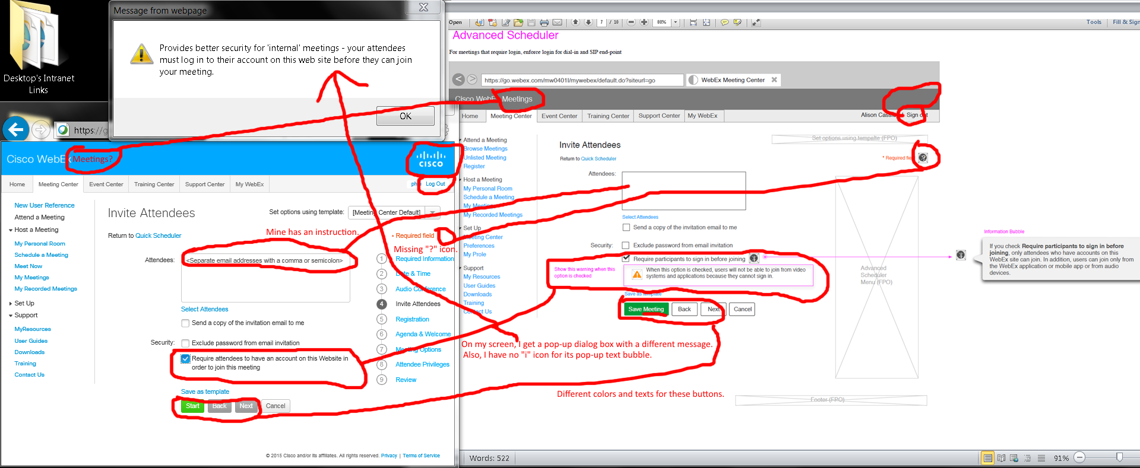
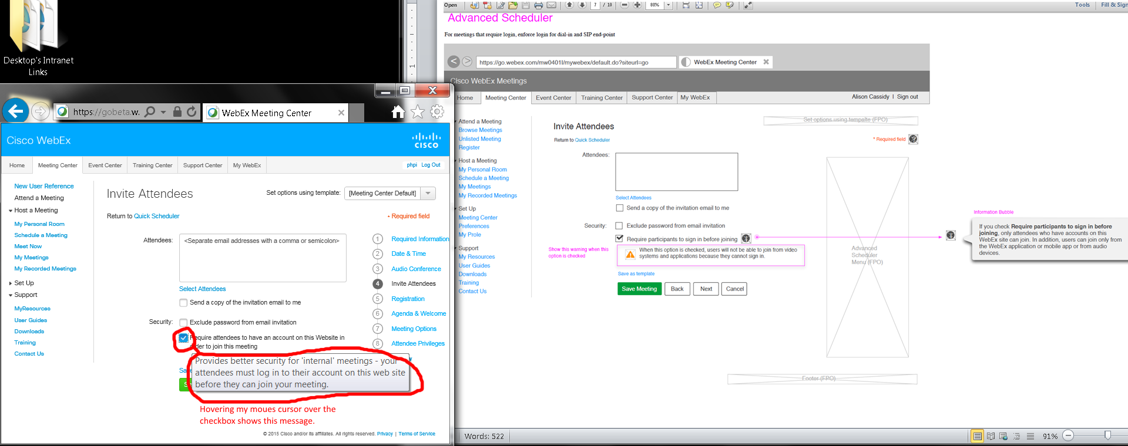
Issues:
- Checking “Require attendees to …” show different message appearances and colored checkmark. Also, mine does not have an “i” icon for its pop-up text balloon.
- Three buttons have different colors and the green colors’ have different texts.
- Top right corners are different.
- Mine shows “Cisco WebEx” without “Meetings” text.
- My “*Required field” does not have a “?” icon.

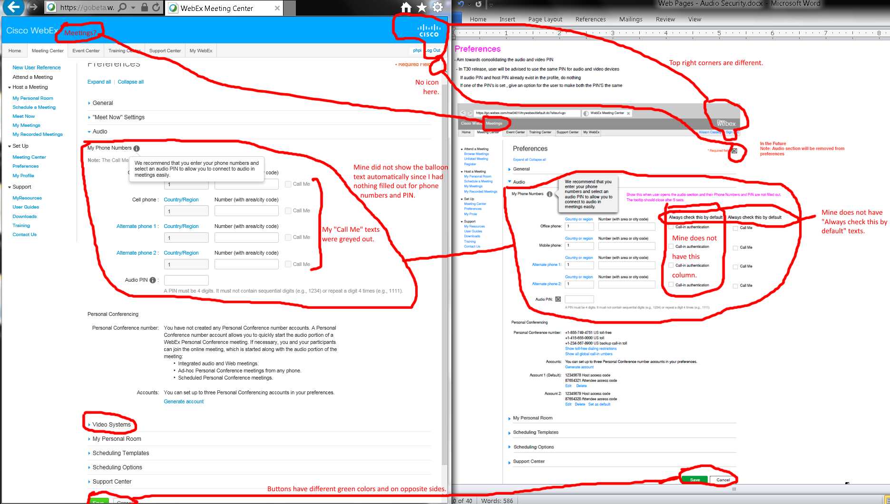
Issues:
- “My Phone Numbers”’s “i” icon’s text balloon did not show up from my empty phone number and PIN forms.
- My “Call Me” options column were greyed out.
- Mine did not have “Call-in authentication” option column and “Always check this by default” texts.
- Mine has “Video Systems” option.
- Both bottom buttons have different green colors and on the opposite sides.
- Top right corner are different.
- My top left corner has no “Meetings” text.
- *Required Field’s icon is missing on my screen.
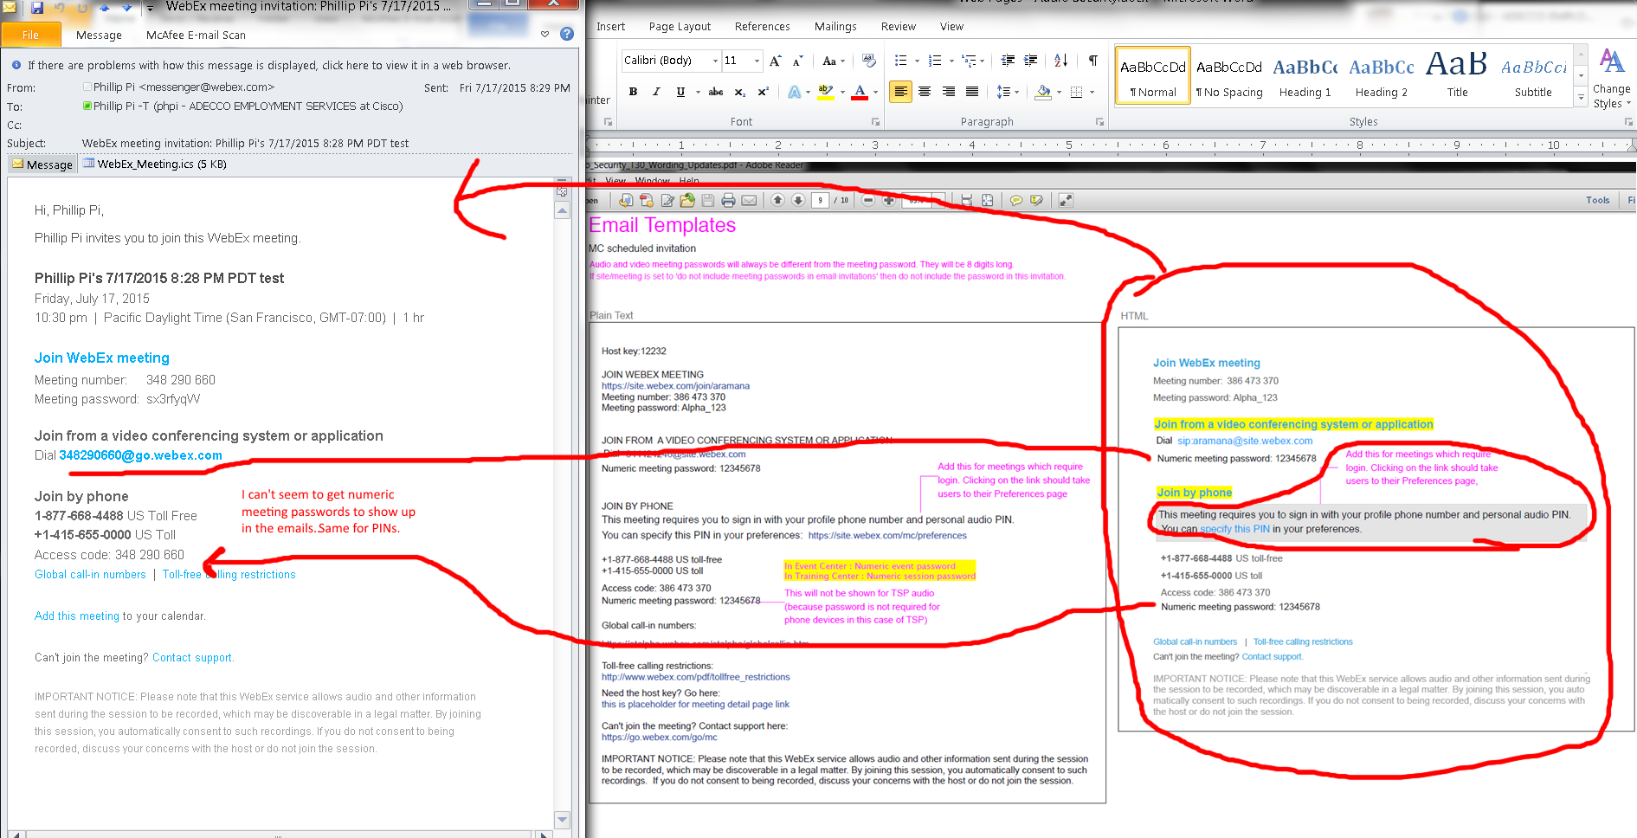
Issues:
- Unable to get numeric meeting passwords and PINs to show up in emails even if I set them (correctly?).
- Also, no options to use plain text email format.

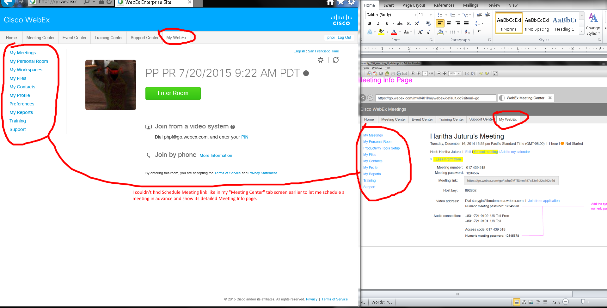
Issues:
- I was unable to find my “Meeting Info Page” in my account’s “My WebEx” tab screen. I did see this "Meeting Info Page" screen in my "Meeting Center"’s tab screen though when I schedule a meeting in advance. Basically, “My WebEx” tab screen didn’t have a scheduler option. I am confused how to get this “Meeting Info Page” in “MyWebEx” tab. I emailed Haritha Juturu (hjuturu) hjuturu@cisco.com on 7/20/2015 10:08 AM PDT to get help.
- Also, I was unable to test its Meeting Client's Audio Conference Pop-Over from here.

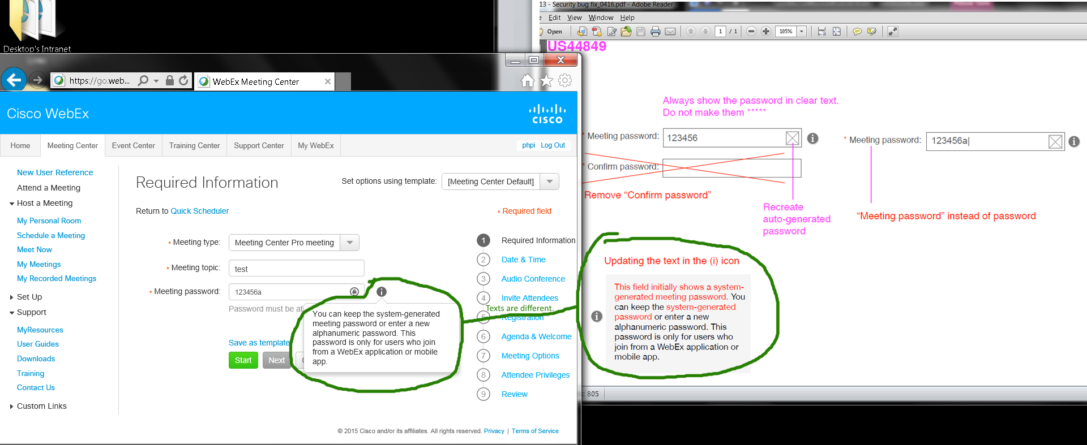
Issue: “Meeting Center” tab’s Advanced Scheduler’s “Meeting password”’s “i” icons show different bubble pop-up texts.

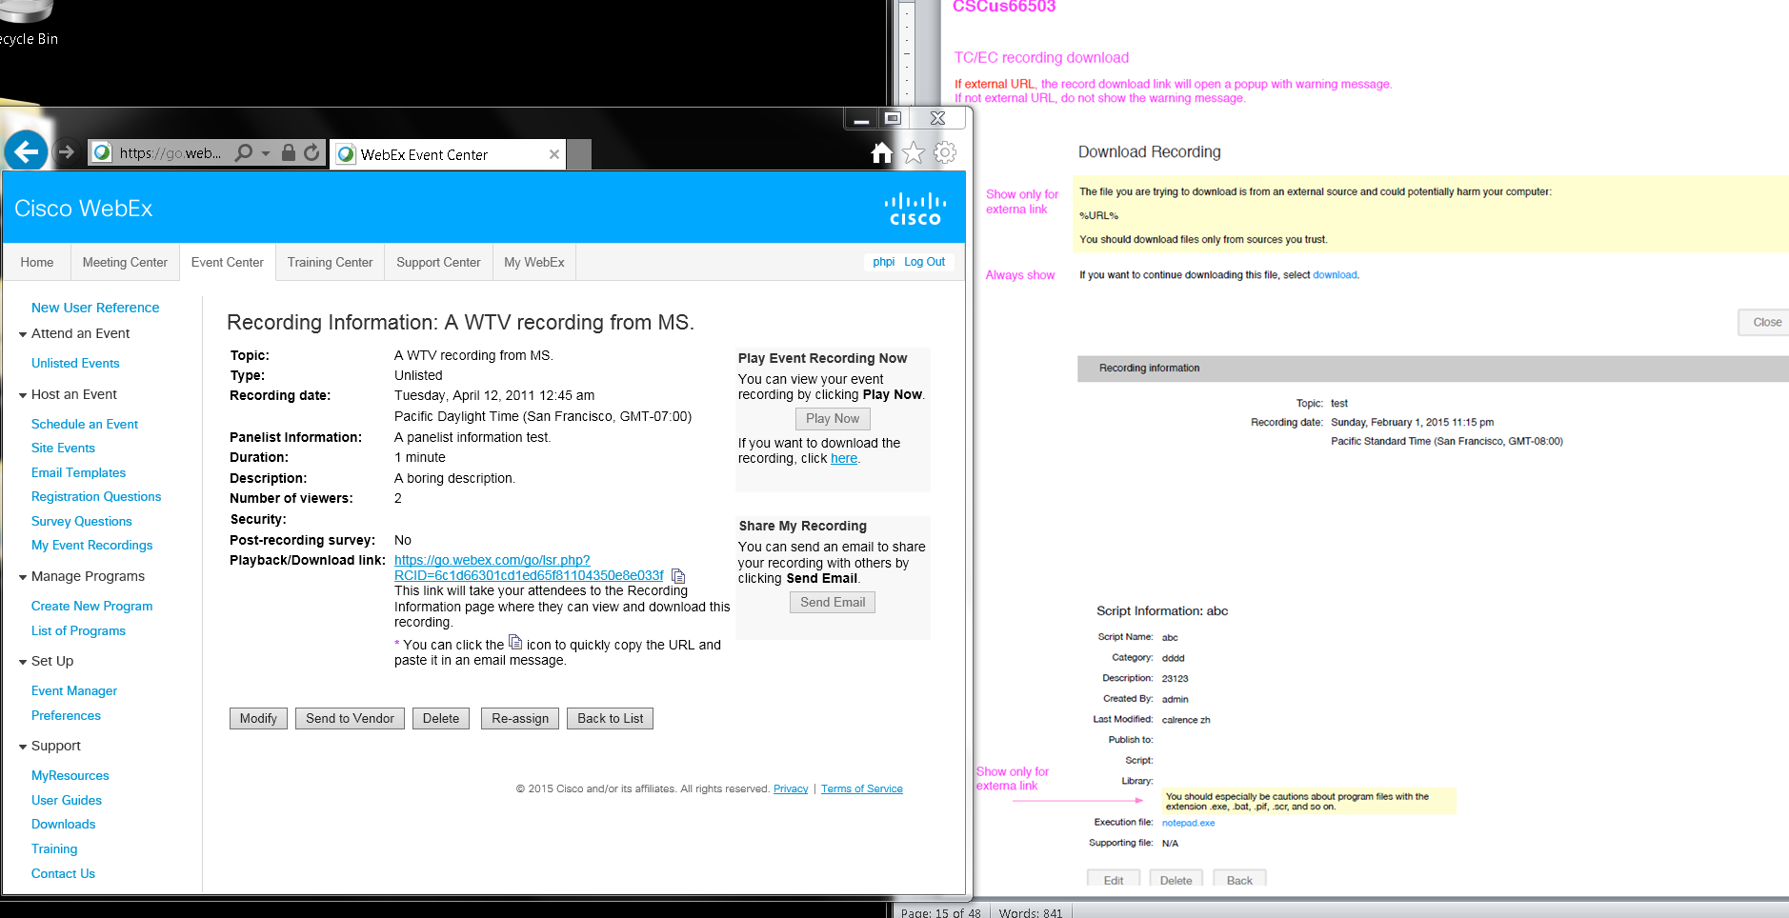
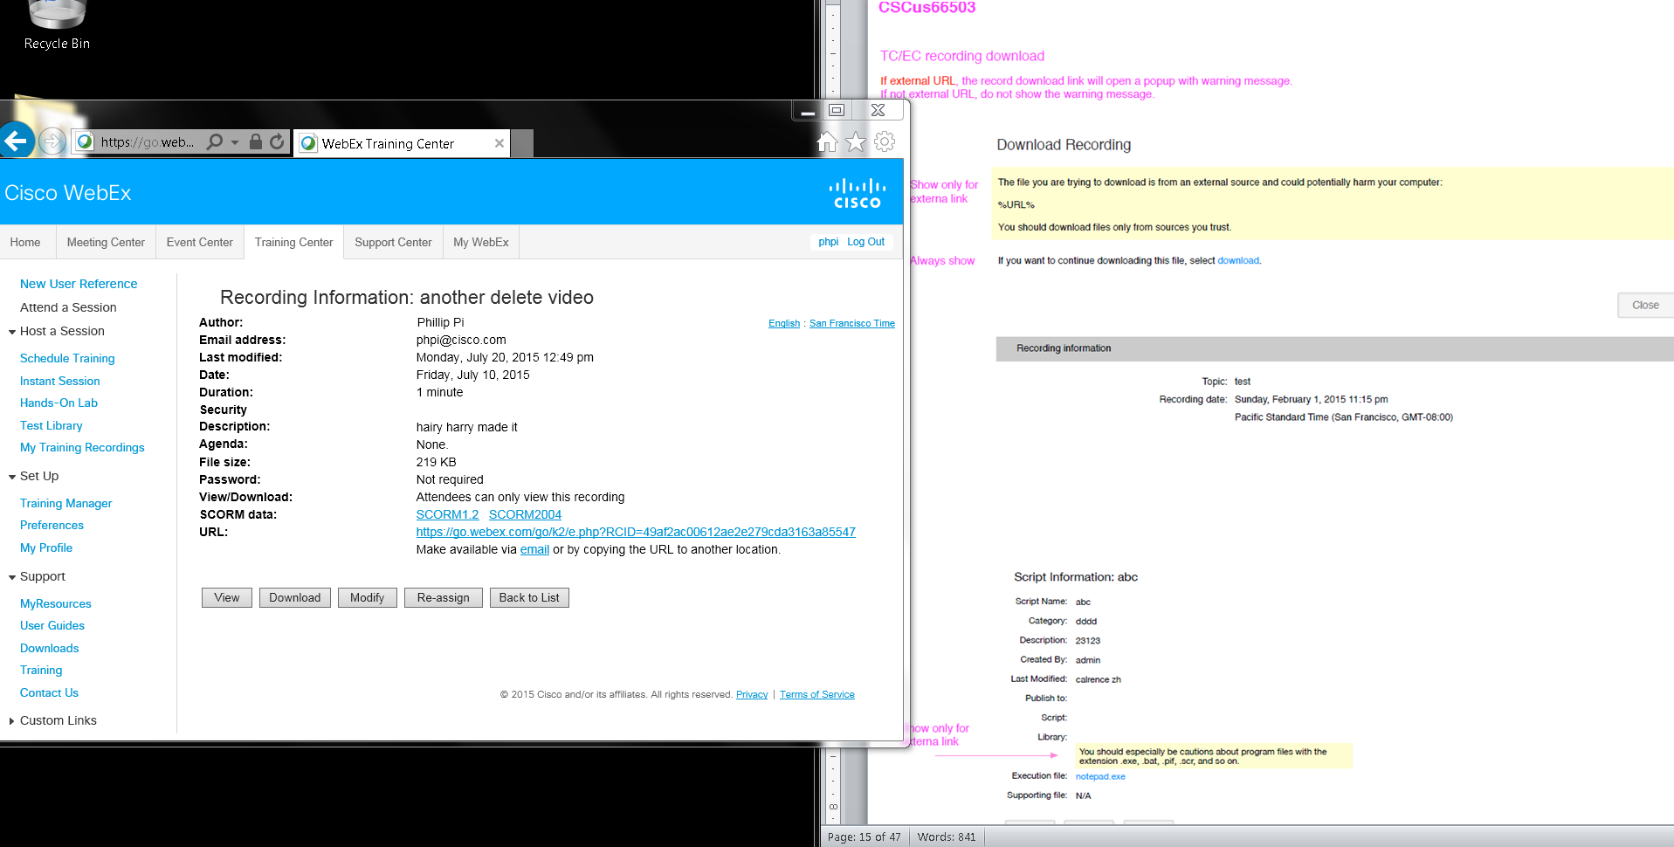
Issues: I was unable to find these exact areas like external link, “Script Information”, etc. Maybe I need site admin access?

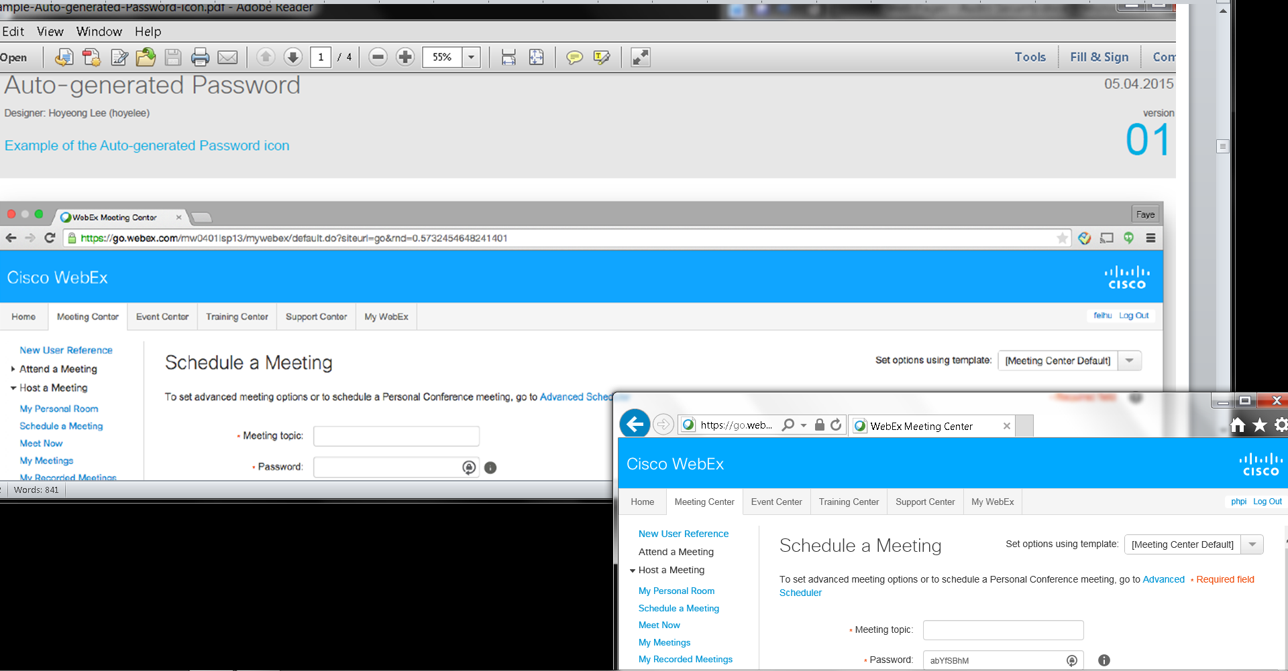
No issues found.

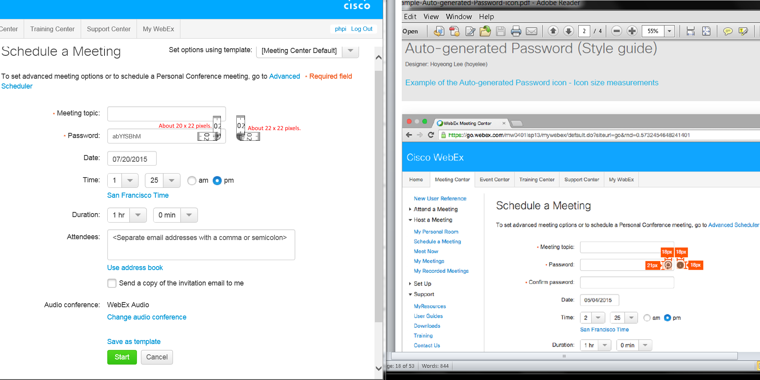
Issues: Icons’ pixel sizes aren’t the same.

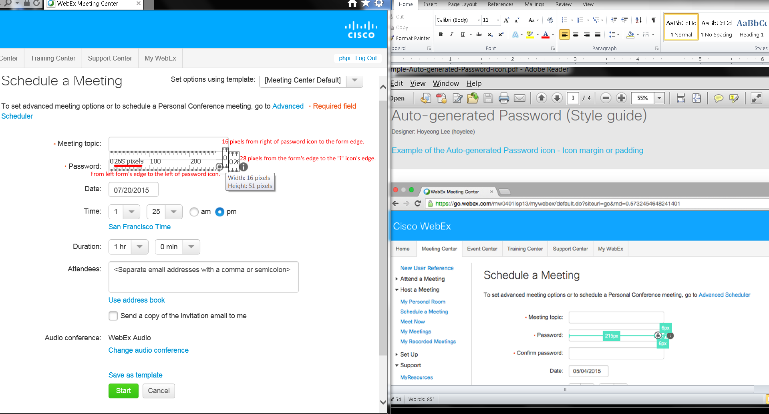
Issues: Spacing sizes are different.

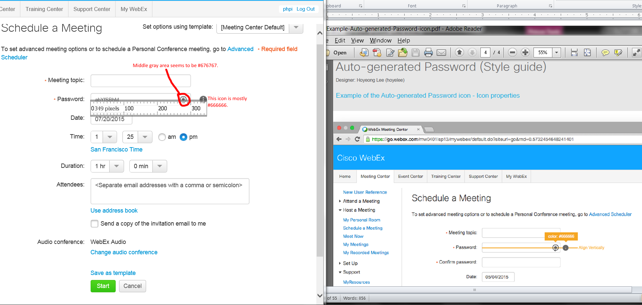

OVERALL ISSUES:
- No site admin access.
- Did not see any phone/SIP options in my personal room’s preferences web page.
- No option to send as HTML or plain text email format.
- Received e-mails show different layouts and texts compared to document’s email template.
- Video address: Mine shows “Dial” and no clickable blue address.
- My screen did not have system generated 8 digit numeric meeting passwords and options (if any).
- Left menu and top right corner are diffferent.
- No green button and disclaimer (links and texts).
- No “Meetings” in top left corner “Cisco WebEx” title.
- Diffferent Password forms.
- Missing Back and Next buttons on my screen.
- Missing second half of the Password’s bubble texts on my screen.
- Don’t have audio/SIP passcodes?
- Missing "* Required field"'s "?" icon, "Next" button, "Use Personal Room" option, "Listed on public calendar" option, "Delete from My Meetings when completed" option.
- Different password form layouts.
- Missing the second half of pop-up balloon texts "... Users calling in from audio or from video conference systems will be required to enter a numeric 8-digit system-generated password." for "Meeting password"'s "i" icon.
- Missing "Meetings" title.
- Different top right corner.
- “Use Personal Room for all my instant meetings”’s option had a checkmark by default that made all of its below options greyed out. Unchecking it made them available and editable. However, password form still not have an ‘I’ icon for its pop-up texts balloon even when I entered a password manually. Also, there was no system-generated password before I typed a password.
- Audio and video options are different.
- My “*Required Field”’s right side text has a missing icon.
- Bottom web page’s buttons on different sides and their green colored “Save” buttons are different.
- My top left corner has missing “Meetings” text.
- Top right corners show differences.
- My Cisco WebEx Meeting Client software shows Video connection as well.
- My Attendee ID shows only random one digit in both “Quick Start” and “Meeting Info” tabs.
- Dialing in and connecting from a phone seems to skip the blue “Connecting…” status pop-over.
- The green checkmark connected status went away in about a couple seconds.
- Checking “Require attendees to …” show different message appearances and colored checkmark. Also, mine does not have an “i” icon for its pop-up text balloon.
- Three buttons have different colors and the green colors’ have different texts.
- Top right corners are different.
- Mine shows “Cisco WebEx” without “Meetings” text.
- My “*Required field” does not have a “?” icon.
- “My Phone Numbers”’s “i” icon’s text balloon did not show up from my empty phone number and PIN forms.
- My “Call Me” options column were greyed out.
- Mine did not have “Call-in authentication” option column and “Always check this by default” texts.
- Mine has “Video Systems” option.
- Both bottom buttons have different green colors and on the opposite sides.
- Top right corner are different.
- My top left corner has no “Meetings” text.
- *Required Field’s icon is missing on my screen.
- Unable to get numeric meeting passwords and PINs to show up in emails even if I set them (correctly?).
- Also, no options to use plain text email format.
- I was unable to find my “Meeting Info Page” in my account’s “My WebEx” tab screen. I did see this "Meeting Info Page" screen in my "Meeting Center"’s tab screen though when I schedule a meeting in advance. Basically, “My WebEx” tab screen didn’t have a scheduler option. I am confused how to get this “Meeting Info Page” in “MyWebEx” tab. I emailed Haritha Juturu (hjuturu) hjuturu@cisco.com on 7/20/2015 10:08 AM PDT to get help.
- Also, I was unable to test its Meeting Client's Audio Conference Pop-Over from here.
- “Meeting Center” tab’s Advanced Scheduler’s “Meeting password”’s “i” icons show different bubble pop-up texts.
- I was unable to find these exact areas like external link, “Script Information”, etc. Maybe I need site admin access?
- Icons’ pixel sizes aren’t the same.
- Spacing sizes are different.

