Meeting Client’s WBX Spark interop (After Meeting Flow):
In 64-bit W7 EE SP1 with its IE11 web browser and logged In with my Cisco account on 6/24-25/2015 & 7/7/2015:
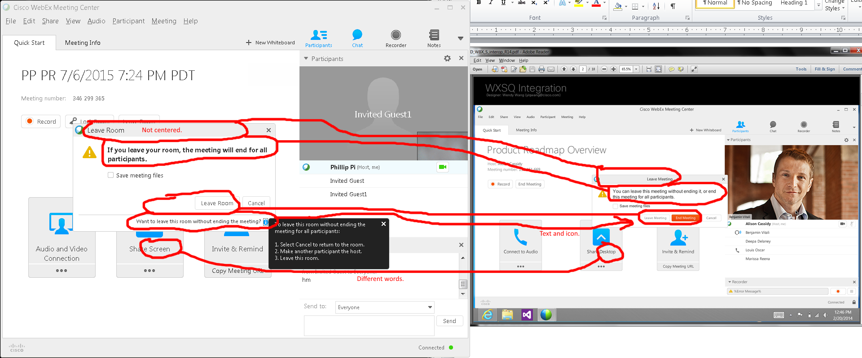
Issues:
- “Leave Room” title justification.
- Different texts for leaving the meeting room.
- Orange “End Meeting” button option.
- “Share …” texts.

End meeting (note: I never got its random survey):
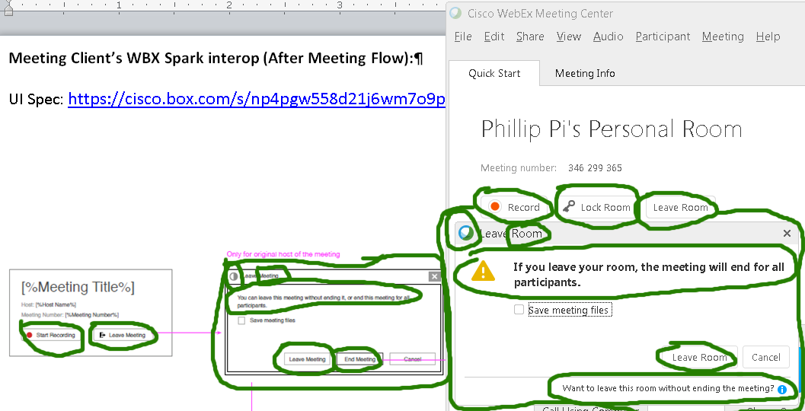
Issues:
- Different dialog boxes, graphics (red record buttons, top left corner of the leave dialog boxes), and texts (Leave Meeting/Room, leaving warning message, record, etc.).
- Missing graphics (yellow ! triangle and the red record) and texts (“Want to leave this room without ending the meeting?” with its blue i icon, “Lock Room” with its key logo, “Leaving Meeting” with its door arrow logo).
- I never got its random survey.
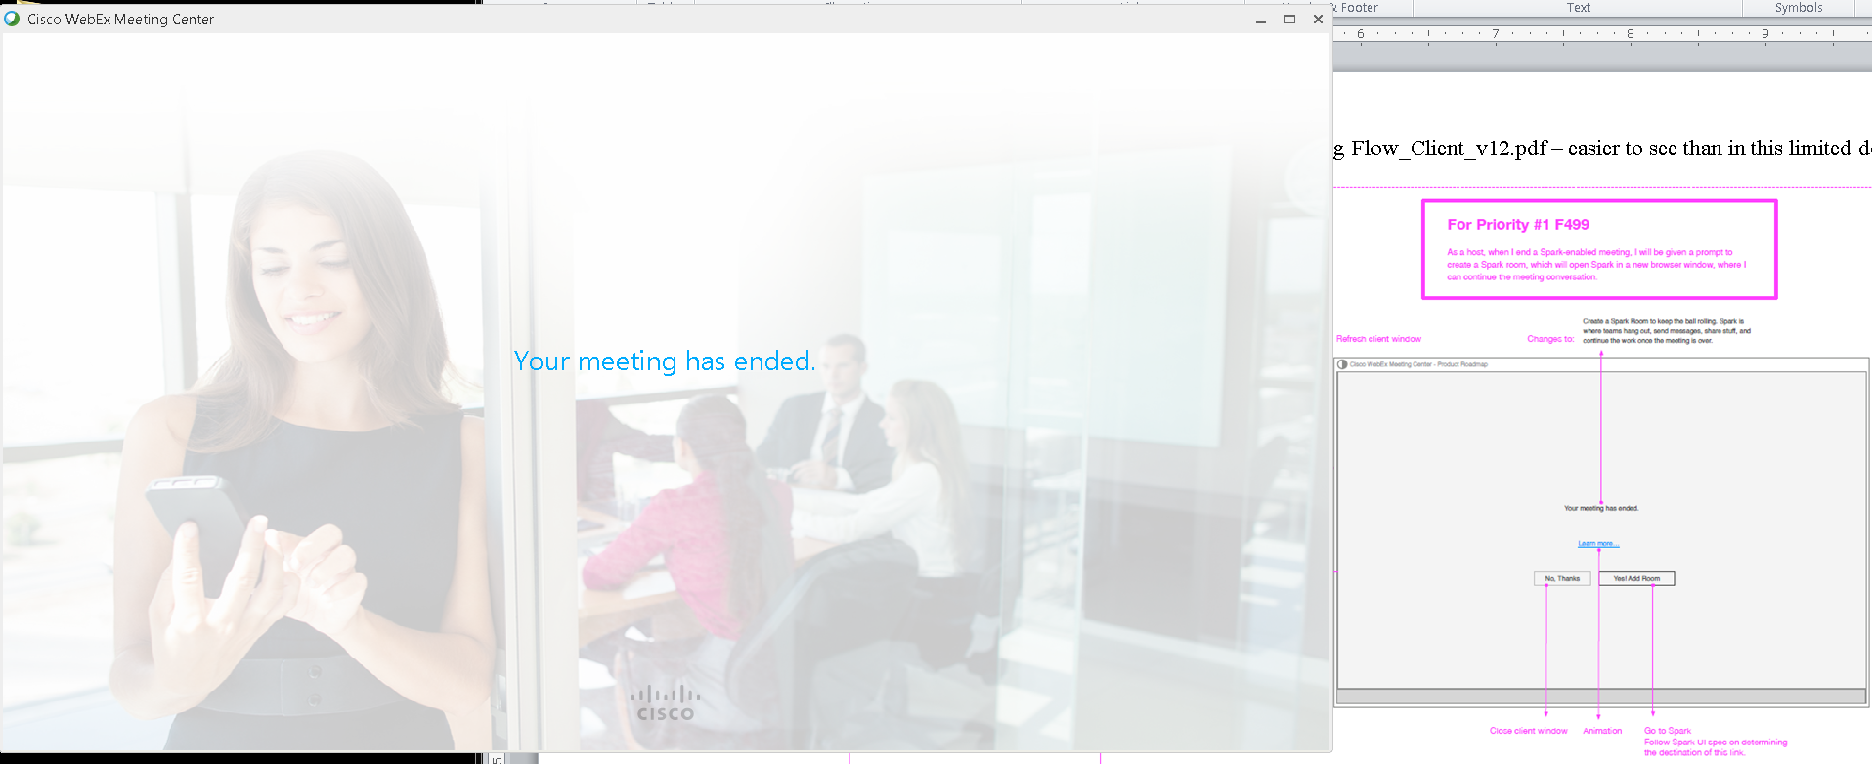
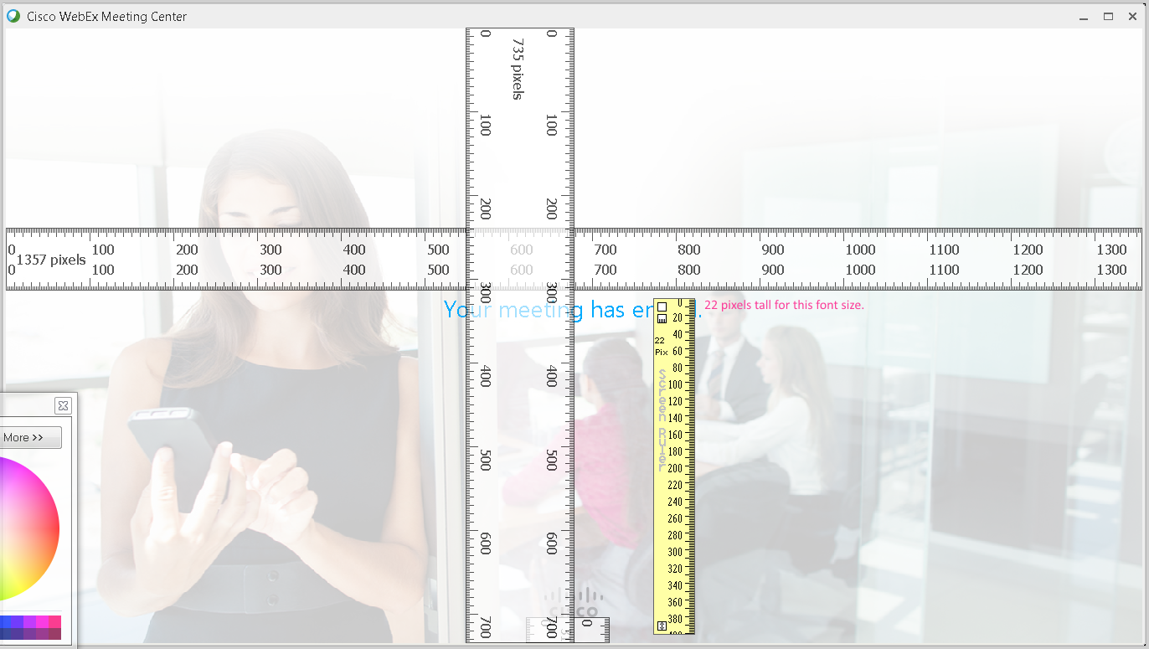
This “Your meeting has ended.” screen was up for about a second until the next screen below:
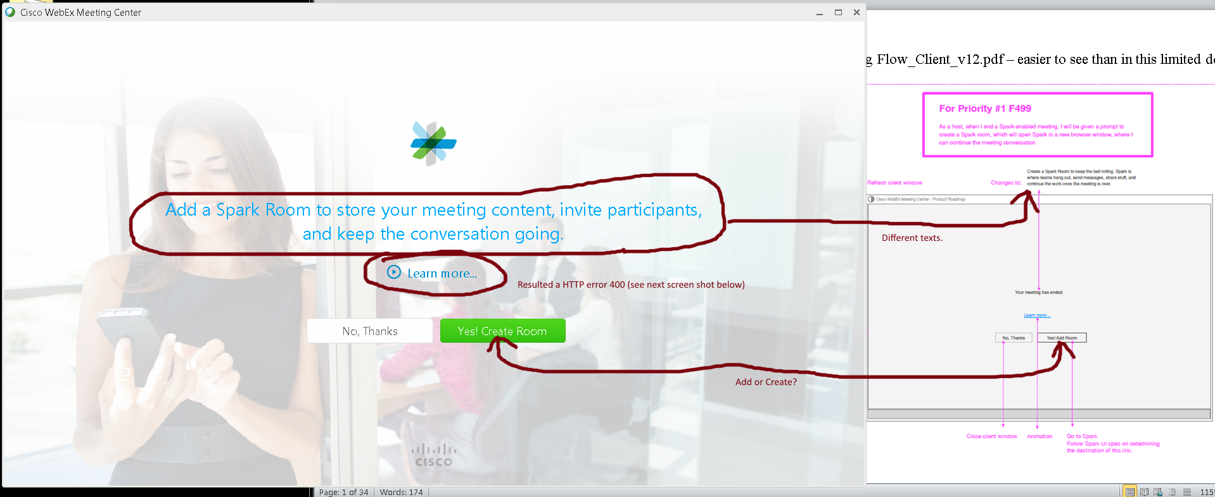

Clicking on “Learn more…” resulted a HTTP error 400 on 6/24/2015:
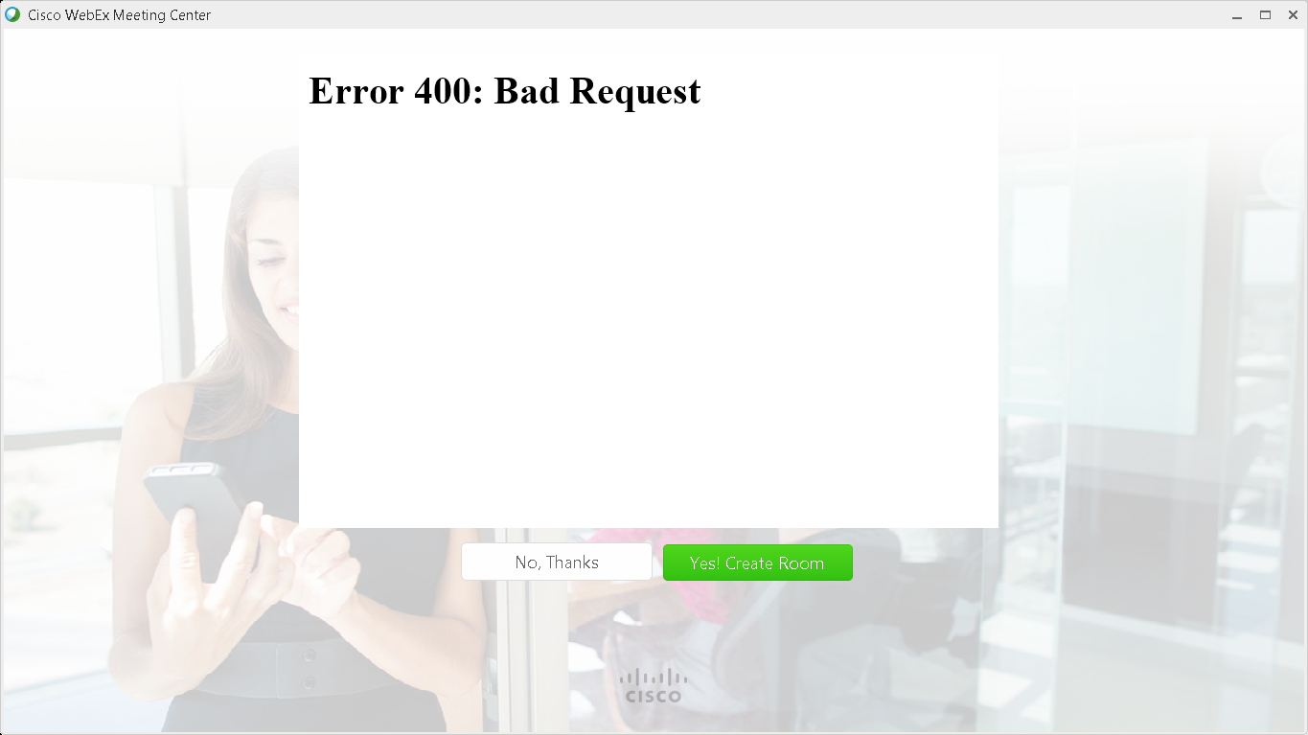
As of 6/25/2015 9 AM PDT hour, the error was gone and this Flash (using the same v18 b194 player) animation worked correctly:
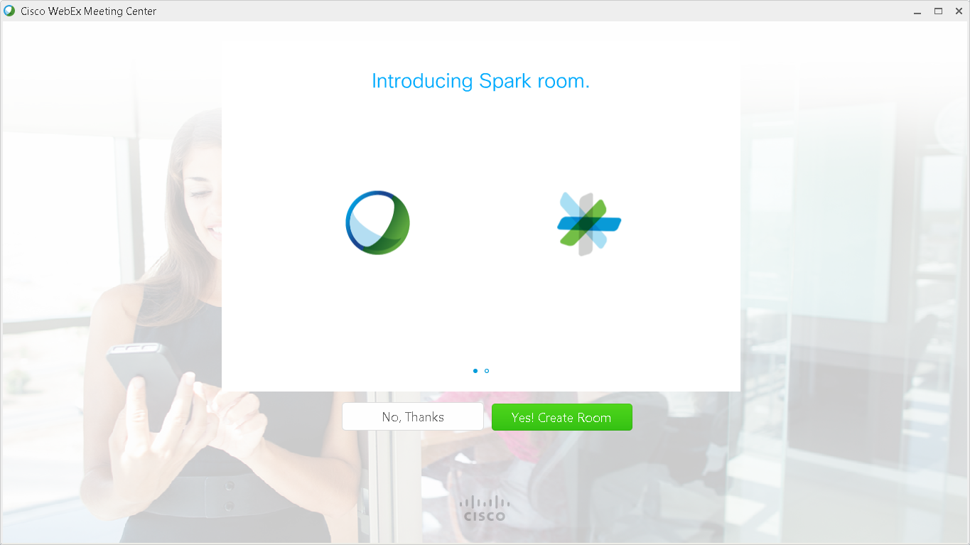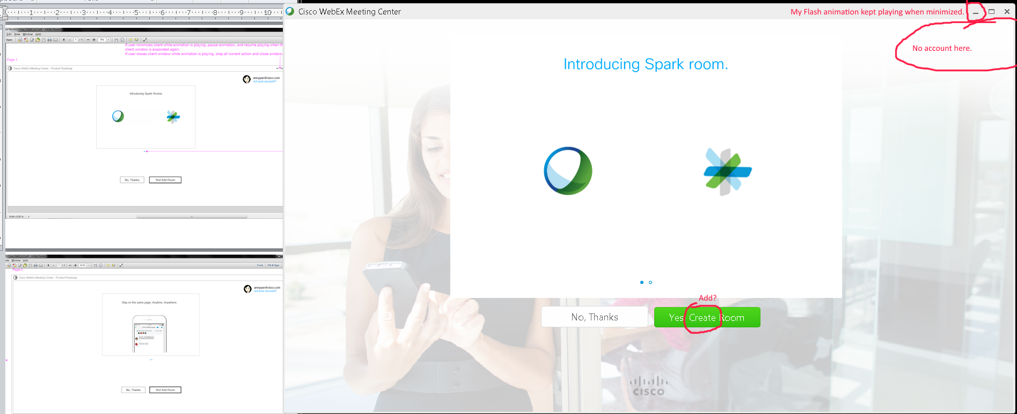
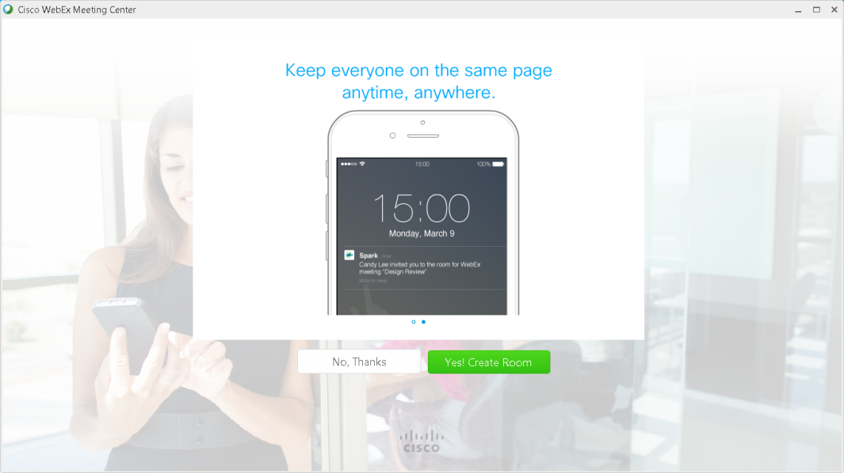
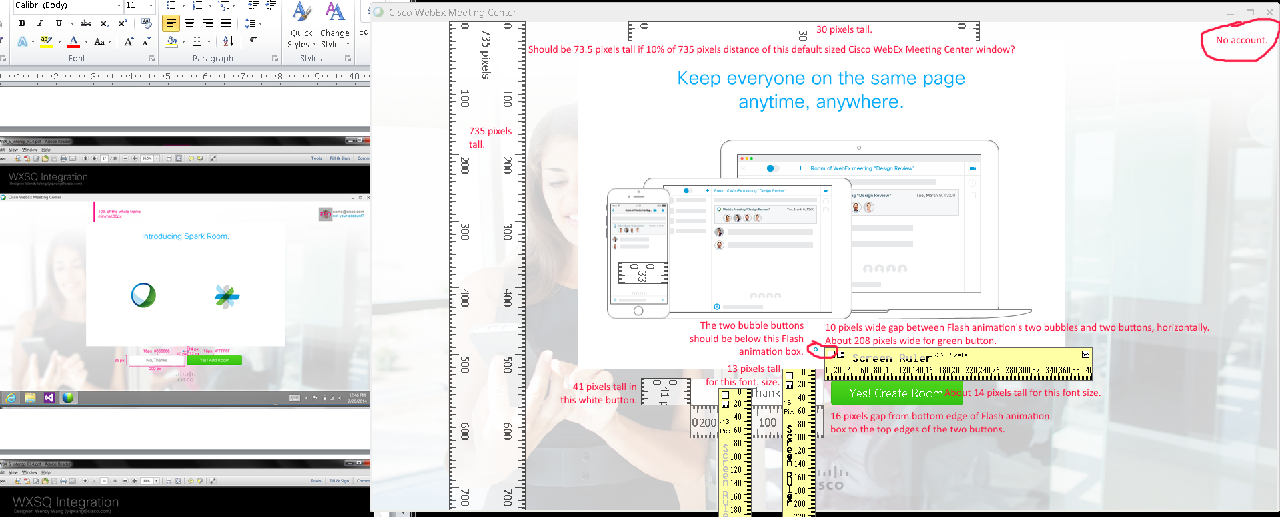
Issues:
- Flash animation still plays when Cisco WebEx Meeting Center’s window is minimized.
- Top right corner’s account area still does not show.
- Different sizes seen with texts, gaps, and images.
- Flash animation’s bubble buttons are not in the right area (should be below the Flash animation box?).
- Alignment problems.

Clicking on “Yes! Create Room” button took me to Spark’s production server (already recognized my login from beta server):
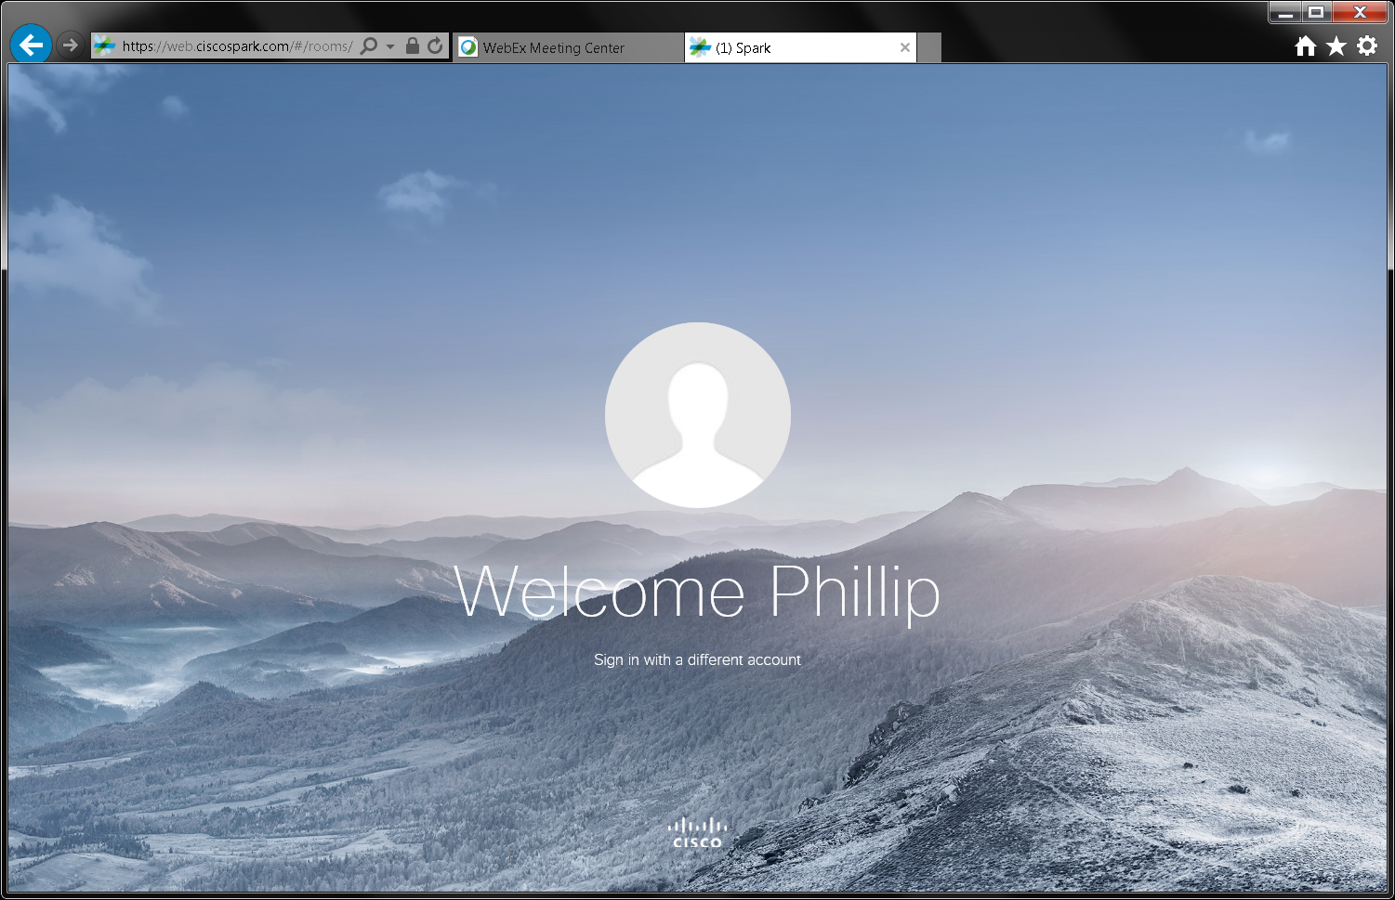
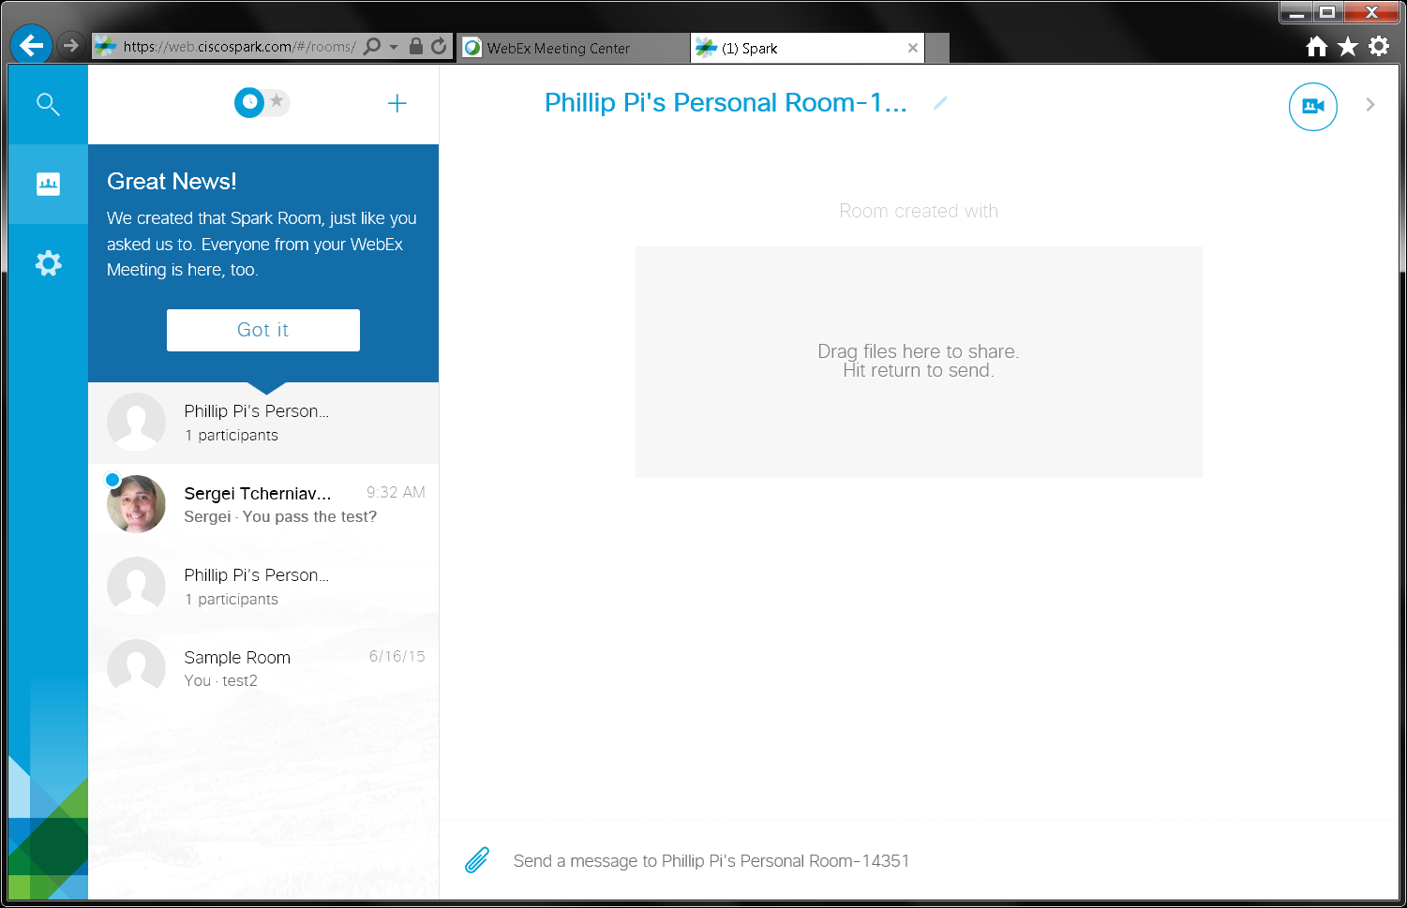
Issues:
- Different texts.
- Clicking on “Learn more…” link resulted a HTTP error 400 on 6/24/2015, but worked on the next day.
- Unable to get a random survey to appear. I have never seen it before too since I started using gobeta.webex.com server on 6/17/2015.
- Unable to figure how to create non-trusted users and hosts and using without logging in with an account.
- Unable to recreate the error in failing to syncing participants as the only participant (host).

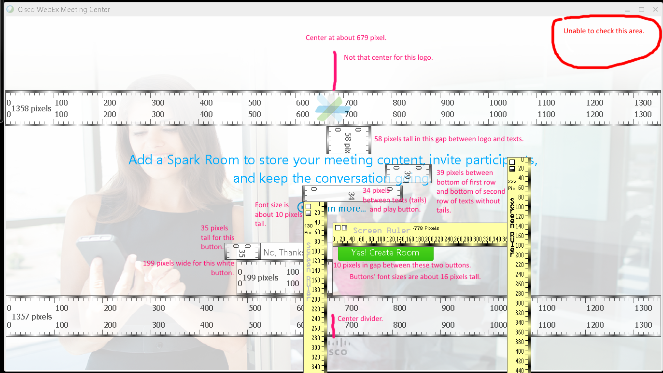
Issues:
- Pixel lengths for texts, gaps, etc.
- Spark’s logo isn’t totally center like Cisco’s logo.
- I cannot seem to reproduce "We have added a Spark Room for your meeting." message from Cisco WebEx Meeting Center before going to Spark’s production server.

OVERALL ISSUES:
- Pixel lengths/Different sizes for texts, gaps, images, etc.
- Alignment problems (e.g., Spark’s logo isn’t totally center like Cisco’s logo and Flash animation’s bubble buttons are not in the right area (should be below the Flash animation box?).
- I cannot seem to reproduce "We have added a Spark Room for your meeting." message from Cisco WebEx Meeting Center before going to Spark’s production server.
different texts.
- Clicking on “Learn more…” link resulted a HTTP error 400 on 6/24/2015, but worked on the next day.
- Unable to get a random survey to appear. I have never seen it before too since I started using gobeta.webex.com server on 6/17/2015.
- Unable to figure how to create non-trusted users and hosts and using without logging in with an account.
- Unable to recreate the error in failing to syncing participants as the only participant (host).
- Flash animation still plays when Cisco WebEx Meeting Center’s window is minimized.
- Top right corner’s account area does not show.
- Unable to get the random survey.

