Meeting Client’s Video Thumbnail (no prototype):
https://gobeta.webex.com in Firefox v38.0.5 & v39 web browsers in 64-bit W7 EE SP1 (no antialias and ClearText) on 6/23/2015 (3:45 PM – 7:30 PM PDT) & 7/7/2015 noon PDT:
Graphics, colors, and buttons' texts are different. UI Specs seem to be outdated due to primitive images as shown below:
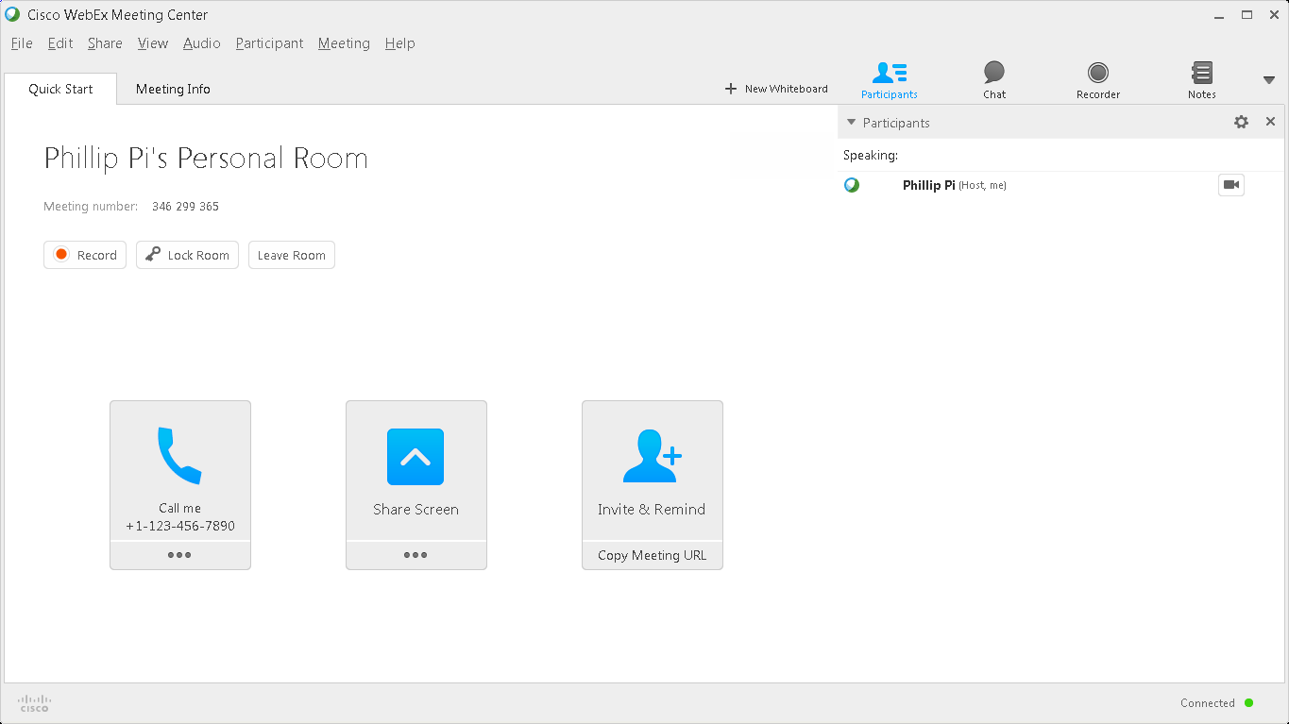
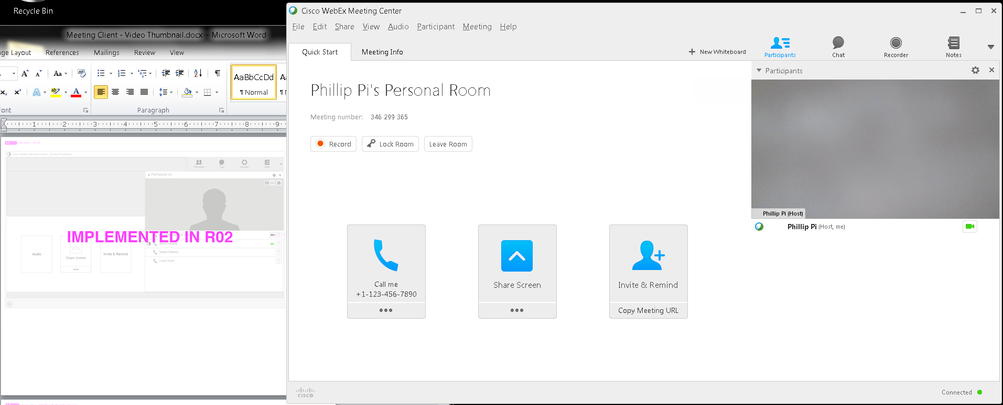

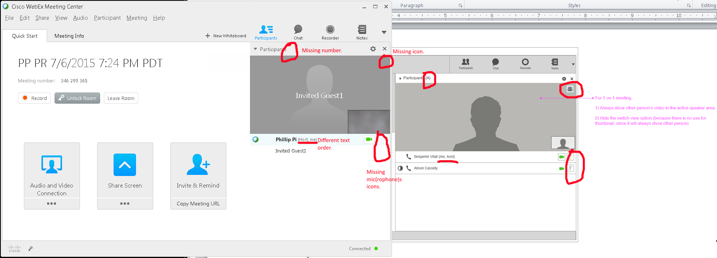

Issue: Did not have any other participants, with videos due to only one work computer with its webcam, to do multiple video screens. So, here are what I saw by myself as a host:
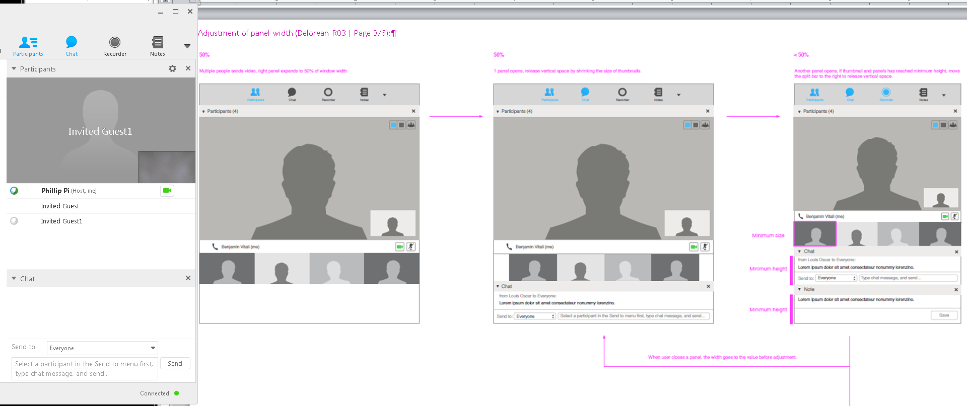
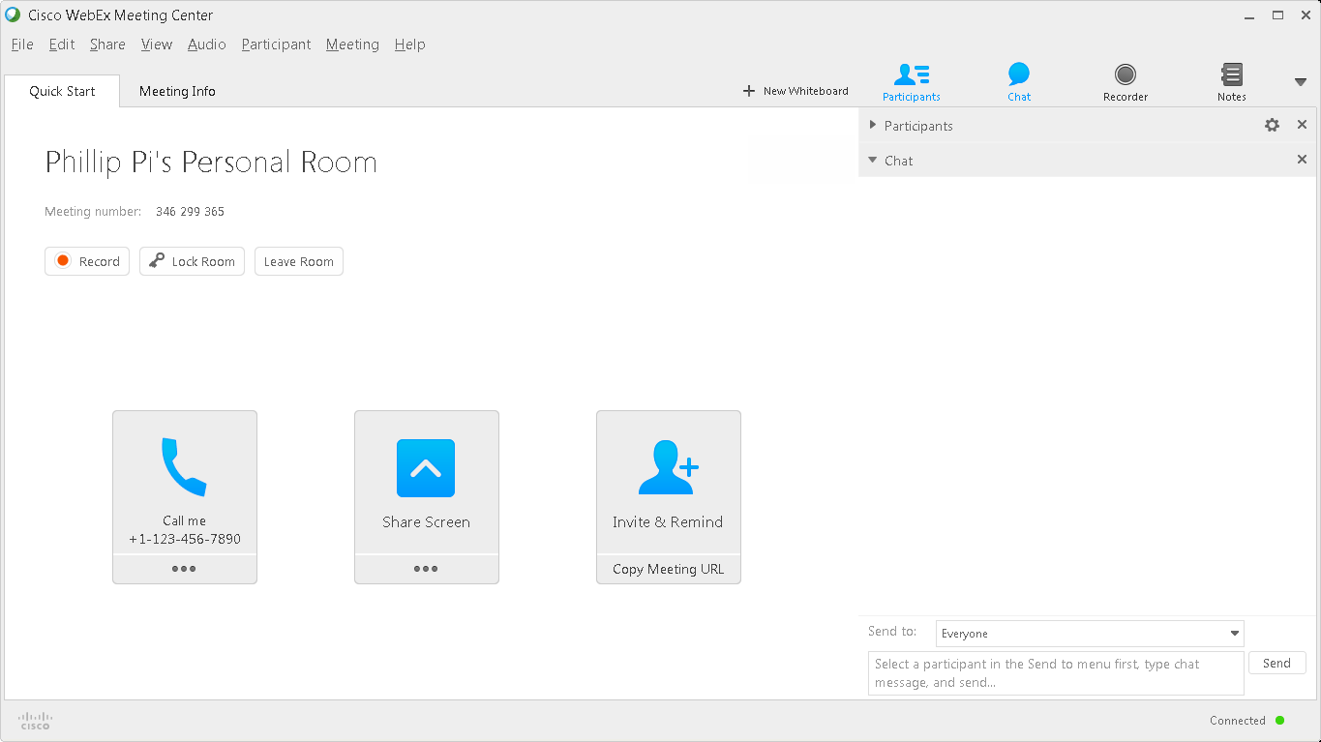
Enabling Chat section, with my webcam on, collapses Participant section.
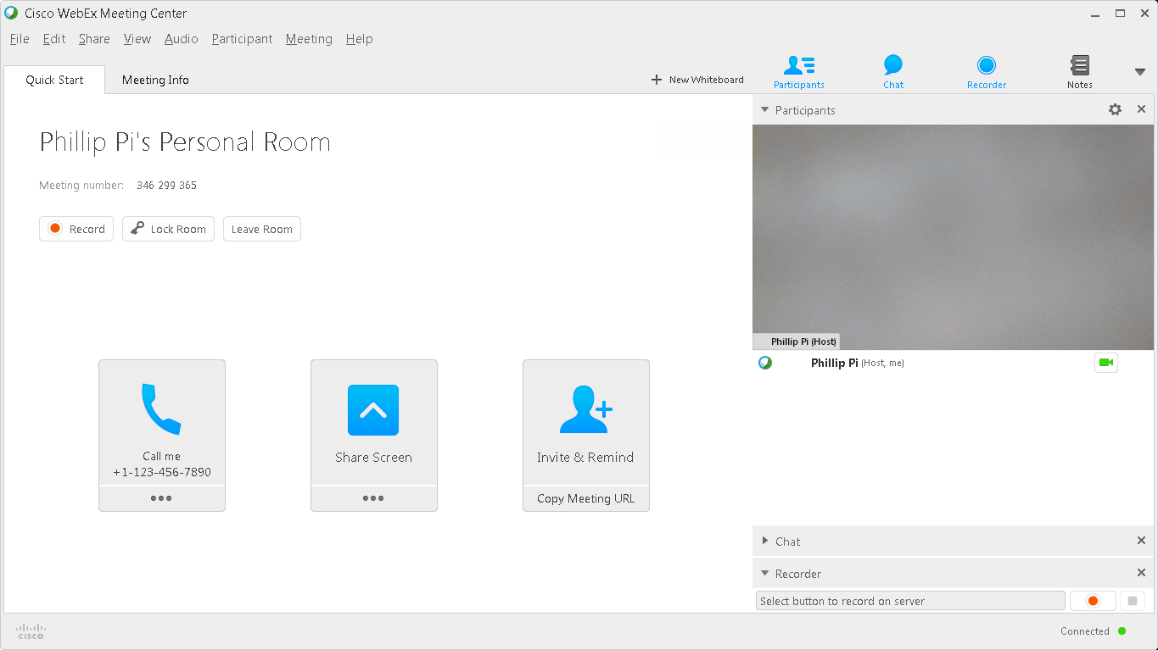
Enabling Recorder collapsed Chat section. However, I found out it is because of the lack of default window spaces to expand all. I had to expand vertically for these sections to stay expanded.
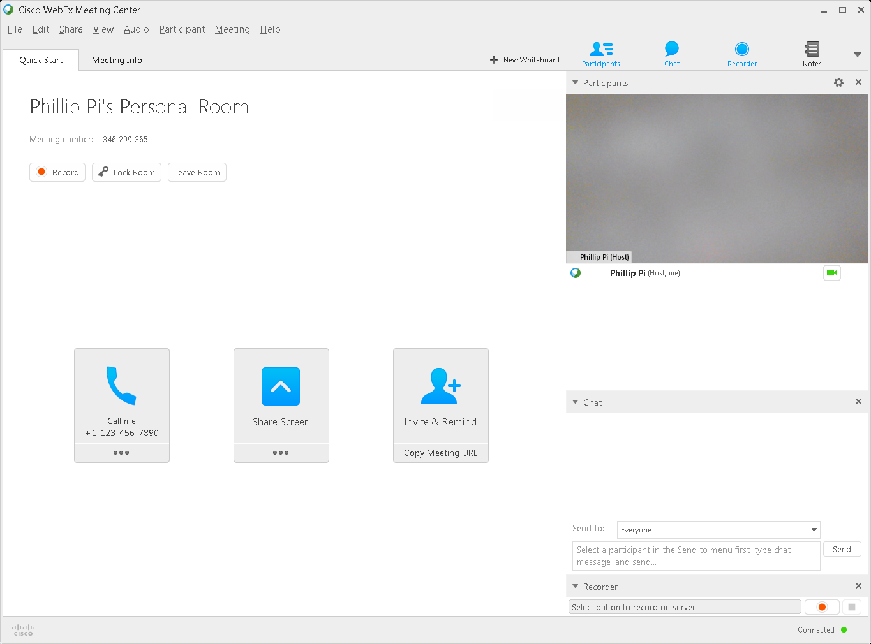

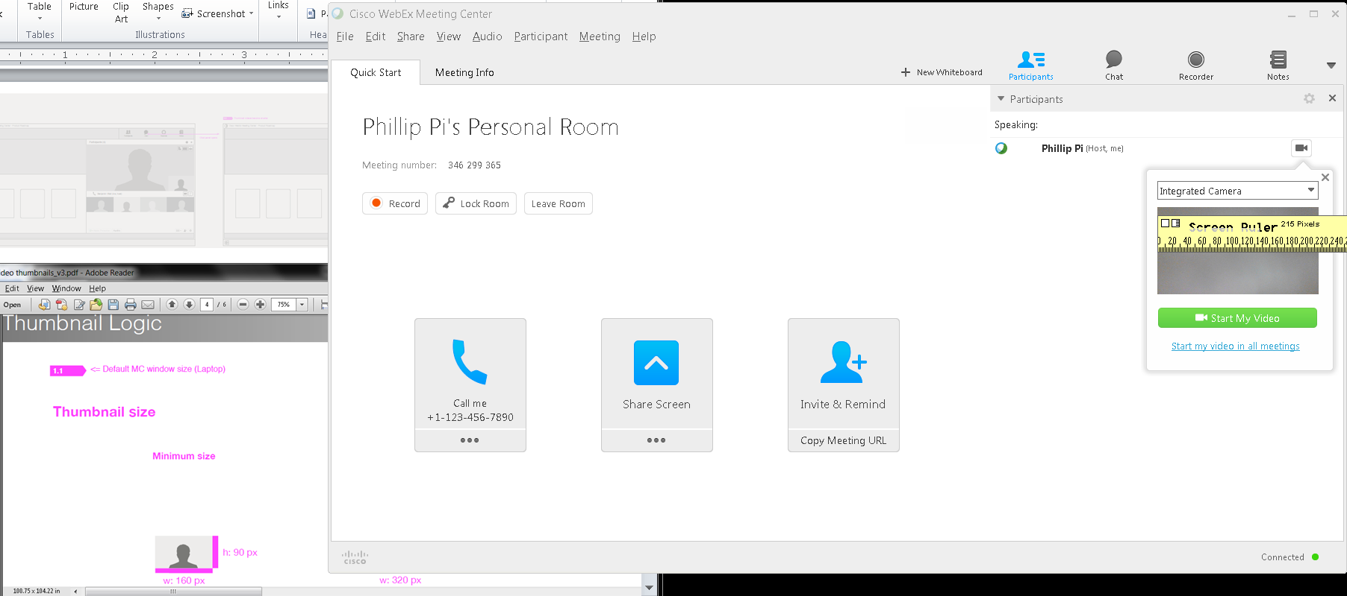
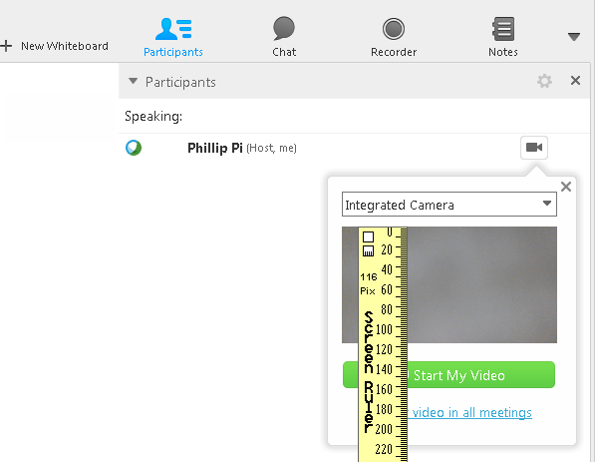Possible Issue: Assuming this is a thumbnail video size when starting my personal room, it is about 215 pixels wide and 116 pixels tall.
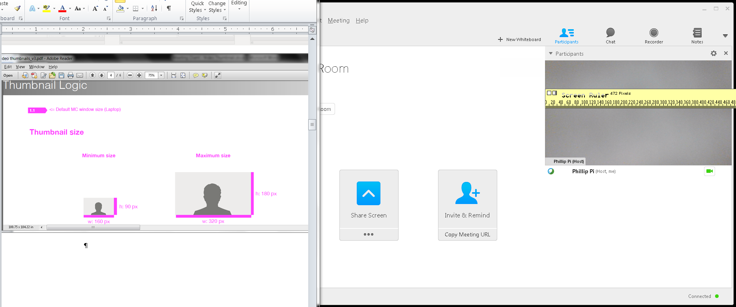
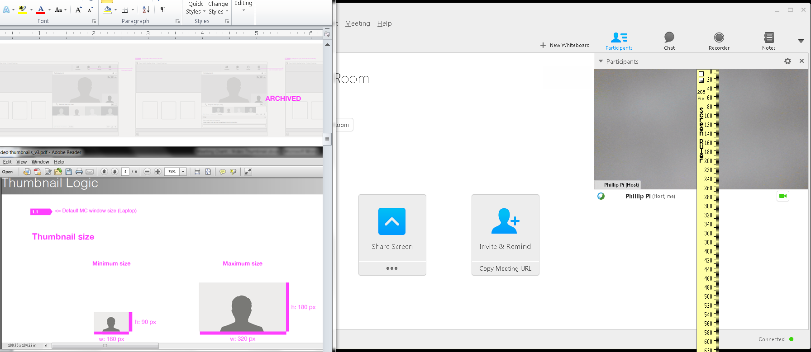
Issue: Maximum non-fullscreen video size is about 472 pixels wide and 265 pixels tall.

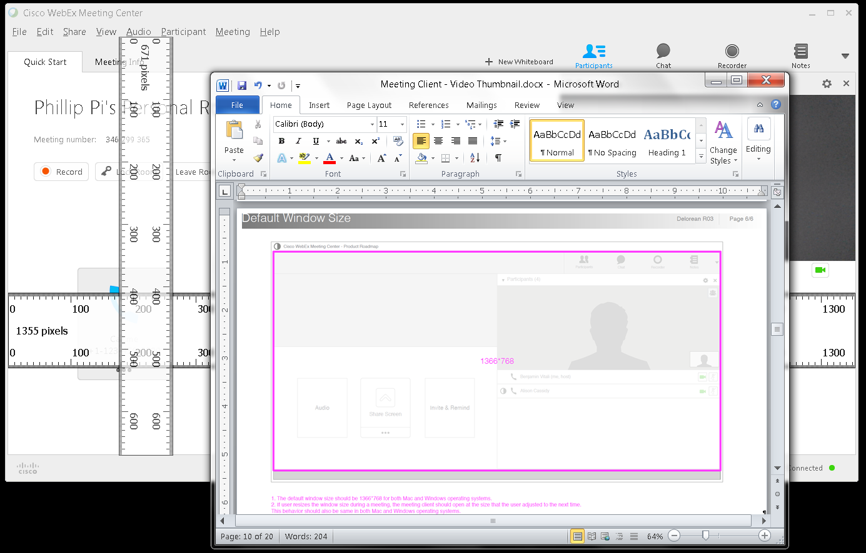
Two Issues:
- About 1,355 pixels by 617 pixels for the default window size. See the rulers where I measured from starts to ends to closely match the UI spec document’s image.
- After changing from its default size to huge window size (almost fullscreen), exiting my meeting, and making my new meeting, the window size is backto default.

OVERALL ISSUES:
- Graphics, colors, and buttons' texts are different. UI Specs seem to be outdated due to primitive images as shown earlier.
- Did not have any other participants, with videos due to one work machine, to do multiple video screens checks. So, I only did stuff by myself.
- Dimension sizes.
- Reverting back to default window size.

