Meeting Client’s Connect Video Popup (note: no prototype):
In 64-bit W7 EE SP1’s IE11 web browser on 6/23/2015:
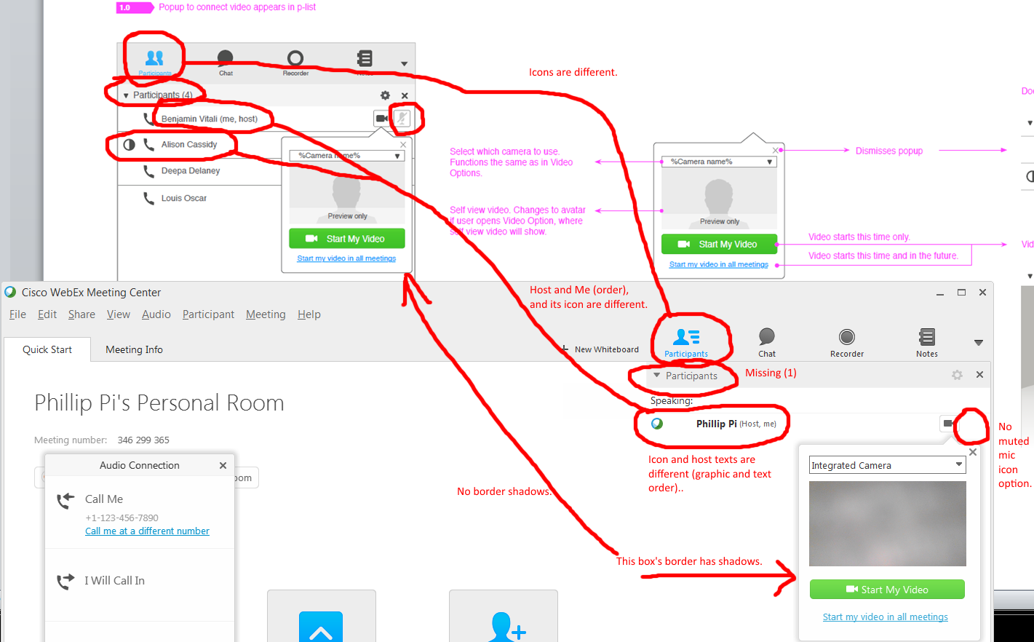
Three Main Issues:
- Host’s texts and icons are different.
- With and without border box shadows for video pop-up windows.
- Participants’ graphics and statistic texts are different.
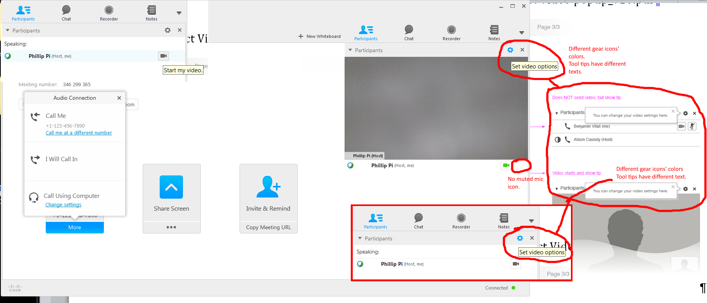
Two Issues:
- Gear Icons: Different colors and tool tips’ texts.
- Missing muted mic icons.

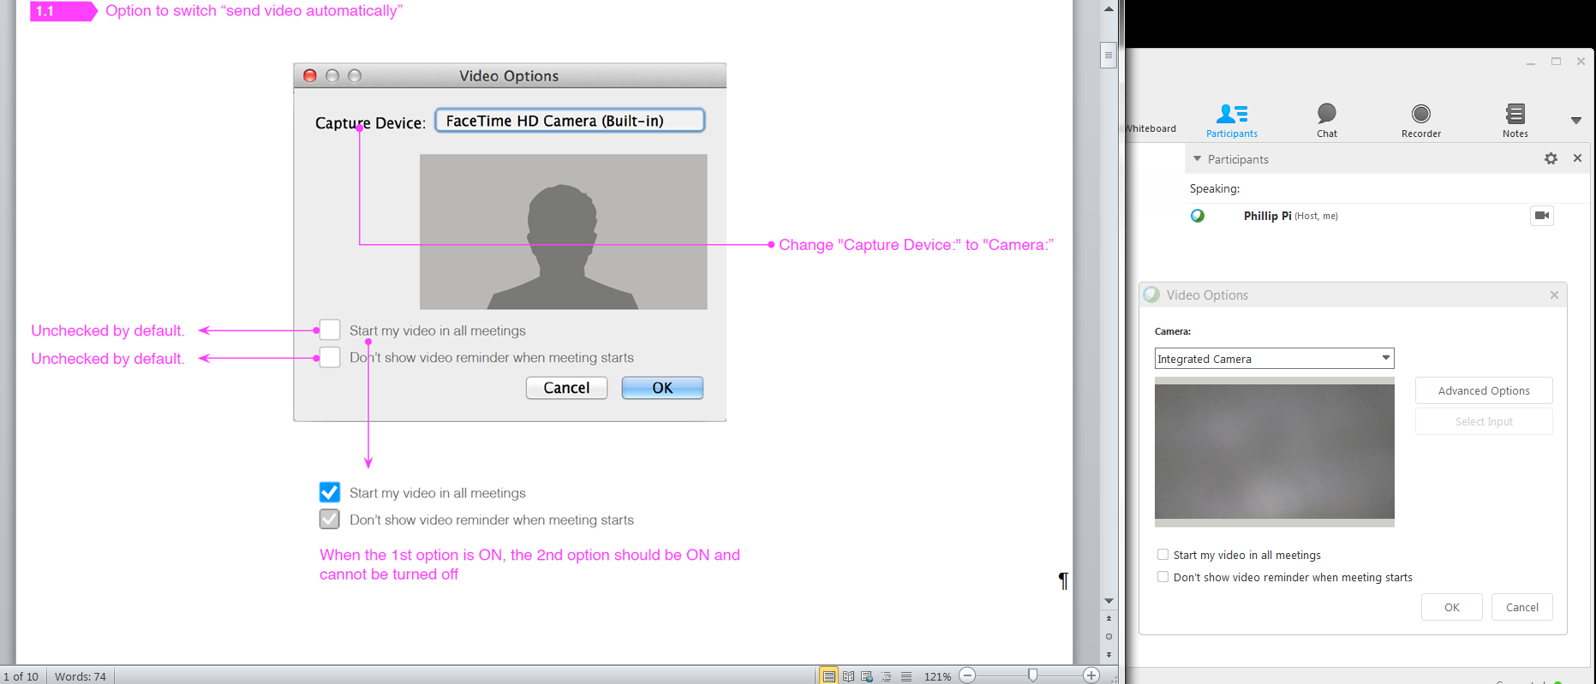
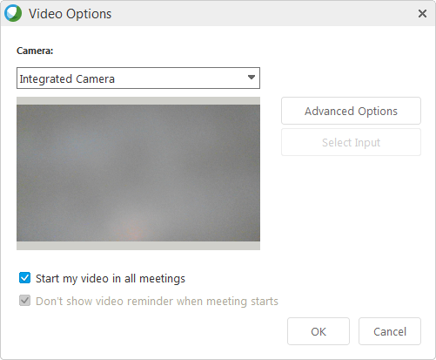
No issues found. I hope Windows’ GUI screen are identical as Mac OS X’s as shown.

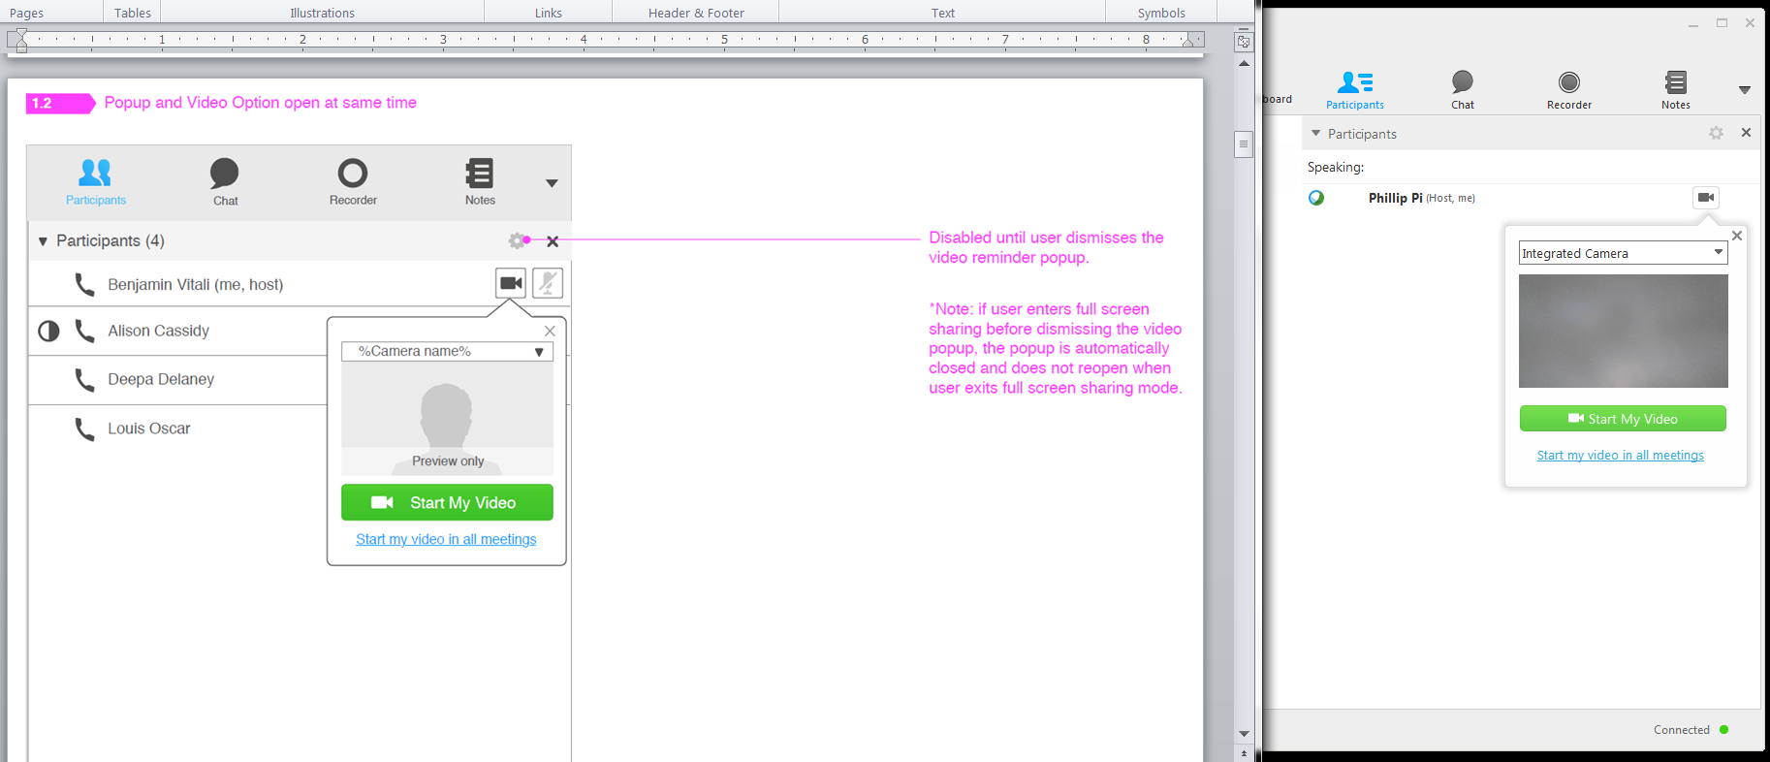
No new issues found. Just the border shadow, missing mic icon, etc.

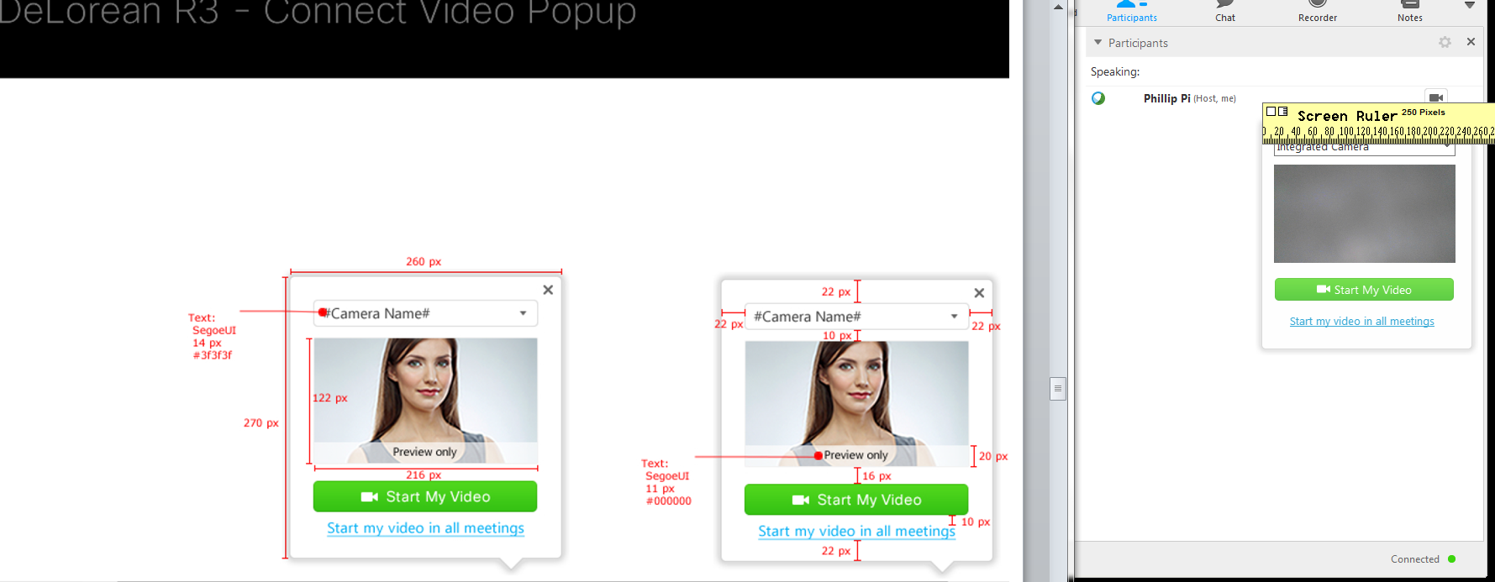
Issues: Pop-up window’s width, without the border shadows, is about 250 pixels.
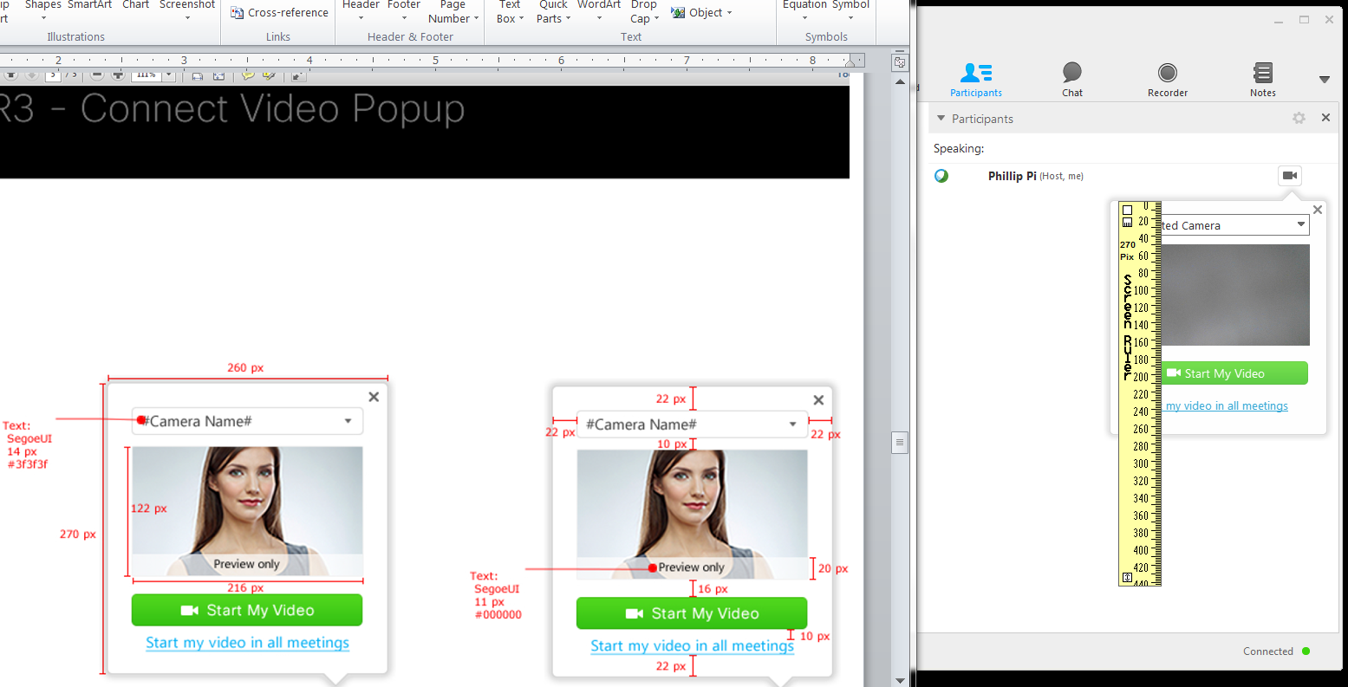

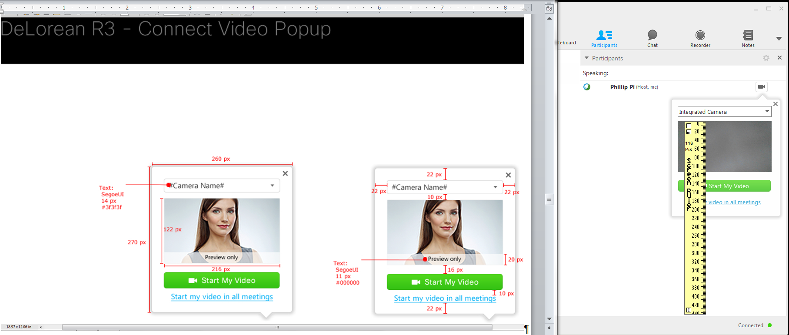
Issue: Video’s height is about 116 pixels.

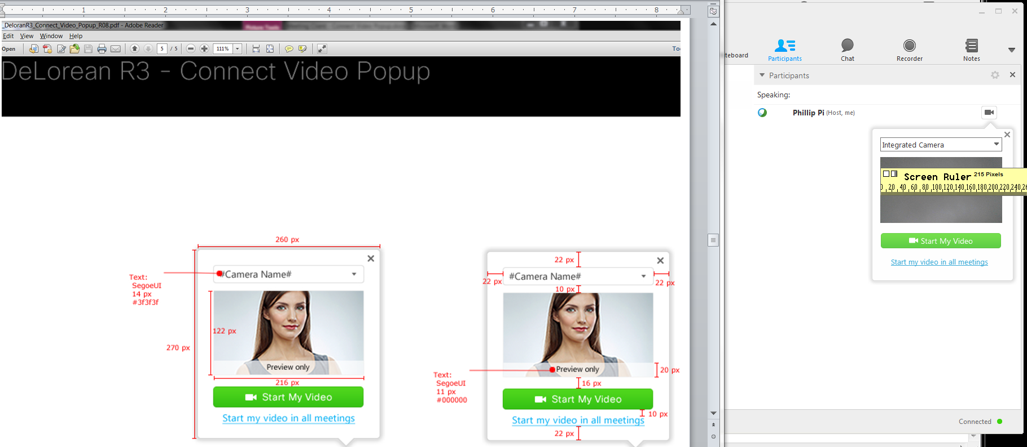
Video’s width is about 215 pixels.

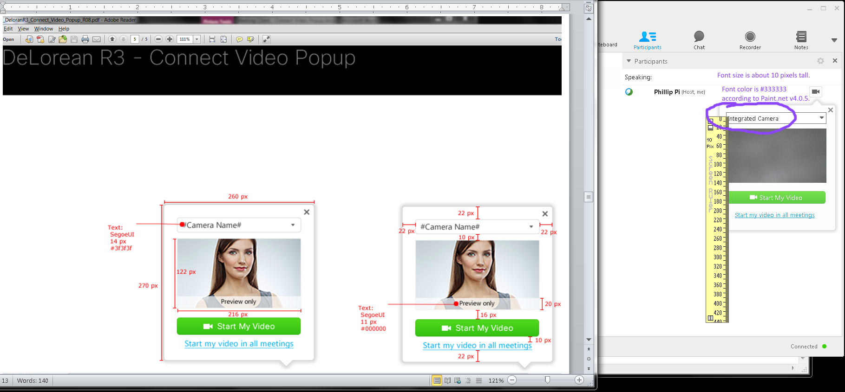
Issues: Camera’s font size is about 10 pixels all and using #333333 font color.

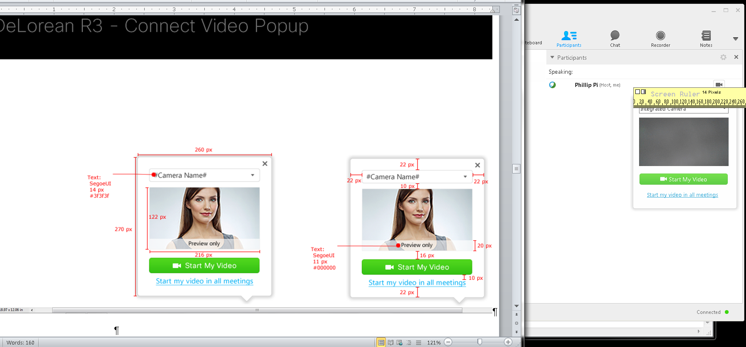
Issues with Margin and pixel sizes:
- Left margin, between the left border window edge and left video border edge, is about 14 pixels wide.
- Right margin, between the right video’s border edge and box’s right border edge is about 20 pixels wide.

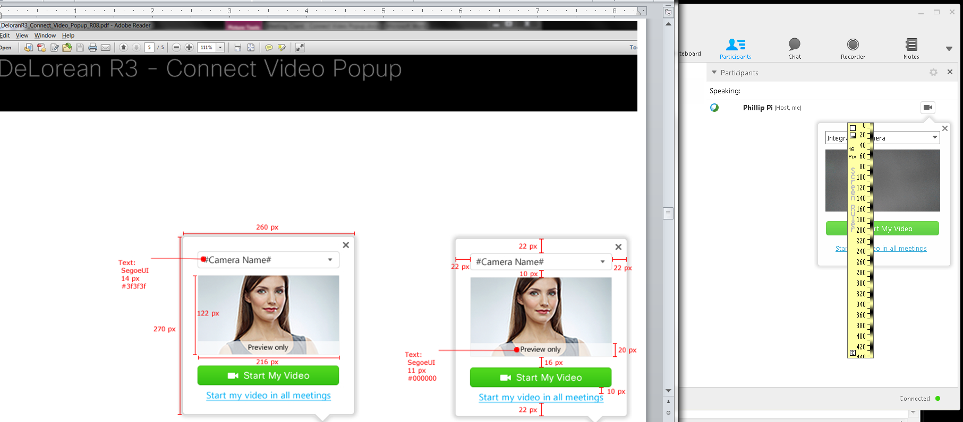
Issues:
- Between the top border edge and the top border edge of camera’s pulldown menu is about 16 pixels tall.
- Between the bottom camera’s pulldown menu and the top of the video’s 10 pixels tall.
- I do not get a “Preview only” text overlay over the camera video window.
- Between the bottom of the video’s border edge and the top of the green “Start My Video” button is about 20 pixels tall.
- Between the bottom of the green “Start My Video” button’s edge and the top of the “Start my video in all meetings” blue text link is about 20 pixels tall.
- Between the bottom of the blue “Start my video in all meetings” link and top of the bottom box’s edge is about 28 pixels tall.

OVERALL ISSUES:
- Host’s texts and icons are different.
- With and without border box shadows for video pop-up windows.
- Participants’ graphics and statistic texts are different.
- Gear Icons: Different colors and tool tips’ texts.
- Missing muted mic icons.
- Dimensions.
- Font colors.
- Missing "Preview only" for videos.

