Meeting Client’s Collaboration Meeting Room (CMR) call back:

https://gobeta.webex.com in 64-bit W7 EE SP1’s IE11 web browser on 6/19/2015 & 7/6-7/2015:
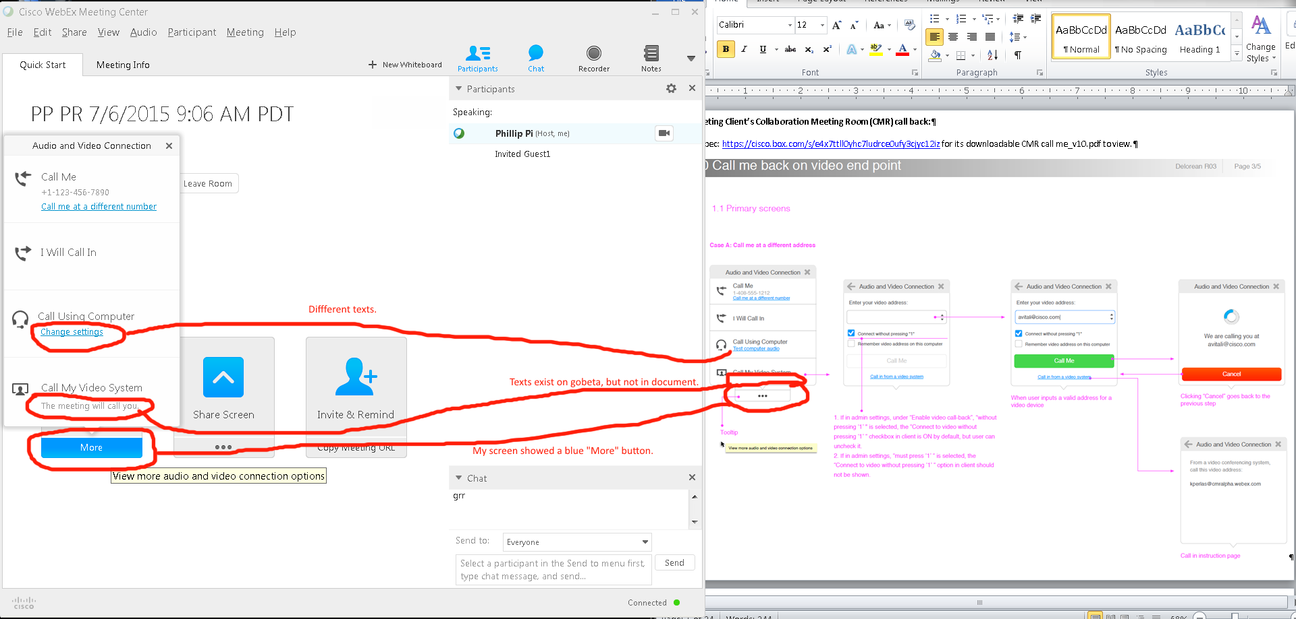

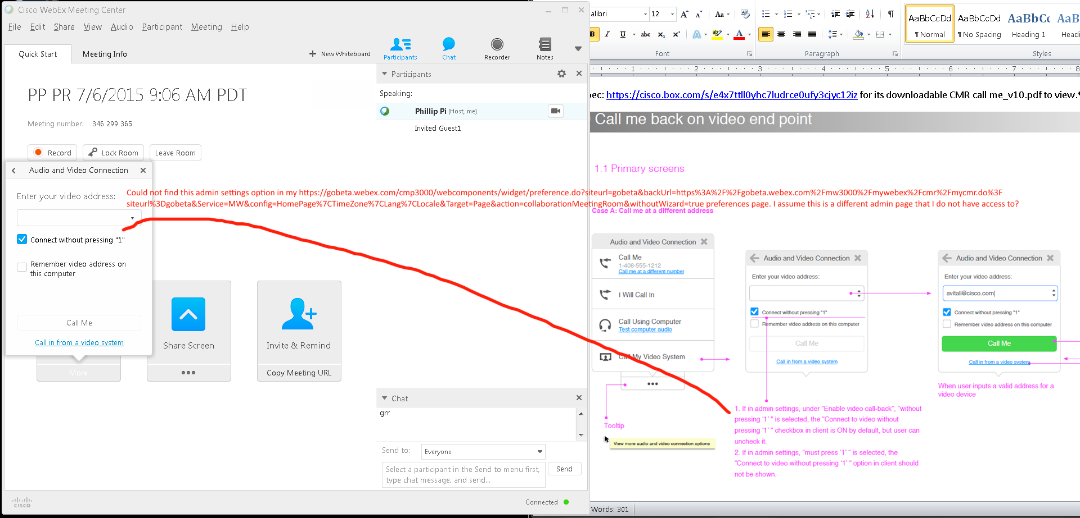
Issues:
- Different texts.
- “The meeting will call you.” text is shown on my Cisco WebEx Meeting Center’s gobeta screen.
- Could not find the admin settings for “Enable video call-back”. I assume it is another page that I don’t have access to.
- “More” buttons that has blue color and pop-up bubble’s drop shadows.

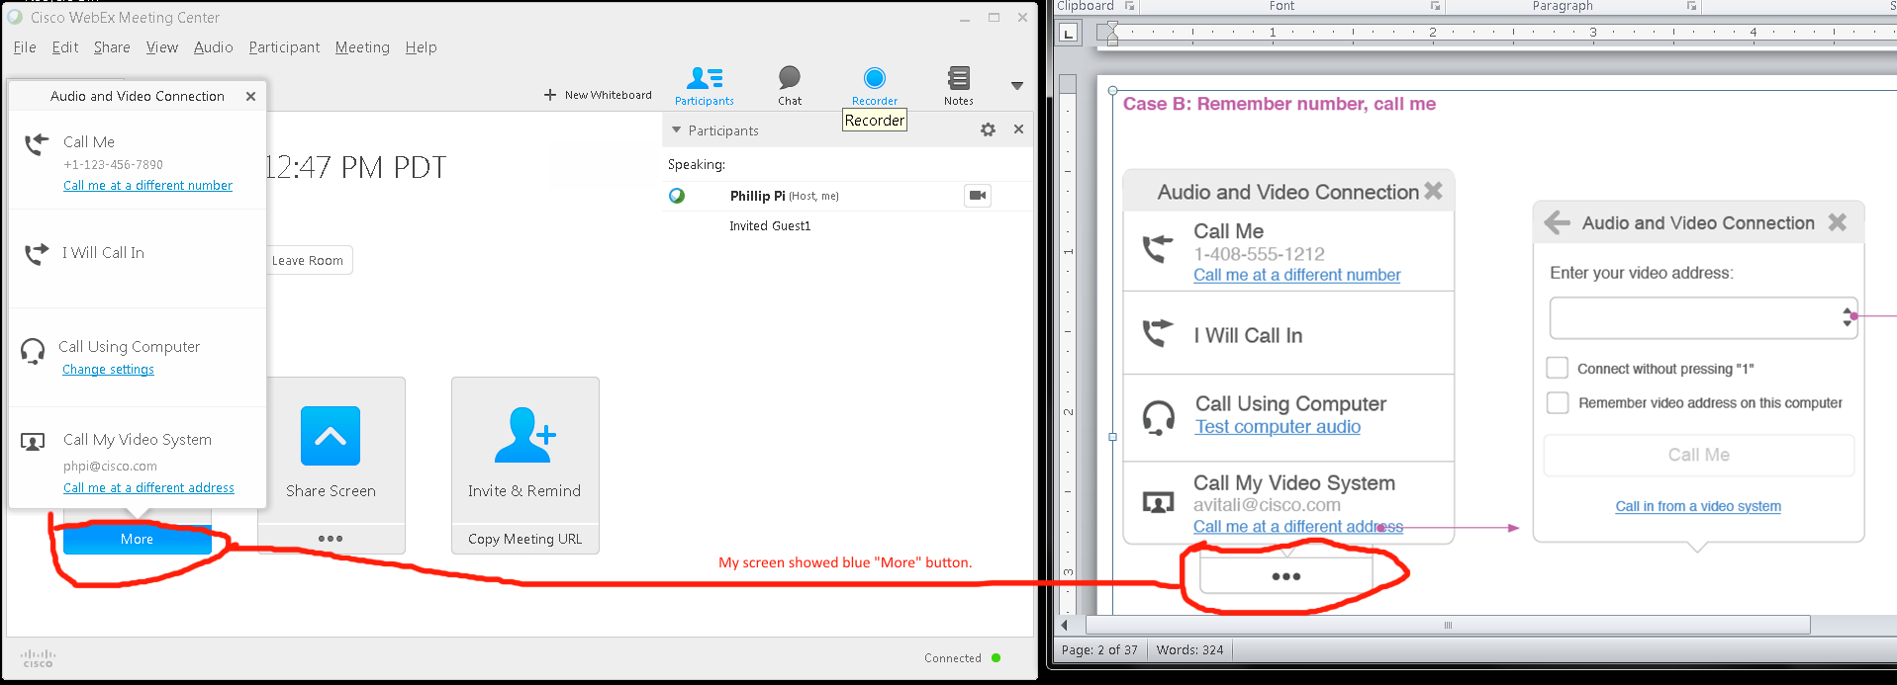
Issue: I saw the same blue “More” button.

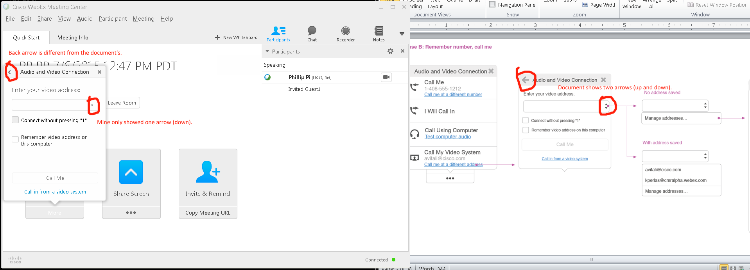
Issues:
- Different arrows.
- Blue pulldown menu highlight.
- “More” button.

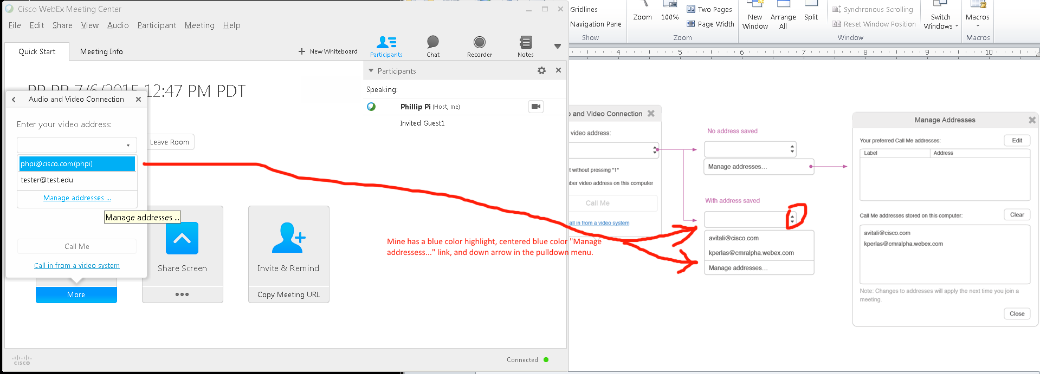
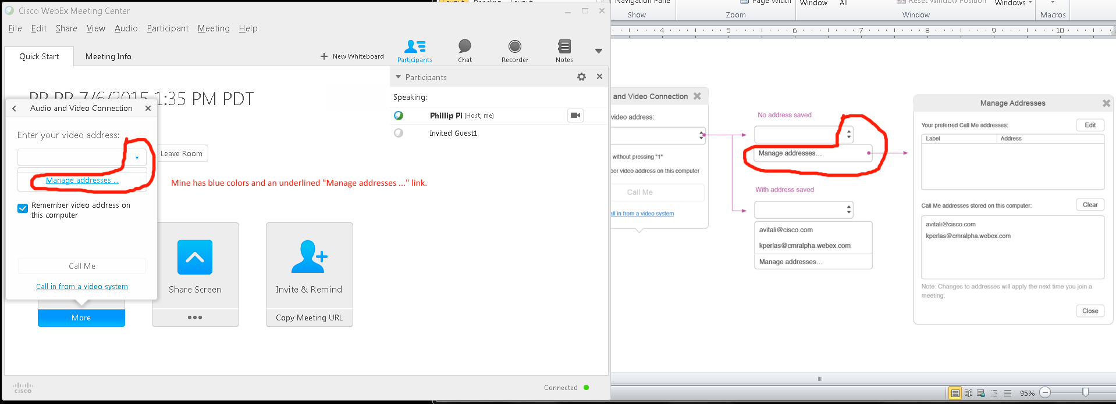
Issues:
- Different arrows.
- Blue pulldown menu colors.

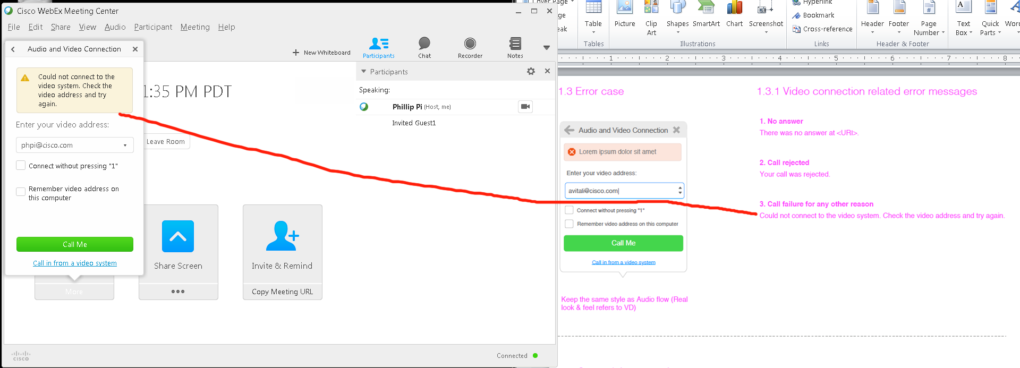
Due to missing Video System at my phpi@cisco.com e-mail addresss(?), I was only able to reproduce 1.3.1’s video connection related error message #3 (“Call failure for any other reason”). Also, could not test more features like this assuming I am on the correct screen:
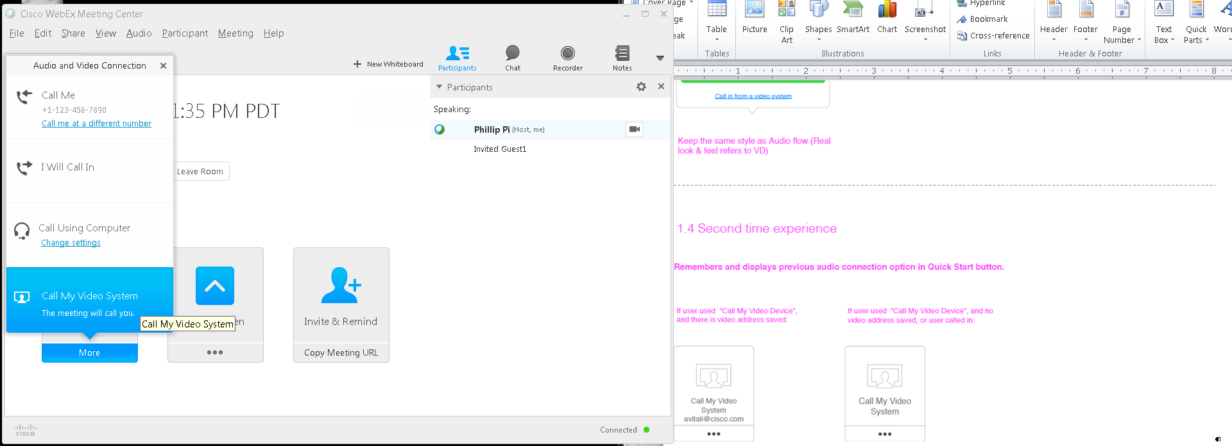
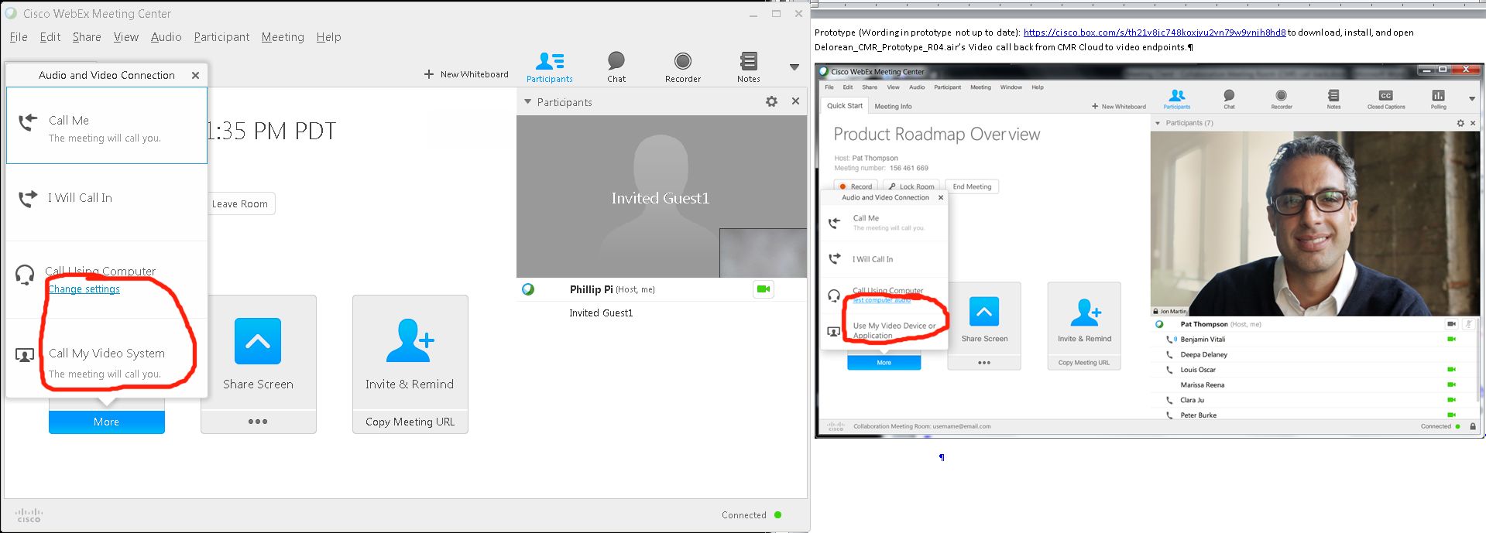
Issues: Different texts.

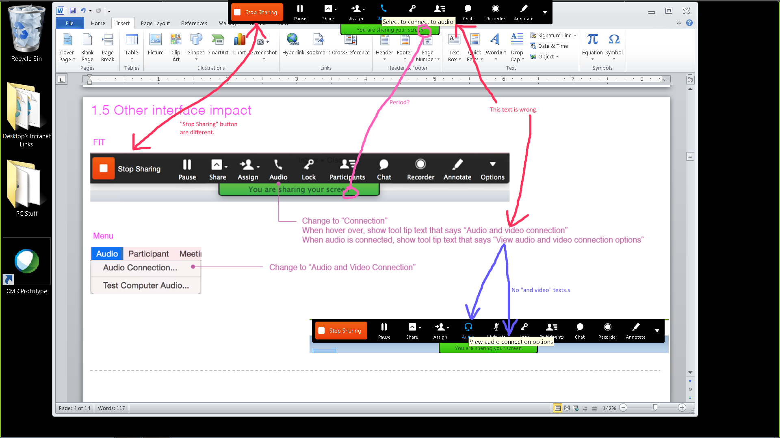
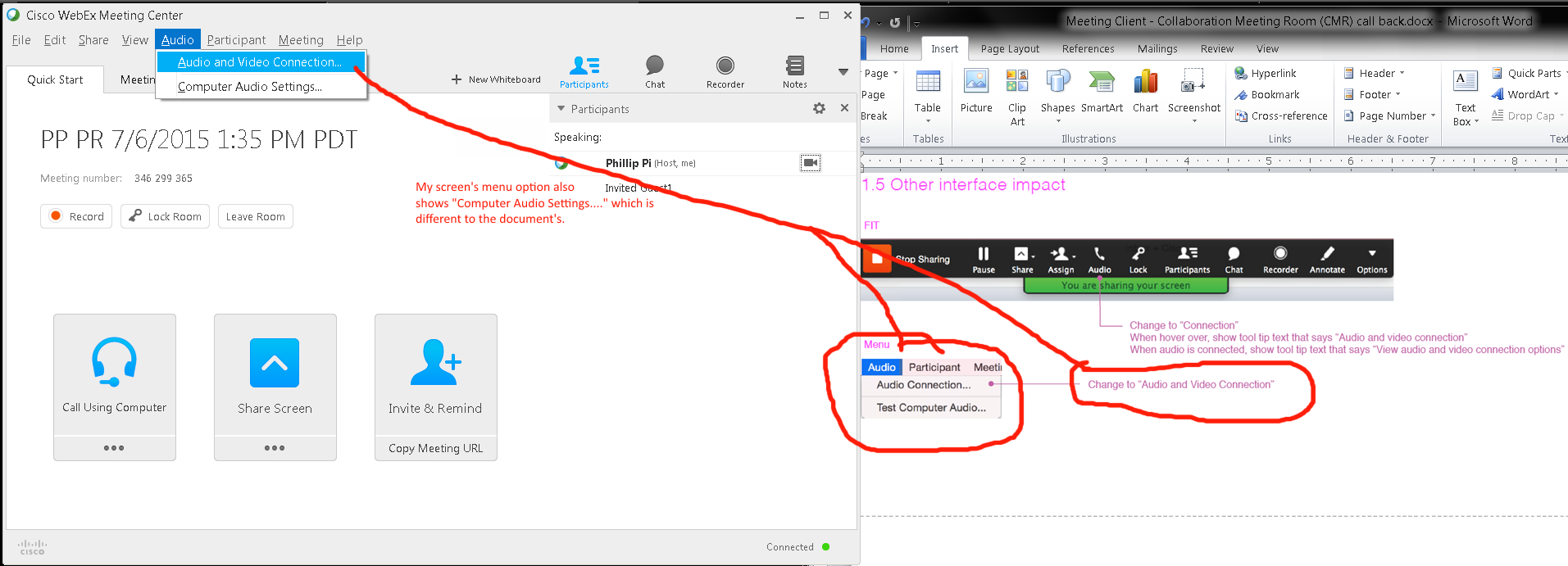
Issue: “Computer Audio Settings...” text.

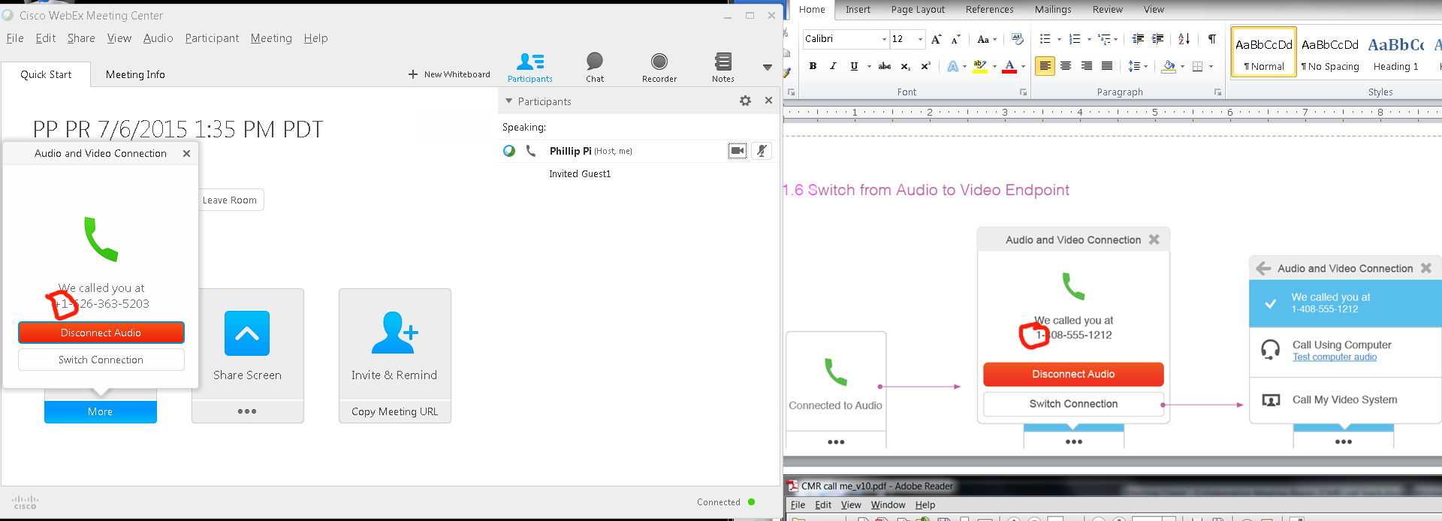
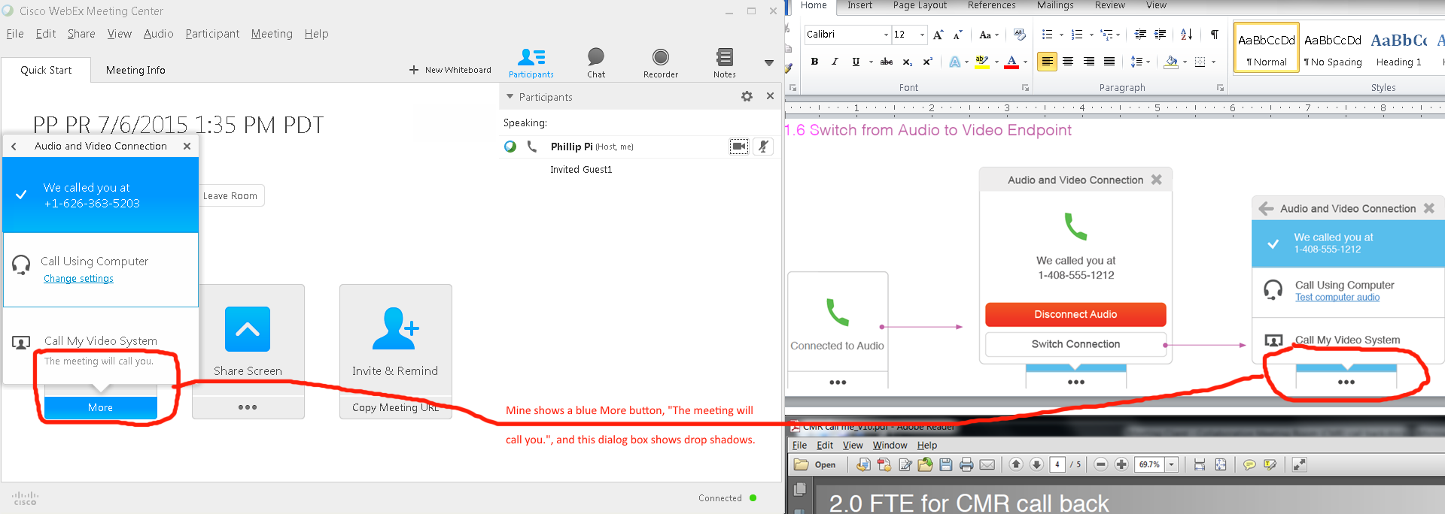
Issue: Blue more button and “The meeting will call you.” text on my screen.

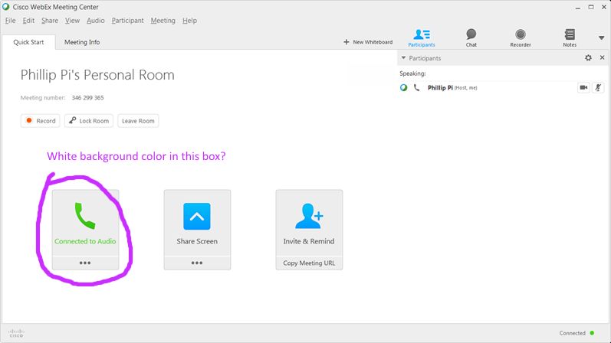

Note: This was with just me, the host, in my own personal room which showed less settings like the Video System:
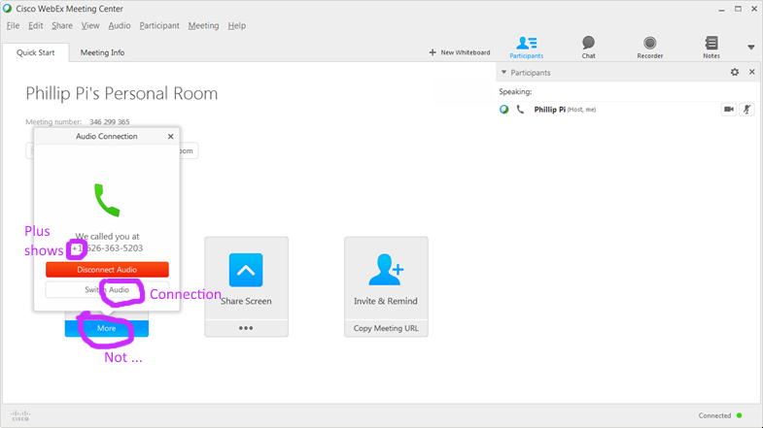
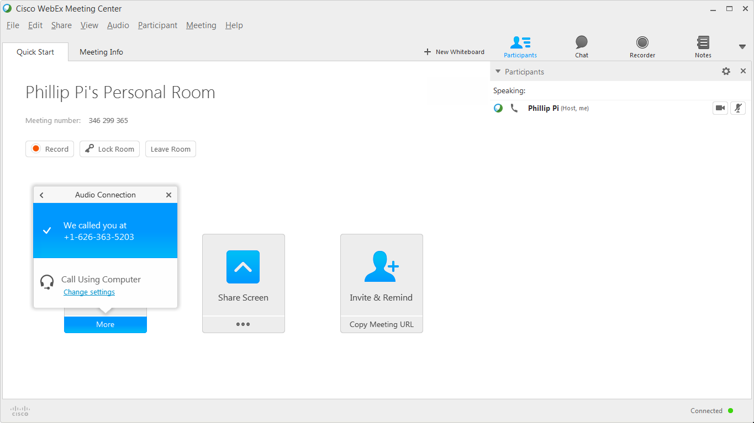

Issues:
- “Connected to Audio” doesn’t use white background color in its box.
- No “Call My Video System” by myself, as the host.
- No “…” where “More” should show.

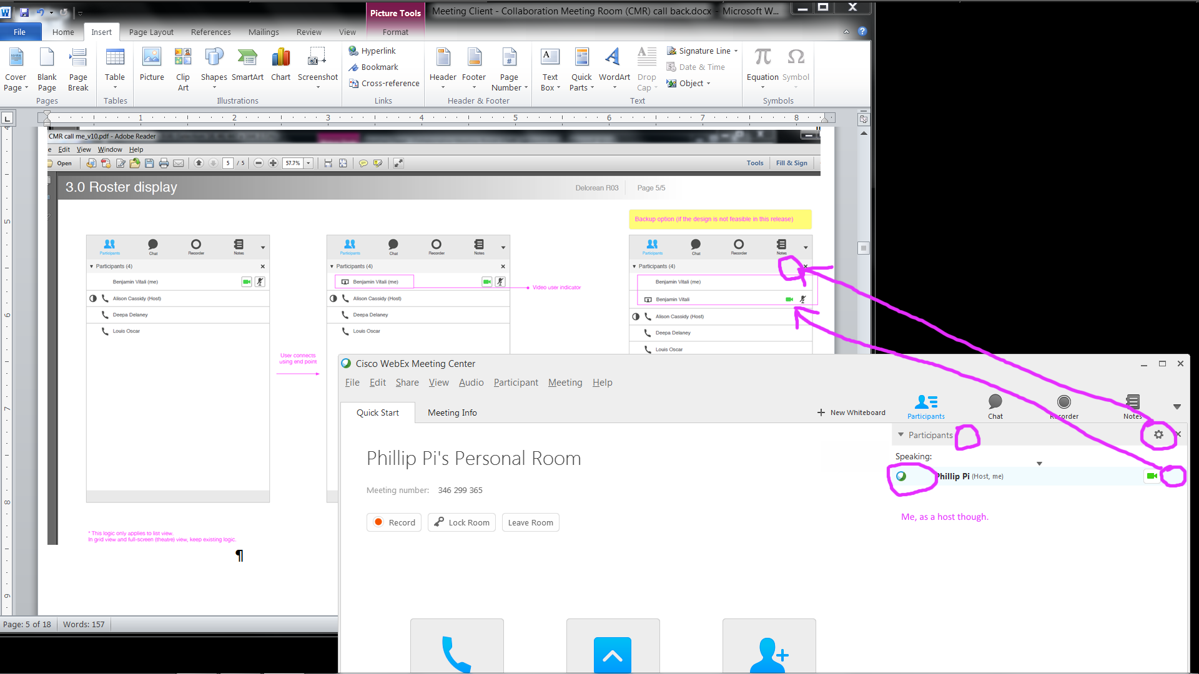
Issues:
- Options icon shouldn’t be there?
- Ball graphics.
- Disabled mic(rophone) icon was missing even though I tried it enabled and disabled.

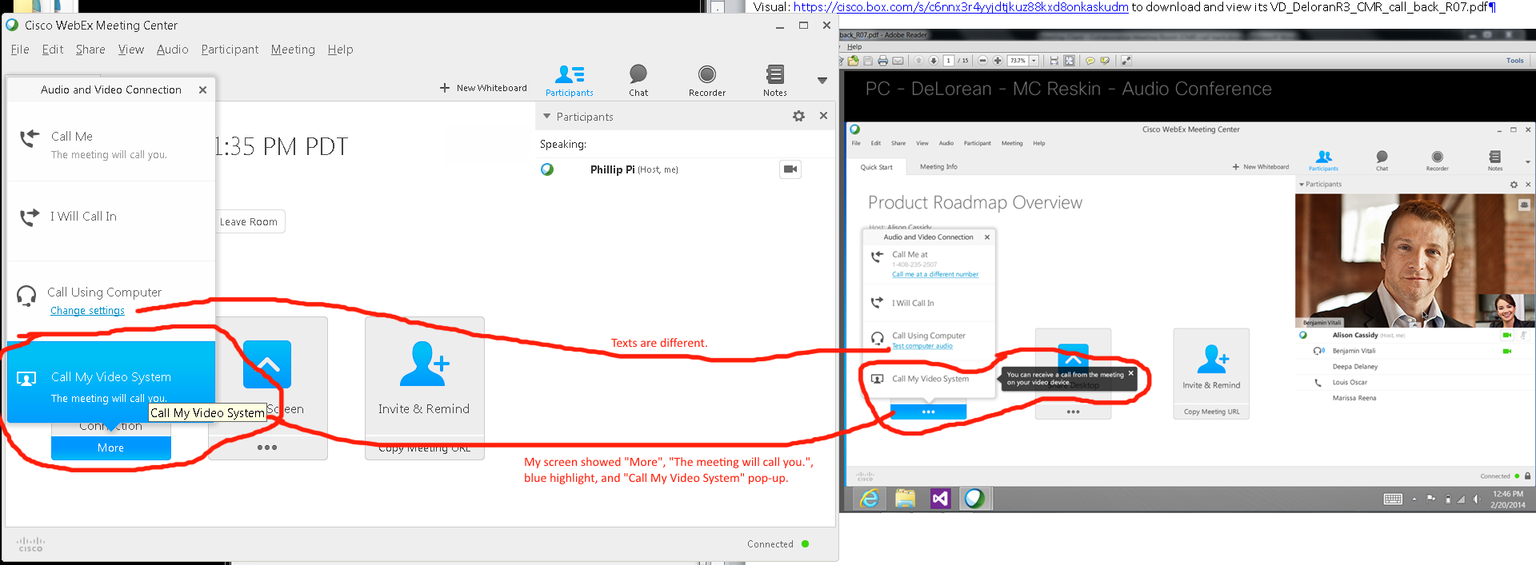
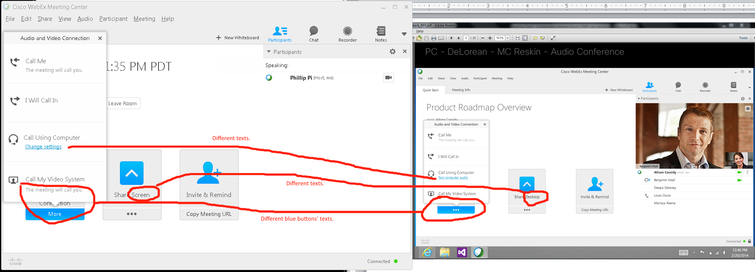
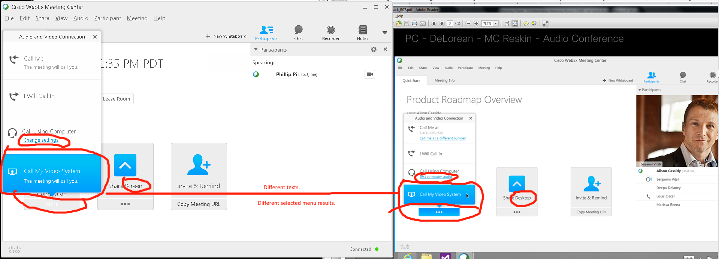
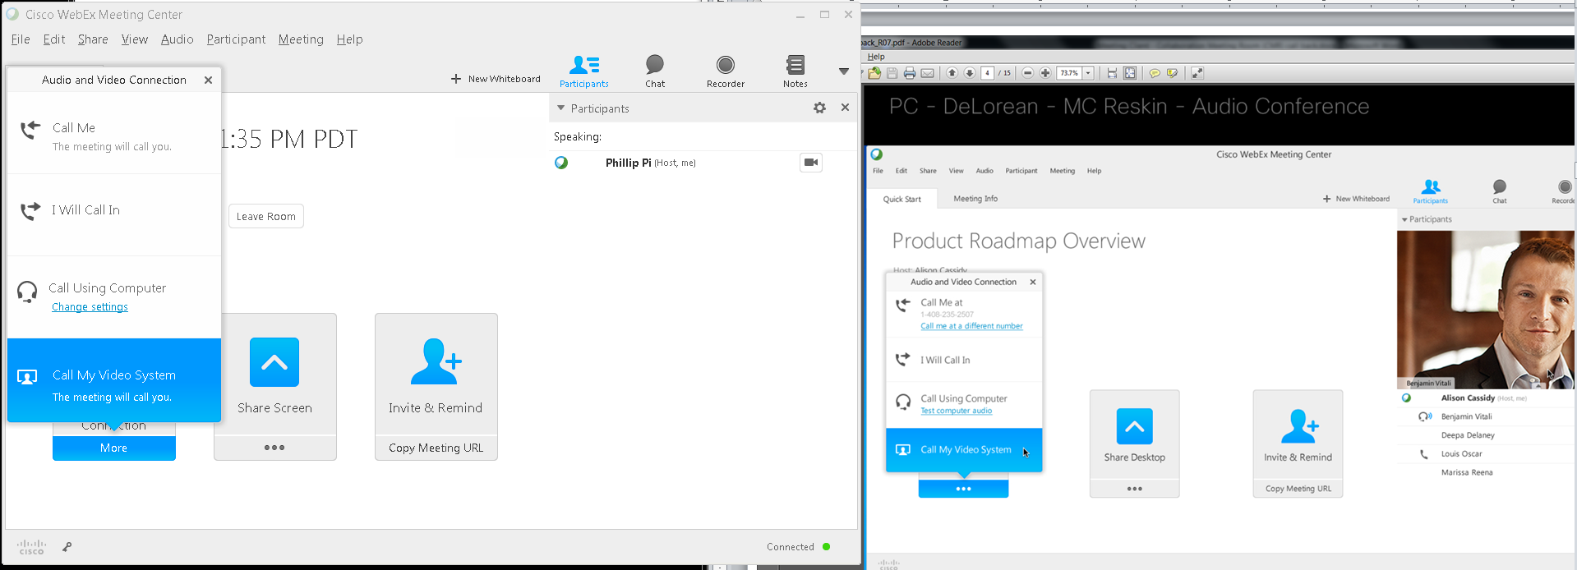
Same as above screen shot/capture, but with reversed blue gradient selection when clicking on its menu option.
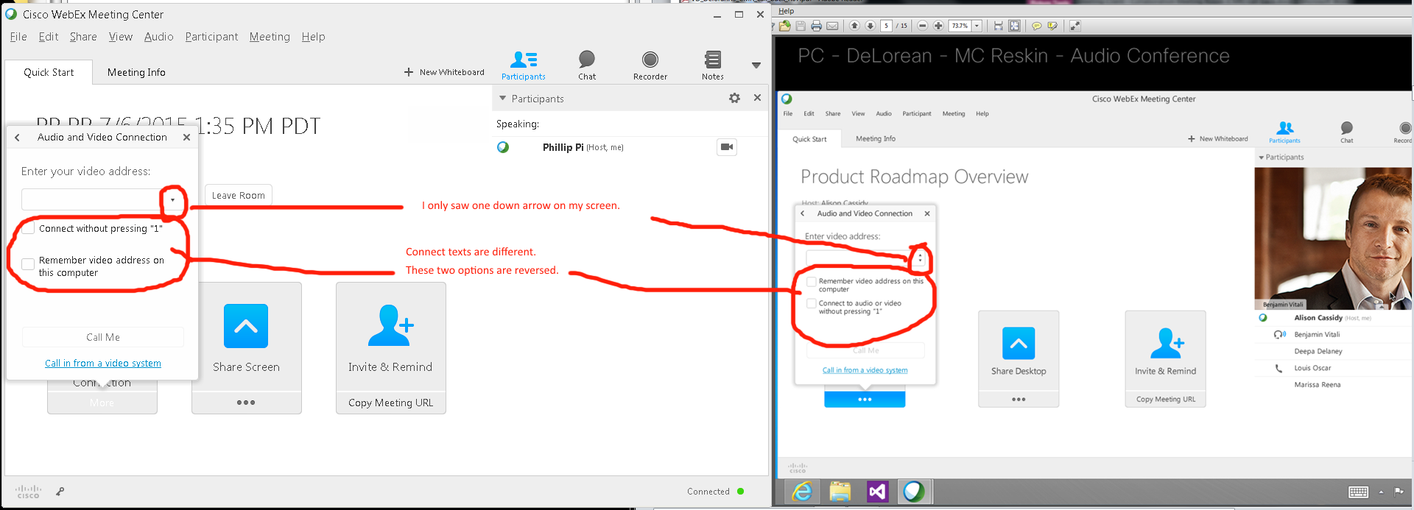
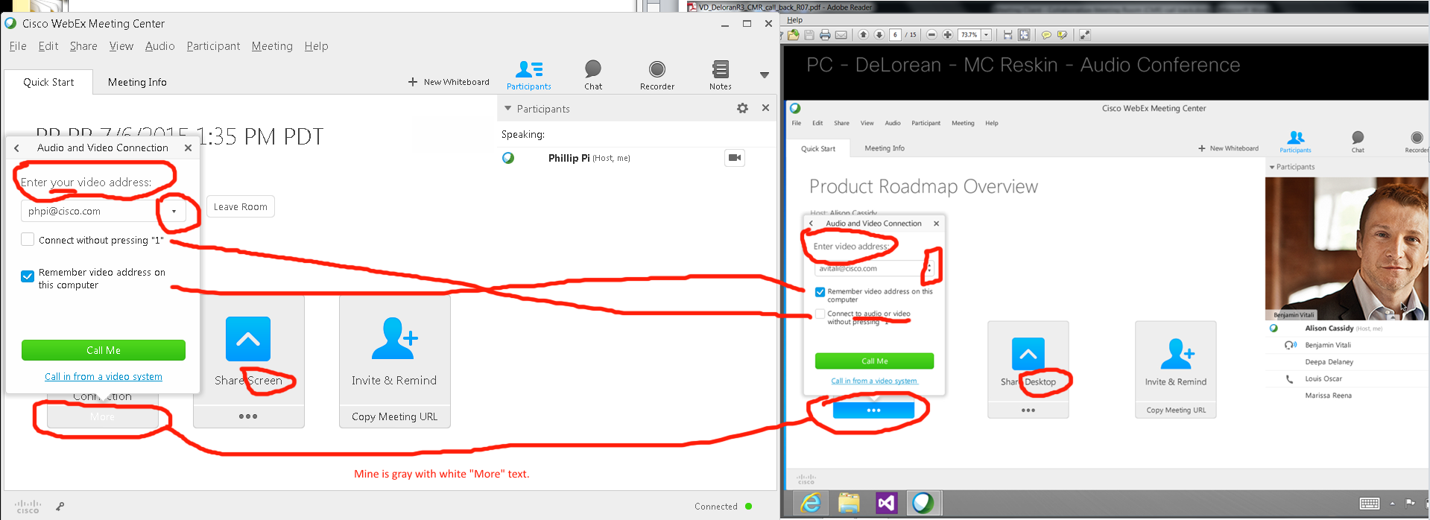
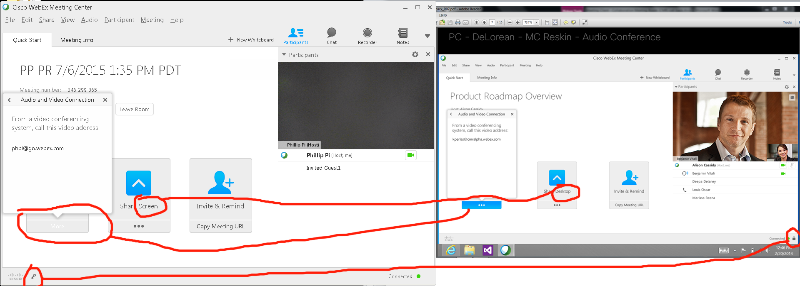
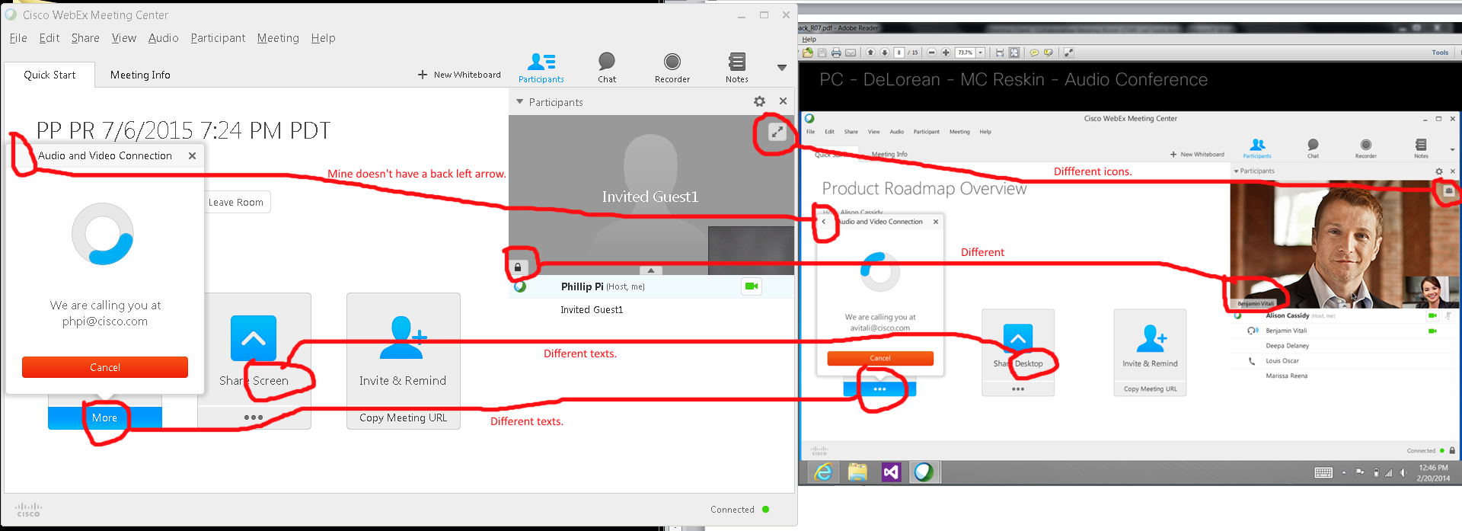
Issues:
- “More” and “…” buttons.
- “Change settings” and “Test computer audio” blue links.
- Unable to use “Call My Video System” fully like connecting to a valid e-mail address.
- “Share …”
- Reversed video address options.
- Locked room with its different status icons and sides.
- Different texts and (graphic/image/icon)s.

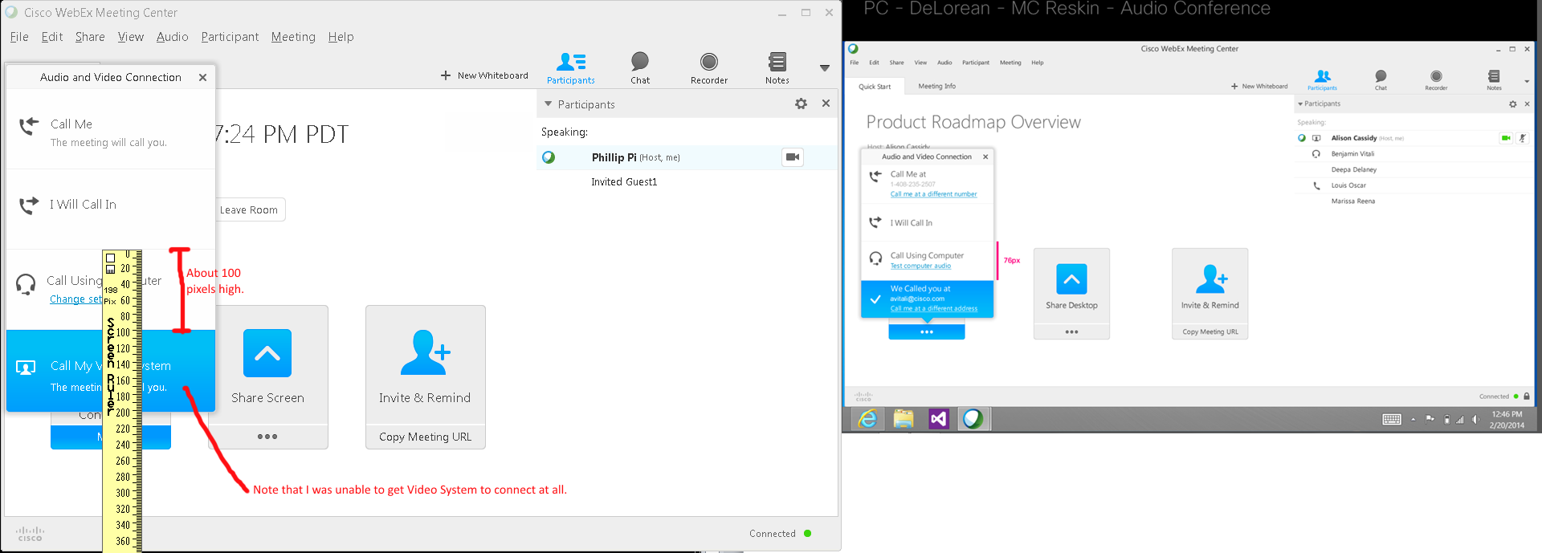
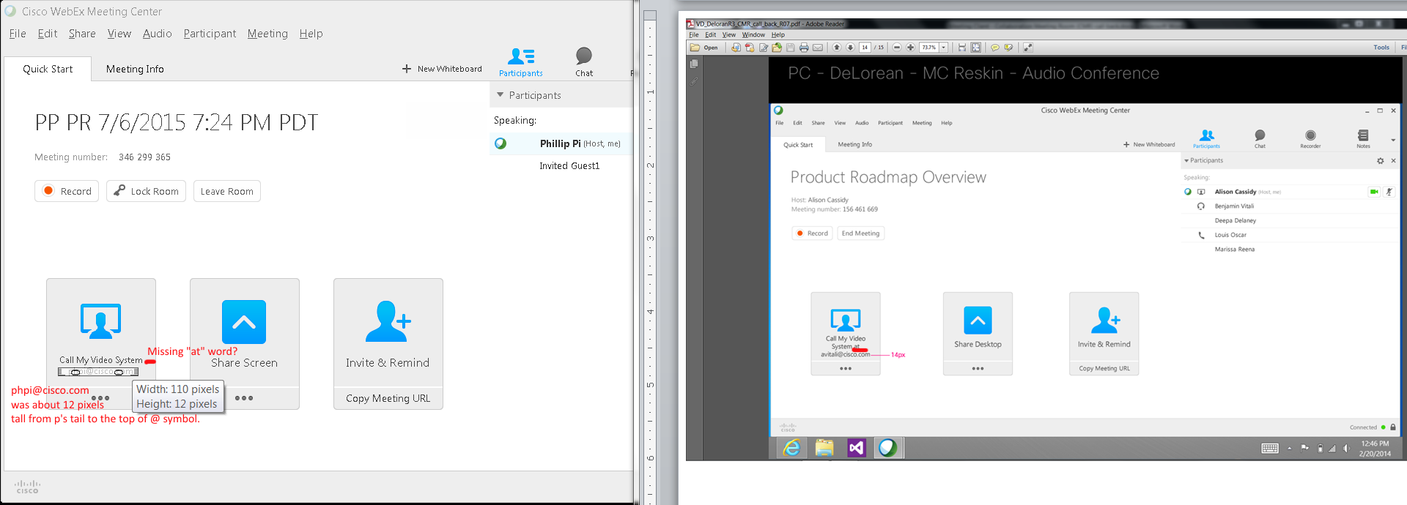
Issues:
- Pixel size differences.
- Missing “at” word in “Call My Video System …”

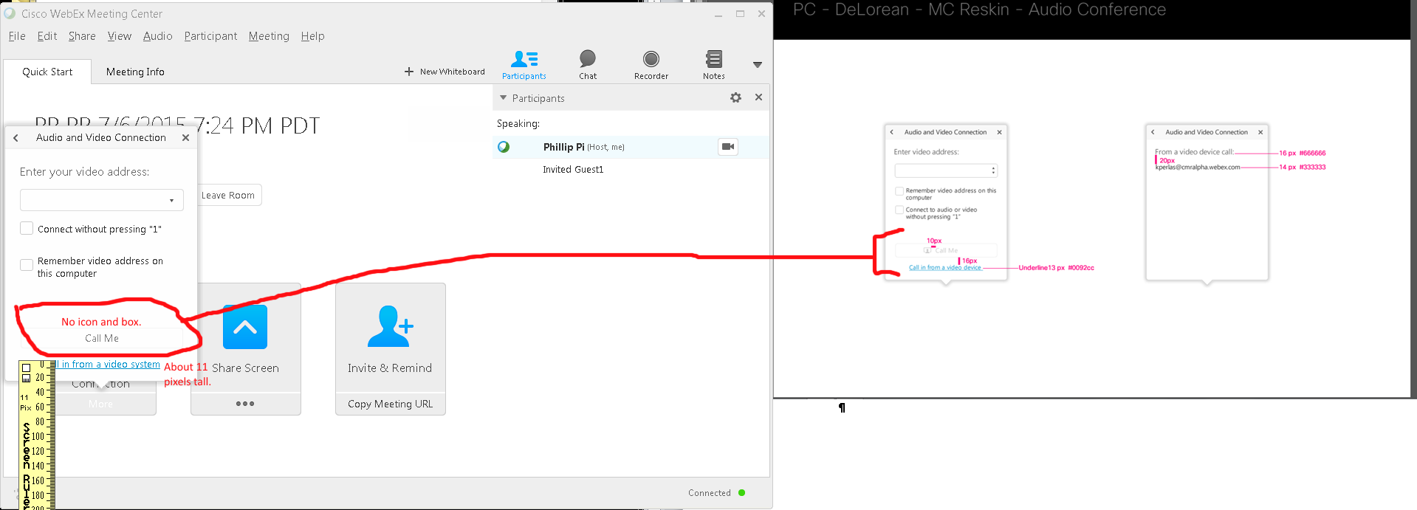
Issues:
- No box.
- No icon.
- Pixel size difference.

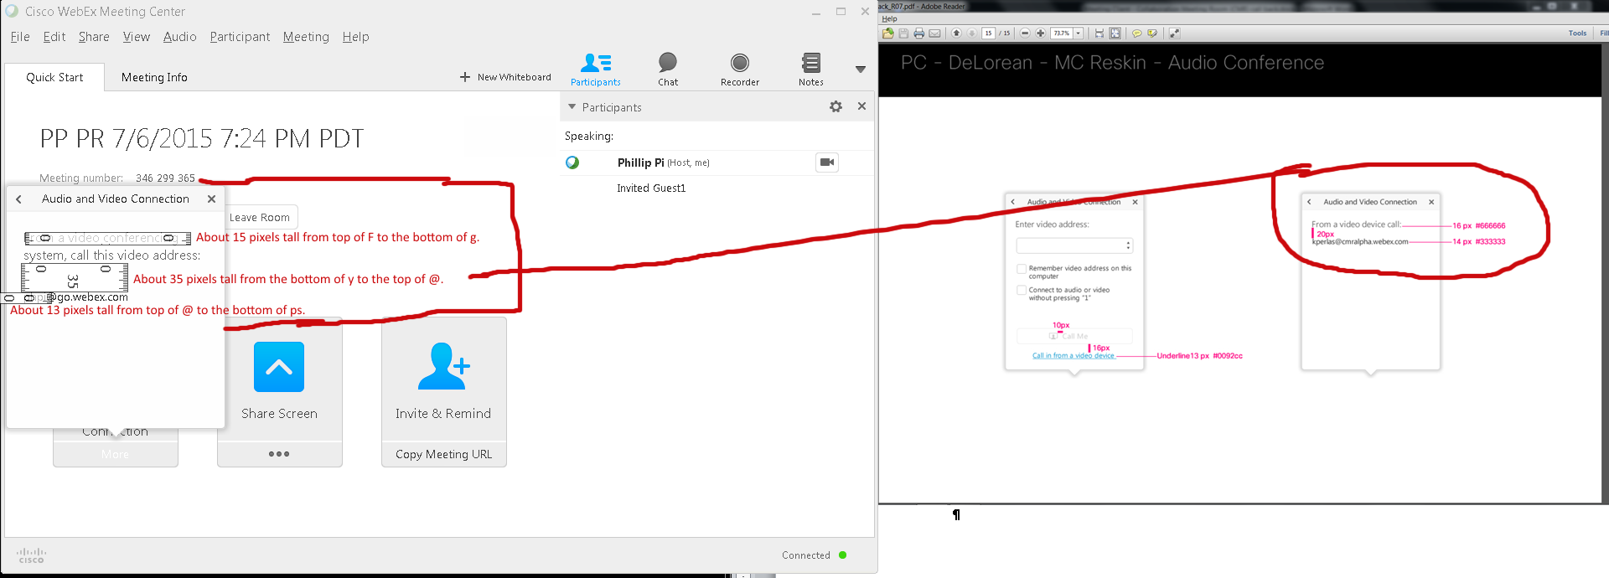
Issues: Pixel size differences.
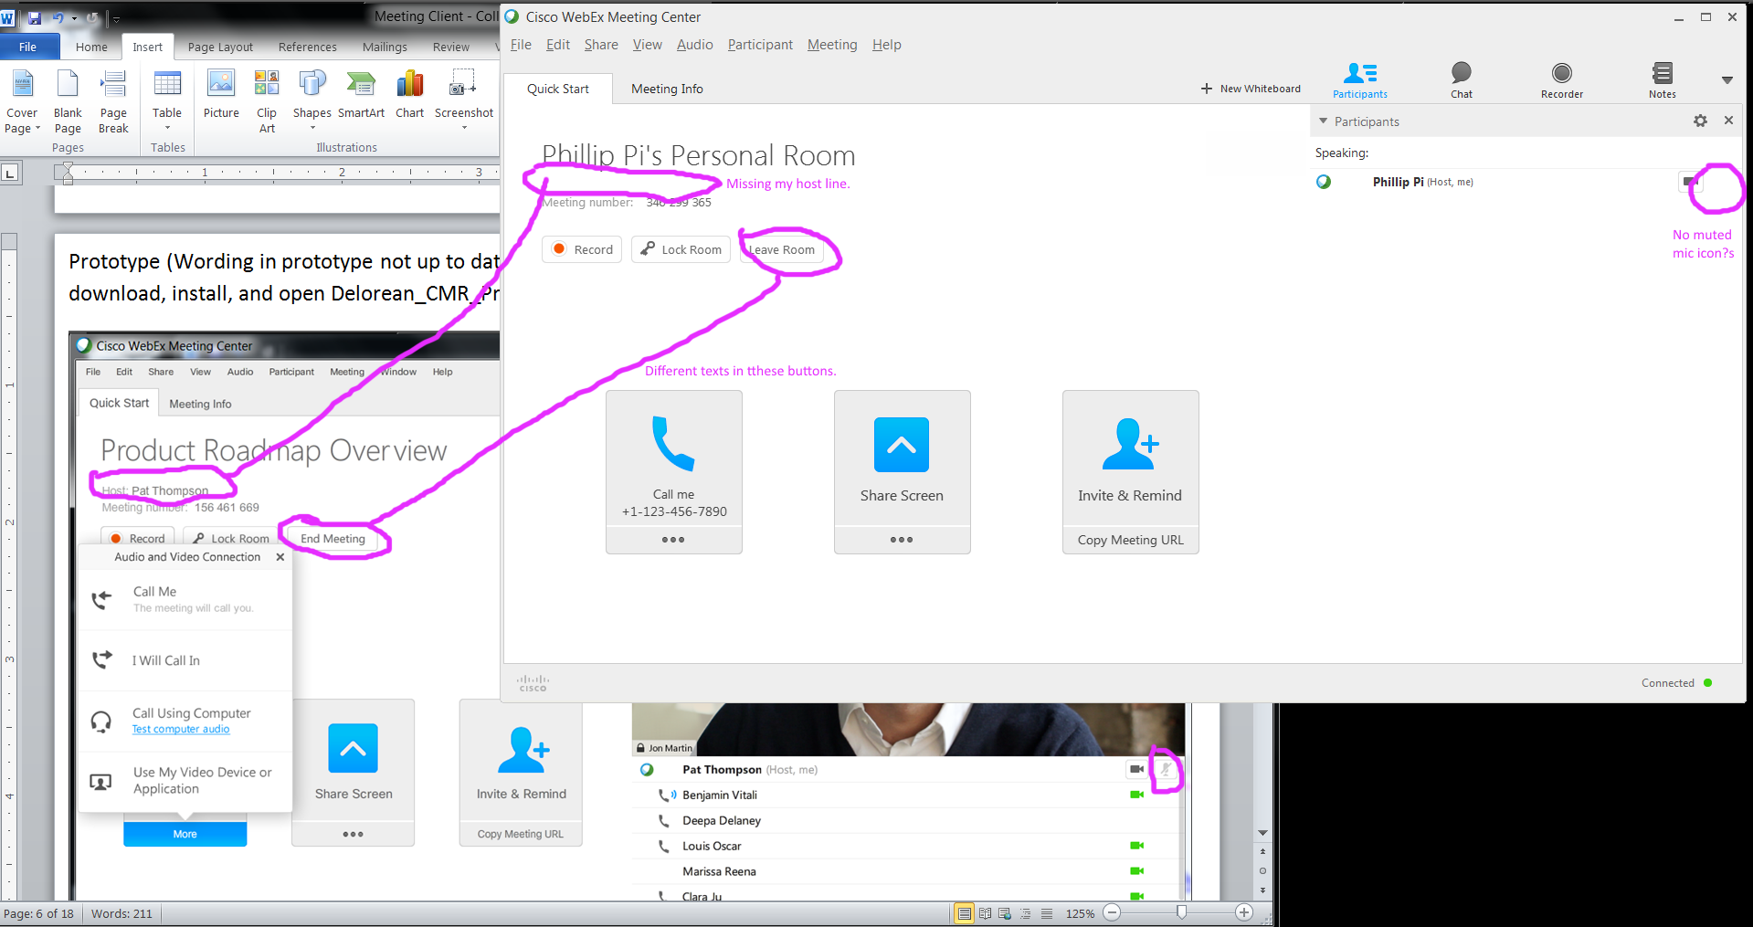
Issues (update the Prototype document?):
- Missing my host line.
- My “Leave Room” and “End Meeting” buttons.
- No muted microphone icon on my screen.

OVERALL ISSUES:

- Different texts.
- Could not find the admin settings for “Enable video call-back”. I assume it is another page that I don’t have access to.
- Unable to connect to a Video System fully with any e-mail address.
- “More” and "..." buttons.
- Pop-up bubbles' drop shadows.
- Graphics like different arrows, balls, etc.
- Blue pulldown menu colors.
- “Computer Audio Settings...” text.
- Blue more button and “The meeting will call you.” text on my screen.
- “Connected to Audio” doesn’t use white background color in its box.
- Options icon shouldn’t be there?
- Disabled mic(rophone) icon was missing even though I tried it enabled and disabled.
- “Change settings” and “Test computer audio” blue links.
- Host line.
- My “Leave Room” and “End Meeting” buttons.
- No muted microphone icon on my screen.

