Meeting Client’s Button Consolidation:
UI Spec: https://cisco.box.com/s/yvdnxy7blfhahsczcr80u8jcl2jqfwam (Button Consolidation_v8-1.pdf):
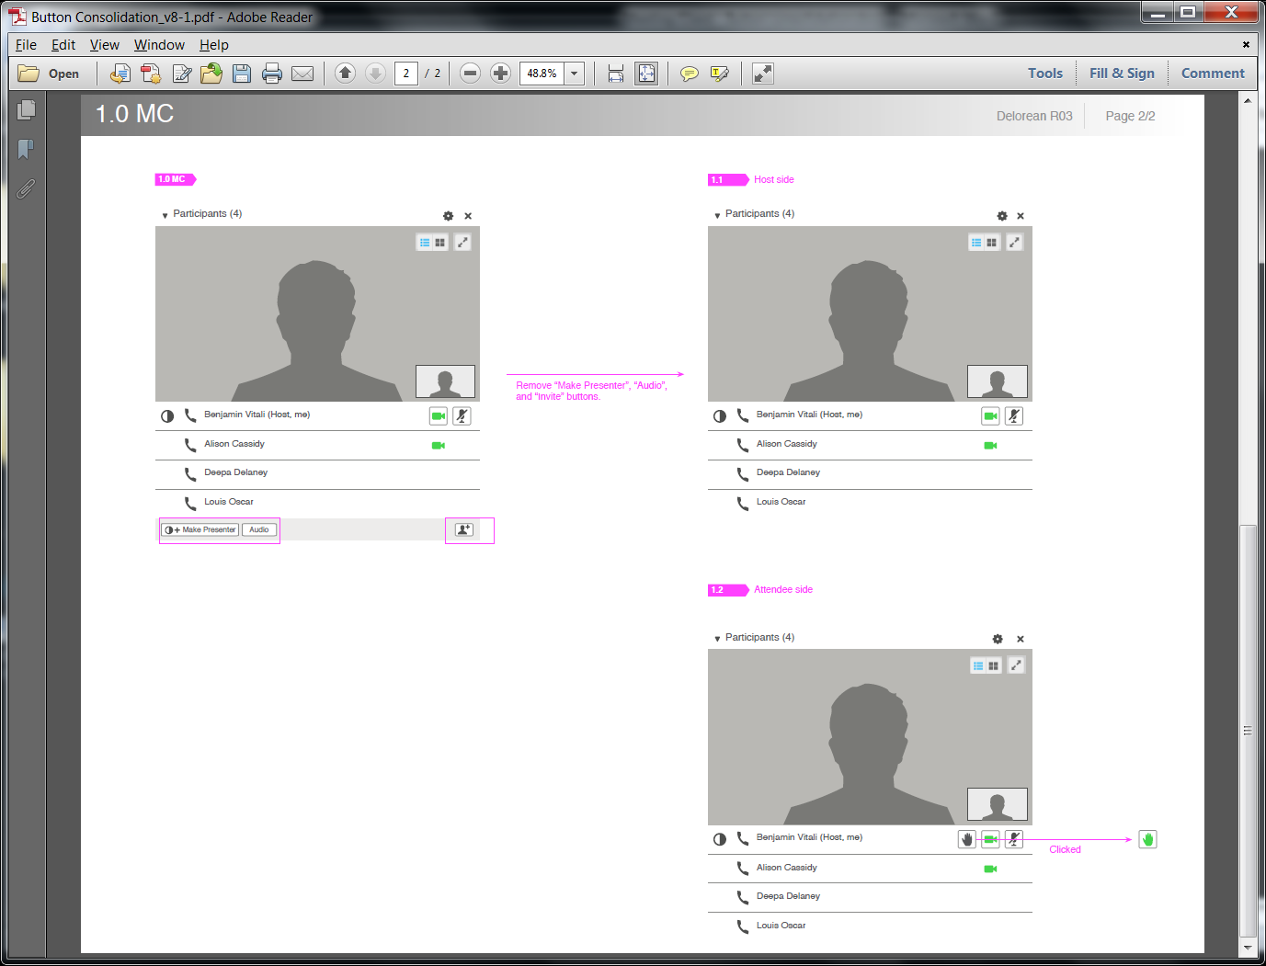
Prototype: https://cisco.box.com/s/ddp71nn0fjwh8j035nzk (downloaded and installed its Delorean_2_Client_Prototype_R35.air (Delorean 2 Prototype)
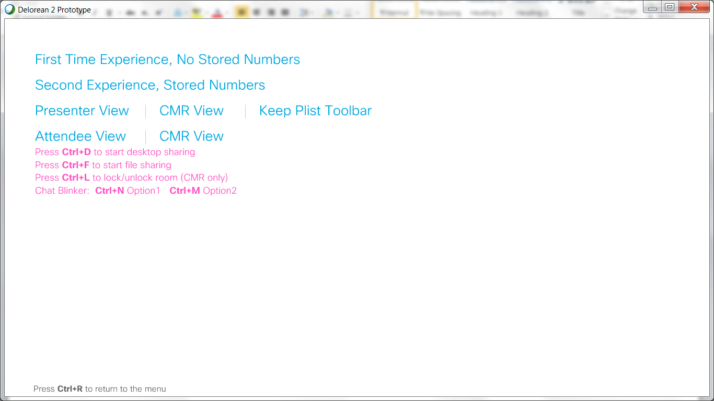
Notes -- Ctrl+<letter> hotkeys for action results if any and shown below:
First Time Experience, No Shared Numbers:
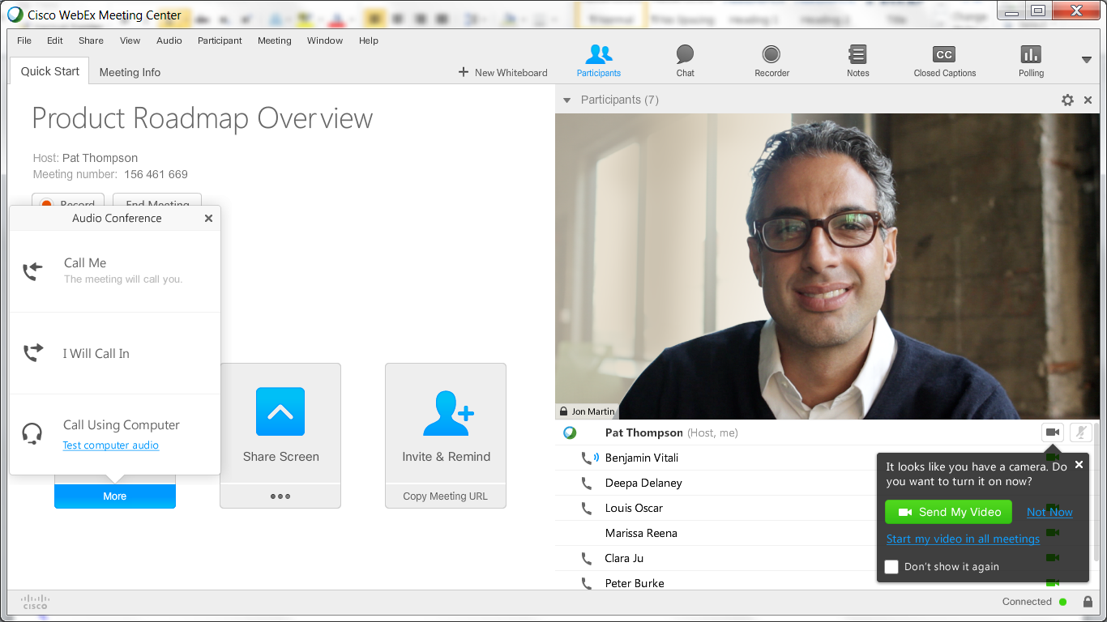
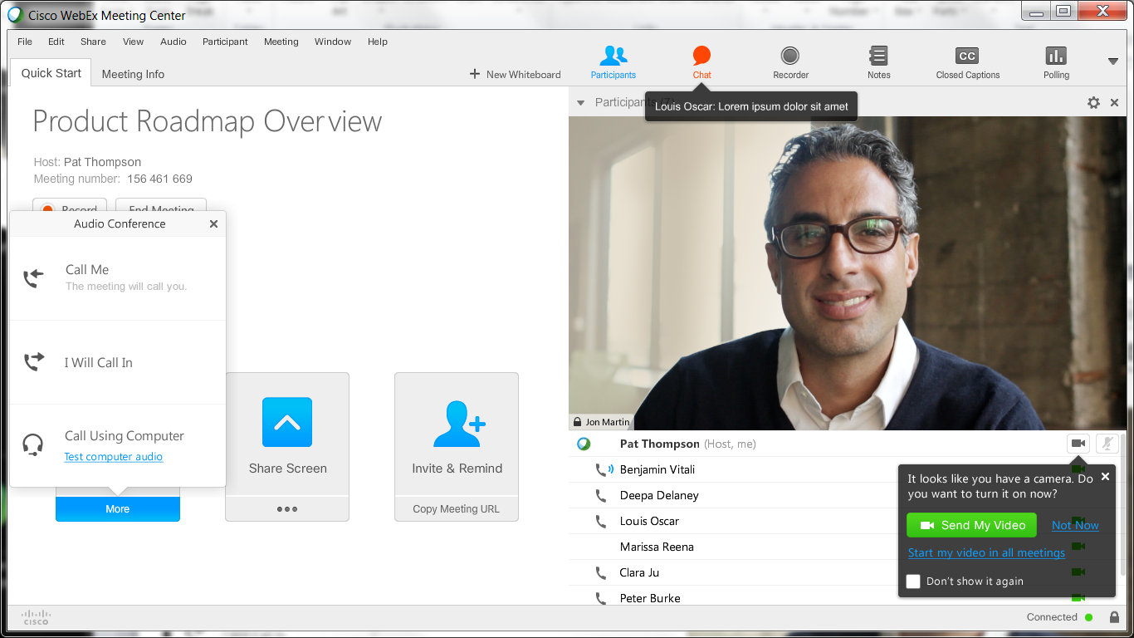
Ctrl-N resulted a blinking red Chat toolbar button and its pop-up help that lasted a couple seconds. And the Chat toolbar button stayed red.
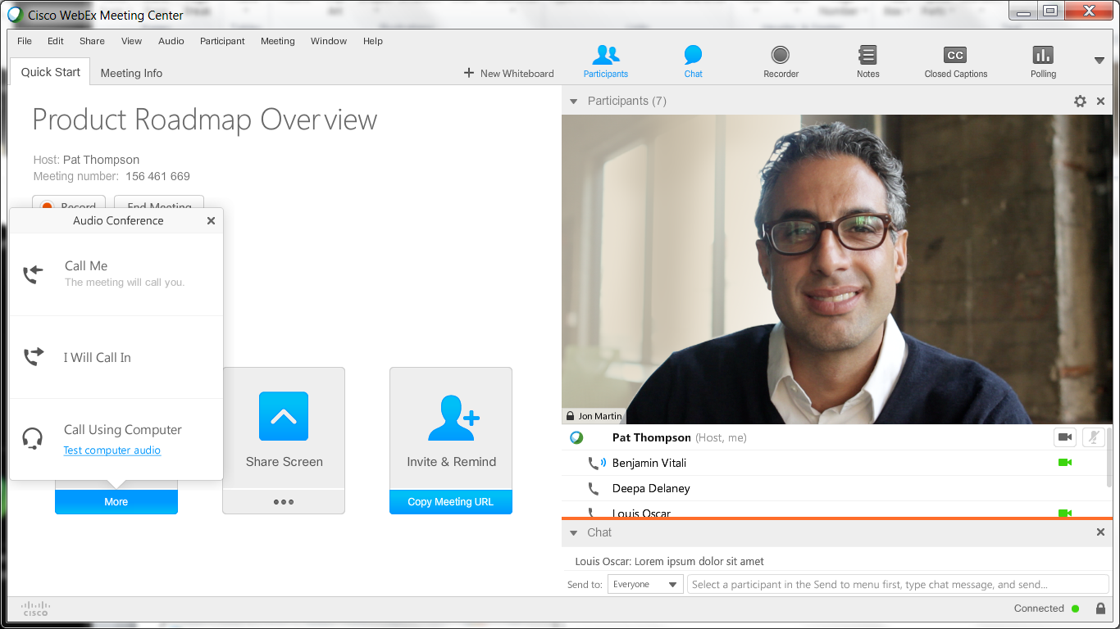
Ctrl-M resulted a blinking orange horizontal line, for about three seconds, above the expanded Chat section.
Second Experience, Stored Numbers:
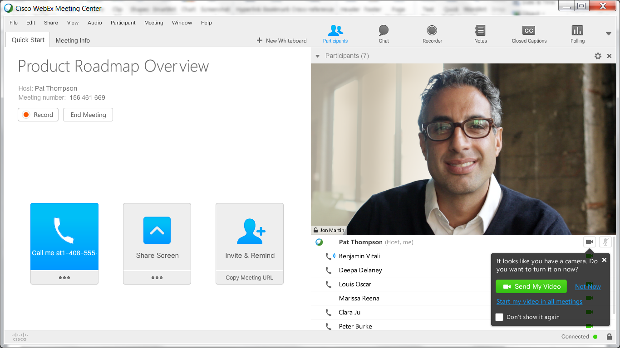
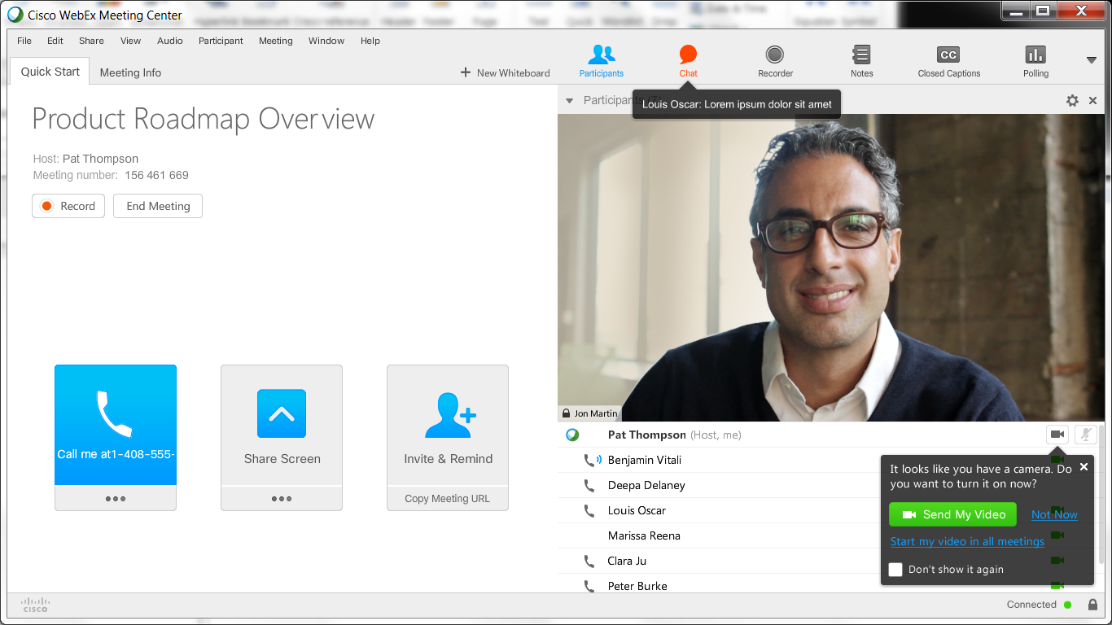
Ctrl-N resulted a blinking red Chat toolbar button and its pop-up help that lasted a couple seconds. And the Chat toolbar button stayed red.

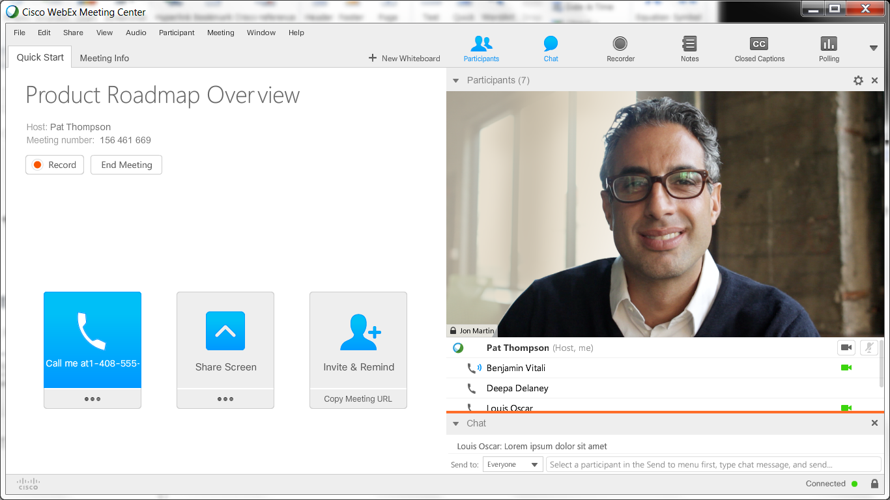
Ctrl-M resulted a blinking orange horizontal line, for about three seconds, above the expanded Chat section.
Presenter View | CMR View | Keep Plist Toolbar:
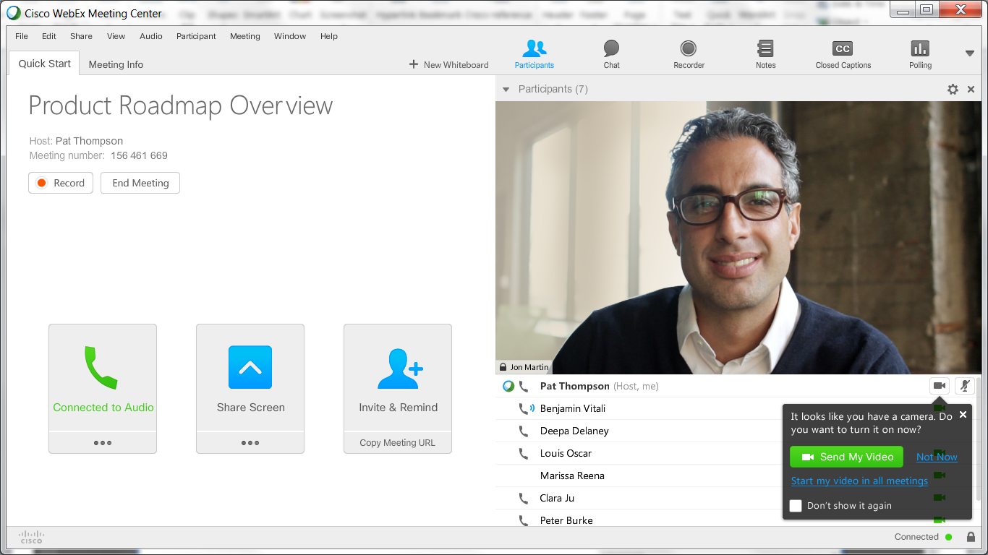
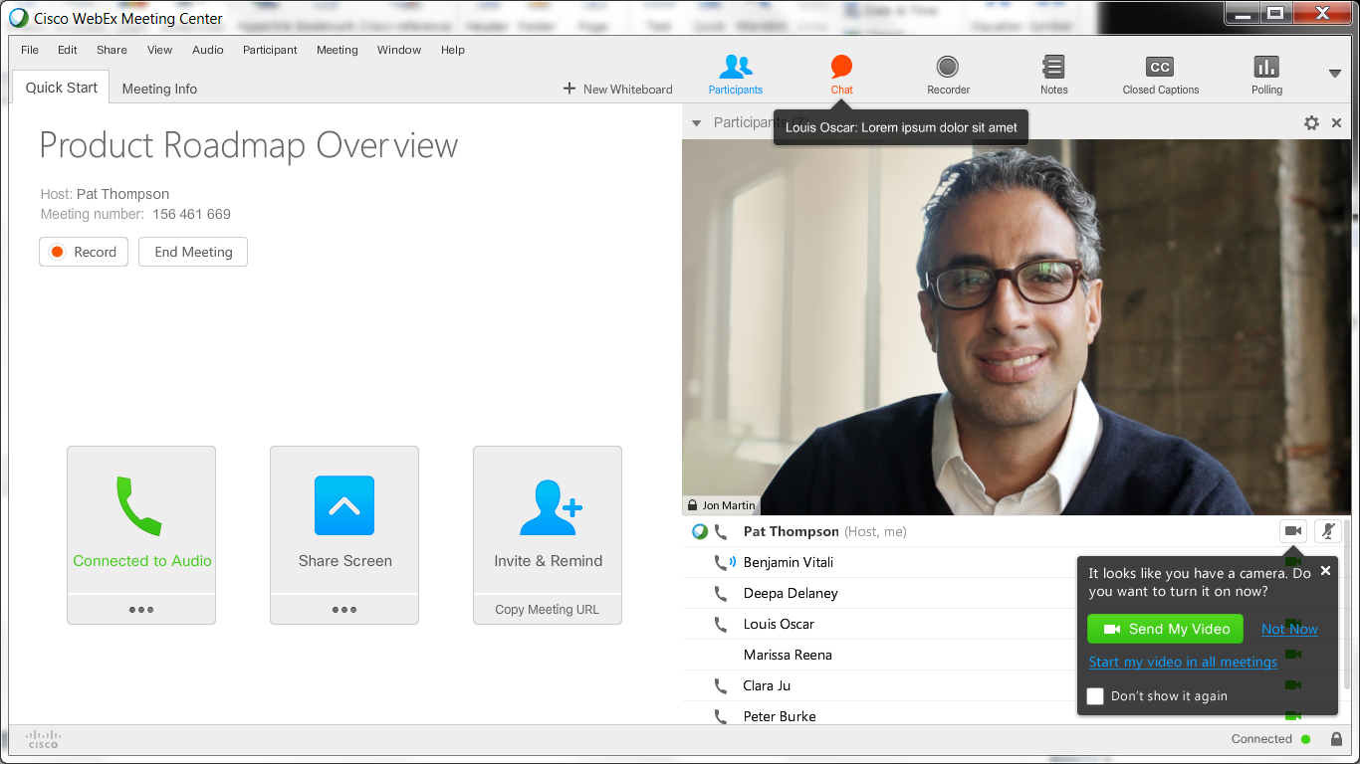
Ctrl-N resulted a blinking red Chat toolbar button and its pop-up help that lasted a couple seconds. And the Chat toolbar button stayed red.

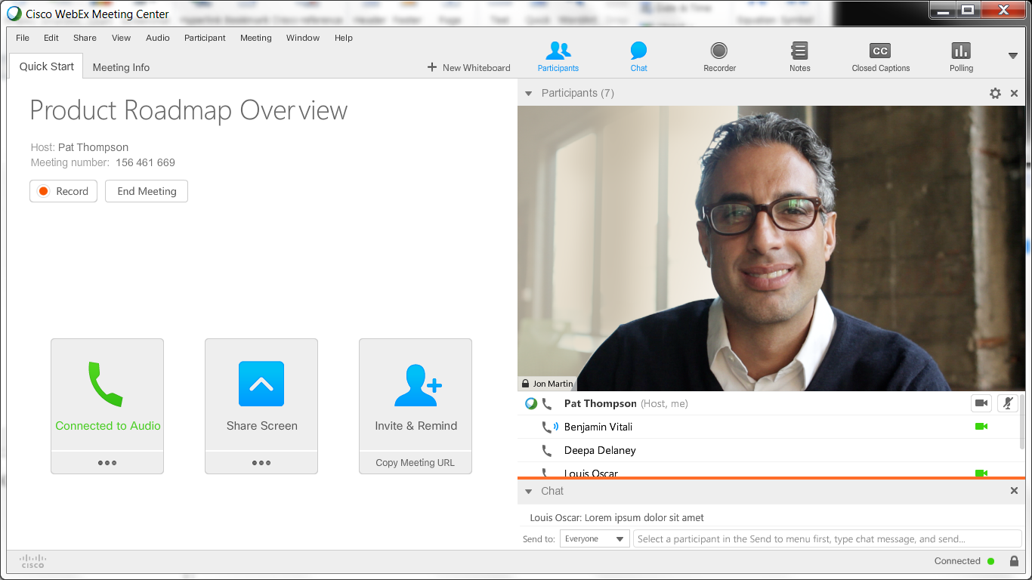
Ctrl-M resulted a blinking orange horizontal line, for about three seconds, above the expanded Chat section.

Presenter View | CMR View | Keep Plist Toolbar:
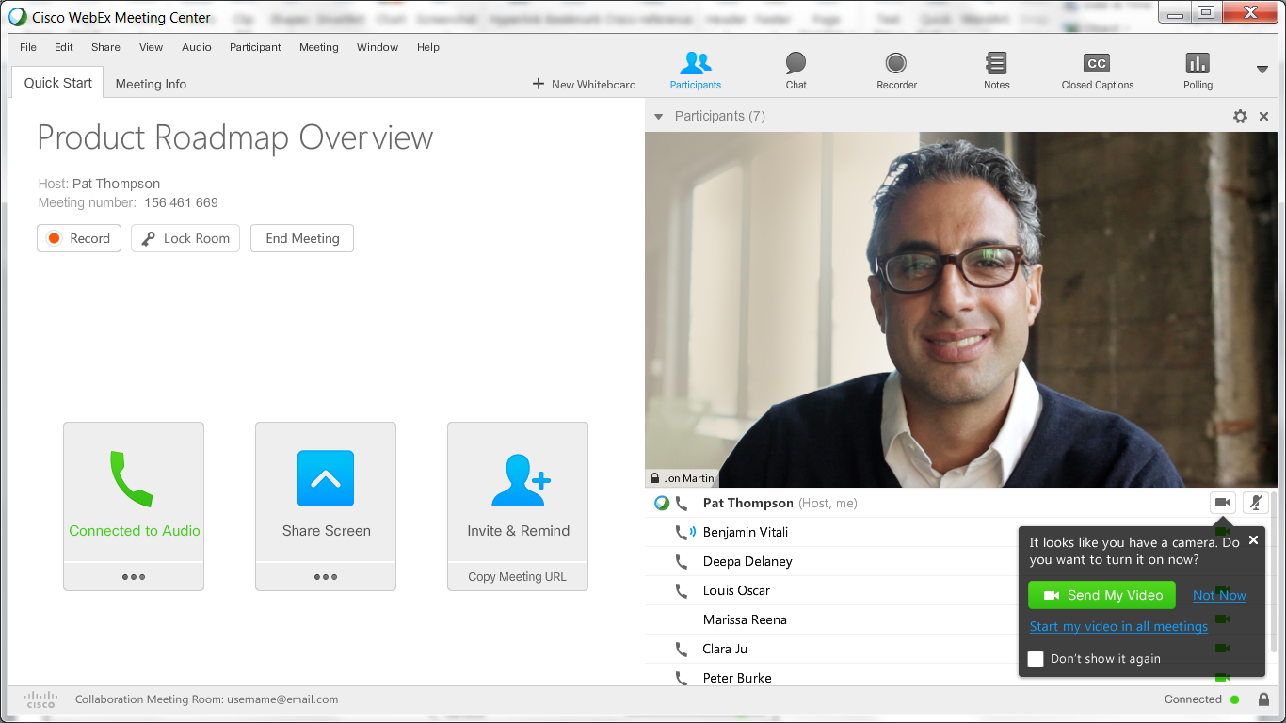
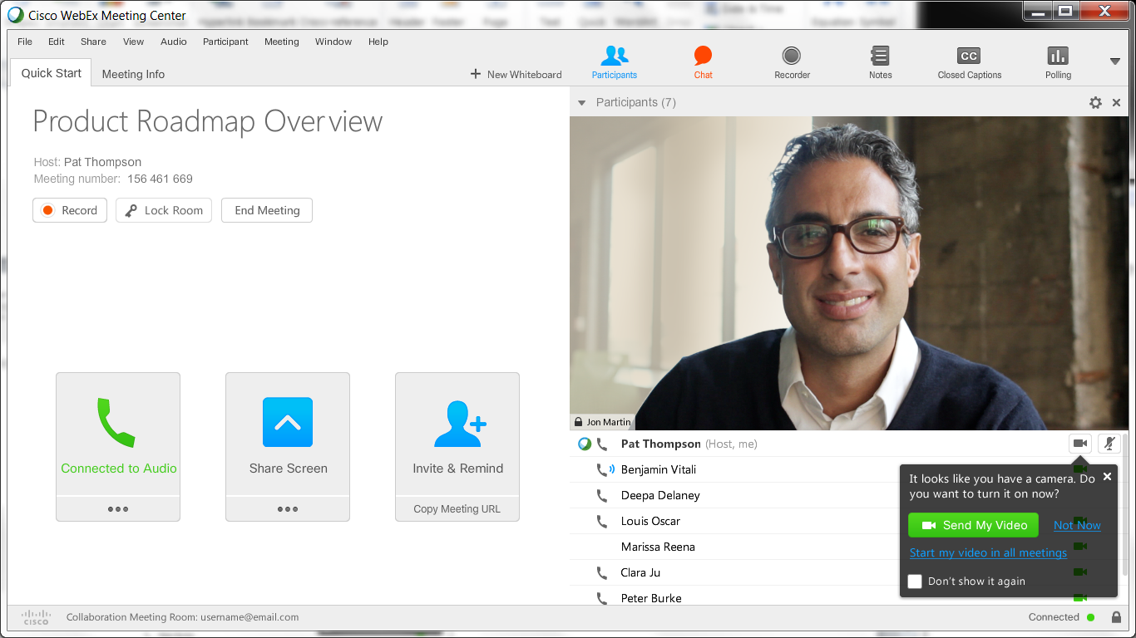
Ctrl-N resulted a blinking red Chat toolbar button and its pop-up help that lasted a couple seconds. And the Chat toolbar button stayed red.
Presenter View | CMR View | Keep Plist Toolbar:
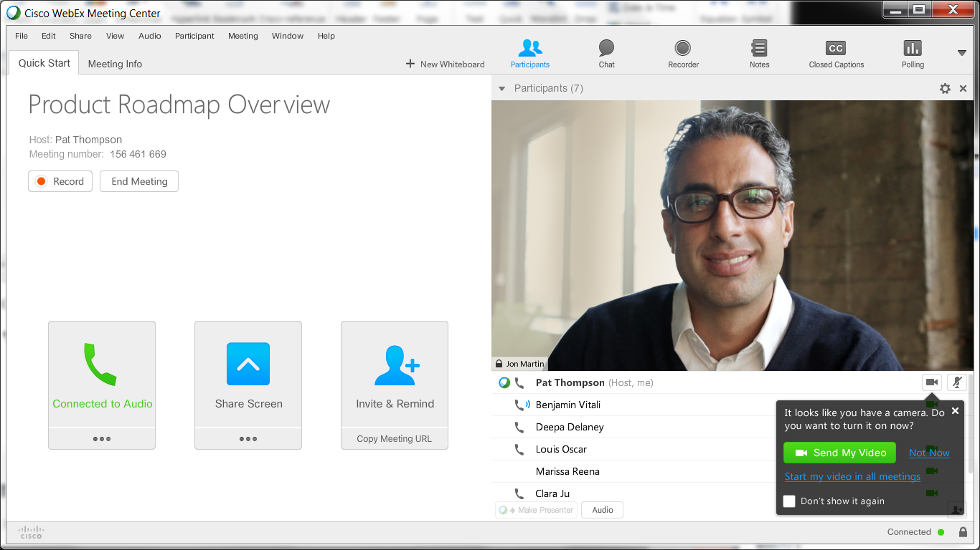

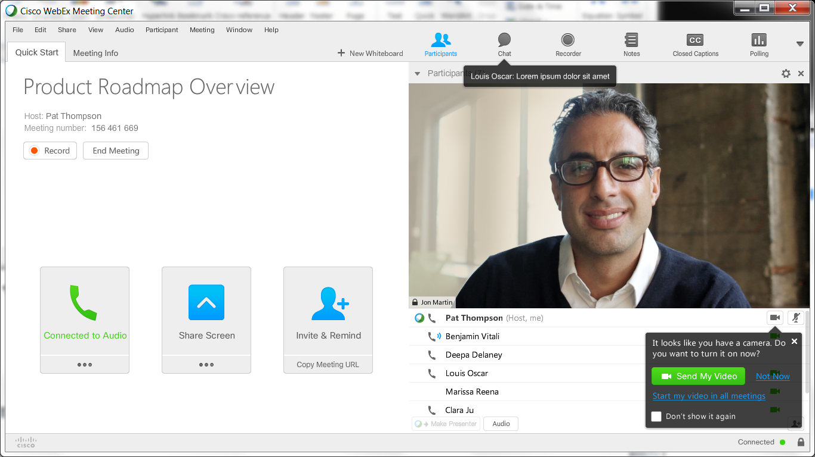
Ctrl-N resulted a blinking red Chat toolbar button and its pop-up help that lasted a couple seconds. And the Chat toolbar button stayed red.
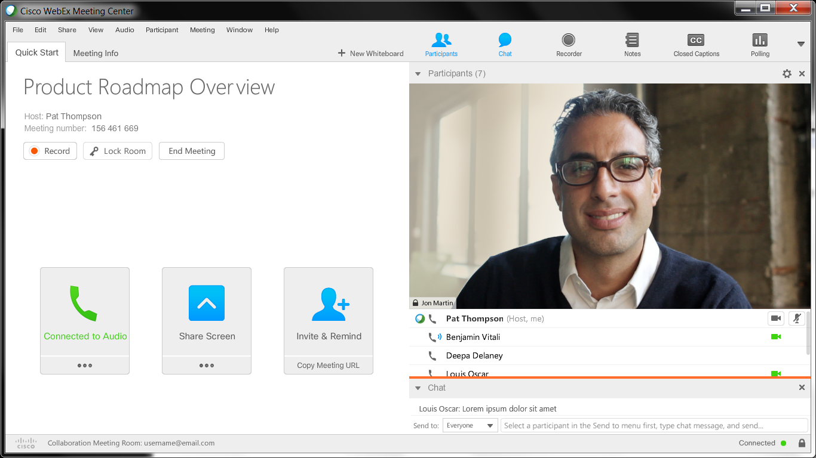
Ctrl-M resulted a blinking orange horizontal line, for about three seconds, above the expanded Chat section.

Attendee View | CMR View
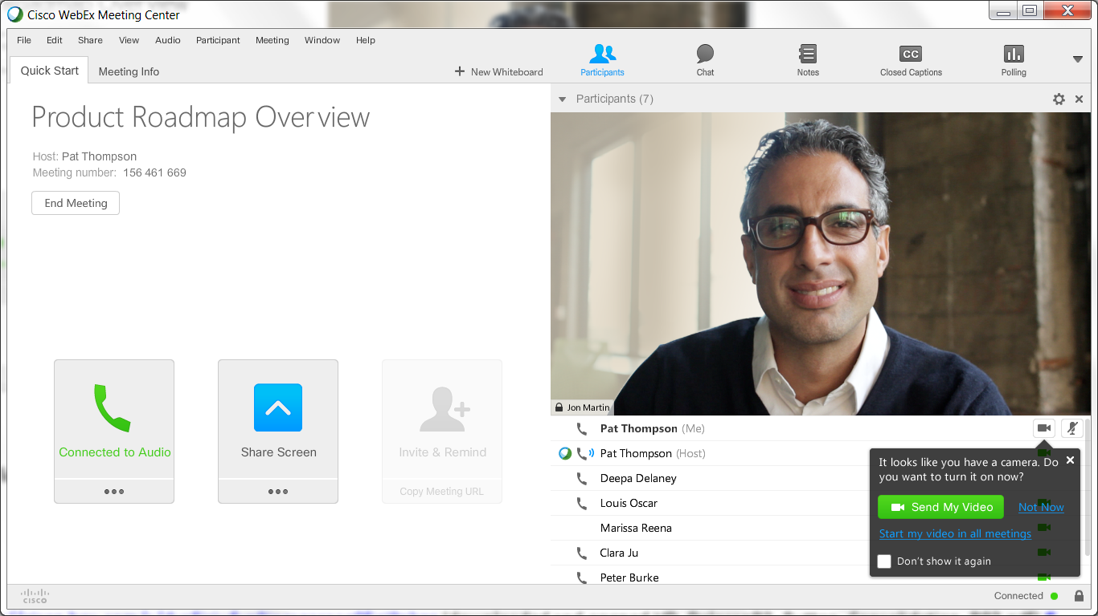
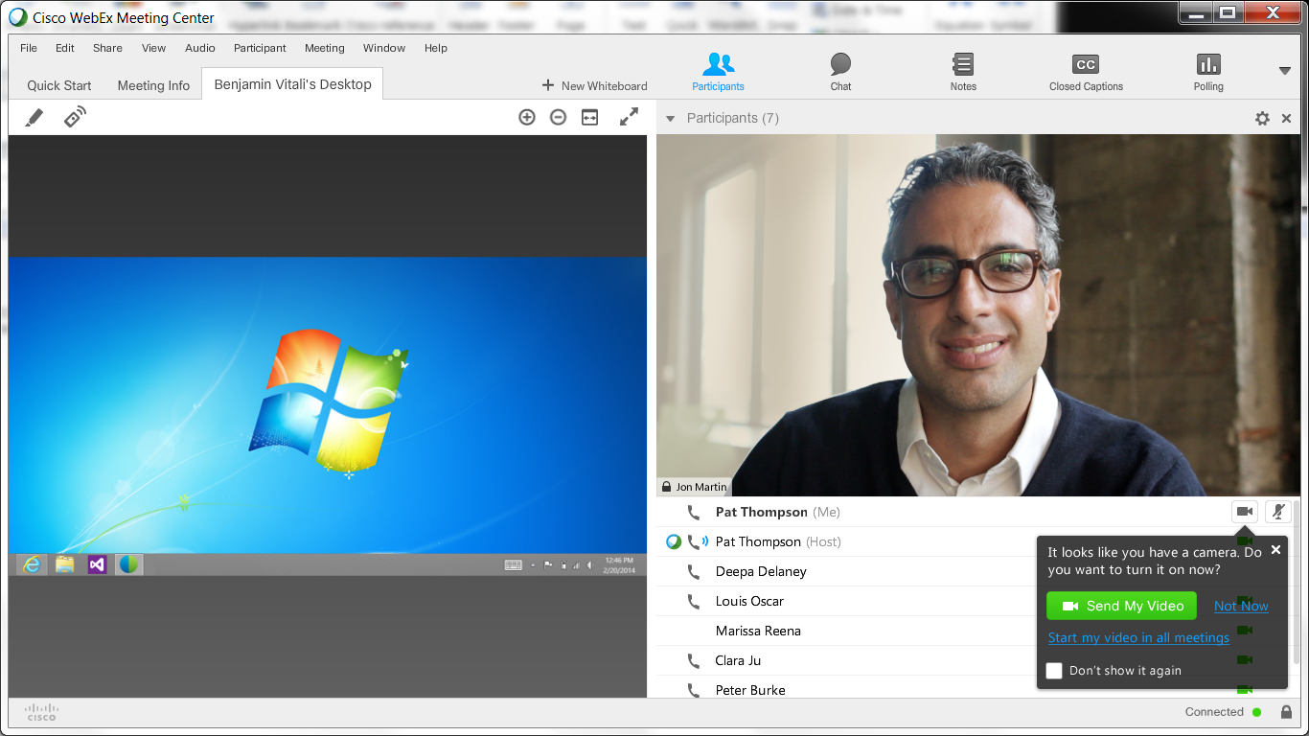
Ctrl-D resulted shared desktop.
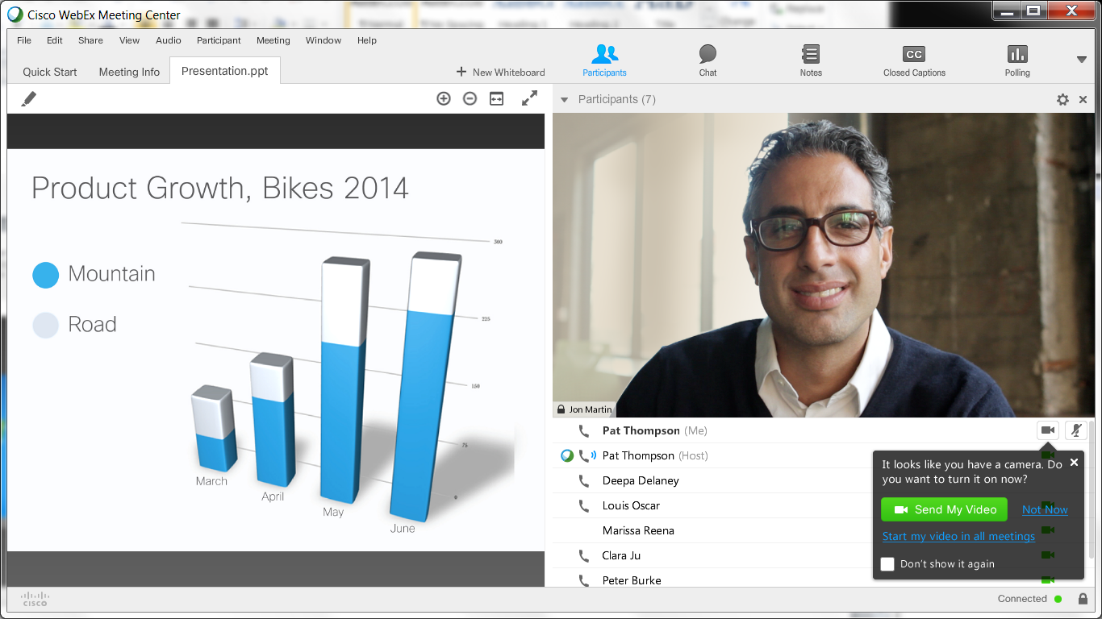
Ctrl-F resulted file sharing.

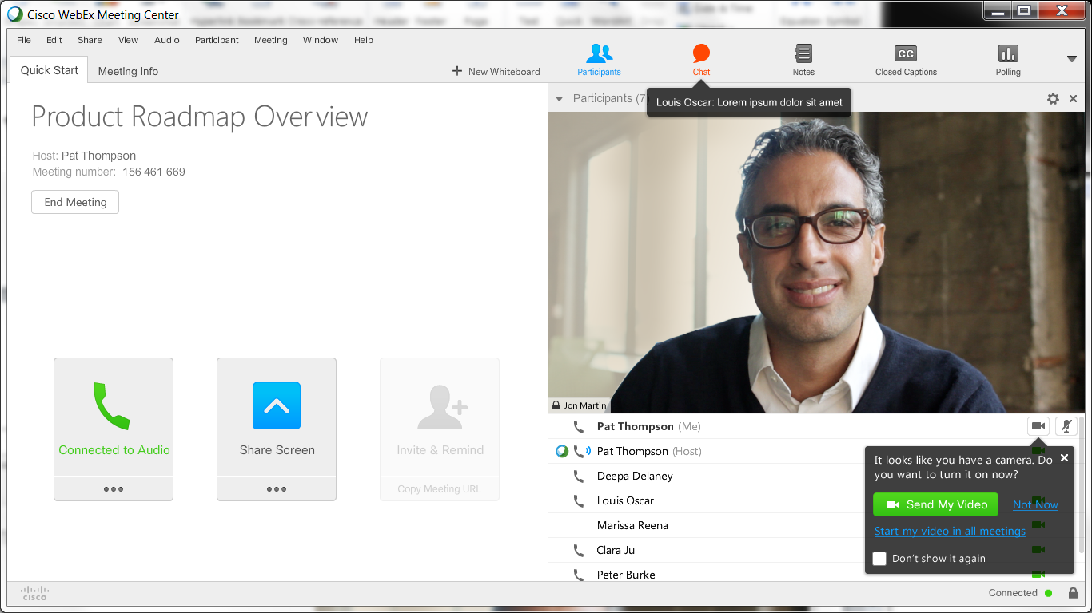
Ctrl-N resulted a blinking red Chat toolbar button and its pop-up help that lasted a couple seconds. And the Chat toolbar button stayed red.

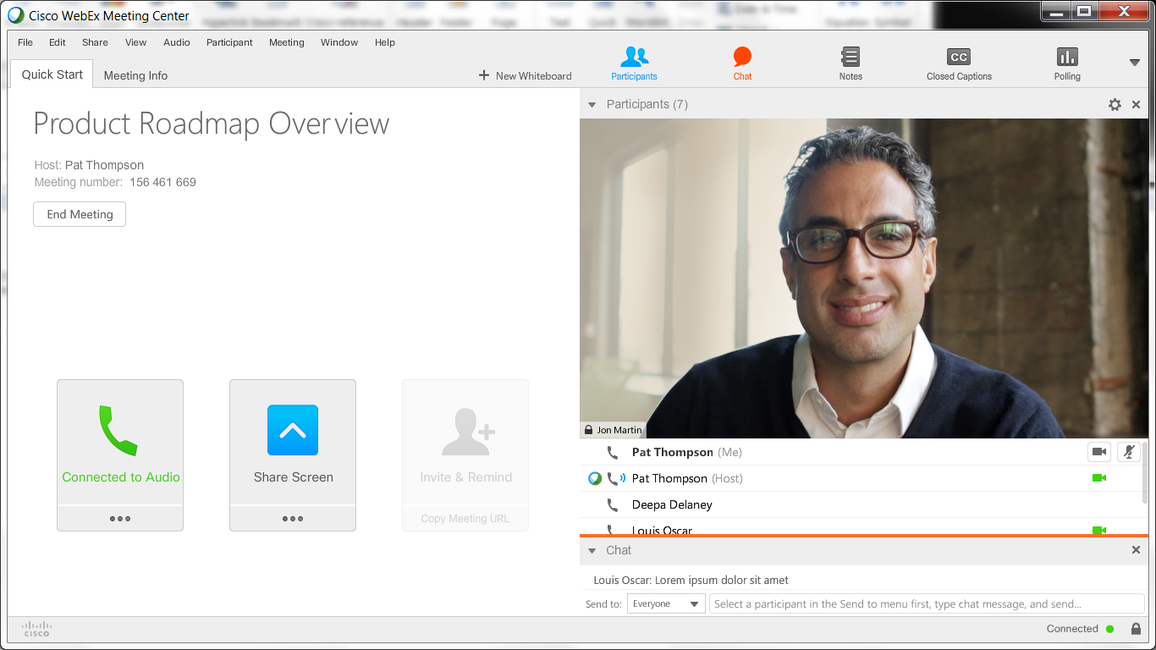
Ctrl-M resulted a blinking orange horizontal line, for about three seconds, above the expanded Chat section.

Attendee View | CMR View
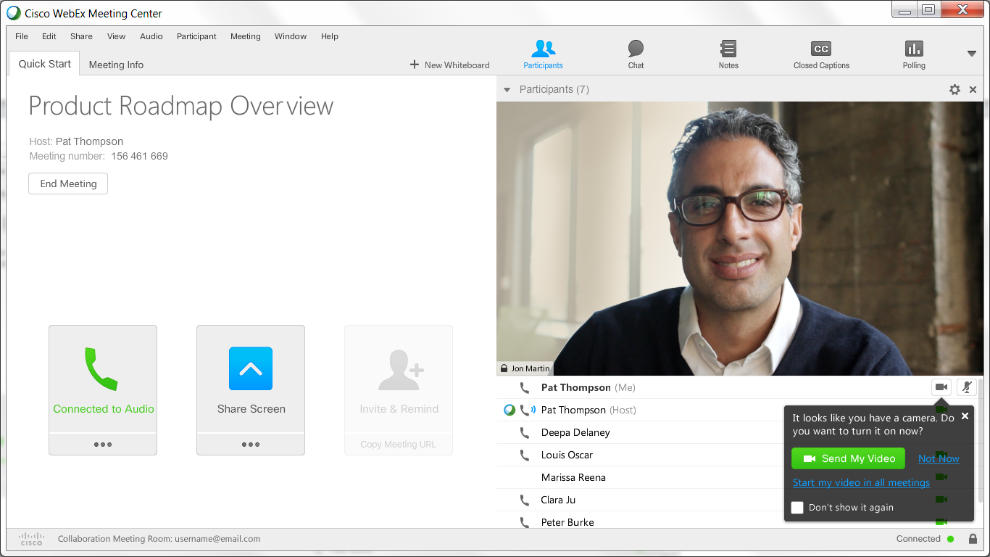

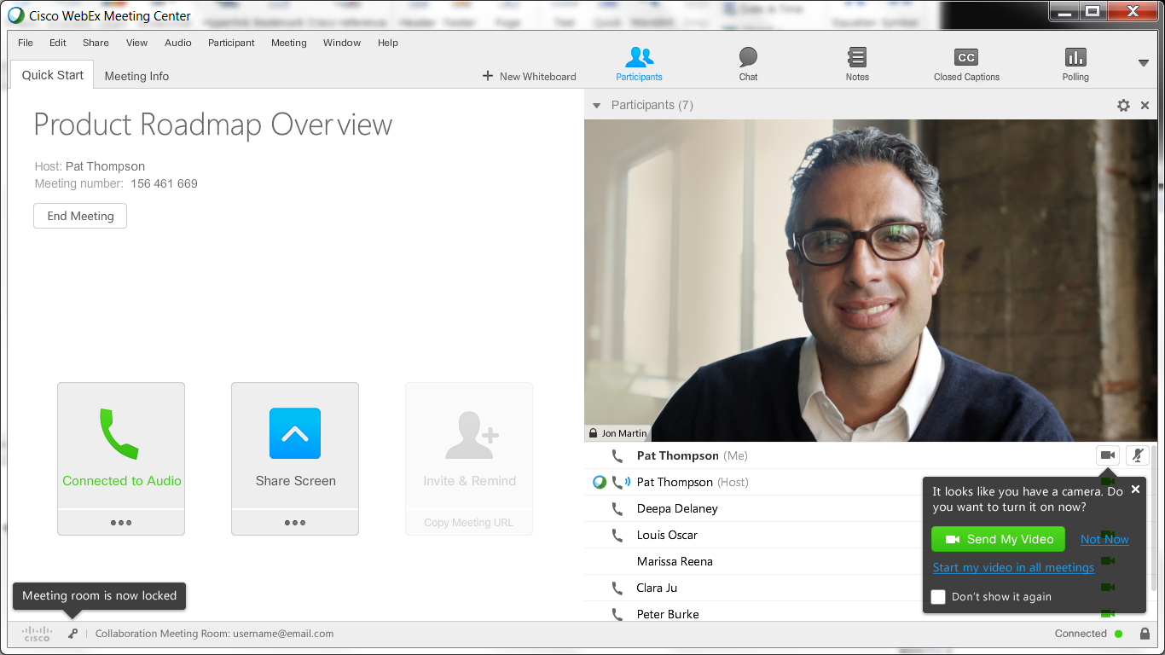
Ctrl-L resulted the locked room with a key icon and its pop-up in the bottom left of the status bar. Doing it again unlocked it.

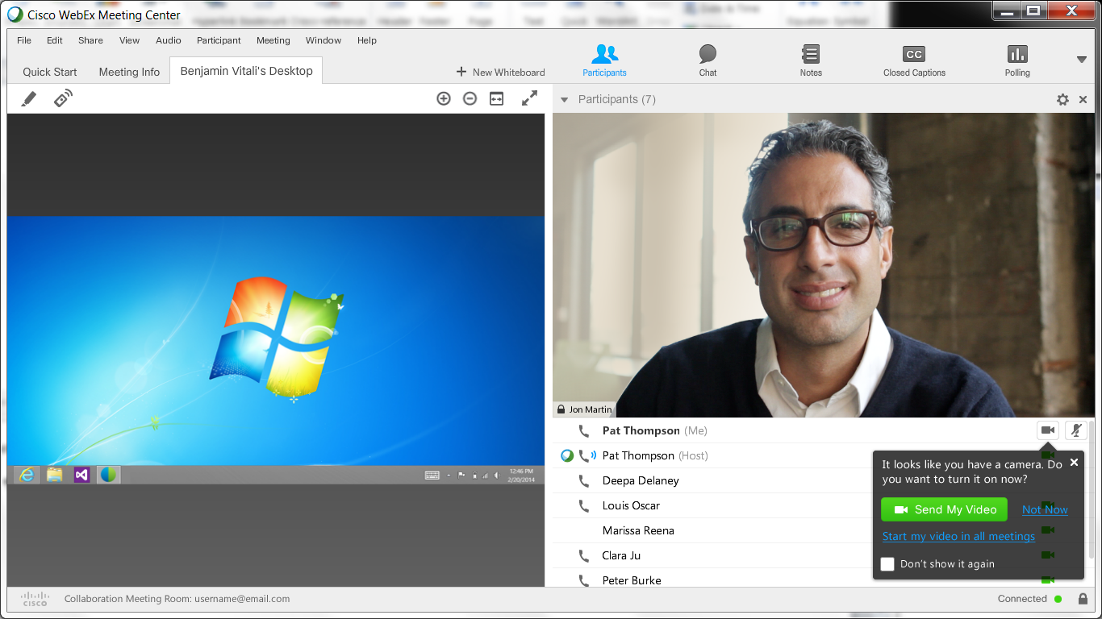
Ctrl-D resulted shared desktop.

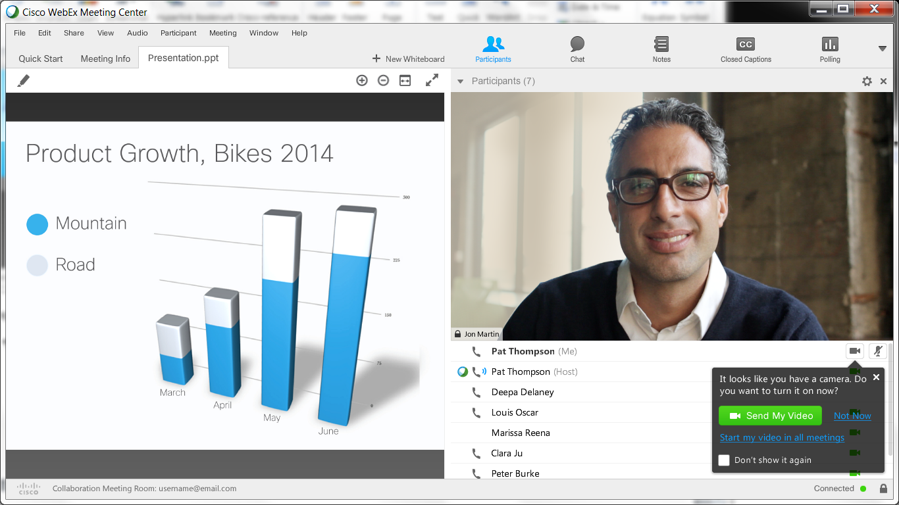
Ctrl-F resulted file sharing.

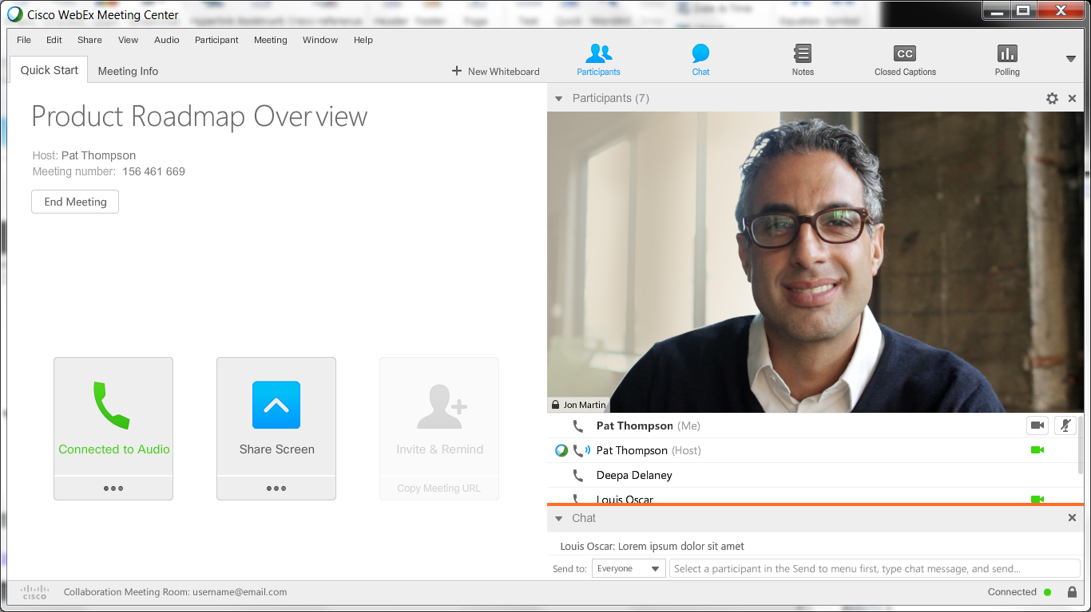
Ctrl-M resulted a blinking orange horizontal line, for about three seconds, above the expanded Chat section.

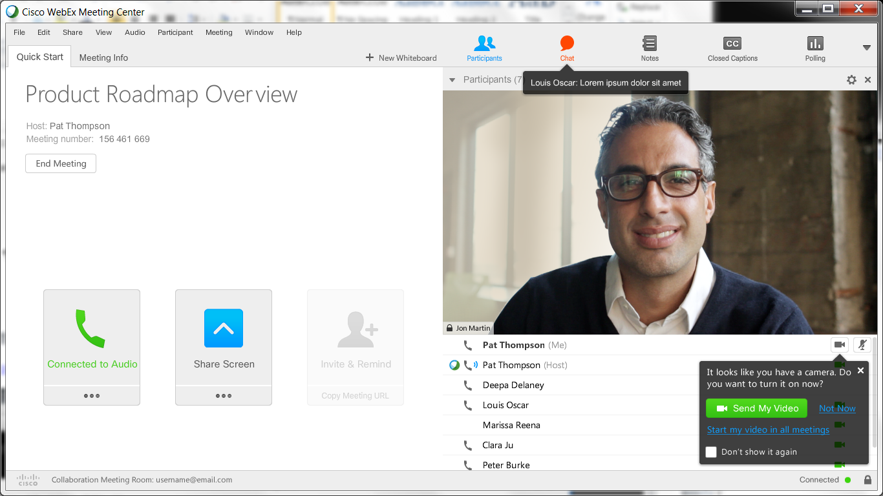
Ctrl-N resulted a blinking red Chat toolbar button and its pop-up help that lasted a couple seconds. And the Chat toolbar button stayed red.
https://gobeta.webex.com/ with 64-bit W7 EE SP1’s IE11 web browser on 6/17/2015, 6/18/2015, & 7/6/2015:
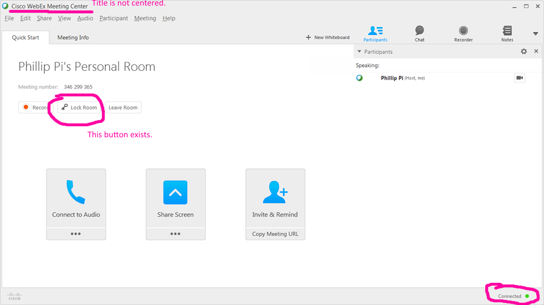
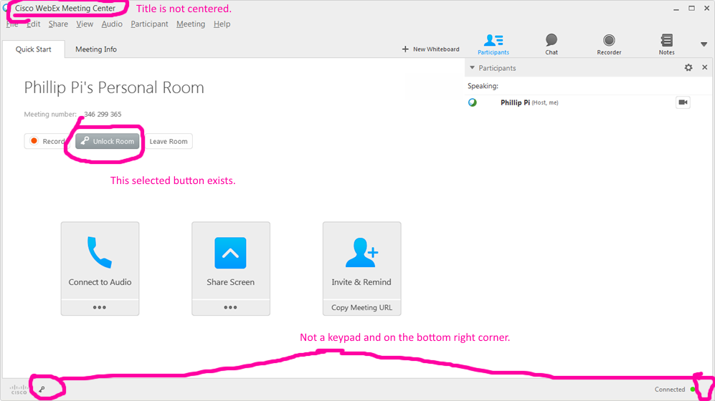
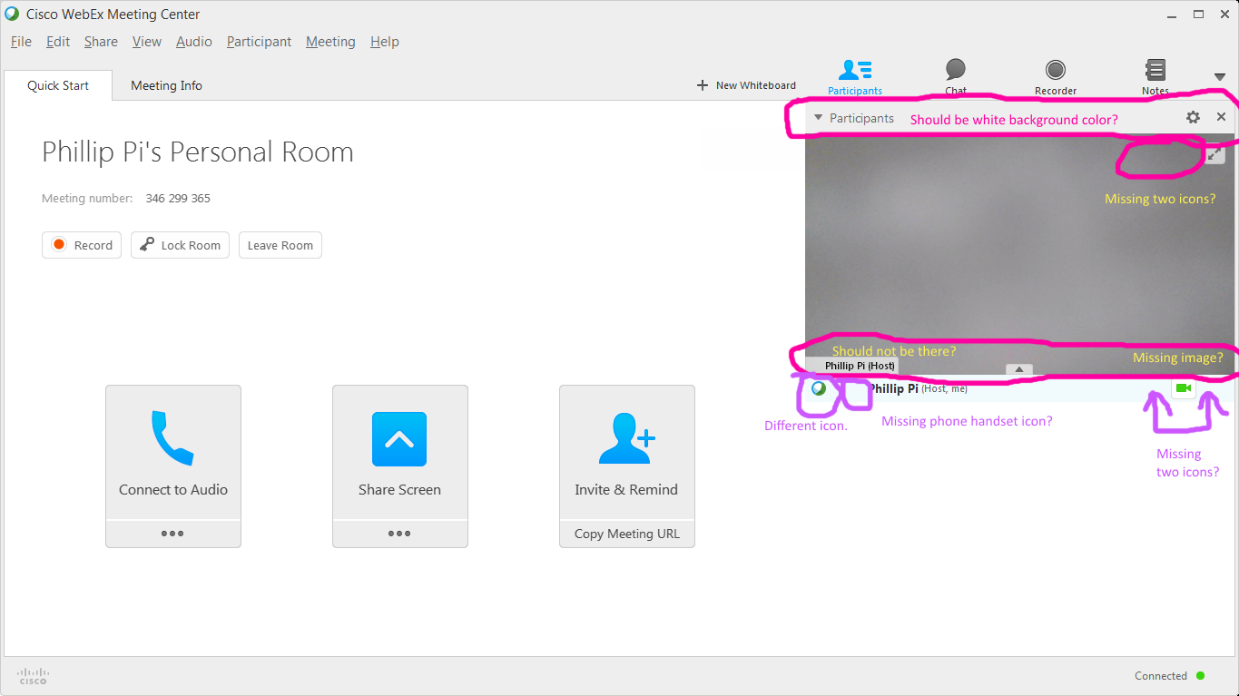
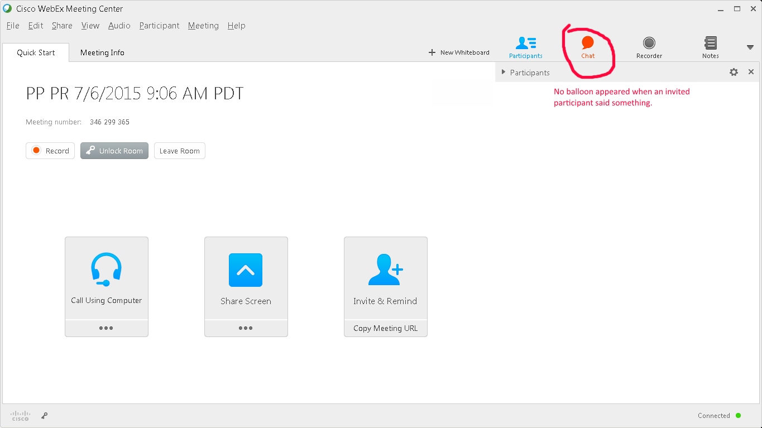
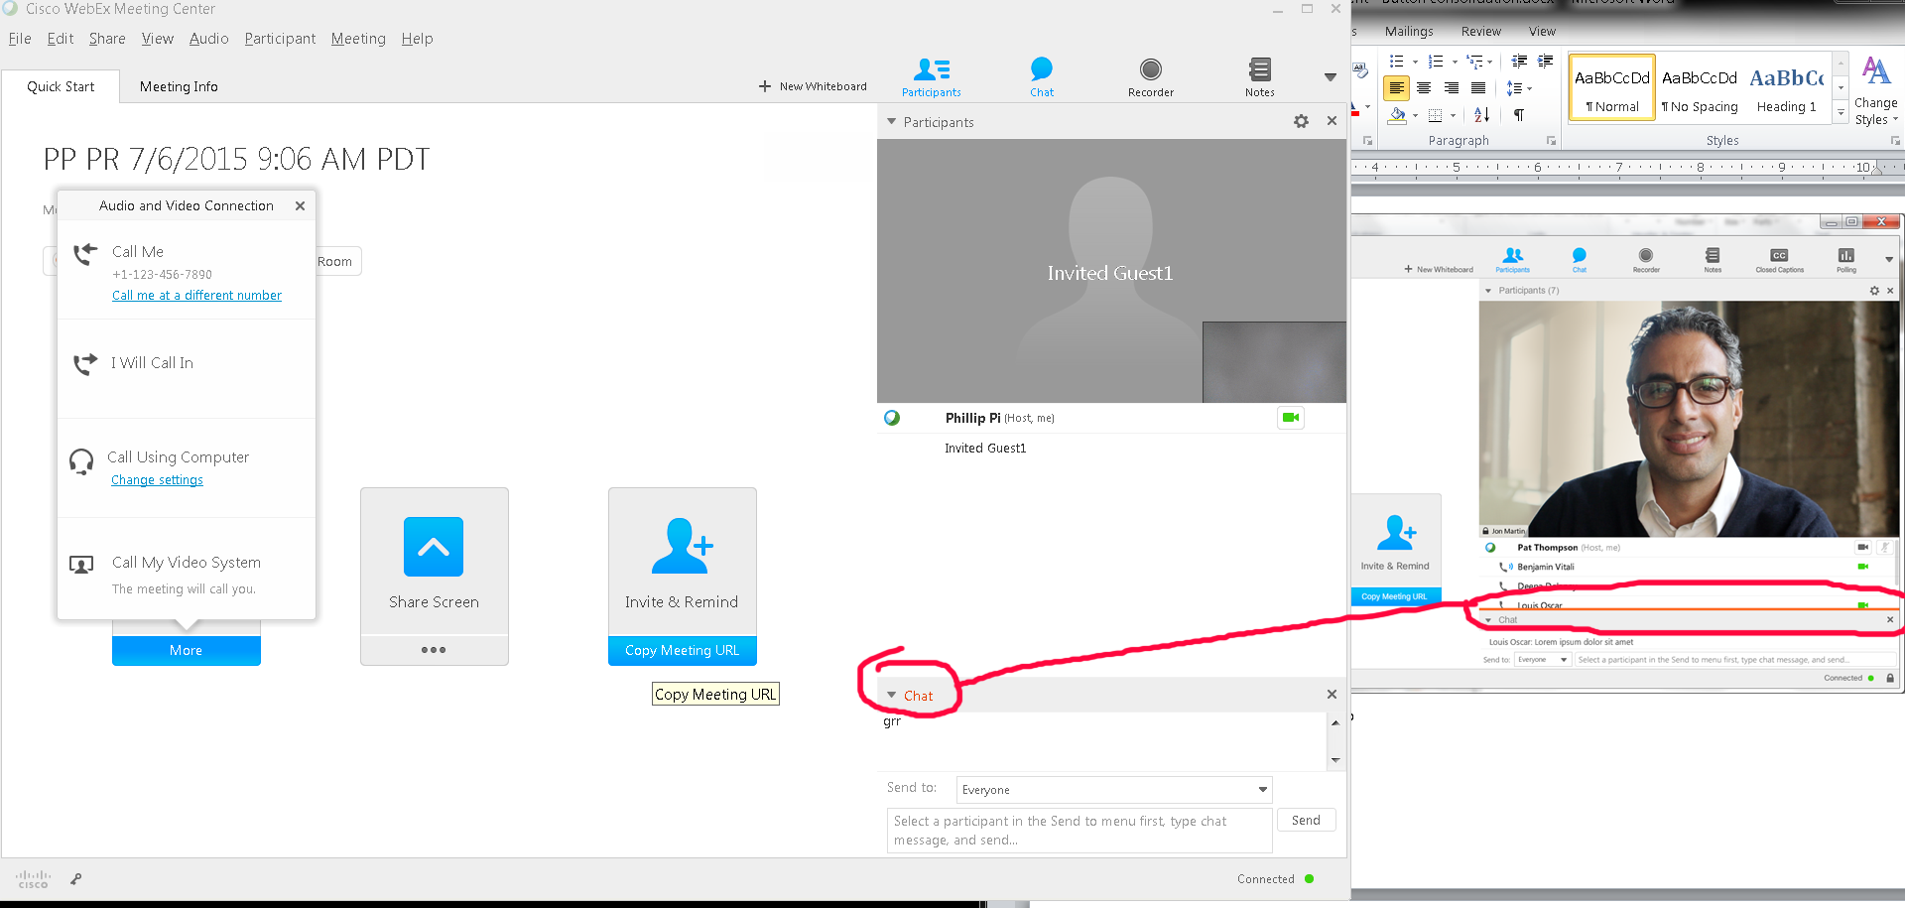
Five Issues:
- A Lock/Unlock Room button right of Record button
- Bottom corners’ padlock graphics (right for padlock and left for key).
- "Cisco WebEx Meeting Center" title is not centered.
- Missing and different icons and images with host’s webcam enabled.
- Missing pop-up chat balloon when the chat section is collapsed.
- Orange “Chat” text shown instead of orange horizonal line for new chat messages.
- Can’t seem to share my screen and file correctly as a host like the documents’ screen shots.

