Phillip Pi’s UI QA Results (mainly visual defect (VD) issues like icons, colo(u)rs, type, alignment, layout grid, etc.) for Spark’s v1.5 desktop client for Windows v1.5… 4/15-19/2016
Notes: Used https://app.zeplin.io/project.html#pid=56e2d17c427e9ee22207db27&dashboard (PostStorm-Finished Concept Images-Desktop) and 64-bit W7 EE SP1 (OS’ (D/P)PI @ 100% (smaller; not default) on a Thinkpad Lenovo W530 laptop/notebook. All softwares had the (new/lat)est updates. All dates and times were based on USA’s PDT zone. Only general differences are documented, not the details like color codes, sizes, etc. Unable to check most of the video conferencing features due to lack of options and access (e.g, having more than three room members with non-Cisco accounts) to test.
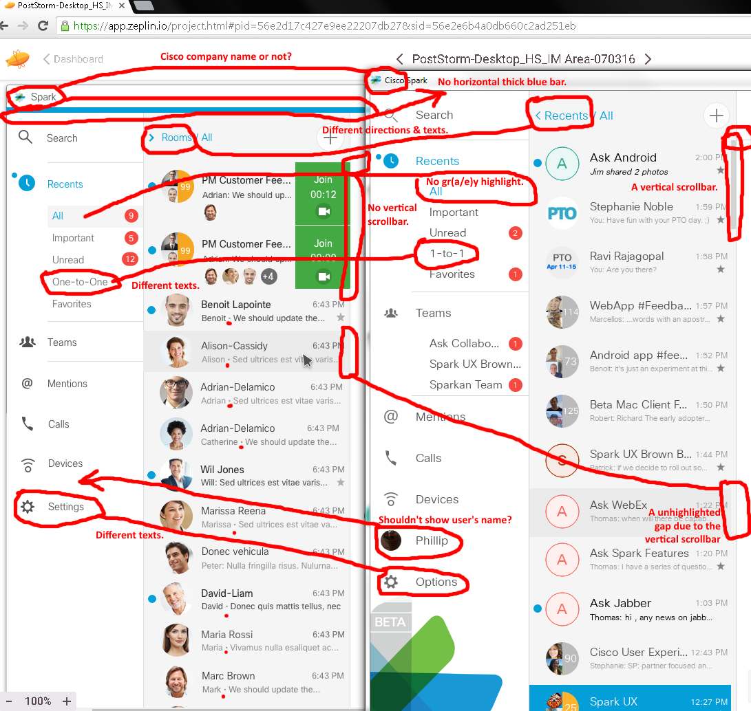V1.5.1464.0 on 4/15/2016 with https://app.zeplin.io/project.html#pid=56e2d17c427e9ee22207db27&sid=56e2e6b4a0db660c2ad251eb (PostStorm-Desktop_HS_IM Area-070316):
Most of top left side (not enough screen desktop resolution to show all at 100% in Zeplin and bottom comparisons didn’t show any obvious mismatches)’s issues found:
- “Cisco” in Spark’s title bar. Redline says no to the company’s name.
- Client shows no horizontal thick blue bar below “Cisco Spark”’s title bar.
- Redline’s “> Rooms” versus beta’s “< Recents” for “/ All”.
- “Recents” sections show different room texts: Redline’s “One-to-One” versus client’s “1-to-1”.
- “Recents”’s highlighted “All” shows a missing gr(a/e)y color background rectangle box.
- Vertical scrollbar: Redline doesn’t show it, but it exists in the build.
- Windows also shows the darker gr(e/a)y color gap where the vertical scrollbar area is.
- Above my build’s vertical scrollbar, there is a horizontal gr(a/e)y line on its right. Redline doesn’t show this line.
- Redline doesn’t show user’s menu option with its circular avatar image and name, but client did with “Phillip” and his circular ninja ant image.
- Menu options’ gear icons’ texts: Redline’s “Settings” versus client’s “Options”.
- Redline shows middle dots (·) between most names and their messages. Others show colons like in my client.

Most of top’s right side’s (not enough screen desktop resolution to show all at 100% in Zeplin and bottom comparisons didn’t show any obvious mismatches):
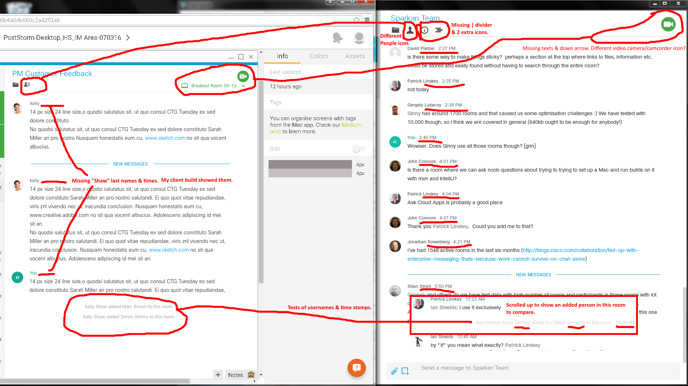
Issues Found:

- Different "Show people..." icons.
- | divider in the icon area.
- Two extra icons ("Room meeting information" and "Integrations") in the client build or maybe the redline’s two icons were missing.
- Redline showed missing people’s last names and their time stamps in their messages, but client build showed them.
- Client build showed added users, to the room, show their usernames and times. Redline didn’t.

Bottom Right’s Section’s Comparisons:
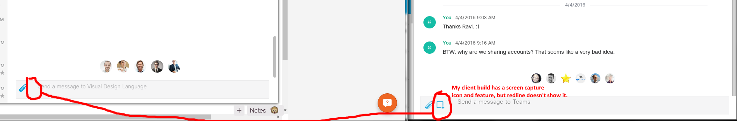
Issue Found: Redline shows there is no screen capture icon and option, but the client build has it.
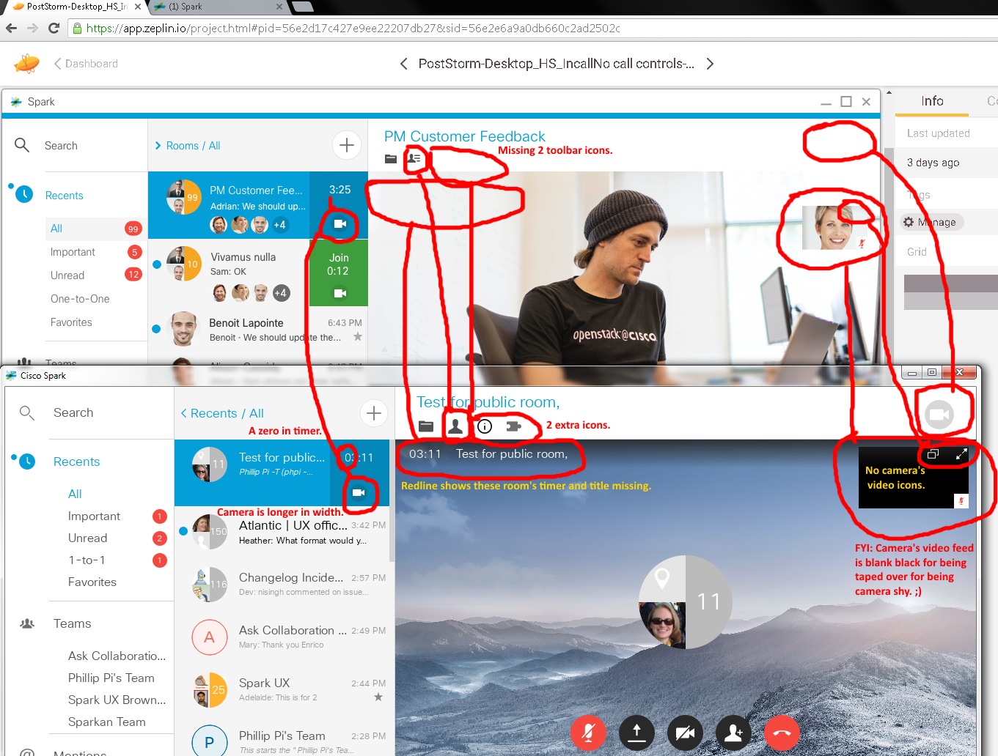
V1.5.1464.0 on 4/18/2016 with https://app.zeplin.io/project.html#pid=56e2d17c427e9ee22207db27&sid=56e2e6a9a0db660c2ad2502c (PostStorm-Desktop_HS_IncallNo call controls-070316 [never saw no controls though]). Issues found (ignoring the same ones reported earlier) in top (not enough screen desktop resolution to show all at the same time) section:
- Active camera icon sizes are slightly different in terms of widths (redline shows thin camera while the build shows a long camera).

- Build’s timer shows a zero in the minutes’ first digit for a single non-0 minute (03:11) while redline’s timer doesn’t show it (3:25).

- Rooms’ toolbar icons: Redline shows two missing right two icons ("Room meeting information" and "Integrations") after its | divider, but the build shows them without its | divider. Also, "Show people..." icons are different.

- In the top right corner, redline does not show a video gr(a/e)y camera icon while the build does.

- Windowed camera screens are in different positions. Redline shows lower than the build’s (closer to the top).

- Redline’s video camera’s windowed screen does not show the two icons (pop-up and fullscreen) while client does.

- In the rooms, redline doesn’t show the timer and its room’s title. Client build does.

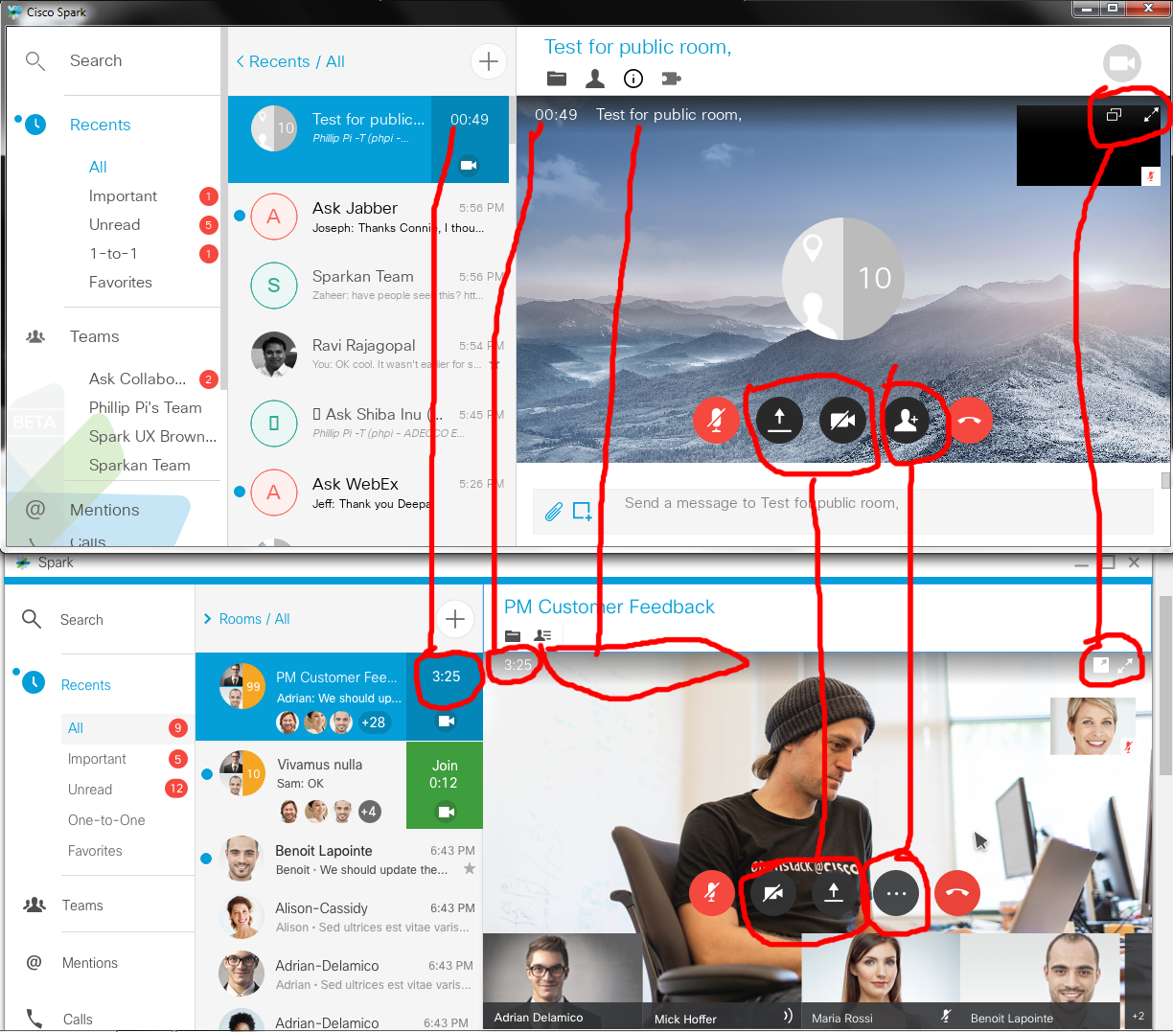V1.5.1464.0 on 4/18/2016 with https://app.zeplin.io/project.html#pid=56e2d17c427e9ee22207db27&sid=56e2e6abcd65b9192e47b551 (PostStorm-Desktop_HS_Incall-070316):
Issues found (ignoring the same ones reported earlier) in top (not enough screen desktop resolution to show all at the same time) section:
- Rooms’ timers show zeros (00:49) in the minutes in the build while redline doesn’t (3:25).
- Client shows the room’s title, but redline’s doesn’t.
- Room’s controls have different icons (build’s “Invite guests and redline’s “…”) and different (location/order)s (screen share and webcam).
- Windowed video camera feed show its icons in different positions (redline’s show then above the windowed video screen while build shows it inside).
On 4/19/2016, I finally sort of figured out and managed to get a couple calls to join and after joining with v1.5.1464.0 with a few accounts (2 non-Cisco accounts + 1 Cisco account; couldn’t go more than 3 at the same time for its free service and required paid upgrades) and clients with limitations:
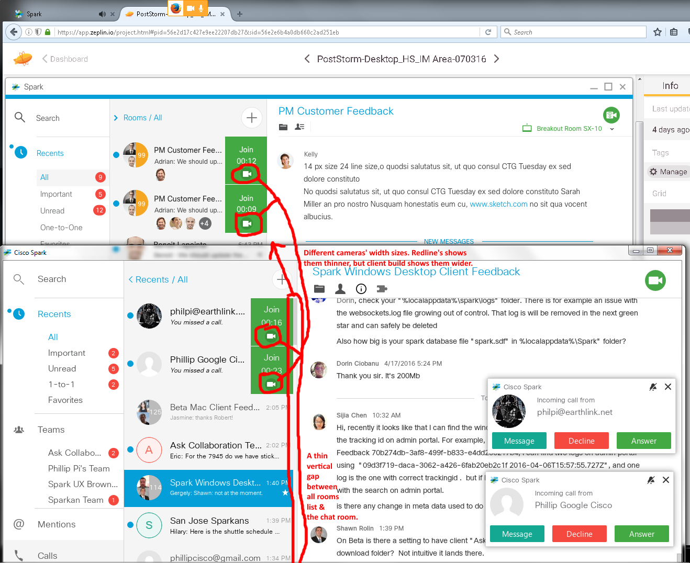
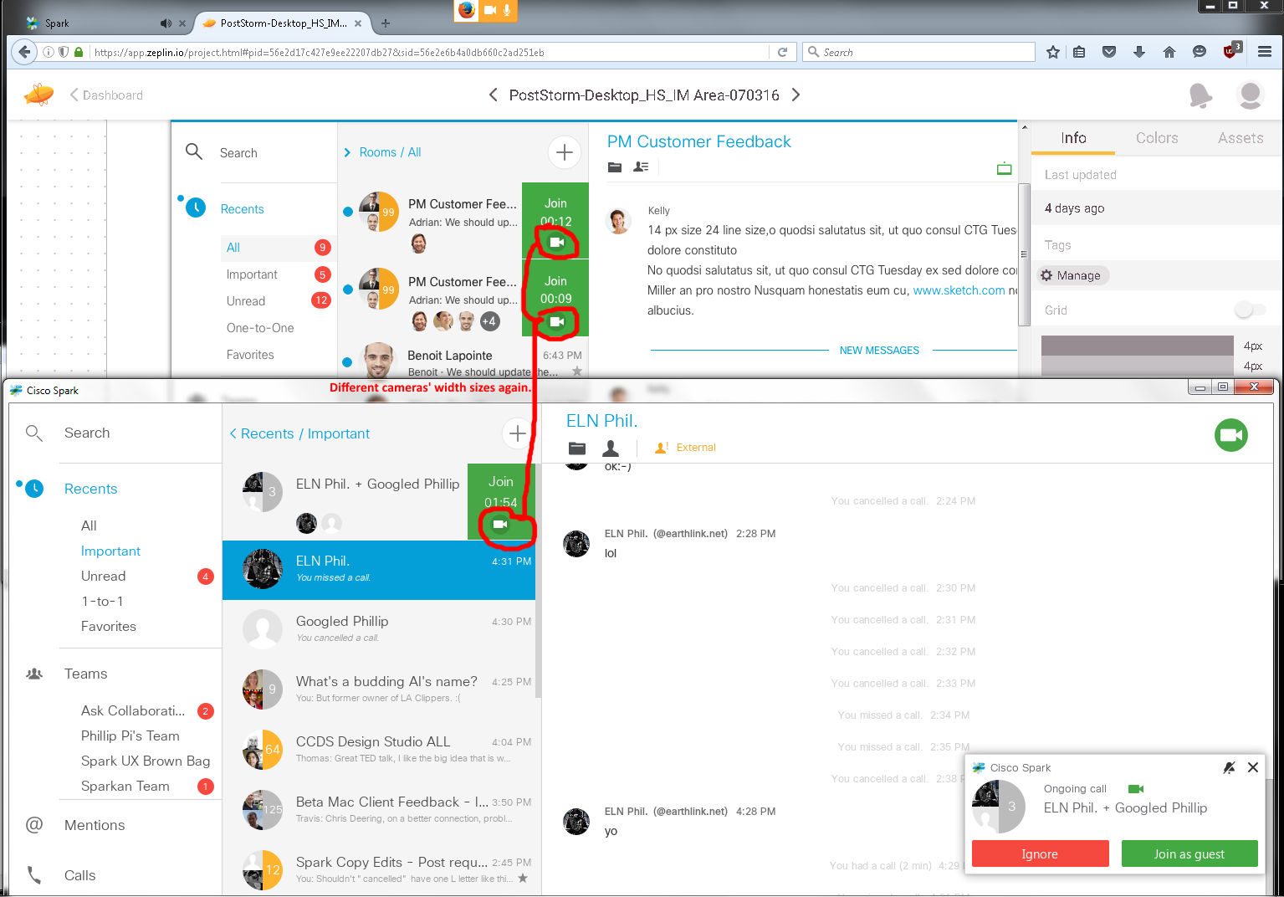
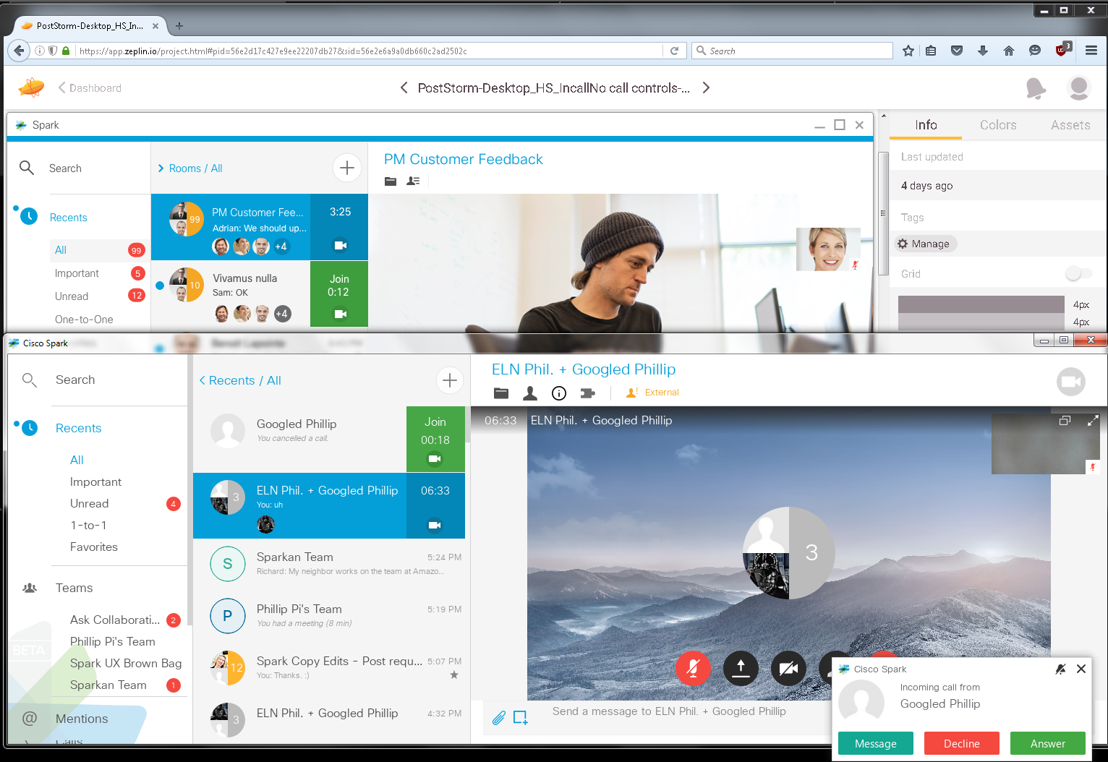
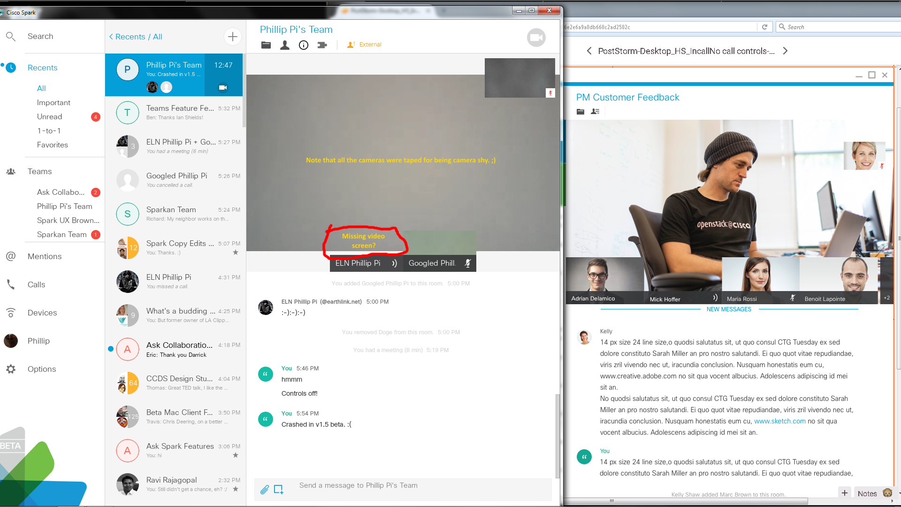
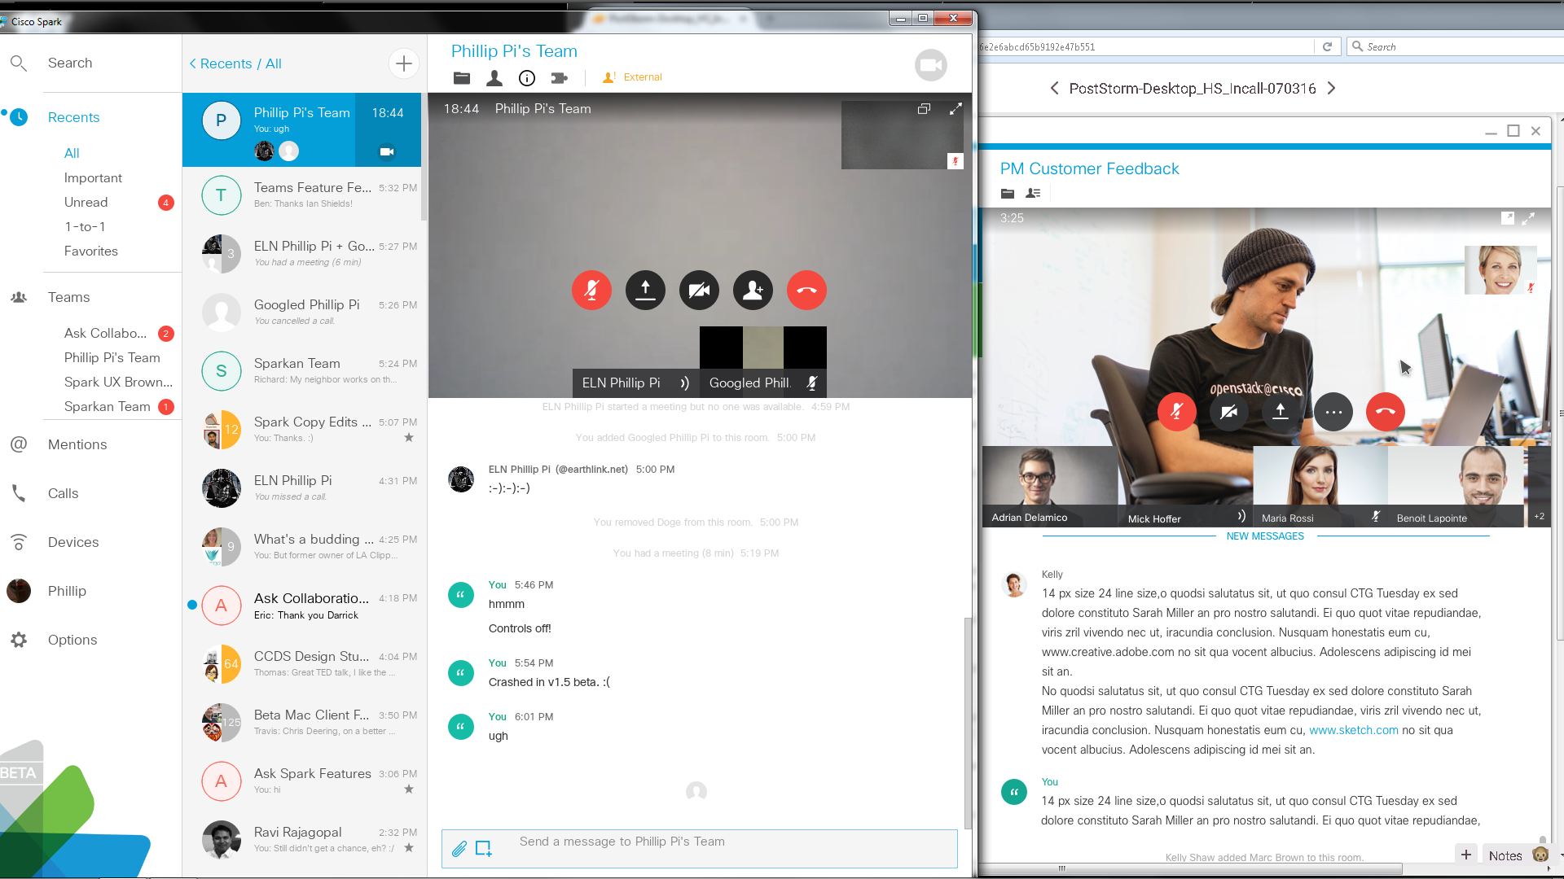
Issues were identical/similiar what were seen in the previous pages.

