Elements of Spark Copy Edits (10/21/2015 (top) - 12/10/2015 (bottom); USA’s West Coast Time Zone) by Phillip Pi
3 KEY Notes From 10/21/2015 Evening PDT in Mac OS X client:
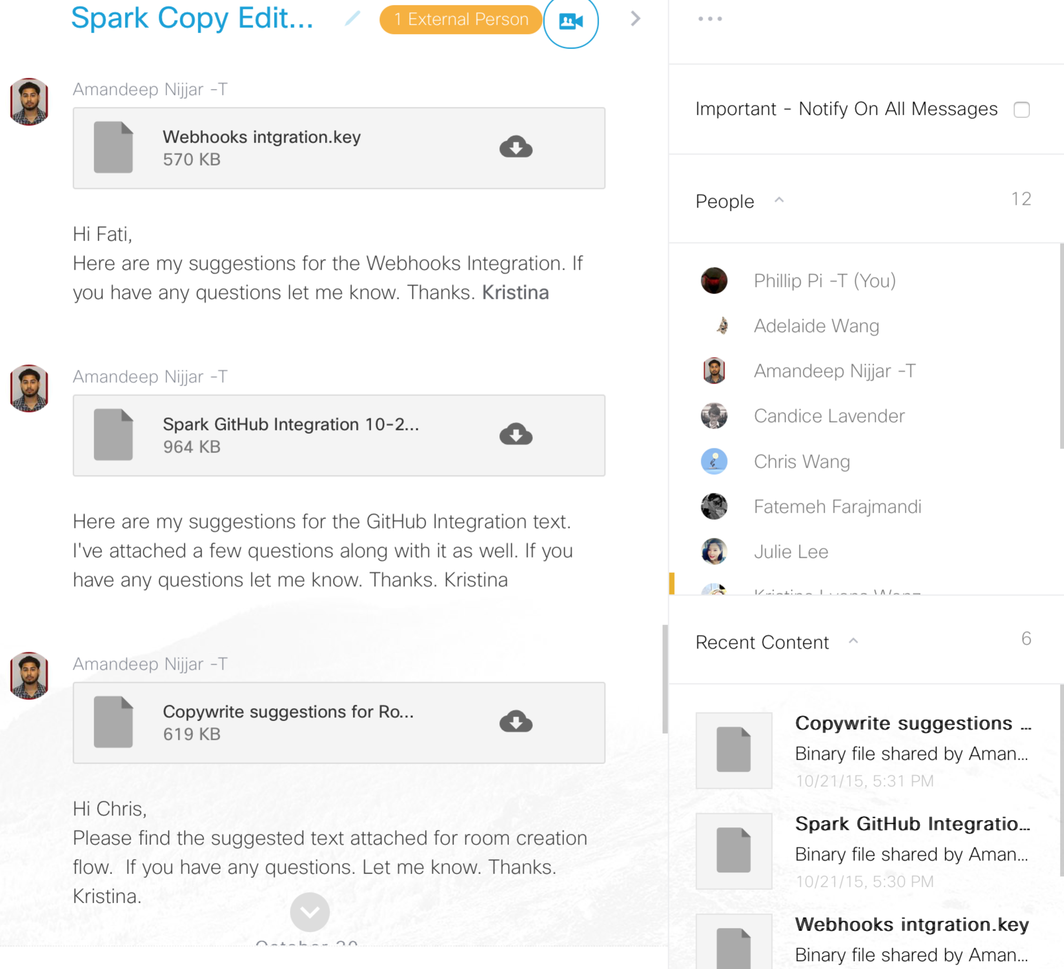
“Images” instead of “Photos” for sharing from 11/4/2015 afternoon PST:
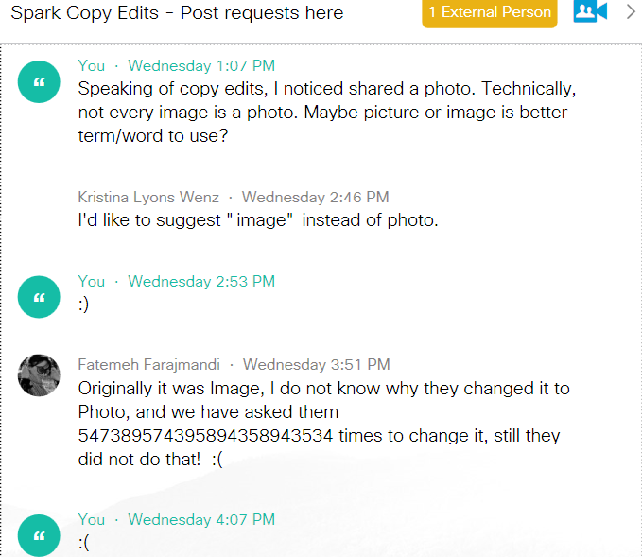
Below is a screen shot/capture example in Windows’ b2723 software client (same in Mac OS X’s b3603 & its SDK v0.5.32 software, and Google Chrome web browser clients) when “… shared a photo.” (only Windows software client showed a period) in “Web App #Feedback” room on 11/6/2015 at 1:59 PM PST from Admas Molla:
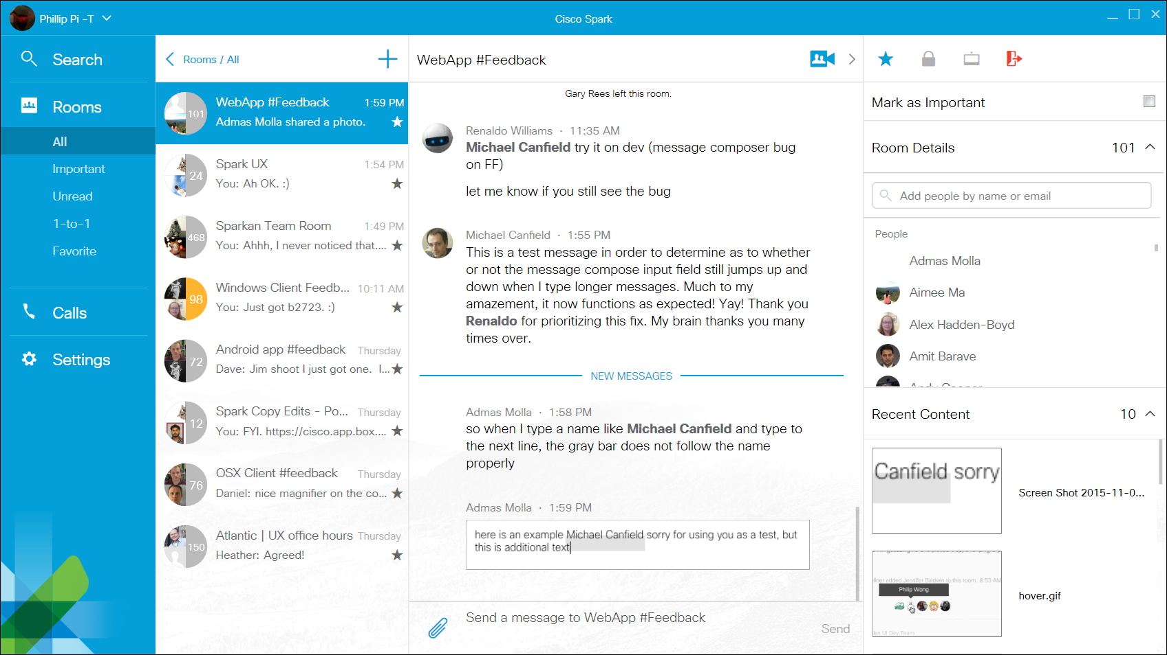

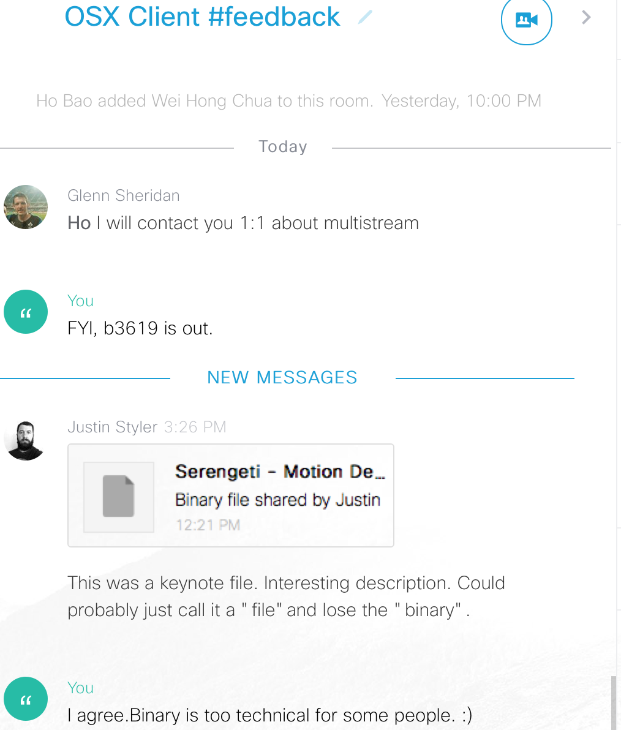
On 11/9/2015, Justin Syler shared a text issue with “Binary file shared by…” with a shared .KEY file in his Mac OS X software client. “Binary” word is too technical for non-technical users.
12/10/2015 (seen in both Windows’ b3074 & Mac OS X’s b3734 clients) when seeing other people (your own is OK)’s deleted messages like in this example screen shot/capture:

