V1.0.0.1(566-609) (downloaded and installed https://download.ciscospark.com/windows/SparkInstaller.exe from http://www.webex.com/ciscospark/downloads.html on 8/3/2015 at about 3:35 PM PDT. Got its developer console access, from Alex Hadden-Boyd, and automatic software upgrade with their required restarts on 8/10/2015 at about 2 PM PDT. (Enabl/Check mark)ed 3 options (enable/show side bar, call tab, and side bar’s extra options). Used on both 10^{th (b1566)} and 11^{th (b1609 after 10 AM PDT)}. Used an updated 64-bit W7 EE SP1 (125% DPI medium default preinstalled)):
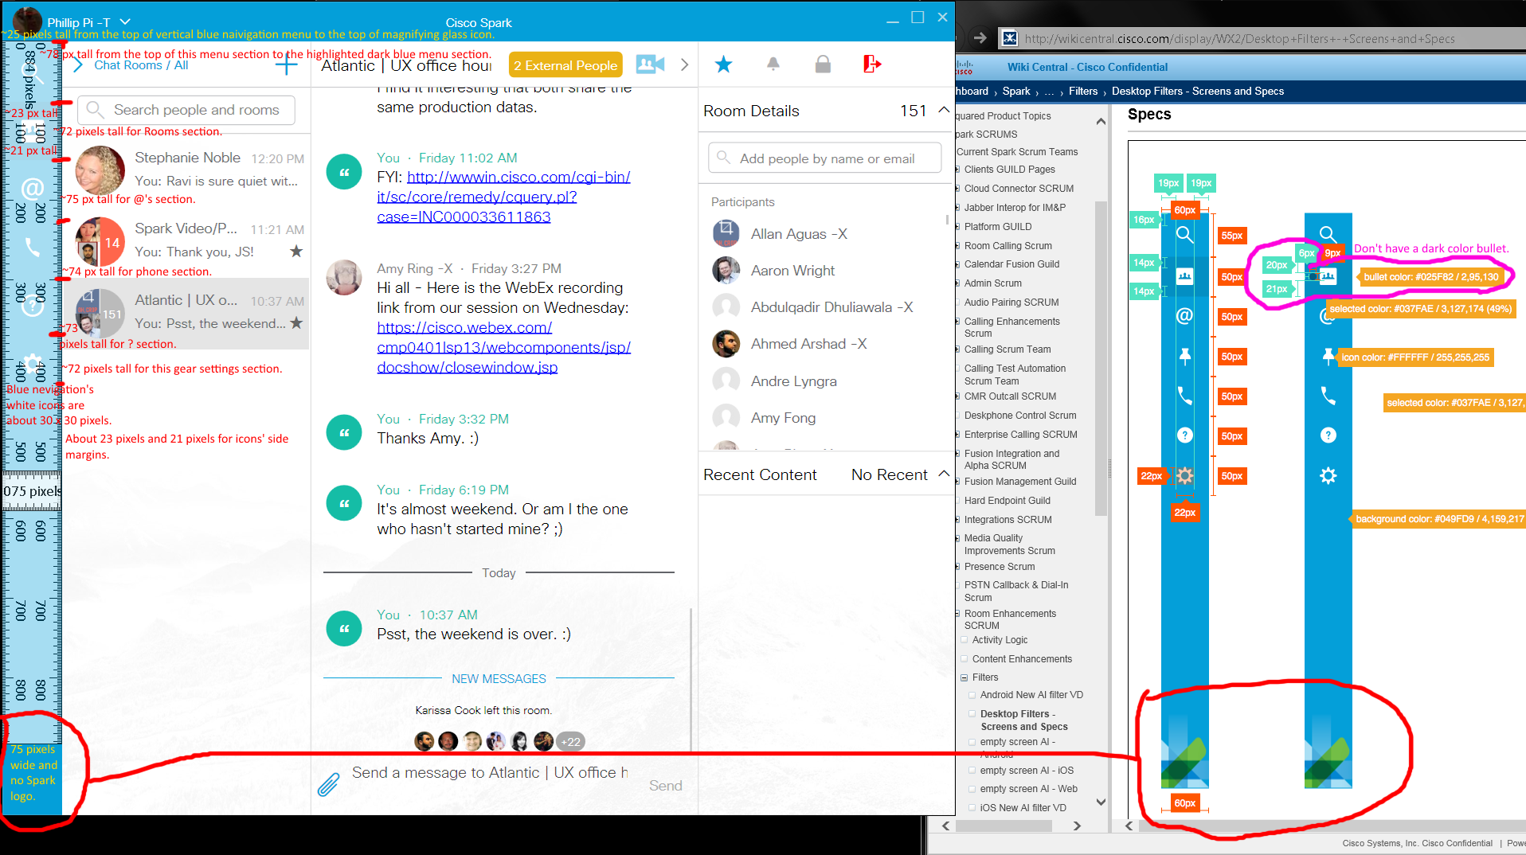
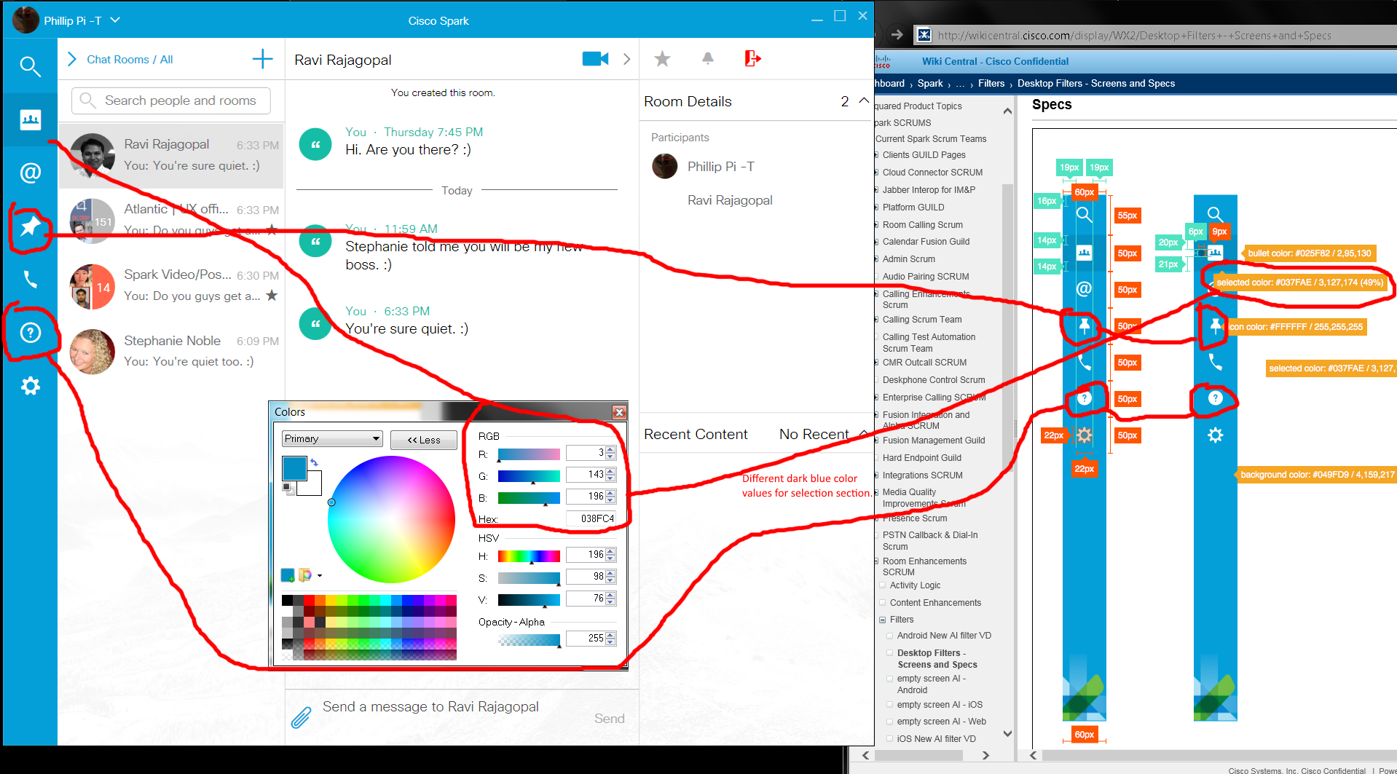
Issues:
- Dimension sizes are not the same.
- No black bullet on my blue navigation menu.
- Missing Spark’s logo on the bottom of my blue navigation menu.
- Dark blue selections have different color values.
- Different menus’ white icons (pinned and “?”).

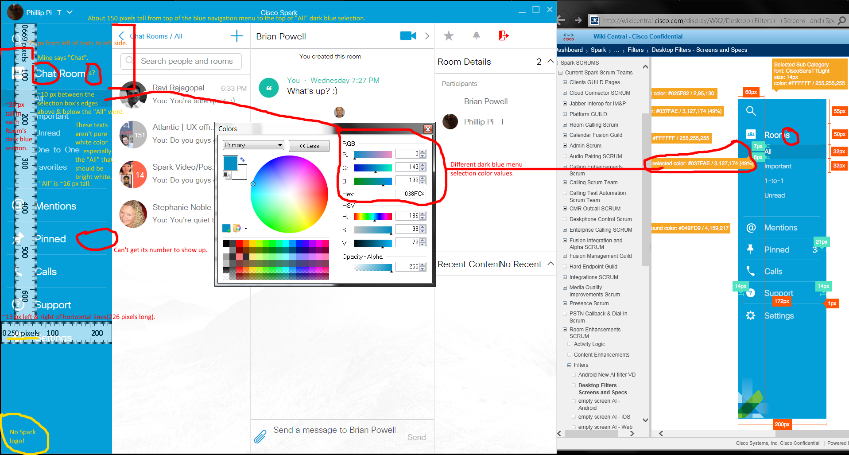
Issues:
- Dimension sizes are not the same.
- Missing Spark’s logo on the bottom of my blue navigation menu.
- Dark blue selections have different color values.
- Different menus’ white icons (pinned and “?”).
- Can’t get Pinned’s numbers to show up after pinning.
- White font colors aren’t really pure white.
- Mine says “Chat” before “Room” (not plural too).

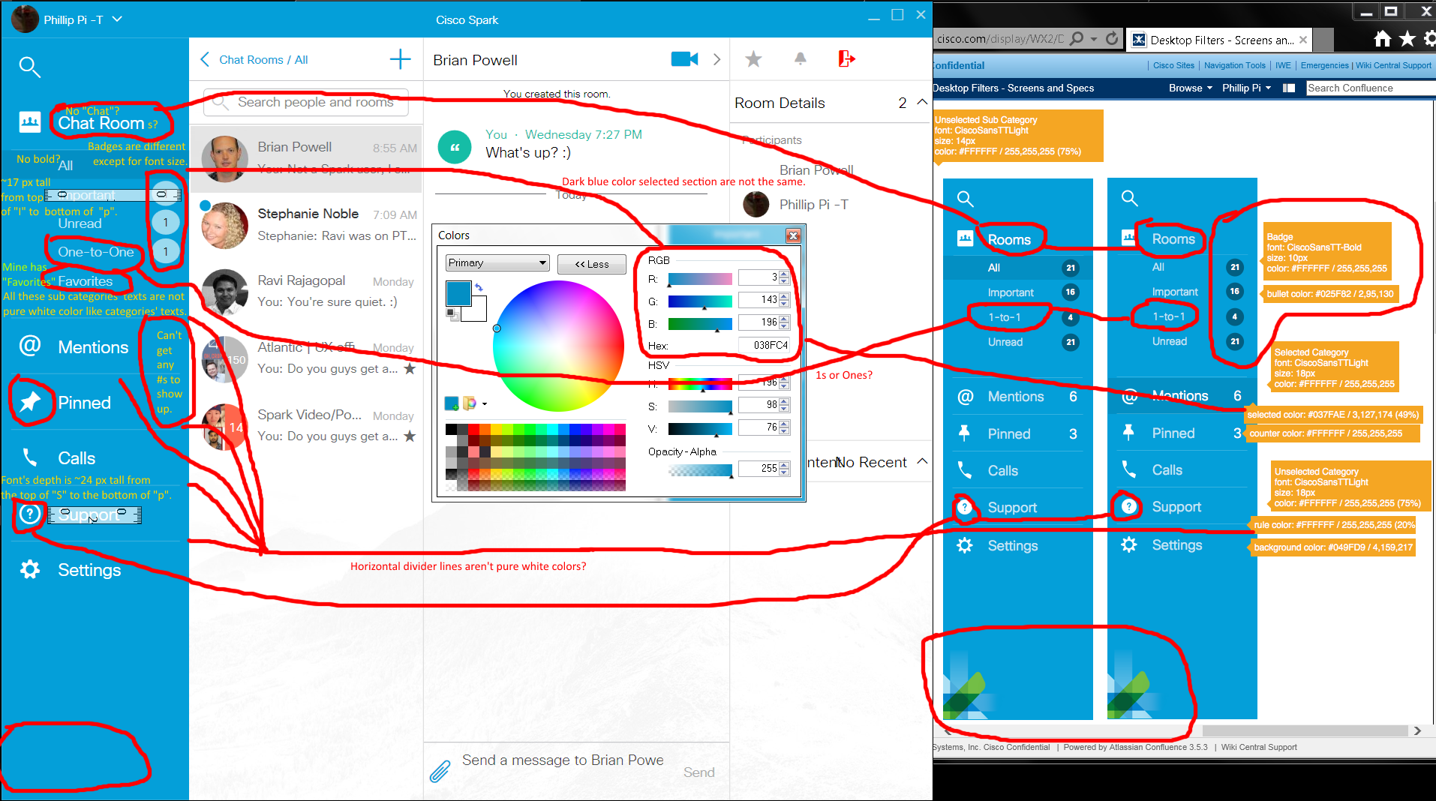
Issues:
- Different dimension sizes.
- Different icons for “Pinned” and “?”.
- Unable to get counters’ numbers from “Mentions” and “Pinned”.
- No pure white color for the horizontal divider lines and sub categories’ texts.
- Mine shows “Chat Room” instead of “Rooms”.
- My “Chat Room” shows no bolded “All” sub category text when its section is selected.
- Dark blue menu selections’ colors are not the same.
- (Chat) Room(s)’ “1-to-1” versus “One-to-One” texts.
- “Favorites” section is shown in my blue navigation menu.
- Missing Spark logo on the bottom of my blue navigation menu.

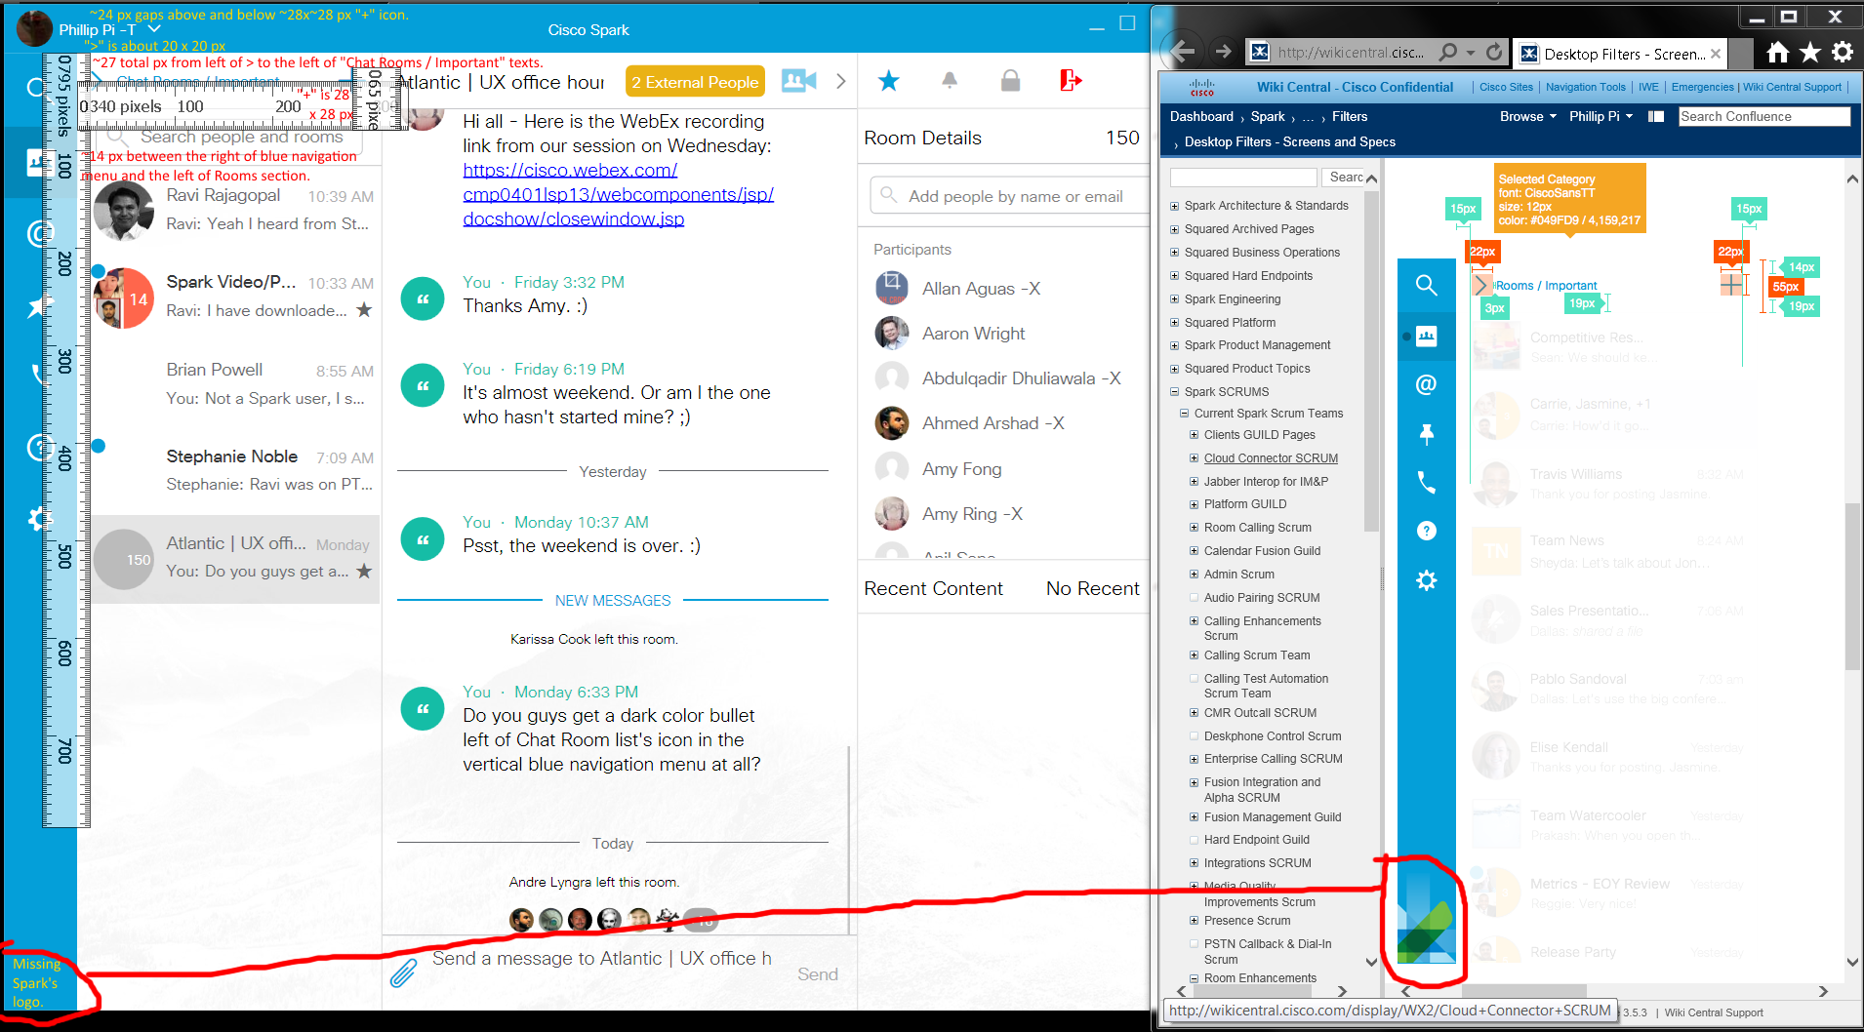
Issues:
- Missing Spark logo in the bottom left blue navigation menu.
- Different dimension sizes.
- Blue navigation menu’s icons do not vertically align up correctly with "> Chat Room / Important ...".
- Mine has a search form for people and rooms.

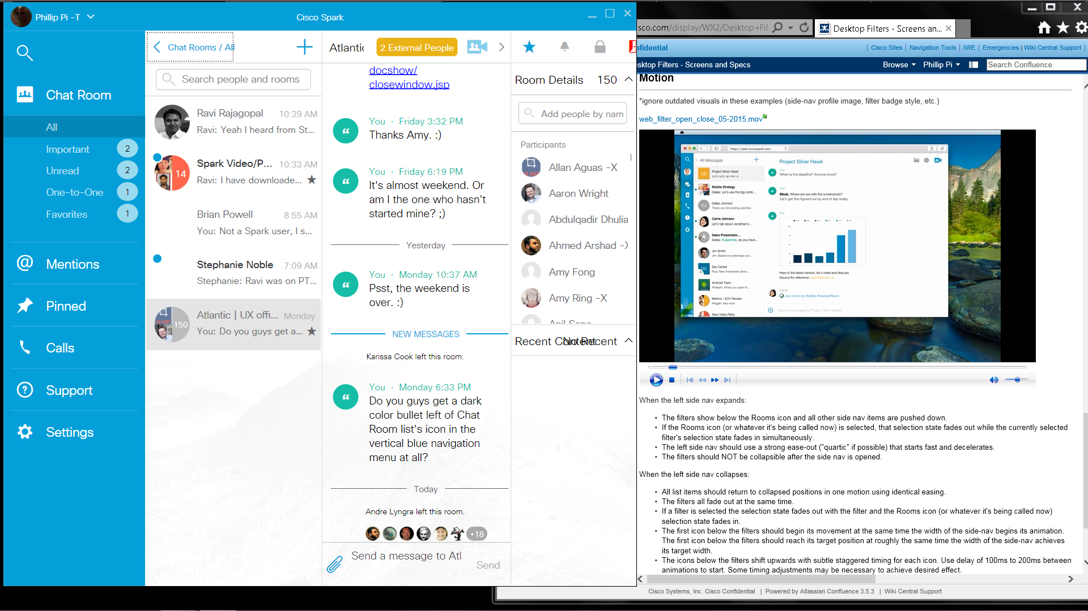
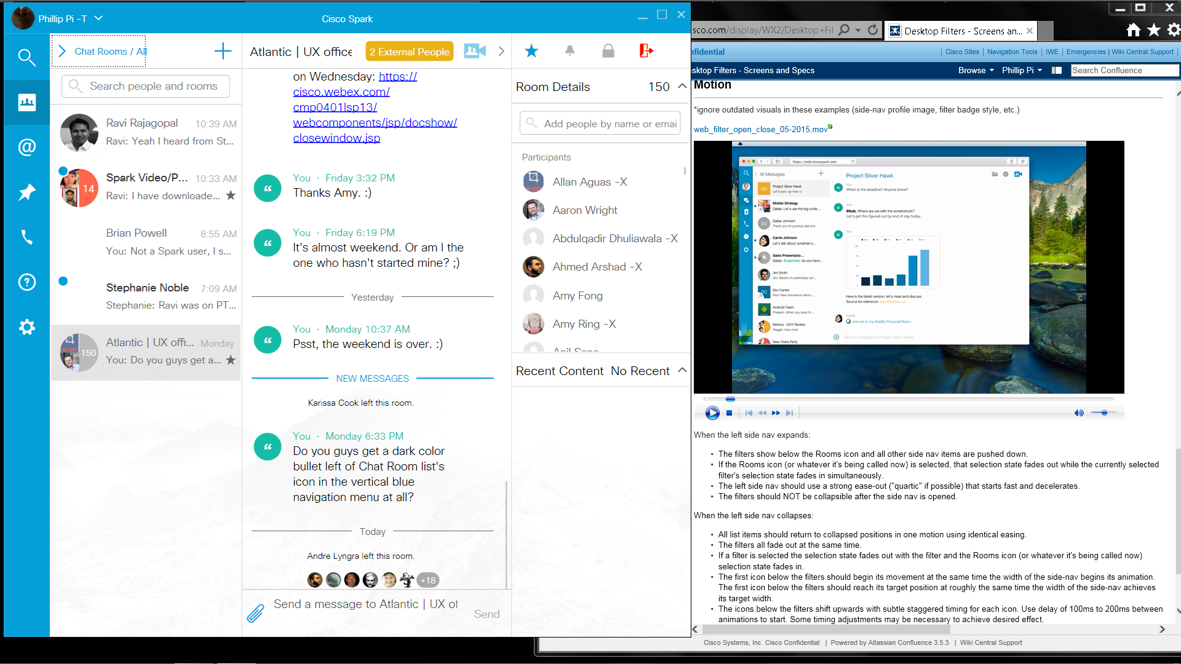
Issues: I saw no motion animations, fading, etc. It was all instant (no lags, waiting, etc.). However, everything else looked OK.

