Build URL (https://sqbu-github.cisco.com/pages/fonchin/web-client/web/) in an updated 64-bit W7 EE SP1 (125% DPI medium default preinstalled):

Google Chrome v44.0.2403.155 m (its default @ 100%) web browser on 8/12-13/2015 (just downloaded and installed at about 10:35 AM PDT):
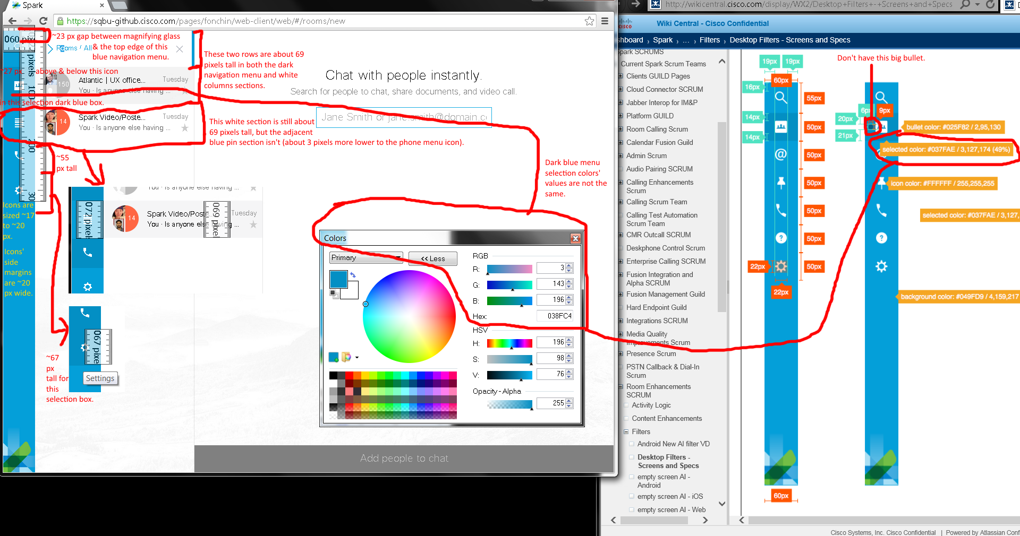
Issues:
- Different dimension sizes.
- Mine doesn’t show a big bullet in the blue navigation menu.
- Selected dark blue menu sections have different color values.

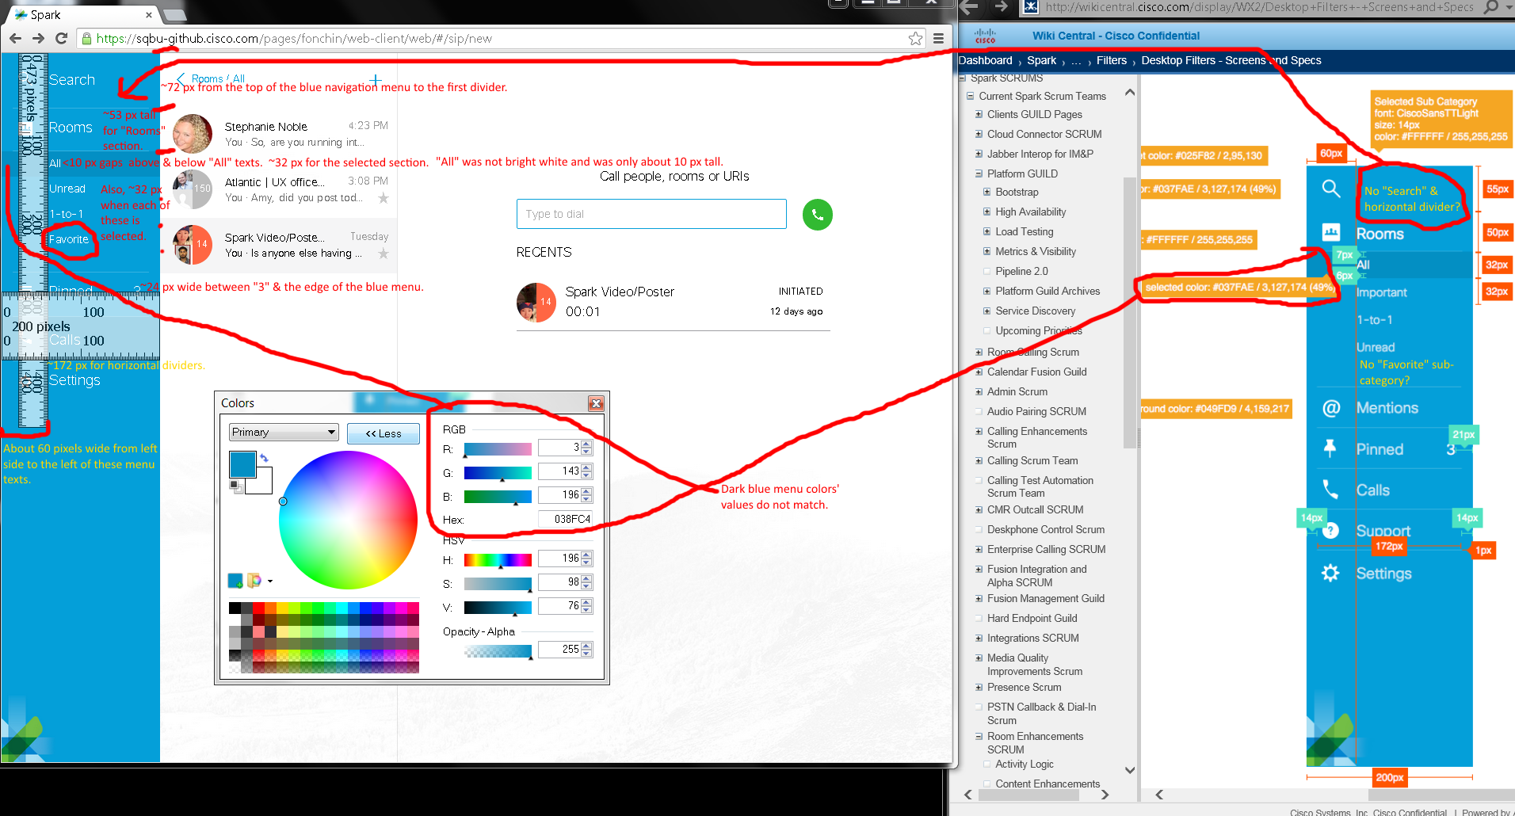
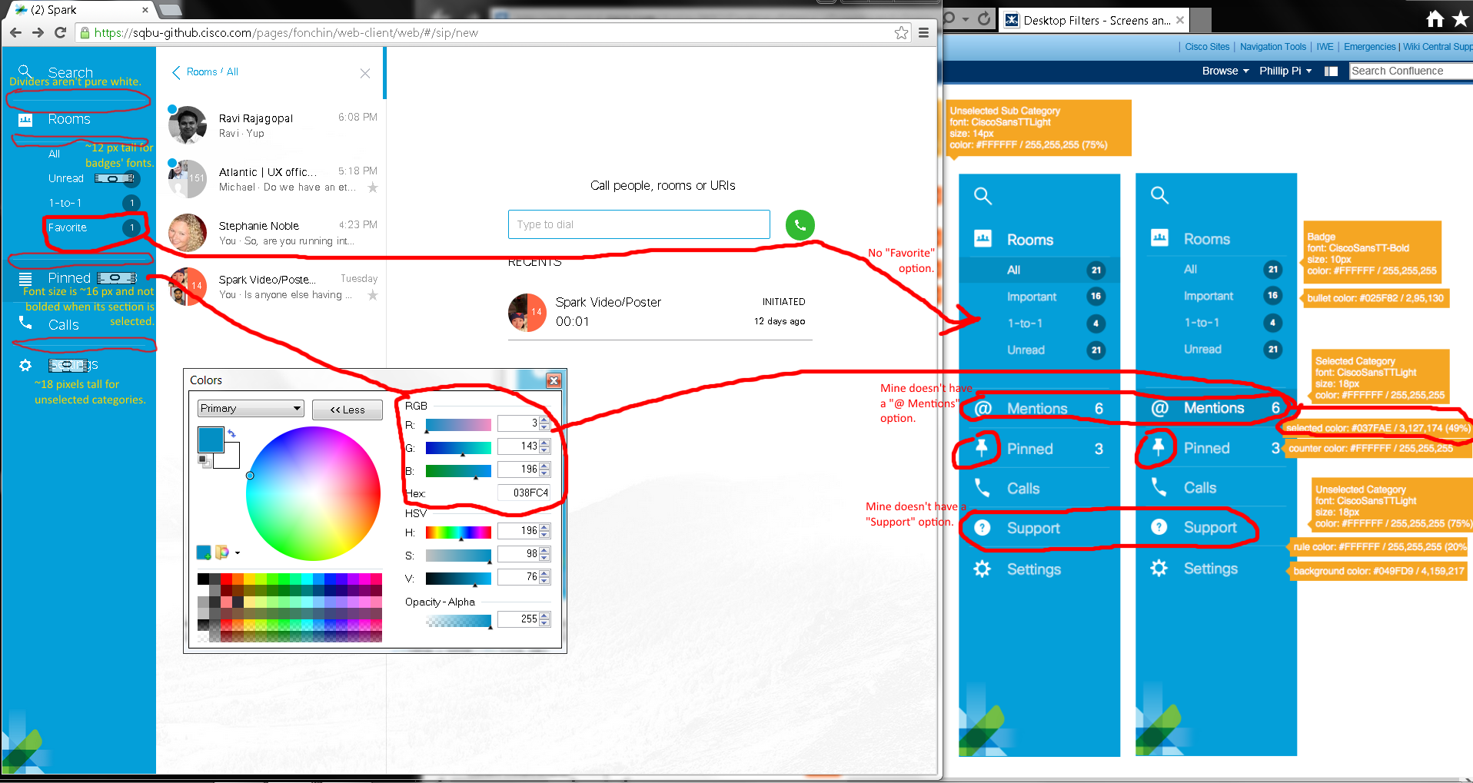
Issues:
- Different dimension sizes.
- Selected “All” sub category was not bright white and only about ten pixels tall.
- My blue navigation menu shows “Favorite” option, but no “Important” option under its “Rooms” section.
- Mine has “Search” and a white horizontal divider line below it.
- Dark navigation blue selection colors have different values.
- Different “Pinned”’s icons on blue navigation menus.
- No “@Mention” options on my blue navigation menu.
- Horizontal white dividers are not pure white color due to antialias effect?

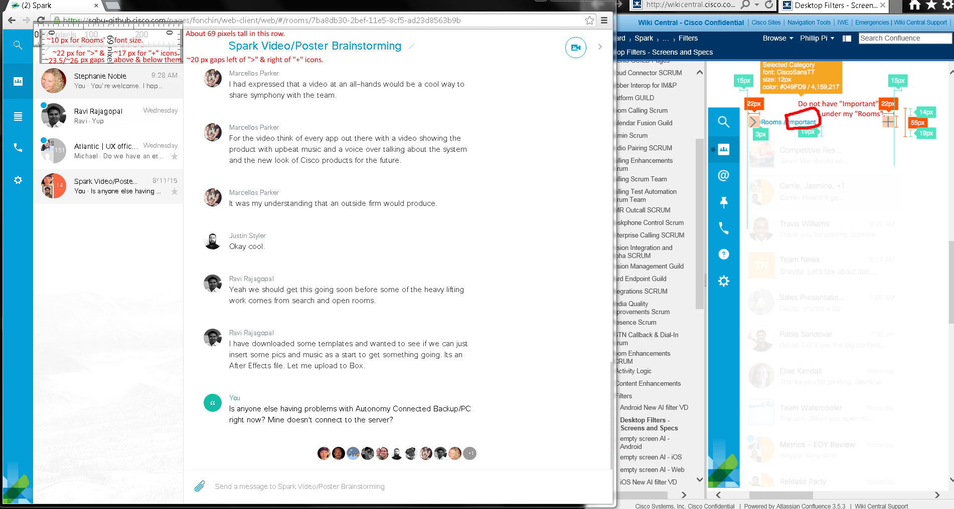
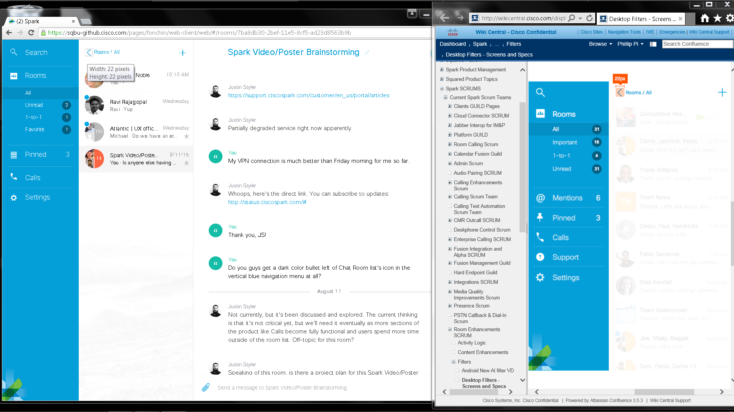
Issues:
- Different dimension sizes.
- My screen didn’t show “Impotrant” in its Rooms’ filters options.

Screen captured in the middle of my expanding blue navigation menu:
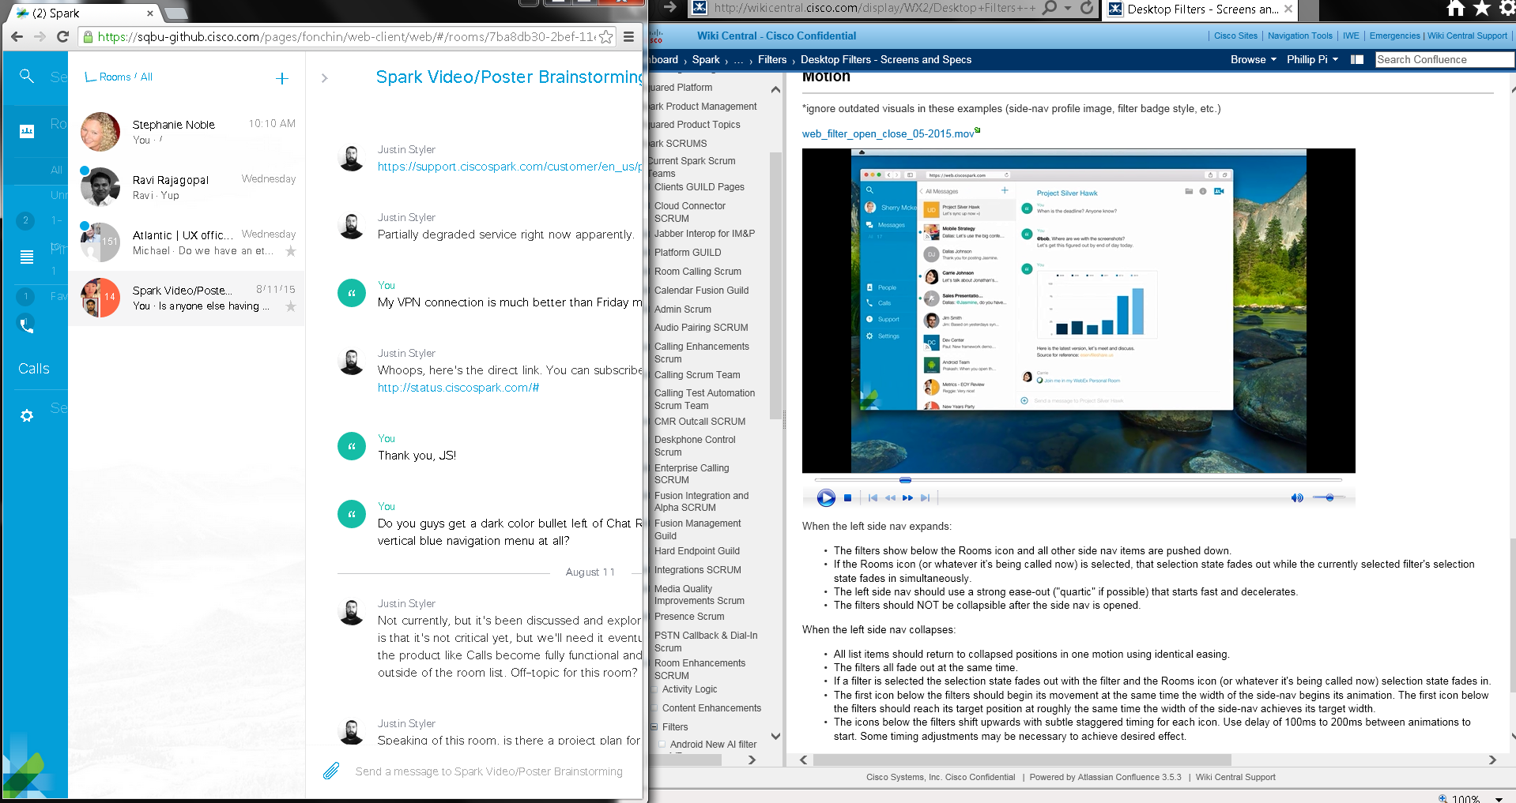

Screen captured in the middle of my collapsing blue navigation menu:
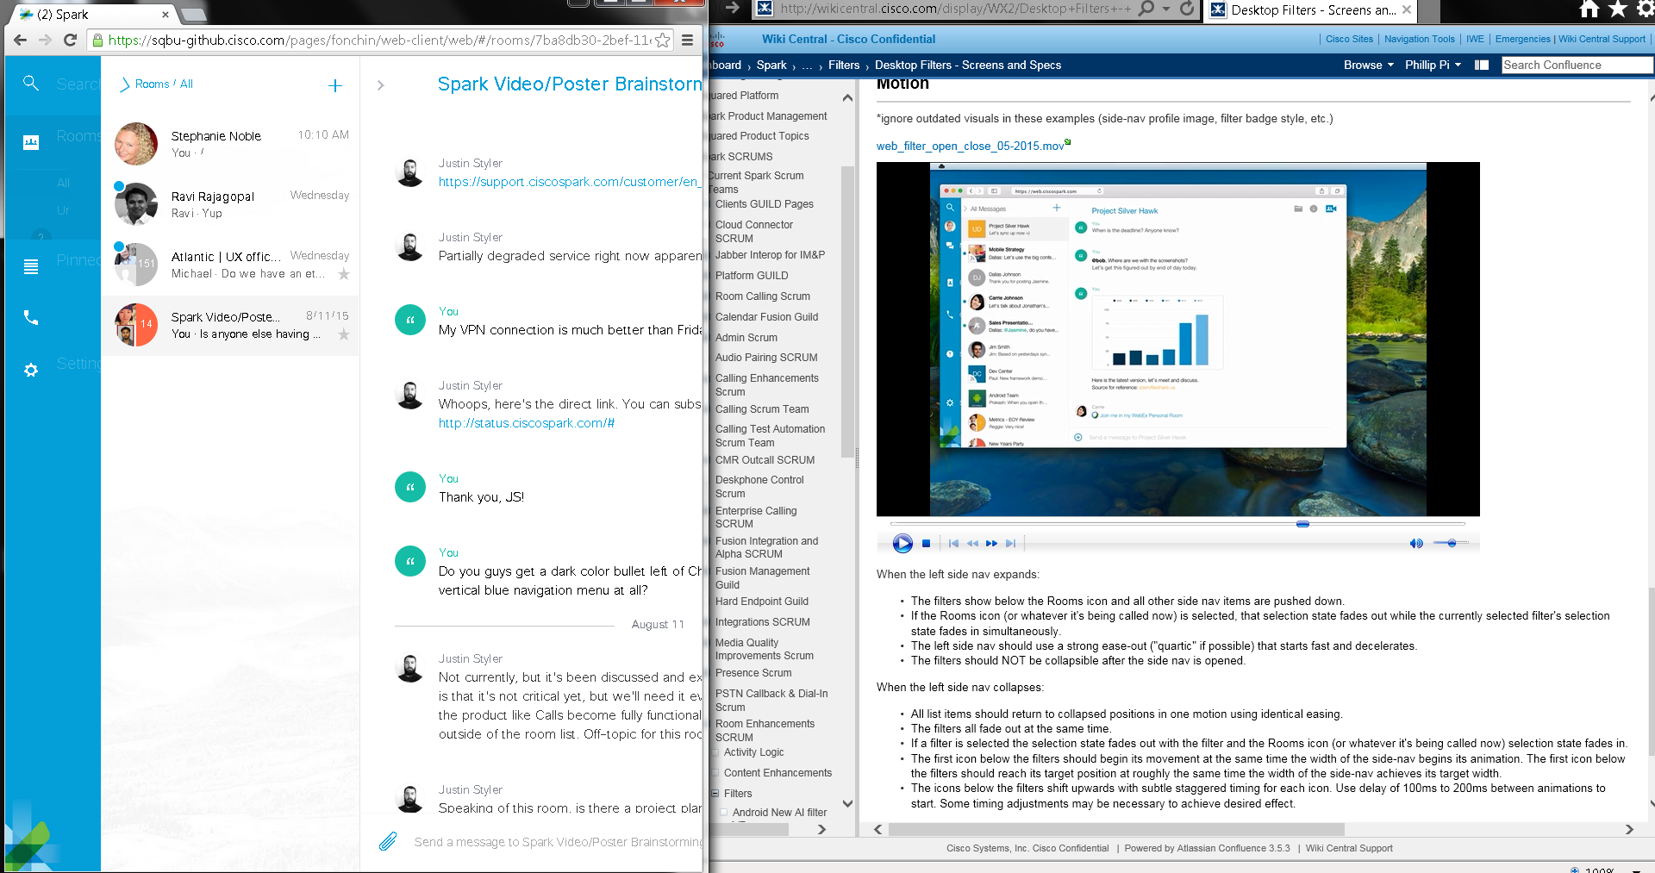
Issue: Rooms’ statistics numbers are supposed to be misaligned during the blue menu’s animation before they become aligned?
No other problems seen even though animations go too fast for my old eyes to see their details.
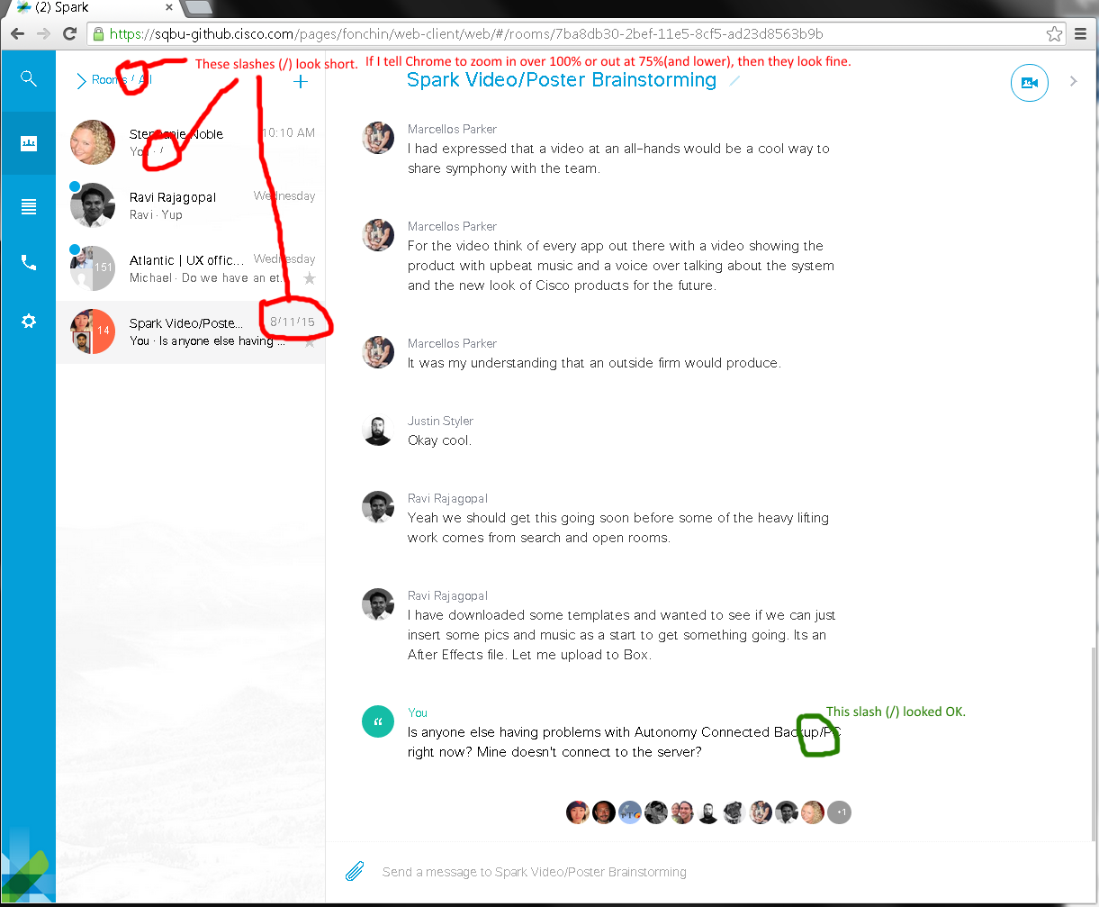
Issue: Slashes (/s) are short depending on Chrome’s zooms and where they are shown (room list column for its dates and comment previews).

IE11 (its zoom @ 100%) web browser on 7/31/2015 & 8/3-5 & 11/2015:
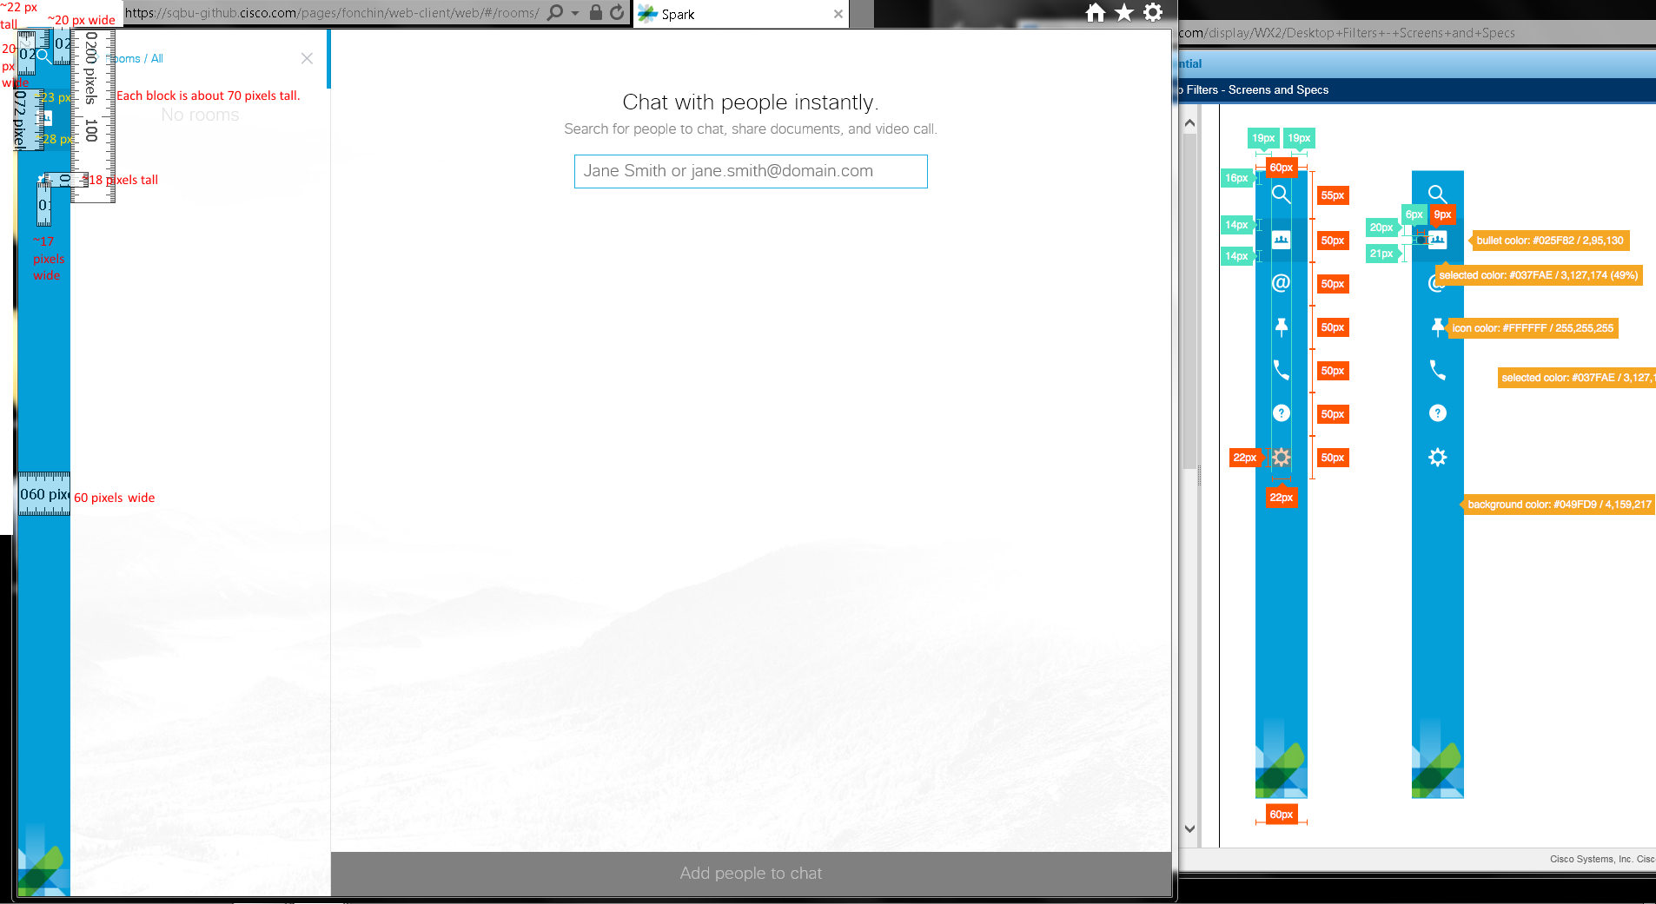
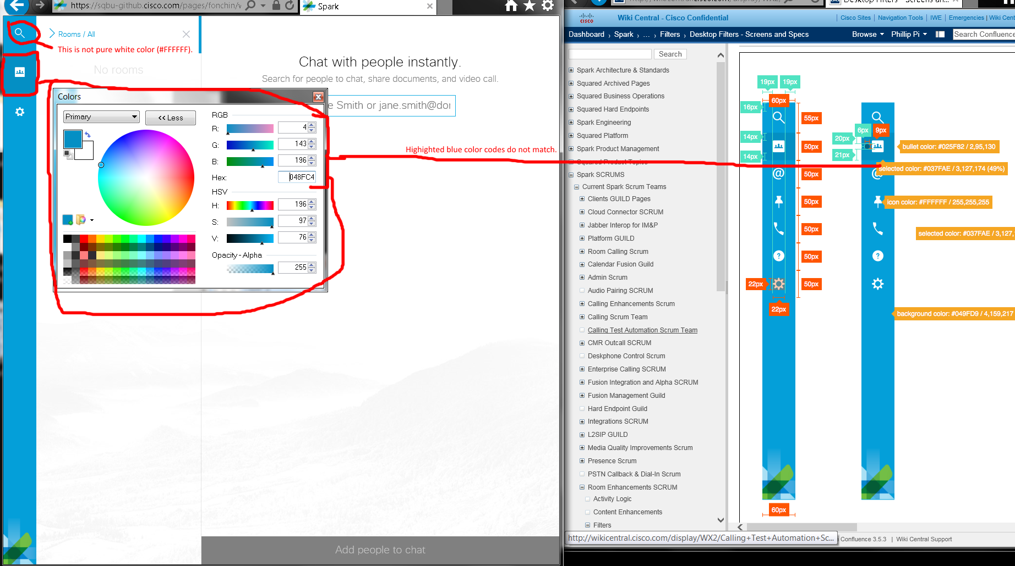
Issues:
- Dimension sizes were not exactly the same except for the 60 pixels wide left side menu Sparks graphic.
- Did not see the dark bullet on selected item in the left side menu Sparks graphic. I asked various people in Spark’s big group chat room, but got no answers.
- White magnifying glass and selected blue background box colors do not match.
- Mine doesn’t show all categories’ options.

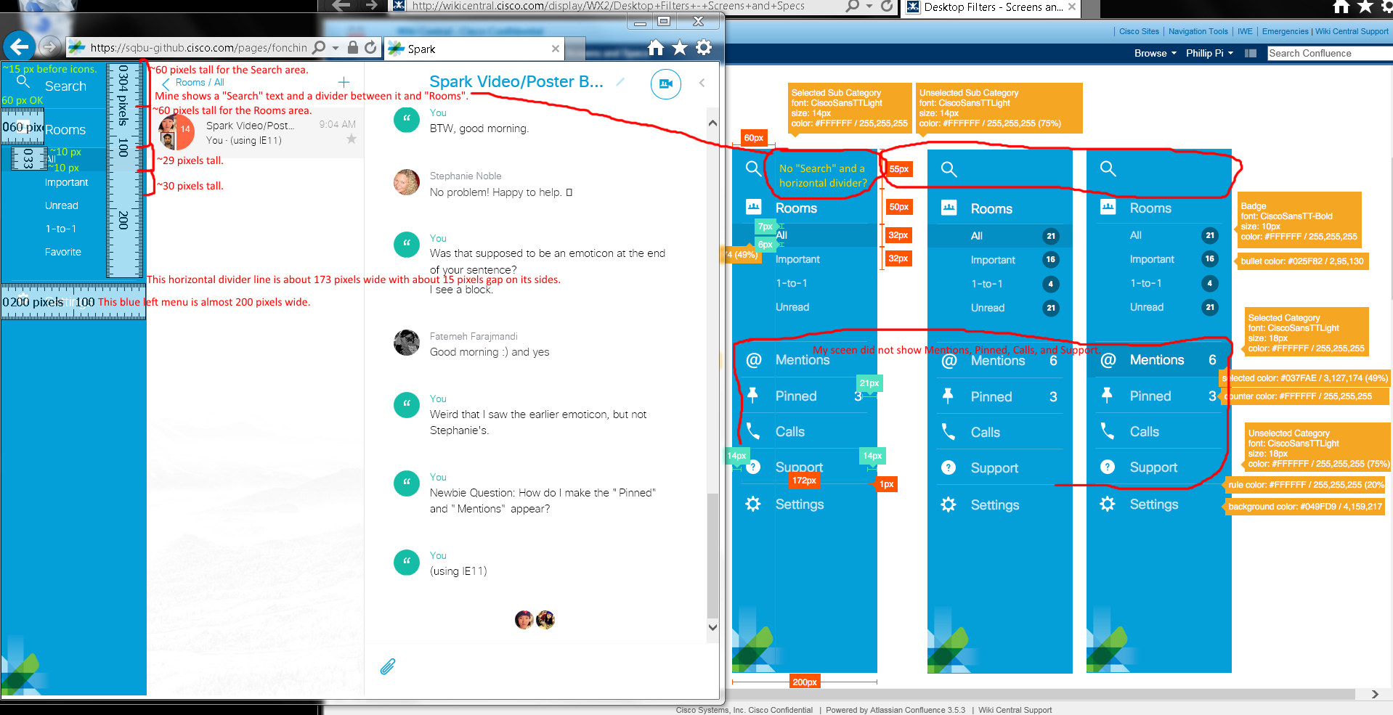
Issues:
- Dimension sizes match closely, but not exactly.
- Mine shows “Search” text on the right of the magnifying glass icon. Also, there is a horizontal divider below this icon.
- Mine does not show Mentions, Calls (Jeremy Santy said it IE11 won’t show it according to https://support.ciscospark.com/customer/portal/articles/1335167?b_id=8722), and Support icons and divided sections. I was unable to get any numerical values except “Rooms” and Pinned (had to get developer console access to enable) section.
- Icons and their texts do not vertically align to each other on my screen. Icons are higher while their texts are lower.
- Mine doesn’t show all categories’ options.
- My Room list does not show "Important", but "Favorite".

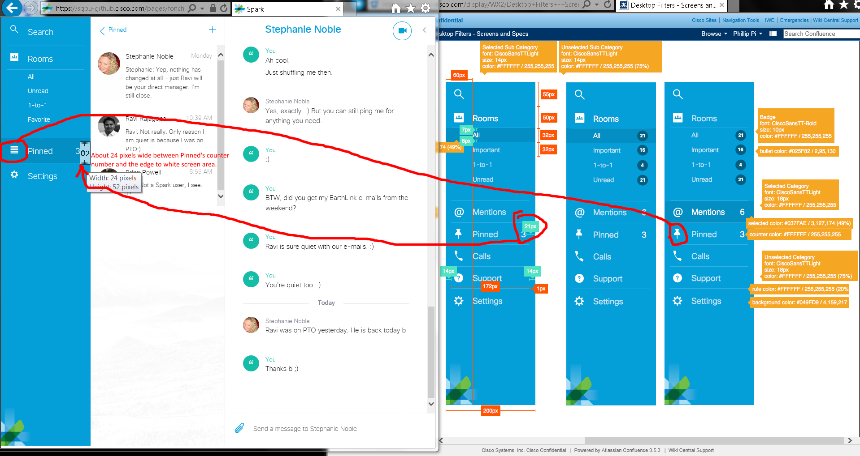
Issues: Enabled developer console’s Pinned icon is different and has a diferent sized gap after “3” number to the edge.

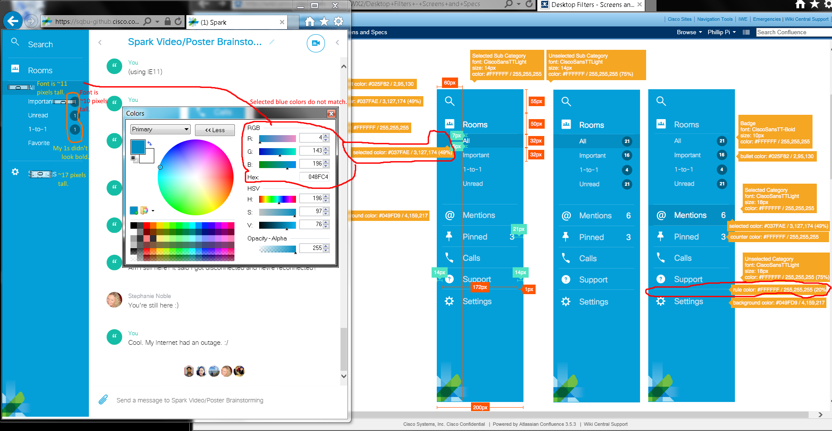
Issues:
- No categories’ numbers that I could reproduce. I only could reproduce the subcategories’ numbers for “Room”.
- One pixel horizontal white dividers don’t seem to be pure white color.
- Selected sections’ blue colors don’t match.
- Some font sizes do not match.
- Icons and their texts do not vertically align to each other on my screen. Icons are higher while their texts are lower.
- Mine doesn’t show all categories’ options.
- My Room list does not show "Important", but "Favorite".
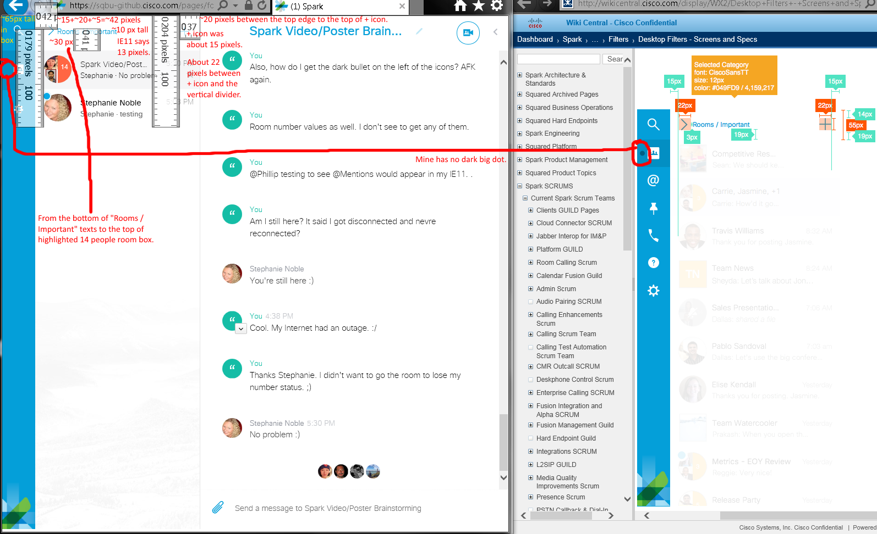
Issues:
- Different dimension.
- No big black dot on the menu on my screen.
- My Room list does not show "Important", but "Favorite".

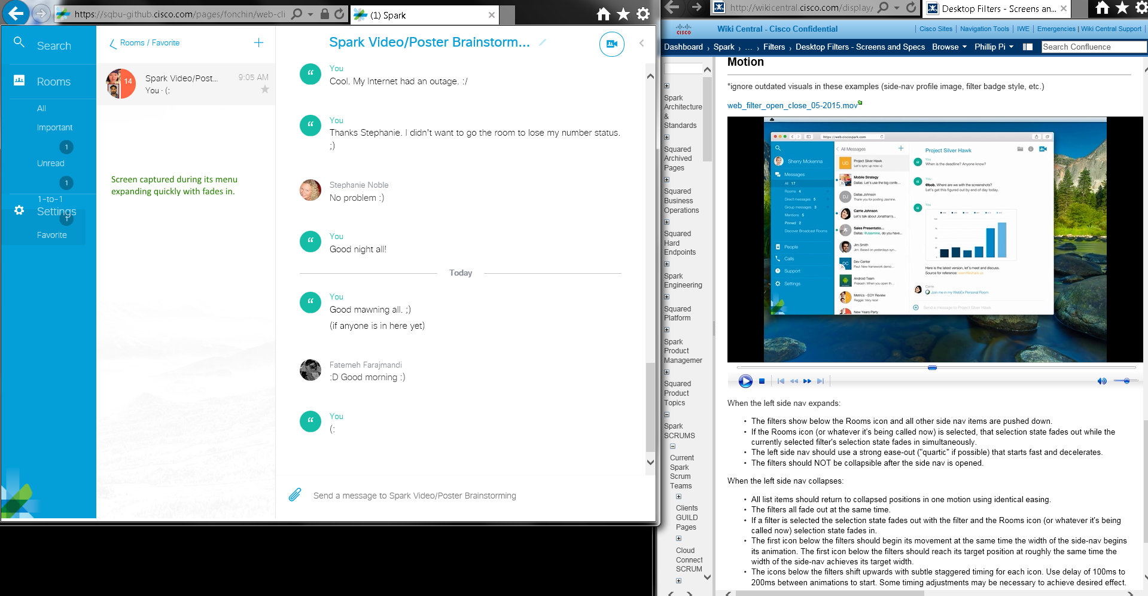
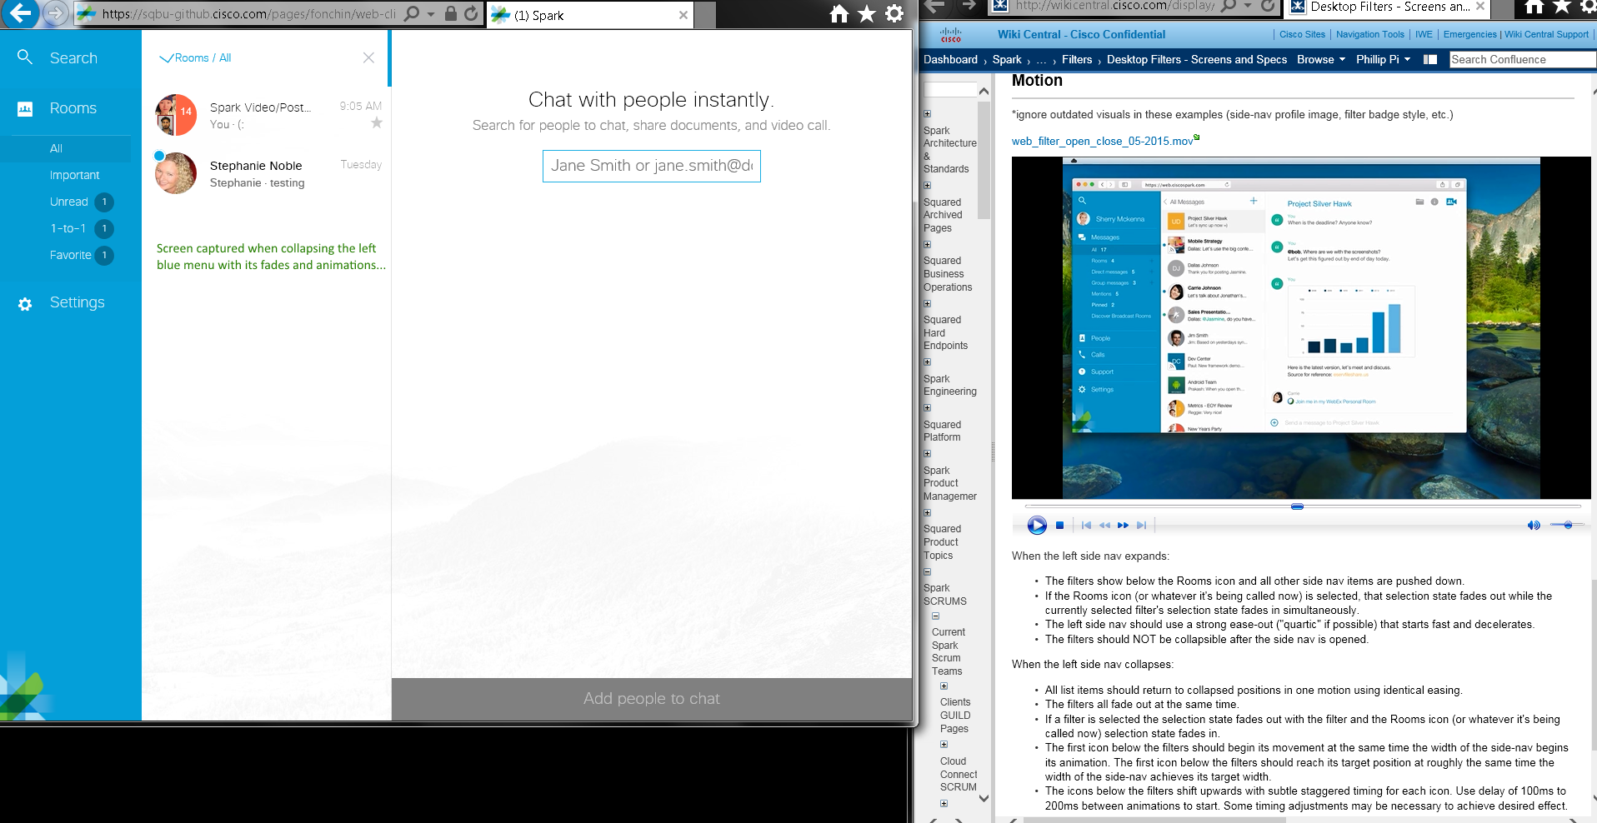
Issue: Rooms’ statistics numbers are supposed to be misaligned during the blue menu’s animation before they become aligned?
No other problems seen even though animations go too fast for my old eyes to see their details.
Firefox v39.0.(0/3(update since 5:40:06 PM PDT), & with its resetted zoom & defaults) web browser on 8/5-6 & 11/2015 :
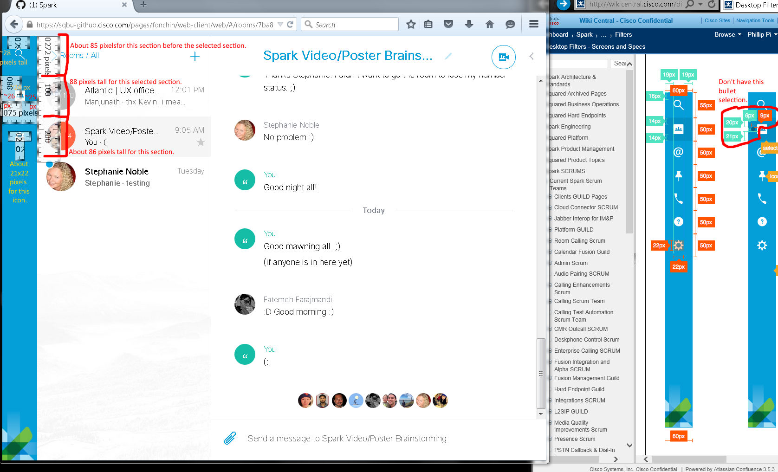
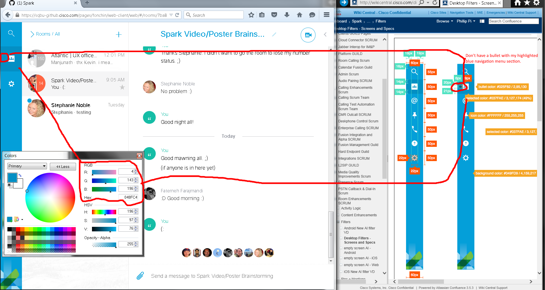

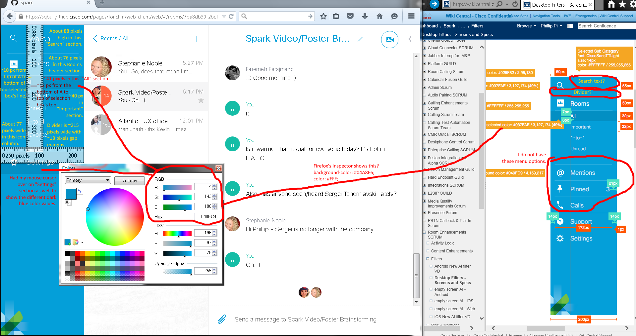
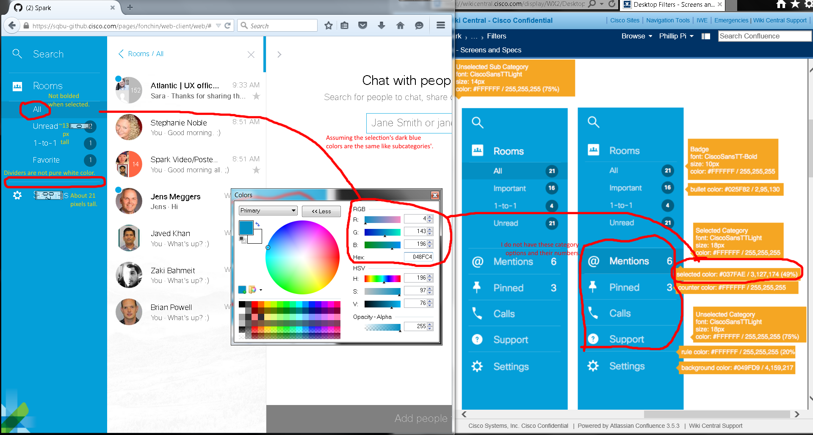
Issues:
- Some dimension sizes don’t match exactly, and some are way off.
- Don’t have a bullet in my dark blue color selected navigation menu box.
- Selected navigation menu box has different blue color values.
- Mine doesn’t show all categories’ options without their numbers.
- Mine shows “Search” and a horizontal divider below it.
- Missing bold fonts.
- My horizontal dividers’ color is not pure white.
- My Room list does not show "Important", but "Favorite".

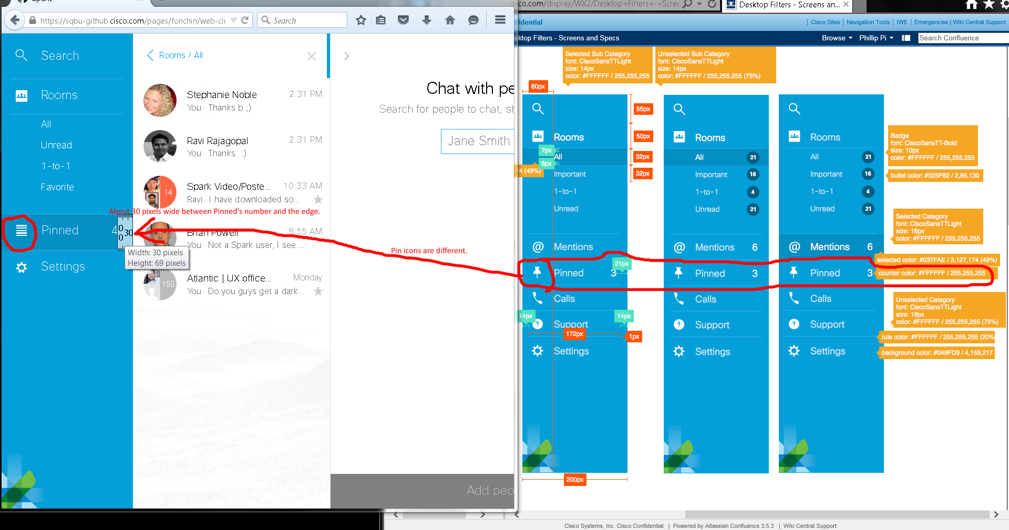
Issues: Pinned’s icons are different and its counter numbers’ gap have different distances to their right edge.

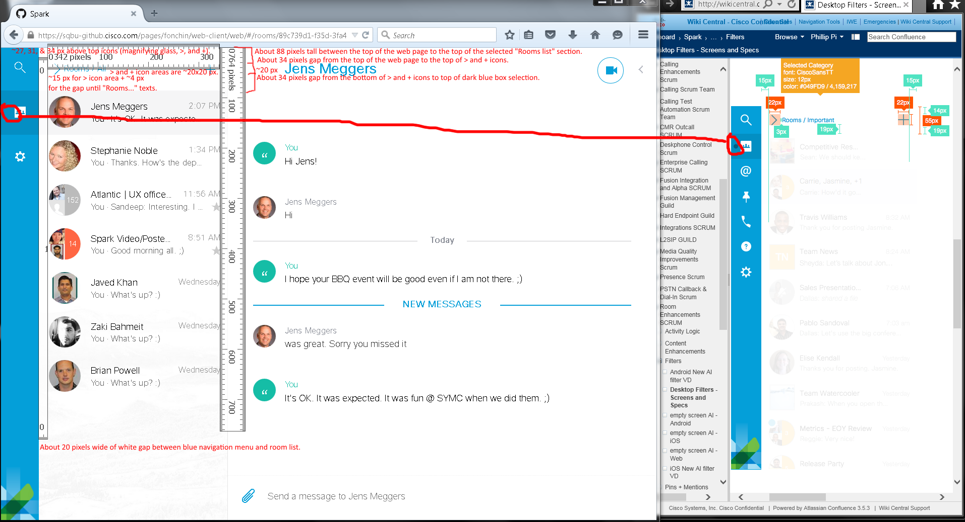
Issues:
- Dimension sizes are not the same.
- Mine did not have a dark big dot in my selected blue navigation menu section.

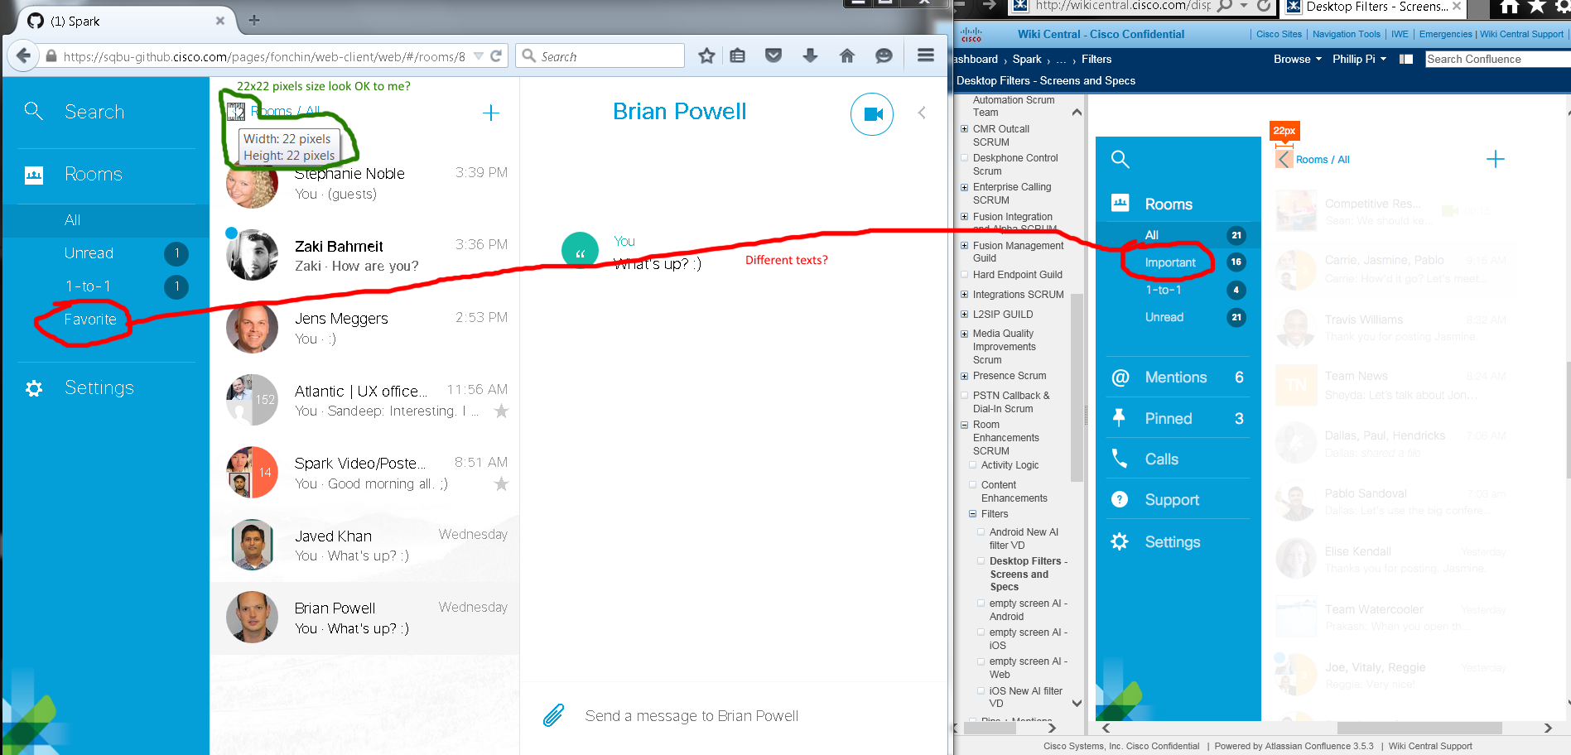
Issues:
- My Room list does not show "Important", but "Favorite".
- 22x22 pixels < icon seems OK?
Screen captured while expanding the blue menu:
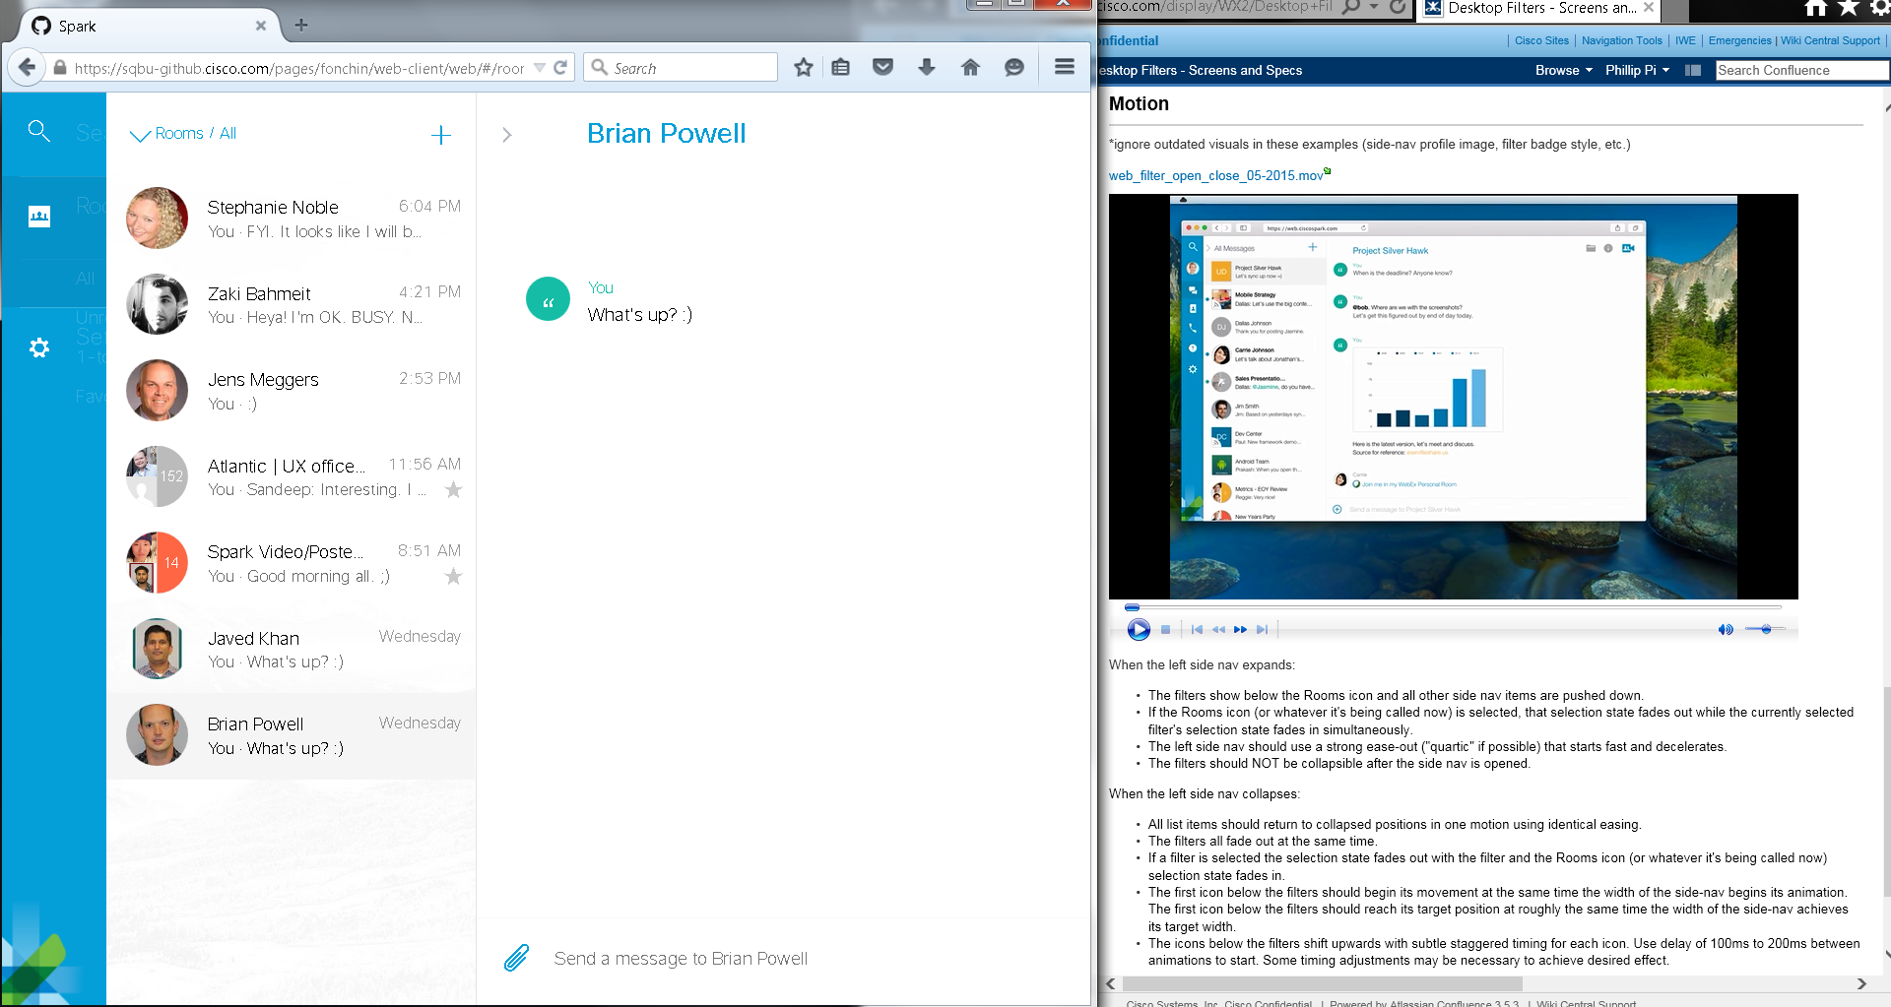

Screen captured while collapsing the blue navigation menu:
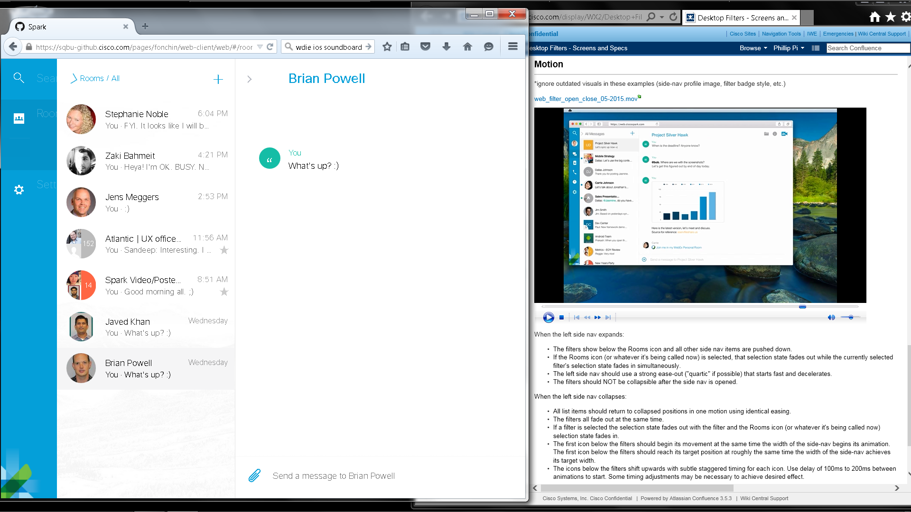
Issue: Rooms’ statistics numbers are supposed to be misaligned during the blue menu’s animation before they become aligned?
No other problems seen even though animations go too fast for my old eyes to see their details.

Other issues found in the web browsers on 7/31/2015 & 8/7&12/2015 that were not shown in the Wiki documents:
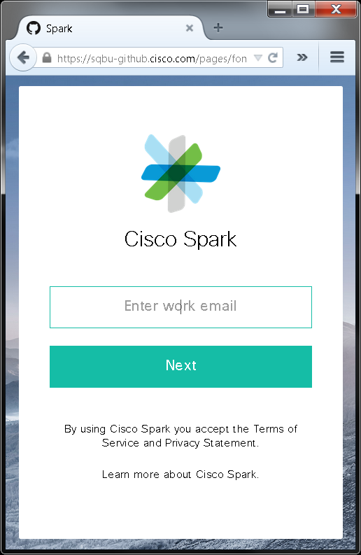  Firefox v39 & Chrome v44: When the cursor is focused in this form box, “Enter work email” texts show with the keyboard cursor blinking for user to type the email address. | 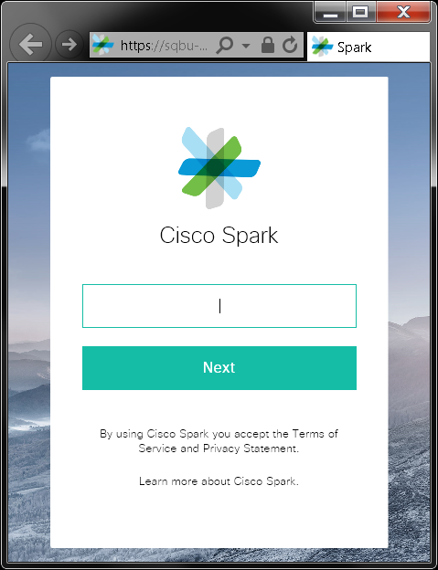  IE11: When the cursor focused is in this form box, “Enter work email” texts goes away with the keyboard cursor blinking for user to type the email address. The texts should stay until the user types something.

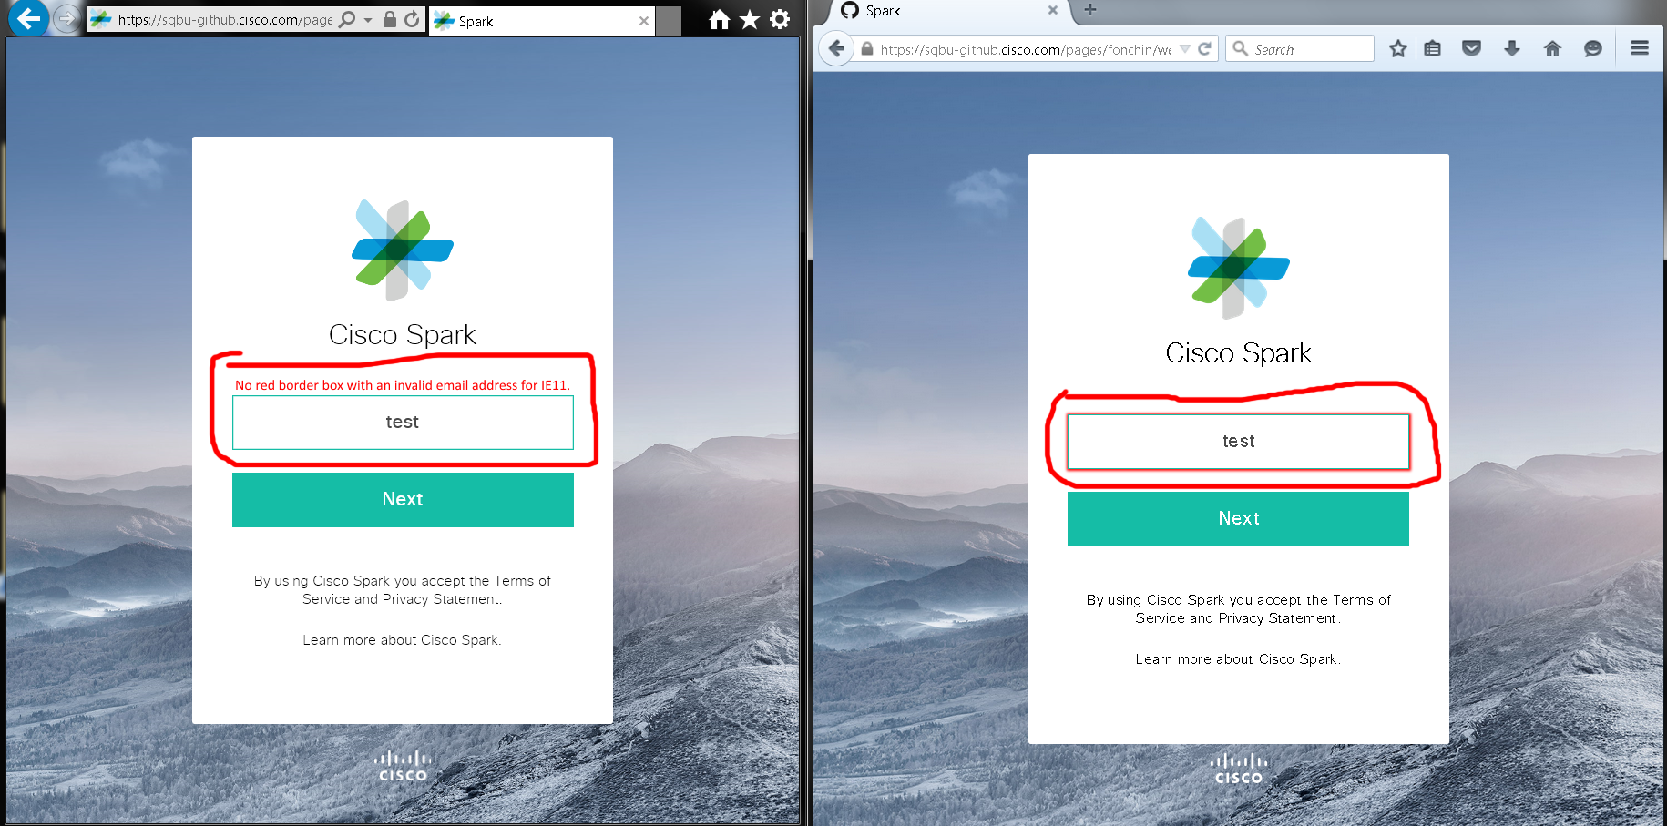
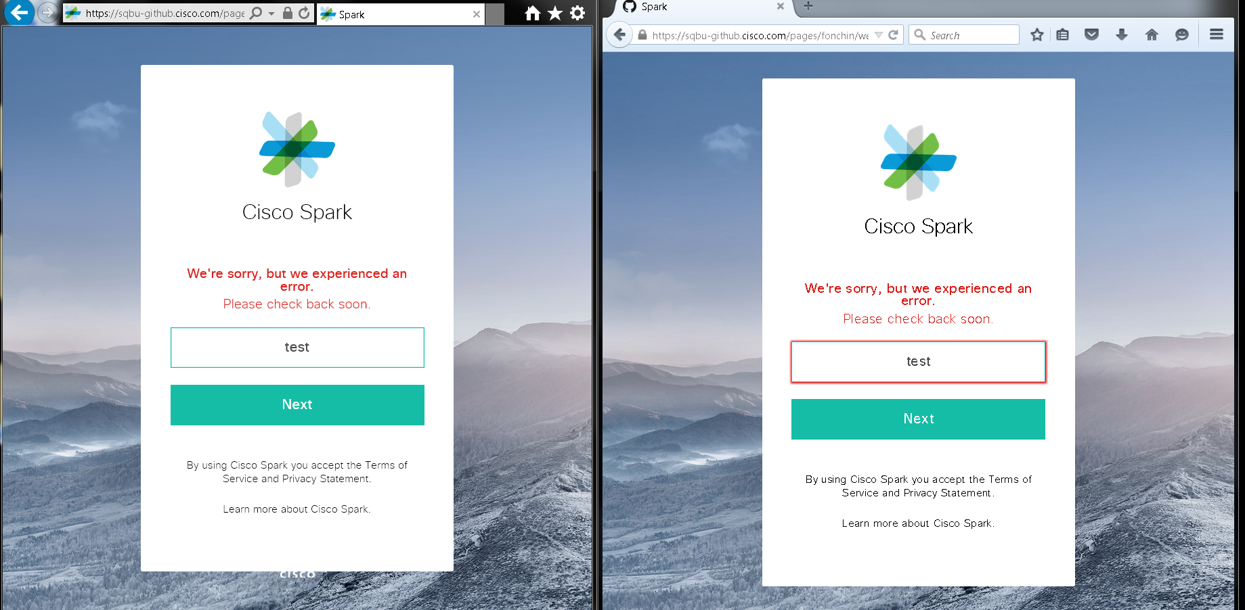
Above screen shots were captured in IE11 and Firefox v39.0 web browsers.

Chrome v44:
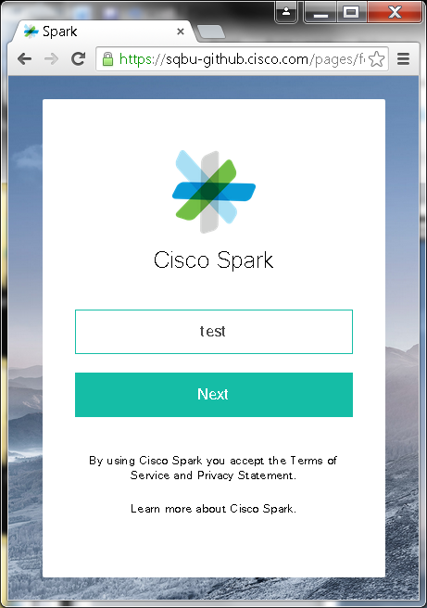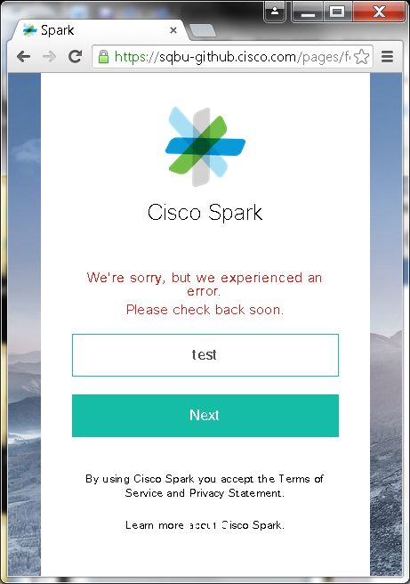
Issues:
- In IE11 and Chrome v44, Cisco Spark’s login screen didn’t show a red border box for an invalid email address like Firefox (right shot).
- “We’re sorry, but we experienced an error. Please check back soon.” is a misleading error. It should say the email address was invalid or something.
Issue: A blinking vertical cursor was seen in IE11 web browser. I did not see it under Firefox v39 and Chrome v44 web browsers though.

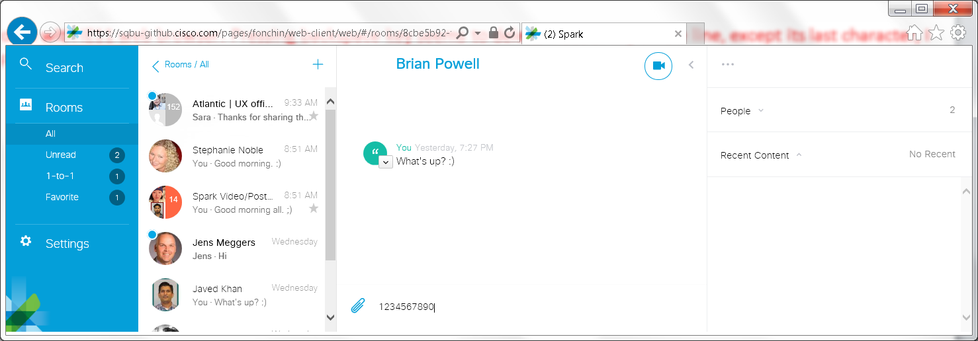
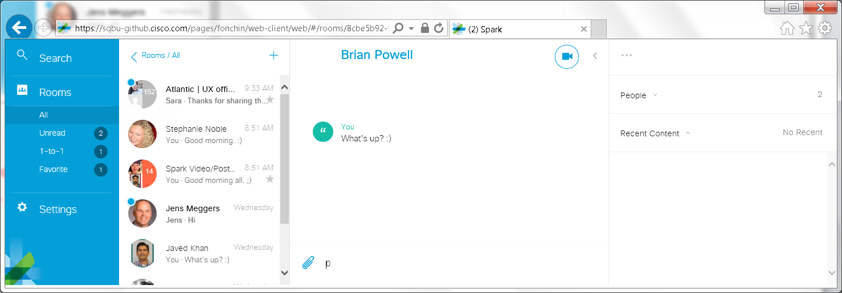
Issues: In any room (1-to-1 and group) with IE11 web browser: Pressing backspace key seems to delete most of my whole line, except its last character, I just typed in. Also, it moves my cursor behind this untouched character as well. Firefox v39 web browser did not show this problem.

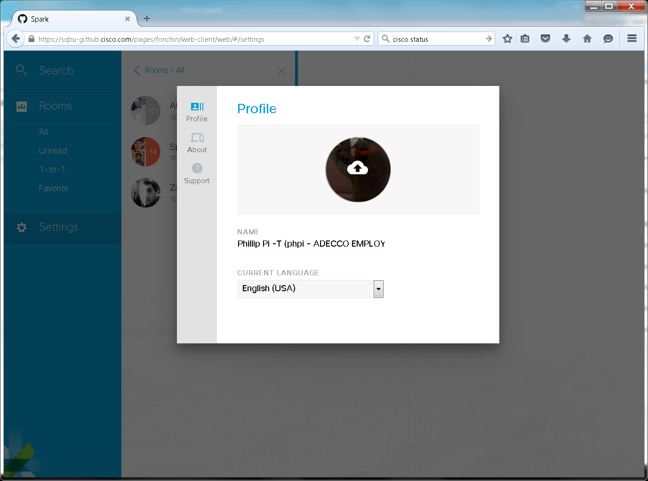
Issues in both IE11 and Firefox v39.0.(0/3): Why are “About” and “Support” sections under Settings? I find this an odd usability design seen. Also, why are their links inside each option all in yellow and CAPS like below for “Support”:
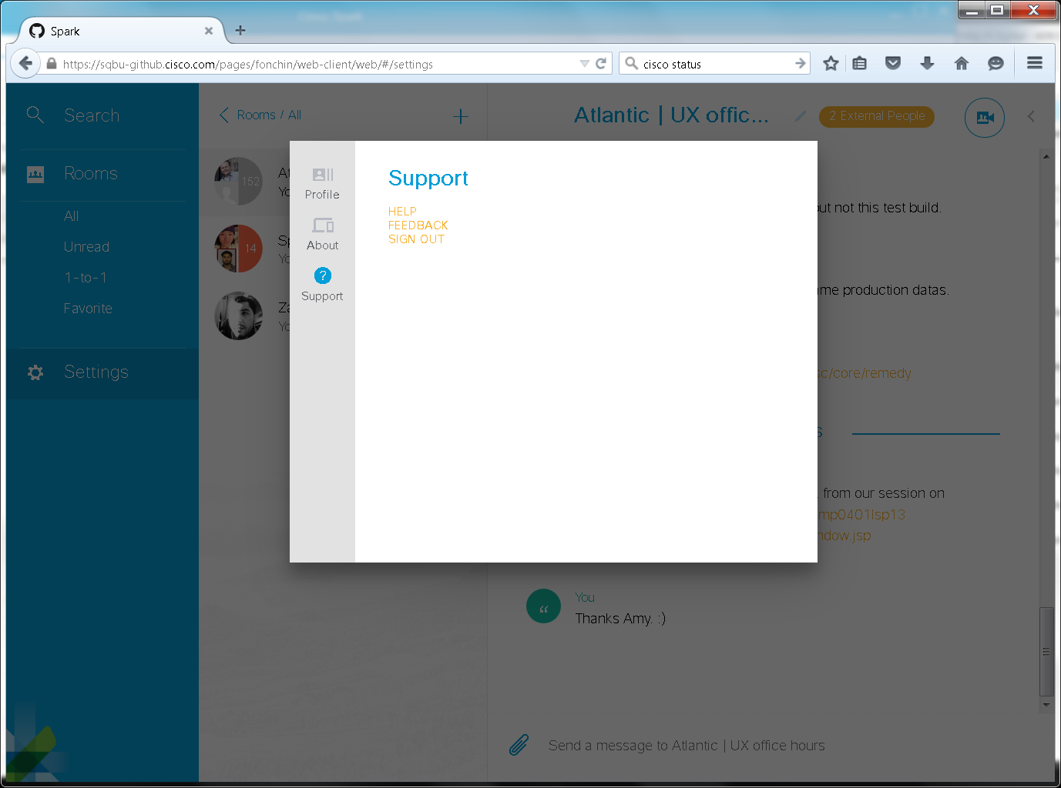
Issue: I was trying to figure out how to log off Spark in my web browsers. Ravi Rajagopal also thought this “Sign out”’s location is a strange place to put it from his 8/7/2015 2:59 PM PDT email.

