Spark Clients’ Usability Issues (11/9/2015 – 11/11/2015):

Need visual indicators to collapse avatar sections in Spark clients:
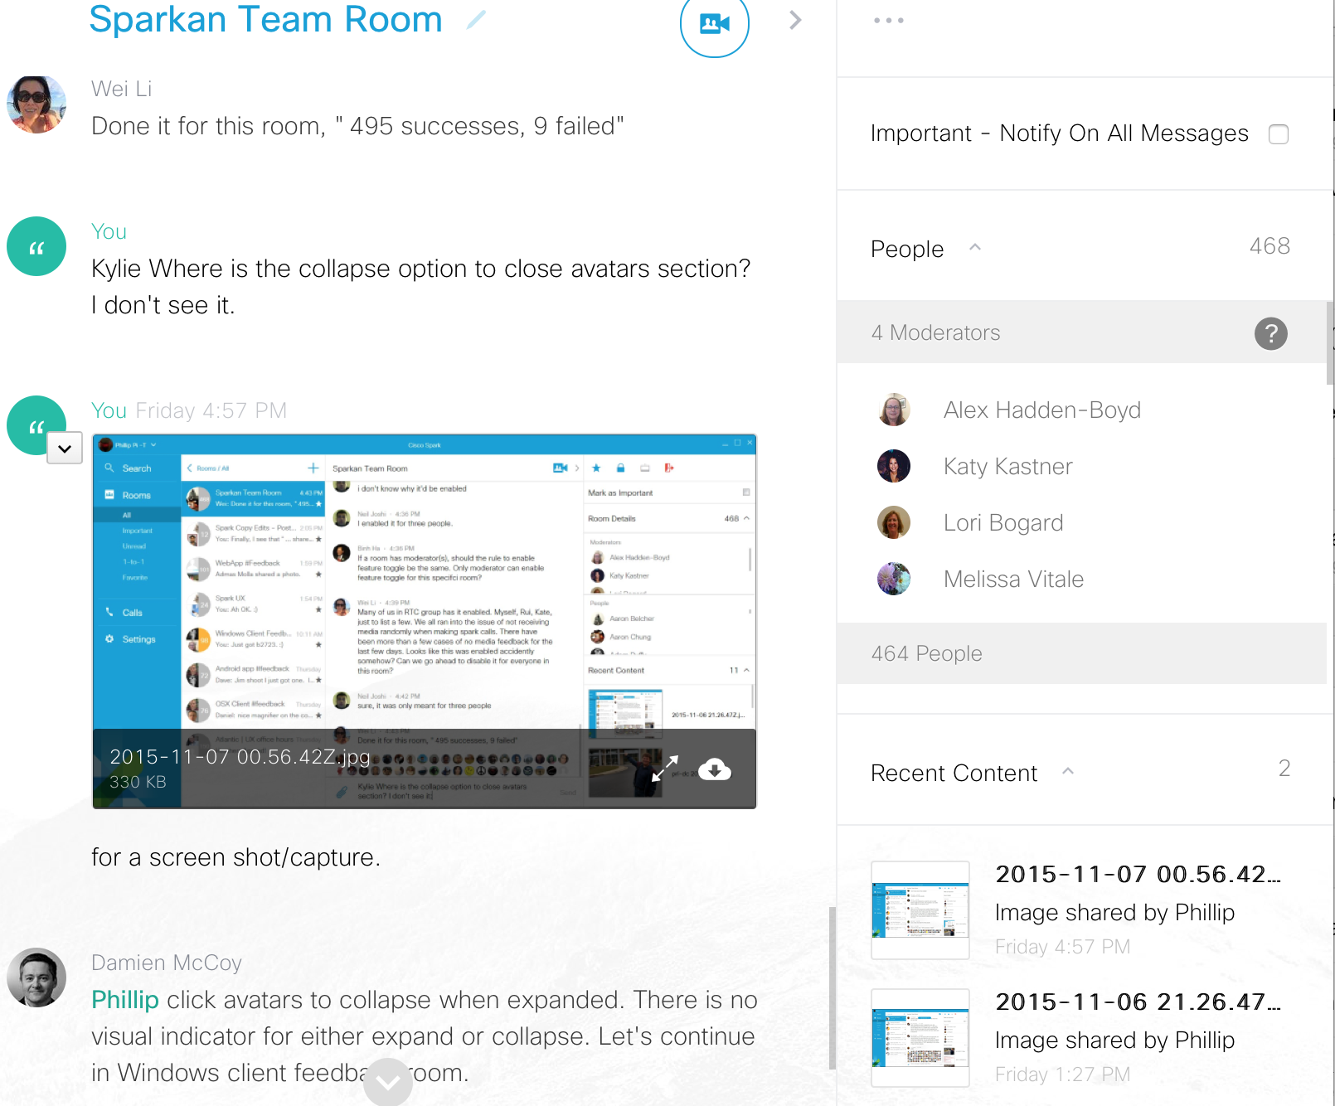
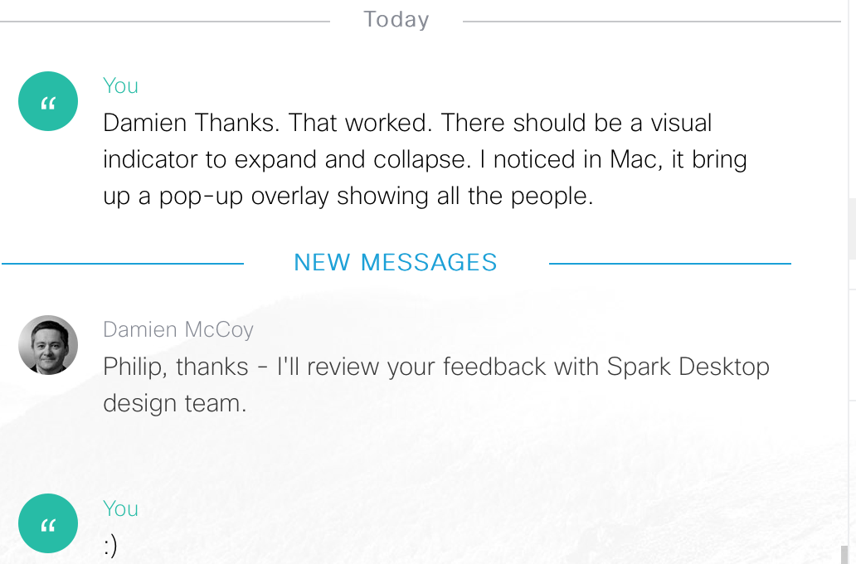

Examples:
Windows (v1.0.0.2735) software clients:

Mac OS X software client v1.3603 (SDK v0.5.32) and Google Chrome v46 web browser in an updated Mac OS X v10.10.5 (Yosemite):
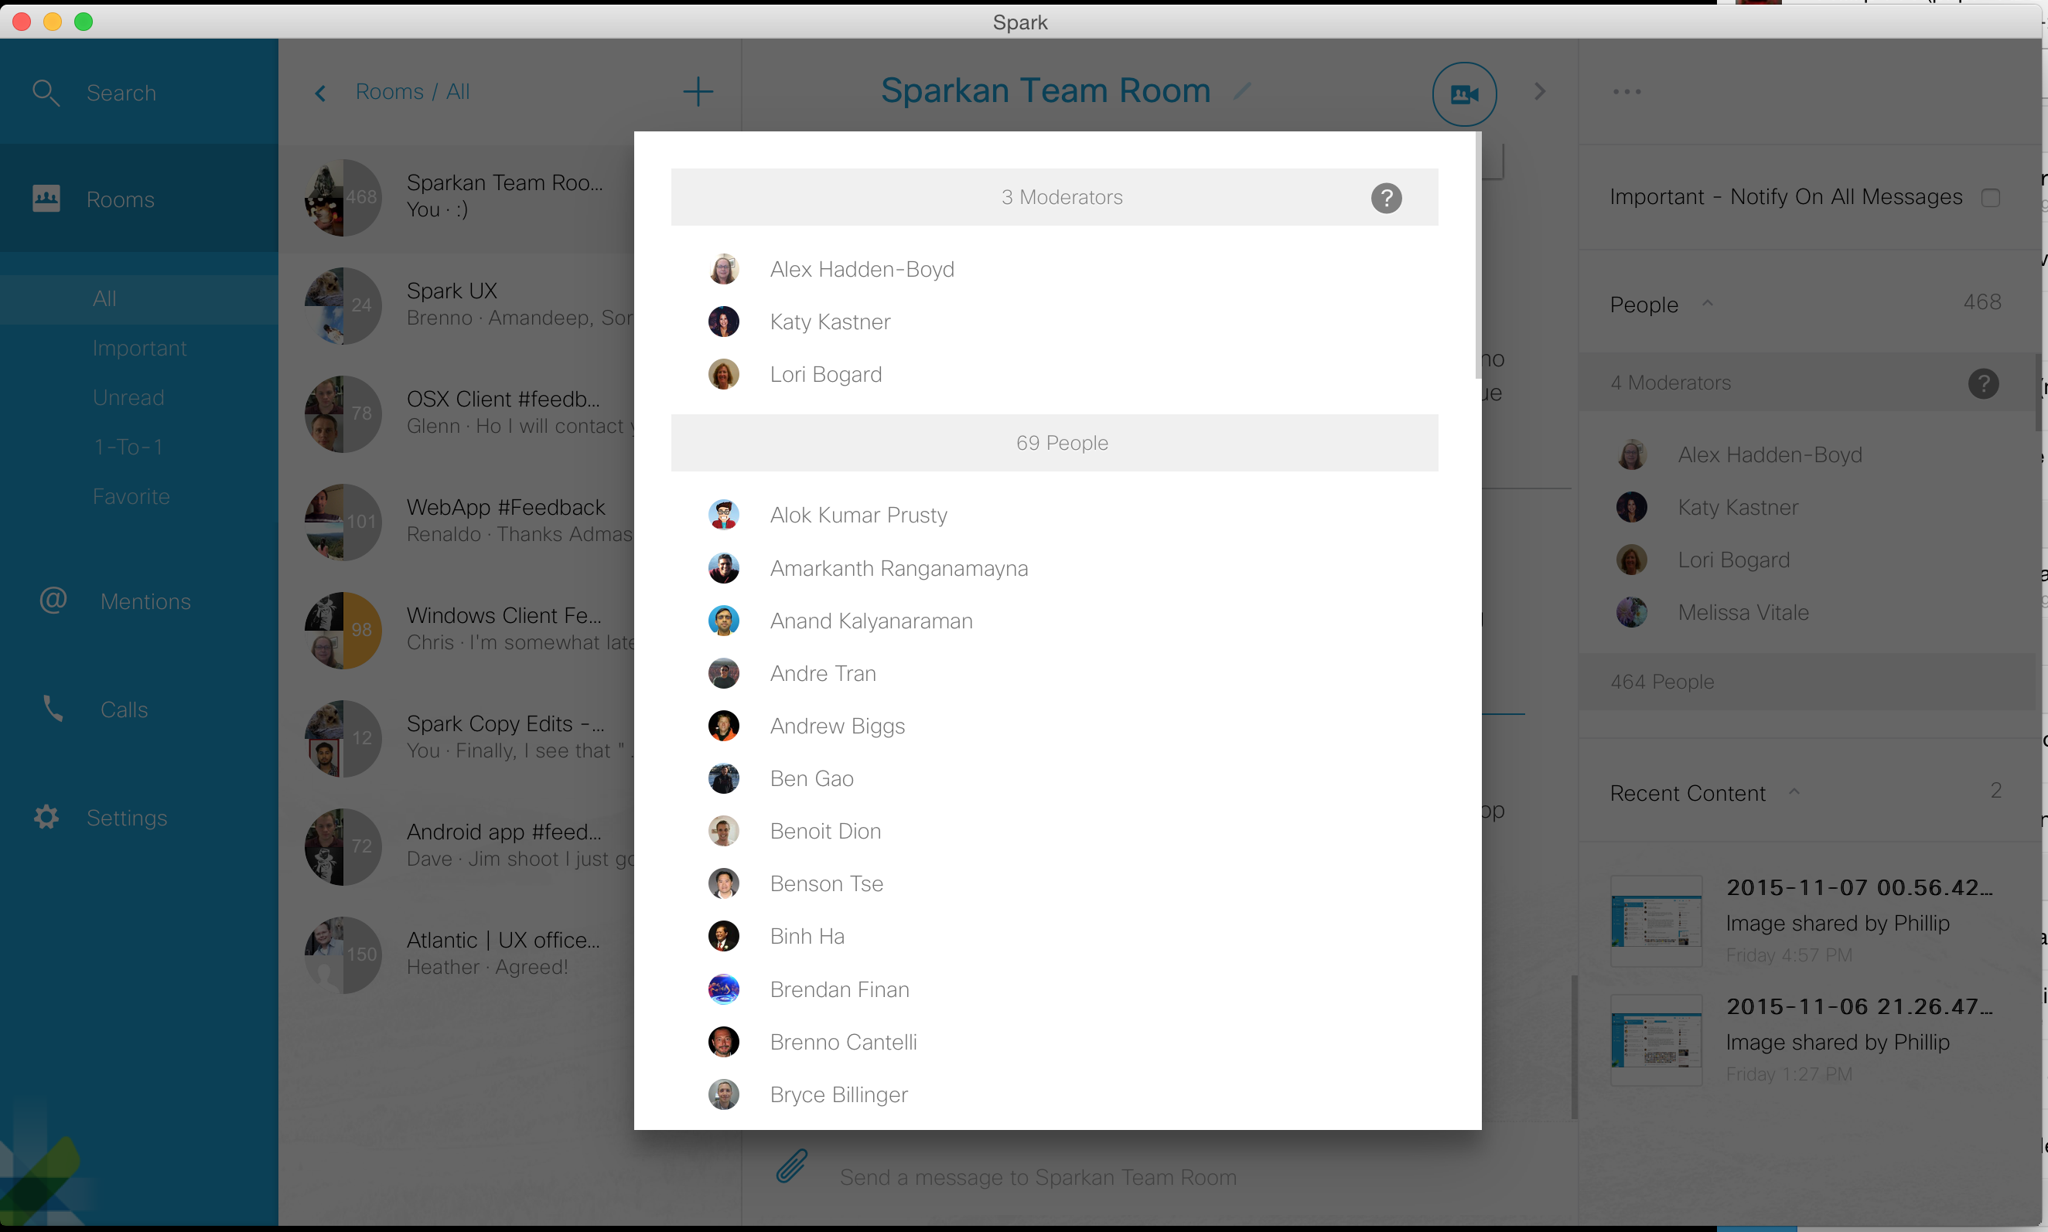

Two/2 issues shown below in this screen shot/capture: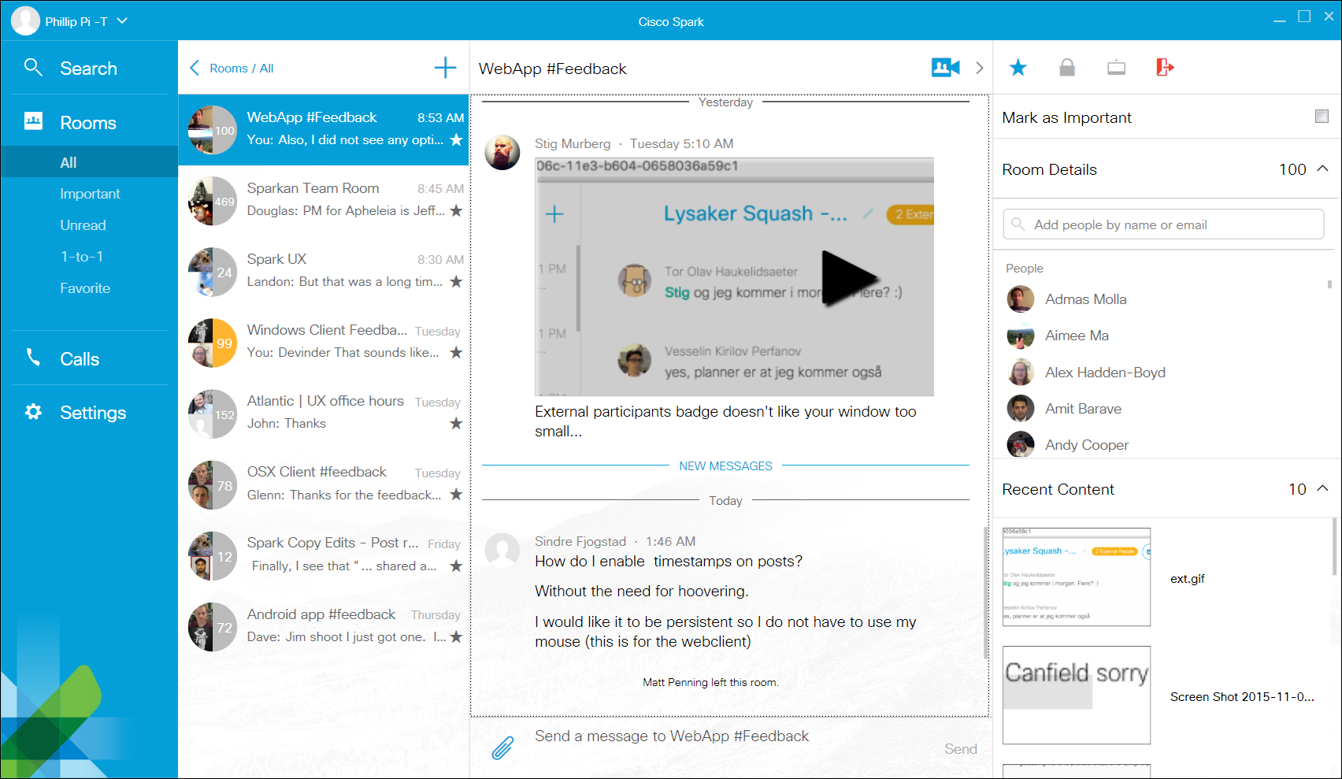
- In Windows v1.0.2745 software client for a posted 905.3 KB GIF image file in “WebApp #Feedback” room on 11/10/2015 5:10 AM PST, there was a “play” icon overlay over this. I did not see this “play” graphic overlay in Mac OS X v10.10.5 (Yosemite) software client v1.3619 (SDK v0.5.32) and 64-bit W7 EE SP1’s Google Chrome v46.0… I clicked on it, and only saw a larger static image (nothing animating). I assume this is a non-animated image and this “play overlay graphic is misleading and confusing.
- Suggestions from Sindre Fjogstad’s 11/11/2015 1:46 AM PST and me, give us an option to always show time stamps without having to use our mouse cursor to hover each message/post. Currently, there is no way to do this.

