9/29/2015-10/1/2015 Issues with Spark

Spark UX’s room’s transcript of issues mentioned:
…
Justin StylerYesterday, 7:13 PM
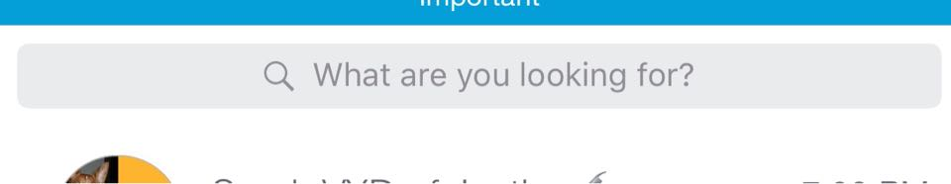 I would add this to the list of strings that needs to be refined. Feels awkward to me. The majority of search field hint text I see in other apps is either "Search" or "Search <product name>" or "Search <category>" (sometimes with multiple categories). I think we should go back to something clearer like that so users will know what they can expect to be able to find via our search.

Today
Candice Lavender4:17 AM
Agreed. This also came up in a desktop engineering team meeting for search yesterday. Feedback was that it sounds harsh, could encourage users to type "I'm looking for x" Also the "what" could be a "who" and may be confusing etc.

Ravi Rajagopal6:58 AM
Oliver this search string is coming up multiple times and wanted to see if we can get a resolution on this first.

Oliver Wenz10:07 AM
Let me open up a room for copy strings to be fixed. I will call the room Spark Copy Edits. Please post all of these again there as I will add the copy writer to it. You might have to post previous requests as well.

Oliver Wenz10:09 AM
Can someone work with engineering to remove the “Failed to create room” error message that has been showing on Mac client now for over a week ?

Oliver Wenz10:10 AM
Ha, it really failed to create the room ;)

Ravi Rajagopal10:26 AM
Hi Phillip Can you help to capture this in a document. If you dont have Mac I can send you the screenshots. Also current search bug needs to be captured 1) Title of room and converstation room are not the same sometimes 2) User searches for name and hits return and expectation is to go to room but different bahviorr.
*Behavior
Reproduced Spark for Mac Client v1.3523 (SDK v0.5.26) Issues With Screen Captures In an Updated Mac OS X v10.10.5 (Yosemite) on a 15” MacBook Pro (Retina; early 2013):

Current Search Examples:

1. I searched for Oliver Queen with and without quotation marks (did not want any Oliver like Wenz) and got these on my screens:
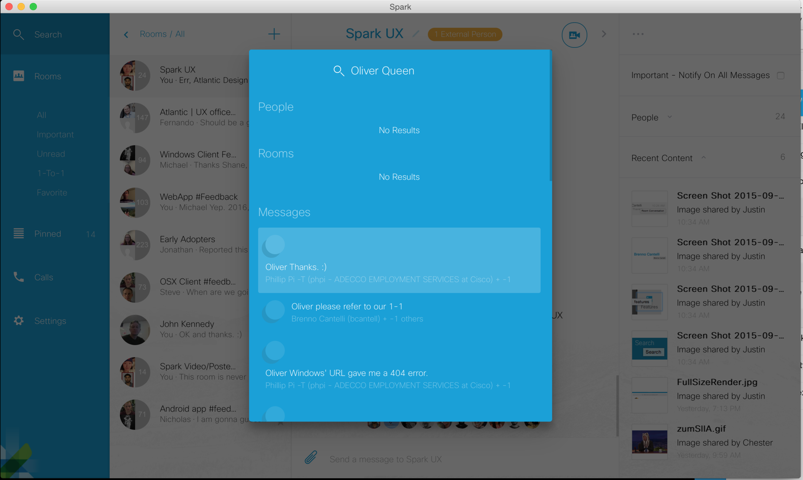
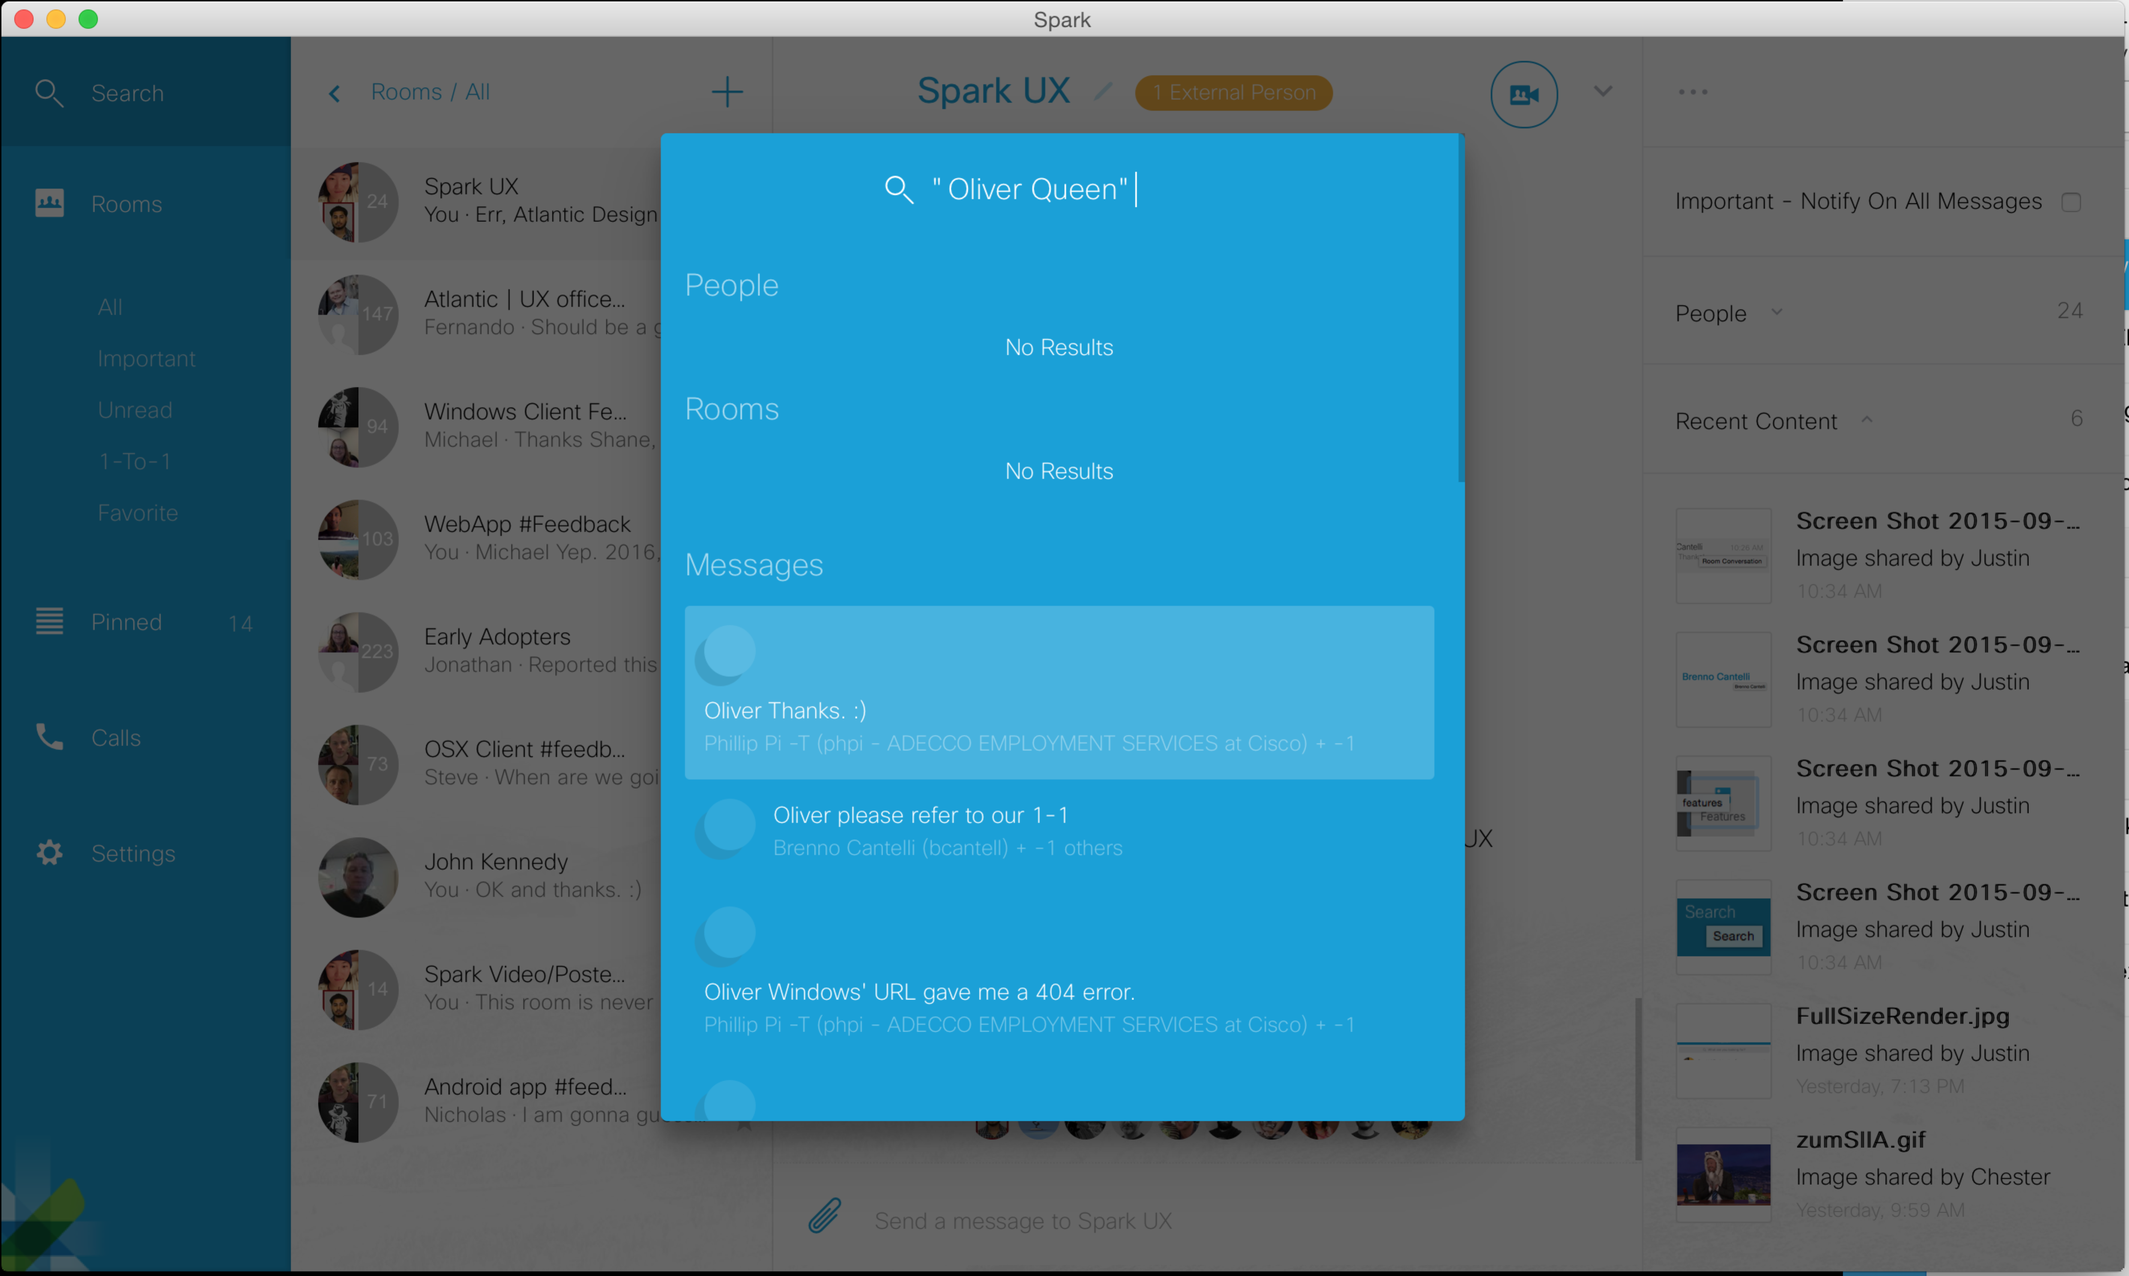

2. I tried a question:
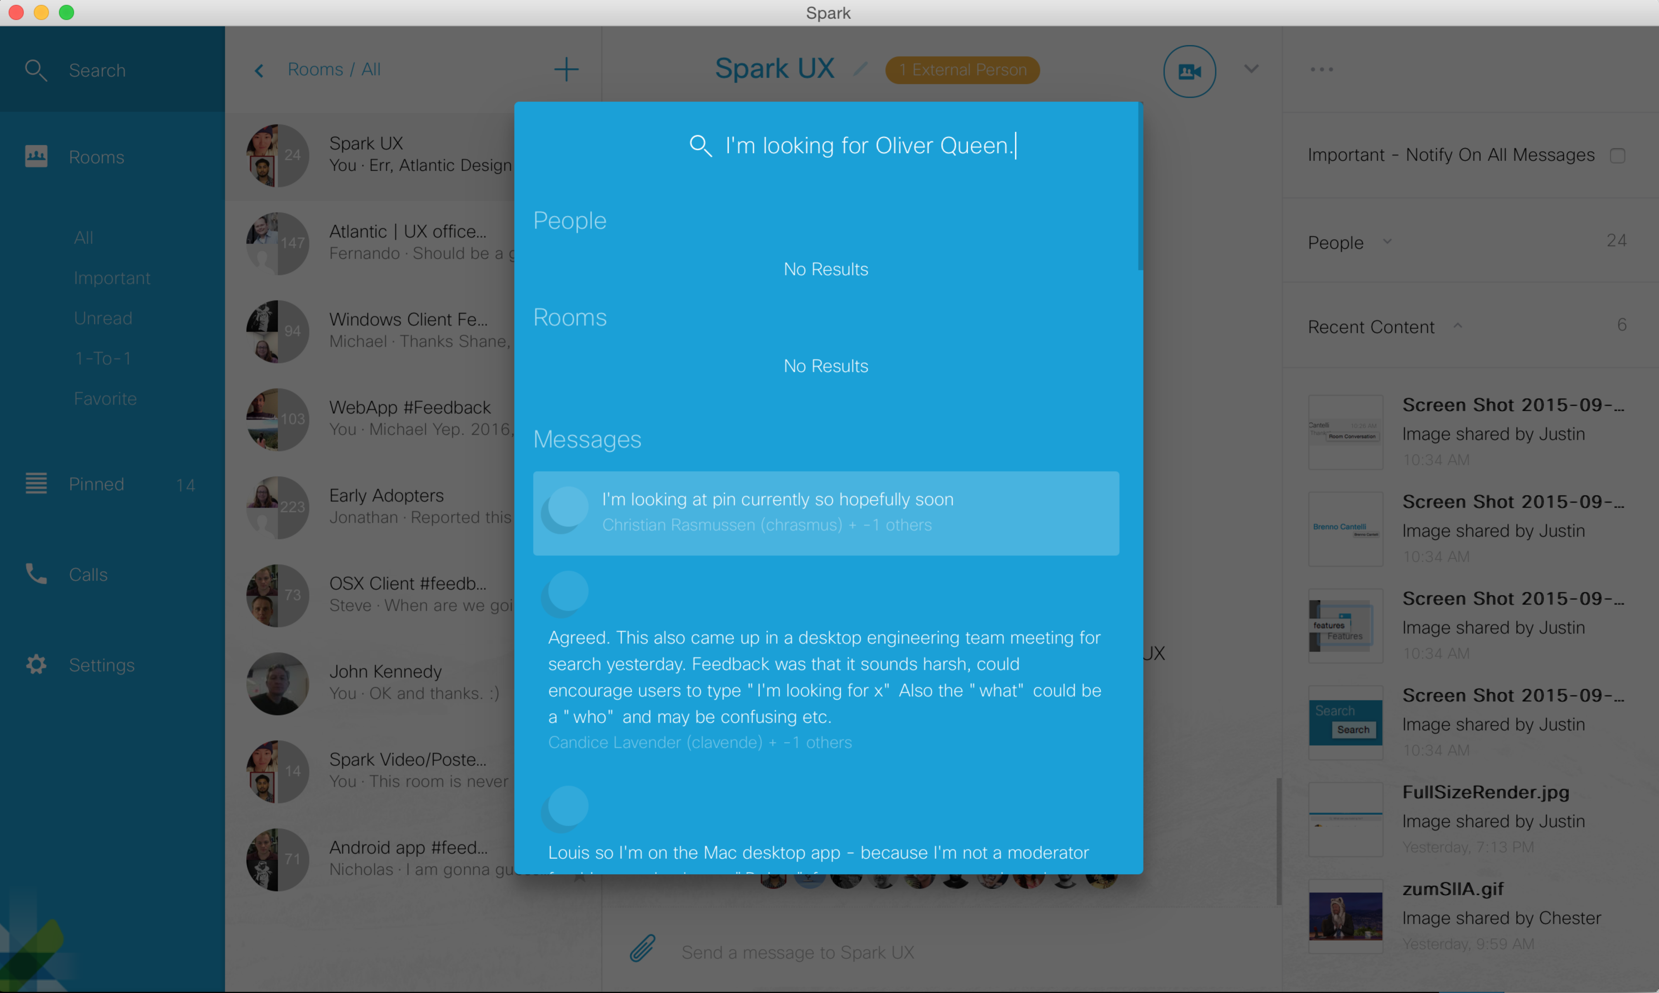

3. Keyboard navigations:
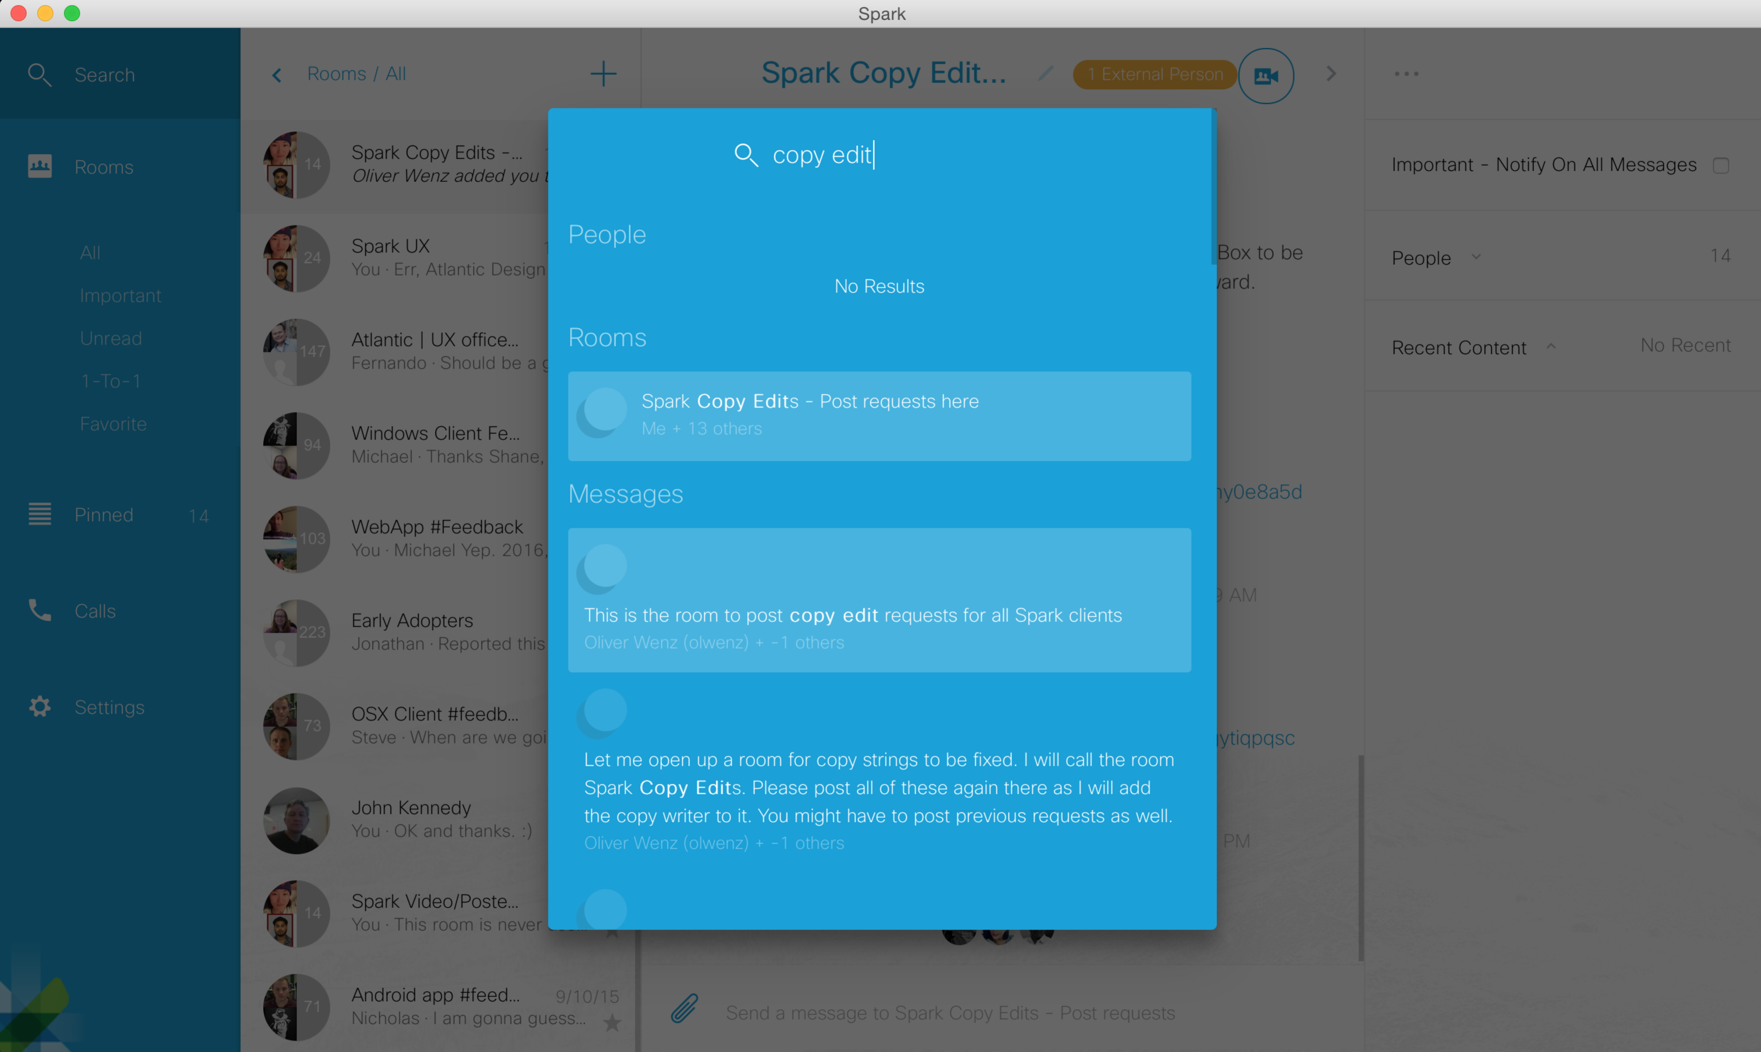
After clicking in the blue search results window, my arrow keys stop working to move around my selection. Sometimes even escape key doesn’t exit this search pop-over. I have to restart Spark to fix it. I cannot find the exact pattern to reproduce this.

Also, search should be able to let me use my tab keys to move my selection.

4. Search “spark” keyword seems to get its Searching… Messages stuck forever and arrow keyboard navigation do not work:
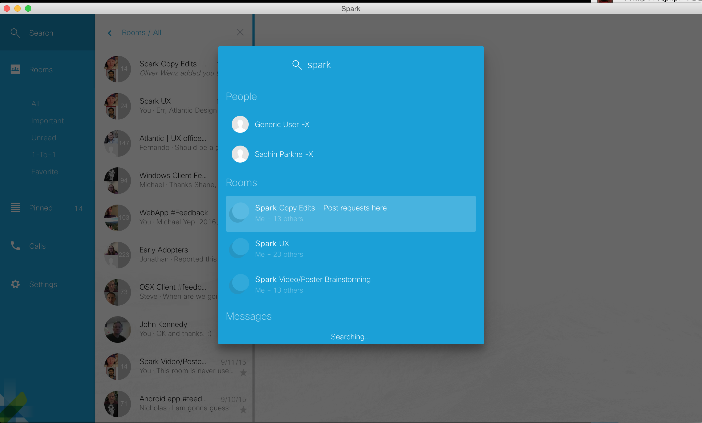

5. Scrolling down the long search results list with the working keyboard navigation (down arrow) does not scroll the list since it goes to the top of the list (note there were two highlights):
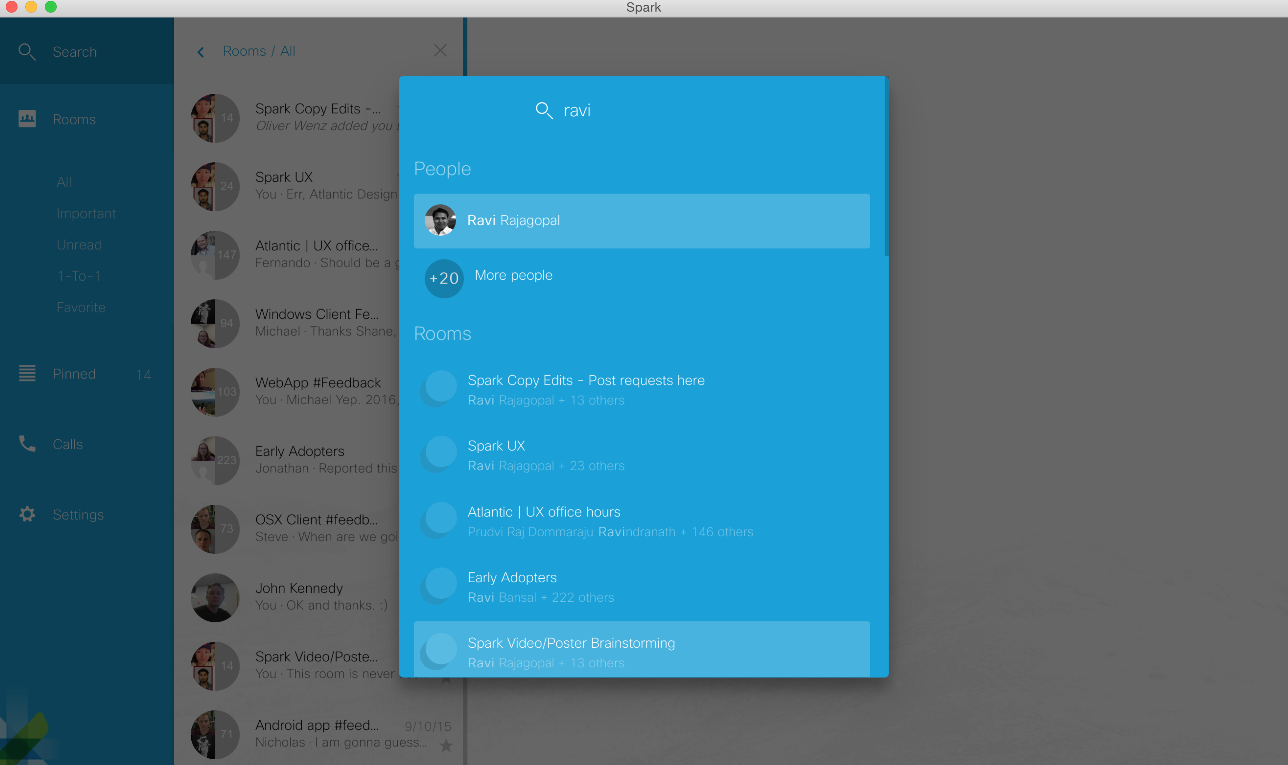

Title of room and conversation room are not the same sometimes: I was unable to reproduce this so far by searching to join, manually my existing room list, etc. Do you have the instructions for this?

User searches for name and hits return and expectation is to go to room, but different behavior:
Searching “Ravi” name and then pressing keyboard’s enter key sometimes shows a blank “Room Preview”, a red “Spark UX – Fail to get activity set” failure error, and/or to “Spark UX” room (should be going to 1:1 room with him):
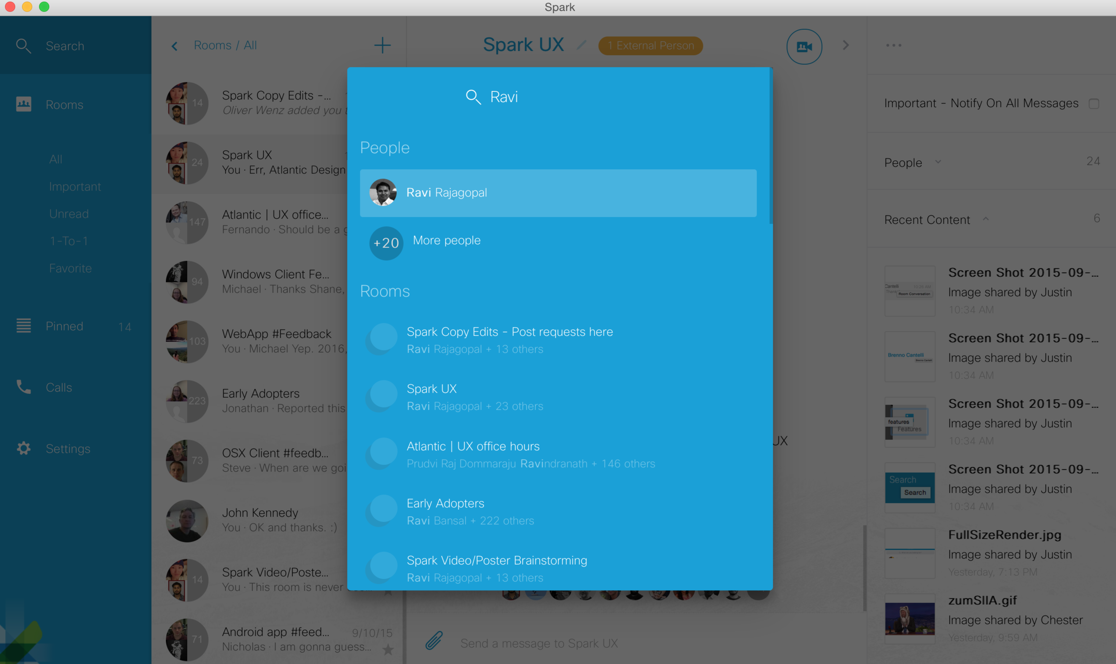

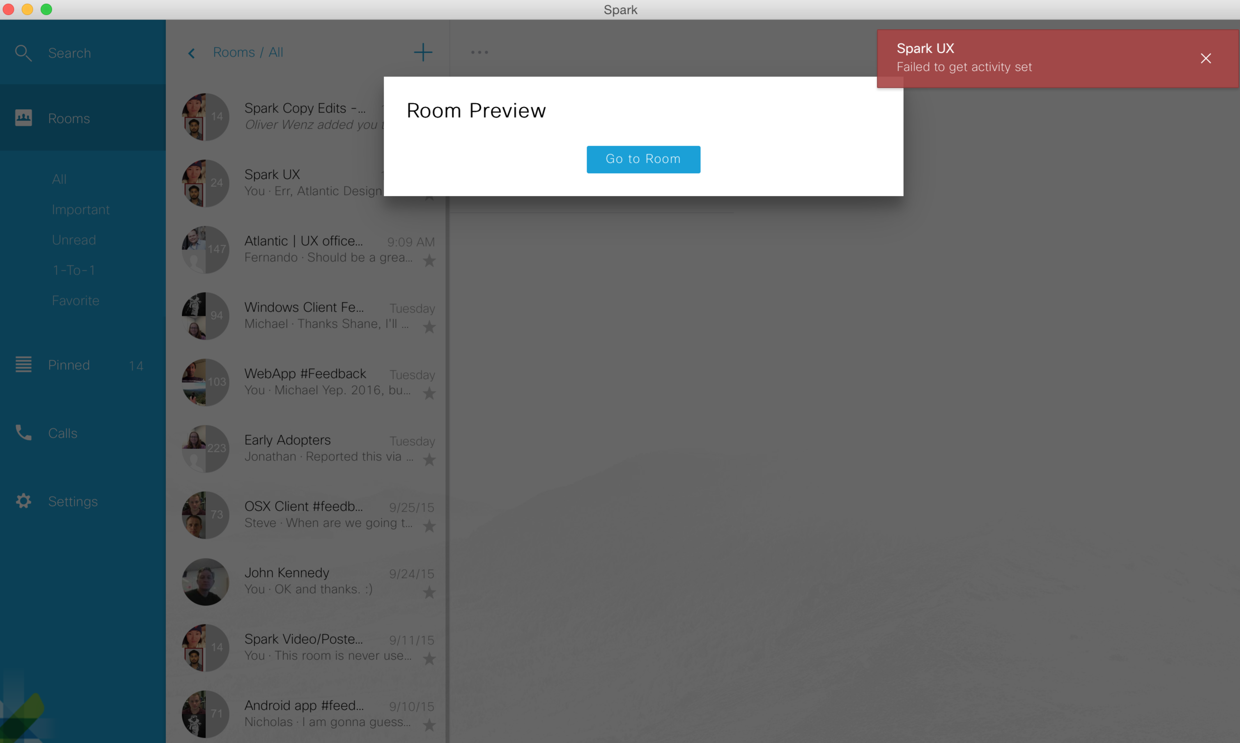

From Justin Styler’s 10/1/2015 10:31AM PDT in “Spark Copy Edits” room: Desktop - "Chat with people instantly."title, "Search for people to chat, share documents, and video call."subtext, "Jane Smith or jane.smith@dom" entry field hint text, "Add people to chat" disabled button by default, "Chat with <name>" button if one person is entered, "Go chat!" button if multiple people are entered.
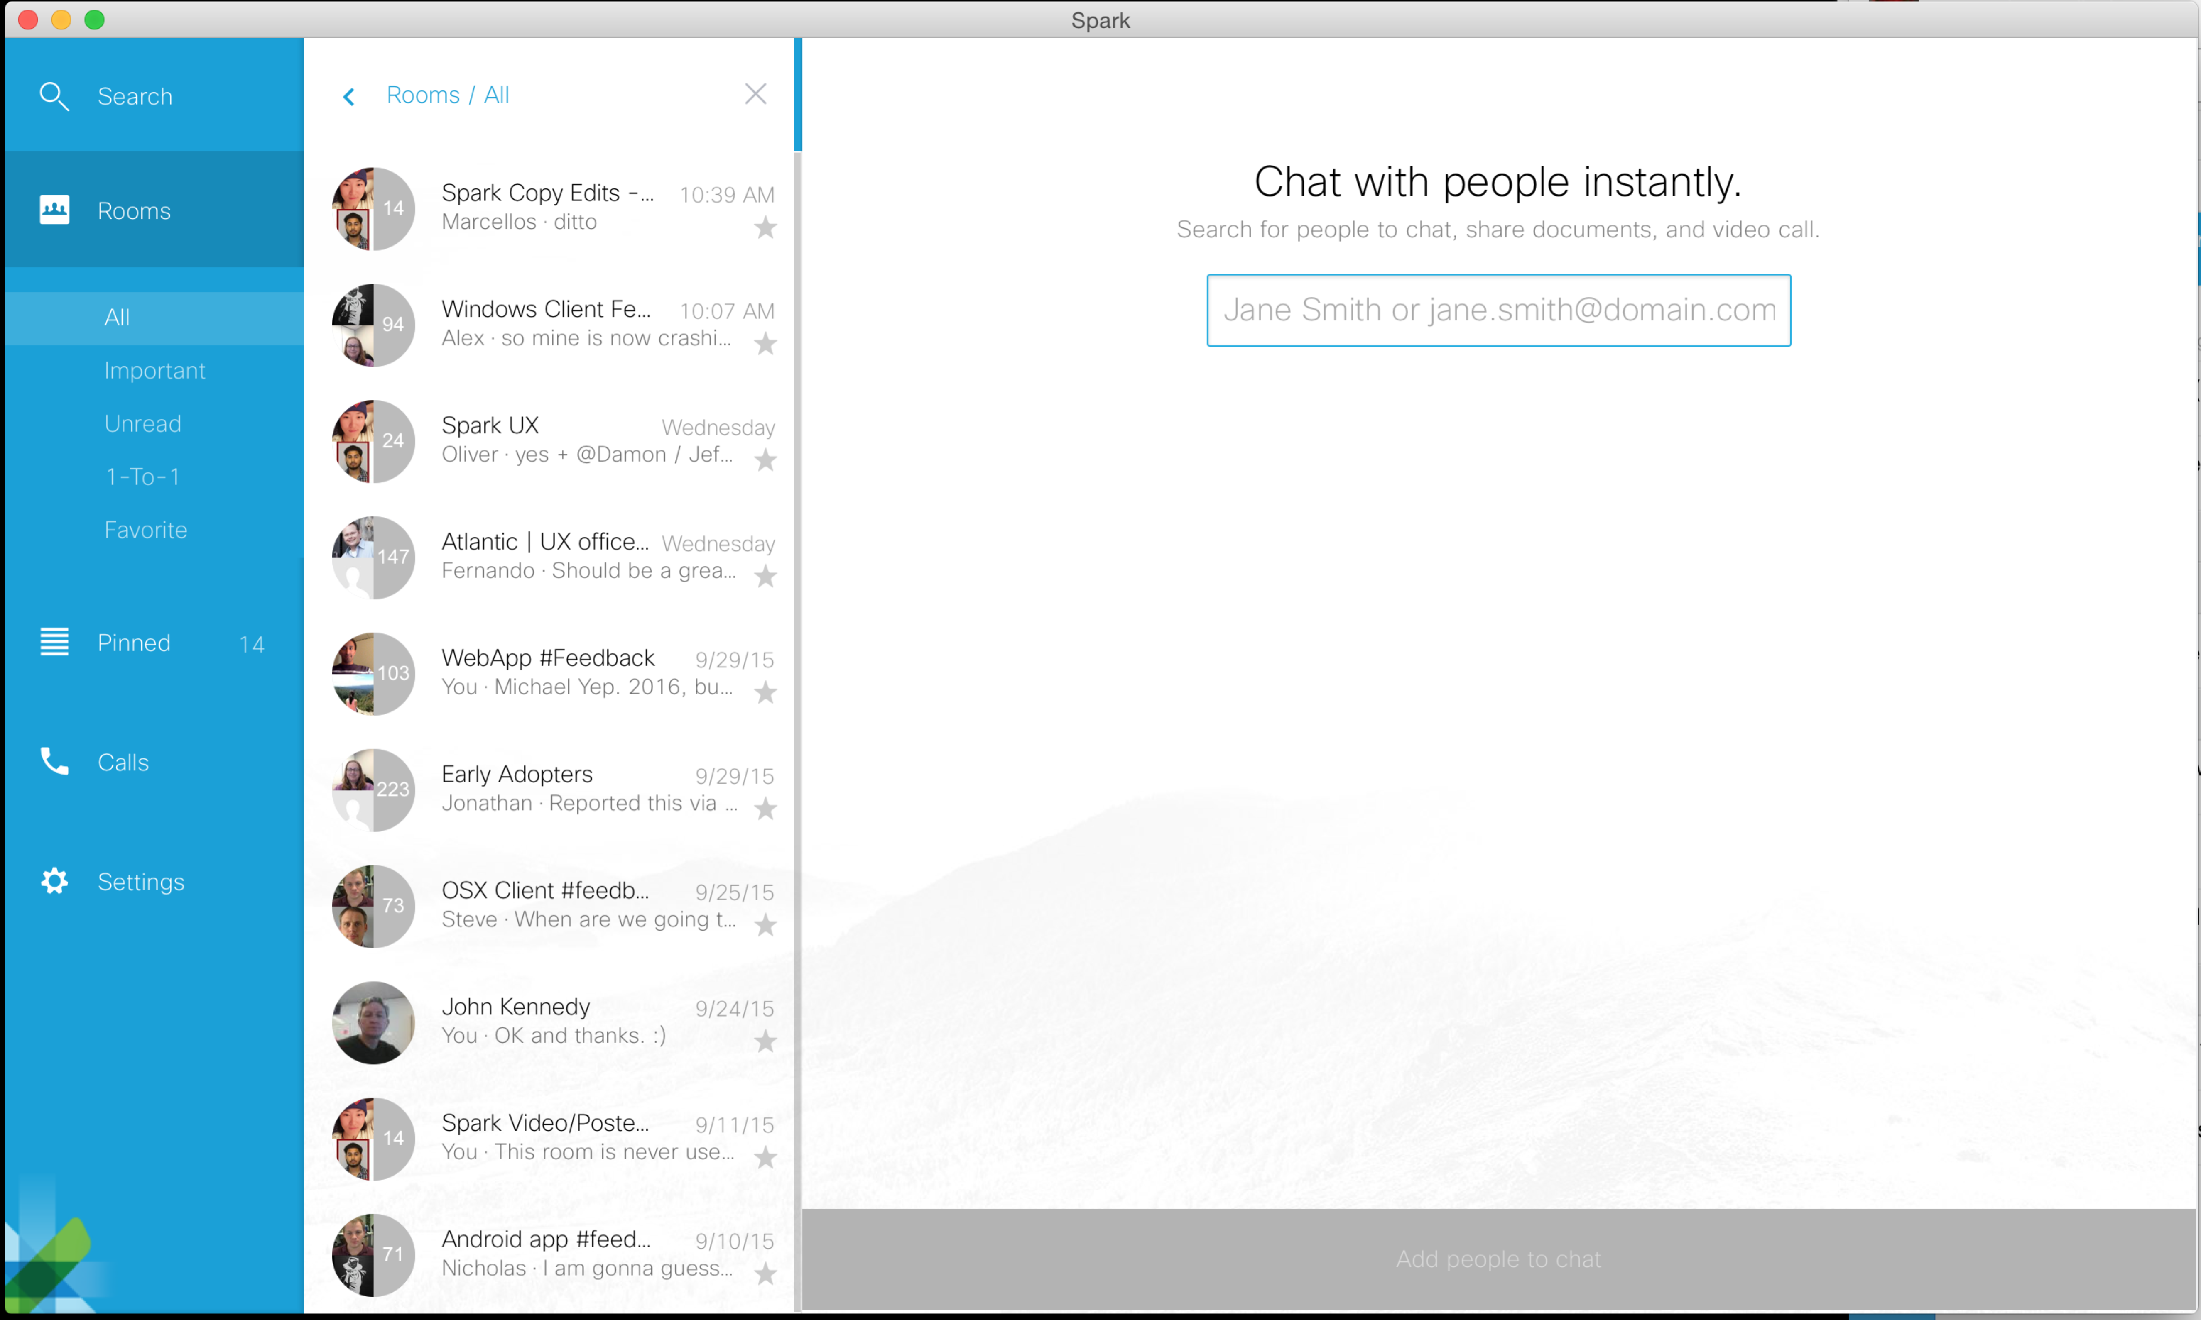
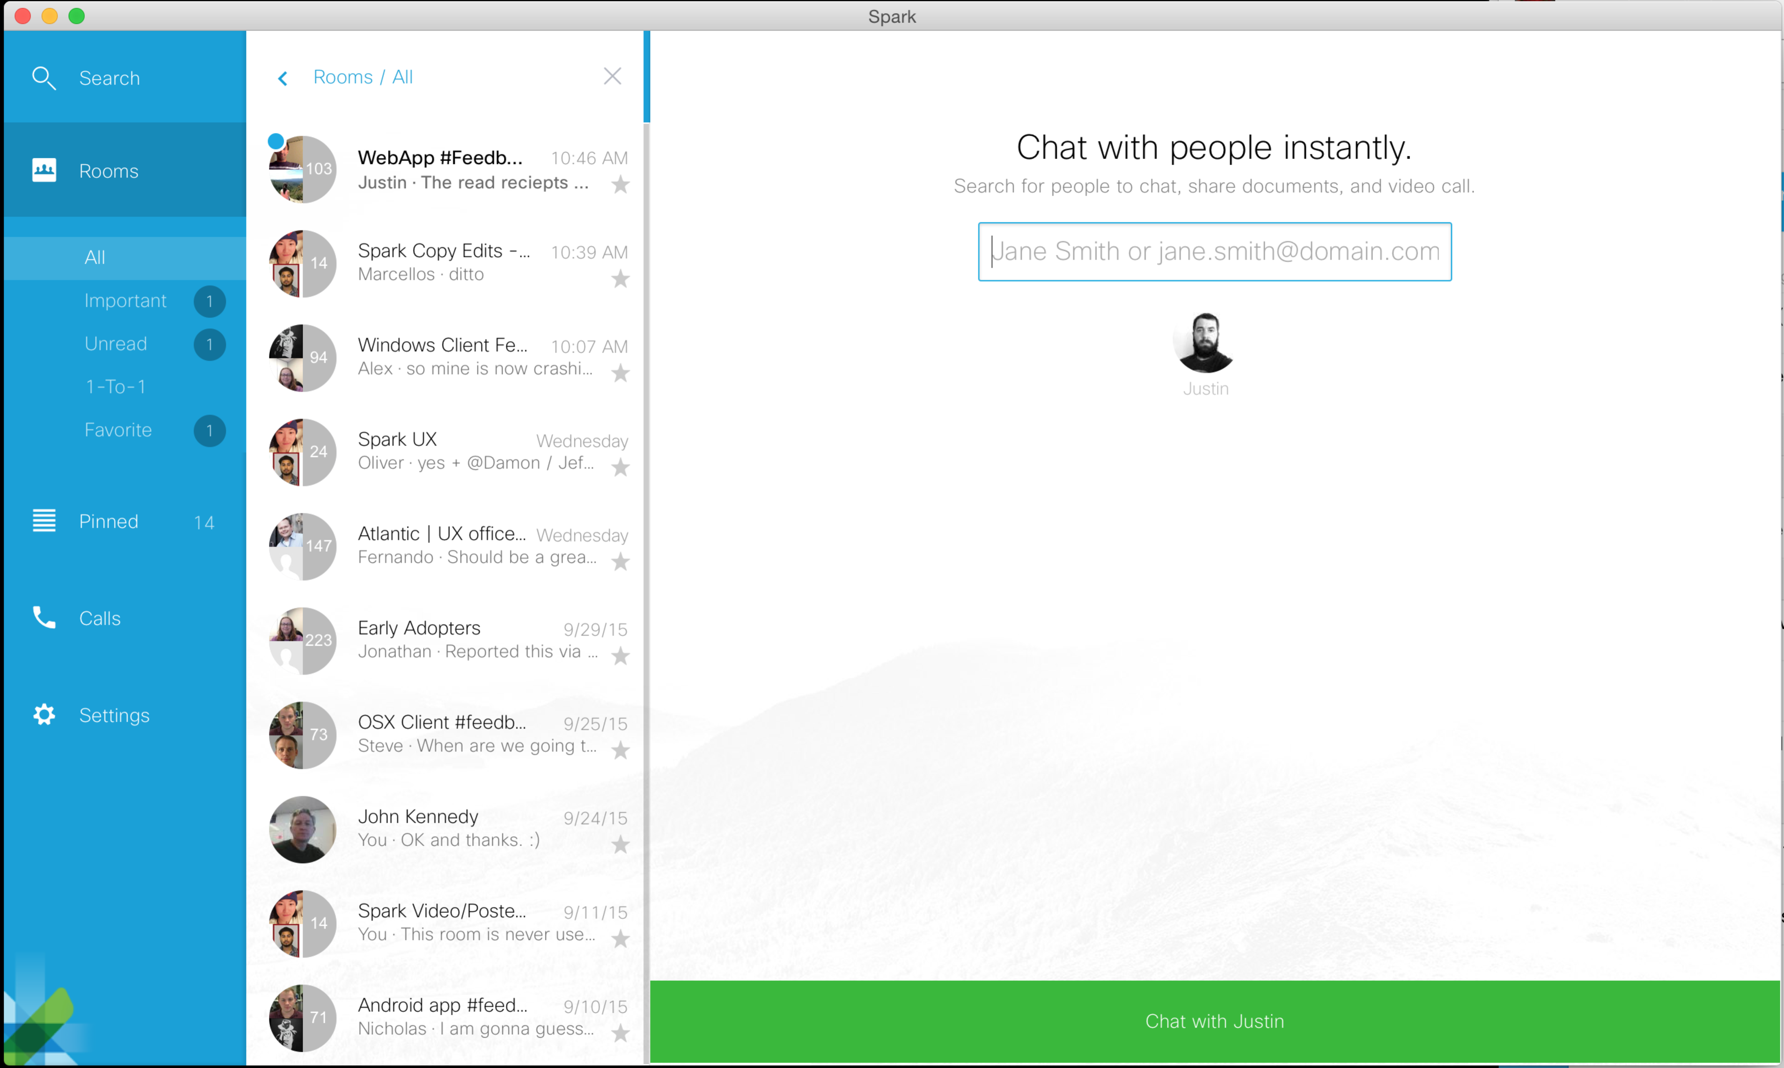
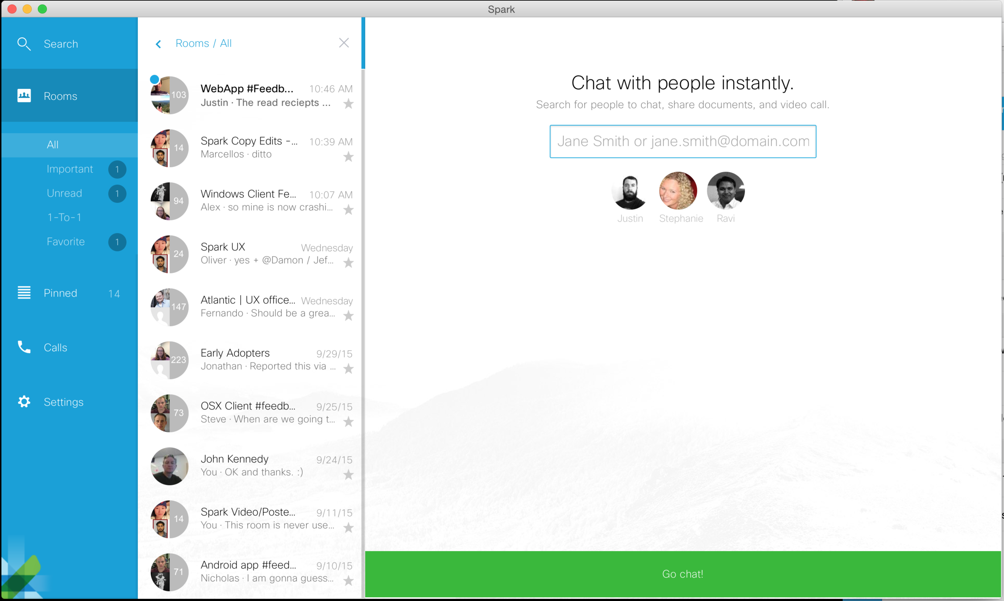

From Justin Styler · October 1 10:31 AM PDT in Spark’s “Spark Copy Edits” Room:
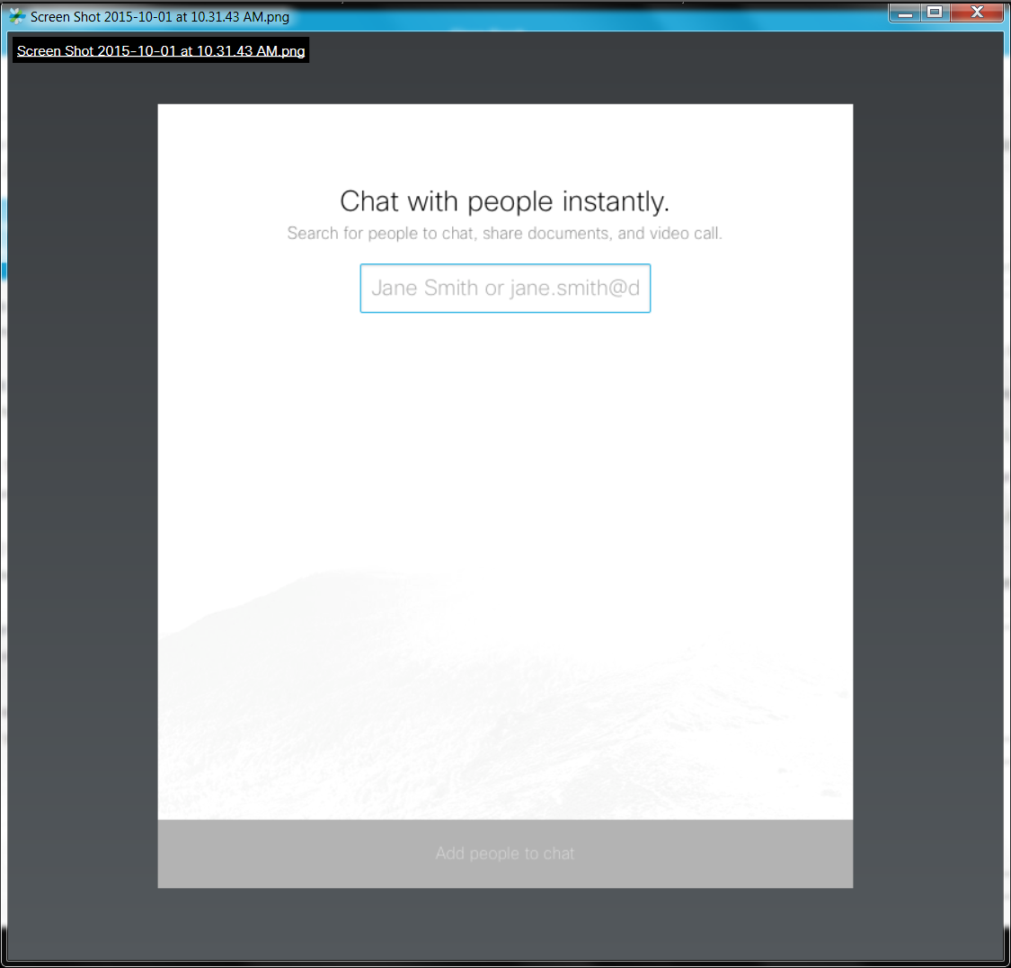
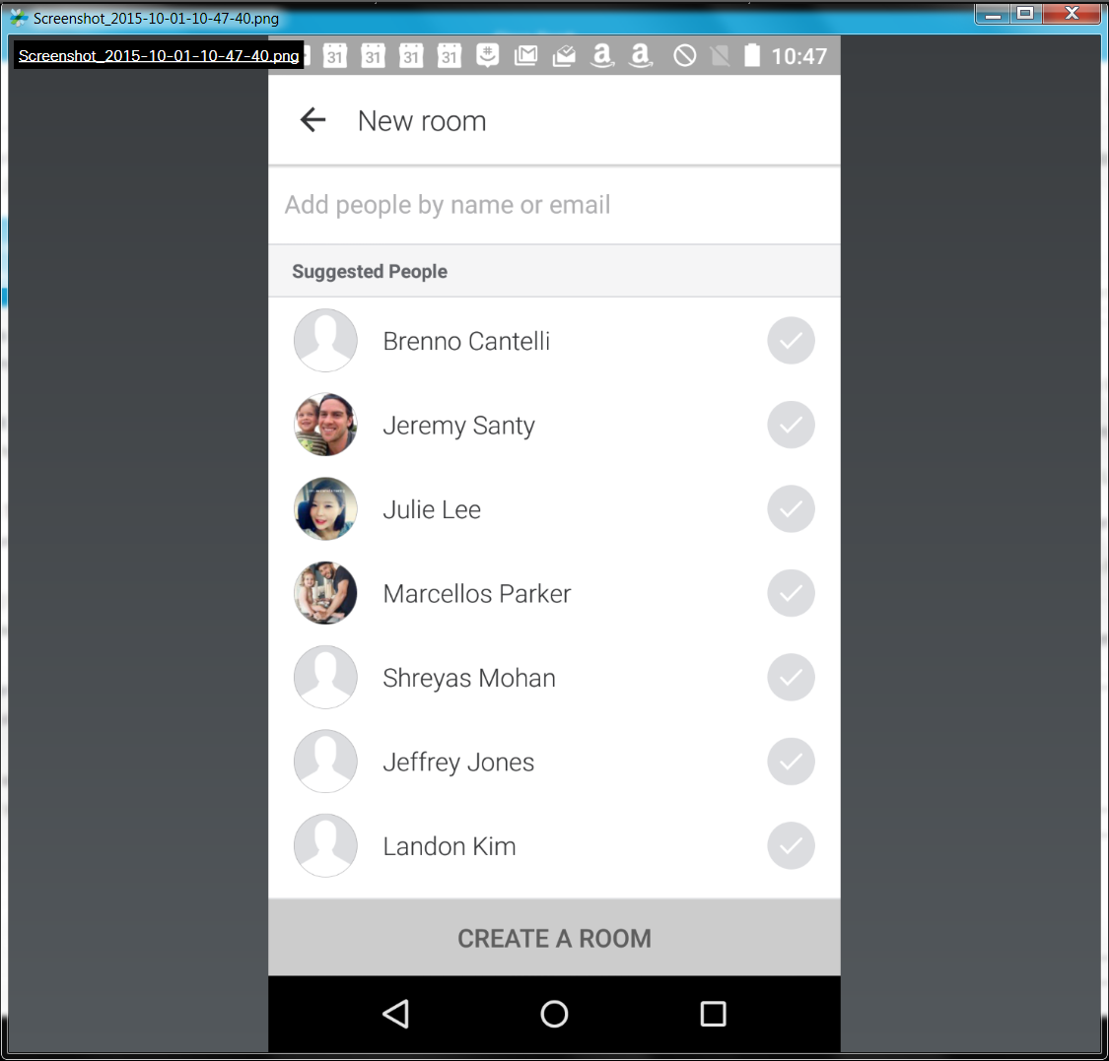
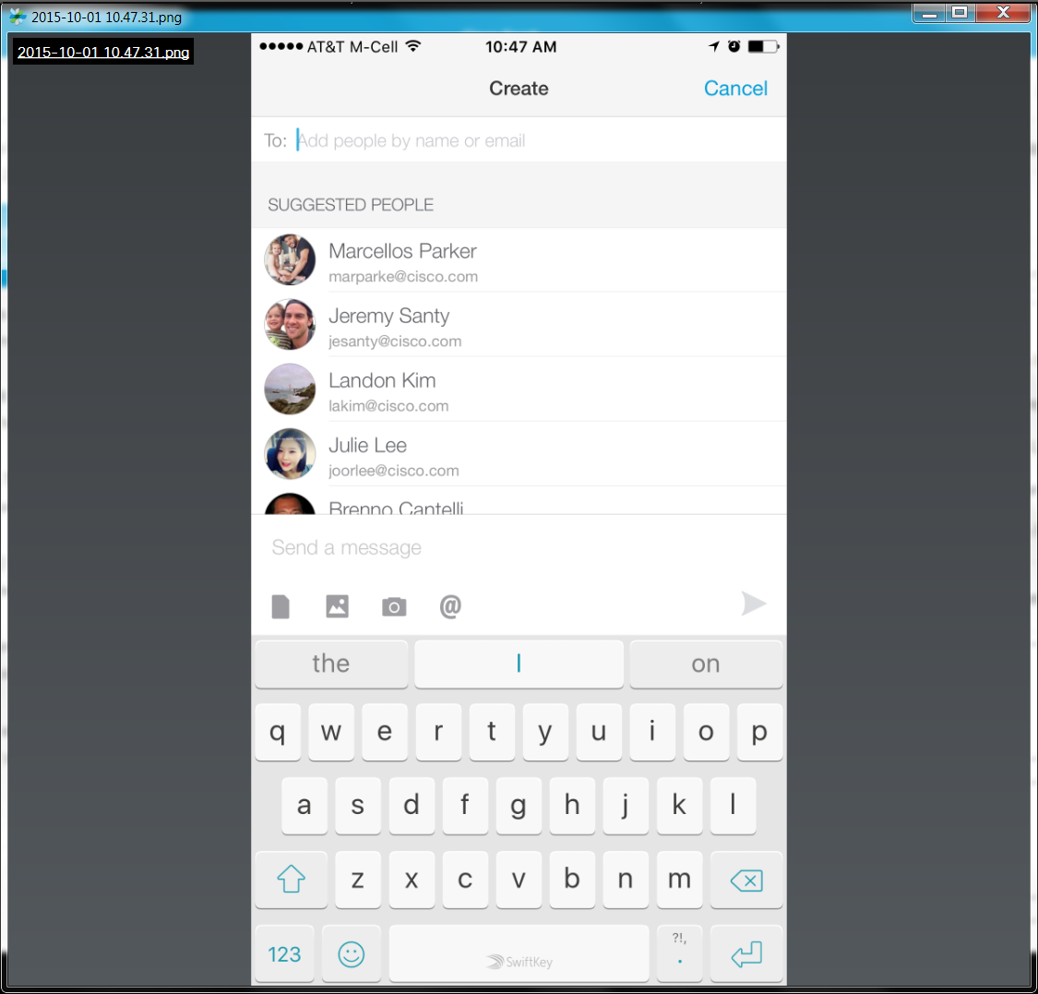
“I think Jeremy already asked for copy writing help with this, but I'll add my 2 cents that for this flow in particular the cross-platform consistency and clarity of the copy is critical. What we currently have across platforms creates a large conceptual divide between mobile and desktop products:

• iOS - "Create"title, "Add people by name or email" entry field hint text, sending a message as the only way to complete the creation flow for 1-to-1s and groups.
• Android - "New room" title, "Add people by name or email" entry field hint text, "Create A Room" disabled button by default, "Enter 1-to-1 room" if one person is entered, "Create a room" if multiple people are entered.
• Desktop - "Chat with people instantly."title, "Search for people to chat, share documents, and video call."subtext, "Jane Smith or jane.smith@dom" entry field hint text, "Add people to chat" disabled button by default, "Chat with <name>" button if one person is entered, "Go chat!" button if multiple people are entered.

Since the creation flow is going to change with the new teams model it's a big opportunity for us to clean up the mess.”

Onboarding Issues:
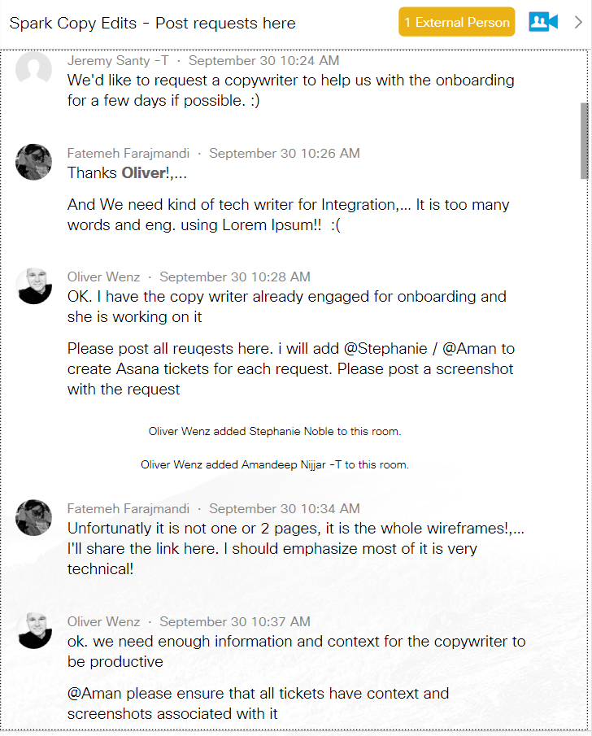
…
Fatemeh Farajmandi · September 30 10:34 AM
Unfortunatly it is not one or 2 pages, it is the whole wireframes!,… I'll share the link here. I should emphasize most of it is very technical!

Oliver Wenz · September 30 10:37 AM
ok. we need enough information and context for the copywriter to be productive
@Aman please ensure that all tickets have context and screenshots associated with it

Fatemeh Farajmandi · September 30 10:40 AM
Webhooks Integration: https://www.dropbox.com/s/ngvwxklmzpl7ma4/Web-Integration10.pdf?dl=0
Github Integration: https://www.dropbox.com/s/7vklfmwx5nwc5sd/Web-Integration-GitHub1.pdf?dl=0

Oliver Wenz · September 30 10:56 AM
Thanks for posting. Please move all of this stuff to Box to be compliant. Please do not use dropbox moving forward. PLease repost links from there
[Phillip’s Comments: These big PDF file links were still online as of 11/5/2015’s early afternoon PST! They should had been removed to be compliant?]

Fatemeh Farajmandi · September 30 11:49 AM
Sure
Here is GitHub Integrationn: https://cisco.box.com/s/1ext3ozm2e0dtfpvqd0b3hy0e8a5dotw
Fatemeh Farajmandi deleted their own message.

Fatemeh Farajmandi · September 30 11:50 AM
Webhooks Integrations: https://cisco.box.com/s/1rzi7ld3km1qh75u1uzn6gytiqpqscvw

