Phillip Pi’s QA UI results with Windows v1.0.0.2862 desktop client’s coach marks in an updated 64-bit W7 EE SP1 (Smaller - 100% DPI) on 11/23-30/2015.
Notes: All specifications were from http://wikicentral.cisco.com/display/WX2/VXD+-+Coach+Mark. Also, starting up Spark with its dev(eloper) console’s reset coach marks option and after relogging in with my June 2015 account.

Desktop’s Screen Shot Specifications With Introduction Texts Without Technical Details:
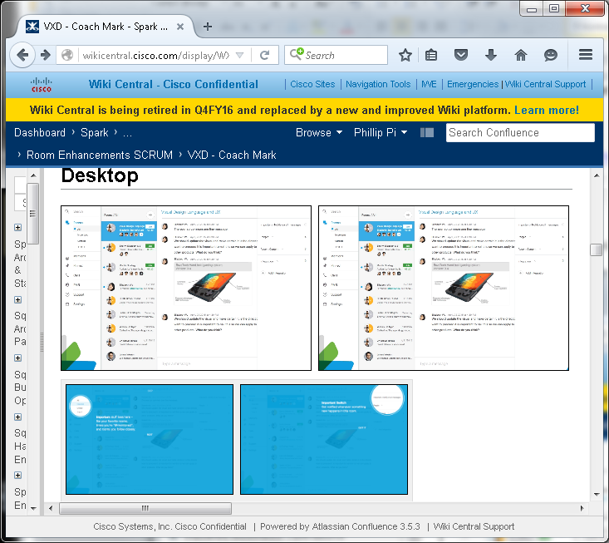
Top/First Row: http://wikicentral.cisco.com/download/attachments/509751860/web-coachmark-mock01.png and http://wikicentral.cisco.com/download/attachments/509751860/web-coachmark-mock02.png

Second/Bottom Row (animated GIF images): http://wikicentral.cisco.com/download/attachments/509751860/coachmark-web-v1.gif?version=1&modificationDate=1441914073000 and http://wikicentral.cisco.com/download/attachments/509751860/coachmark-web-importantswitch_v3.gif?version=1&modificationDate=1441914072000

Desktop’s Texts (most of them matched what I saw in my Spark except for its “Mark … as Important …”) Specifications: http://wikicentral.cisco.com/download/attachments/509751860/Coach+Mark+Copy_v3.docx?version=2&modificationDate=1445546301000 (I assume all of these are correct texts to use in Spark).
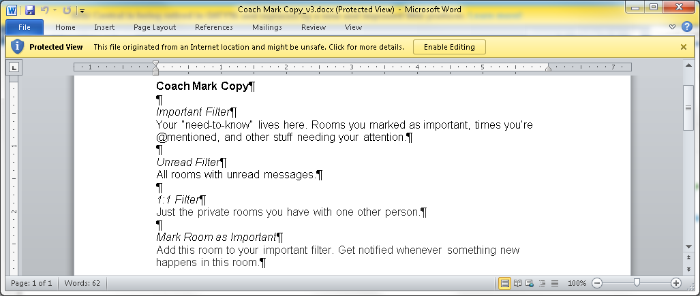

What I saw:
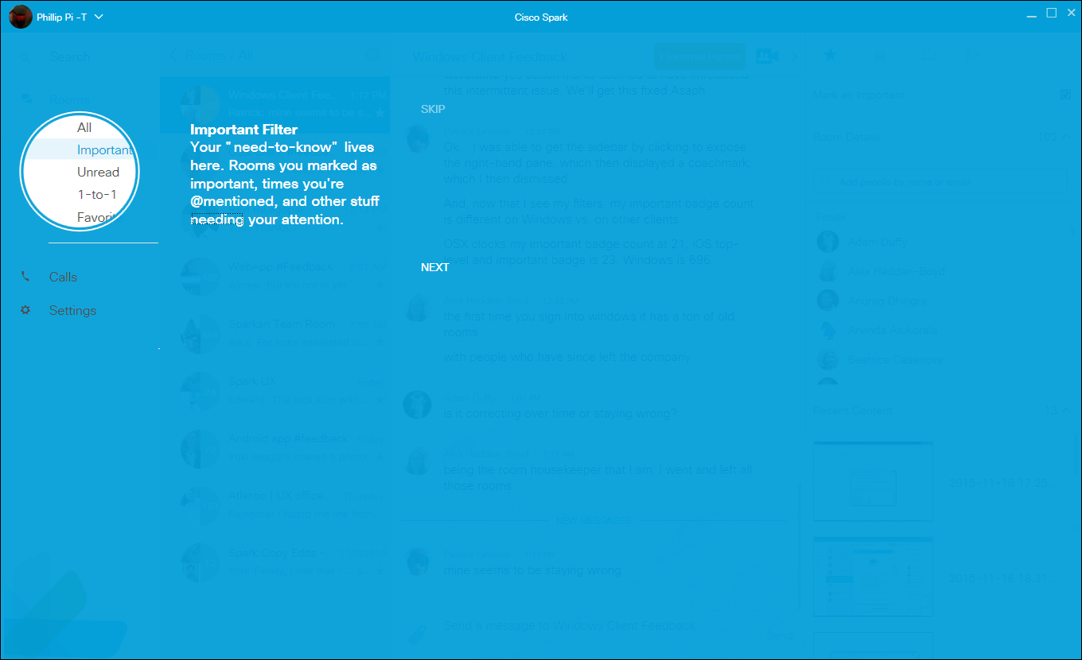
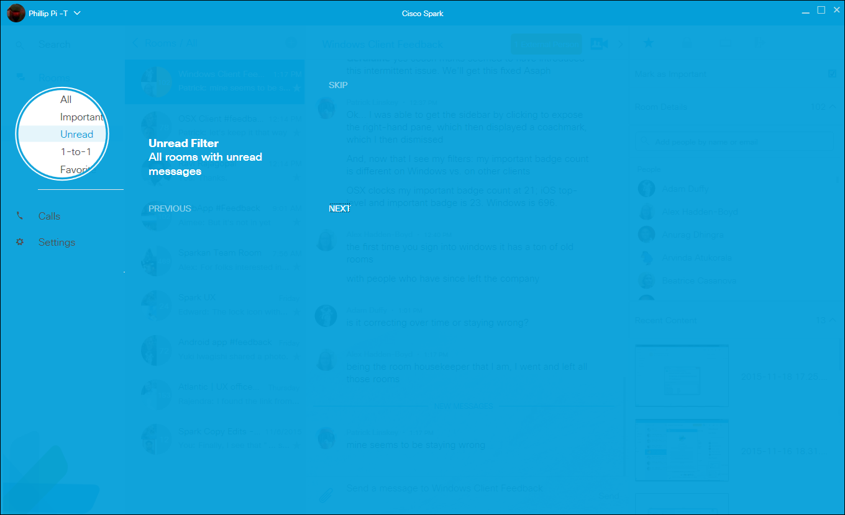
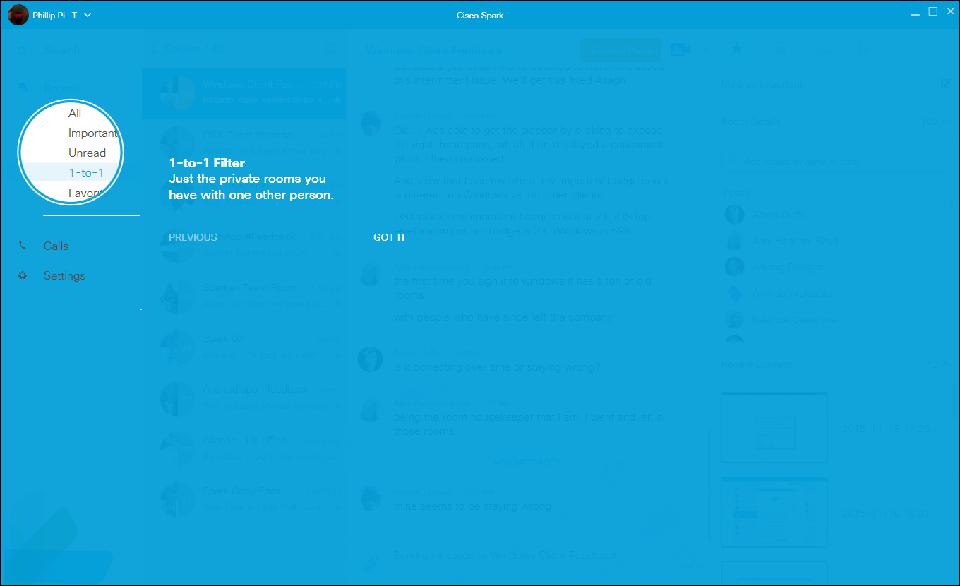
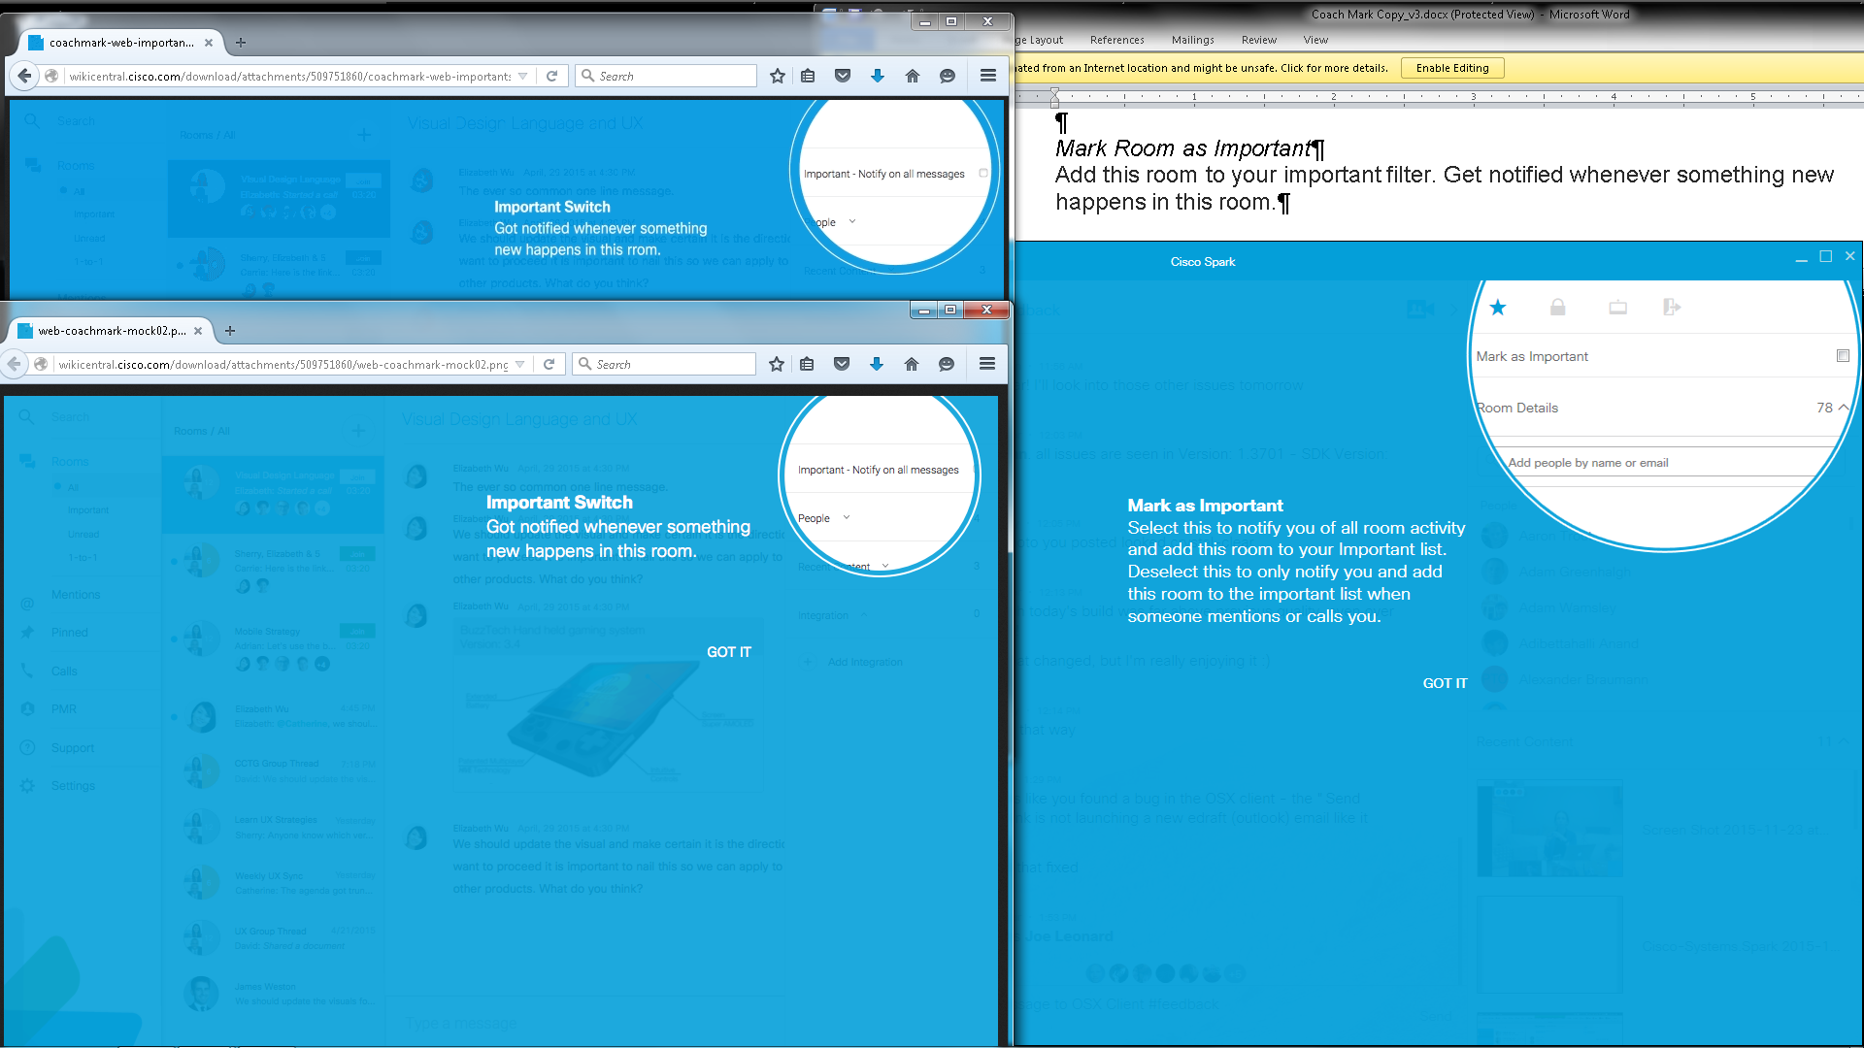
Issue: Which texts are correct for the “Important” part? Does http://wikicentral.cisco.com/download/attachments/509751860/Coach+Mark+Copy_v3.docx?version=2&modificationDate=1445546301000 have all the correct updated texts and not from the specifications’ images? If so, then my Spark client is showing the wrong texts for this part.

Technical Details (color codes, sizes, etc.):
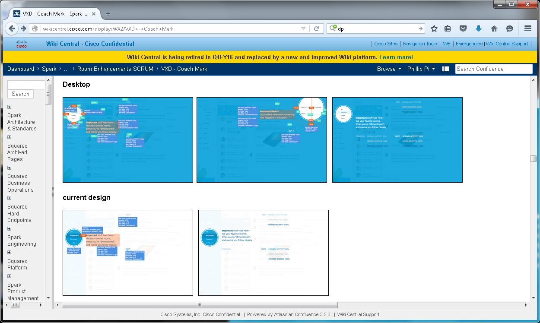
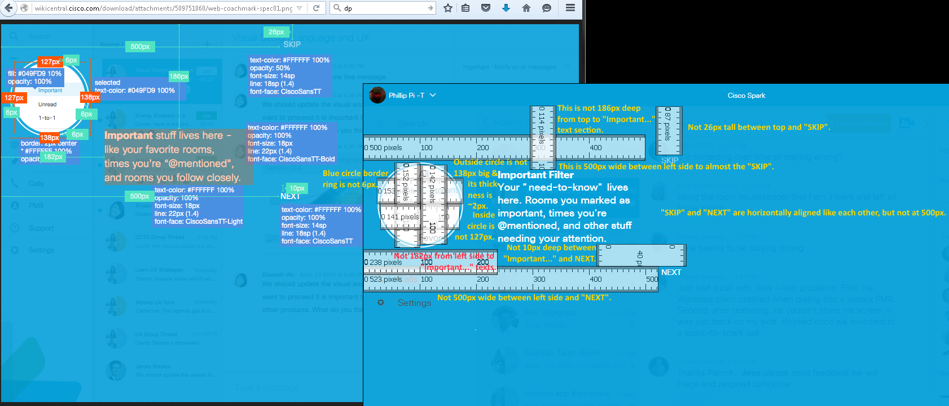
Compared with http://wikicentral.cisco.com/download/attachments/509751860/web-coachmark-spec01.png?version=1&modificationDate=1441919975000
Issues: Dimension sizes didn’t match each other.

Colors, fonts, etc.:
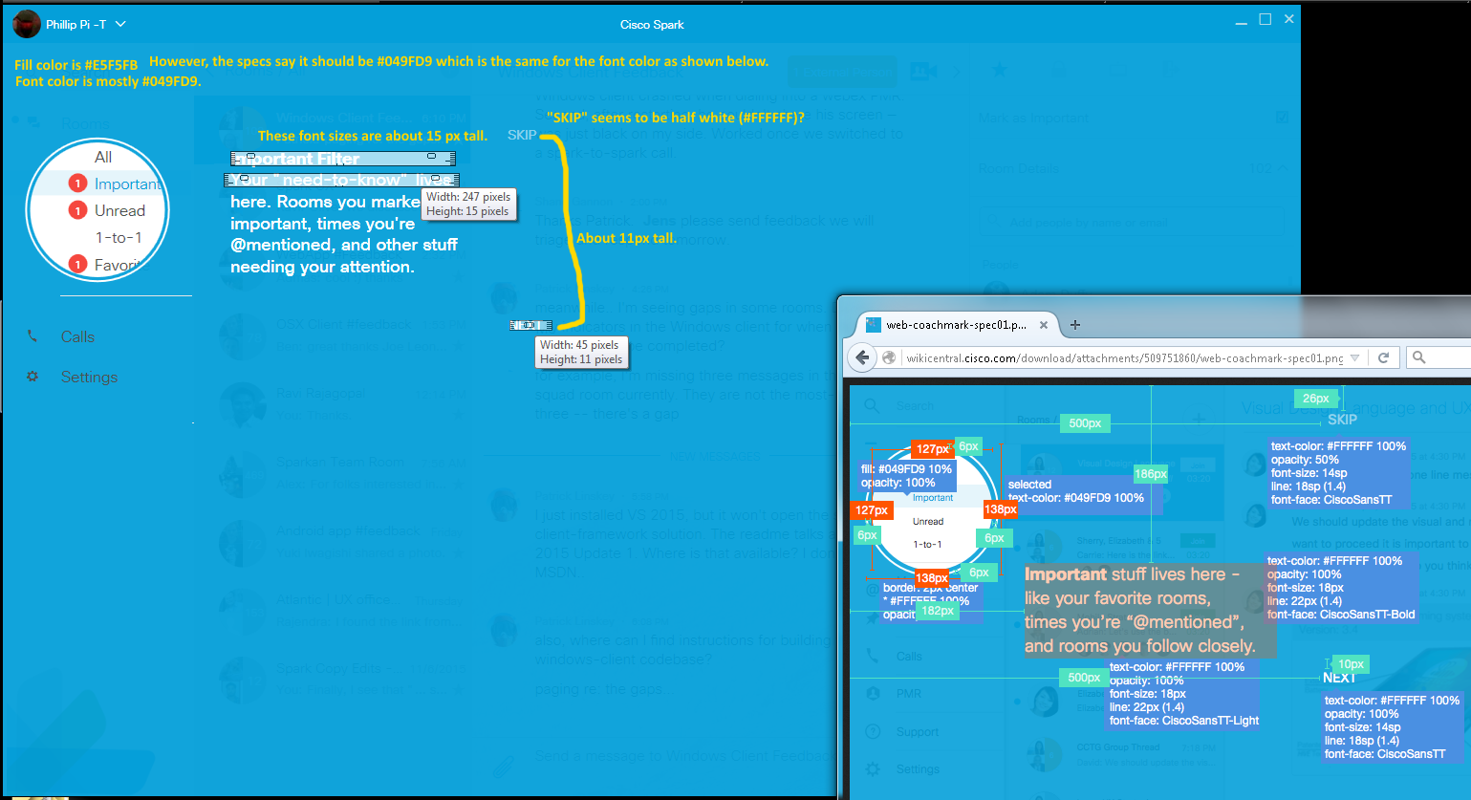
Issues: Colors and sizes didn’t match.

http://wikicentral.cisco.com/download/attachments/509751860/web-coachmark-spec02.png?version=1&modificationDate=1441919991000
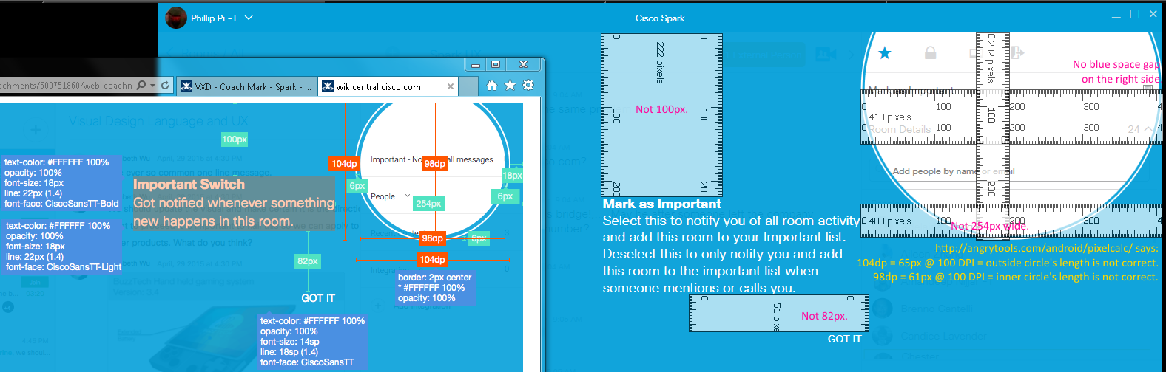
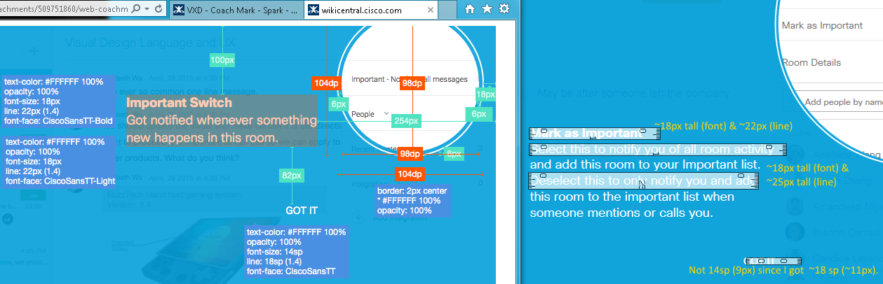
Issues: Sizes did not match.

http://wikicentral.cisco.com/download/attachments/509751860/web-coachmark-textcolor-+motion_spec.png?version=2&modificationDate=1444167547000
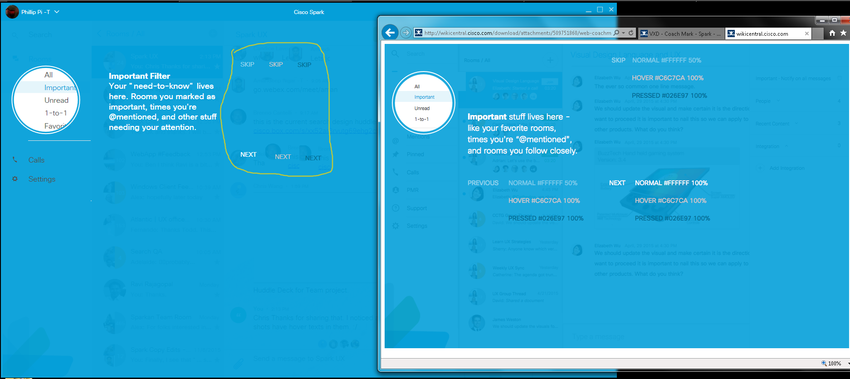
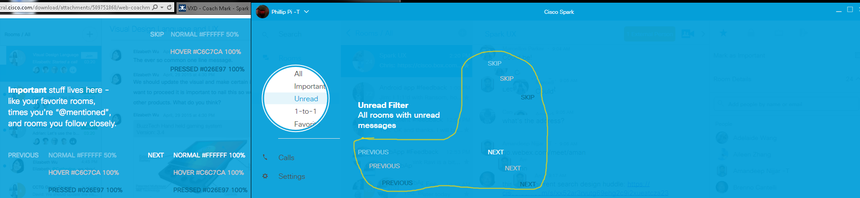

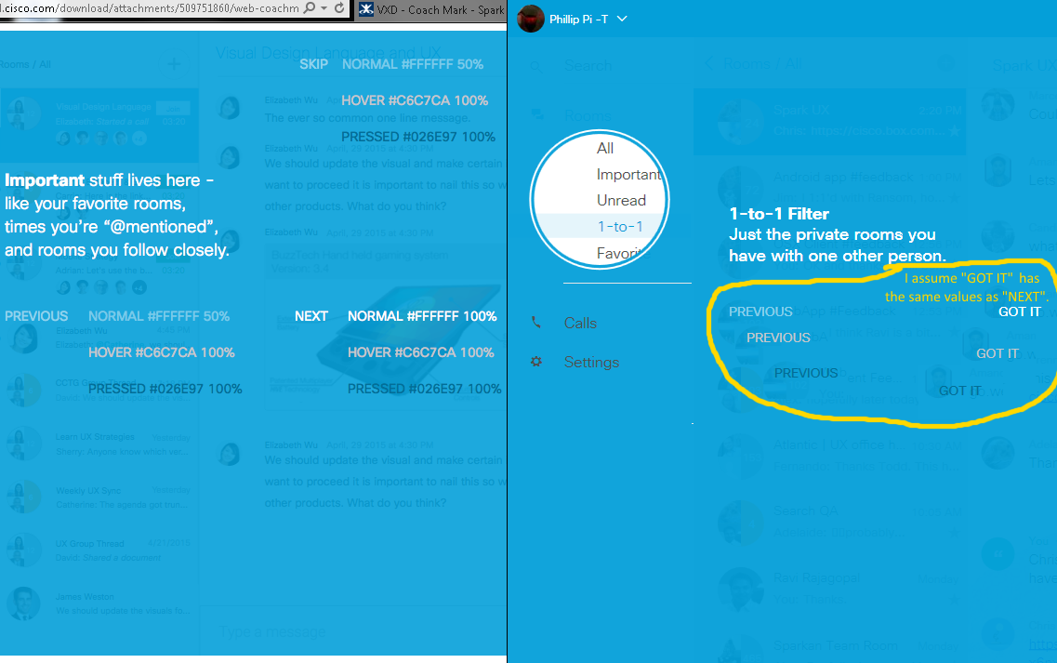
All colors looked correct to me as shown in my circled, copied, and pasted mouse cursor's actions on "NEXT", “PREVIOUS”, "SKIP", and “GOT IT” links. 50% white color opacity colors were hard/difficult to compare for their codes, but they looked correct/similar to my eyes.
Minor usability glitch/issue: Holding down on selected “SKIP” link with the mouse button and moving away from it not to click it, resulted a click to Spark to skip Coach Marks. Other Coach Marks’ links did not show this and will not click when I moved away from their links.
http://wikicentral.cisco.com/download/attachments/509751860/web-coachmark-currentdesign_spec.png?version=1&modificationDate=1442502651000
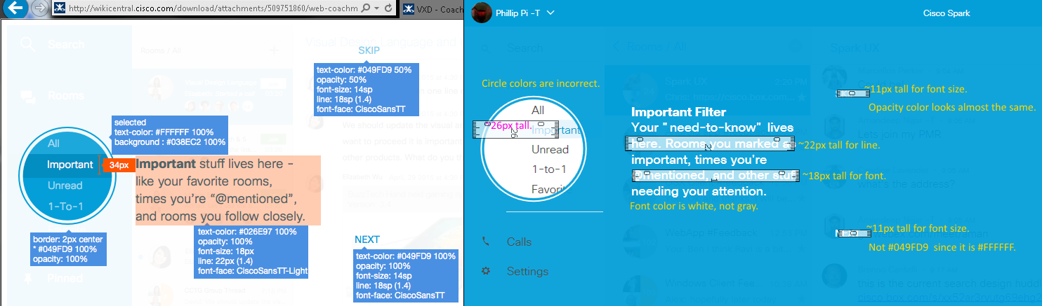
Issues: Incorrect colors and sizes.

http://wikicentral.cisco.com/download/attachments/509751860/web-coachmark-textcolor-+motion_spec+02.png?version=2&modificationDate=1444167582000
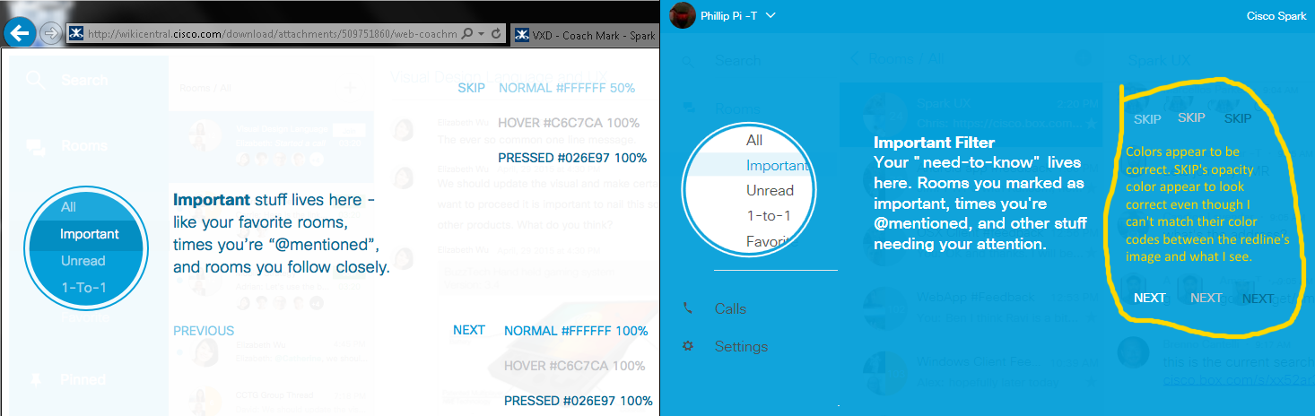
Filter’s Motions (animated):
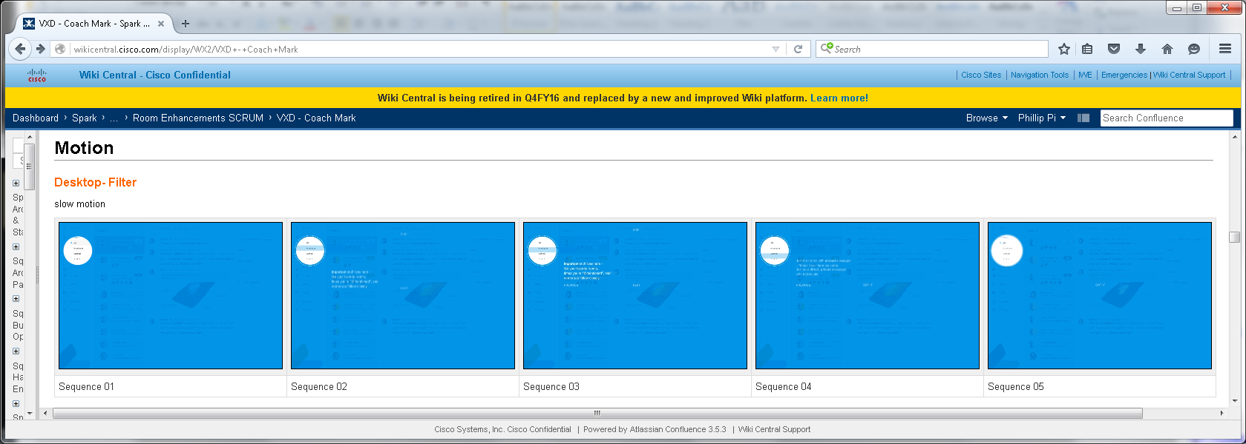http://wikicentral.cisco.com/download/attachments/509751860/web-coachmark-motion+01.png?version=3&modificationDate=1443040981000 for the big full flow image with its details.

What I saw: Motion Sequence 1 to reach to Sequence 2’s start was very fast under a second. Ignore the highlighted under my mouse cursor pointer since that was from Icecream Screen Recorder below:
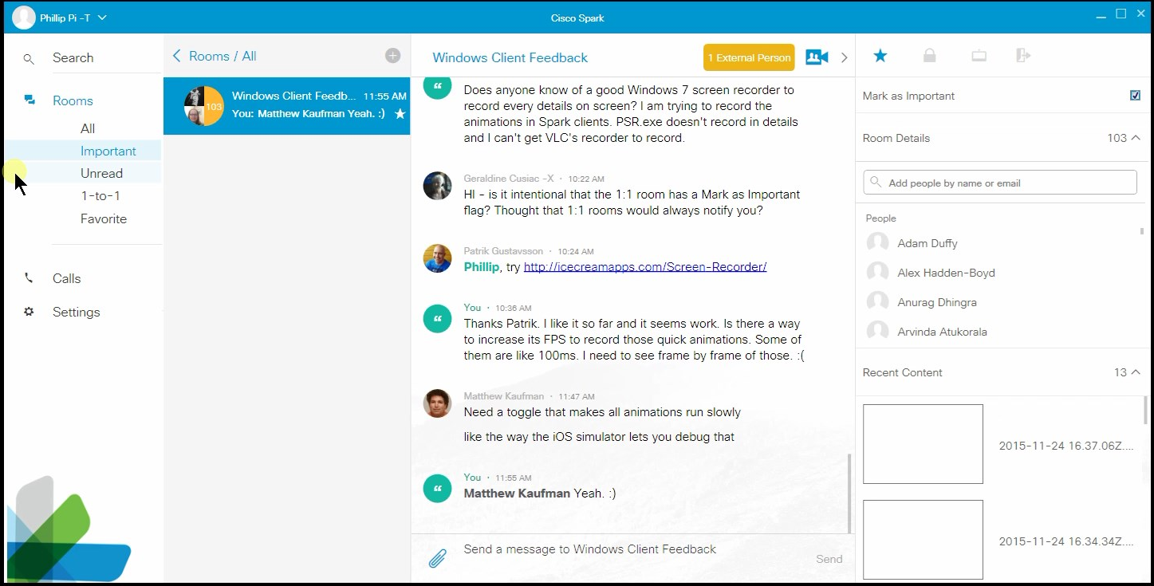

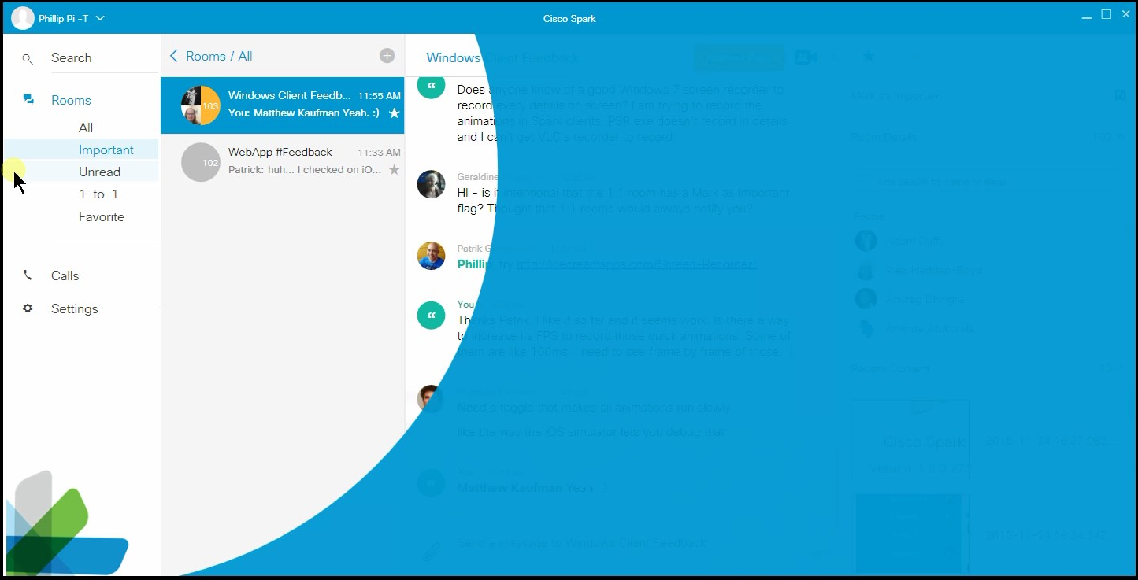
Note the missing gradient in the shrinking circle’s white to blue edge.
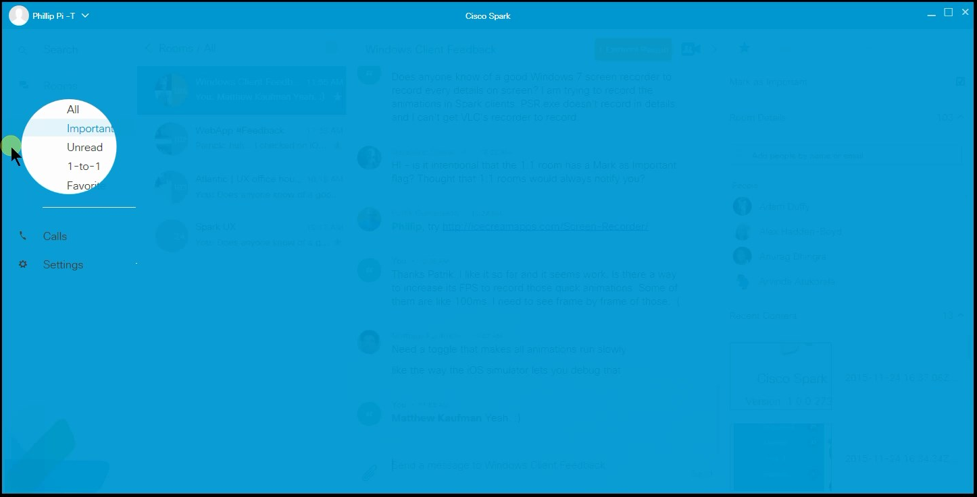
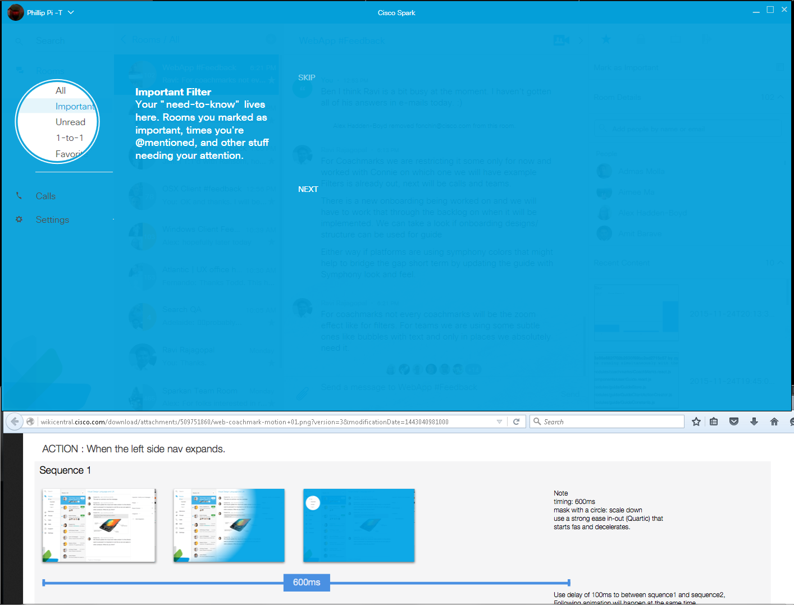
Issue: The shrinking circle animation did not show a gradient curve edge between white and blue in my screen shot.

Motion Sequence 2:
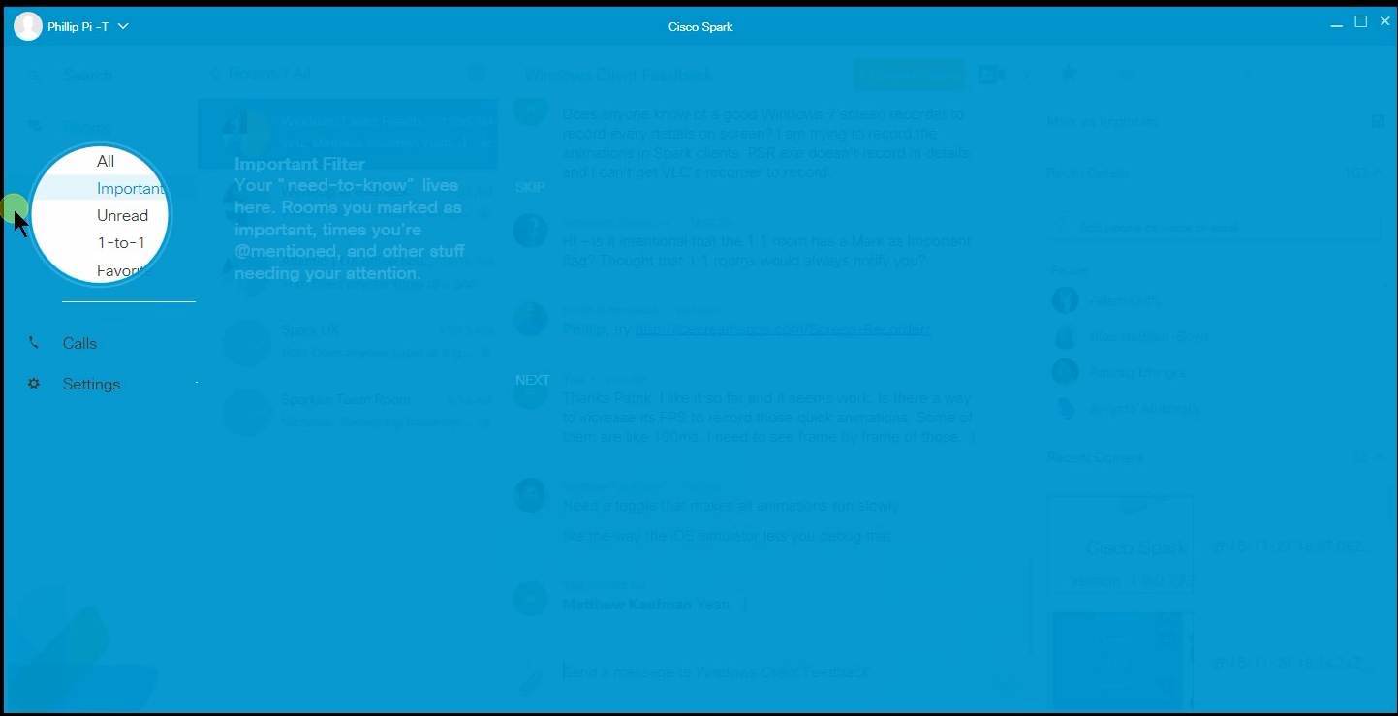
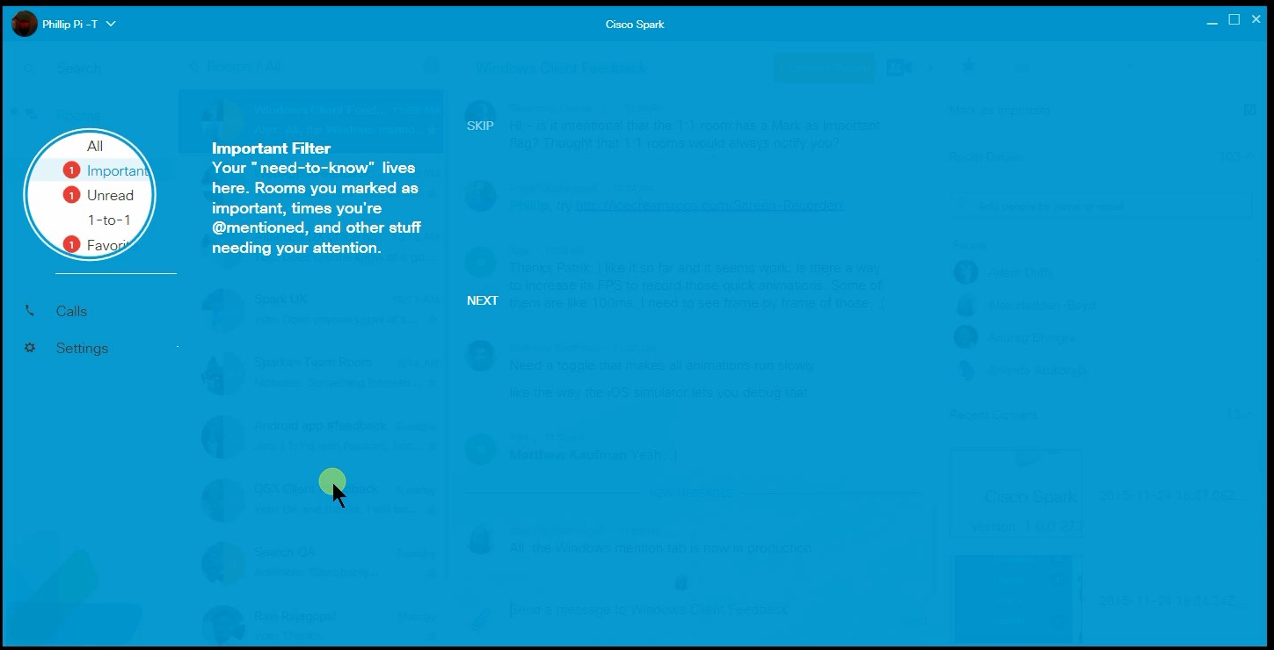

I compared from its beginning and end of the animation below for their differences:
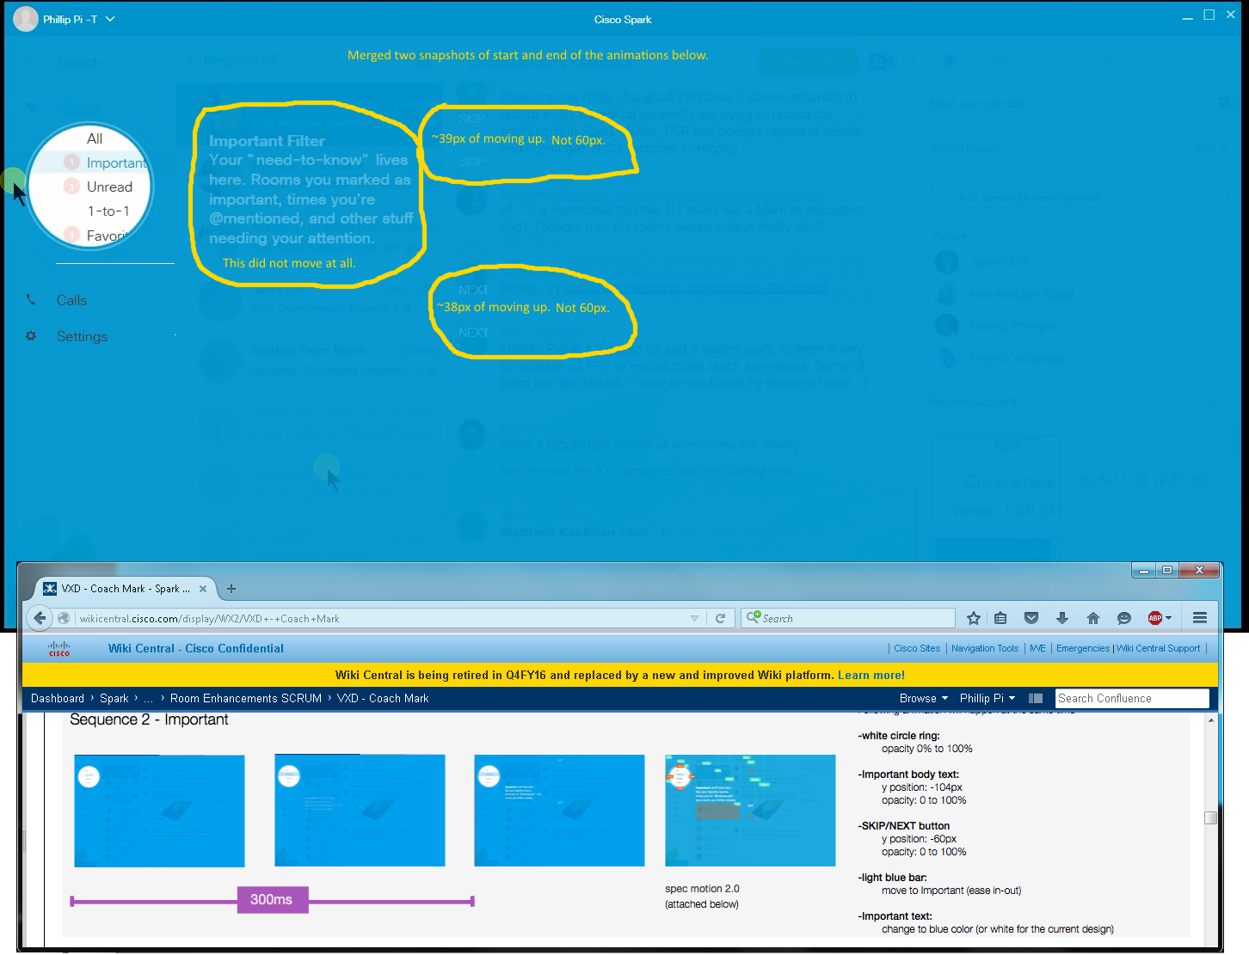
Sequence 2’s 2/Two Issues: “Important” text section did not move at all. “NEXT” and “SKIP” links did not move up vertically by 60 pixels when it started to appear (almost 40 pixels though).

What I saw with Motion Sequence 3:
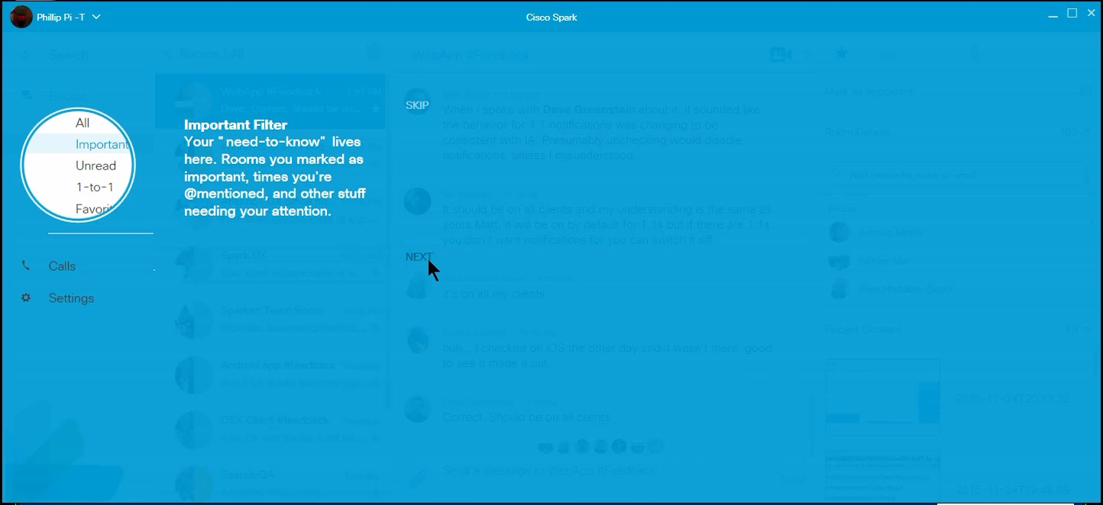
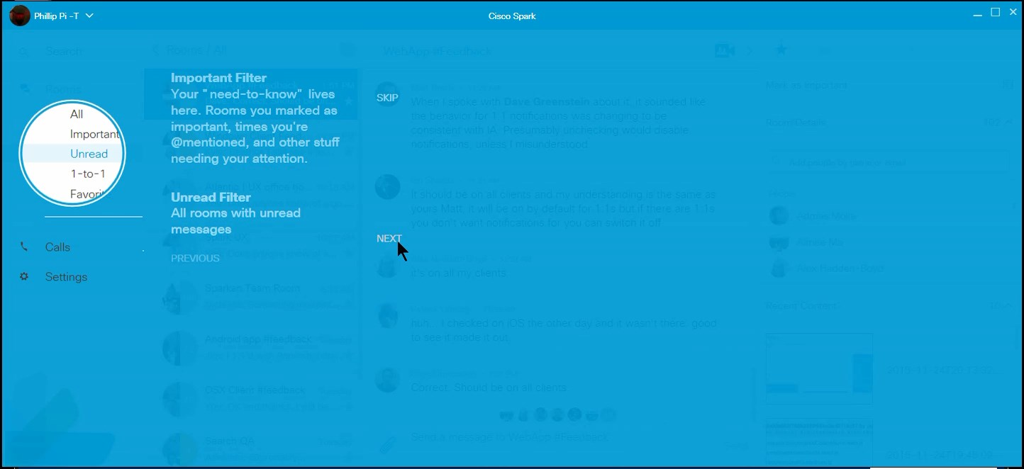
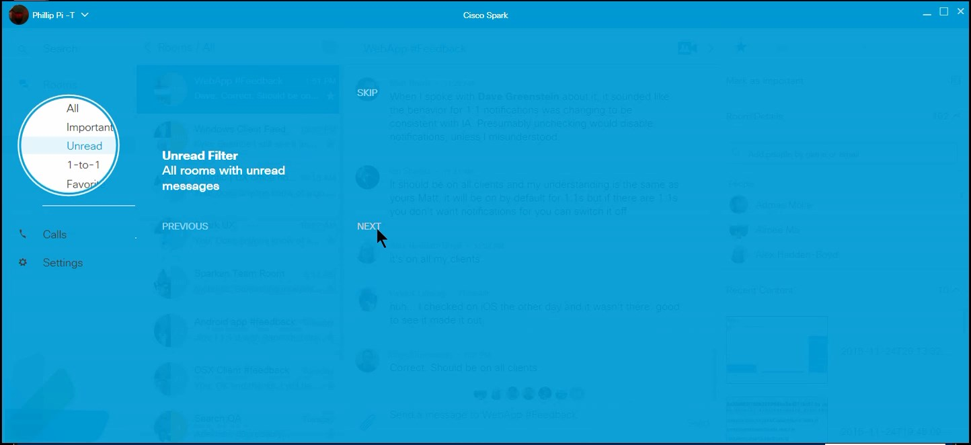

I compared again with the animation’s start and end to see the differences:
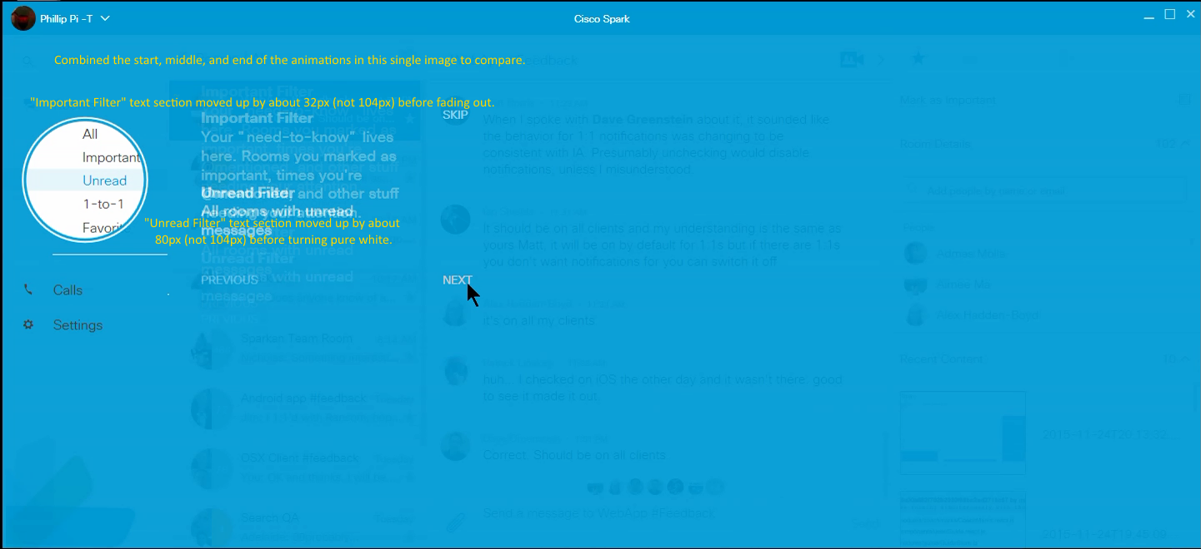
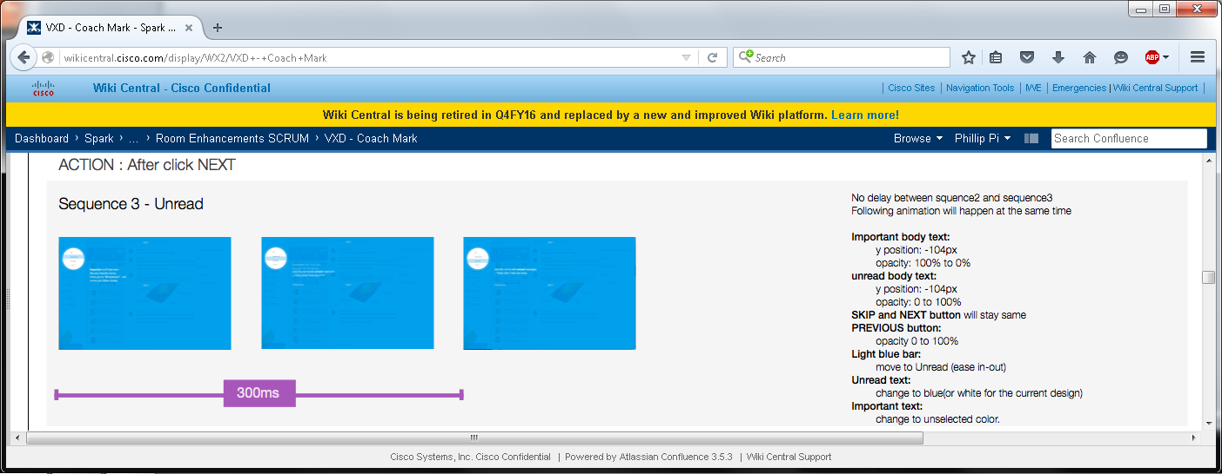
Sequence 3’s Issues: Moving text sections were not going up 104px.

What I saw in Motion Sequence 4:
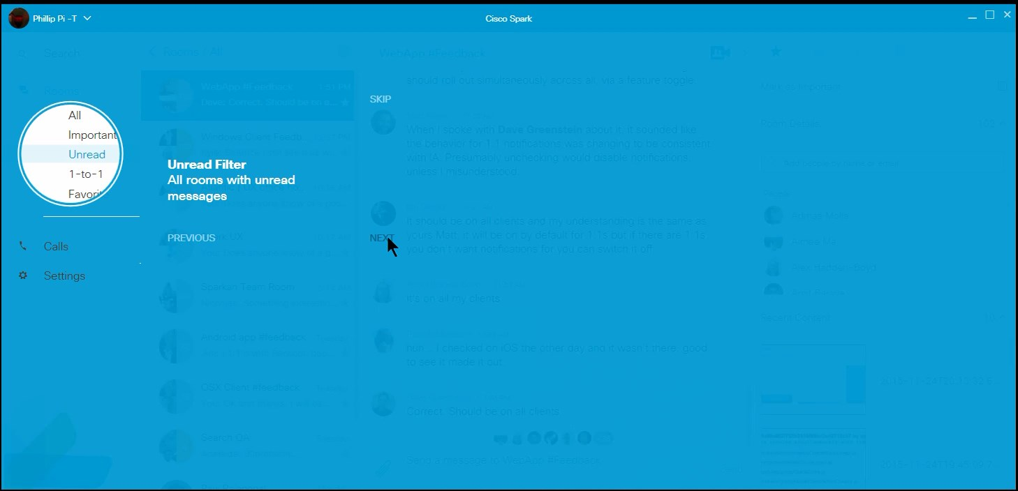
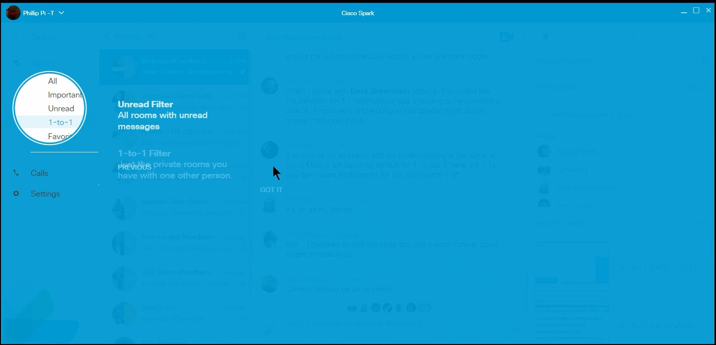
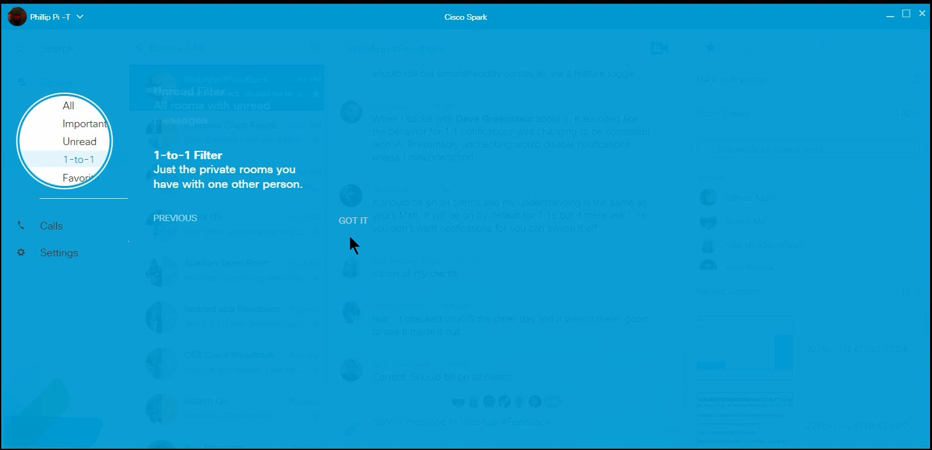
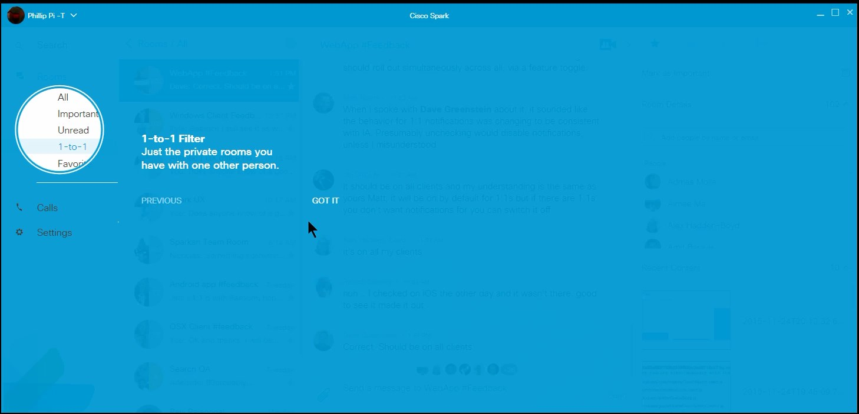
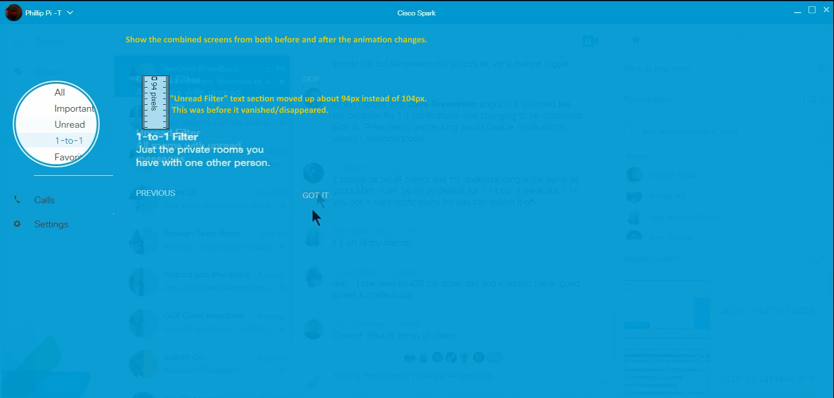
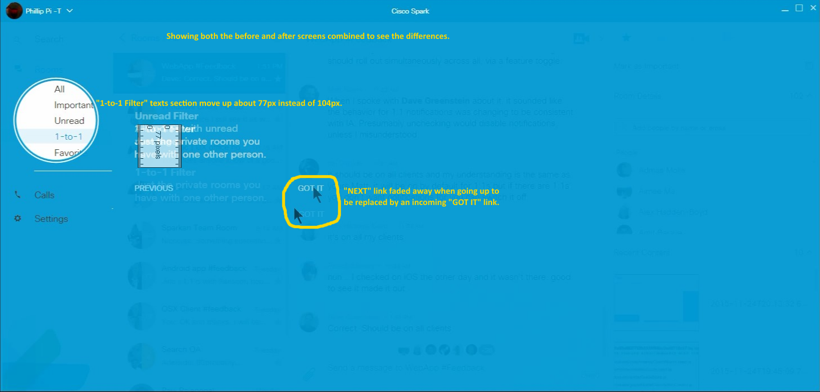
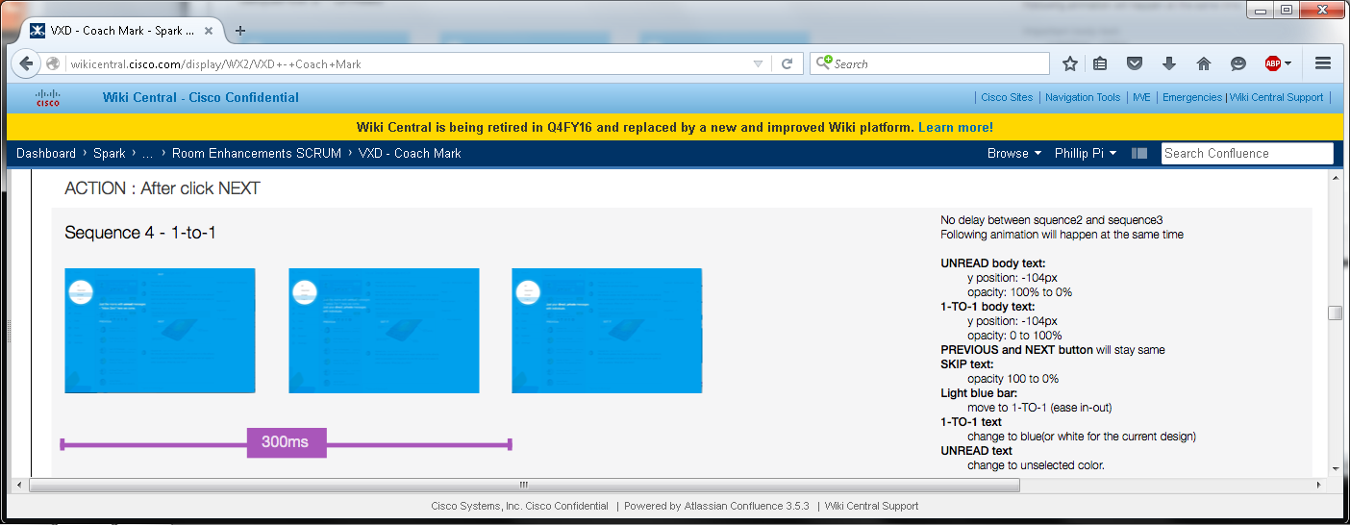
Issues: Incorrect movement lengths and texts.

What I saw in Sequence 5:
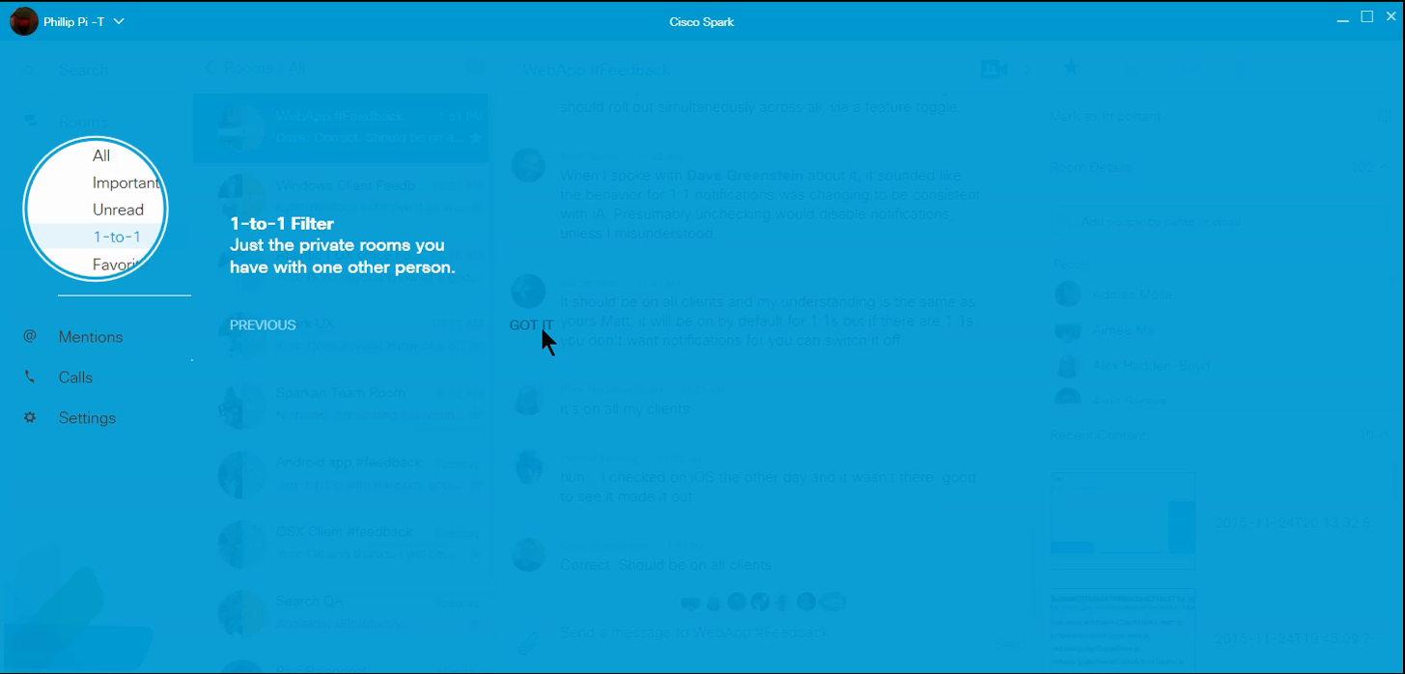
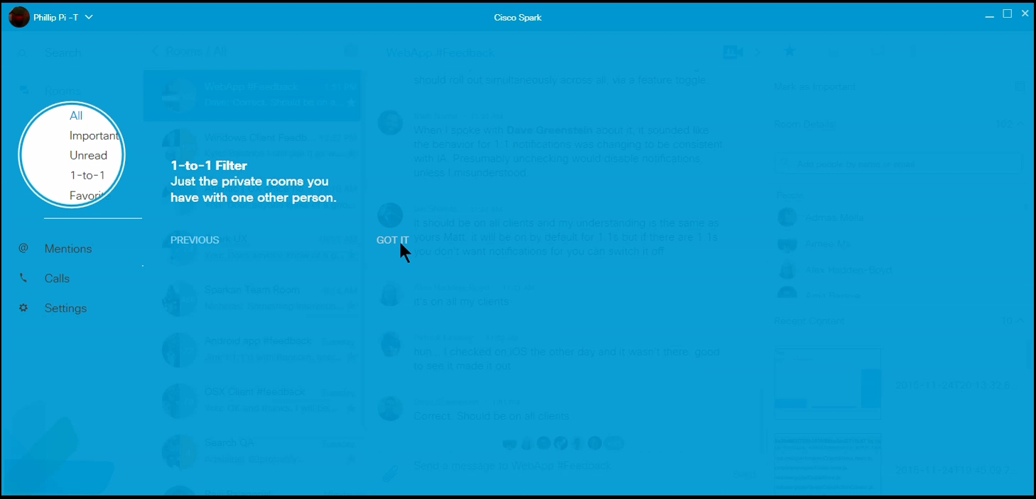
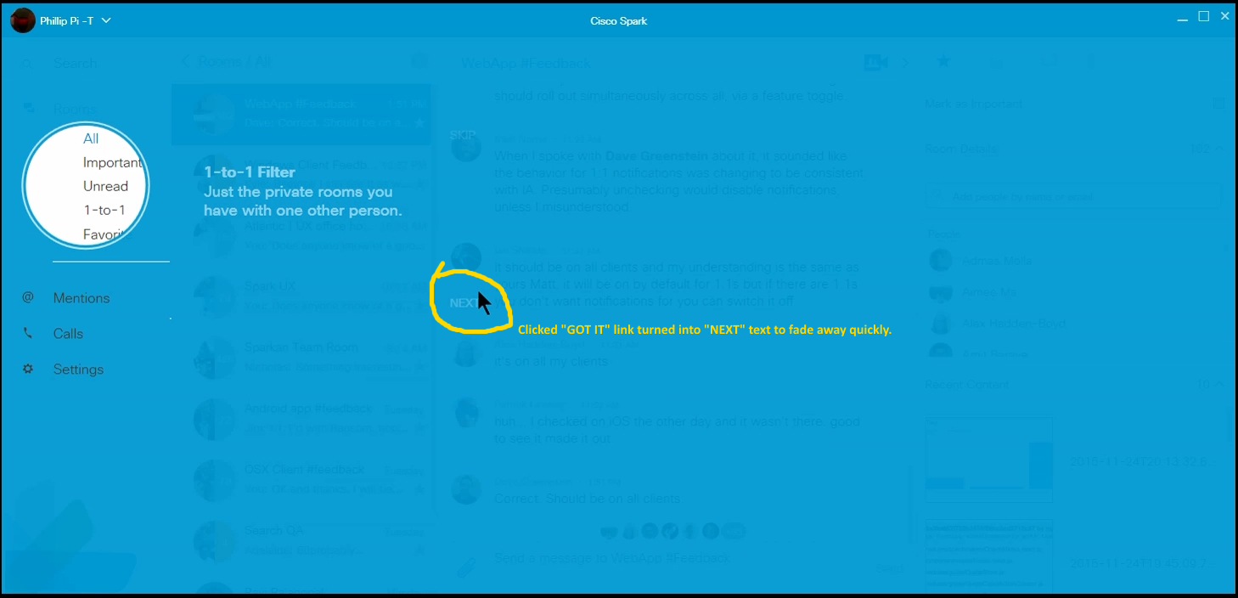
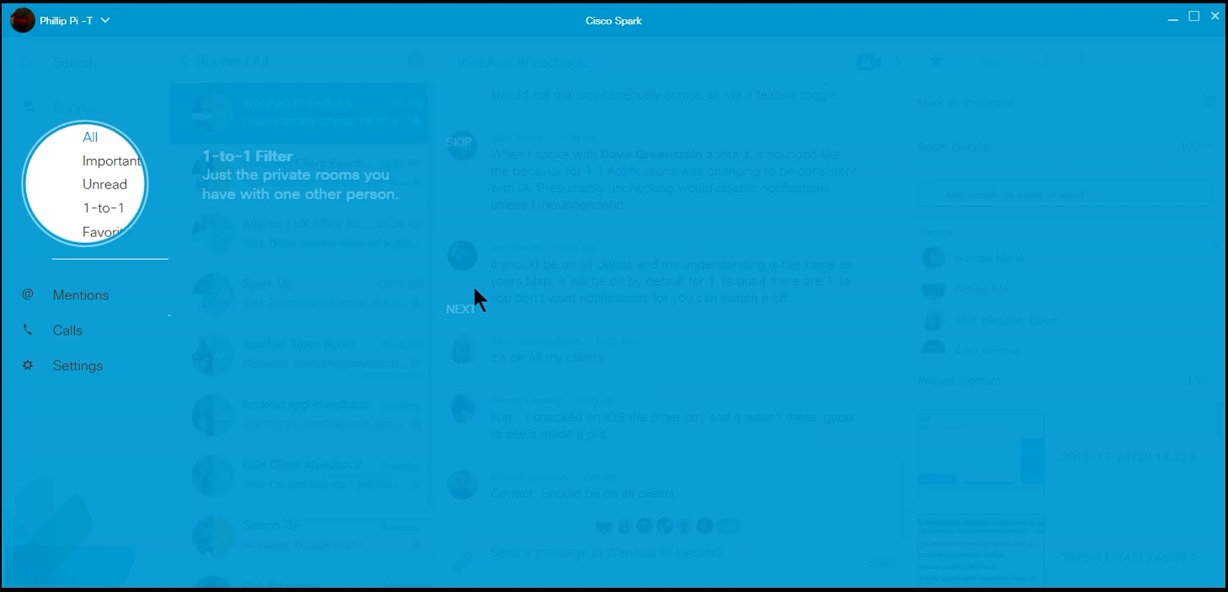
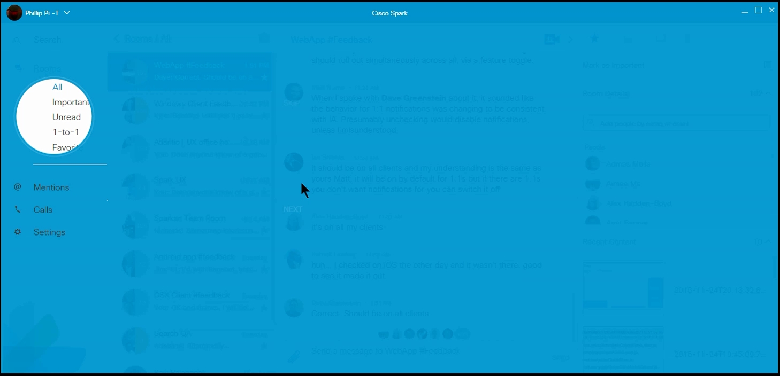
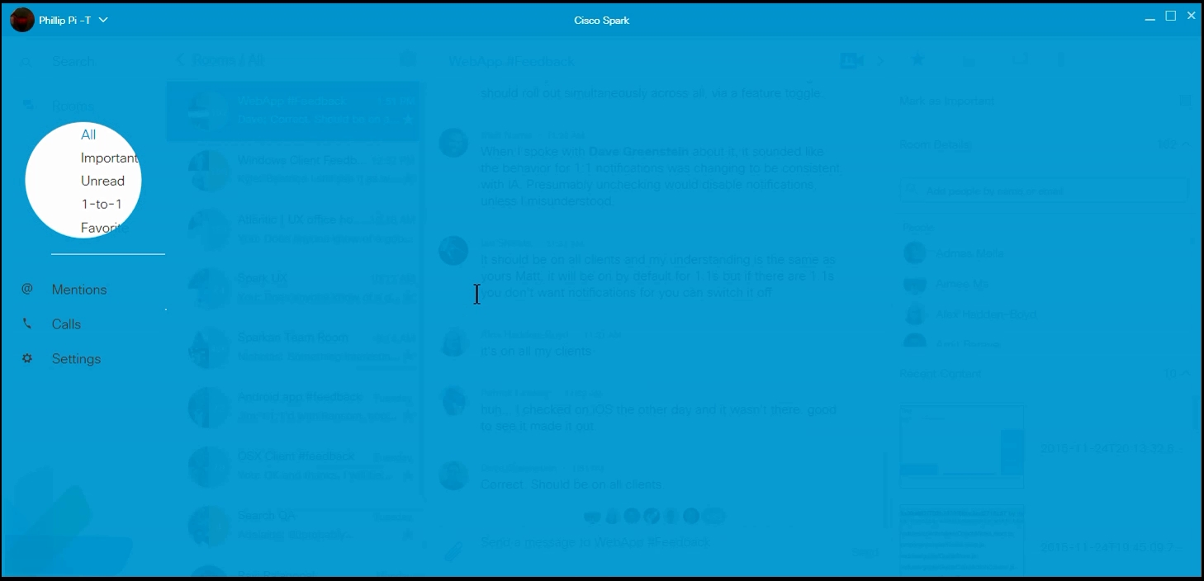
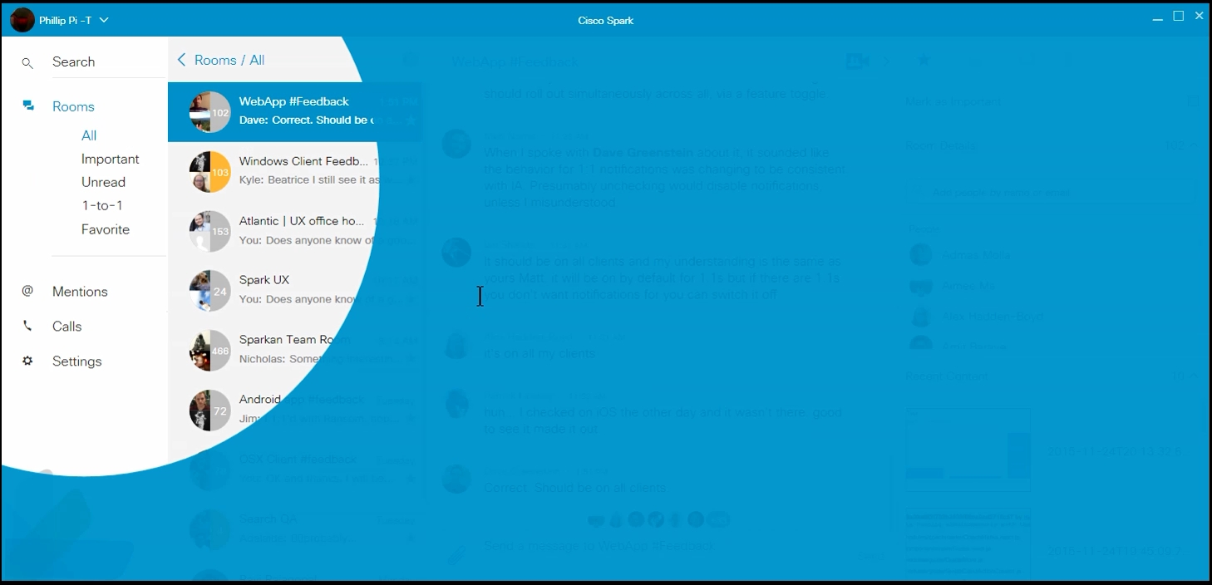
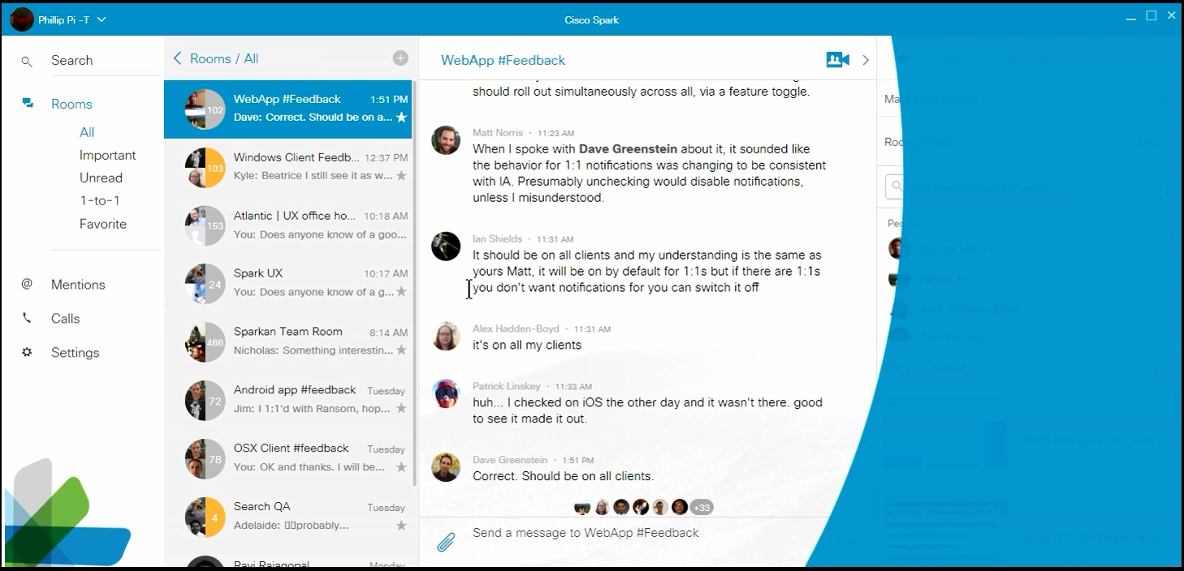
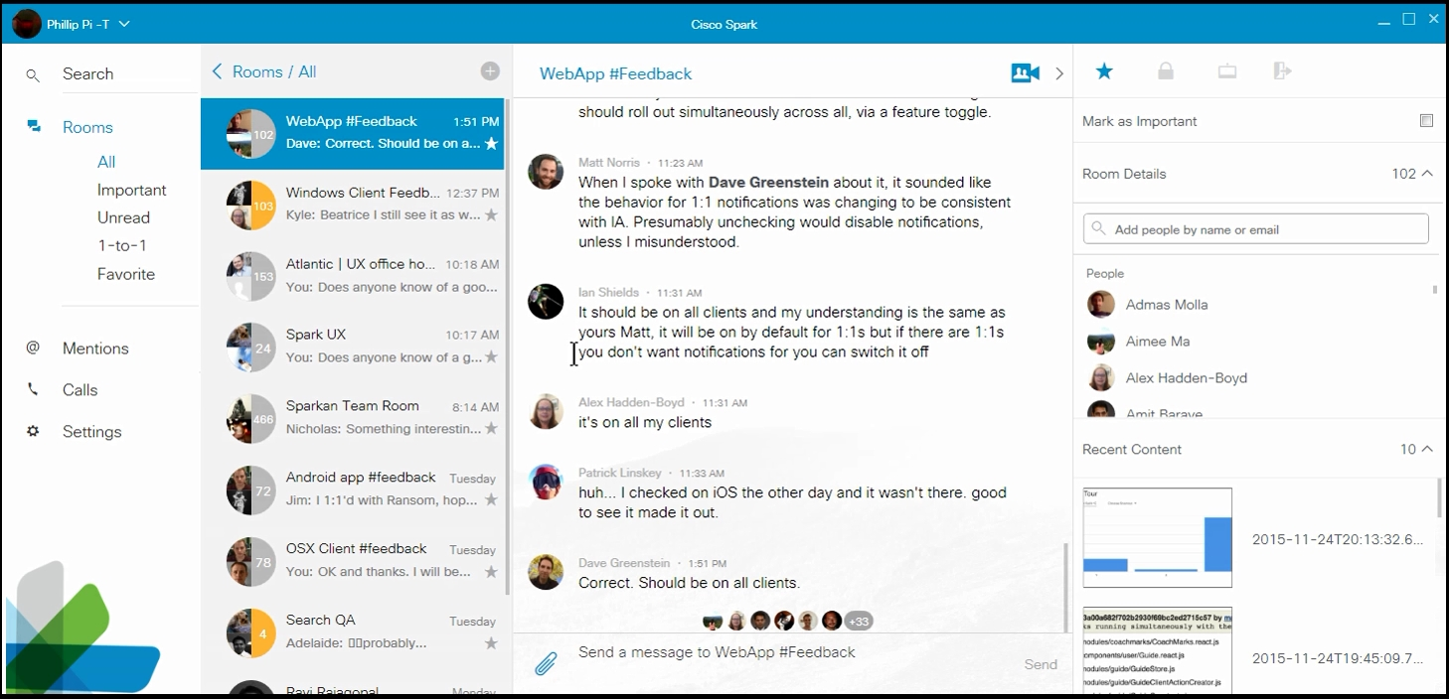

Comparisons with http://wikicentral.cisco.com/download/attachments/509751860/web-coachmark-motion+01.png?version=3&modificationDate=1443040981000:
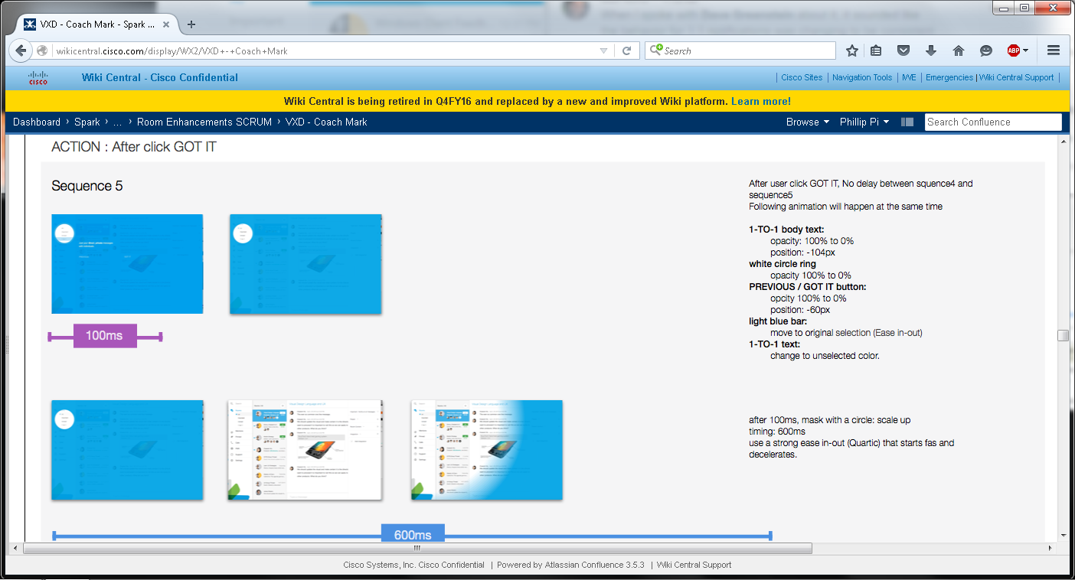
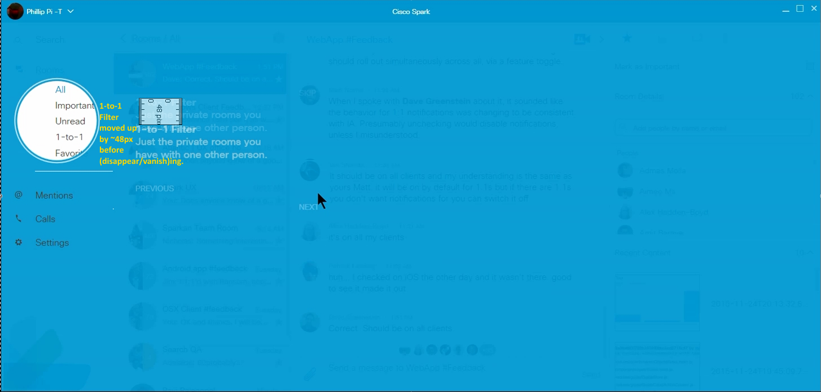
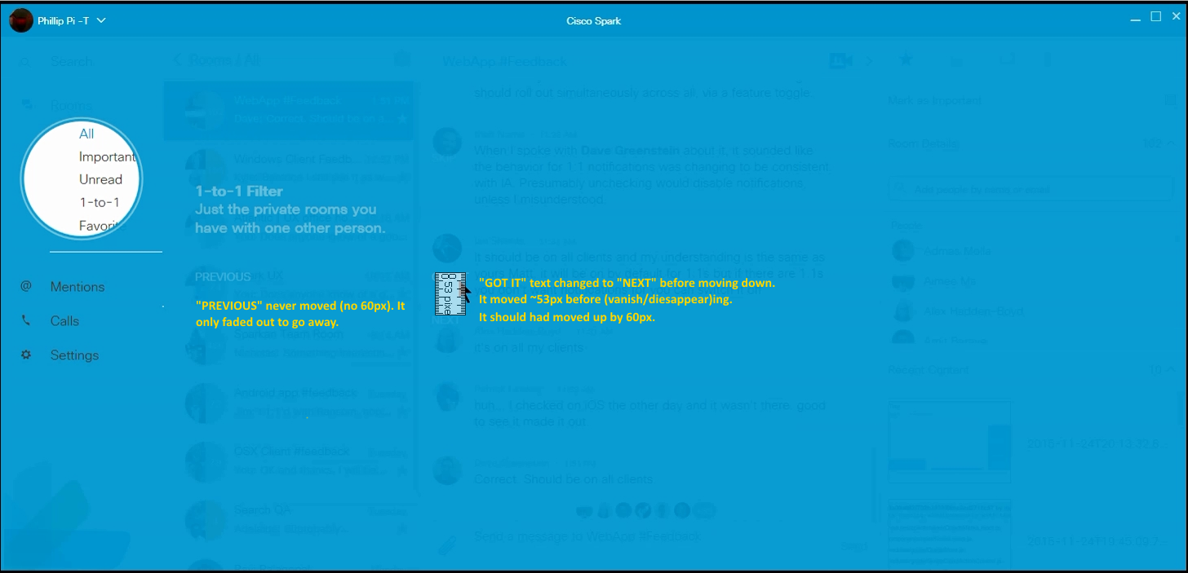
Issues:
- Clicked “GOT IT” link changed to “NEXT” when fading away and going down (wrong direction too)
- Incorrect sizes.
- No gradient between blue and white for the growing circle edge.

Motion Spec 2.0 (http://wikicentral.cisco.com/download/attachments/509751860/web-coachmark-appendix2.0.png?version=1&modificationDate=1442518133000):

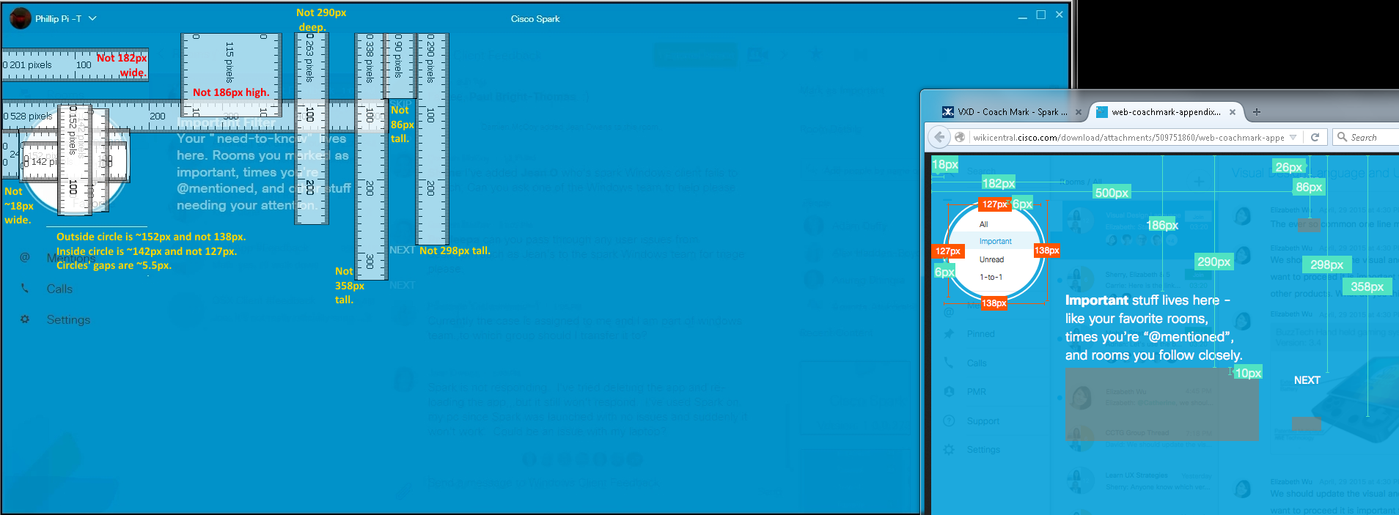

Issues:
- Wrong sizes.
- “Important…” texts did not move up at all.

