Phillip Pi’s UI QA Coach Mark Redline Results With A 64-bit W7 EE SP1’s IE11 Web Browser
Notes: All specifications were from http://wikicentral.cisco.com/display/WX2/VXD+-+Coach+Mark. Started up Spark with its dev(eloper) console’s reset coach marks option checked & after relogging with my June 2015 account between January 2016’s 13th to the 26th on production’s https://web.ciscospark.com. Both OS’ DPI (96) & IE’s zoom were @ 100% (smaller). All softwares had the (new/lat)est updates. Important coachmarks doesn’t always show up for some reason.

https://cisco.app.box.com/s/zy5lf2f9q3jxizqkhisf6qr3u3pwl9f3/1/4664542058 (desktop mock ups -- desktop-mocks) & https://cisco.app.box.com/s/b7x4pv9oyfdmkgxy4oxmquubhv0x7hfm (2 coachmark-web*.m* video files) on v4289 - SDK v0.5.46:

https://cisco.app.box.com/s/zy5lf2f9q3jxizqkhisf6qr3u3pwl9f3/1/4664542058/37981886454/1 (web-coachmark-filter-currentdesign.png) [also [http://wikicentral.cisco.com/download/attachments/509751860/web-coachmark-currentdesign.png?version=1&modificationDate=1442502864000 Current design - Web]:
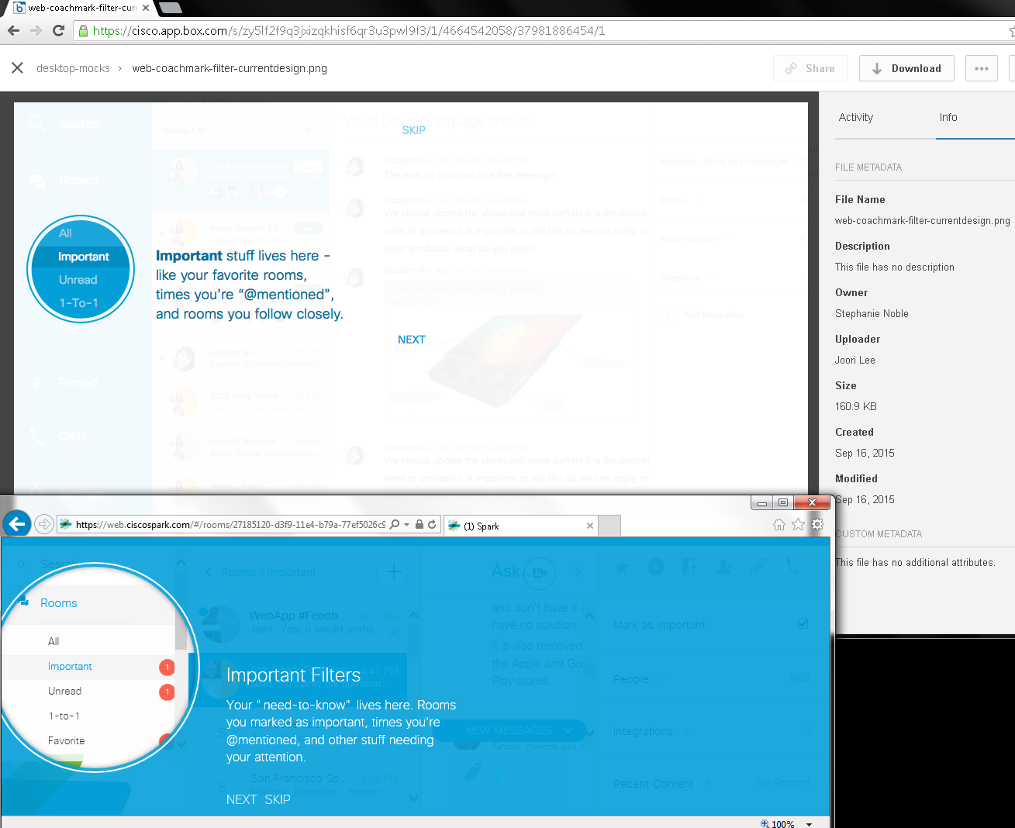
Issues: Completely different layouts, designs, colors, and texts.

https://cisco.app.box.com/s/zy5lf2f9q3jxizqkhisf6qr3u3pwl9f3/1/4664542058/37981889350/1 (web-coachmark-mock01.png):

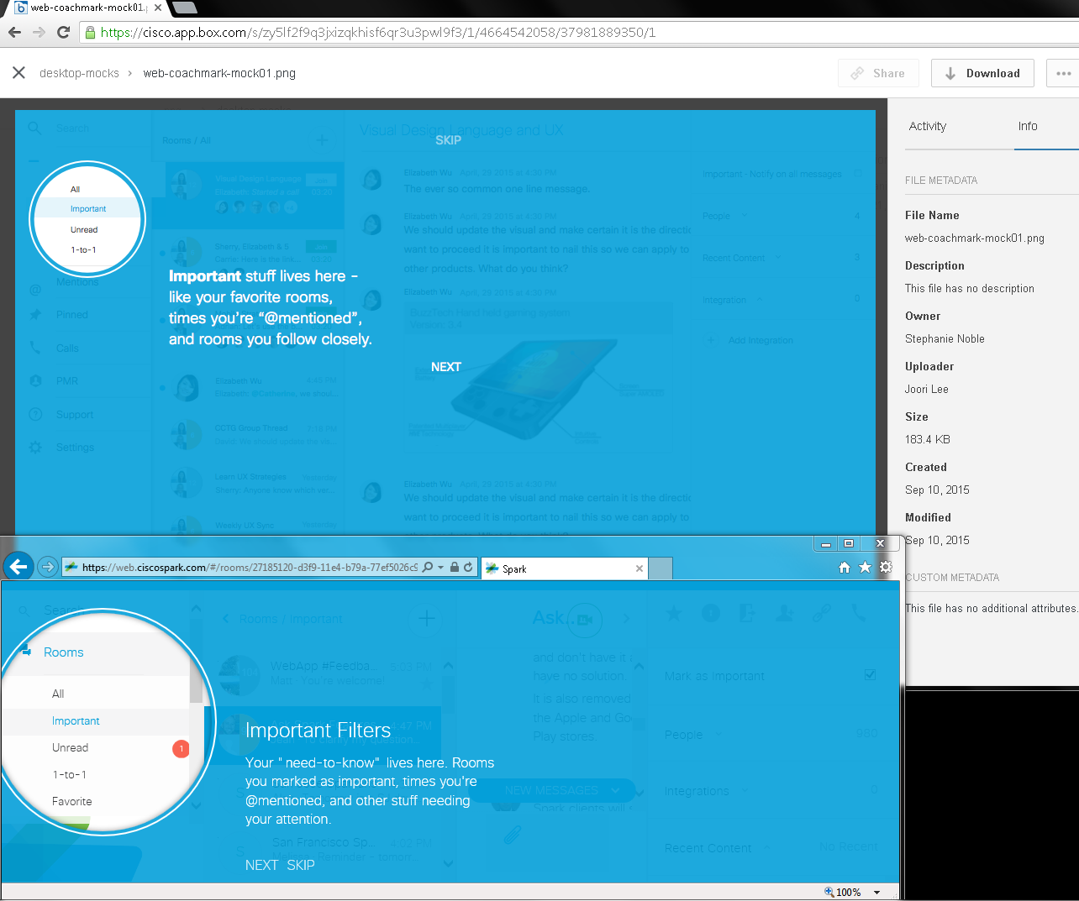

https://cisco.app.box.com/s/zy5lf2f9q3jxizqkhisf6qr3u3pwl9f3/1/4664542058/37981892770/1 (web-coachmark-mock02.png):

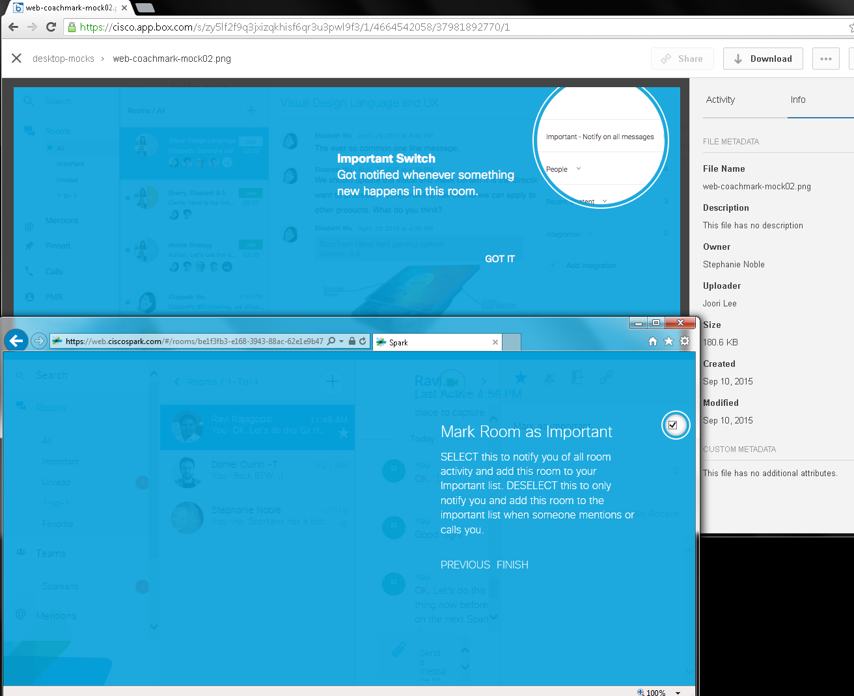
Issues:

All “Important” screens did not match each other with designs, texts, etc.

https://cisco.app.box.com/s/eomsuei1bnhu7un942vbdzolv9mpmbwg & https://cisco.app.box.com/s/zdwnxodahs0ri49gh8hd906dw892uycm/1/4664441002 (Animated GIFs) [also http://wikicentral.cisco.com/download/attachments/509751860/coachmark-web_sequence01.gif?version=2&modificationDate=1442528840000, http://wikicentral.cisco.com/download/attachments/509751860/coachmark-web_sequence02.gif?version=1&modificationDate=1442515272000, http://wikicentral.cisco.com/download/attachments/509751860/coachmark-web_sequence03.gif?version=1&modificationDate=1442515290000, http://wikicentral.cisco.com/download/attachments/509751860/coachmark-web_sequence04.gif?version=1&modificationDate=1442515305000, & http://wikicentral.cisco.com/download/attachments/509751860/coachmark-web_sequence05.gif?version=1&modificationDate=1442515322000] in v4289 - SDK v0.5.46:

https://cisco.app.box.com/s/eomsuei1bnhu7un942vbdzolv9mpmbwg/1/4664424214/37981443830/1 (coachmark-web-v1.gif)

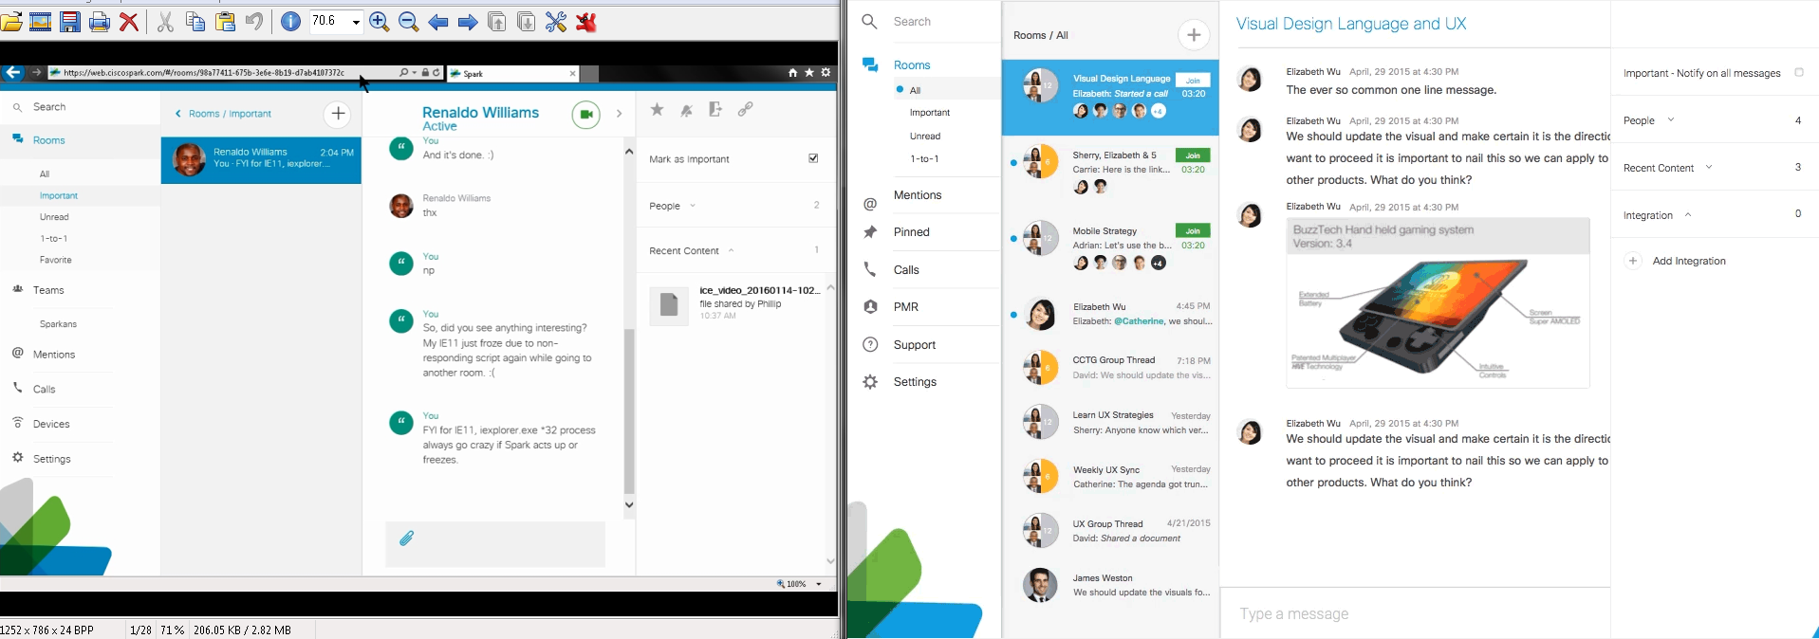

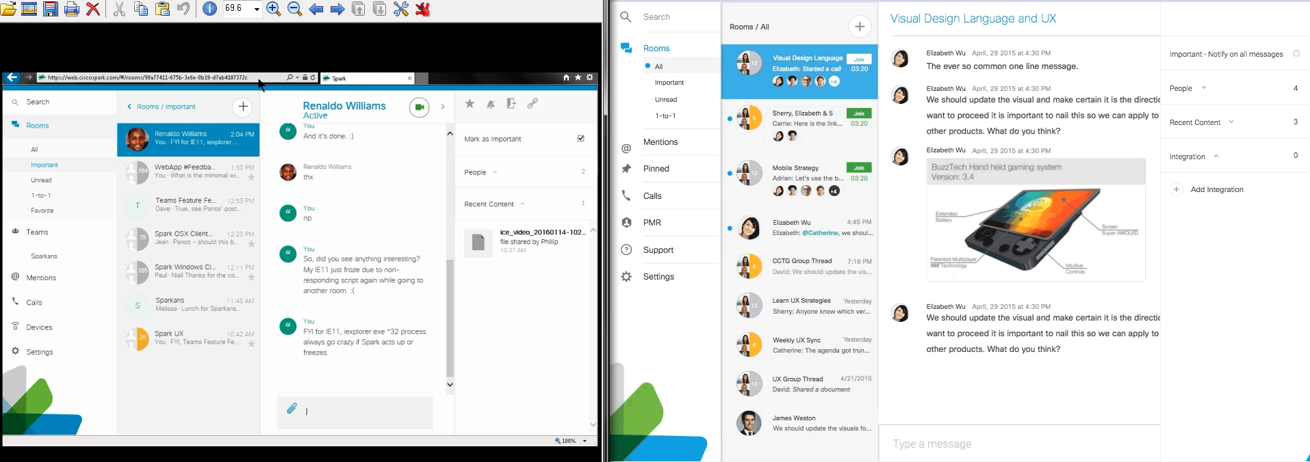

IE did not show any animations and other visual effects as shown in the GIF recording. I screen captured to compare below::

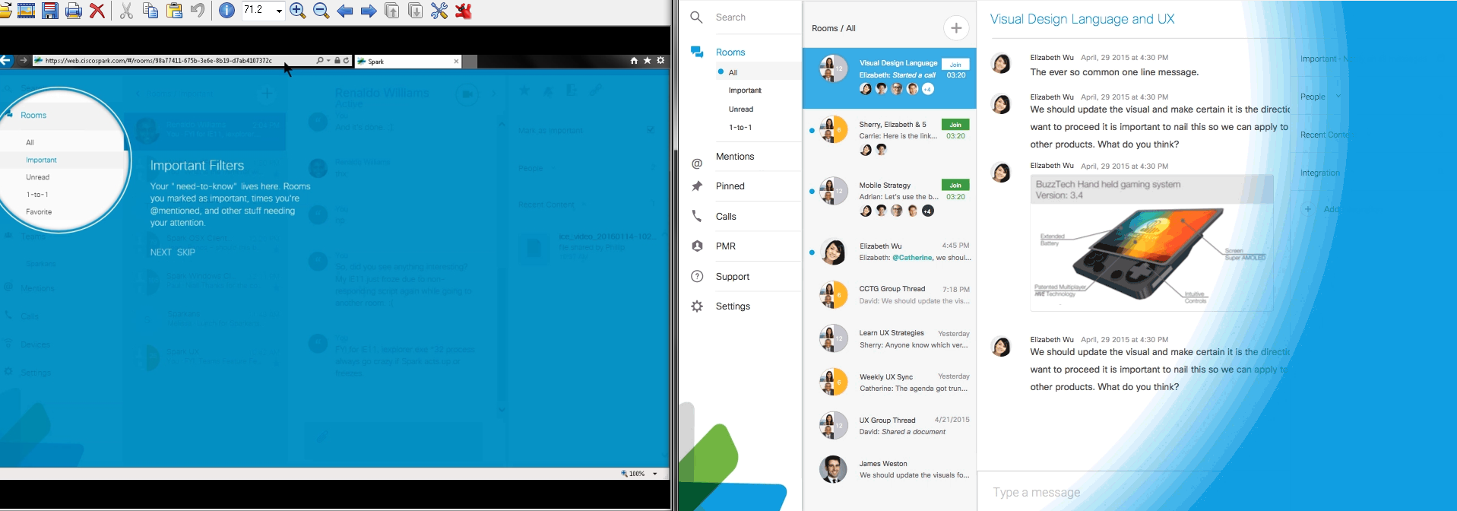

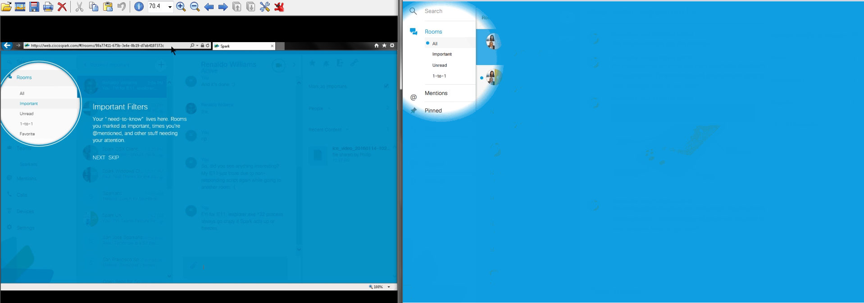

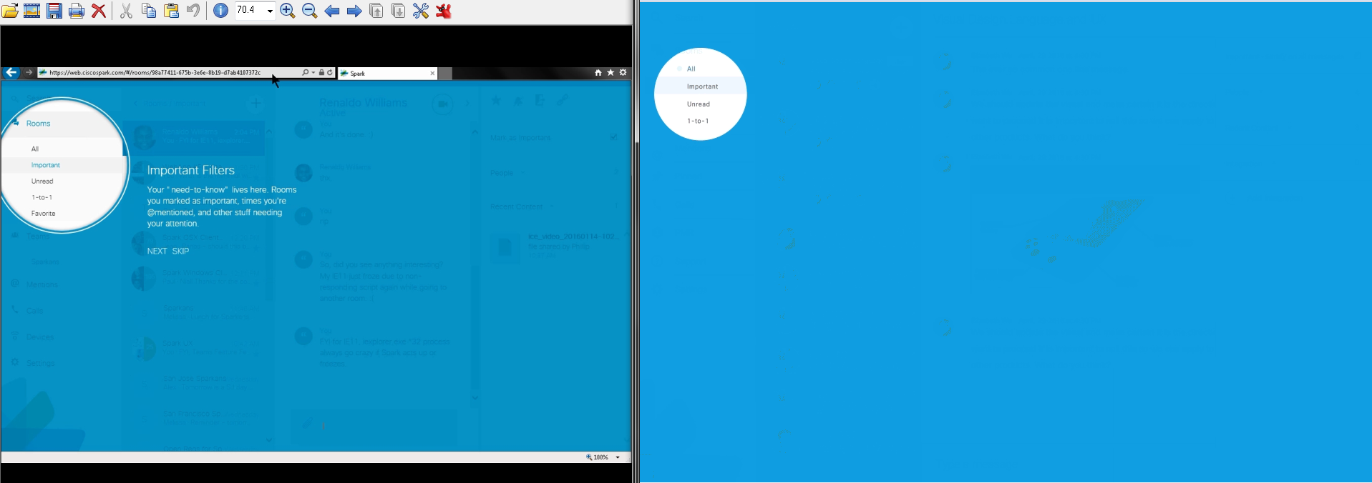

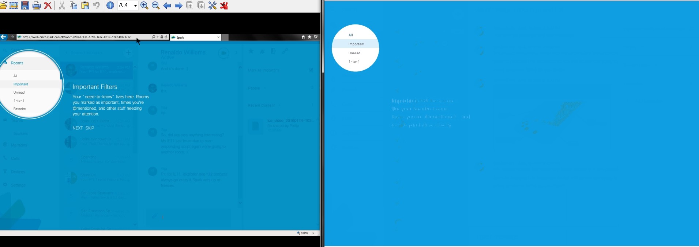

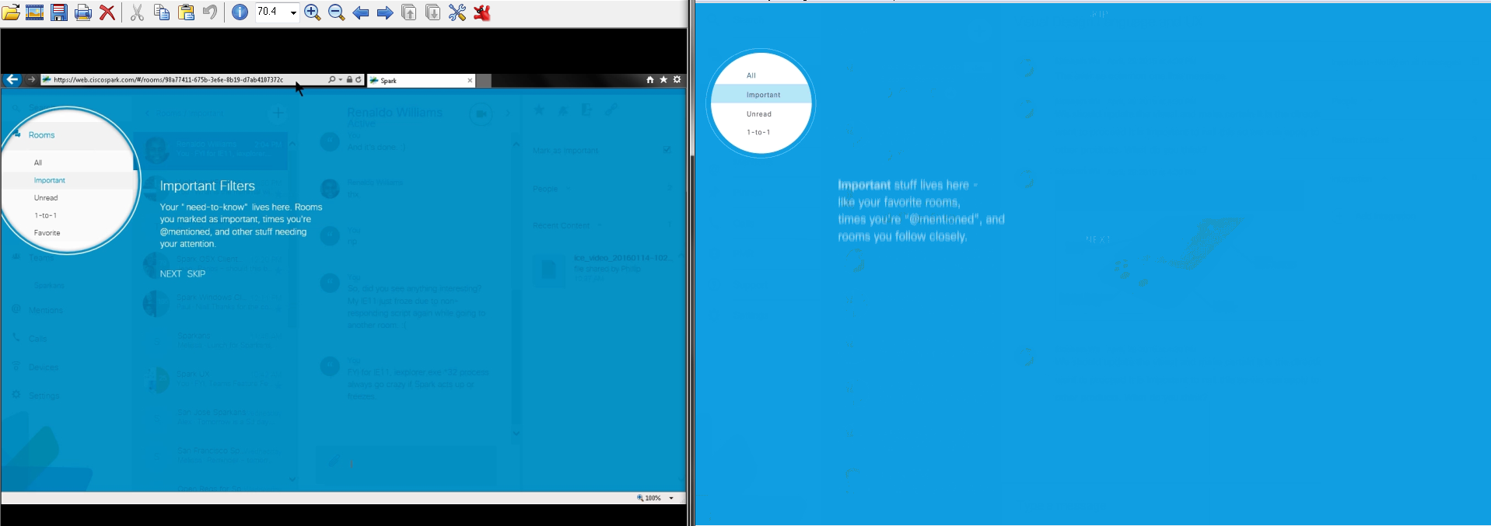

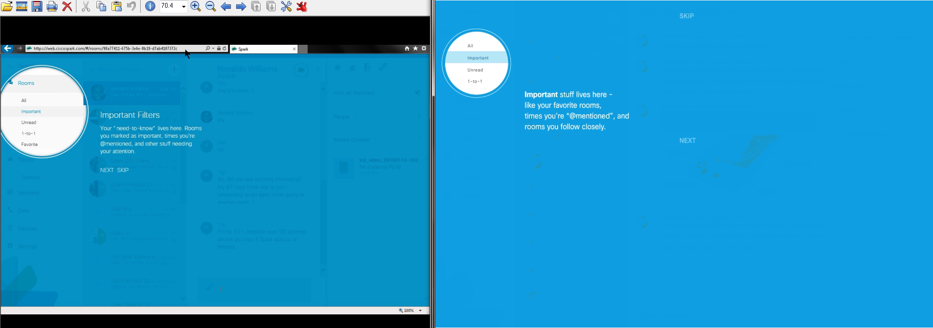

When “Important” screen occurred, they looked different to each other like its texts, alignments, locations, colors, sizes, etc. Animations between “Important” and “Unread” screens are slightly different as shown below:

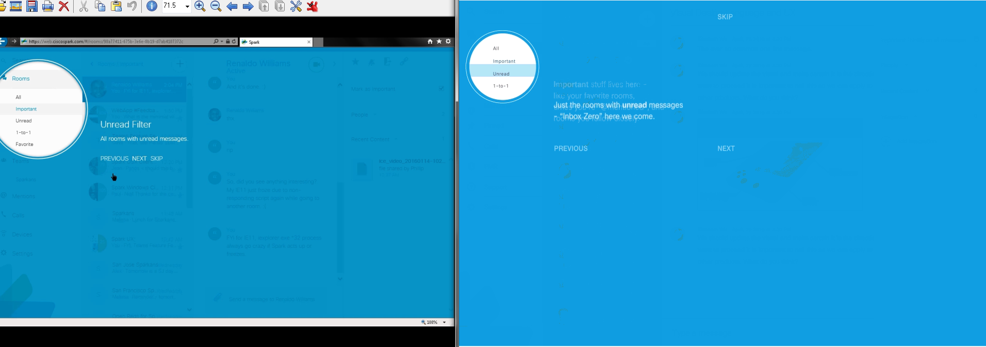

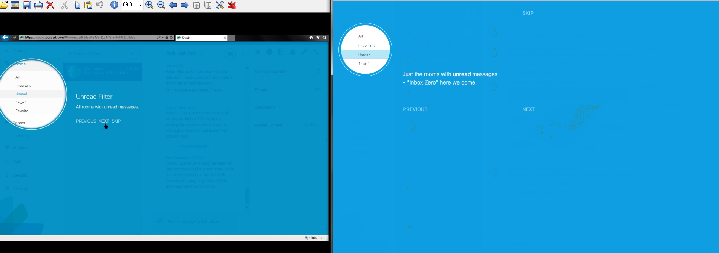

Again, “Unread” screens looked different to each other like their texts, alignments, locations, etc.

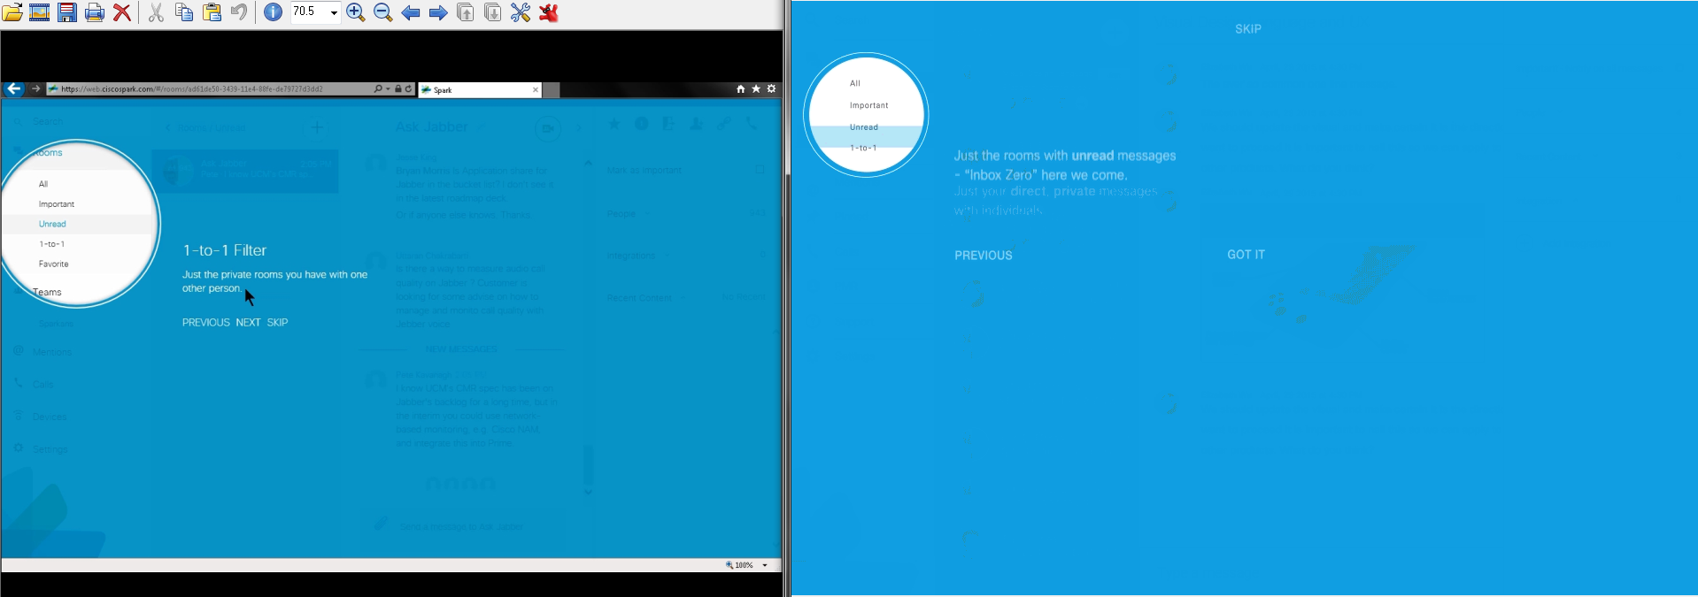

Unread to 1-to-1 texts did not animate in IE, but the circle areas did.

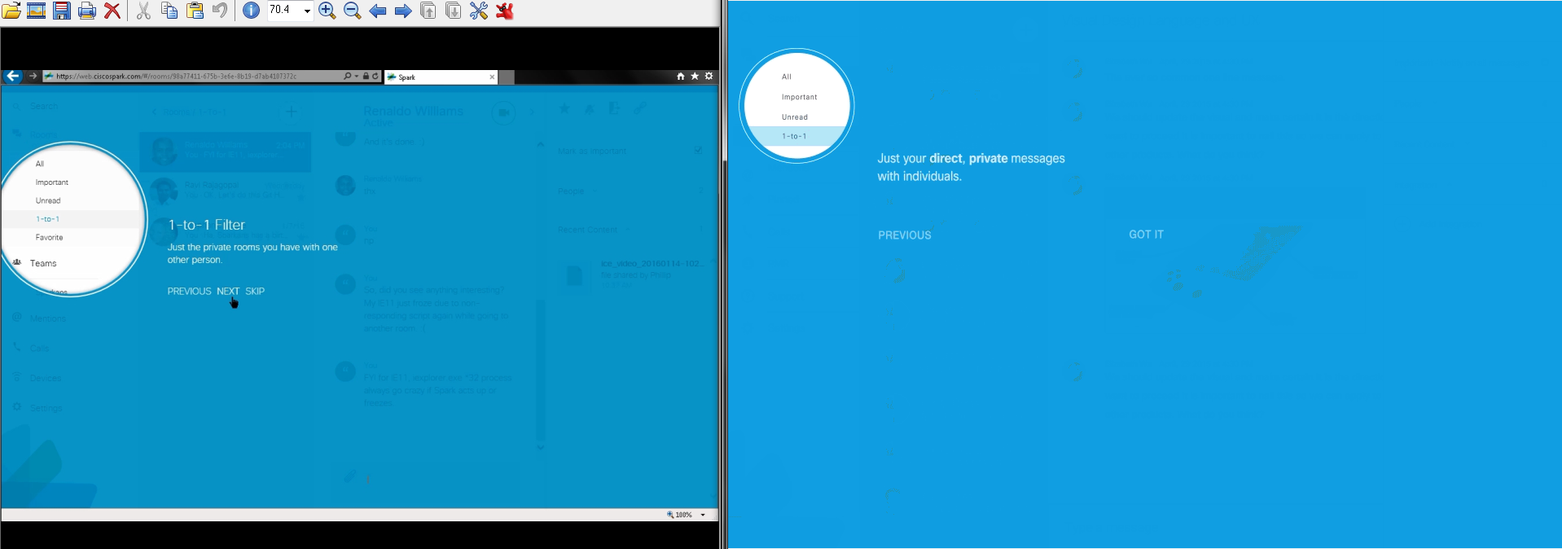

Both screens’ 1-to-1 screens looked different for their texts, colors, (fade/gradient)s, locations, layouts, etc.

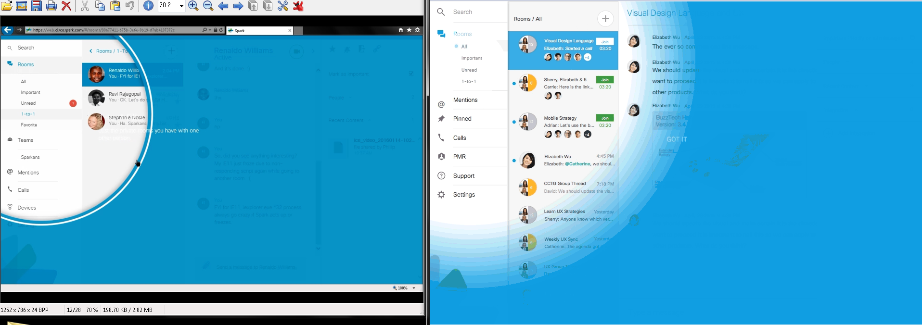

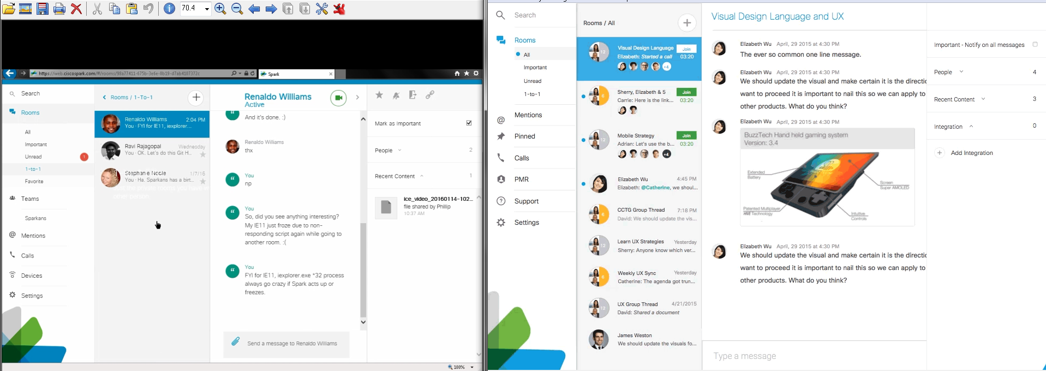

Finishing Coach Marks showed different animations, circles, and Rooms’ filters (IE stayed at 1-to-1 while GIF showed All).

Note that there are still "1-to-1 Filter's white texts left behind before Spark went to the next Coach Mark for its “Mark as important” part:

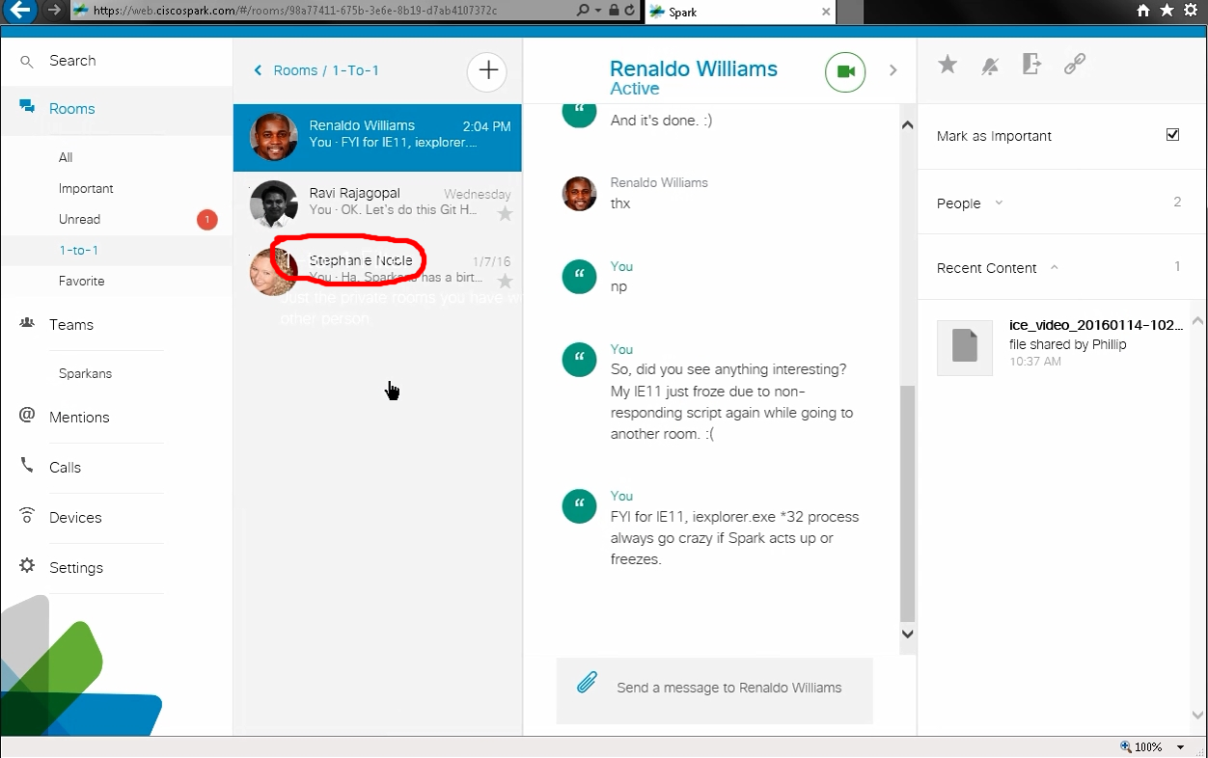

Unlike Windows desktop’s start up with Coach Marks, Spark showed its “Mark Room as Important” right away as shown in https://cisco.app.box.com/s/eomsuei1bnhu7un942vbdzolv9mpmbwg/1/4664424214/37981438270/1 (coachmark-web-importantswitch_v3.gif) & https://cisco.app.box.com/s/zdwnxodahs0ri49gh8hd906dw892uycm/1/4664446310 (desktop-importantswitch-gif) in v4289 - SDK v0.5.46::

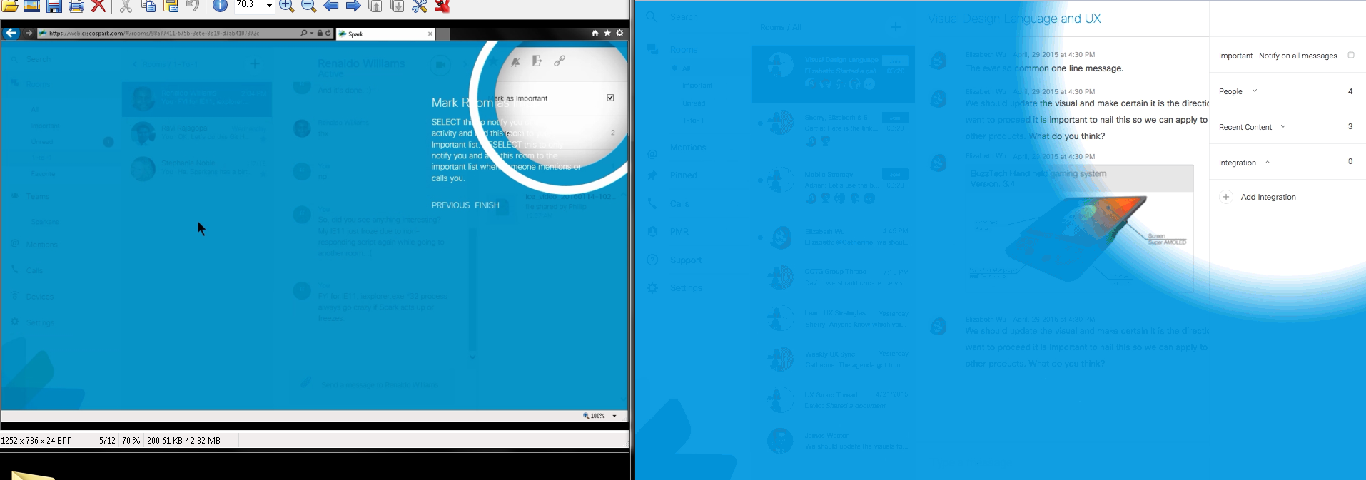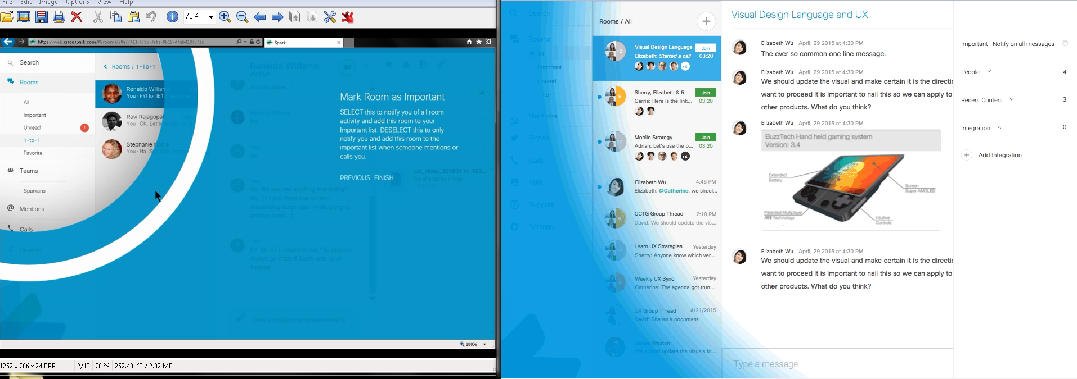

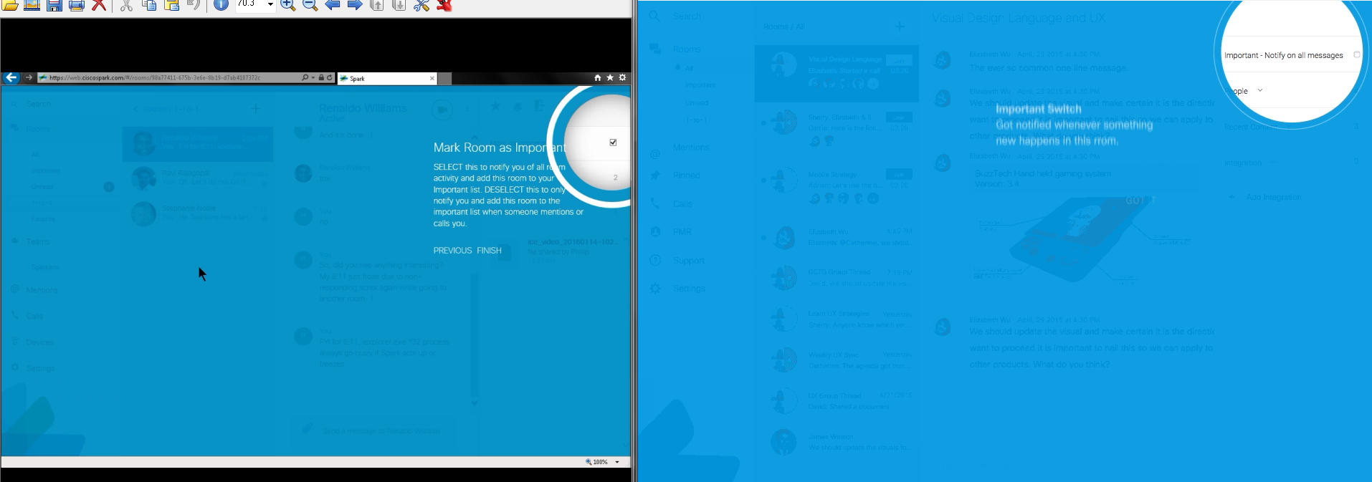

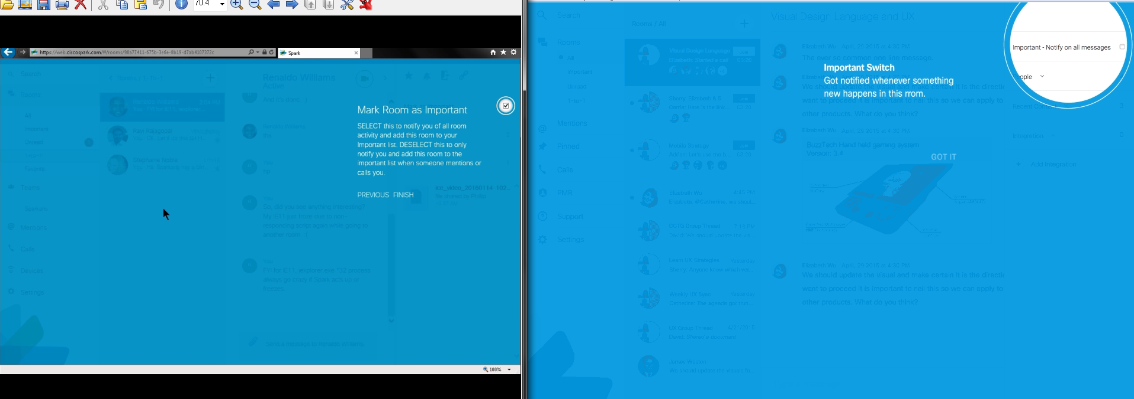

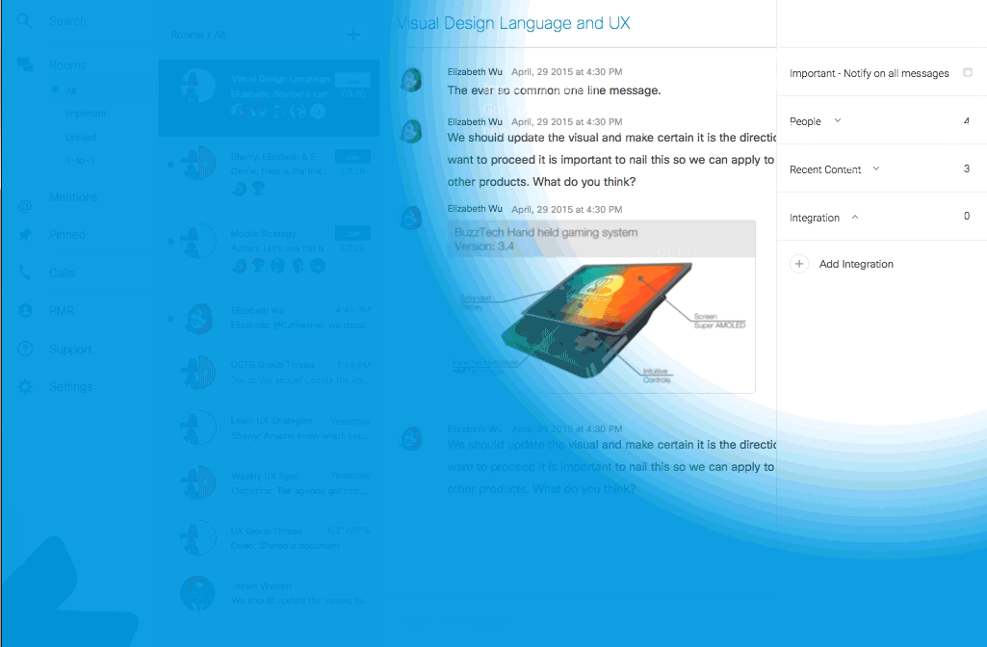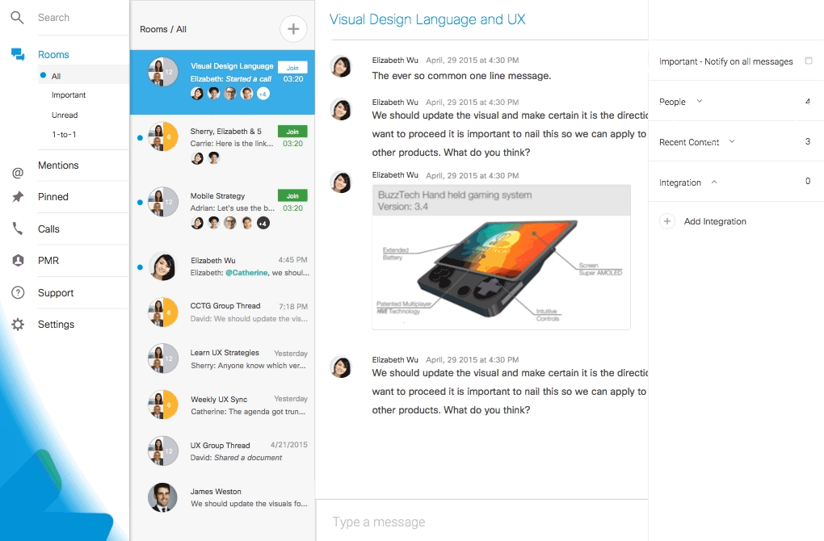

IE did not show the above redline’s animated gradient effect from the blue coach mark to white normal screen with contents. IE showed the regular non-coach mark, with white contents, result as shown below:

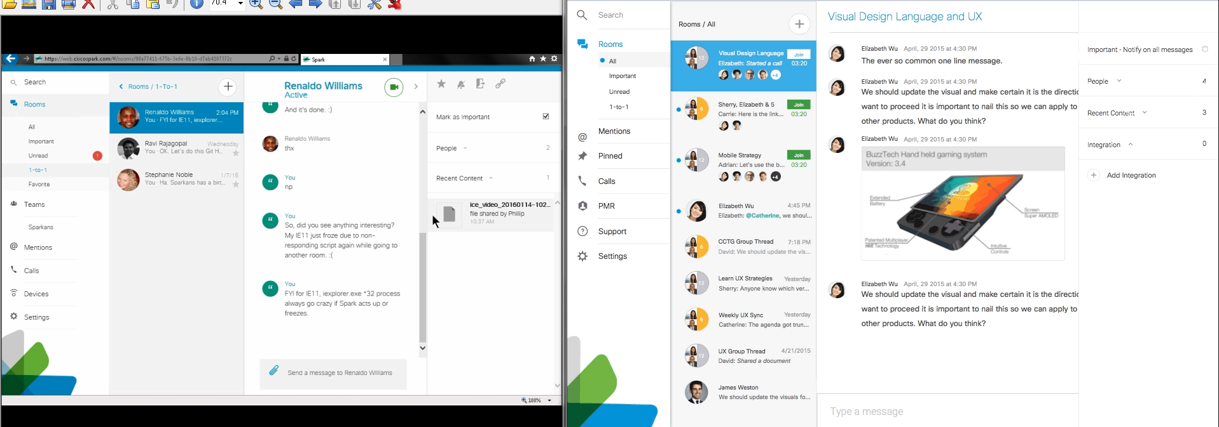

“Mark Room as Important” coach mark shows differently with its positions, layouts, animations, texts, etc. A possible bug and/or annoying usability design before and after the coach mark, showing all rooms (filter) view, and exiting and starting up IE. It does not show all rooms after the coach marks are done since it takes me to “1-to-1” filter view. I could see coach mark changing my filters in the background. Below screen (shot/capture)s are the before and after results:

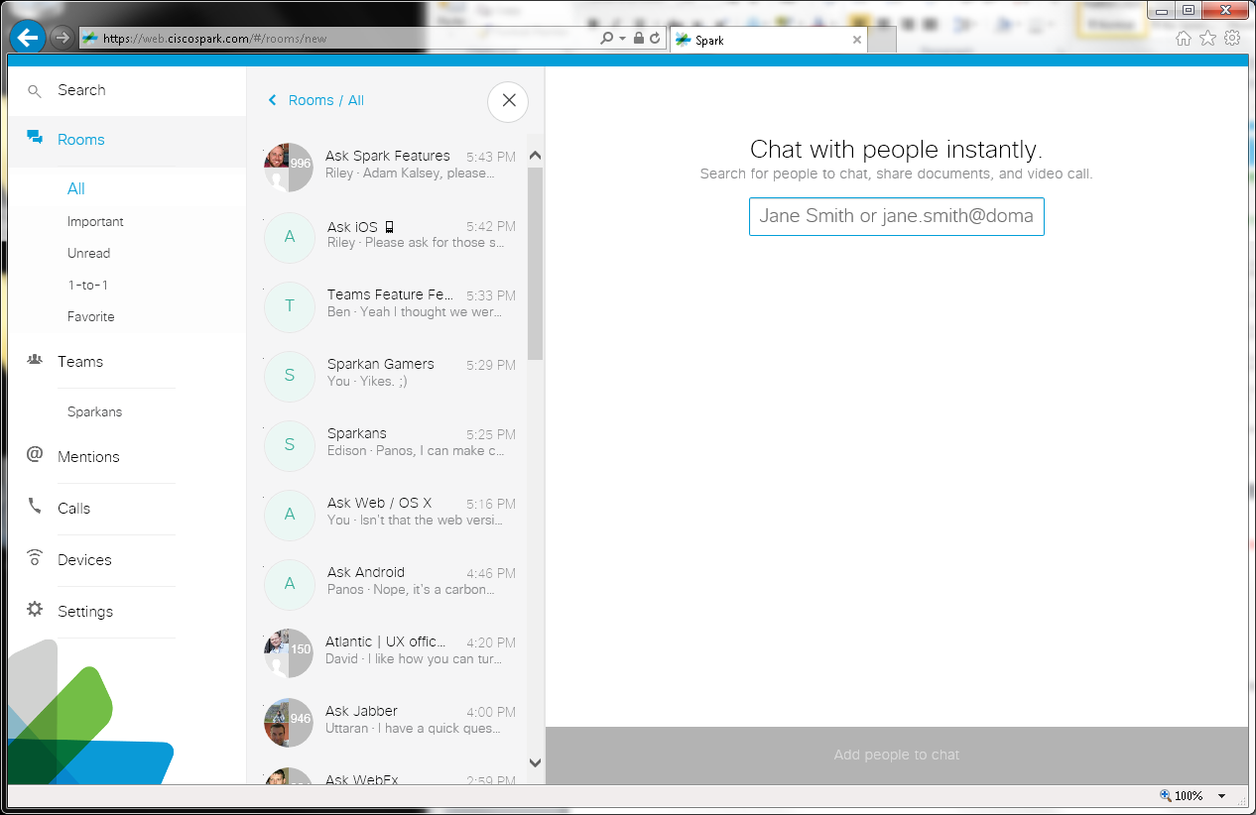

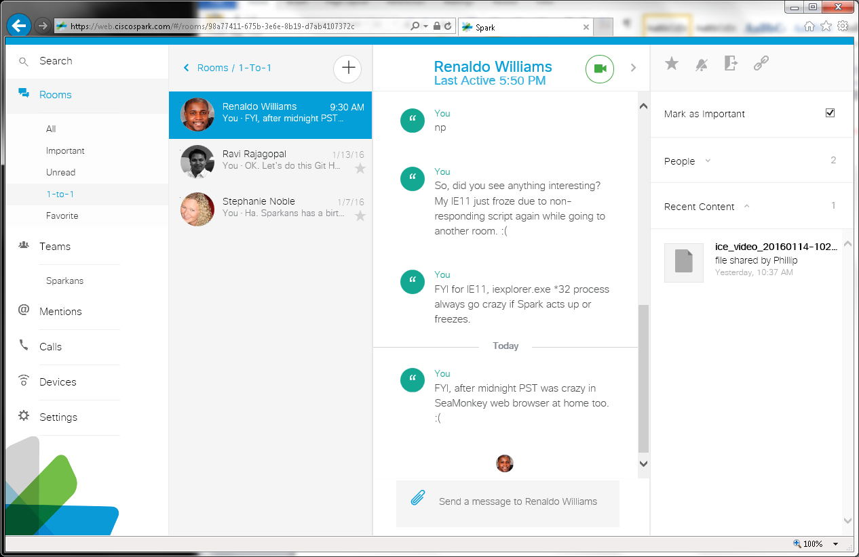

Overall Issues: Different and missing animations, designs, layouts, texts, etc.

https://cisco.app.box.com/s/jgwoykvufd86vrpc3n44oz2p7dd4ba2l (Desktop Specs):

https://cisco.app.box.com/s/jgwoykvufd86vrpc3n44oz2p7dd4ba2l/1/4664550450/37981944562/1 (web-coachmark-appendix2.0.png) [also http://wikicentral.cisco.com/download/attachments/509751860/web-coachmark-appendix2.0.png?version=1&modificationDate=1442518133000 (motion spec 2.0)] in v4318 - SDK v0.5.48:

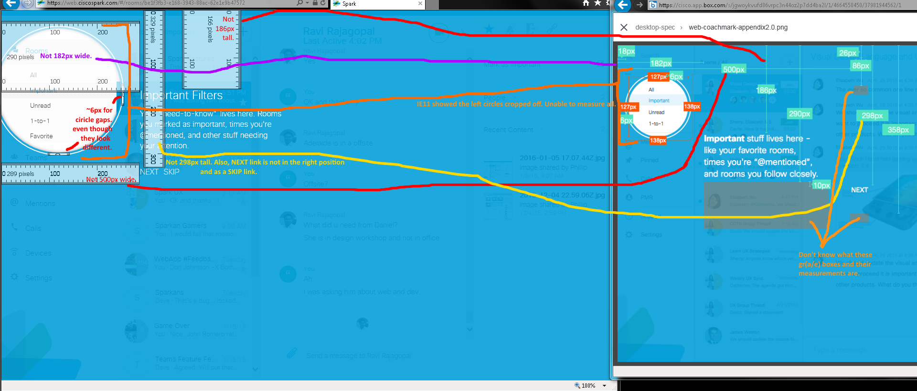

Issues:
- Circles are cropped off.
- Measurements are different.
- Different texts.
- NEXT is in the wrong area and has a SKIP link option.
- No texts’ upward animations seen to measure the movements as shown in redline’s gr(a/e)y boxes?

https://cisco.app.box.com/s/jgwoykvufd86vrpc3n44oz2p7dd4ba2l/1/4664550450/37981948294/1 (web-coachmark-currentdesign_spec.png) [also http://wikicentral.cisco.com/download/attachments/509751860/web-coachmark-currentdesign_spec.png?version=1&modificationDate=1442502651000’s current design] in v 4326 - SDK v0.5.48):

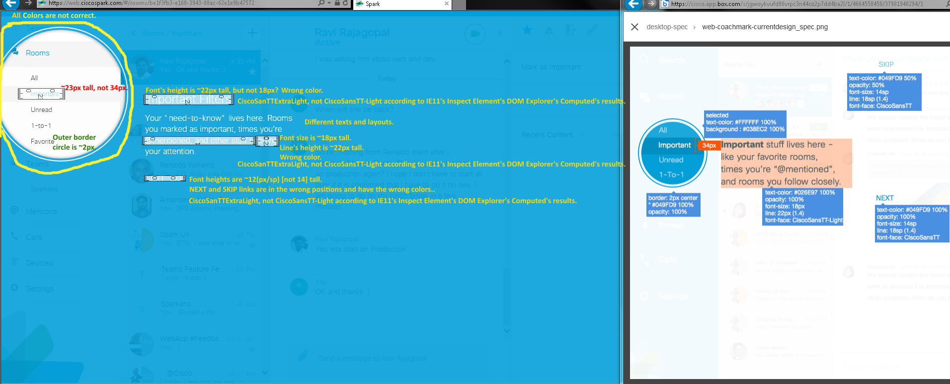

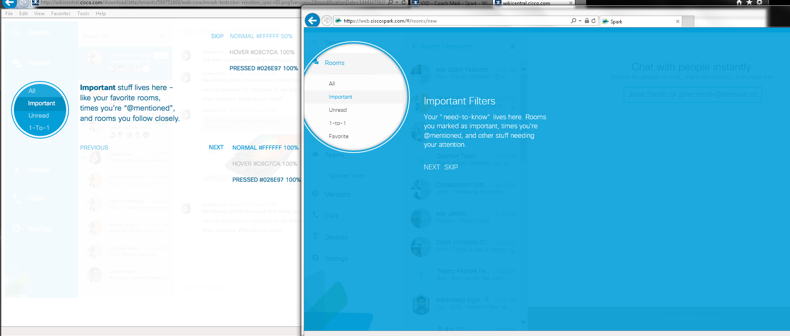

Issues Showing Incorrections: Colors (http://wikicentral.cisco.com/download/attachments/509751860/web-coachmark-textcolor-+motion_spec+02.png?version=2&modificationDate=1444167582000 for texts), sizes, positions (NEXT and SKIP links), texts, fonts, and layouts.

https://cisco.app.box.com/s/jgwoykvufd86vrpc3n44oz2p7dd4ba2l/1/4664550450/37981955326/1 (web-coachmark-importantswitch- motion_spec.png) [also http://wikicentral.cisco.com/download/attachments/509751860/web-coachmark-importantswitch-+motion_spec.png?version=1&modificationDate=1442534045000 motion spec] in v4318 - SDK v0.5.48:

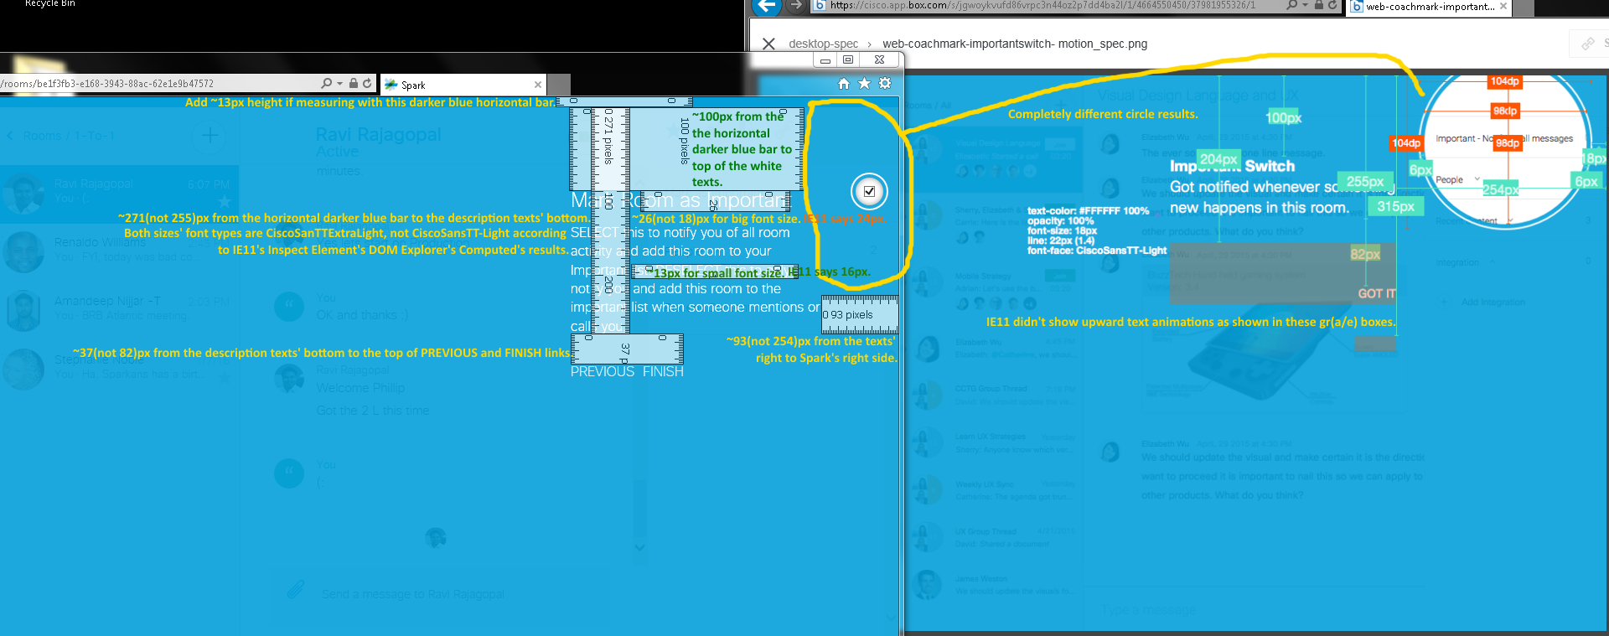

Issues:
- Top right circled corners did not match each other.
- Wrong sizes, texts, fonts, and positions
- IE didn’t show text’s upward animations.

https://cisco.app.box.com/s/jgwoykvufd86vrpc3n44oz2p7dd4ba2l/1/4664550450/37981960050/1 (web-coachmark-motion 01.png) [also http://wikicentral.cisco.com/download/attachments/509751860/web-coachmark-motion+01.png?version=3&modificationDate=1443040981000 Motion’s Desktop-Filter] in v4289 - SDK v0.5.46:

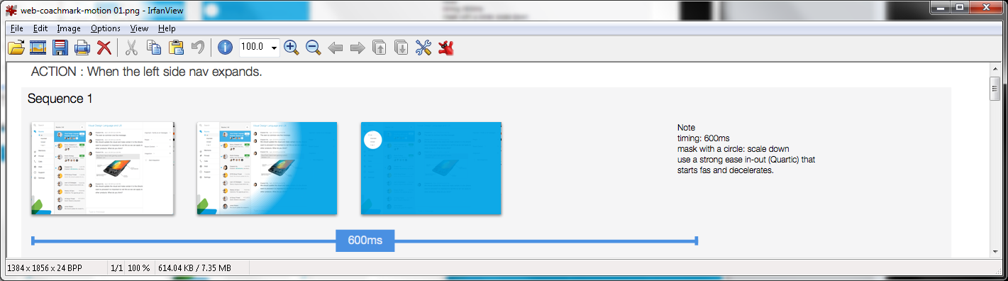

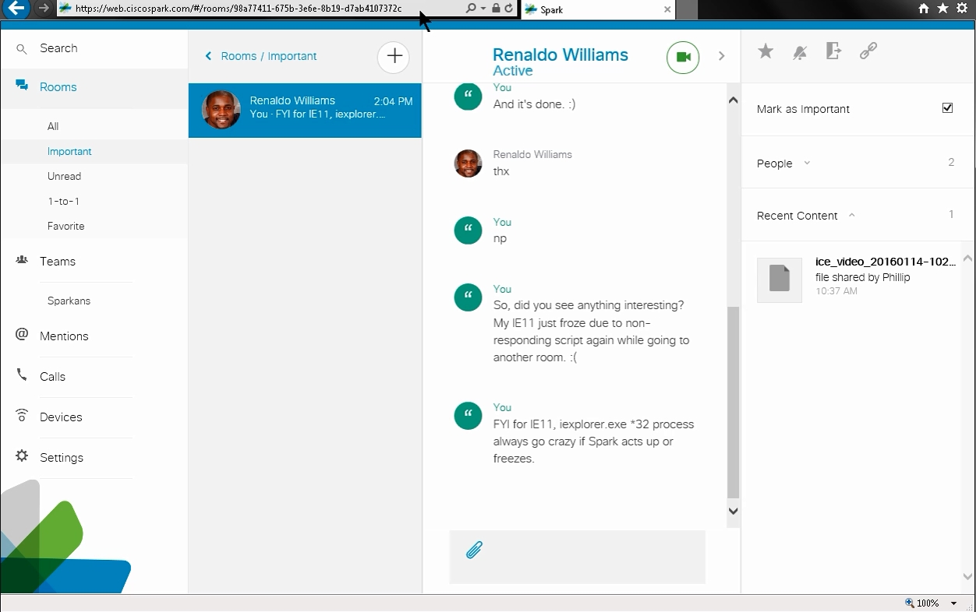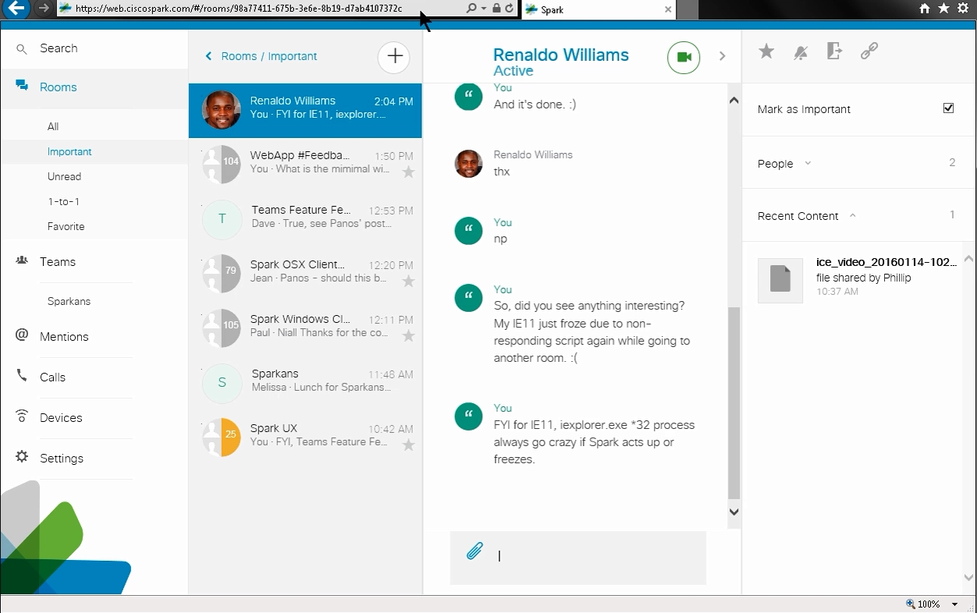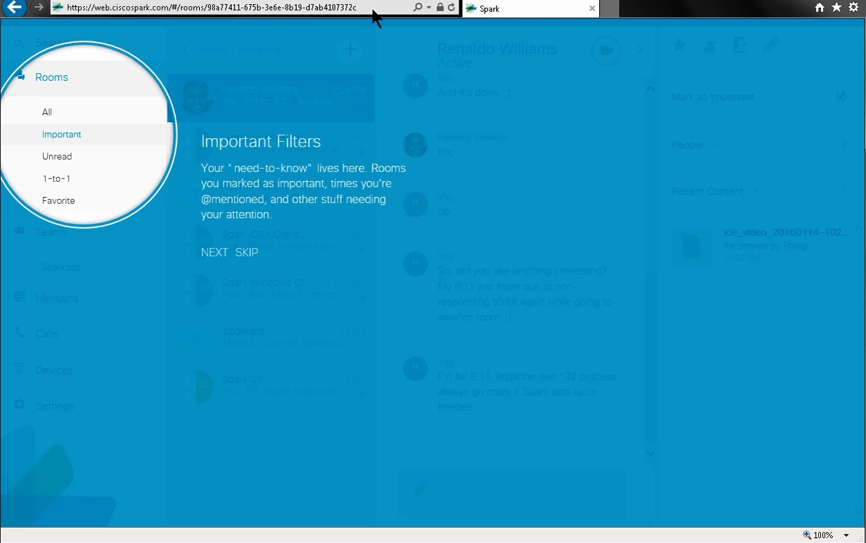

Sequence 1’s Issue: There was no circle animation. Going from white to blue overlay screens was instant.

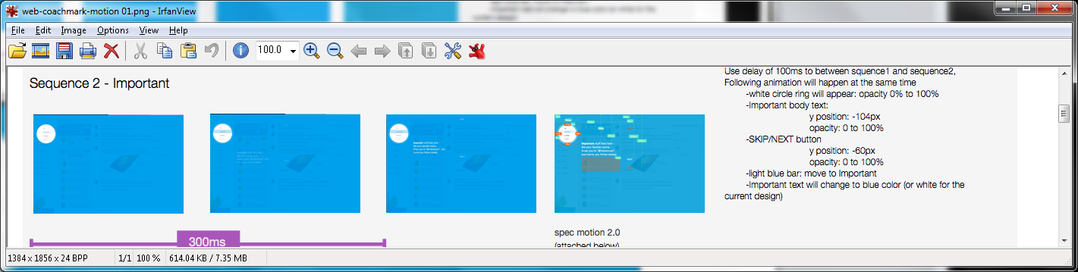

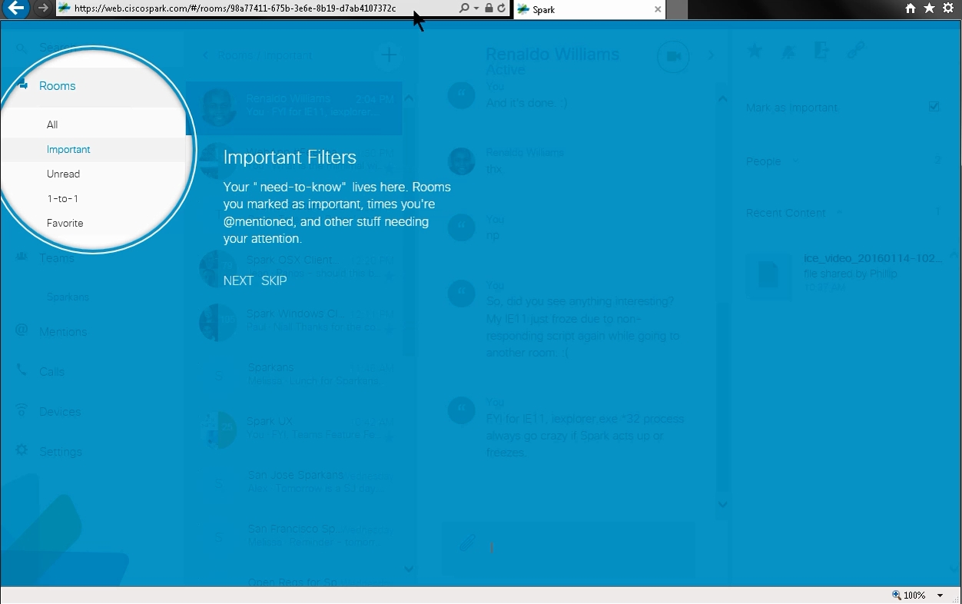
Sequence 2’s Important Issues: No text animations. The only changes were the background’s room list, its avatar images (more thumbnails), slightly brighter white texts, and an added vertical scrollbar behind the blue screen overlay.

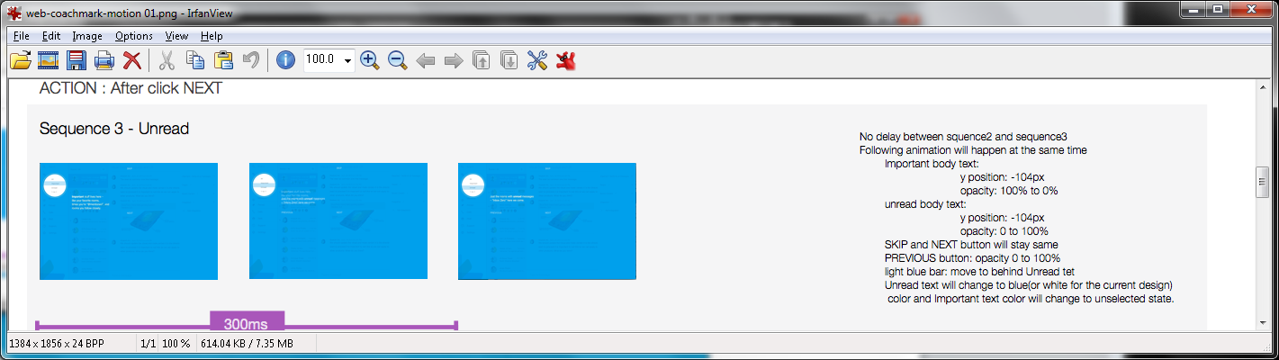

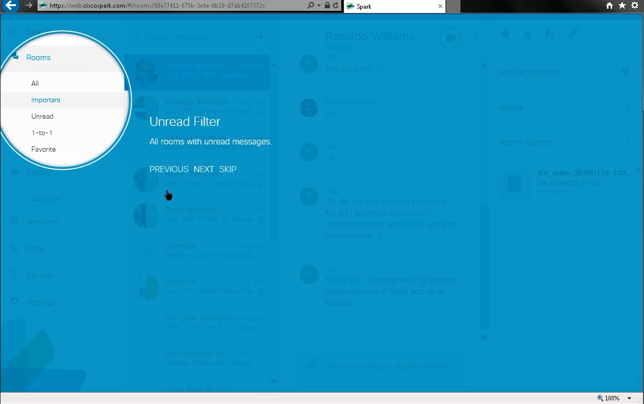

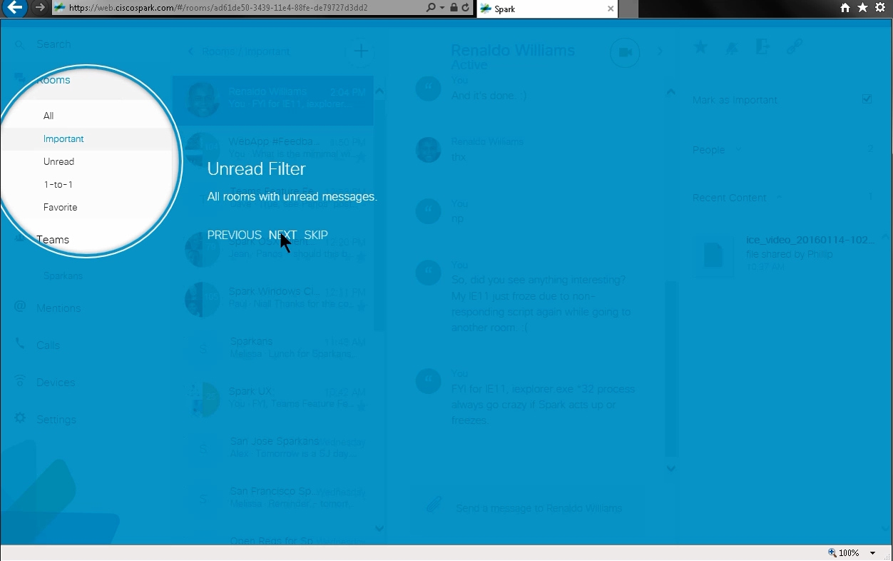

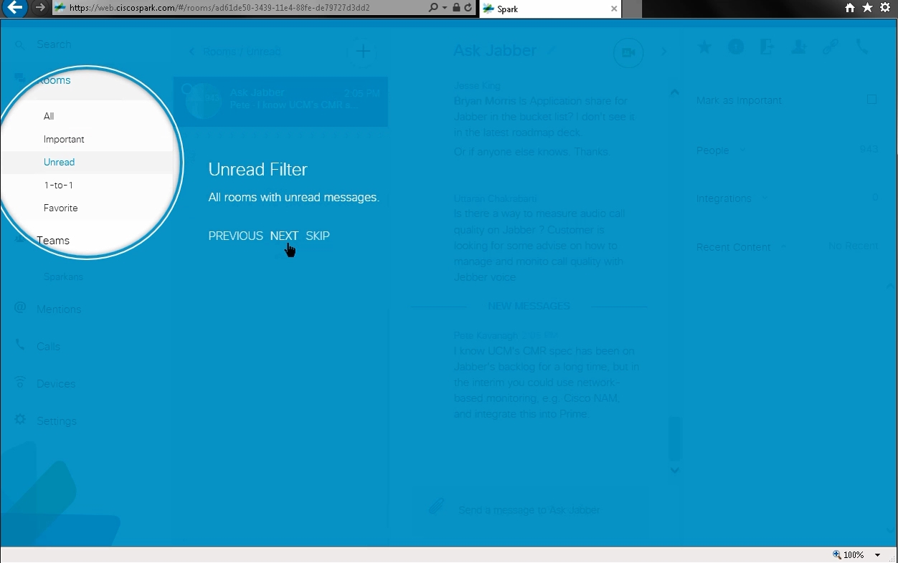

Sequence 3’s Unread Issues:
- Body texts did not fade and move.
- Rooms’ highlight have smooth movements from Important to Unread.
- White circles moved downward though, but redline did not show them moving.

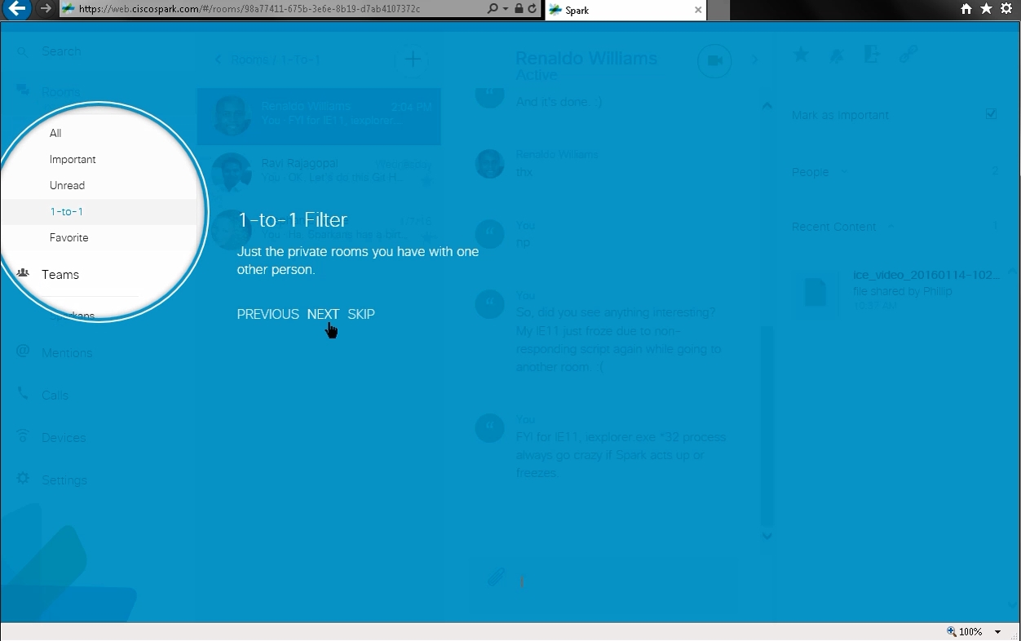
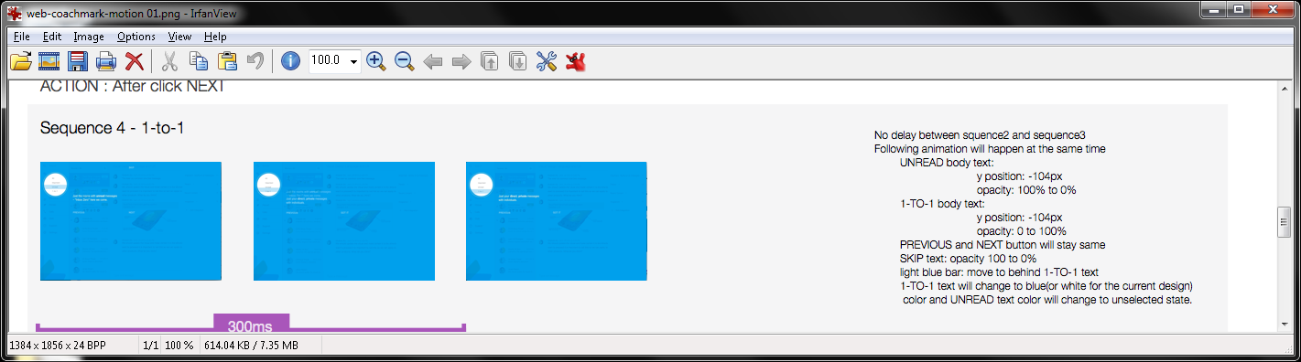
Sequence 4’s 1-to-1 Issues:

Texts did not fade and animate. They changed instantly.

2. Rooms’ circles moved downward to highlight from “Unread” to “1-to-1”.

3. SKIP link did not go away.

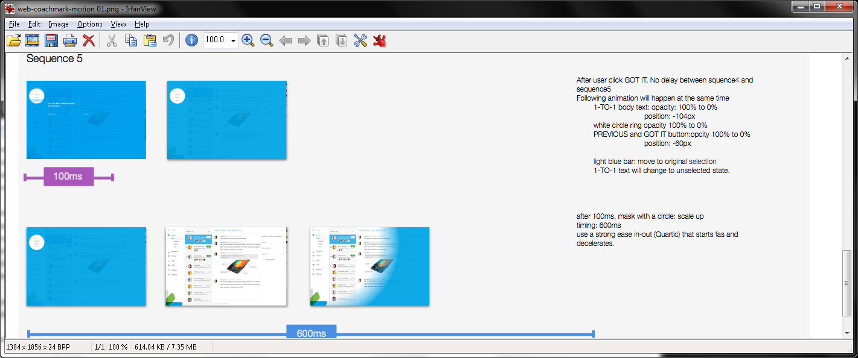

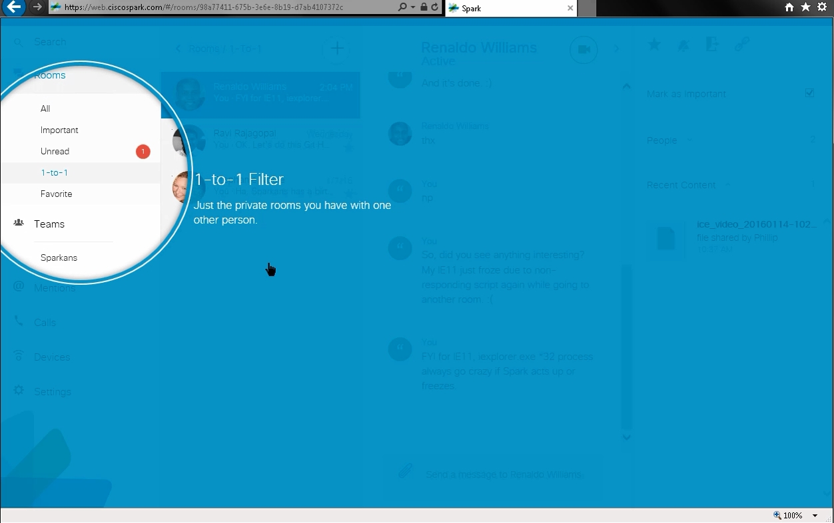

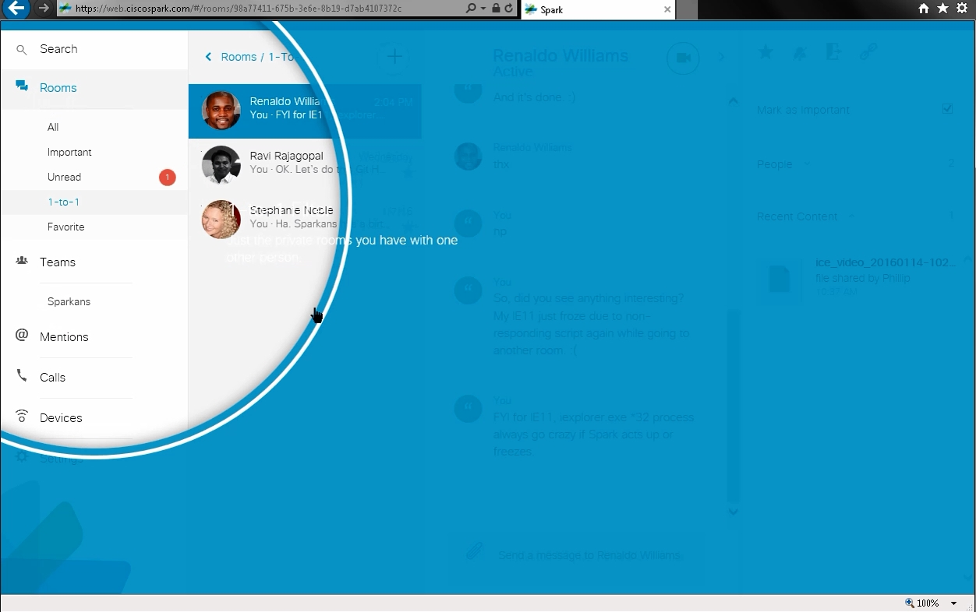

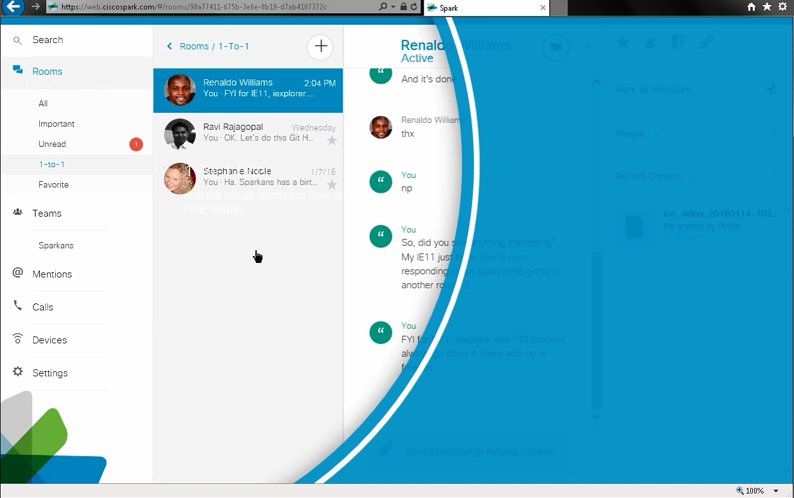

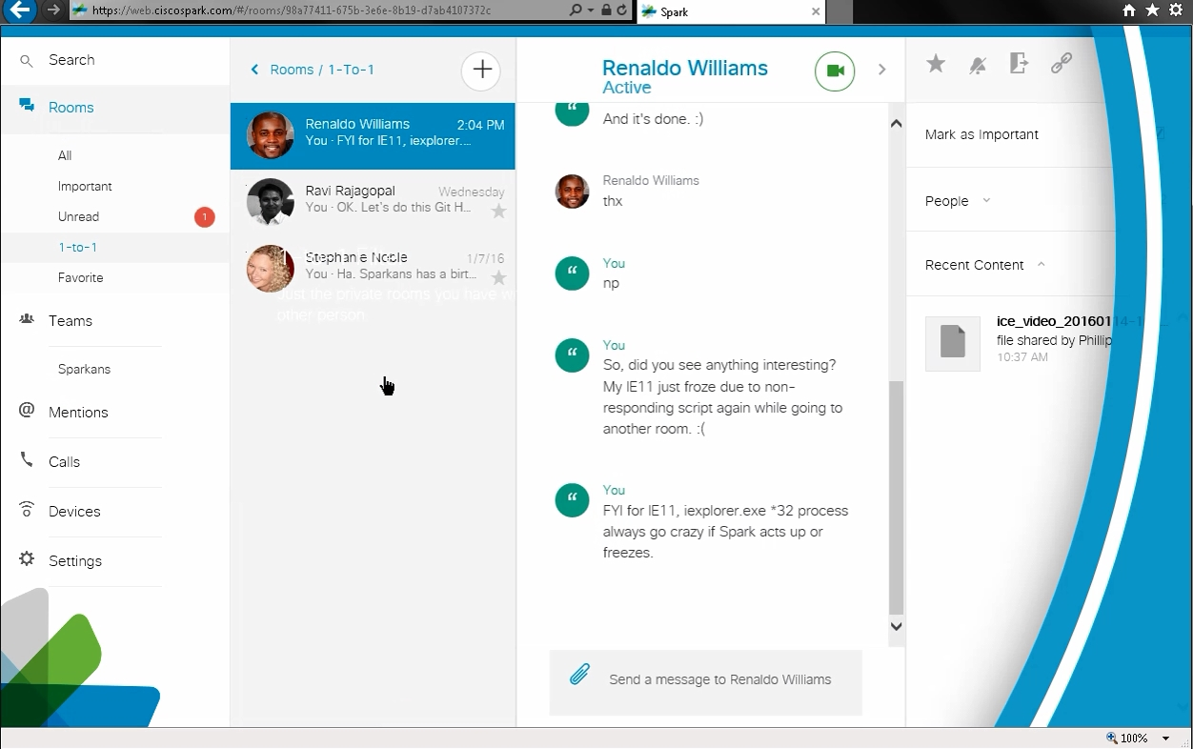

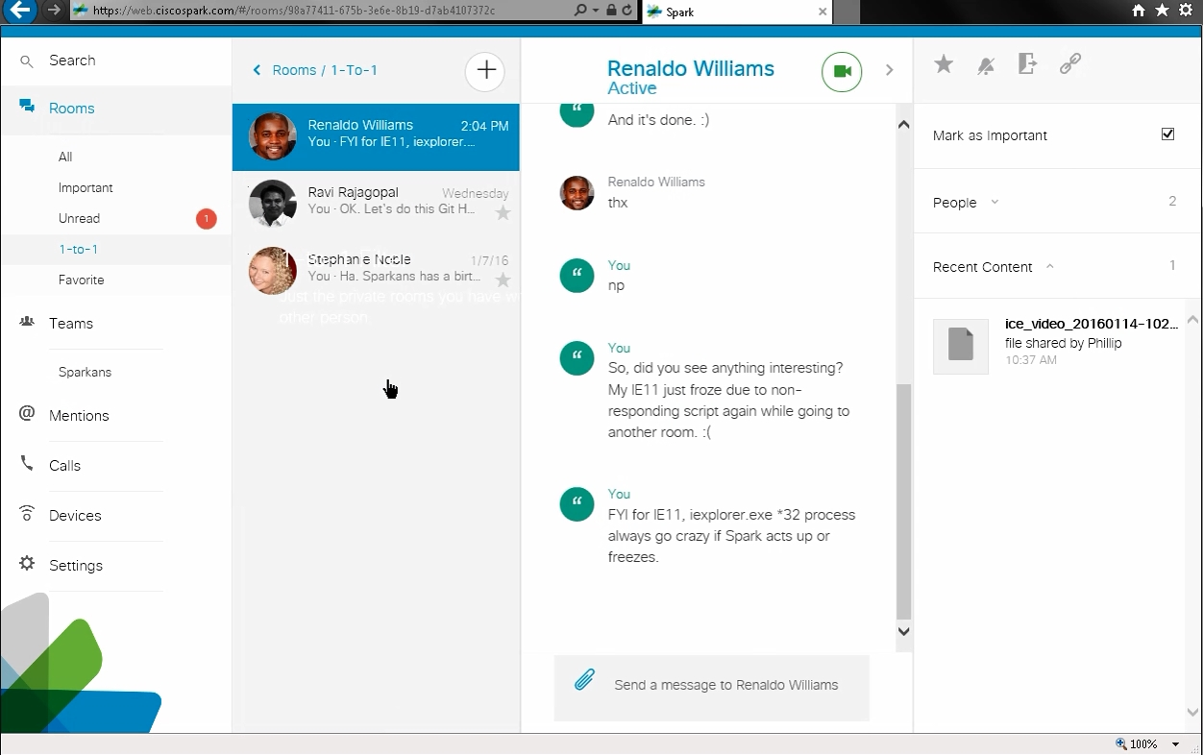

Sequence 5’s Issues:
- Missing “GOT IT” text since “NEXT” link acts like it.
- No fades and color changes.
- “1-to-1”’s body texts did not move and disappear. They remained on the screen, and I could still see the white texts left behind too. PREVIOUS, NEXT, and SKIP links did vanish though.
- The growing circle animation looked different to fullscreen (before starting "Mark as Important"'s coach mark) to remove its blue screen overlay. Redline showed gradient edges, but IE showed thick white and blue rings and a drop shadow.
- Rooms’ “1-to-1” selections stayed the same.

https://cisco.app.box.com/shared/jgwoykvufd86vrpc3n44oz2p7dd4ba2l/1/4664550450/37981963854/1 (web-coachmark-motion 02.png) [also http://wikicentral.cisco.com/download/attachments/509751860/coachmark-web-importantswitch_sequence001.gif?version=1&modificationDate=1442533284000, http://wikicentral.cisco.com/download/attachments/509751860/coachmark-web-importantswitch_sequence02.gif?version=1&modificationDate=1442531597000, http://wikicentral.cisco.com/download/attachments/509751860/coachmark-web-importantswitch_sequence03-Recovered.gif?version=1&modificationDate=1442533239000, http://wikicentral.cisco.com/download/attachments/509751860/coachmark-web-importantswitch_sequence04.gif?version=1&modificationDate=1442533169000, & http://wikicentral.cisco.com/download/attachments/509751860/web-coachmark-motion+02.png?version=2&modificationDate=1443040958000 web slow motion-Important Switch] in v4326 - SDK v0.5.48:

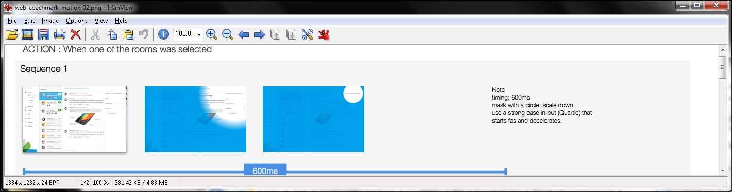

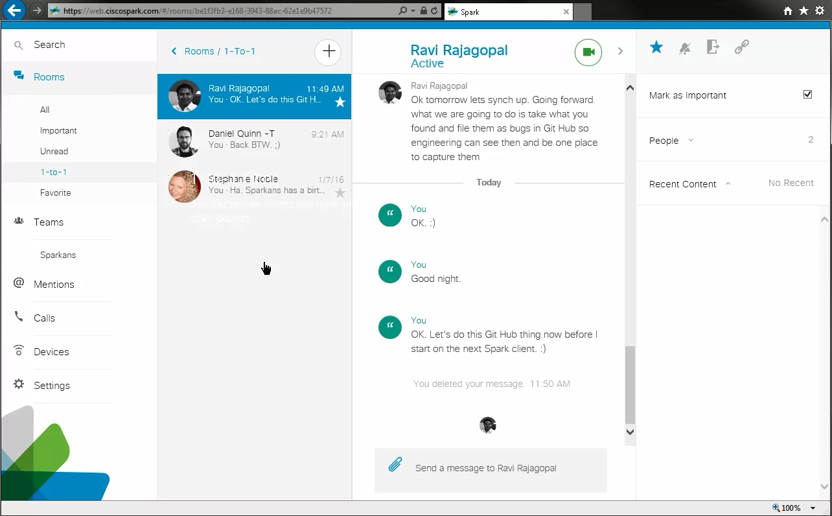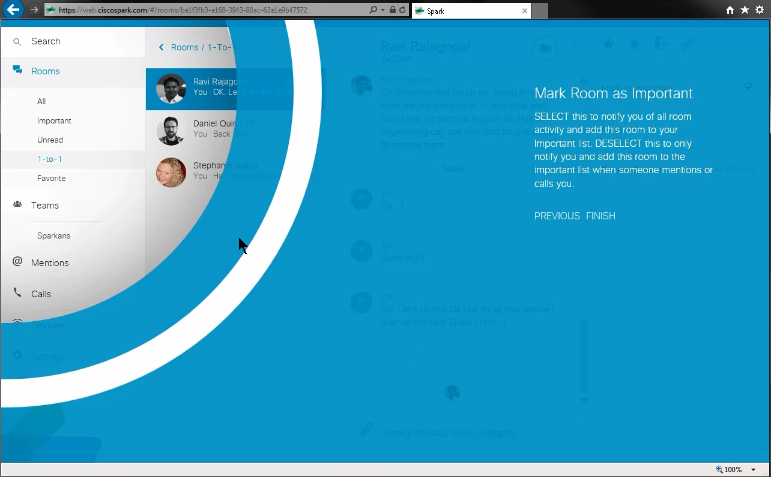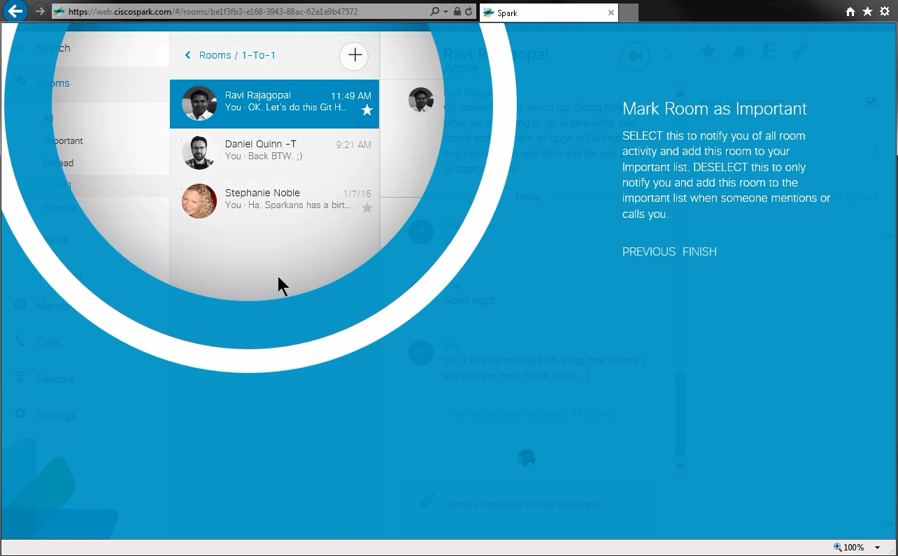

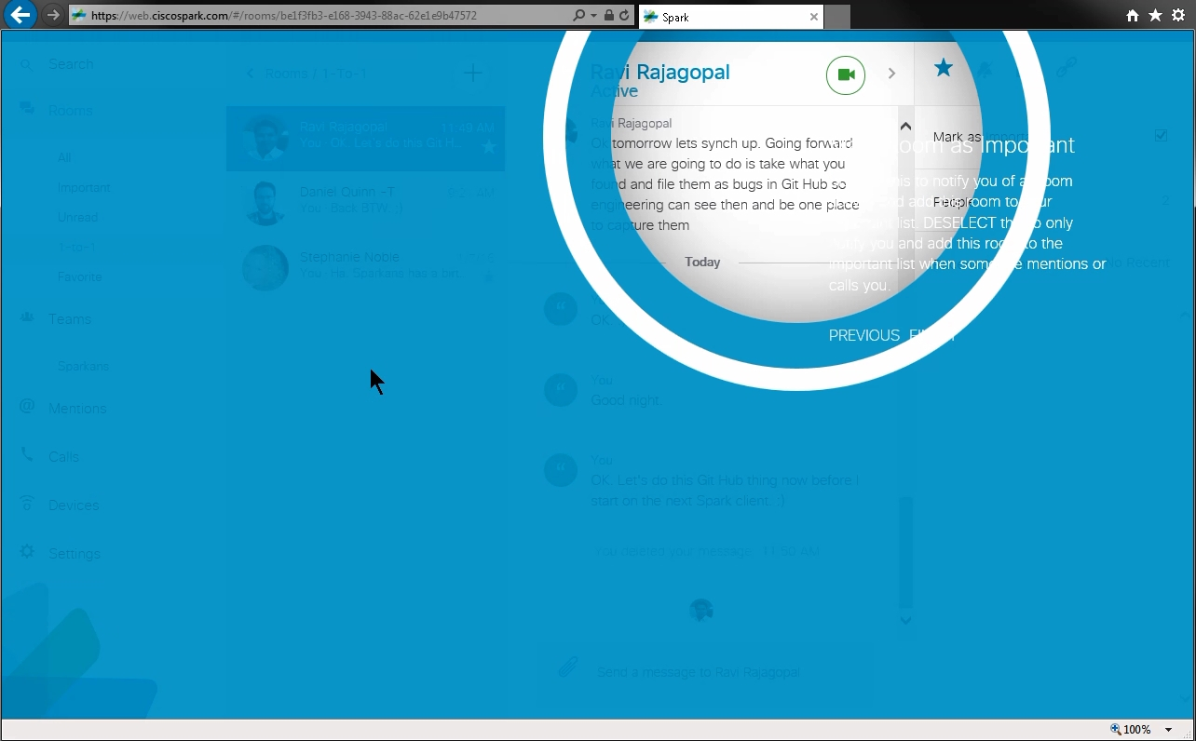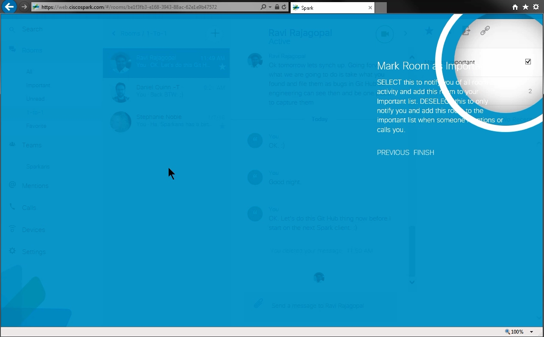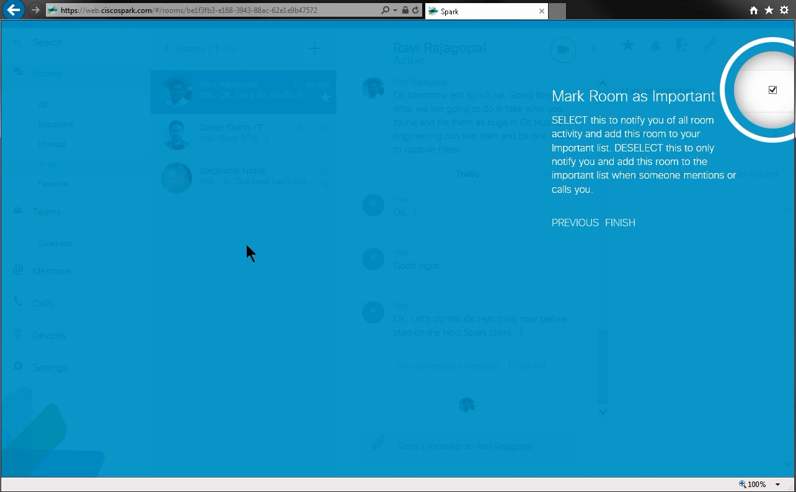

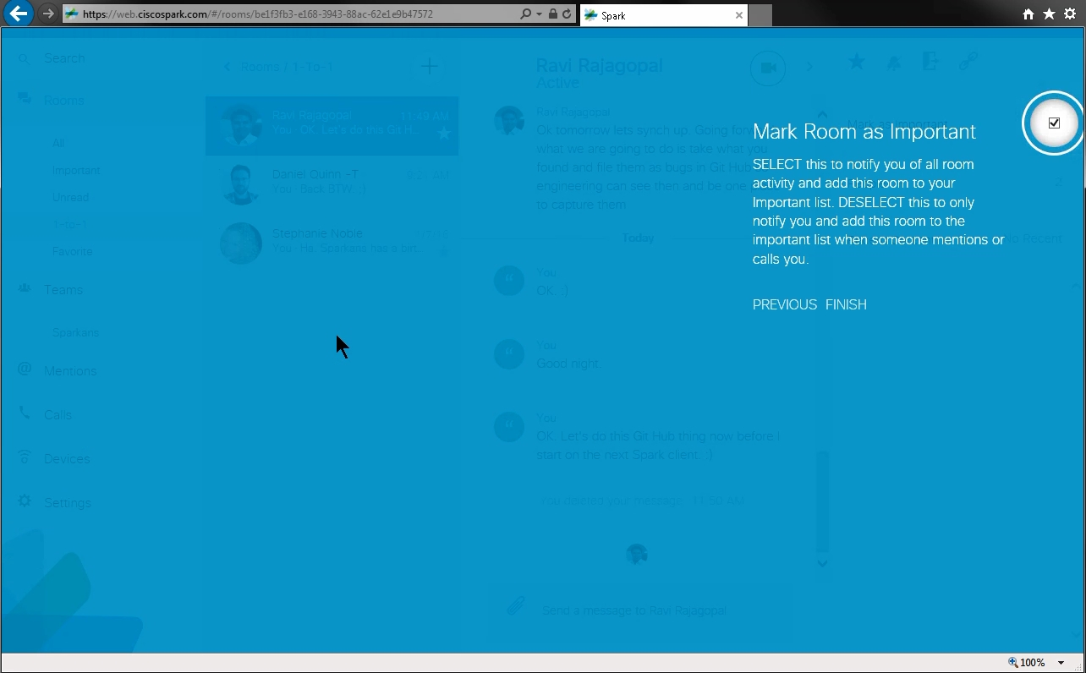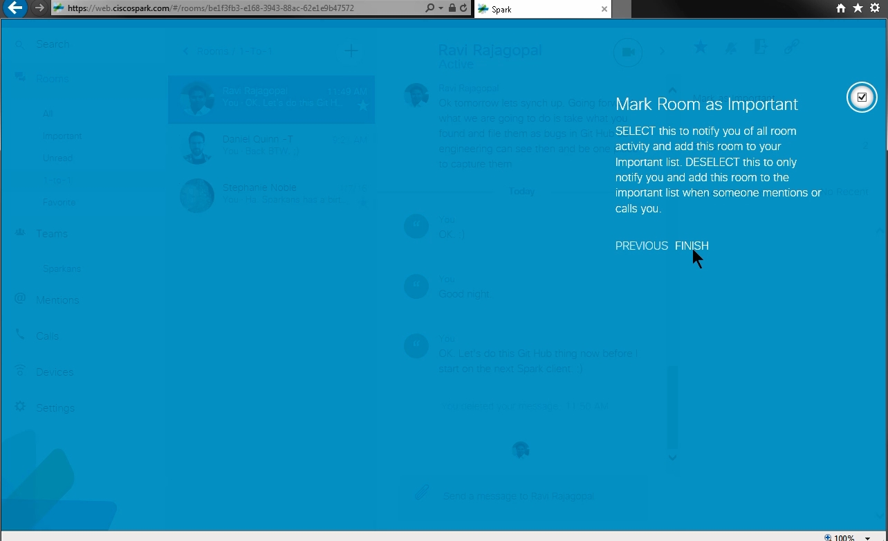

Sequence 1’s Issues:
- I did not click on any room to make this sequence 1 start like in Windows desktop client. It automatically started right after the Rooms’ filters’ coachmarks were completed. However, I could not always reproduce this Important Room switch’s coachmark and could not figure out its patterns. I did not get any answers from Renaldo Williams, Daniel Quinn, and Ravi Rajagopal about it.
- The circles’ designs, movements, and animations were different between redlines and IE web browser.

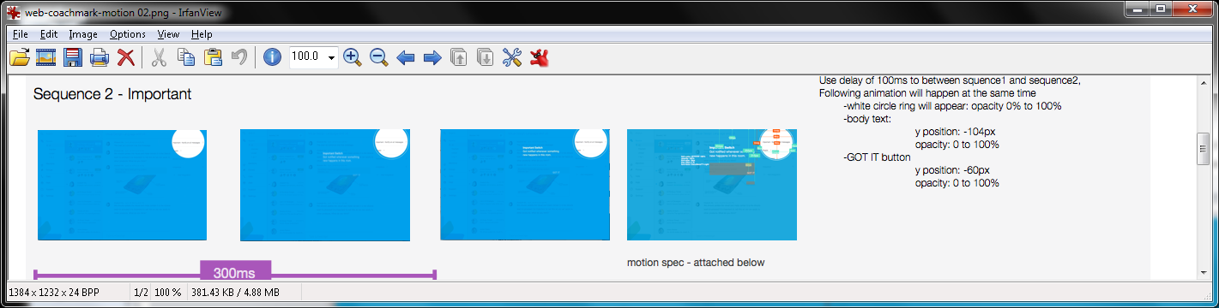

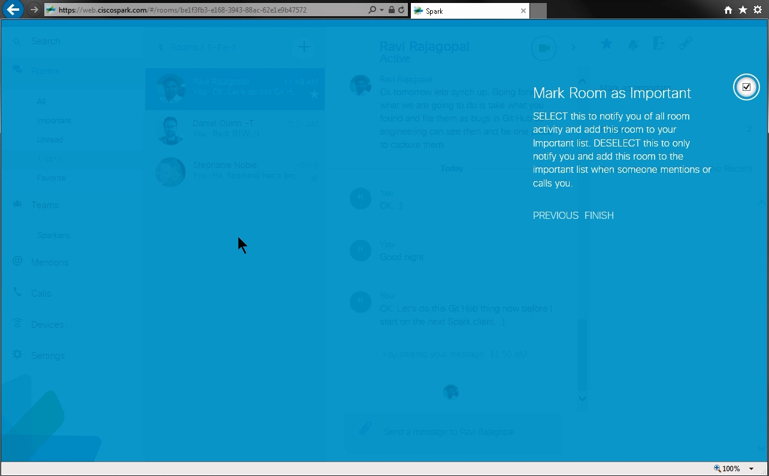

Sequence 2’s Issues:
- IE’s white circle rings were always there when in motions and animations. Also, they looked different when compared to redlines’.
- Texts never moved and faded since they appeared instantly during the circle motions from earlier.
- There is no “GOT IT” link, but a “FINISH” link.

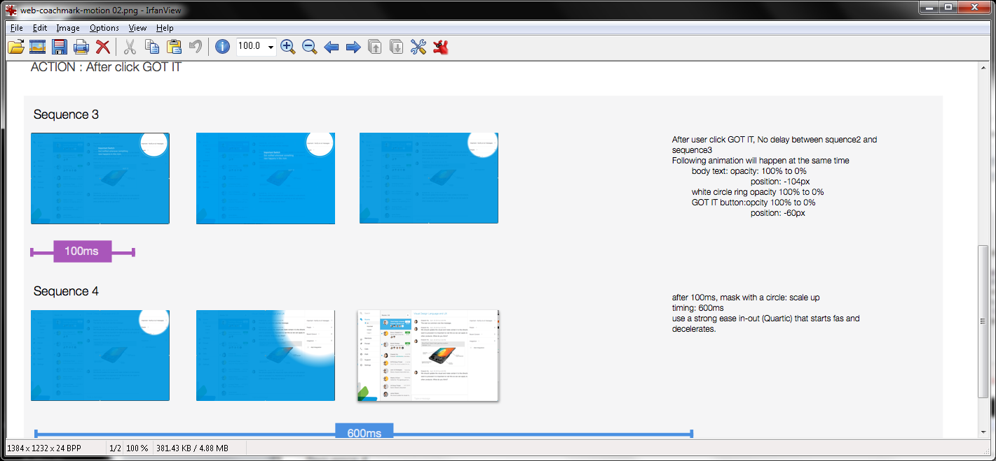

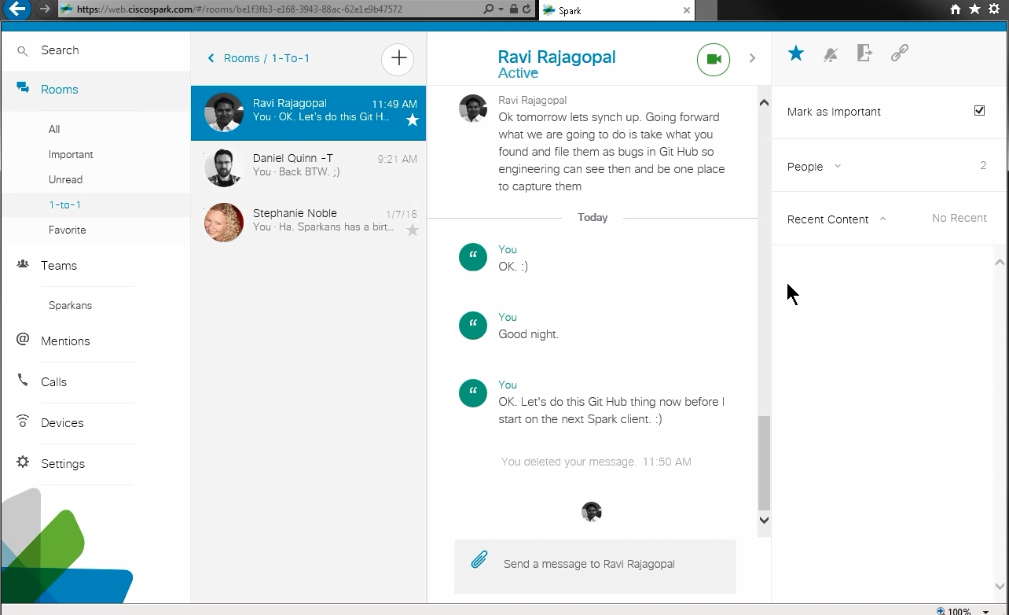

Sequences 3 and 4’s Issues:
- IE showed the instant non-blue Spark’s mostly white screen after clicking on “FINISH” (no “GOT IT”) link.
- Texts never moved and faded since they appeared instantly during the circle motions from earlier.
- No motions with the blue screen overlay like its circles.
https://cisco.app.box.com/shared/jgwoykvufd86vrpc3n44oz2p7dd4ba2l/1/4664550450/37981967526/1 (web-coachmark-spec01.png) [also http://wikicentral.cisco.com/download/attachments/509751860/web-coachmark-spec01.png?version=1&modificationDate=1441919975000 Desktop] in v4326 - SDK v0.5.48:

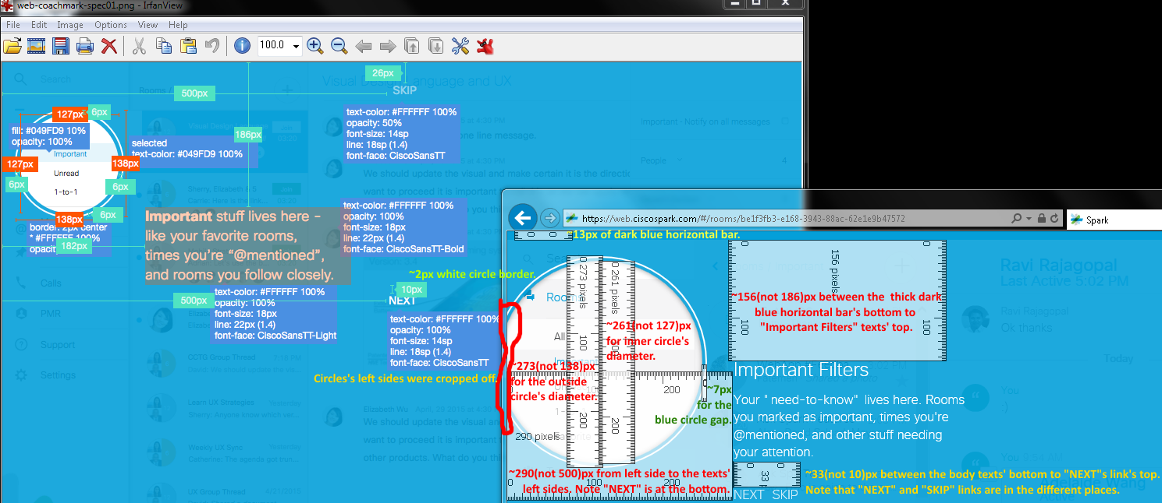

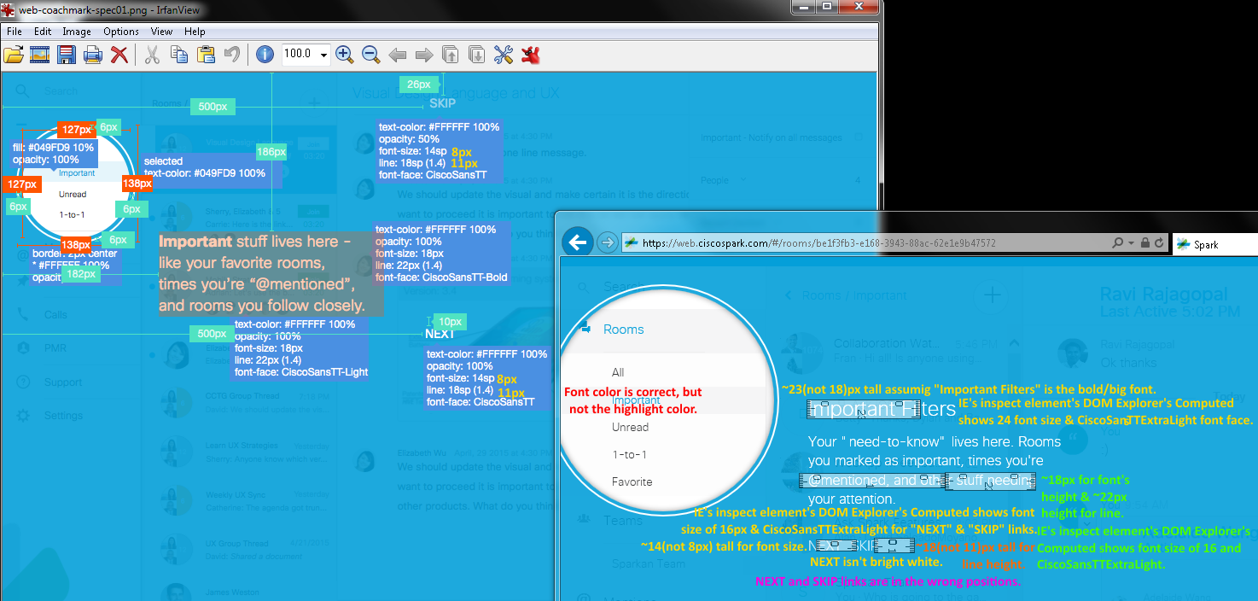

Issues: Wrong sizes, positions, font type, texts, and colors.

https://cisco.app.box.com/shared/jgwoykvufd86vrpc3n44oz2p7dd4ba2l/1/4664550450/37981971382/1 (web-coachmark-spec02.png) [also http://wikicentral.cisco.com/download/attachments/509751860/web-coachmark-spec02.png?version=1&modificationDate=1441919991000 Desktop] in v4326 - SDK v0.5.48:

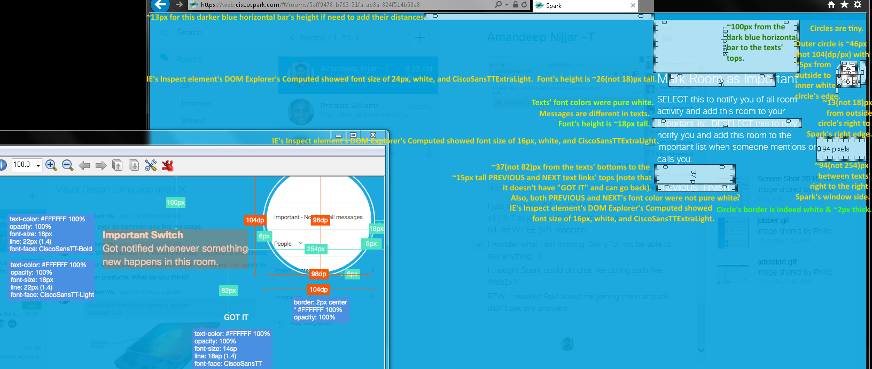

Issues: Wrong sizes, measurements, positions, font types, texts, designs, layouts, positions, and colors.

http://wikicentral.cisco.com/download/attachments/509751860/web-coachmark-textcolor-+motion_spec.png?version=2&modificationDate=1444167547000 (Desktop) for its text colors in v4353 – SDK v0.5.48:

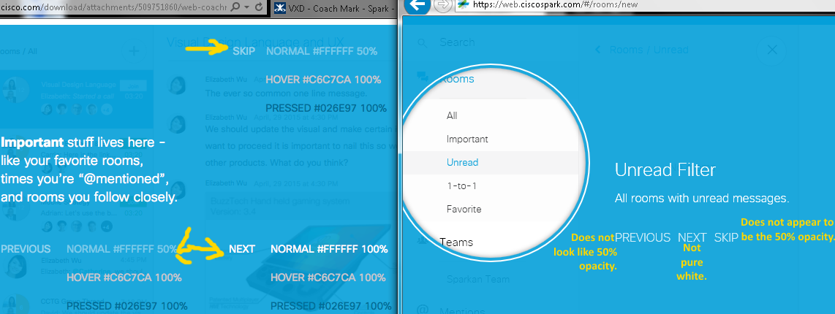

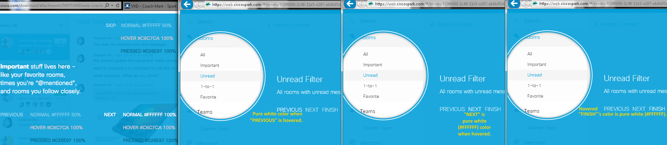
Issues:
- Wrong and missing (when pressed) text colors.
- No SKIP link, but there is a FINISH link.
- NEXT, PREVIOUS, and FINISH (no SKIP) links are in the wrong posiitons.
http://wikicentral.cisco.com/download/attachments/509751860/Coach+Mark+Copy_v3.docx?version=2&modificationDate=1445546301000 (Coach Mark Copy (Edit) from 10/22/2015 12:35 PM) on v4289 - SDK v0.5.46:

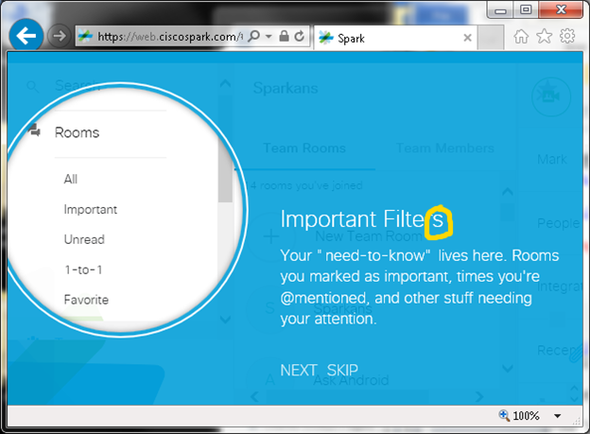
Important Filter
Your “need-to-know” lives here. Rooms you marked as important, times you’re @mentioned, and other stuff needing your attention.
IE showed a plural “Filters”.
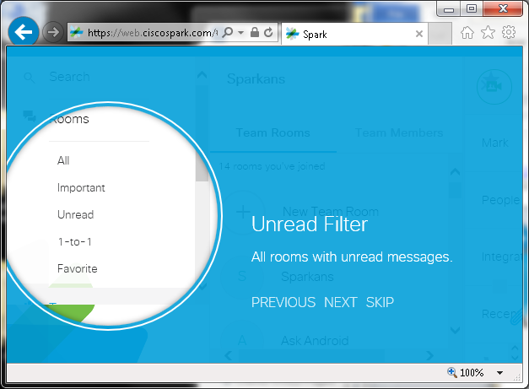
Unread Filter
All rooms with unread messages.
This looked fine in IE.
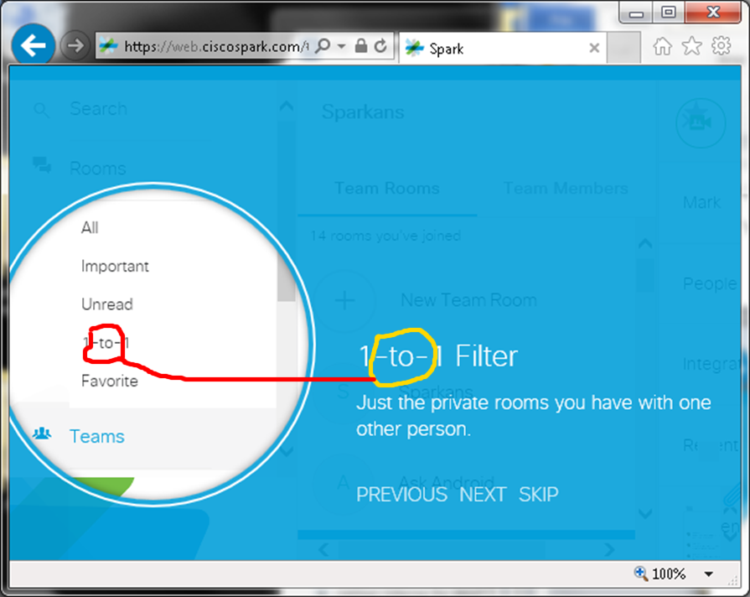
1:1 Filter
Just the private rooms you have with one other person.
IE showed 1-to-1 instead of 1:1.
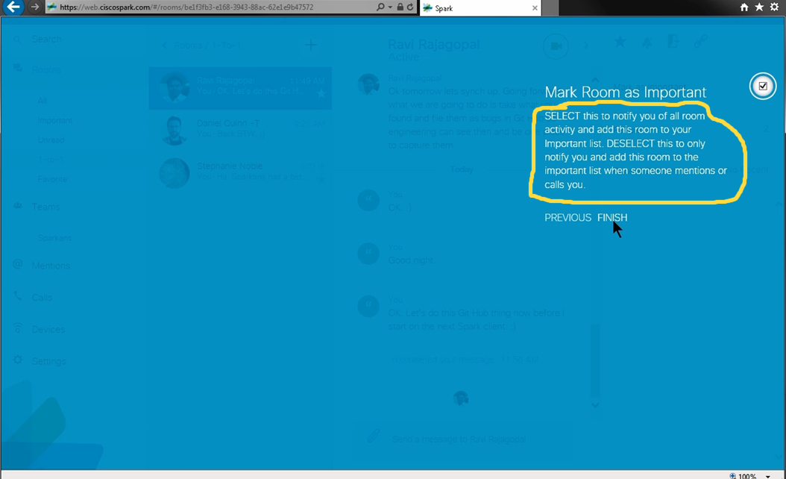
Mark Room as Important
Add this room to your important filter. Get notified whenever something new happens in this room.
This text description did not match in IE.

